Cancer Chemotherapy and Pharmacology

Midkine promotes tumor growth and attenuates the effect of cisplatin in small cell lung cancer

Shotaro Ito¹, Jun Sakakibara-Konishi¹, Megumi Furuta¹, Tetsuaki Shoji¹, Hirofumi Takahashi¹, Mineyoshi Sato¹, Kosuke Tsuji¹, Daisuke Morinaga¹, Masahiro Kashima¹, Hidenori Kitai¹, Junko Kikuchi¹, Eiki Kikuchi¹, Kanako C Hatanaka², Yutaka Hatanaka², Kyoko Hida³, Takuro Noguchi⁴ and Satoshi Konno¹

¹Department of Respiratory Medicine, Faculty of Medicine, Hokkaido University, Sapporo, Japan
²Center for Development Advanced Diagnostics, Hokkaido University Hospital, Sapporo, Japan
³Department of Vascular Biology and Molecular Pathology, Hokkaido University Faculty of Dental Medicine, Sapporo, Japan
⁴Department of Medical Oncology, Faculty of Medicine and Graduate School of Medicine, Hokkaido University, Sapporo, Japan

*Corresponding author: Jun Sakakibara-Konishi, MD, PhD
Department of Respiratory Medicine, Faculty of Medicine, Hokkaido University, N 15, W 7, Kita-ku, Sapporo, 0608638, Japan
E-mail: konishj@med.hokudai.ac.jp
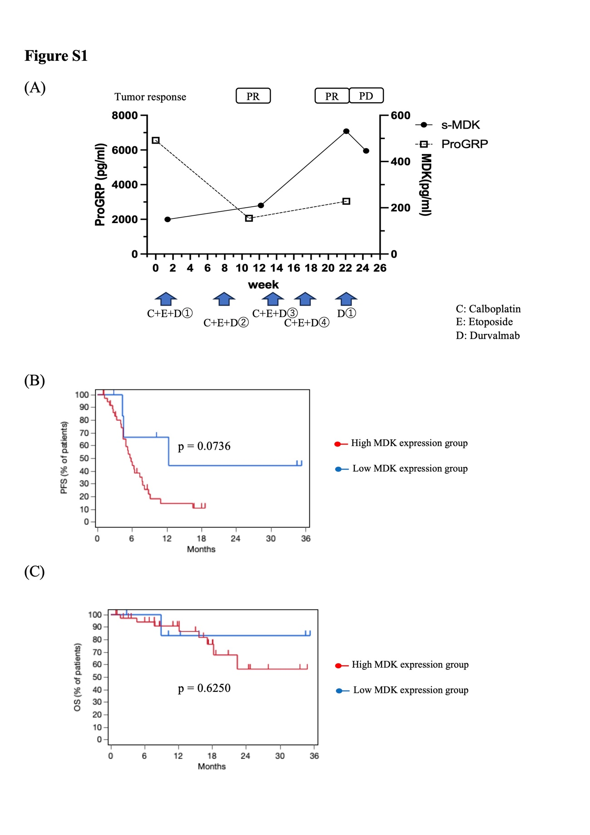
Supplementary Fig. S1 MDK might function as a tumor or prognostic biomarker in small cell lung cancer. (a) The clinical course of the patient with a rapid increase in serum MDK (s-MDK) levels after four chemotherapy cycles and subsequent tumor progression. The left-side scale shows the serum levels of ProGRP. The right-side scale shows s-MDK levels. The tumor response is shown above the graph. Arrows indicate the administration of anticancer drugs. (b) PFS and (c) OS according to s-MDK levels. High- and low-MDK expression groups were defined using the cut-off value optimized by receiver operating characteristic curve analysis. MDK, midkine; s-MDK, serum MDK; ProGRP, pro-gastrin-releasing peptide; PFS, progression-free survival; OS, overall survival

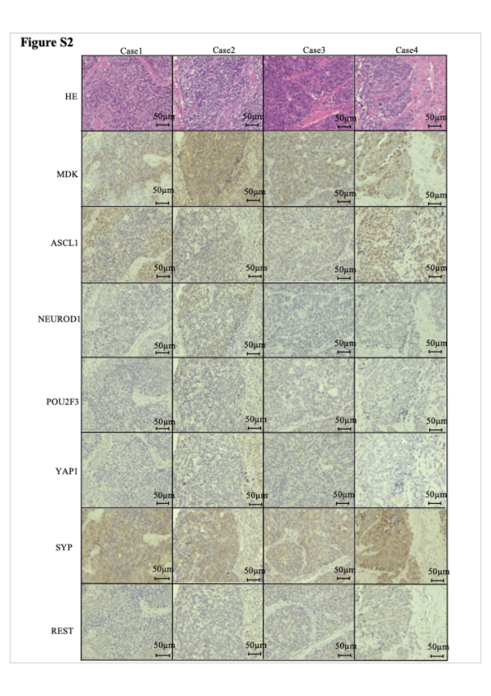
Supplementary Fig. S2 The correlation between MDK expression and small cell lung cancer (SCLC) characteristics (MDK, ASCL1, NEUROD1, POU2F3, YAP1, SYP, and REST expression evaluated) by immunohistochemistry in four surgical specimens of SCLC. Representative high-magnification images of HE and immunohistochemical staining are shown. MDK, midkine; SCLC, small cell lung cancer; SYP, synaptophysin; REST, RE1 silencing transcription factor; ASCL1, achaete-scute family bHLH transcription factor 1; NEUROD1, neuronal differentiation 1; POU2F3, POU class 2 homeobox 3; YAP1, yes-associated protein 1; HE, hematoxylin and eosin

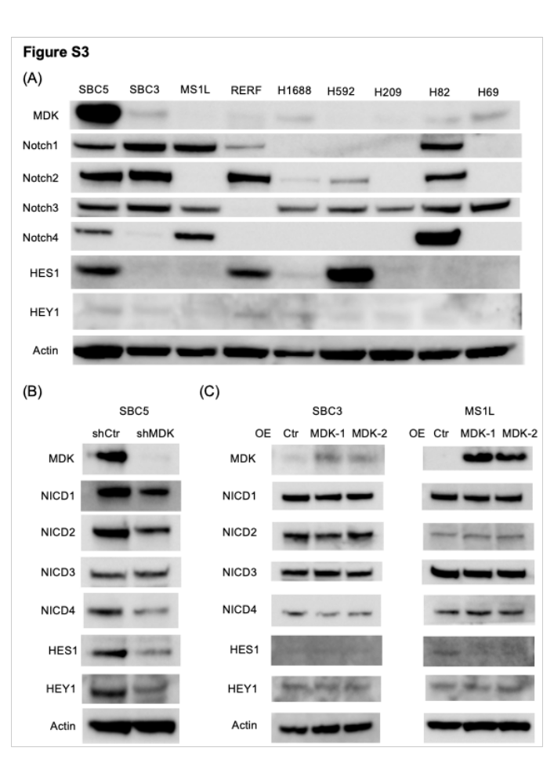
Supplementary Fig. S3 MDK might associate with the Notch pathway in some small cell lung cancer (SCLC) cells. (a) Protein levels of Notch pathway signaling in SCLC cell lines determined by western blotting. (b) Protein levels of Notch pathway signaling upon MDK knockdown in SBC5 evaluated by western blotting. (c) Protein levels of Notch pathway signaling upon MDK overexpression in SBC3 and MS1L evaluated by western blotting. MDK, midkine; Notch, neurogenic locus notch homolog protein; NICD, Notch2 intracellular domain expression; HES1, hairy and enhancer of split-1; HEY1, hairy/enhancer-of-split related with YRPW motif protein 1; OE, overexpression; Ctr, control; RERF, RERF-LC-MA cell

