Supplementary Materials

Questionnaires for telephone-based follow-up：
1. Hello, This is XXX (name of the investigator), a researcher from the Rheumatology and Immunology Department of the Affiliated Hospital of Zunyi Medical University. Are you XXX (patient’s name)? I am calling you to follow-up on your physical condition. The questions may involve your privacy and may cause you discomfort. However, please answer the health questions honestly. Would you be willing to continue answering the questions?
(Continue asking questions after obtaining the verbal consent from the patient or patient’s guardian)
2. How long have you been diagnosed with RA? (Although we can obtain this information through the HIS system, the course of disease in some patients may be omitted in records, so we confirmed the course of each patient.)
3. Are you following the doctor's advice? (0-4 points) 0, never; 1, occasionally; 2, average; 3, usually; 4, always.
4. What is your overall satisfaction with the curative effect in the last year? (0-4 points) 0, very disappointing; 1, dissatisfied; 2, not bad; 3, satisfied; 4, very satisfied.
5. How much do you think the disease being improved or effectively controlled? (Estimated by percentage.)
6. Have there been any gastrointestinal adverse reactions during the treatment, such as acid reflux, stomachache, dyspepsia, melena, abdominal pain, diarrhea, constipation, ulcers proved by gastroscopy, ulcerative lesions indicated by colonoscopy, polyps, and lesions indicated by colonoscopy)?
7. Has there been any pulmonary infection in the last year? and how many times? (Diagnosis must be confirmed by a community center hospital or above.)
8. Has any other infections occurred in the last year, such as tympanitis, nasosinusitis, upper respiratory tract infections (and how often), shingles, urinary tract infections (frequent micturition, urgent micturition, dysuria) or skin infections?

Supplemental Table 1. The details of the patients' backgrounds
Cases no. | n=1155
Gender (male: female) | 226: 929≈1: 4
Age (y/o) | 52.87 ± 11.53
Disease course (y) | 7.40 (range from 0.1 to 65)
Visiting times (in one year) | 5.18 (range from 1 to 21)

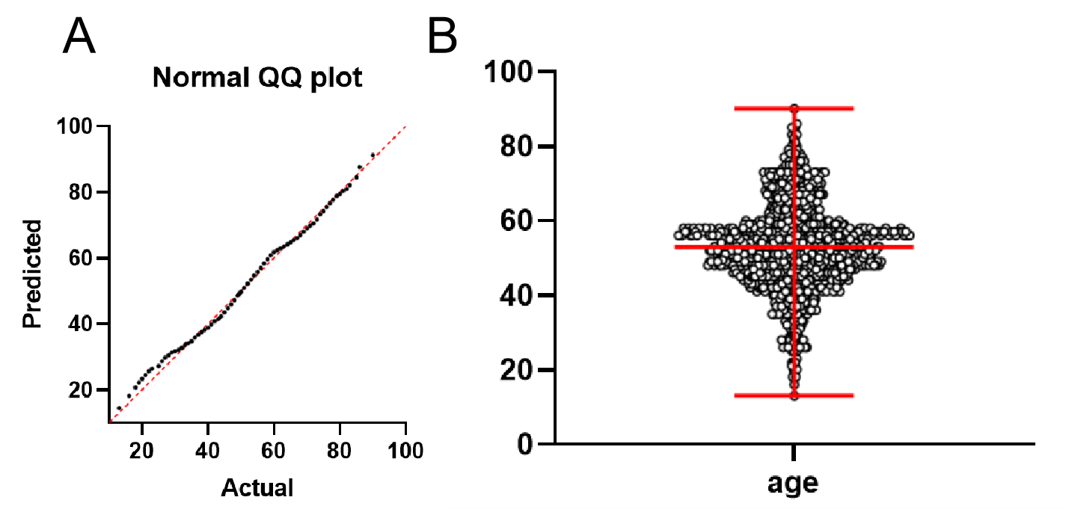
Supplemental figure 1. (A) The QQ plot and (B) scatter plot shows that the age (mean with range) is of normal distribution.

