Table S 1 Summary of saturated mutagenesis Cys-66 showing of interacting residues and binding model by bioinformatic simulations
Enzyme | Binding energy (kcal/mol) | Binding residues | Surface model
SucC (WT) | -3.65 | Asp⁶⁴  Asp¹²²  Arg¹⁹³  Asp¹⁹⁴  Glu²⁷¹ | 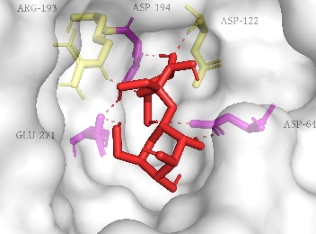
C66A | -3.81 | Asp⁶⁴  Asp¹²²  Arg¹⁹³  Asp¹⁹⁴  Glu²⁷¹ | 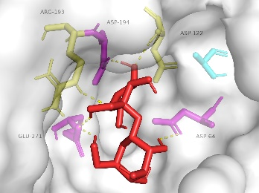
C66D | -3.88 | Asp⁶⁴  Asp¹²²  Arg¹⁹³  Asp¹⁹⁴  Glu²⁷¹ | 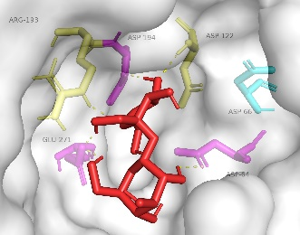
C66E | -3.76 | Asp⁶⁴  Asp¹²²  Arg¹⁹³  Asp¹⁹⁴  Glu²⁷¹ | 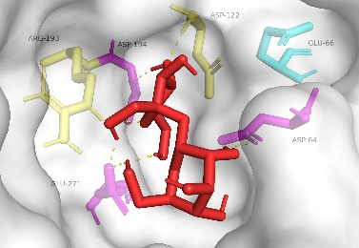
C66F | -3.66 | Asp⁶⁴  Asp¹²²  Arg¹⁹³  Asp¹⁹⁴  Glu²⁷¹ | 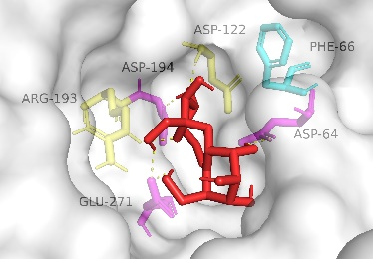
C66G | -3.86 | Asp⁶⁴  Asp¹²²  Arg¹⁹³  Asp¹⁹⁴  Glu²⁷¹ | 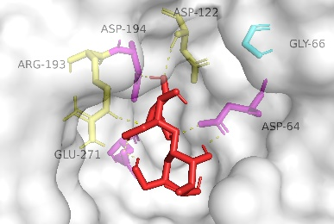
C66H | -3.54 | Asp⁶⁴  Asp¹²²  Arg¹⁹³  Asp¹⁹⁴  Glu²⁷¹ | 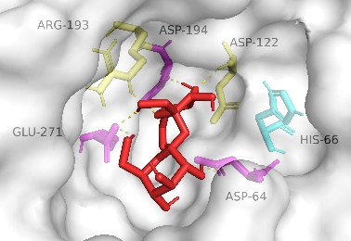
C66I | -3.7 | Asp⁶⁴  Asp¹²²  Arg¹⁹³  Asp¹⁹⁴  Glu²⁷¹ | 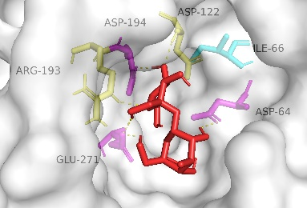
C66K | -3.07 | Asp⁶⁴  Asp¹²²  Arg¹⁹³  Asp¹⁹⁴  Glu²⁷¹ | 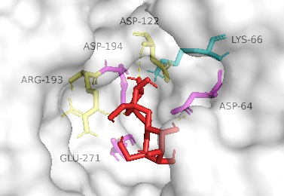
C66L | -3.72 | Asp⁶⁴  Asp¹²²  Arg¹⁹³  Asp¹⁹⁴  Glu²⁷¹ | 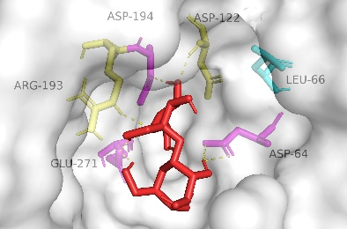
C66M | -3.32 | Asp⁶⁴  Asp¹²²  Arg¹⁹³  Asp¹⁹⁴  Glu²⁷¹ | 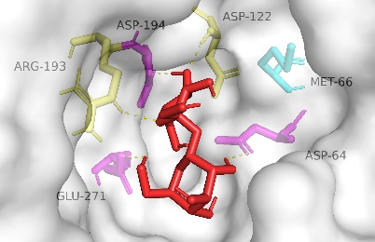
C66N | -3.85 | Asp⁶⁴  Asp¹²²  Arg¹⁹³  Asp¹⁹⁴  Glu²⁷¹ | 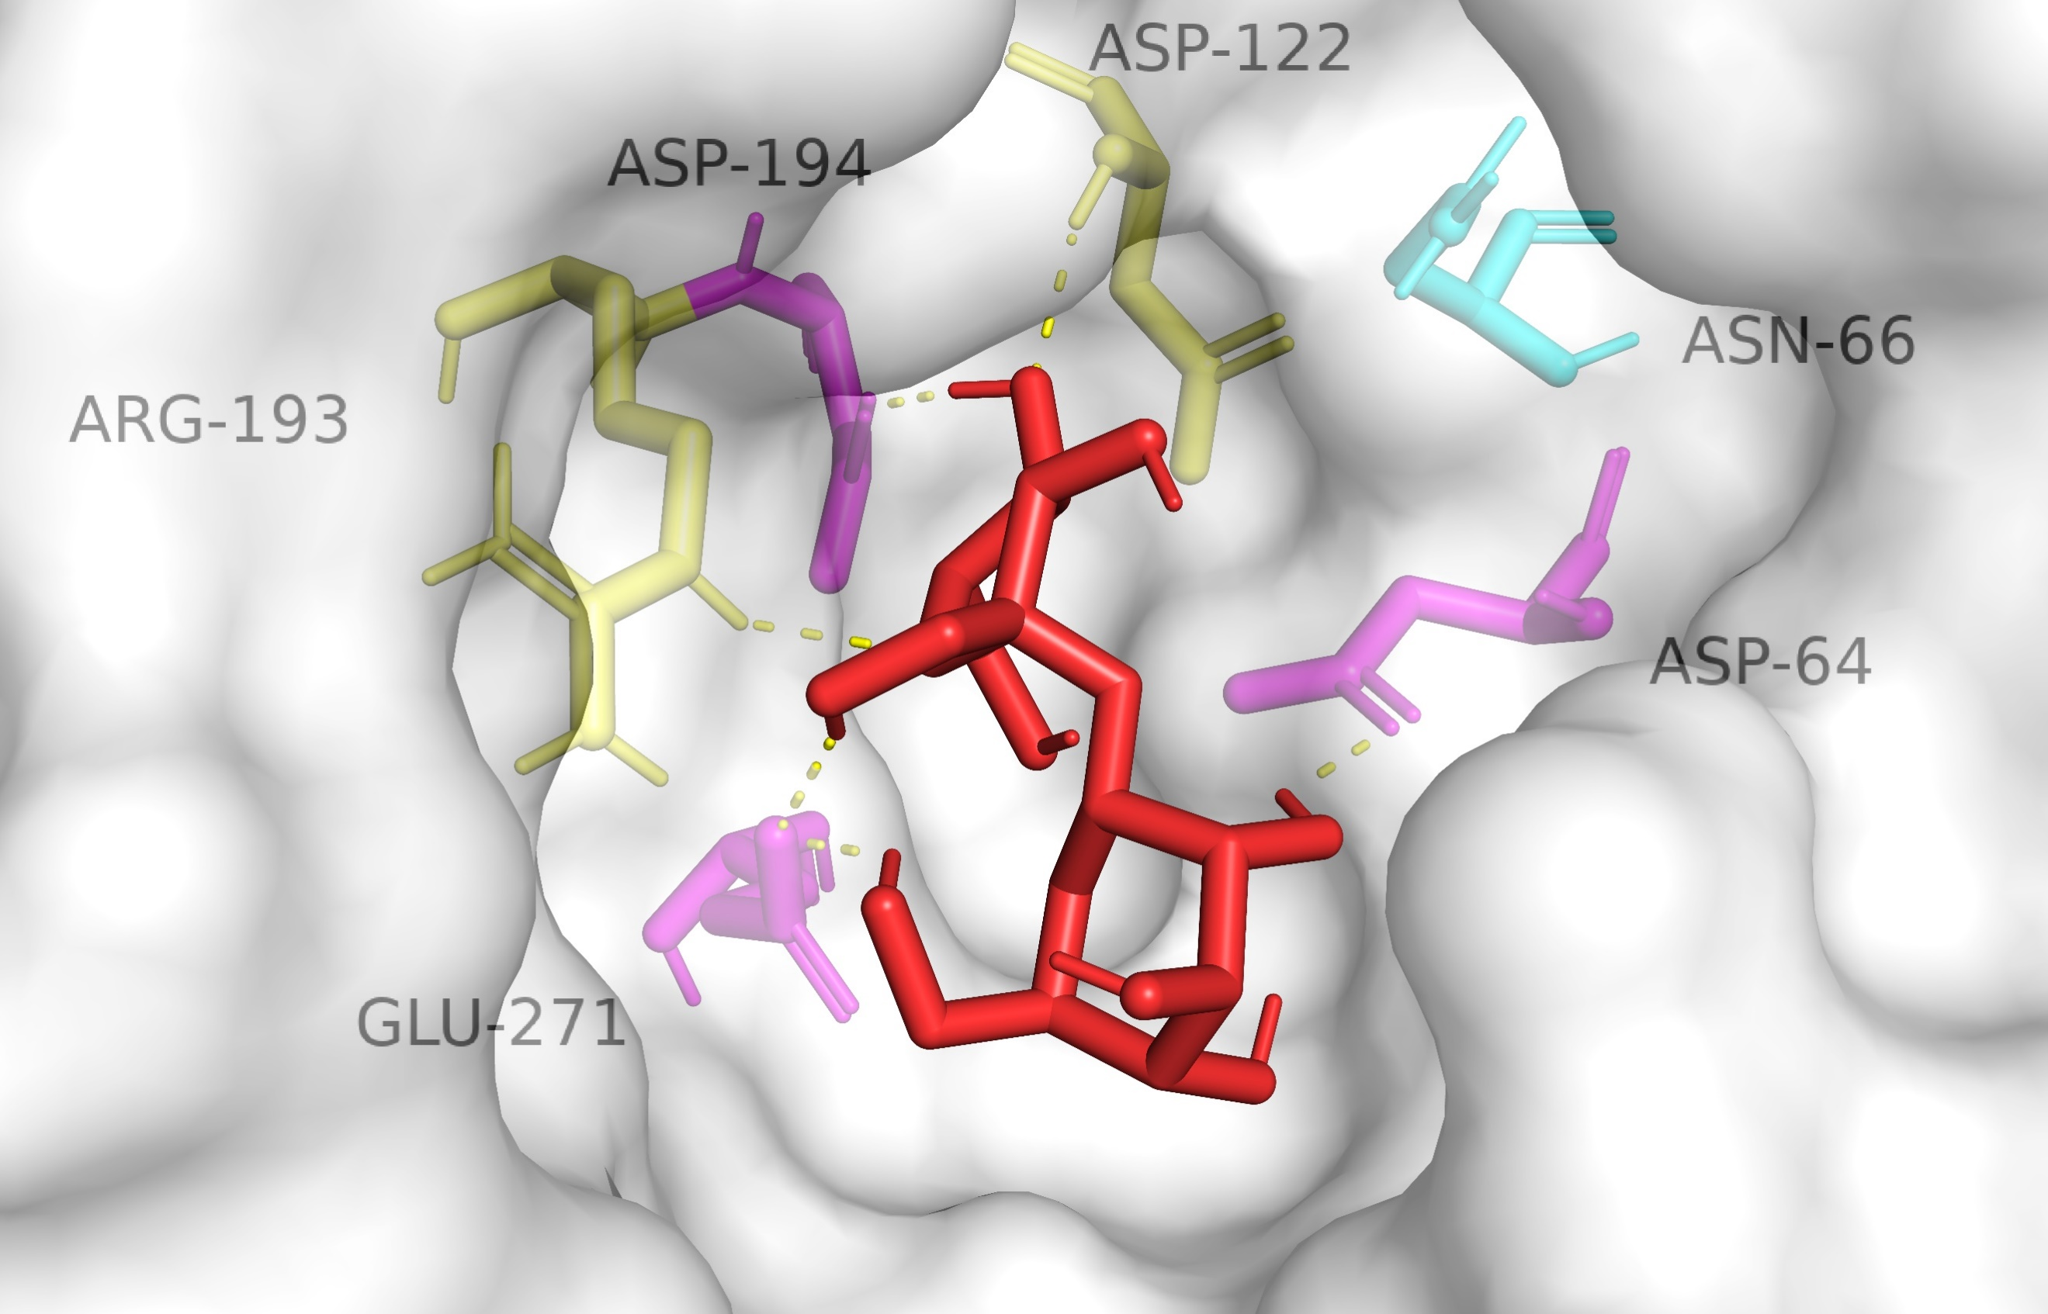
C66P | -3.86 | Asp⁶⁴  Asp¹²²  Arg¹⁹³  Asp¹⁹⁴  Glu²⁷¹ | 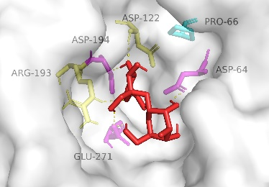
C66Q | -3.84 | Asp⁶⁴  Asp¹²²  Arg¹⁹³  Asp¹⁹⁴  Glu²⁷¹ | 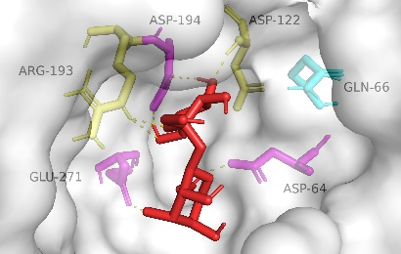
C66R | -3.58 | Asp⁶⁴  Asp¹²²  Arg¹⁹³  Asp¹⁹⁴  Glu²⁷¹ | 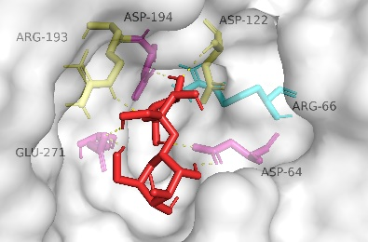
C66S | -4.14 | Asp⁶⁴  Asp¹²²  Arg¹⁹³  Asp¹⁹⁴  Glu²⁷¹  Glu²⁹⁶  His³¹⁰ | 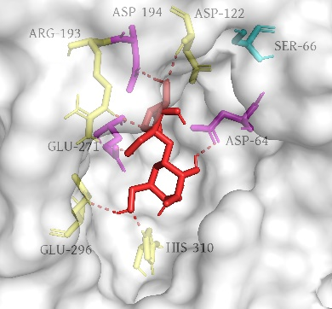
C66T | -3.81 | Asp⁶⁴  Asp¹²²  Arg¹⁹³  Asp¹⁹⁴  Glu²⁷¹ | 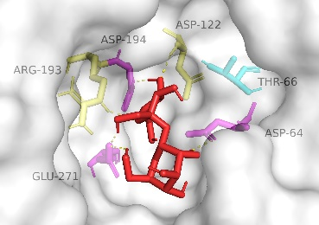
C66V | -3.86 | Asp⁶⁴  Asp¹²²  Arg¹⁹³  Asp¹⁹⁴  Glu²⁷¹ | 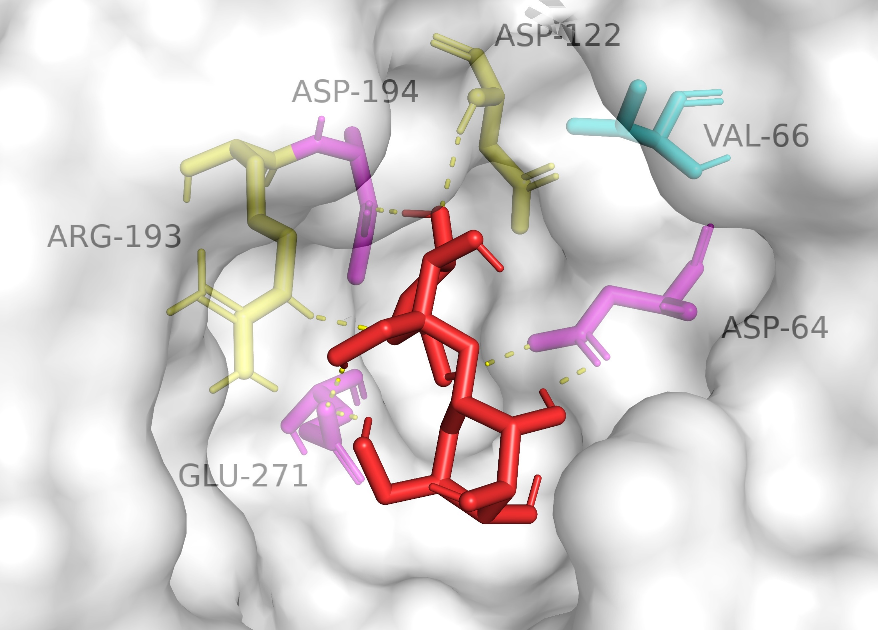
C66W | -3.84 | Asp⁶⁴  Asp¹²²  Arg¹⁹³  Asp¹⁹⁴  Glu²⁷¹ | 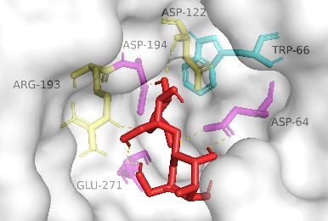
C66Y | -4.12 | Asp⁶⁴  Asp¹²²  Arg¹⁹³  Asp¹⁹⁴  Glu²⁷¹ | 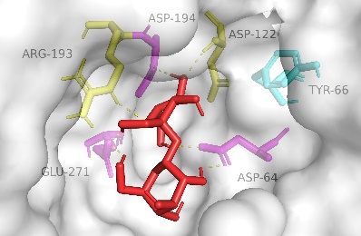
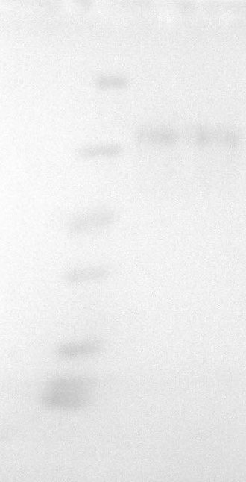
Fig. S 1. SDS-PAGE of AKTA purified SucC and C66S, indicating the pure enzymes obtained.
70.0 kDa
66.2 kDa
94.0 kDa

Fig. S 2. Partial presentation of DNA sequencing of C66S aligned with SucC, indicating the correct mutation of Cys-66 to Ser-66 (TGC to TCT).

