A secreted Botrytis cinerea stage-specific effector promotes virulence by targeting the plant ROS-generating machinery
Kai Bi et, al
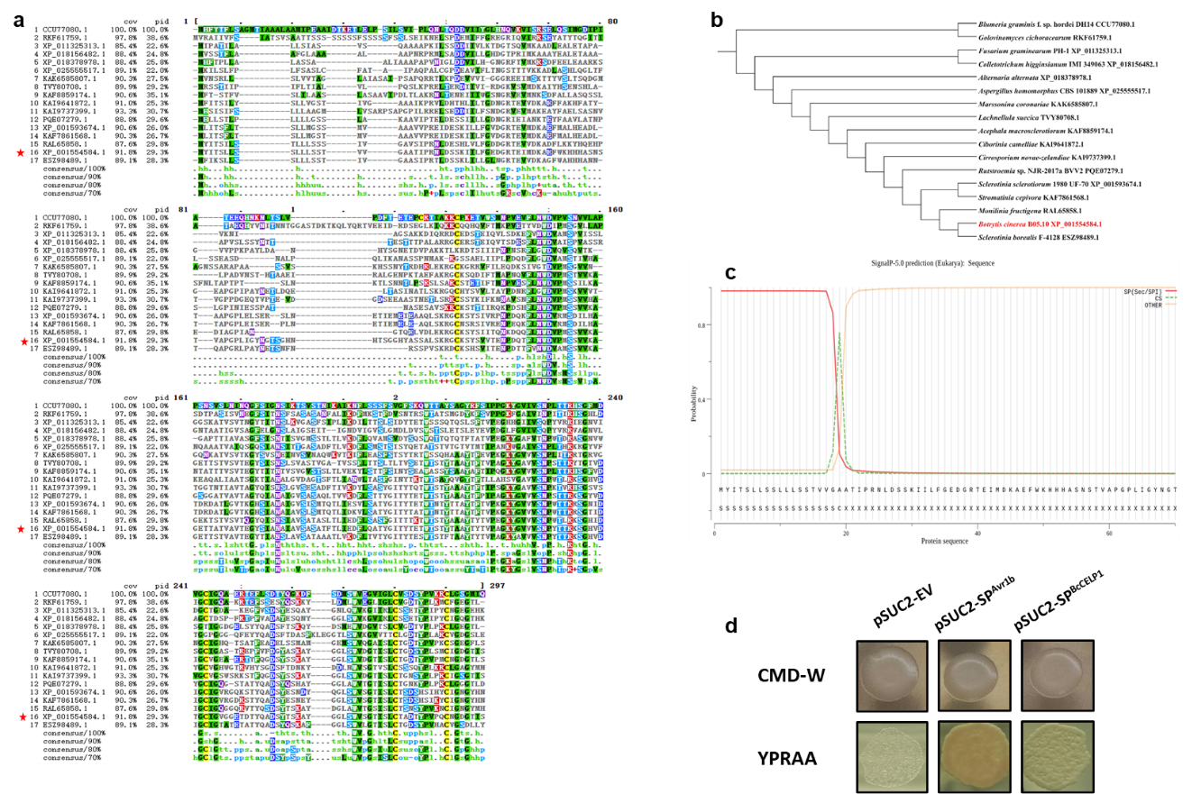
Supplementary Figures

Supplementary figure 1. CELP0023 domain containing protein Bcin09g02160 has a functional signal peptide. a, A multiple sequence alignment of Bcin09g02160 (marked with red star) and its homologues from other species generated by Clustal Omega online tool. Only 1-251 of Bcin09g02160 was used for alignment, as the C-terminus part has low sequence identity. The MSA results were reformatted by Mview. b, Neighbour-joining tree based on the MSA results. c, Prediction of a N-terminal signal peptide (SP) and the location of cleavage site of BcCELP1 by SignalP 5.0 server. d, Functional validation of the BcCELP1 SP using yeast invertase secretion assay. Yeast YTK12 strains that lacks a functional secreted invertase gene and carrying the BcCELP1 SP fused in frame to the invertase gene manage to grow in both the CMD-W medium (with sucrose, yeast growth even in the absence of invertase secretion) and YPRAA media (with raffinose instead of sucrose, growth only when invertase is secreted). A YTK12 yeast strain expressing the invertase under control of Avr1b was used as a positive control. A strain carrying the empty pSUC2 vector serves as negative control.

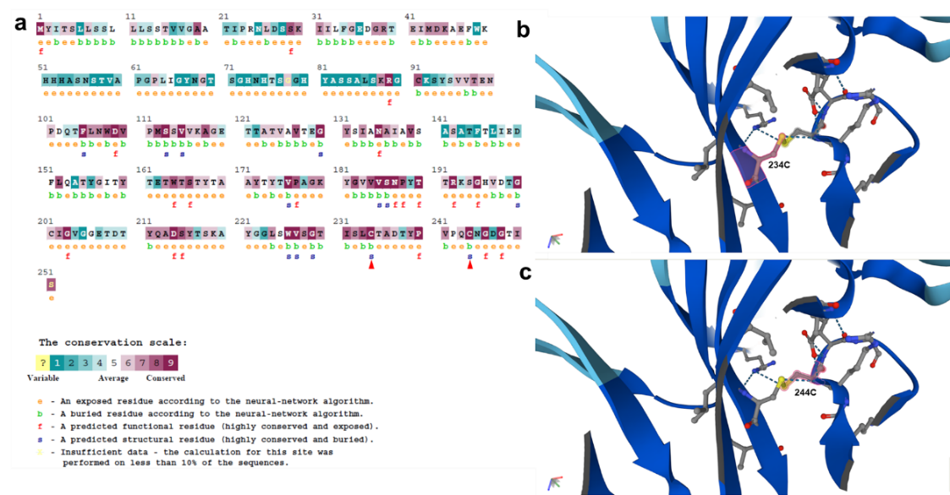

Supplementary figure 2. Identification of the functionally and structurally important residues in the BcCELP1 CELP0028 domain. a, The ConSurf Server analysis (https://consurf.tau.ac.il/consurf_index.php) was carried out for estimating the evolutionary conservation of amino acid positions in the BcCELP1 CELP0028 domain based on the phylogenetic relations between homologous sequences. The amino acid sequence was colored by ConSurf conservation scores, which calculated by ConSurf are a relative measure of evolutionary conservation at each amino acid sequence site. The highly conserved and buried structural cysteine residues 234 and 244 are indicated by the red triangle symbols. b,c alphafold2 (https://alphafold.com/) was used to predict 3D structure of cysteine residues 234 and 244 in the BcCELP1 CELP0028 domain.

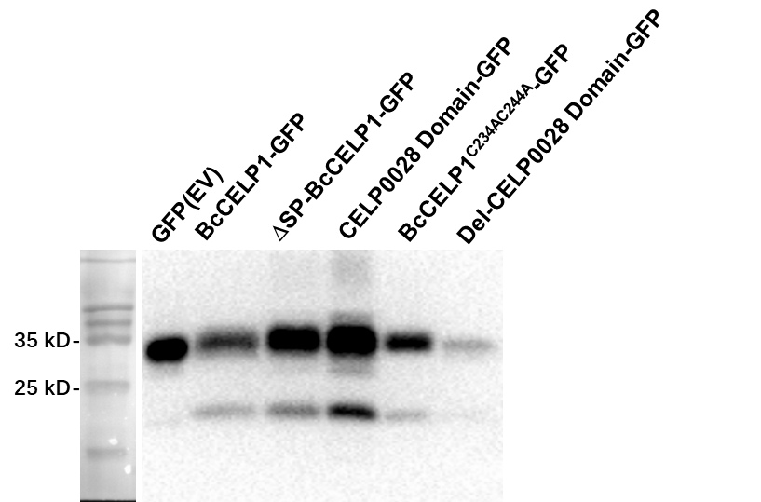

Supplementary figure 3. Immunoblot analysis following transient expression of desired genes in N. benthamiana. Leaf samples were taken 2 days post agroinfiltration. α-GFP antibody was used to detect expression of the indicated constructs.

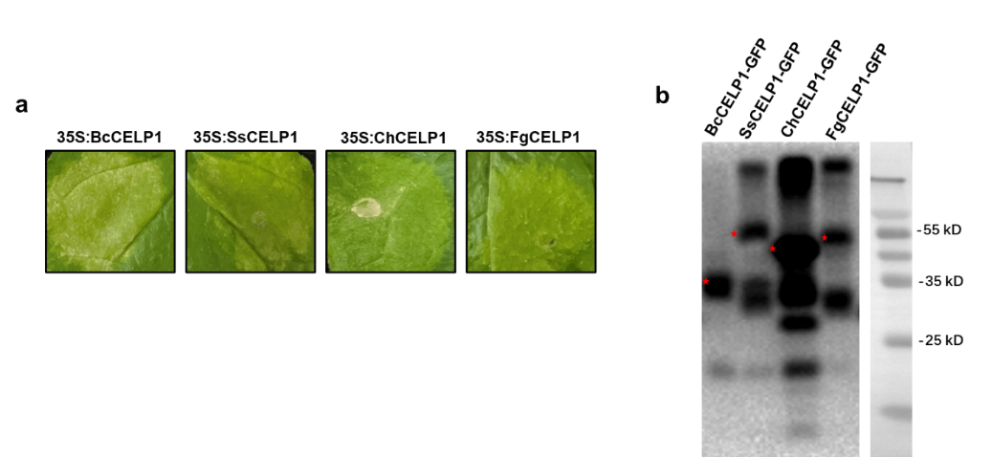

Supplementary figure 4. Induction of cell death in N. benthamiana by CELP0023 domain-containing fungal proteins. a, N. benthamiana leaves of from 4–5 weeks old plants were infiltrated with Agrobacterium strains that were transformed with the indicated CELP0023 domain-containing fungal protein-encoding genes. Leaves were photographed five days after agroinfiltration. b, Western blot analysis. Leaf samples were collected 48 h post agroinfiltration, proteins were extracted and subjected to western blot analysis using α-GFP antibodies. Target protein products are marked with red stars.

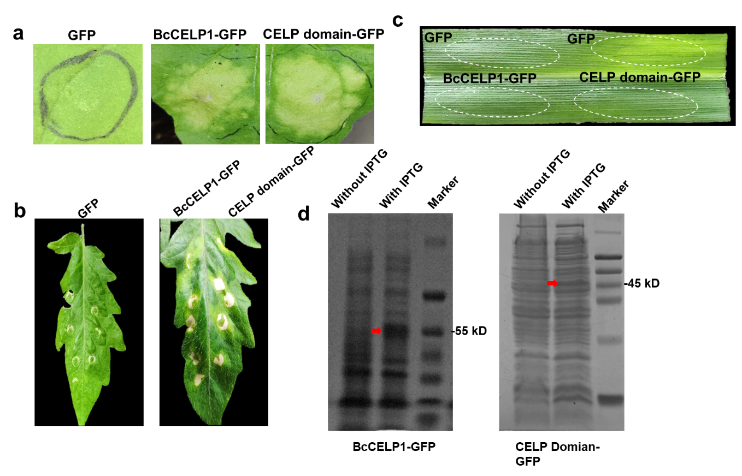

Supplementary figure 5. Induction of cell death in different plant species by purified BcCELP1 and the CELP domain proteins. BcCELP1, CELP domain peptide and GFP proteins with His tag were produced and purified from E. coli. Leaves of N. benthamiana (a), tomato (b), and maize (c) were infiltrated with 20 μM solution of the purified proteins. The leaves were photographed 48 h after treatment. d, Coomassie brilliant blue (CBB) staining of the recombinant E. coli whole cell lysate without / with IPTG induction. Red arrows indicate the expected target proteins produced from E. coli whole cell lysate with background bands.

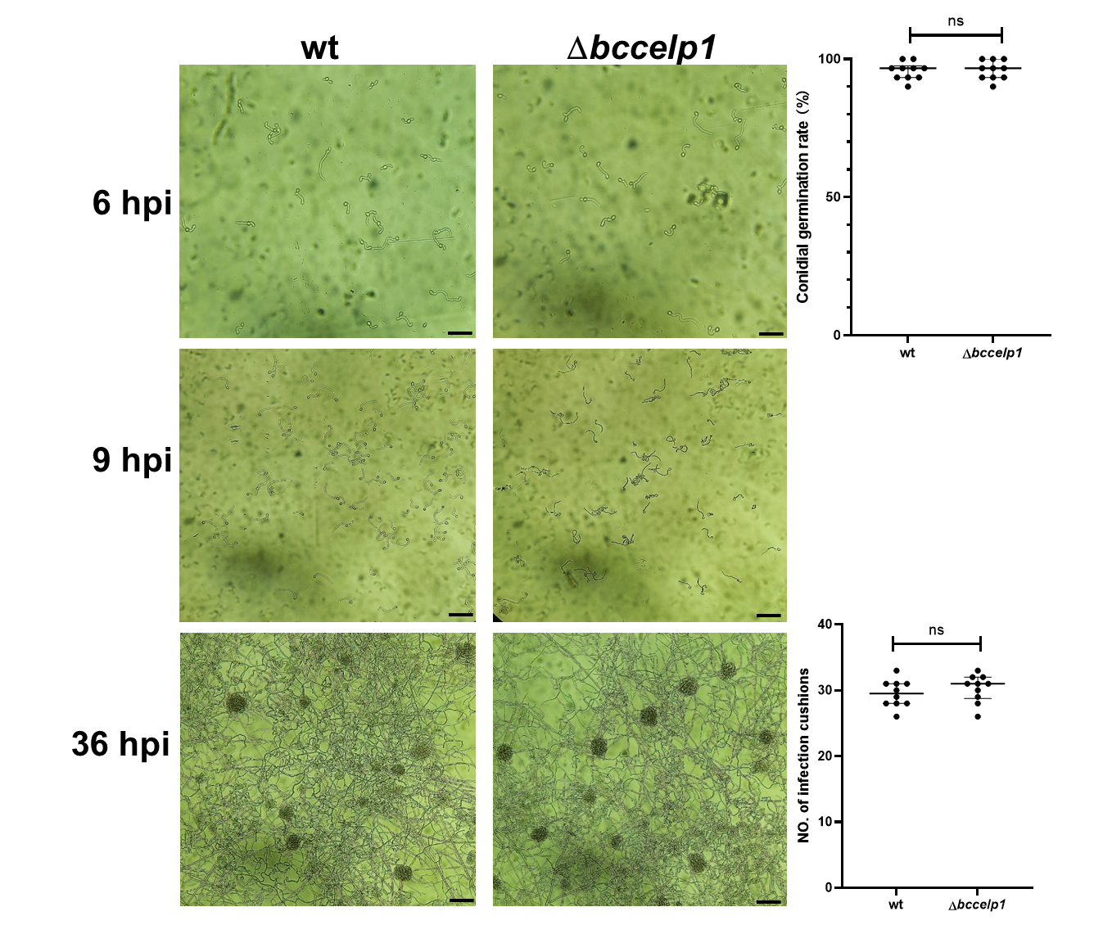

Supplementary figure 6. Deletion of bccelp1 gene does not affect spore germination and infection cushion formation. Conidia (2 × 10⁵ conidia/mL, 2 μL) were suspended with 8 μL GB5+2% Gluc medium, spotted on hydrophobic coverslips and incubated at 22°C. The conidial germination rate was examined at 6 hpi and 9 hpi. The number of infection cushion was determined after 36h by counting the total number of infection cushions in three randomly selected microscope fields per replication. Representative photographs were taken at designed time by Nikon Eclipse 80i microscope (Nikon, Tokyo, Japan). Bar = 100 μm. The conidial germination rate (6 hpi) and number of infection cushion formation (36 hpi) were subjected to statistical analysis. Data in both graphs represent mean ± SD (n = 10) from three independent biological replications. The same letters in the graph indicate no statistical differences at P ≤ 0.01 using one-way ANOVA.

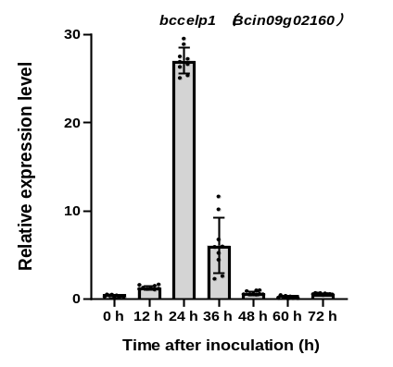
Supplementary figure 7. Quantitative real-time PCR (qRT-PCR) analysis of bccelp1 transcript levels during pathogenic development. bccelp1 expression levels were evaluated by qRT-PCR with the bcgpdh as a normalized gene. Values represent mean ± SD (n = 9) from three independent biological replications and three technical replications. The transcript relative levels were calculated using the comparative Ct method, and the expression level of bccelp1 inoculated on French bean leaves at 0 h was set as control.

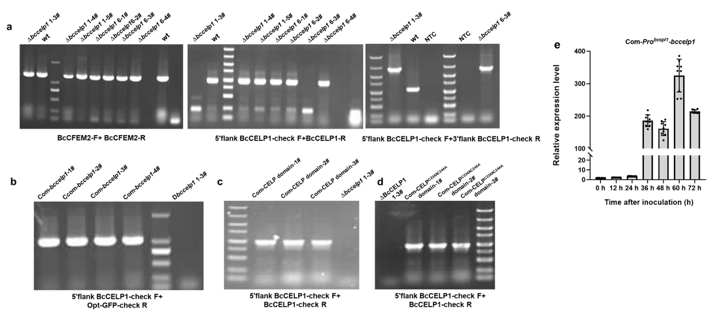

Supplementary figure 8. PCR validation of B. cinerea mutant strains. a, Analysis of bccelp1 deletion strains ∆bccelp1 1-3# and ∆bccelp1 6-3#. b-d, Confirmation of native bccelp1 promoter expression cassettes. Genomic DNA was extracted from the different mutants and primers used in PCR were indicated. NTC - no template control, the ddH₂O was added as negative control. e, RT-PCR analysis of bccelp1 genes expression. Expression levels were evaluated by qRT-PCR with the bcgpdh as a normalized gene. Mean and standard deviations (n = 9) were calculated from three biological replications and three technical replicates. The relative expression levels were calculated using the comparative Ct method.

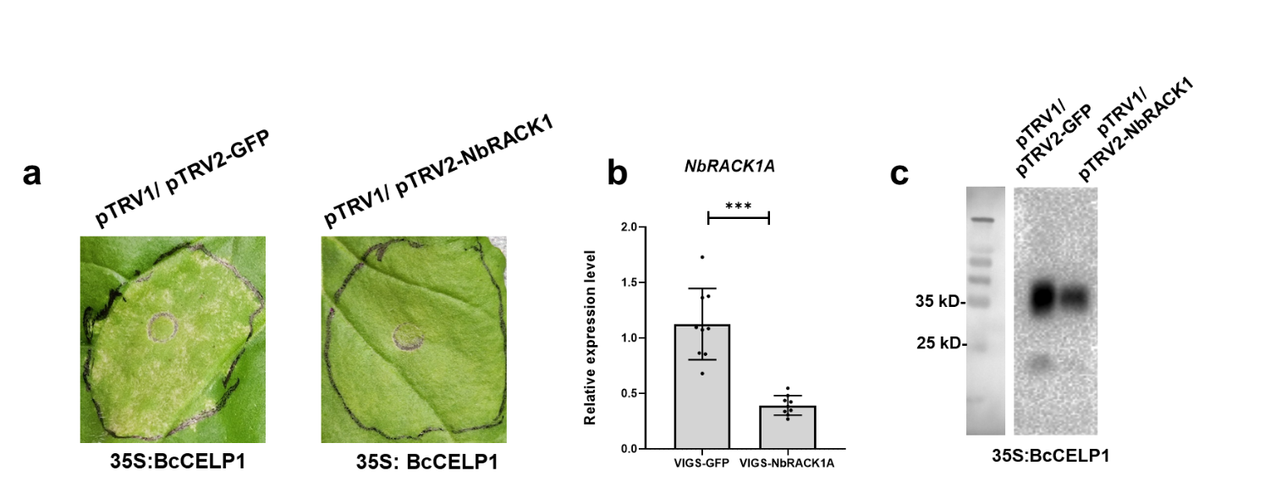

Supplementary figure 9. Virus induced gene silencing (VIGS) of NbRACK1. The N. benthamiana NbRACK1 genes was silenced by agroinfiltration with the VIGS vectors pTRV1/pTRV2-NbRACK1. After three weeks, leaves were agroinfiltrated with 35S:BcCELP1. a, Cell death phenotype after five days. b, Expression levels of NbRACK1. The mean and standard deviation were calculated with data (n = 9) from three independent biological replicates and three technical replicates. Asterisks indicate statistical significant differences of VIGS- NbRACK1 compared to VIGS-GFP (P < 0.01, unpaired two-tailed Student‘s t tests). c, Western blot analysis of 35S:BcCELP1 recombinant protein. N. benthamiana leaves were harvested 2 days after the agroinfiltration, protein was extracted and the expression of 35S:BcCELP1 construct in pTRV1/ pTRV2-GFP and pTRV1/ pTRV2-NbRACK1 VIGS-silenced plants was validated by western blot analysis with an anti-GFP antibody.

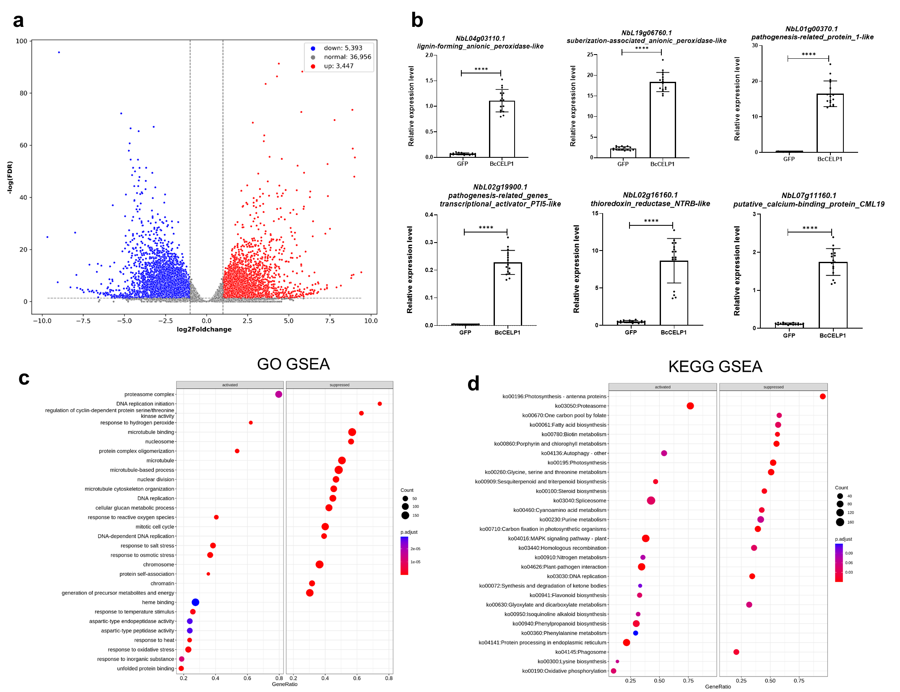

Supplementary figure 10. RNA-seq analysis of BcCELP1-modulated N. benthamiana genes. a, A volcano plot illustrating differentially regulated gene expression from transcriptional analysis between the control (GFP) groups and BcCELP1 transient expressed groups. Upregulated-genes and downregulated-genes are shown in red and blue, respectively. Values of x axis are presented as the log₂ of fold change. The y axis shows the level of statistical significance of the gene expression differences by FDR (False discovery rate). b, qRT-PCR validation analysis. Error bar represents the standard deviation (SD) and P- value was generated by using unpaired two-tailed Student‘s t tests (P < 0.0001). c, GO (Gene ontology) GSEA (Gene Set Enrichment Analysis) was conducted to identify the enriched GO pathways (including BP, CC and MF aspects) in activated and suppressed gene lists. d, KEGG (Kyoto Encyclopedia of Genes and Genomes) GSEA was conducted to identify the enriched KEGG pathways in activated and suppressed gene lists. For the pathway enrichment in b and c, padj < 0.05 was set as the threshold of significant enrichment. Bubble plot of top 15 enriched terms that activated and suppressed in BcCELP1 transient expressed N. benthamiana compared with GFP (the control).

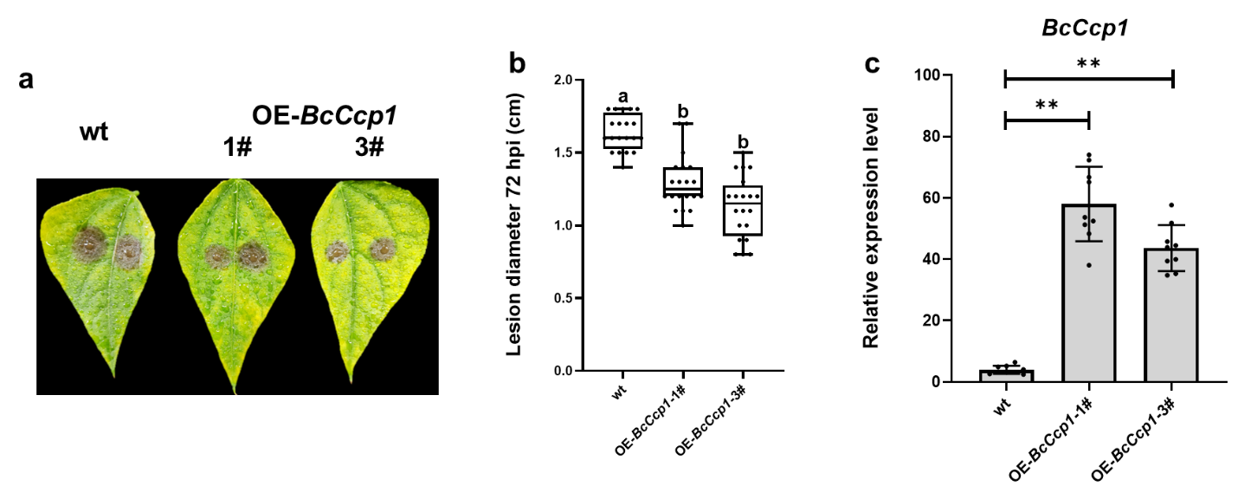

Supplementary figure 11. Effect of constitutive over expression of BcCcp1 on B. cinerea virulence. a-b, Virulence assay. Bean leaves were inoculated with spore suspensions of B05.10 and OE-BcCcp1 mutant strains. Photographs were documented (a) and lesion diameter size were recorded at 72 hpi (b), Box limits show the 25th and 75th percentiles. Boxplots center lines indicate the medians values; whiskers extend to minimum and maximum values from the 25th and 75th percentiles; all present data are indicated as black dots. 20 sample points from three independent biological replications used for statistical analysis. Different letters indicate statistical differences at P < 0.01 using one-way ANOVA. c, Expression levels of BcCcp1. The expression levels of BcCcp1 between wt and OE-BcCcp1 (1# and 3#) mutant strains were measured by reverse transcription-quantitative PCR. The mean and standard deviation were calculated with data (n = 9) from three independent biological replicates and three technical replicates. Asterisks indicate statistical significant differences of OE-BcCcp1 compared to wt strain (P < 0.01, unpaired two-tailed Student‘s t tests).

