Table S1 | Overview of datasets
Dataset | #Slides | #Patients | #Centers | Patch size | Magnification | Classes
 |  |  |  |  |  | Short-term survival | Long-term survival
HCC | 549 | 549 | 4 | 256 x 256 | 20X | 164 | 385
GBM | 726 | 343 | 1 | 256 x 256 | 20X | 543 | 183
LUSC | 367 | 335 | 1 | 256 x 256 | 20X | 119 | 248
LUAD | 640 | 640 | 3 | 256 x 256 | 20X | 83 | 557
CRC | 886 | 822 | 2 | 256 x 256 | 20X | 157 | 729
STAD | 216 | 201 | 1 | 256 x 256 | 20X | 90 | 126
HNSC | 355 | 342 | 1 | 256 x 256 | 20X | 159 | 196
UCEC | 379 | 344 | 1 | 256 x 256 | 20X | 47 | 332
KIRC | 427 | 427 | 1 | 256 x 256 | 20X | 82 | 345
BRCA | 624 | 650 | 1 | 256 x 256 | 20X | 45 | 605

Table S2 | The AUROC comparison of HeMiCoRe and the existing benchmark methods using five-fold stratified cross-validation in the task of survival prediction.

Methods  (metrics: AUROC) | DSMIL | MuRCL_ABMIL | MuRCL_CLAM | SlideGraph + | HeMiCoRe(Ours)
HCC | 0.6603±0.0354  (0.6164, 0.7042) | 0.6852±0.0399  (0.6356, 0.7347) | 0.6933±0.0547  (0.6253, 0.7613) | 0.7085±0.0301  (0.6710, 0.7459) | 0.7267±0.0293  (0.6904, 0.7630)
GBM | 0.6528±0.0554  (0.5840, 0.7215) | 0.6748±0.0843  (0.5701, 0.7794) | 0.6855±0.0599  (0.6111, 0.7599) | 0.6942±0.0468  (0.6361, 0.7522) | 0.7162±0.0669  (0.6331, 0.7993)
LUSC | 0.6066±0.0387  (0.5586, 0.6547) | 0.6185±0.0526  (0.5532, 0.6838) | 0.6795±0.0426  (0.6208, 0.7381) | 0.6764±0.0626  (0.5987, 0.7542) | 0.7012±0.0473  (0.6424, 0.7599)
LUAD | 0.7937±0.0198  (0.7691, 0.8182) | 0.7943±0.0450  (0.7383, 0.8503) | 0.8065±0.0277  (0.7722, 0.8409) | 0.8249±0.0119  (0.8101, 0.8396) | 0.8253±0.014  (0.8068, 0.8436)
CRC | 0.6552$±$0.0495  (0.5937, 0.7167) | 0.6214$±$0.0537  (0.5547, 0.6881) | 0.6598$±$0.0258  (0.6278, 0.6918) | 0.6706$±$0.0256  (0.6351, 0.7062) | 0.6805$±$0.0411  （0.6294, 0.7315）
STAD | 0.6809±0.1063  (0.5490, 0.8129) | 0.6366±0.0715  (0.5478, 0.7254) | 0.6744±0.0740  (0.5825, 0.7662) | 0.6949±0.0608  (0.6184, 0.7704) | 0.6763±0.0865  (0.5688, 0.7837)
HNSC | 0.6262±0.0600  (0.5517, 0.7008) | 0.5846±0.0372  (0.5384, 0.6307) | 0.5800±0.0980  (0.4582, 0.7017) | 0.6038±0.0655  (0.5225, 0.6851) | 0.6176±0.0574  (0.5463, 0.6889
UCEC | 0.7196±0.0694  (0.6334, 0.8057) | 0.6769±0.0665  (0.5943, 0.7595) | 0.6512±0.0720  (0.5617, 0.7406) | 0.7176±0.0389  (0.6694, 0.7659) | 0.7479±0.0655  (0.6666, 0.8292)
KIRC | 0.7485±0.0505  (0.6859, 0.8112) | 0.7020±0.1116  (0.5635, 0.8405) | 0.7252±0.0664  (0.6427,0.8076) | 0.7577±0.0605  (0.6823, 0.8326) | 0.7621±0.0480  (0.7024,0.8217)
BRCA | 0.6083±0.1122  (0.4691, 0.7476) | 0.6412±0.1189  (0.4936, 0.7888) | 0.6032±0.1212  (0.4528, 0.7537) | 0.6517±0.0778  (0.5552, 0.7485) | 0.6614±0.0327  (0.6208, 0.7020)
The metrics (mean AUROC $±$ standard deviation with 95% confidence intervals in brackets), are measured through five-fold cross-validation. Bold with underline indicates the best performance, while bold only and underlined only indicate second-best and third-best performance, respectively.

Table S3 | The AUPRC comparison of HeMiCoRe and the existing benchmark methods using five-fold stratified cross-validation in the task of survival prediction.
Methods  (metrics: AUPRC) | DSMIL | MuRCL_ABMIL | MuRCL_CLAM | SlideGraph + | HeMiCoRe(Ours)
HCC | 0.4753±0.0722  (0.3750, 0.5756) | 0.5104±0.0599  (0.4272, 0.5935) | 0.5169±0.0637  (0.4285, 0.6053) | 0.5371±0.0521  (0.4648, 0.6094) | 0.5600±0.0619  (0.4741, 0.6459)
GBM | 0.8435±0.0191  (0.8169, 0.8701) | 0.8559±0.0475  (0.7899, 0.9218) | 0.8527±0.0326  (0.8074, 0.8981) | 0.8679±0.0274  (0.8298, 0.9059) | 0.8732±0.0350  (0.8246, 0.9218)
LUSC | 0.4867±0.0839  (0.3703, 0.6032) | 0.4770±0.1047  (0.3316, 0.6223) | 0.5950±0.0496  (0.5262, 0.6638) | 0.5290±0.1039  (0.3847, 0.6732) | 0.5551±0.0766  (0.4487, 0.6614)
LUAD | 0.3451±0.1170  (0.1826, 0.5075) | 0.3283±0.1132  (0.1712, 0.4854) | 0.3770±0.0905  (0.2514, 0.5026） | 0.3697±0.1214  (0.2012, 0.5382） | 0.3749±0.1216  (0.2061, 0.5437)
CRC | 0.2699$±$0.0454  (0.2080, 0.3134) | 0.2661$±$0.0444  (0.2109, 0.3212) | 0.3011$±$0.0409  (0.2503, 0.3519) | 0.3049$±$0.0220  (0.2744, 0.3355) | 0.3304$±$0.0372  (0.2842, 0.3765)
STAD | 0.6015±0.1137  (0.4603, 0.7426) | 0.4587±0.0287  (0.4230, 0.4944) | 0.5911±0.0901  (0.4793, 0.7030) | 0.5603±0.0646  (0.4801, 0.6405) | 0.5882±0.0920  (0.4740, 0.7024)
HNSC | 0.5633±0.0578  (0.4916, 0.6351) | 0.5421±0.0523  (0.4771, 0.6070) | 0.5259±0.0620  (0.4489, 0.6030) | 0.5407±0.0497  (0.4789, 0.6024) | 0.5646±0.0535  (0.4982, 0.6310)
UCEC | 0.2994±0.0587  (0.2265, 0.3723) | 0.2852±0.0692  (0.1993, 0.3711) | 0.2388±0.0578  (0.1670, 0.3105) | 0.3574±0.0516  (0.2933, 0.4214) | 0.3555±0.0800  (0.2562, 0.4548)
KIRC | 0.4521±0.1103  (0.3151, 0.5891) | 0.3432±0.0780  (0.2463, 0.4401) | 0.4359±0.0972  (0.3152, 0.5567) | 0.4454±0.1136  (0.3043, 0.5864) | 0.4509±0.0632  (0.3724, 0.5294)
BRCA | 0.1140±0.0268  (0.0807, 0.1474) | 0.1353±0.0444  (0.0802, 0.1904) | 0.1629±0.0516  (0.0988, 0.2270) | 0.1767±0.0653  (0.0956, 0.2578) | 0.1694±0.0402  (0.1194, 0.2193)
The metrics (mean AUPRC $±$ standard deviation with 95% confidence intervals in brackets), are measured through five-fold cross-validation. Bold with underline indicates the best performance, while bold only and underlined only indicate second-best and third-best performance, respectively.

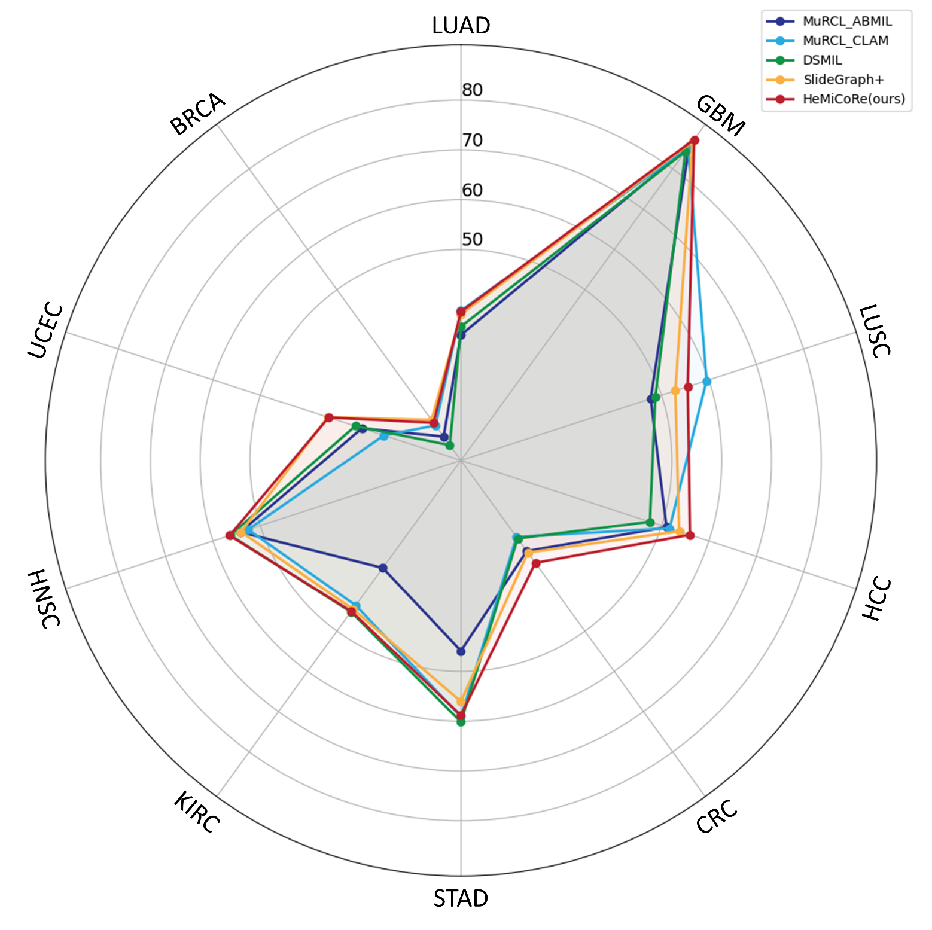
Fig. S1 | The radar illustrating the mean AUPRC values of all methods under five-fold cross-validation on 10 datasets.

