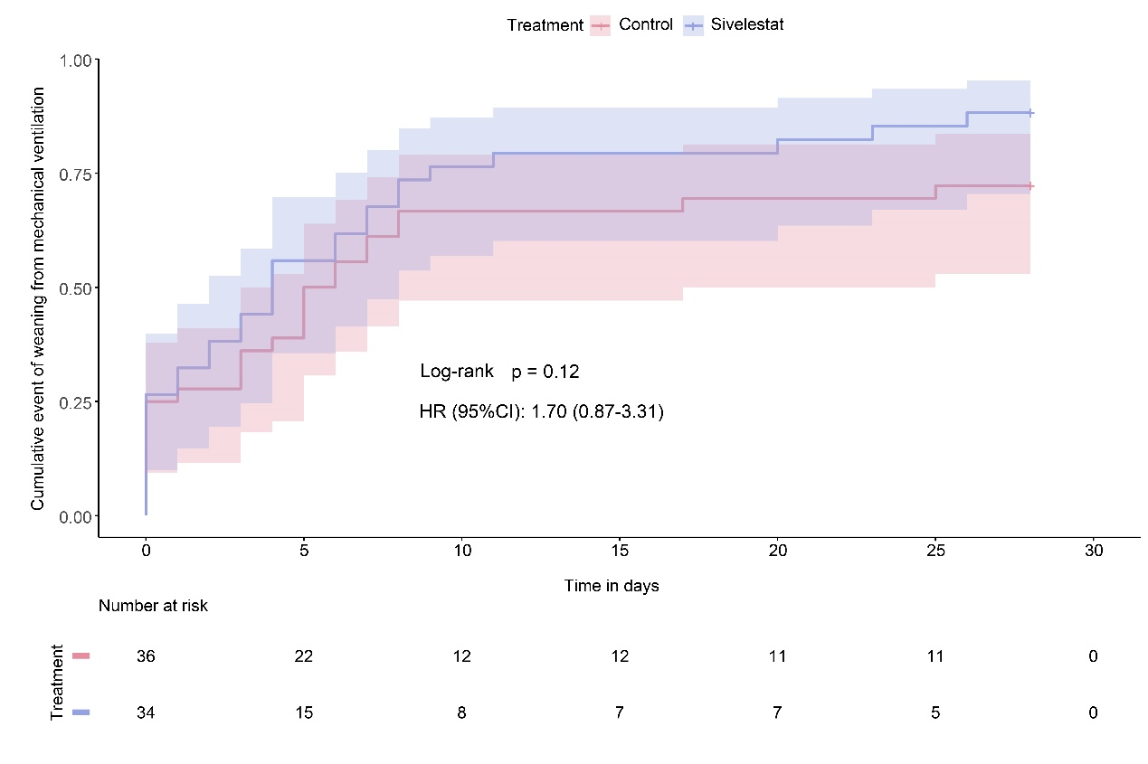Figure S1. Cumulative event of weaning from mechanical ventilation. HR denotes hazard ratio. CI denotes confidence interval.

