Supporting data for “The effect of solvent in controlling the antioxidant activities of Curcumin and its metal complexes, as well as an insight into the mechanism of action”

Priya Breitener¹, Mohanan P.V. ², Balachandran.Nair ³ and Shaikha S. AlNeyadi⁴
¹Fatima College of Health Sciences, Abu Dhabi, UAE.
²Department of Applied Chemistry, Cochin University of Science and Technology, Kochi 682 022, India; mohan@cusat.ac.in (M. P. V)
³Department of Chemistry, MG College, Trivandrum, Kerala, India; sbcnair@gmail.com (B. N)
⁴Department of Chemistry, College of Science, UAE University Al-Ain, 15551 UAE; shaikha.alneyadi@uaeu.ac.ae (S. A)

* Correspondence: priya.breitener@fchs.ac.ae (P. B); Tel.: +971-529182522

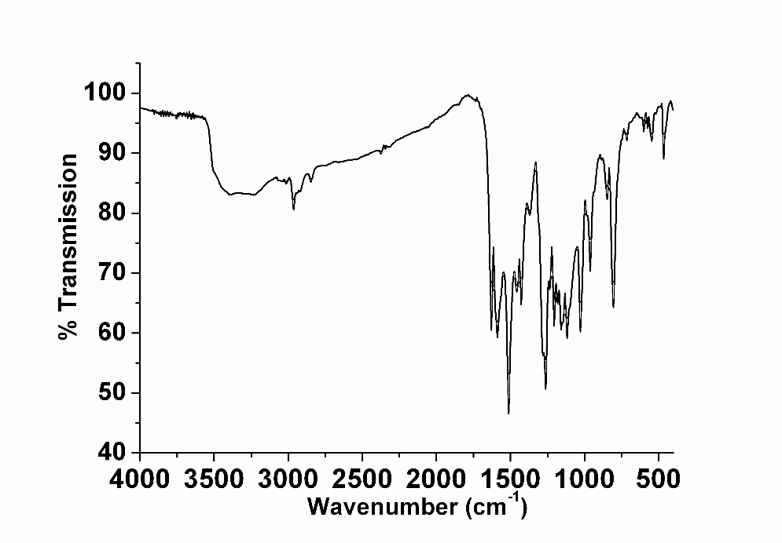
Fig S1. FTIR spectrum of curcumin-I

Figure S2. ¹H NMR spectra of curcumin-I

Fig S3. FTIR spectrum of curcumin-II
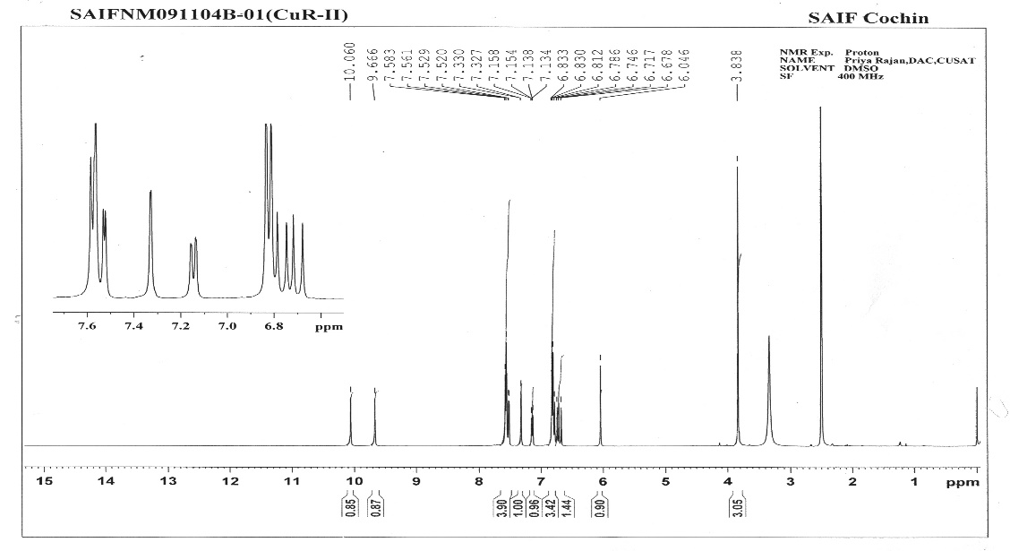
Figure S4. ¹H NMR of curcumin-II

Metal complexes of curcumin
Elemental analysis
The analytical data suggest that all the complexes are mononuclear and have a metal to curcumin ratio of 1:1 and are as show in the Table 1
Table S1. Analytical and conductance data of metal complexes of curcumin-I
Sl. No | Compound | C (%)  obtain  (Cal) | H (%)  obtain  (Cal) | Metal obtain  (Cal) | Cl% | Molar conductance  (Ohm⁻¹ cm² mol⁻¹)
1 | Mn-Cur | 53.88  (53.01) | 4.70  (4.45) | 11.30  (11.55) | 7.85  (7.45) | 6
2 | Mg-Cur | 56.76  (56.66) | 4.56  (4.76) | 5.9  (5.46) | 8.21  (7.96) | 17

Based on the analytical and molar conductance data complex have been assigned the molecular formula [Mn(Cur)H₂O.Cl₂] and [Mg(Cur)H₂O.Cl₂]
Infrared spectra
Table S2. FTIR bands of curcumin-I and its metal complexes and their assignments
Sl.No | Compound | ν(O-H)  (cm⁻¹) | ν(C=O)  (cm⁻¹) | ν (C=C) (cm⁻¹) | ν(C-O phenol) (cm⁻¹) | ν(-OCH₃) (cm⁻¹)
 | Curcumin-I | 3440 | 1628 | 1500 | 1271 | 1029
1 | Mn-Cur(1) | 3433 | 1579 | 1500 | 1287 | 1015
2 | Mg-Cur(2) | 3428 | 1598 | 1500 | 1277 | 1023

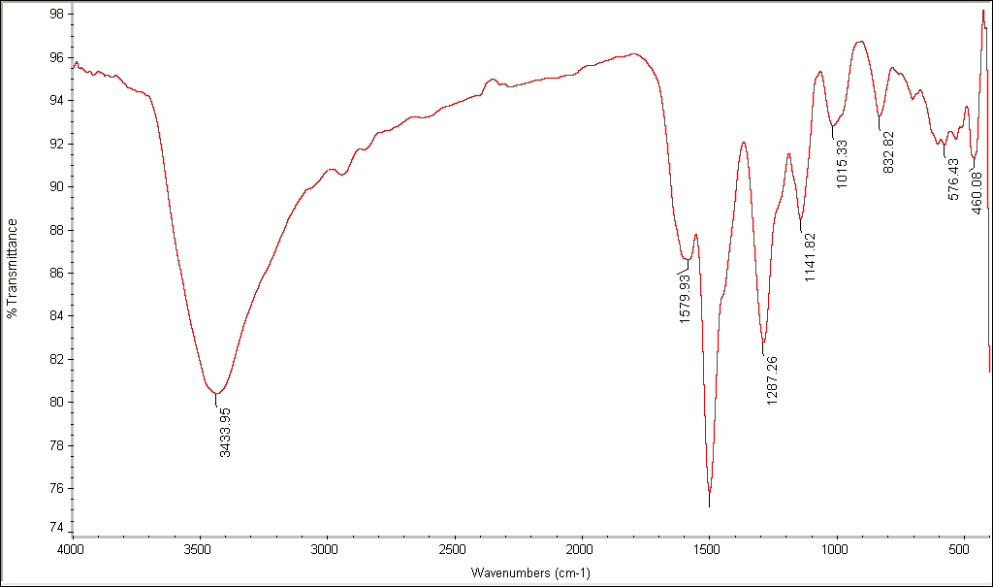

Fig S5. FTIR spectrum of Mn-curcumin complex
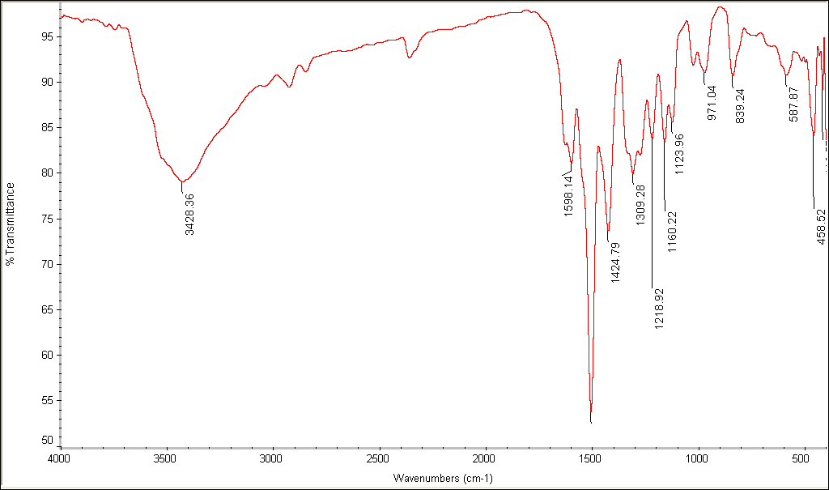

Fig S6. FTIR spectrum of Mg-curcumin complex

Thermal Analysis
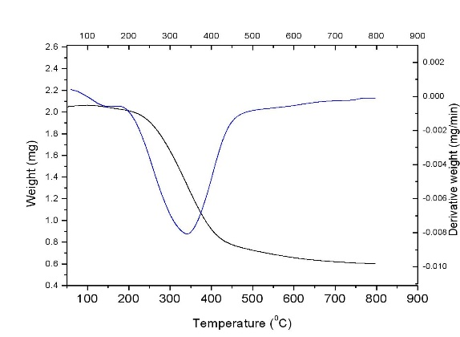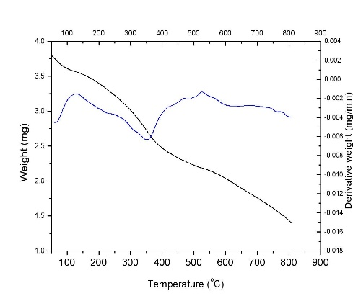
(i) (ii)
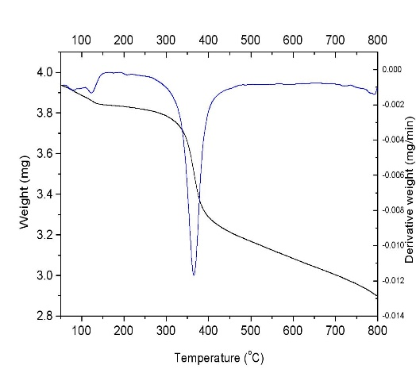
(iii)

Fig S7. TG-DTG curves of (i) Curcumin-I, (ii) Mn-curcumin, (iii) Mg-curcumin

