Table 1 The area fraction (%) of the cleaned oxide surface
DCEN 50% - DCEP 50%
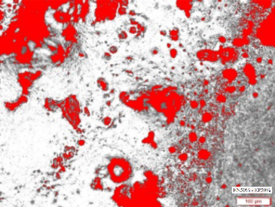 | 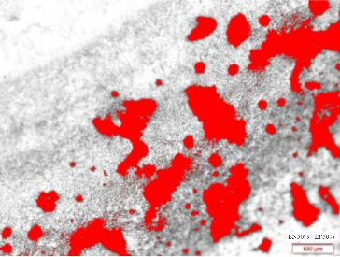 | 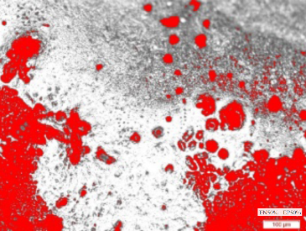
77.10 % | 73.70% | 76.61%
DCEN 40% - DCEP 60%
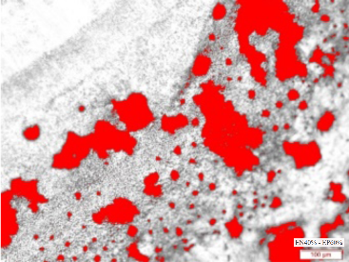 | 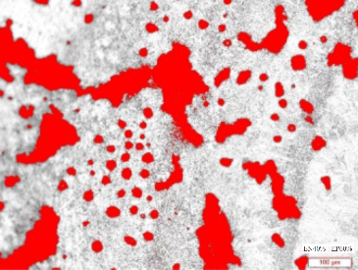 | 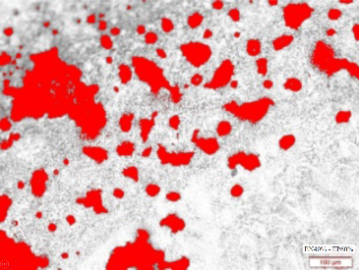
82.10 % | 81.33 % | 78.31 %
DCEN 30% - DCEP 70%
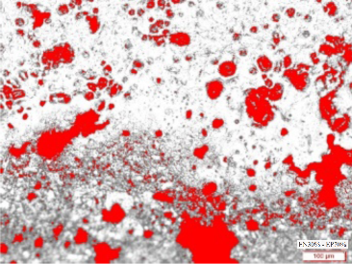 | 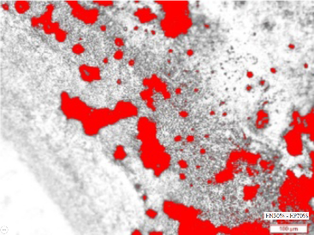 | 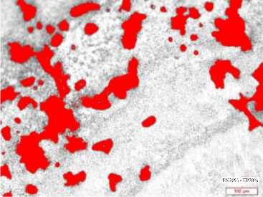
84.81 % | 83.46 % | 82.47 %

