SupplementaryFile

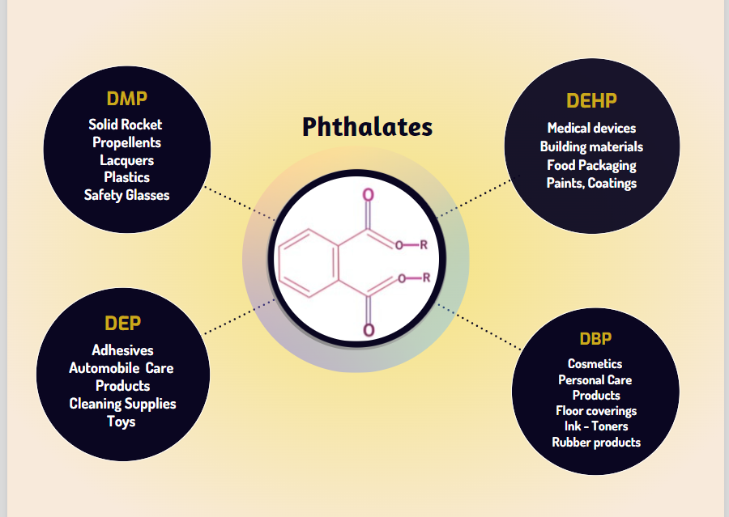
Fig 1: PAEs as priority pollutants

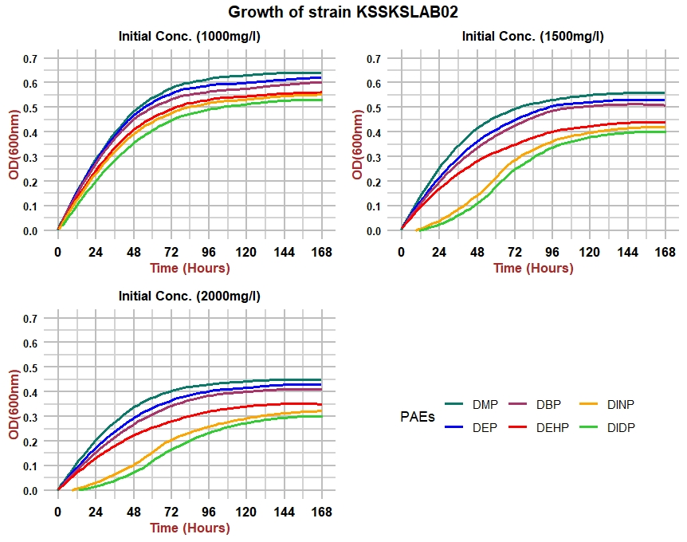
Fig 2. Growth of strain KSSKSLAB02 at different initial Concentrations of PAEs

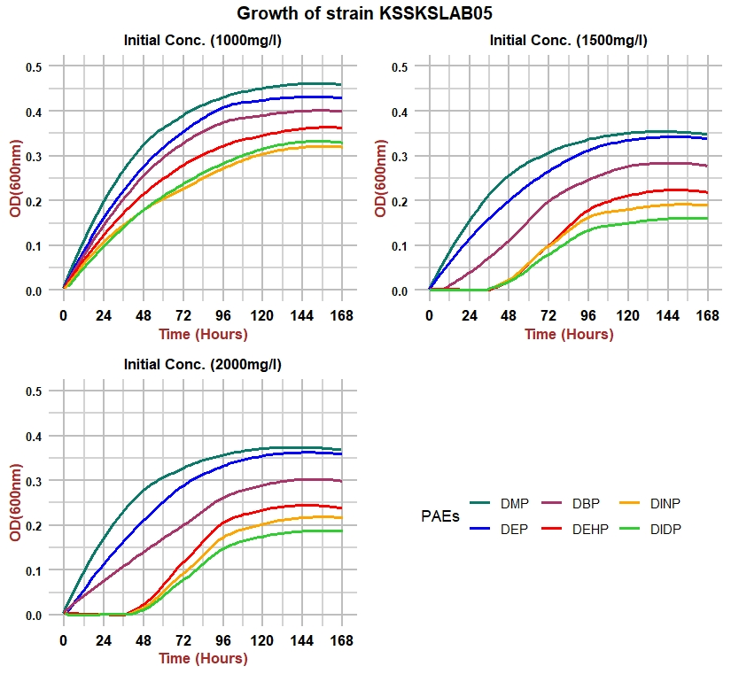
Fig 3: Growth of strain KSSKSLAB05 at different initial Concentrations of PAEs
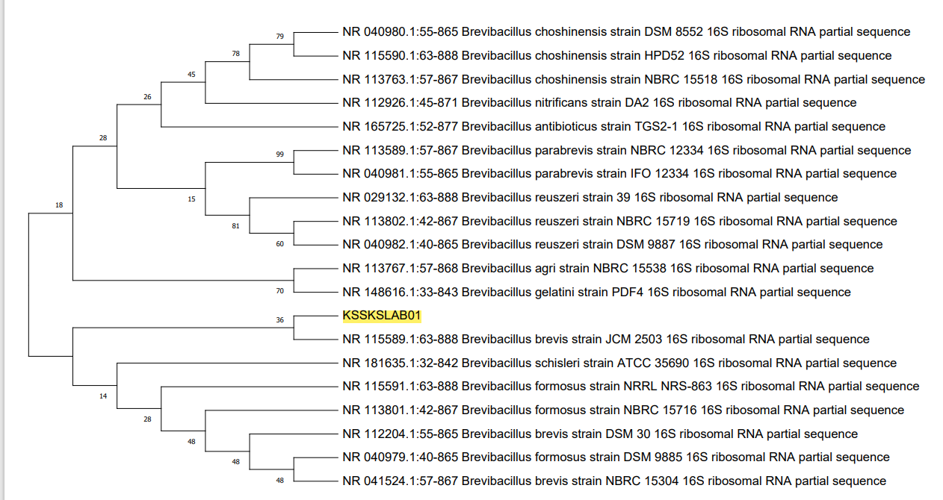
Fig 4: Phylogenetic analysis of Brevibacillus brevis strain KSSKSLAB01 against other species of Brevibacillus

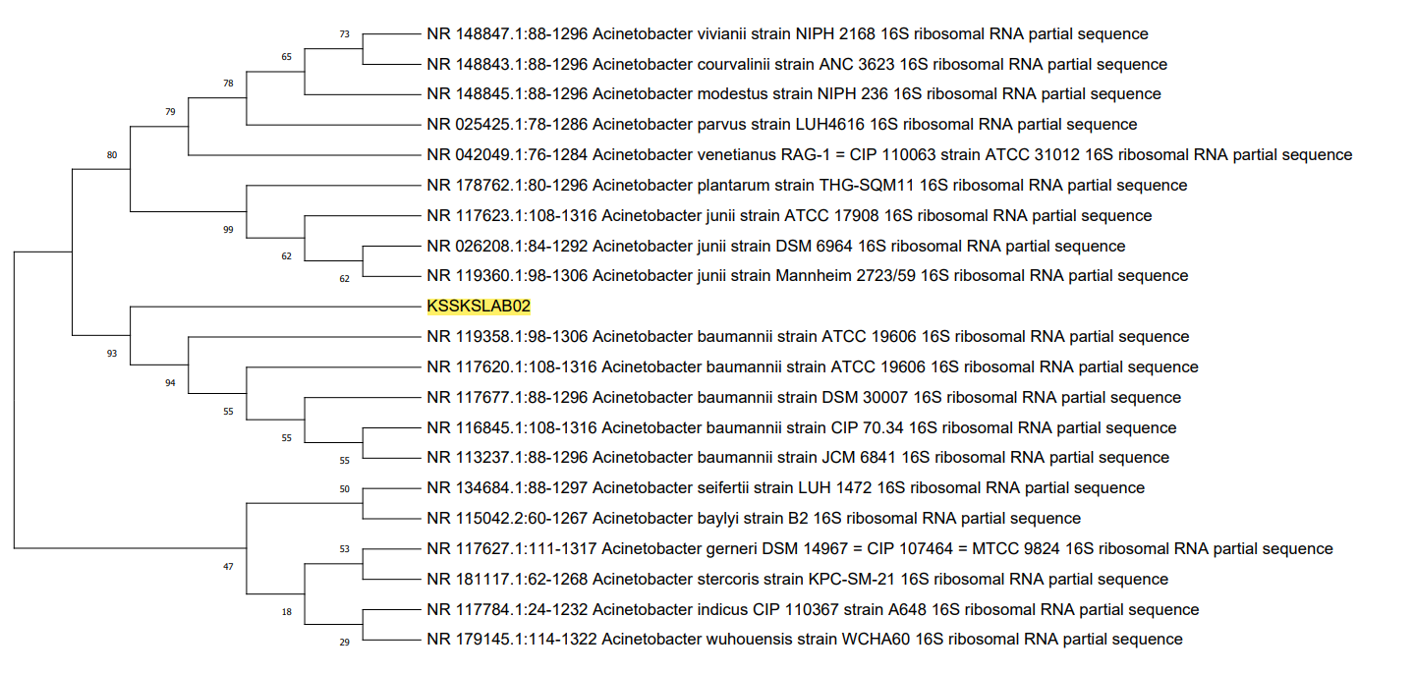
Fig 5: Phylogenetic analysis of Acinetobacter baumannii strain KSSKSLAB02 against other species of Acinetobacter.

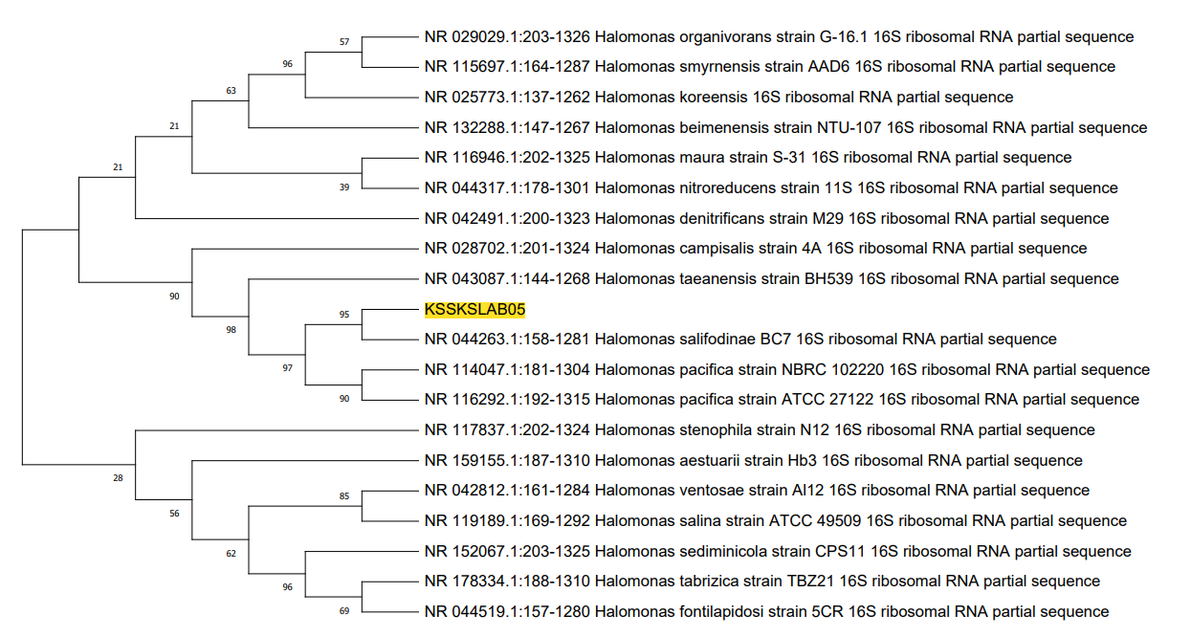
Fig 6: Phylogenetic analysis of Halomonas sp. strain KSSKSLAB05 against other species of Halomonas

Fig 7: rRNA structure of Brevibacillus brevis strain KSSKSLAB01
Fig 8: rRNA structure ofAcinetobacter baumannii strain KSSKSLAB02

Fig 9: rRNA structure ofHalomonas sp. strain KSSKSLAB05

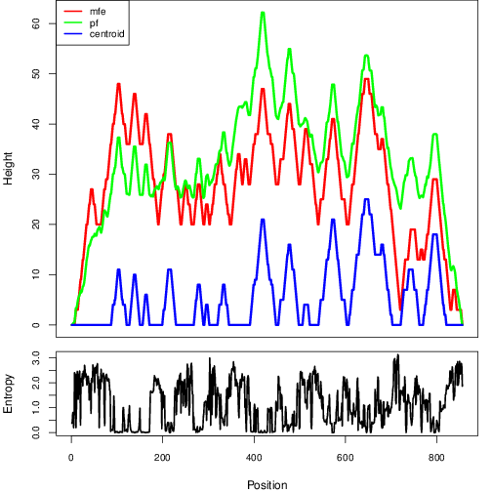
Fig 10: Hill plot: 16S rRNA for Brevibacillus brevis strain KSSKSLAB01.

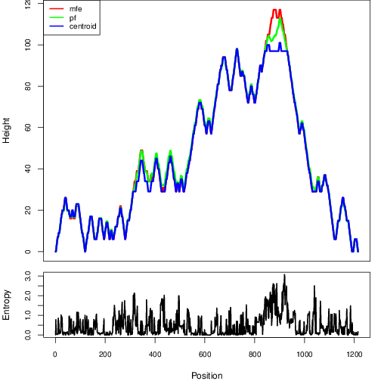
Fig11: Hill plot: 16S rRNA for Acinetobacter baumannii strain KSSKSLAB02.

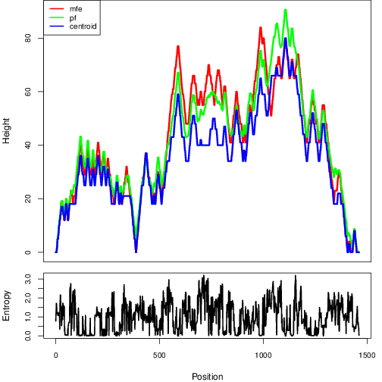
Fig12: Hill plot: 16S rRNA for Halomonas sp. strain KSSKSLAB05.

Table 1: Thermodynamics of Brevibacillus brevis strain KSSKSLAB01
Structural element | δG | Information
External loop | -0.40 | 12 ss bases & 2 closing helices.
Stack | -2.40 | External closing pair is C ⁵⁰⁹-G ⁸⁵⁰
Helix | -11.40 | 7 base pairs.
Interior loop | 1.60 | External closing pair is U ⁵¹⁵-G ⁸⁴⁴
Stack | -3.30 | External closing pair is G ⁵¹⁹-C ⁸³⁹
Helix | -12.40 | 5 base pairs.
Multi-loop | 1.40 | External closing pair is G ⁵²³-C ⁸³⁵  12 ss bases & 3 closing helices.
Stack | -3.40 | External closing pair is G ⁷²¹-C ⁸³⁰
Helix | -2.40 | 2 base pairs.
Interior loop | -0.40 | External closing pair is A ⁷⁷⁴-U ⁸¹⁶
Helix | -5.50 | 3 base pairs.
Bulge loop | 2.80 | External closing pair is C ⁷⁷⁸-G ⁸¹²
Stack | -3.30 | External closing pair is G ⁷⁸¹-C ⁸¹¹

Table 2: Thermodynamics of Acinetobacter baumannii strain KSSKSLAB02
Structural element | δG | Information
External loop | -1.00 | 5 ss bases & 3 closing helices.
Stack | -3.30 | External closing pair is G ¹¹⁹⁶-C ¹²¹⁵
Helix | -2.10 | 2 base pairs.
Multi-loop | 2.30 | External closing pair is G ¹⁷⁷-C ¹¹¹³  5 ss bases & 3 closing helices.
Stack | -1.00 | External closing pair is U ¹⁰⁹²-A ¹¹¹²
Helix | -15.20 | 7 base pairs.
Hairpin loop | 5.80 | Closing pair is U ¹⁰⁹⁸-A ¹¹⁰⁶
Stack | -2.40 | External closing pair is G ¹⁸²-C ¹⁰⁹⁰
Helix | -9.40 | 6 base pairs.
Multi-loop | 1.80 | External closing pair is U ¹⁸⁷-G ¹⁰⁸⁵  3 ss bases & 3 closing helices.
Helix | -4.60 | 3 base pairs.
Hairpin loop | 5.70 | Closing pair is C ¹⁰⁷⁶-G ¹⁰⁸⁰
Stack | -3.30 | External closing pair is C ¹⁸⁸-G ¹⁰⁷²

Table 3: Thermodynamics of Halomonas sp. strain KSSKSLAB05
Structural element | δG | Information
External loop | -1.30 | 16 ss bases & 3 closing helices.
Stack | -2.10 | External closing pair is C ¹³⁶⁰-G ¹³⁸⁰
Helix | -7.60 | 4 base pairs.
Bulge loop | 0.50 | External closing pair is C ¹³⁶³-G ¹³⁷⁷
Stack | -2.10 | External closing pair is C ¹³⁶⁴-G ¹³⁷⁵
Helix | -5.60 | 4 base pairs.
Hairpin loop | 0.90 | Closing pair is C ¹³⁶⁷-G ¹³⁷²
Stack | -2.20 | External closing pair is A ¹³⁴⁸-U ¹³⁵⁷
Helix | -5.50 | 3 base pairs.
Hairpin loop | 0.40 | Closing pair is C ¹³⁵⁰-G ¹³⁵⁵
Stack | -2.50 | External closing pair is G ⁵-U ¹³⁴⁶
Helix | -11.20 | 7 base pairs.
Multi-loop | 4.30 | External closing pair is A ¹⁰-U ¹³⁴¹  3 ss bases & 3 closing helices.
Helix | -5.70 | 3 base pairs.
Hairpin loop | 3.50 | Closing pair is G ¹³³³-C ¹³³⁸
Stack | -2.10 | External closing pair is U ¹³-A ¹³²⁹

