Supplementary Table 1: Summary of demographics for the S-PRESTO dataset and number of subjects, mean and standard deviation of the scores for all assessments.
 | S-PRESTO cohort
 | n | mean | sd
Demographics
Sex | 327
- Male | 180 | (55.0)
- Female | 147 | (45.0)
Ethnicity | 327
- Chinese | 255 | (78.0)
- Malay | 45 | (13.8)
- Indian | 22 | (6.7)
- Others/Mixed | 5 | (1.5)
Mother Highest Education | 315
- Primary | 4 | (1.3)
- Secondary/Technical | 117 | (37.1)
- GCE ‘A’ levels/University | 194 | (61.6)
Monthly Household income (SGD) | 289
- <1621 | 2 | (0.7)
- 1622-6144 | 78 | (27.0)
- >6145 | 209 | (72.3)
Maternal Mental Health
- Edinburgh Postnatal Depression Scale (PW26) | 301 | 6.48 | 4.51
- Beck Depression Inventory 2 (PW26) | 297 | 8.92 | 6.44
- State-Trait Anxiety Inventory (PW26) | 303 | 70.59 | 18.22
- Negative Maternal Mental Health (PW26) | 297 | 0.01 | 0.48
- Positive Maternal Mental Health (PW26) | 297 | 0.05 | 0.25
Offspring Measures (Y4.5-6.3)
- Peabody Picture Vocabulary Test, 5th Ed (Standard Score) | 205 | 96.73 | 15.08
- Behavior Rating Inventory of Executive Function Preschool (Standard Score) | 197 | 95.90 | 19.35
* Number in brackets indicate percentage of cohort. Note: Range for monthly household income is different due to different grading scheme used for the S-PRESTO cohort.

Supplementary Table 2: Full list of regression estimates and confidence intervals for serial mediation analysis
LHS |  | RHS | label | Estimate | S.E. | Lower CI | Upper CI
bayleys_CC_Y2 | ~ | general_p26w | na1 | -0.201 | 0.121 | -0.444 | 0.036
bayleys_CC_Y2 | ~ | positive_p26w | pa1 | 0.219 | 0.105 | 0.013 | 0.427
BRIEF_GEC_Y7 | ~ | general_p26w | na2 | 0.116 | 0.063 | 0.011 | 0.233
BRIEF_GEC_Y7 | ~ | positive_p26w | pa2 | 0.071 | 0.068 | -0.057 | 0.209
BRIEF_GEC_Y7 | ~ | bayleys_CC_Y2 | d21 | 0.010 | 0.037 | -0.063 | 0.082
CDI_Total_Y9 | ~ | general_p26w | ncp | -0.033 | 0.060 | -0.147 | 0.086
CDI_Total_Y9 | ~ | positive_p26w | pcp | -0.084 | 0.074 | -0.231 | 0.057
CDI_Total_Y9 | ~ | bayleys_CC_Y2 | b1 | -0.084 | 0.036 | -0.157 | -0.013
CDI_Total_Y9 | ~ | BRIEF_GEC_Y7 | b2 | 0.172 | 0.069 | 0.038 | 0.308
Significant regression relations are bolded. Note: general_p26w: General (Negative) Maternal Mental Health Score at Prenatal Week 26, positive_p26w: Positive Maternal Mental Health Score at Prenatal Week 26, bayleys_CC_Y2: Bayley’s Scale of Infant Development Composite Language Score at 2 years, BRIEF_GEC_Y7: Behavior Rating Inventory of Executive Function Global Executive Composite Score at 7 years, CDI_Total_Y9: Childhood Depression Inventory Total Score at 9 years.
Supplementary Table 3: Full list of mediation pathways for serial mediation analysis
Path | label | Estimate | S.E. | Lower CI | Upper CI
general_p26w -> bayleys_CC_Y2 -> BRIEF_GEC_Y7 -> CDI_Total_Y9 | na1*d21*b2 | 0.000 | 0.002 | -0.006 | 0.002
general_p26w -> bayleys_CC_Y2 -> CDI_Total_Y9 | na1*b1 | 0.017 | 0.014 | -0.001 | 0.056
general_p26w -> BRIEF_GEC_Y7 -> CDI_Total_Y9 | na2*b2 | 0.020 | 0.013 | 0.001 | 0.058
positive_p26w -> bayleys_CC_Y2 -> BRIEF_GEC_Y7 -> CDI_Total_Y9 | pa1*d21*b2 | 0.000 | 0.002 | -0.002 | 0.005
positive_p26w -> bayleys_CC_Y2 -> CDI_Total_Y9 | pa1*b1 | -0.018 | 0.013 | -0.055 | -0.001
positive_p26w -> BRIEF_GEC_Y7 -> CDI_Total_Y9 | pa2*b2 | 0.012 | 0.014 | -0.007 | 0.053
Significant pathways are bolded. Note: general_p26w: General (Negative) Maternal Mental Health Score at Prenatal Week 26, positive_p26w: Positive Maternal Mental Health Score at Prenatal Week 26, bayleys_CC_Y2: Bayley’s Scale of Infant Development Composite Language Score at 2 years, BRIEF_GEC_Y7: Behavior Rating Inventory of Executive Function Global Executive Composite Score at 7 years, CDI_Total_Y9: Childhood Depression Inventory Total Score at 9 years.

Supplementary Table 4: Table of functional connections that are significantly correlated with positive or negative maternal mental health with corresponding Pearson’s correlation coefficients and p-values.
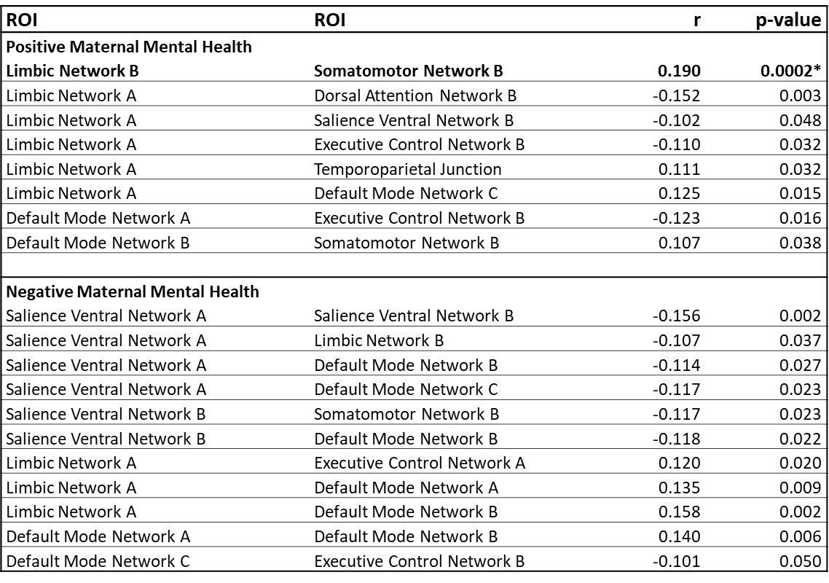
* indicates significant after correction for multiple comparisons
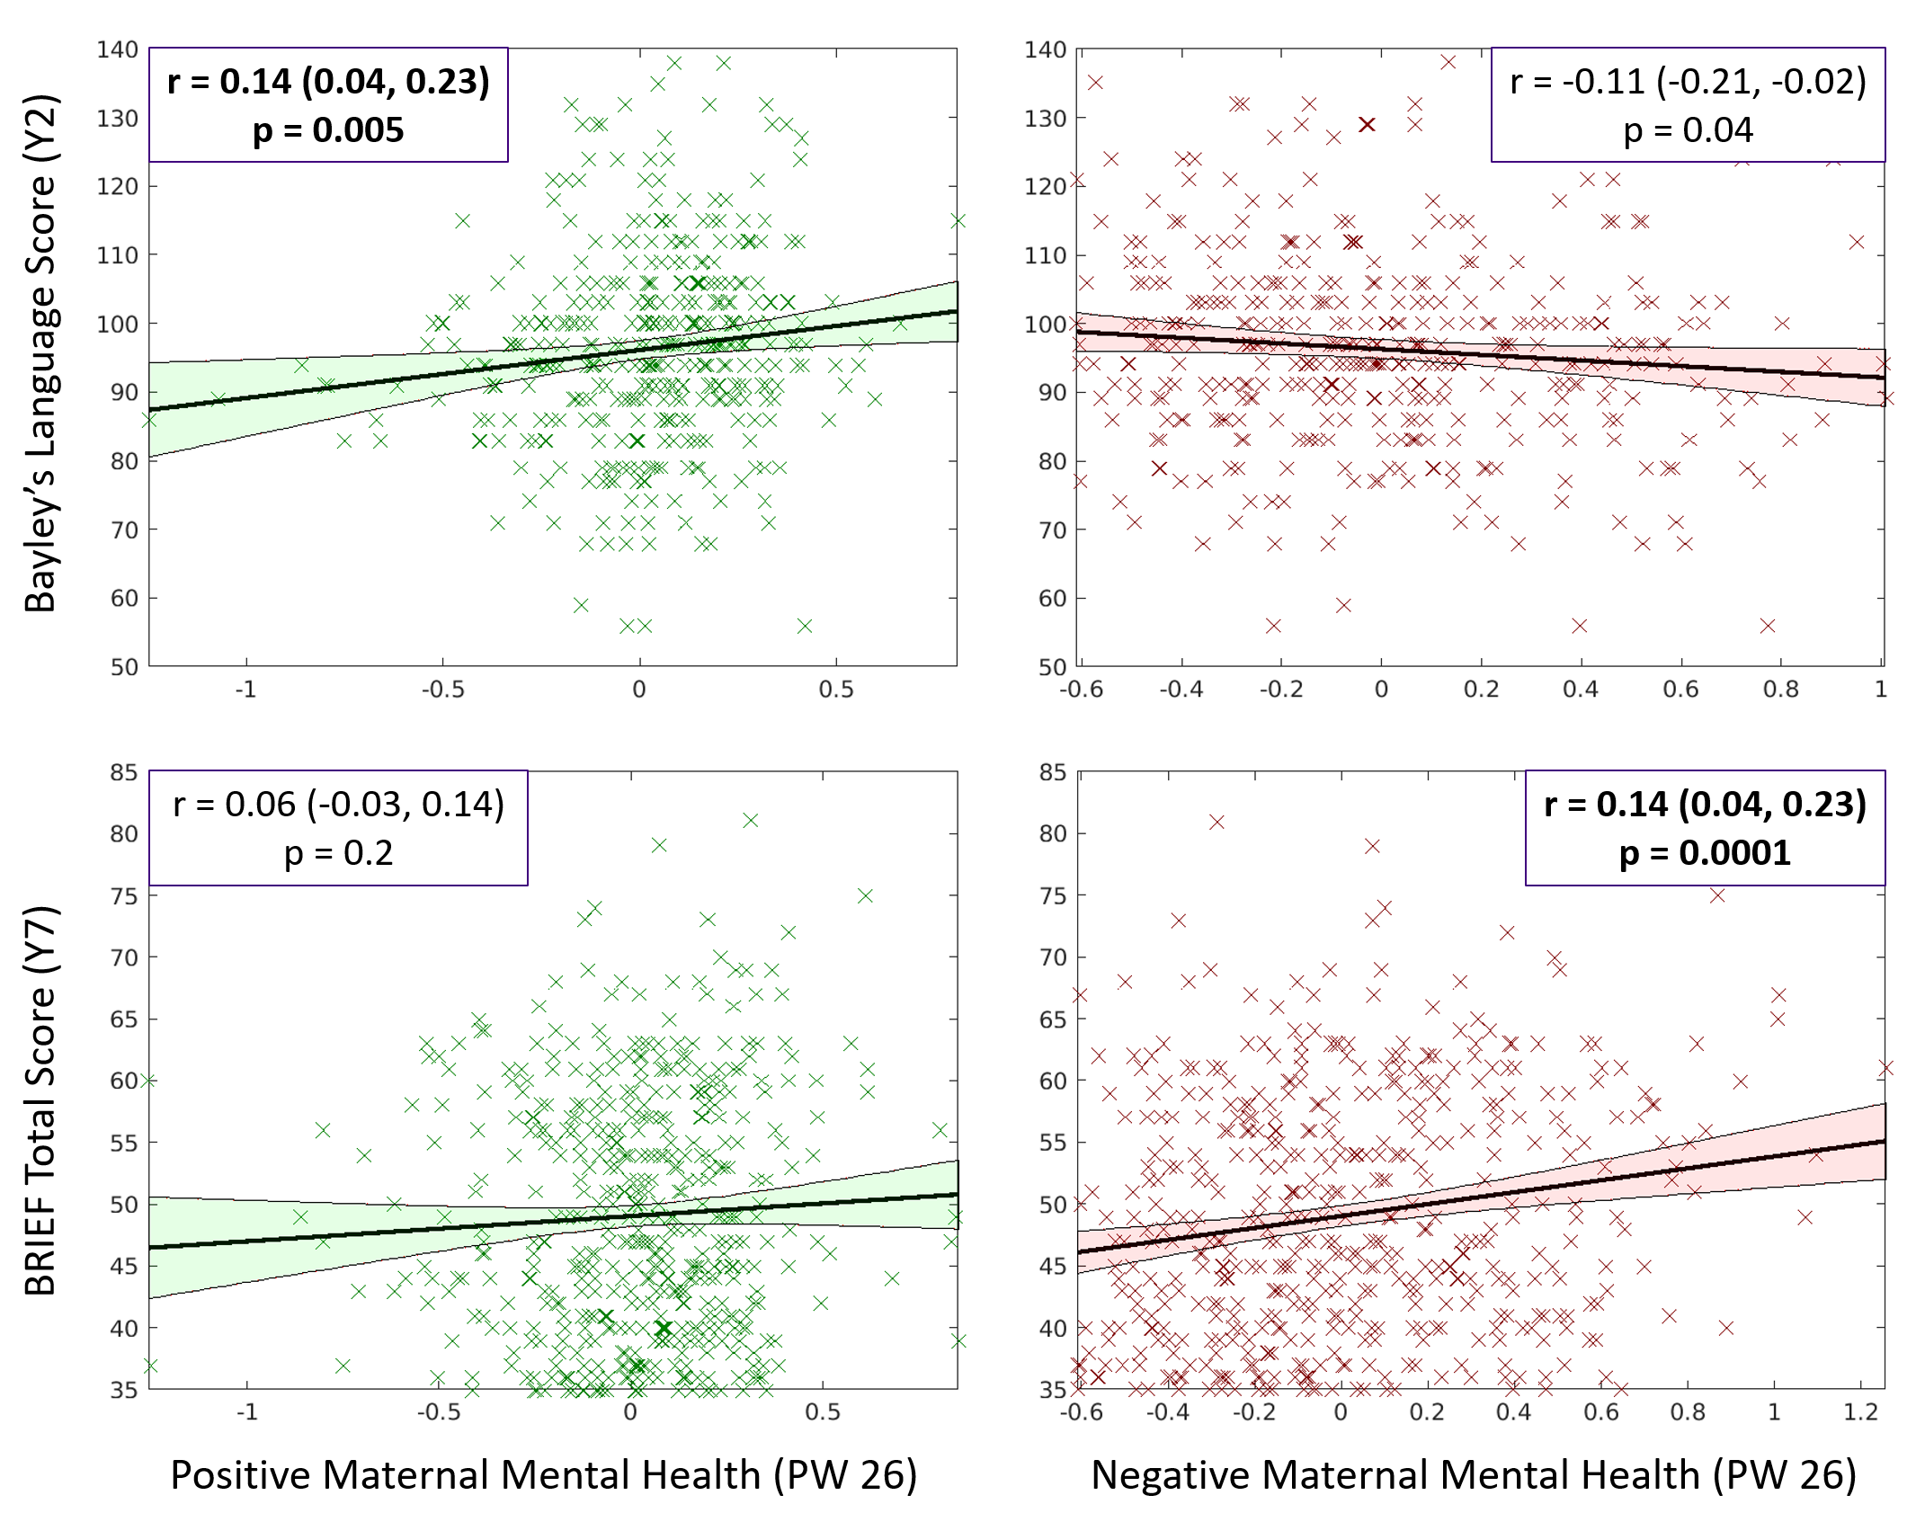
Supplementary Figure 1: Scatterplots showing the correlation positive and negative maternal mental health at Pregnancy Week 26 and Bayley’s composite language score at 2 years and BRIEF total score at 7 years. Correlation values, 95% CI and p-values are included in the inserts. Bolded text indicates significant correlations after Bonferroni’s correction for multiple comparisons.

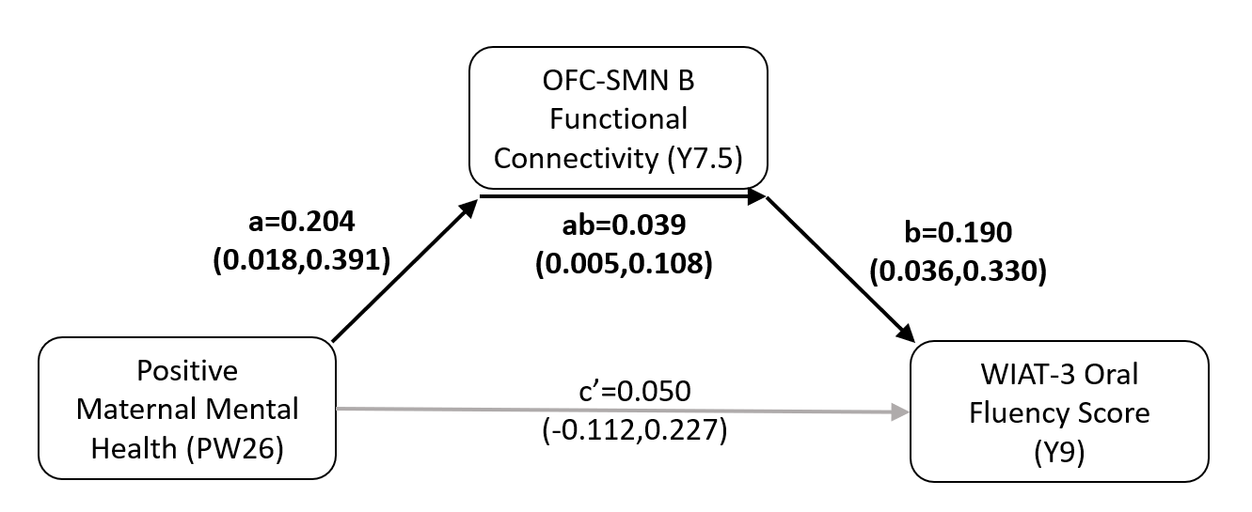Supplementary Figure 2: Mediation analysis showed that the orbitofrontal-Somatomotor Network B (OFC-SMN B) functional connectivity at 7.5 years significantly mediated the relation between positive maternal mental health at prenatal 26 weeks and WIAT-3 Oral Fluency Score at 9 years (β=0.039 (0.005, 0.108)).

