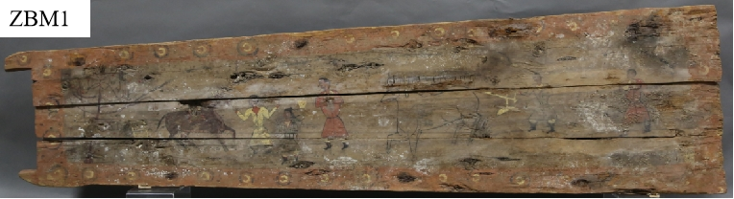
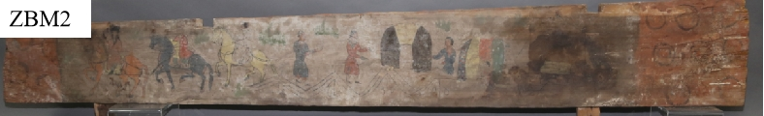
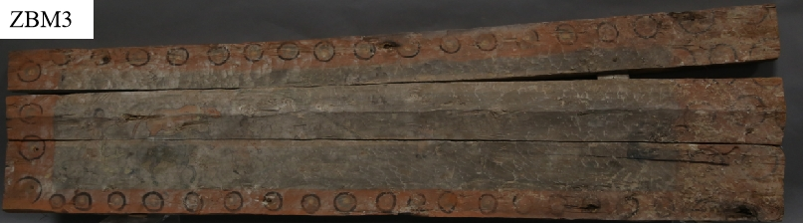
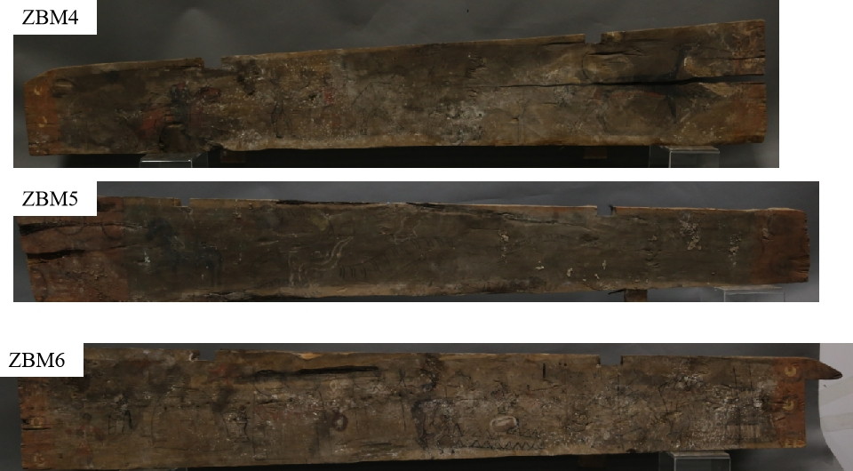
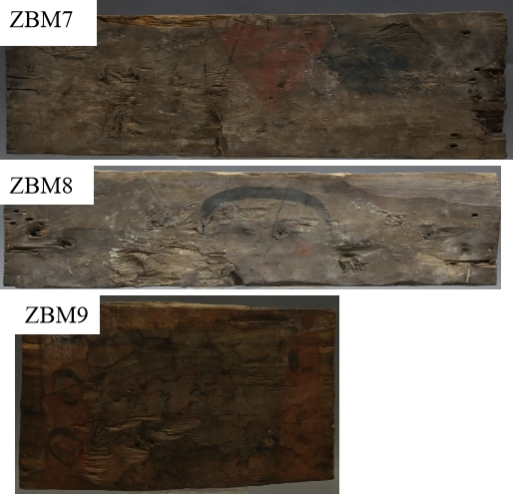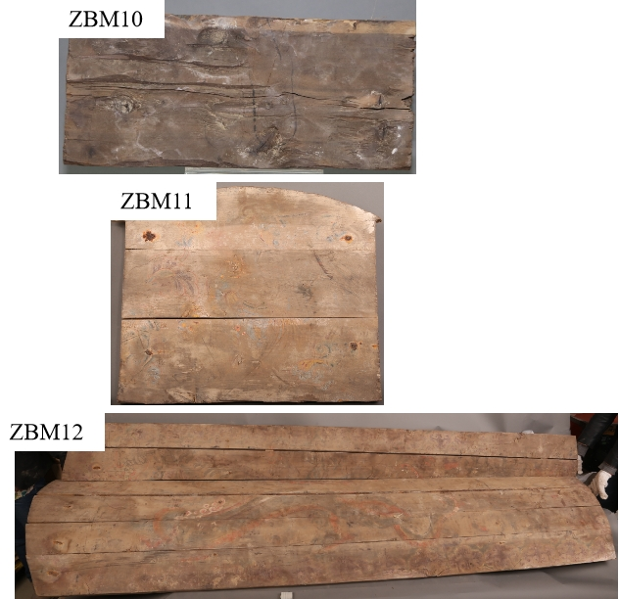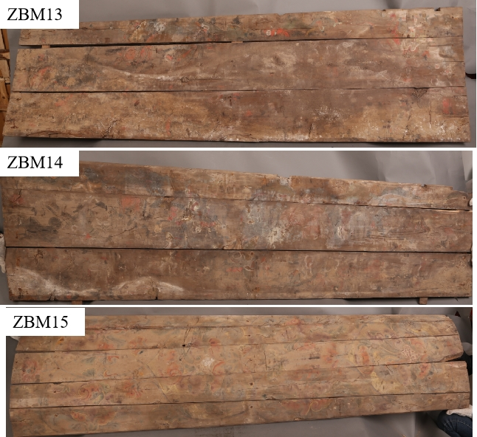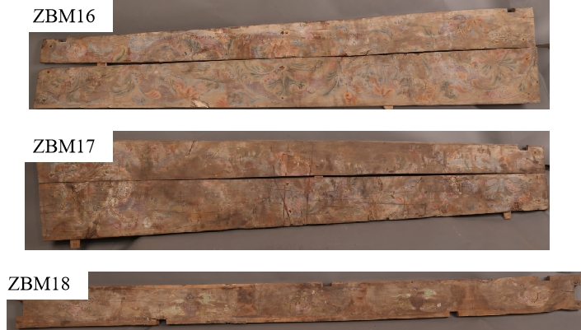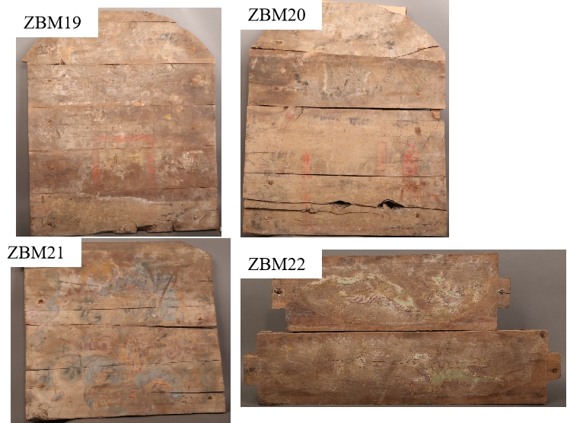
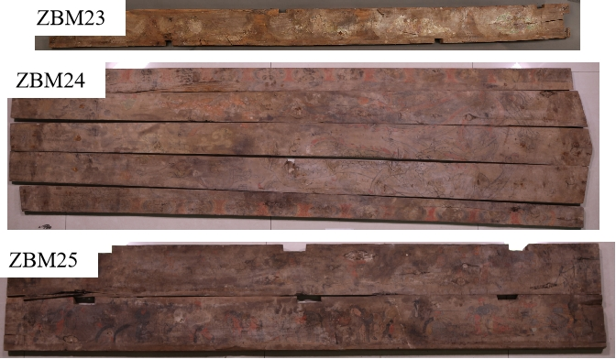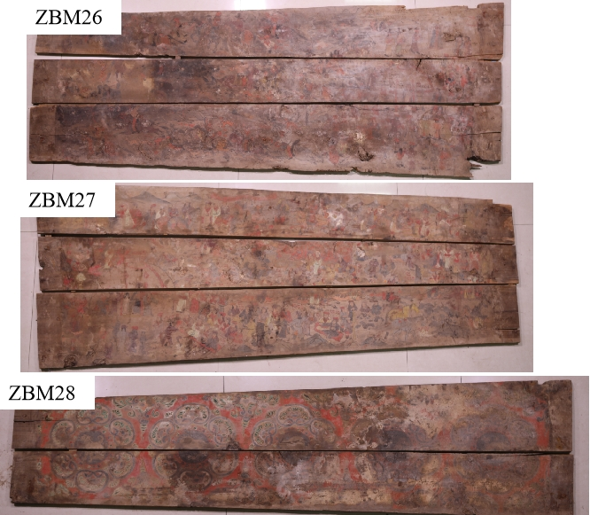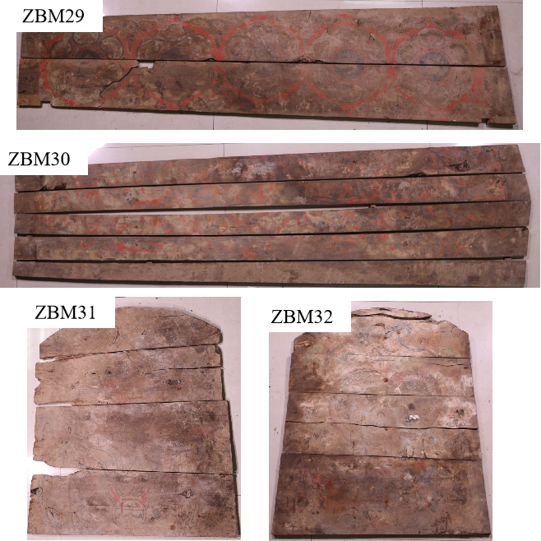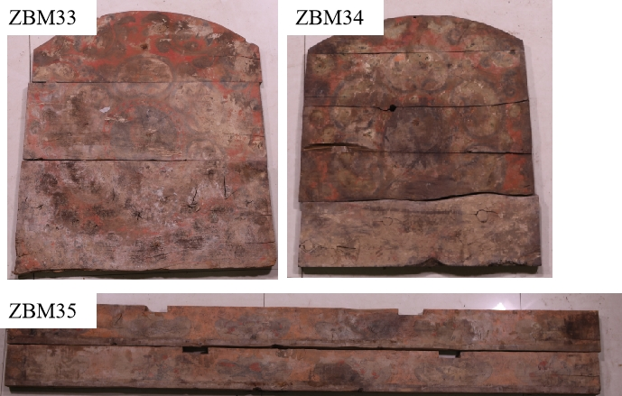
Fig.S1 The photos of wooden coffin paintings

Table S1 Types and areas of diseases in wooden coffin paintings
 | soil rust | rotten | crack | mutilation | pulverization | water stain | microorganism | deformation | discoloration | drop | chap | crystal salt
ZBM1 | 0.15 | 0.24 | 0.20 | 0 | 0.07 | 0 | 0.02 | 0 | 0 | 0.01 | 0 | 0.13
ZBM2 | 0 | 0.06 | 0.01 | 0 | 0.15 | 0.10 | 0.01 | 0 | 0 | 0 | 0 | 0.03
ZBM3 | 0.36 | 0.10 | 0 | 0 | 0.15 | 0.10 | 0 | 0.12 | 0.05 | 0.01 | 0 | 0
ZBM4 | 0.03 | 0.01 | 0 | 0.01 | 0.01 | 0.50 | 0.01 | 0.01 | 0 | 0.05 | 0 | 0.01
ZBM5 | 0.01 | 0.01 | 0 | 0 | 0 | 0.50 | 0 | 0 | 0 | 0 | 0 | 0
ZBM6 | 0.06 | 0.03 | 0.01 | 0 | 0.18 | 0.14 | 0 | 0 | 0.05 | 0 | 0 | 0
ZBM7 | 0.05 | 0.04 | 0.01 | 0 | 0 | 0 | 0 | 0.01 | 0 | 0 | 0 | 0
ZBM8 | 0.01 | 0.05 | 0.01 | 0 | 0 | 0 | 0 | 0.01 | 0.01 | 0 | 0 | 0
ZBM9 | 0 | 0.03 | 0.01 | 0 | 0 | 0.02 | 0 | 0.01 | 0 | 0 | 0 | 0
ZBM10 | 0 | 0.02 | 0.01 | 0 | 0.02 | 0 | 0 | 0 | 0.01 | 0 | 0 | 0
ZBM11 | 0.01 | 0.01 | 0.01 | 0 | 0.05 | 0 | 0.01 | 0 | 0 | 0 | 0.05 | 0
ZBM12 | 0 | 0 | 0 | 0 | 2.40 | 0 | 0 | 0 | 0 | 0 | 0 | 0.06
ZBM13 | 0.01 | 0.01 | 0.02 | 0 | 0.10 | 0.05 | 0 | 0 | 0.91 | 0 | 0 | 0
ZBM14 | 0.30 | 0 | 0.01 | 0 | 0.50 | 0 | 0 | 0 | 0.30 | 0 | 0 | 0
ZBM15 | 0.20 | 0.10 | 0.02 | 0.01 | 0.50 | 0.02 | 0 | 0 | 0.50 | 0 | 0 | 0
ZBM16 | 0.01 | 0.01 | 0.01 | 0 | 0.60 | 0 | 0 | 0.03 | 0.01 | 0 | 0 | 0.01
ZBM17 | 0 | 0.1 | 0.01 | 0 | 0.30 | 0 | 0.01 | 0.03 | 0.25 | 0 | 0.01 | 0.01
ZBM18 | 0.01 | 0.01 | 0 | 0 | 0 | 0 | 0.05 | 0 | 0.01 | 0 | 0 | 0.01
ZBM19 | 0 | 0 | 0.01 | 0 | 0 | 0.02 | 0 | 0.01 | 0.05 | 0.01 | 0 | 0.01
ZBM20 | 0.01 | 0.01 | 0 | 0.01 | 0 | 0.15 | 0 | 0 | 0.15 | 0 | 0 | 0.01
ZBM21 | 0.01 | 0.01 | 0.01 | 0 | 0.20 | 0.15 | 0 | 0.01 | 0.07 | 0 | 0 | 0.01
ZBM22 | 0 | 0.01 | 0 | 0 | 0 | 0.03 | 0 | 0.01 | 0 | 0.03 | 0 | 0
ZBM23 | 0.04 | 0.05 | 0 | 0 | 0.15 | 0 | 0 | 0.01 | 0 | 0.02 | 0 | 0.02
ZBM24 | 0.31 | 0.61 | 0.01 | 0 | 0 | 0 | 0 | 0 | 0.01 | 0.20 | 0 | 0.15
ZBM25 | 0.02 | 0 | 0.01 | 0 | 0.30 | 0 | 0 | 0.01 | 0.01 | 0.15 | 0 | 0.03
ZBM26 | 0.01 | 0.01 | 0 | 0 | 1.20 | 0.15 | 0 | 0.01 | 0.01 | 0 | 0 | 0
ZBM27 | 0.15 | 0.15 | 0 | 0.06 | 0.52 | 0 | 0 | 0 | 0.30 | 0.02 | 0.01 | 0
ZBM28 | 0.05 | 0.21 | 0 | 0 | 0.31 | 0.18 | 0 | 0 | 0.02 | 0.01 | 0.01 | 0.01
ZBM29 | 0.01 | 0.03 | 0.01 | 0.01 | 0.45 | 0.15 | 0 | 0 | 0.01 | 0.01 | 0.01 | 0
ZBM30 | 0.08 | 0.01 | 0 | 0 | 0.64 | 0.06 | 0 | 0 | 0 | 0.05 | 0.02 | 0.01
ZBM31 | 0.21 | 0.15 | 0.01 | 0.03 | 0.10 | 0.11 | 0 | 0.01 | 0 | 0.25 | 0.05 | 0.02
ZBM32 | 0.01 | 0 | 0.01 | 0.01 | 0.08 | 0.20 | 0 | 0.01 | 0.10 | 0.11 | 0.07 | 0.01
ZBM33 | 0.01 | 0.15 | 0 | 0 | 0 | 0.08 | 0.01 | 0.01 | 0 | 0.02 | 0.01 | 0
ZBM34 | 0.01 | 0.01 | 0 | 0.01 | 0 | 0.11 | 0 | 0.01 | 0 | 0.11 | 0.05 | 0
ZBM35 | 0.01 | 0.06 | 0 | 0 | 0.22 | 0.15 | 0 | 0.01 | 0.05 | 0 | 0 | 0.01

