Table S1 Primer sequences for quantitative real-time PCR
Gene | F (5′-3′) | R (5′-3′)
PgCBF10 | AATGGAACAAATGGGCAAGC | CTGTGACGATGACGACGAC
PgCBF11 | GAAGAAGCTGACACGATCCA | CCGTTGATGACGCACGA
PgCBF12 | CAATGCCGGAGACGAAGAG | GAACTCGAAGCCGAACTCAA
PgCBF19 | GACTTGTACTACGCGAGCTT | TAGTAGCTCCAGAGTGGCA
PgCBF20 | TGTGCCAAATCAAGAAGGAGA | GCGTCTCCCTGAACTTGG
PgCBF21 | ATGTGCCAGATCAAGAAGGAG | CTCCGACGAGGTTGTTGATG
PpACT1 | CTATATGCTAGTGGCCGTACAA | CAGCAAGATCGAGACGTAGAA
Table S2 Physicochemical characteristics of 23 PgCBF family members
Gene Name | Locus ID | Protein/aa | Molecular weight/D | pI | Instability  Index | Aliphatic  Index | Grand Average of  Hydropathicity | Subcellular  Location
PgCBF1 | PMD1G05417.1 | 203 | 21582.72 | 6.16 | 65.66 | 52.71 | -0.729 | Nucleus
PgCBF2 | PMD2G01537.1 | 242 | 25272.15 | 5.24 | 47.81 | 67.19 | -0.313 | Nucleus
PgCBF3 | PMD2G01539.1 | 258 | 26651.56 | 4.97 | 51.9 | 61.59 | -0.375 | Nucleus
PgCBF4 | PMD2G04522.1 | 266 | 28710.66 | 6.16 | 59.92 | 50.9 | -0.584 | Nucleus
PgCBF5 | PMD3G01238.1 | 218 | 23666.33 | 5.17 | 62.11 | 56.15 | -0.517 | Nucleus
PgCBF6 | PMD3G01242.1 | 204 | 21471.48 | 5.23 | 59.31 | 51.03 | -0.664 | Nucleus
PgCBF7 | PMD3G01407.1 | 236 | 24747.17 | 5.45 | 66.81 | 56.14 | -0.638 | Nucleus
PgCBF8 | PMD3G01408.1 | 249 | 26532.51 | 4.75 | 56.89 | 71.12 | -0.349 | Nucleus
PgCBF9 | PMD3G01409.1 | 312 | 32417.37 | 4.95 | 62.31 | 54.68 | -0.558 | Nucleus
PgCBF10 | PMD3G02854.1 | 256 | 27918.55 | 5.43 | 55.79 | 74.45 | -0.376 | Nucleus
PgCBF11 | PMD3G07367.1 | 300 | 31125.49 | 5.94 | 46.65 | 69.9 | -0.356 | Endoplasmic reticulum
PgCBF12 | PMD3G07368.1 | 256 | 26356.8 | 4.57 | 49.66 | 66.33 | -0.402 | Nucleus
PgCBF13 | PMD4G03055.1 | 324 | 34271.7 | 9.82 | 66.35 | 70.4 | -0.5 | Nucleus
PgCBF14 | PMD4G03529.1 | 243 | 25850.89 | 5.19 | 62.06 | 67.65 | -0.33 | Chloroplast
PgCBF15 | PMD4G05292.1 | 196 | 21064.67 | 4.79 | 41.59 | 77.3 | -0.315 | Cytoplasm
PgCBF16 | PMD5G02721.1 | 187 | 19688.36 | 6.18 | 66.64 | 64.44 | -0.356 | Nucleus
PgCBF17 | PMD5G03051.1 | 286 | 30101.39 | 4.88 | 72.43 | 61.05 | -0.528 | Nucleus
PgCBF18 | PMD6G00337.1 | 257 | 26767.32 | 5.35 | 63.6 | 55.64 | -0.612 | Nucleus
PgCBF19 | PMD7G02245.1 | 228 | 24583.23 | 4.79 | 72.89 | 62.24 | -0.385 | Nucleus
PgCBF20 | PMD7G02246.1 | 234 | 24909.58 | 4.75 | 66.66 | 60.68 | -0.319 | Nucleus
PgCBF21 | PMD7G02247.1 | 232 | 24914.72 | 5.43 | 63.47 | 57.84 | -0.341 | Nucleus
PgCBF22 | PMD7G02252.1 | 270 | 27921.02 | 6.11 | 68.76 | 64.59 | -0.304 | Chloroplast
PgCBF23 | PMD7G02253.1 | 264 | 28248.8 | 7.84 | 60.13 | 68.98 | -0.308 | Chloroplast

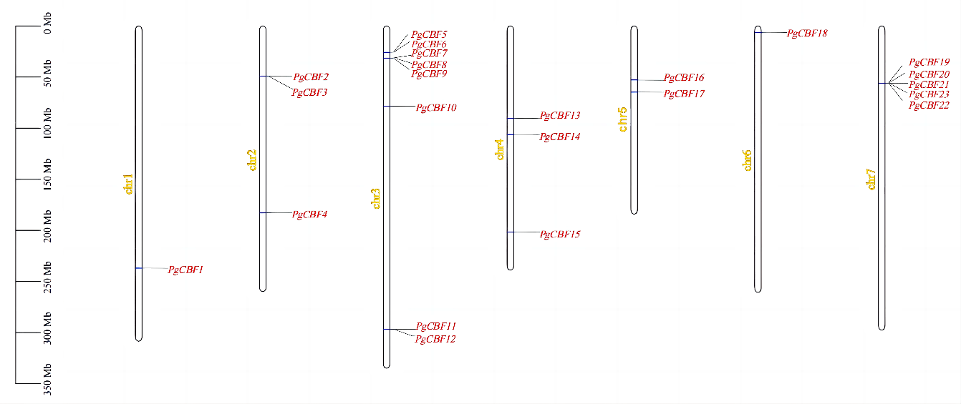
Fig. S1 Distribution of PgCBF genes on the chromosome.

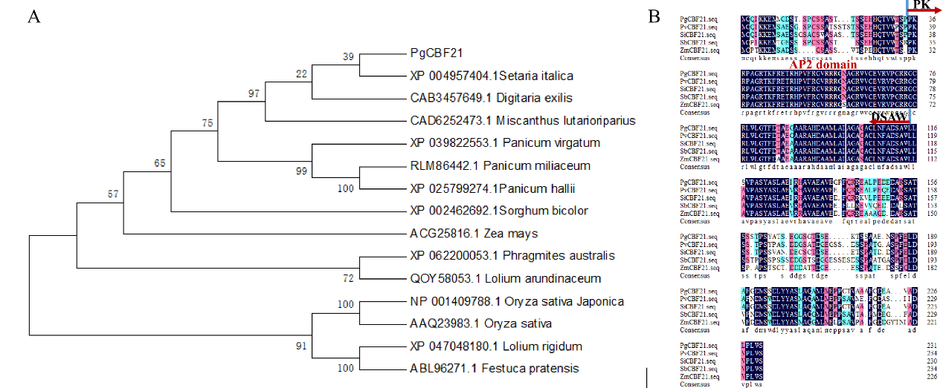
Fig. S2 Evolutionary relationship analysis.
A Phylogenetic analysis of CBF21 protein from fifteen different plant species. Fifteen LBD12 proteins from Pennisetum hybrid, Setaria italica, Digitaria exilis, Miscanthus lutarioriparius, Panicum virgatum, Panicum miliaceum, Panicum hallii, Sorghum bicolor, Zea mays, Phragmites australis, Lolium arundinaceum, Oryza sativa Japonica, Oryza sativa, Lolium rigidum, Festuca pratensis.
B Amino acid sequence alignment of CBF21 proteins from five different plant species.

