Fabrication of Spin-1/2 Heisenberg Antiferromagnetic Chains via Combined On-surface Synthesis and Reduction for Spinon Detection

Xuelei Su$​^{1,†}$, Zhihao Ding$​^{1,†}$, Ye Hong$​^{1,†}$, Nan Ke$​^{1,}$, KaKing Yan$​^{1,*}$, Can Li$​^{2,3,*}$ ,Yifan Jiang$​^{1,*}$and Ping Yu$​^{1,*}$

Contents
1 Precursor Synthesis 3
1.1 Materials and instrumentations 3
1.2 Synthetic procedures 3
1.3 NMR and MS data 6
2 Extended electronic characterization data 10
2.1 dI/dV spectra on olympicenone 10
2.2 TB and MFH calculation. 10
2.3 dI/dV spectra on Trans-/Cis-configuration. 11
2.4 Calculated first spin excitation energies of OSCs . 12
2.5 dI/dV spectra on OSCs with different unit numbers. 12
3 Supplementary References 13

1 Precursor Synthesis

1.1 Materials and instrumentations
Most experiments were performed under an atmosphere of dry nitrogen using standard Schlenk techniques. All starting materials were obtained from commercial suppliers and used as received, without further purification. Anhydrous n-hexane was purchased and utilized directly. Thin-layer chromatography (TLC) was performed on SYNTHWARE HSGF254 TLC plates, while silica-gel column chromatography was carried out using silica gel from Greagent (40-63 μm). NMR spectra were obtained with Bruker Avance NEO 400 and Bruker Avance III HD 500 NMR spectrometer. ¹H NMR spectra were recorded at 500 MHz or 400 MHz and ¹³C{¹H} NMR spectra were recorded at 125 MHz or 100MHz. ¹H NMR chemical shifts were determined relative to the signal of the residual protonated solvent. Data for ¹H NMR are reported as follows: chemical shift (δ ppm), multiplicity (s = singlet, d = doublet, t = triplet, m = multiplet). ¹³C{¹H} NMR chemical shifts NMR spectra were reported as chemical shifts in ppm and multiplicity where appropriate. High Resolution Mass spectra (HR-MS) were obtained from ultimate 3000-Q Exactive Focus High resolution MS (Thermo Fisher, Massachusetts, USA) using electrospray ionization (ESI) source.

1.2 Synthetic procedures

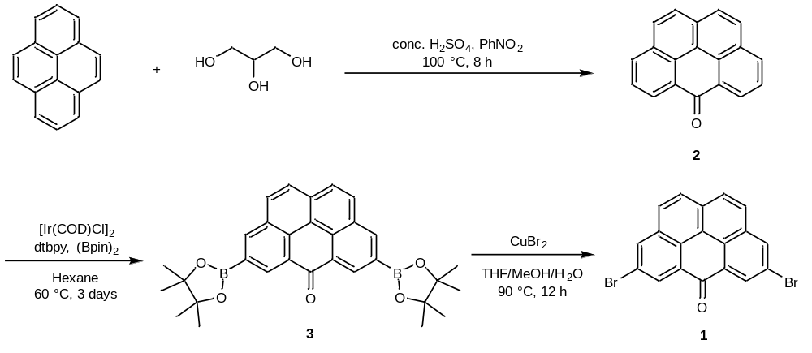
Figure S1. The synthetic route of precursor 1.
6H-benzo[cd]pyren-6-one (2)
Compound 2 was prepared by a simplified method¹. Glycerin (16 ml), water (25 ml) and conc. H₂SO₄ (100 ml) were added to a 500 ml round-bottomed flask. Pyrene (10 g, 49.50 mmol) in hot nitrobenzene (10 ml) was added to the reaction solution and kept at 110 °C for 12 hours. The black tar was poured into ice water and the filtrate was collected, washed with water and dried under reduced pressure. The crude product was extracted with hot toluene (200 ml × 3). The solvent was evaporated with a rotavap to give 2 as a yellow solid (2.6 g, 10.2 mmol, 21 %).
¹H NMR (400 MHz, CDCl₃) δ 8.77 (dd, J = 7.4, 1.3 Hz, 2H), 8.21 (dd, J = 7.9, 1.3 Hz, 2H), 7.97 (d, J = 8.7 Hz, 2H), 7.85 (d, J = 8.7 Hz, 2H), 7.80 (t, J = 7.7 Hz, 2H).
¹³C{¹H} NMR (101 MHz, CDCl₃) δ 184.4, 134.5, 132.0, 131.1, 129.7, 129.2, 128.6, 128.1, 127.0, 126.8, 121.0.
HRMS (ESI) m/z [M]⁺ calc. for C₁₉H₁₁O⁺ 255.0805, found 255.0804.

4,8-bis(4,4,5,5-tetramethyl-1,3,2-dioxaborolan-2-yl)-6H-benzo[cd]pyren-6-one (3)
The synthesis and characterization data of 3 was previously reported in reference². Compound 2 (1.0 g, 3.94 mmol), [Ir(COD)Cl]₂ (134.4 mg, 0.2 mmol, 0.05 eq), dtbpy (107.4 mg, 0.4 mmol, 0.1 eq), and Bpin₂ (6.0 g, 23.6 mmol, 6 eq) were added to a 100 mL reaction tube equipped with a magnetic stirring bar and the mixture was suspended in dry n-hexane (20.0 mL). The mixture was heated at 60 ° for 3 days under N₂ atmosphere. The reaction mixture was cooled to room temperature and the solvent was removed via a rotavap. The residue was purified by column chromatography (SiO₂, PE/DCM = 1:3) and recrystallized with DCM and cyclohexane to obtain pure compound 3 as a yellow solid (350 mg, 0.69 mmol, 18 %).
¹H NMR (400 MHz, CDCl₃) δ 9.28 (d, J = 1.2 Hz, 2H), 8.77 (d, J = 1.2 Hz, 2H), 8.13 (d, J = 8.7 Hz, 2H), 7.98 (d, J = 8.7 Hz, 2H), 1.45 (s, 24H).
¹³C{¹H} NMR (101 MHz, CDCl₃) δ 184.5, 141.6, 135.1, 133.3, 130.6, 130.1, 129.6, 129.3, 127.0, 121.1, 84.5, 25.1.
HRMS (ESI) m/z [M]⁺ calc. for C₃₁H₃₃B₂O₅⁺ 507.2509, found 507.2519.

4,8-dibromo-6H-benzo[cd]pyren-6-one (1)
Compound 3 (253 mg, 0.5 mmol) was dissolved in a mixed solution of THF (10 ml) and methanol (30 ml). CuBr₂ (2.5 g, 11.2 mmol, 22.4 eq) was dissolved in water (30 ml) and added dropwise to the reaction and the resulting mixture was stirred at 90°C for 12 h. After cooling to room temperature, the reaction solution was diluted with water and DCM. The residue was collected by filtration. The crude product was washed with ethanol and cyclohexane to obtain pure product 1 as a yellow solid (213 mg, 0.51 mmol, 100%). Due to the low solubility of 1, a well-resolved ¹³C NMR spectrum cannot be obtained in a reasonable time frame.

¹H NMR (400 MHz, CDCl₃) δ 8.90 (s, 2H), 8.47 (s, 2H), 8.07 – 7.99 (m, 4H).
HRMS (ESI) m/z [M]⁺ calc. for C₁₉H₉Br₂O⁺ 412.8995, found: 412.8990

1.3 NMR and MS data
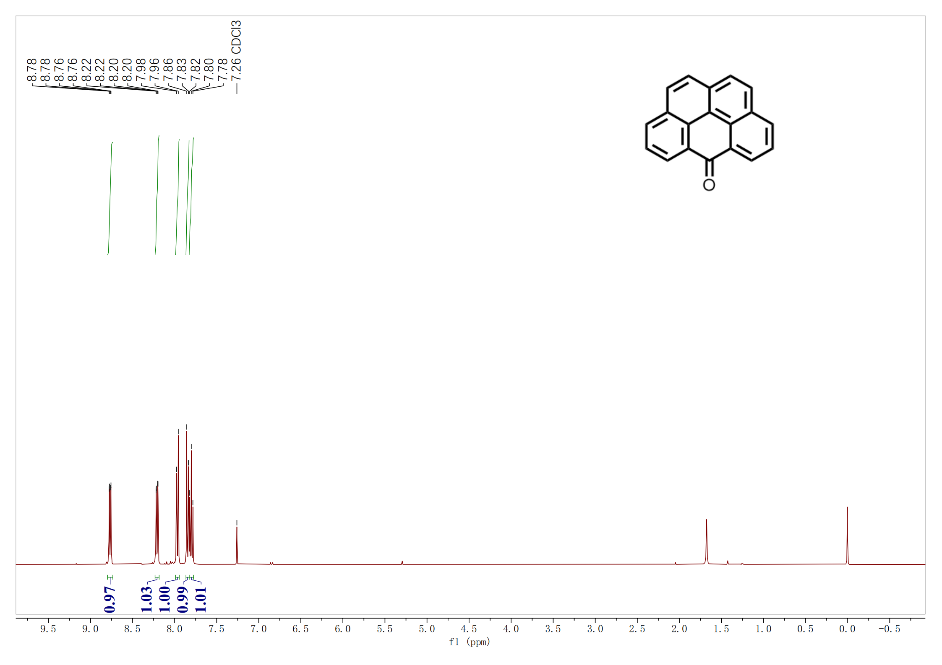
Figure S2. ¹H NMR (400 MHz) of 2 in CDCl₃ at 298 K.

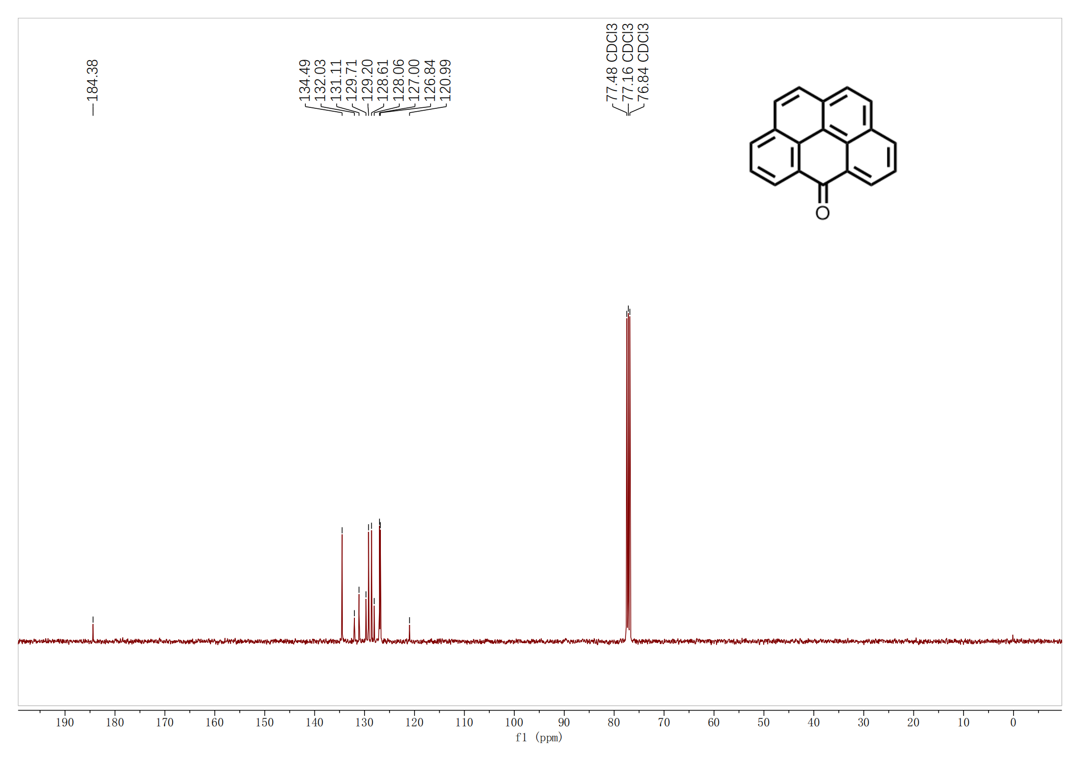
Figure S3. ¹³C{¹H} NMR (101 MHz) of 2 in CDCl₃ at 298 K.
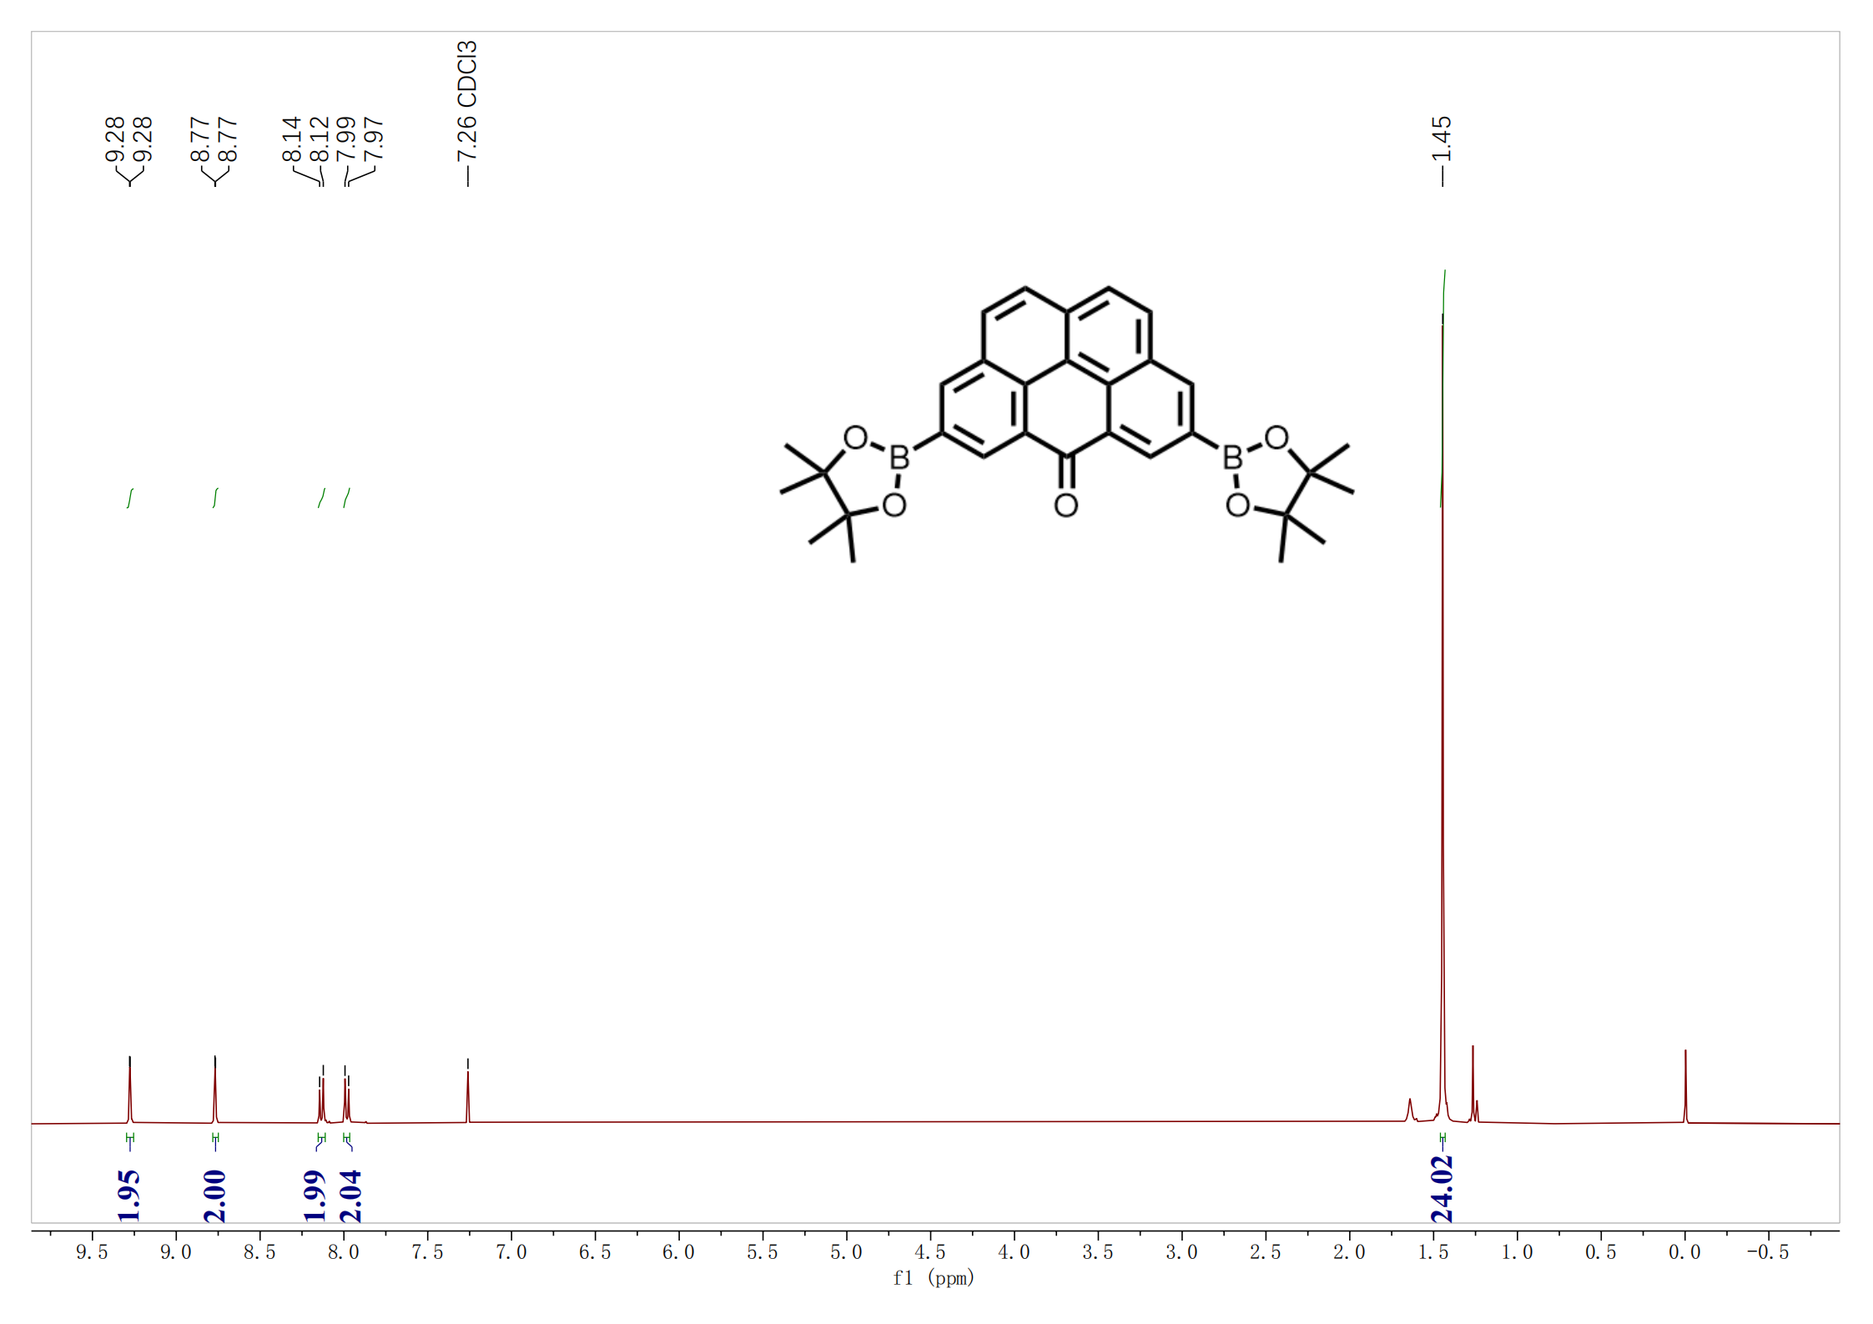
Figure S4. ¹H NMR (400 MHz) of 3 in CDCl₃ at 298 K.

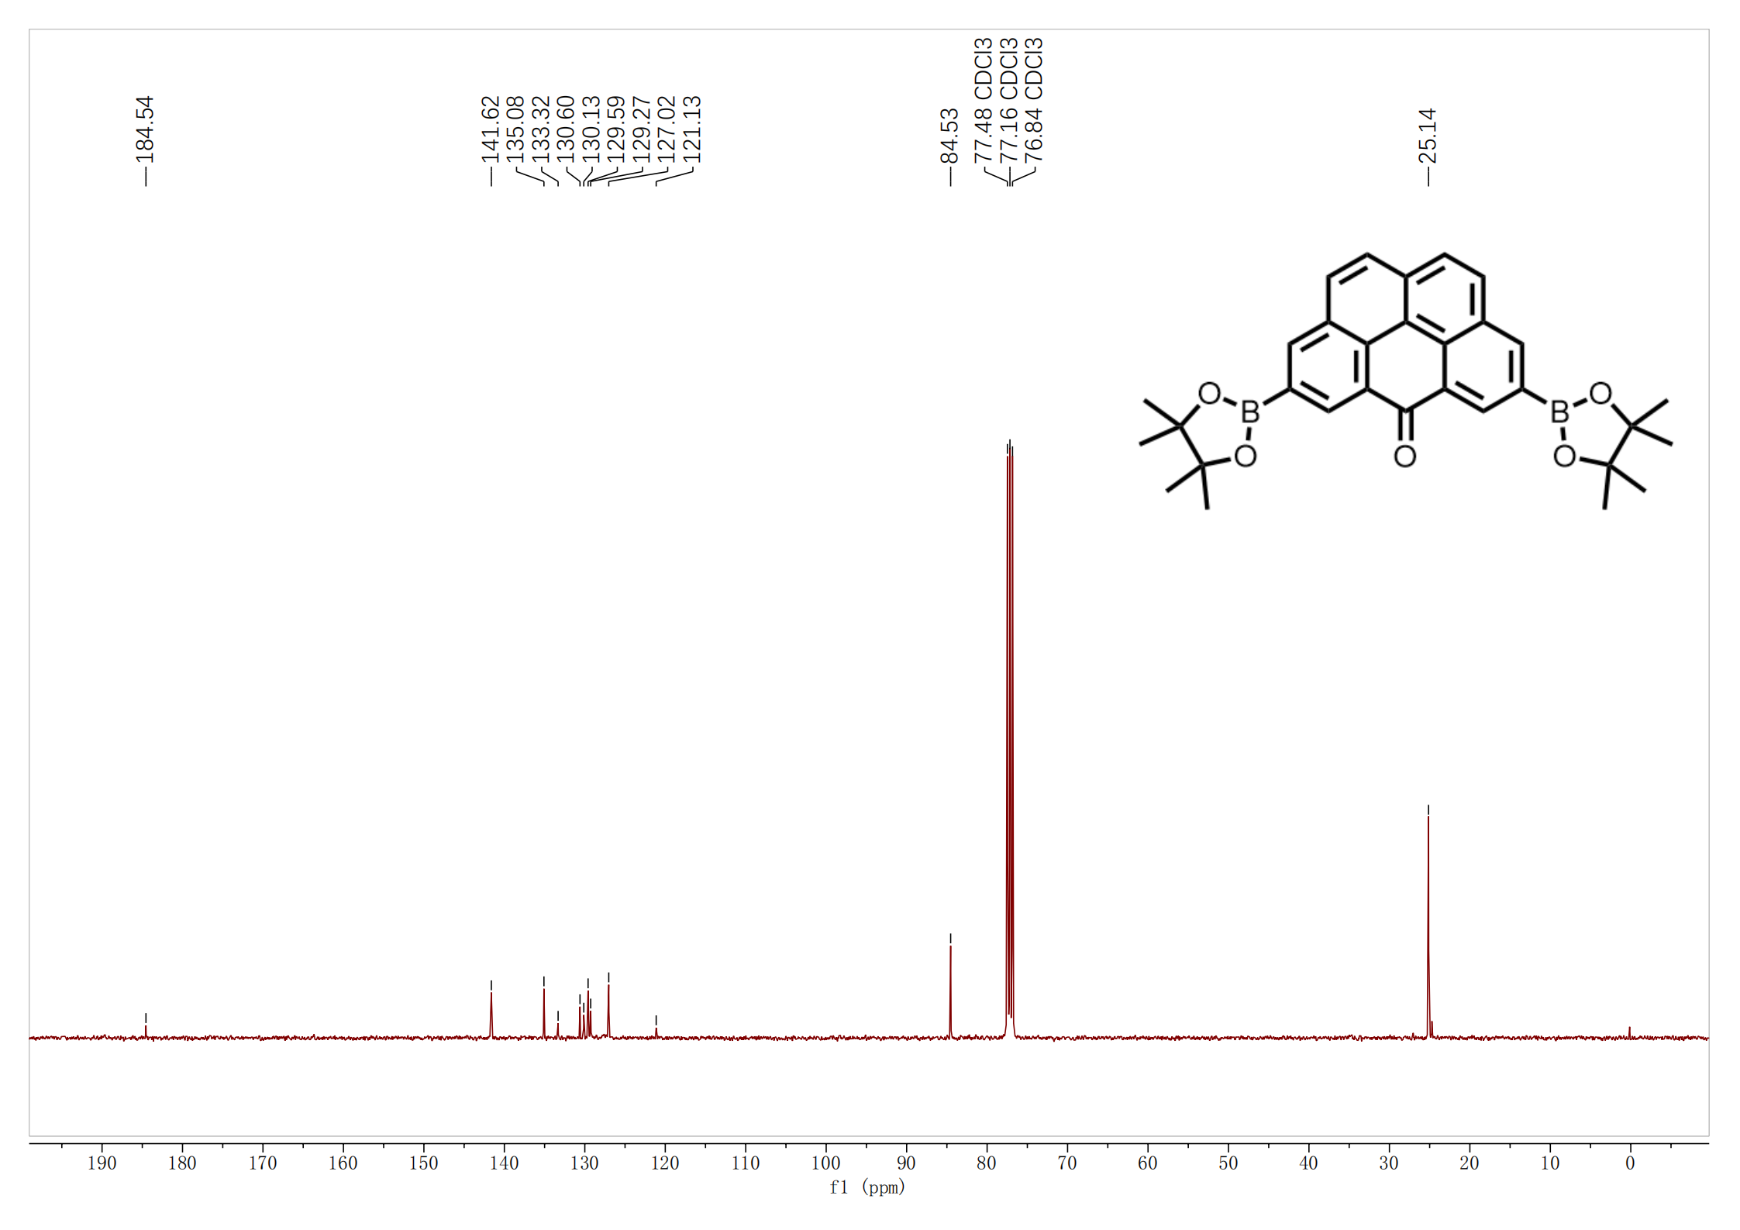
Figure S5. ¹³C{¹H} NMR (101 MHz) of 3 in CDCl₃ at 298 K.
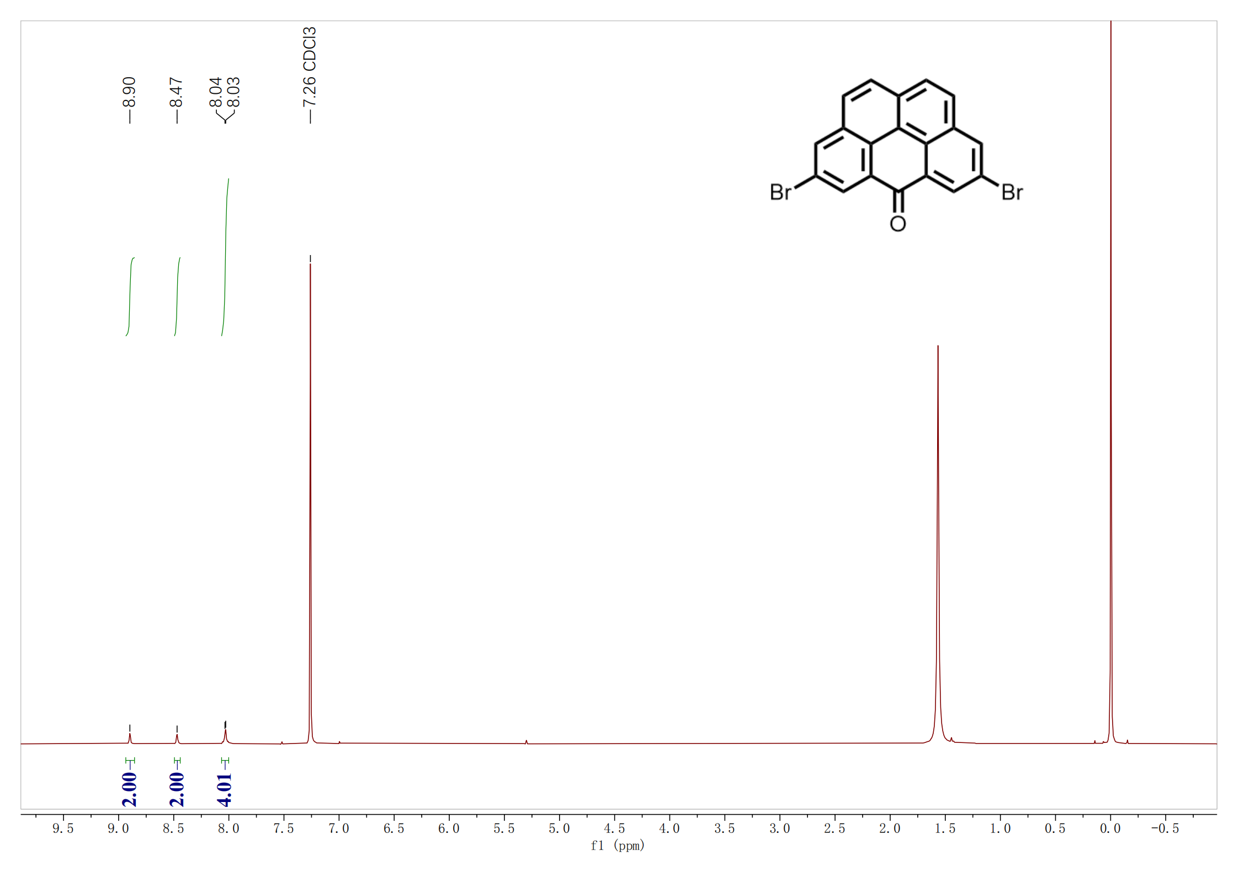
Figure S6. ¹H NMR (400 MHz) of 1 in CDCl₃ at 298 K.

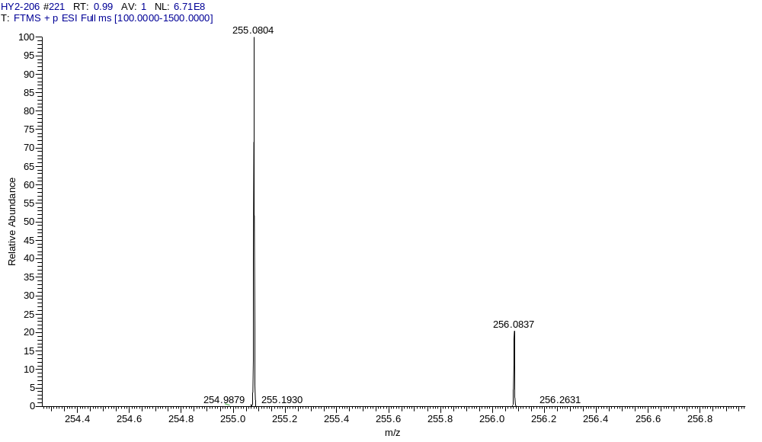
Figure S7. HR-ESI-MS (positive mode) spectrum of 2. Calc. for C₁₉H₁₁O⁺ 255.0805, found 255.0804.

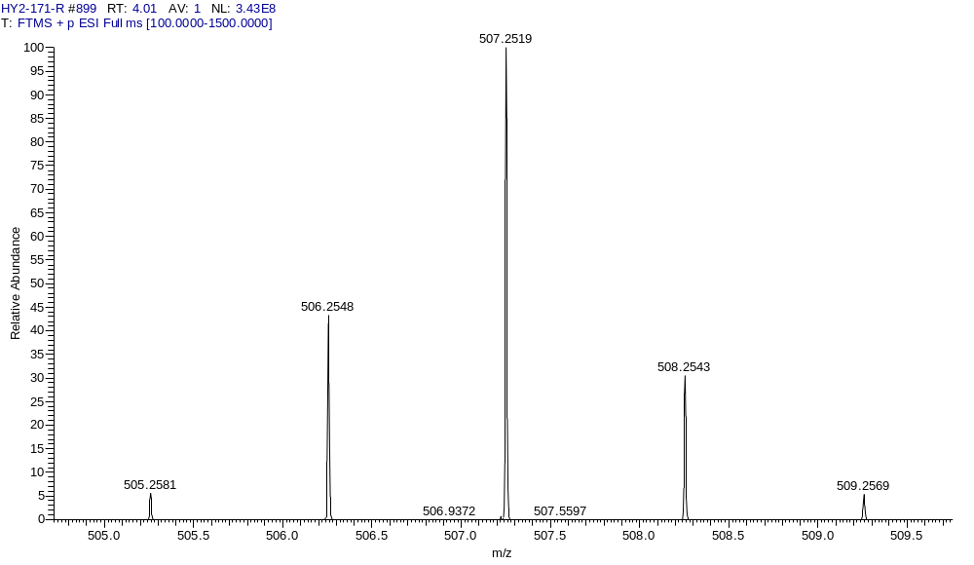
Figure S8. HR-ESI-MS (positive mode) spectrum of 3. Calc. for C₃₁H₃₃B₂O₅⁺ [M]⁺ 507.2509, found 507.2519.

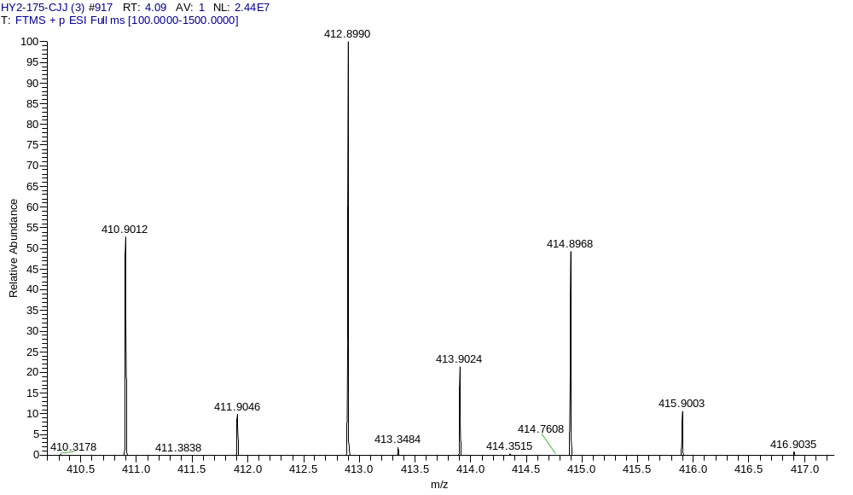
Figure S9. HR-ESI-MS (positive mode) spectrum of 1. Calc. for C₁₉H₉Br₂O⁺ [M]⁺ 412.8995, found: 412.8990.

2 Extended electronic characterization data

2.1 dI/dV spectra on olympicenone
Figure S10. (a) nc-AFM of olympicenone chains. (b) dI/dV spectra measured at red point in (a). Setpoint: V = 100 mV, I = 500 pA, V_{rms} = 2 mV. Scale bars: 1 nm.

2.2 TB and MFH calculation.
Figure S11. (a) TB (left) and MFH (right) energy spectrum of olympicene dimer (t₁ = 2.7 eV). (b) Spin density distribution of olympicene dimer. Red/blue isosurfaces denote spin up/spin down density, respectively

2.3 dI/dV spectra on Trans-/Cis-configuration.
Figure S12. (a) nc-AFM of Tans-/Cis-configuration. (b) dI/dV spectra measured at the positions marked in (a). Setpoint: V = 100 mV, I = 500 pA, V_{rms} = 2 mV. Scale bars: 1 nm.

2.4 Calculated first spin excitation energy of OSCs.
Figure S13. Experimental and calculated first spin excitation energy of OSCs.

2.5 dI/dV spectra on OSCs with the different unit numbers.

Figure S14. The excitation gap of OSCs with unit numbers 8, 9, 10, 12, 14, 16. (a) nc-AFM images of OSCs with the unit numbers 8, 9, 10, 12, 14, 16. Scale bar: 1nm. (b) The dI/dV spectra of OSCs with the unit numbers 8, 9, 10, 12, 14. Setpoint: V = 100 mV, I = 500 pA, V_{rms} = 2 mV.

3 Supplementary References
1 Clar, E. & Mackay, C. C. Circobiphenyl and the attempted synthesis of 1:14, 3:4, 7:8, 10:11-tetrabenzoperopyrene. Tetrahedron 28, 6041-6047 (1972). https://doi.org:10.1016/0040-4020(72)88138-9
2 Xiang, Q. et al. Stable Olympicenyl Radicals and Their pi-Dimers. J Am Chem Soc 142, 11022-11031 (2020). https://doi.org:10.1021/jacs.0c02287

