Supporting Information

New-record efficiency in non-doped ultraviolet OLEDs: Hot-exciton emitters by a crossed long-short axis design boosting EQE up to 8.3% and emission peak close to 380 nm

Jingli Lou, Xuecheng Guo, Han Zhang*, Baoxi Li, Junwei He, Xin He, Yu Huang, Yichao Chen, Dezhi Yang, Dongge Ma, Ben Zhong Tang* and Zhiming Wang*

Scheme S1. Molecular structure and synthetic route of p-Cz.

Scheme S2. Molecular structure and synthetic route of m-Cz.

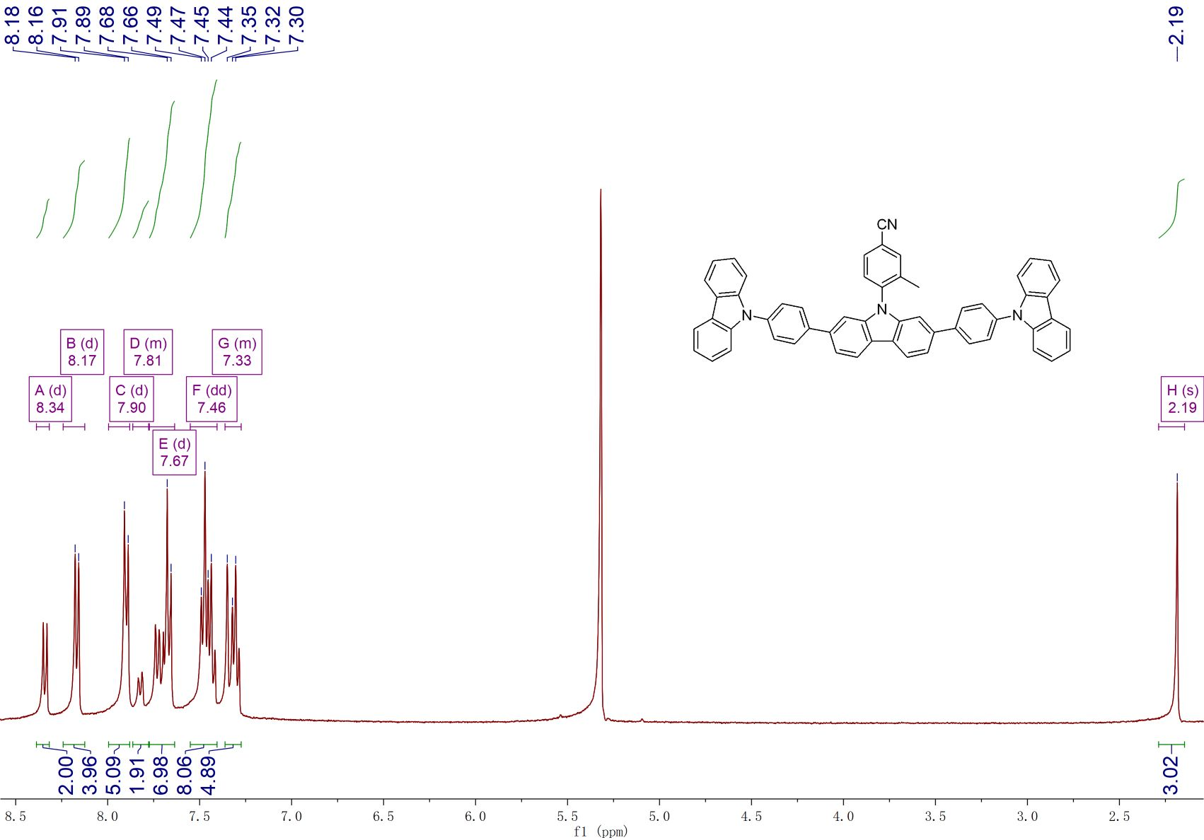
Figure S1. ¹H-NMR spectrum of p-Cz in CD₂Cl₂.

Figure S2. ¹H-NMR spectrum of m-Cz in CD₂Cl₂.

Figure S3. Cyclic voltammograms of p-Cz and m-Cz, measured in DCM/DMF containing 0.1 m tetra-n-butylammonium hexafluorophosphate.

Figure S4. a, c Thermogravimetric analysis and differential scanning calorimetry. b, d Curves of p-Cz and m-Cz.

Figure S5. The S₀ conformations of p-Cz and m-Cz from the top view.

Figure S6. The frontier orbital distributions and NTOs distribution of p-Cz.

Figure S7. The frontier orbital distributions and NTOs distribution of m-Cz.
Figure S8. PL spectra of p-Cz and m-Cz in neat films.

Figure S9. a, b UV-vis absorptions in different solvents with various polarities. c, d Solvatochromic Lippert–Mataga models of p-Cz and m-Cz.

Figure S10. Device configuration, EL spectra, external quantum efficiency-luminance curves of and current density-voltage-luminance curves of doped OLEDs based on p-Cz and m-Cz.

Figure S11. Comparison of the maximum external quantum efficiency (EQE_{max}) values of the doped UV OLEDs with EL peak wavelengths < 400 nm.

Figure S12. The EQE-luminance curves of the OLEDs based on p-Cz and m-Cz.

Figure S13. Current density-luminance curves of non-doped devices of p-Cz and m-Cz.

Figure S14. Transient EL data fitted with the TTA model of the non-doped device based on p-Cz (insert: the ratio of the delayed component at 4.4 V).

Figure S15. Stability test of the p-Cz-based devices at 25 °C in nitrogen. The p-Cz-based doped and non-doped OLEDs exhibit an LT₅₀ (time to 50% of the initial current density) of 0.1 and 249.3 hours at an initial current density of 10 mA m⁻².

Table S1. Energy levels and SOC of singlet and triplet states of p-Cz.
n= | 1 | 2 | 3 | 4 | 5
S_{n} /eV | 3.389 | 3.936 | 4.014 | 4.224 | 4.388
T_{n} /eV | 2.531 | 3.143 | 3.429 | 3.712 | 3.729
(〈S₁ĤSOT_{n}〉) /cm-¹ | 0.114 | 0.042 | 0.159 | 0.020 | 0.028

Table S2. Energy levels and SOC of singlet and triplet states of m-Cz.
n= | 1 | 2 | 3 | 4 | 5
S_{n} /eV | 3.612 | 3.940 | 4.106 | 4.118 | 4.356
T_{n} /eV | 2.574 | 3.345 | 3.445 | 3.727 | 3.766
(〈S₁ĤSOT_{n}〉) /cm-¹ | 0.142 | 0.082 | 0.177 | 0.014 | 0.014

Table S3. Absorption and emission peak positions of p-Cz in different solvents.
Solvents | ε | n | f (ε,n) | λ_{a} (nm) | λ_{f} (nm) | ν_{a}-ν_{f} (cm⁻¹)
Hexane | 1.90 | 1.375 | 0.001 | 342 | 383 | 3130
Triethylamine | 2.42 | 1.401 | 0.048 | 342 | 385 | 3266
Butyl ether | 3.08 | 1.399 | 0.096 | 342 | 386 | 3333
Isopropyl ether | 3.88 | 1.368 | 0.145 | 342 | 385 | 3266
Ethyl ether | 4.34 | 1.352 | 0.167 | 342 | 385 | 3266
Tetrahydrofuran | 7.58 | 1.407 | 0.210 | 343 | 388 | 3381
Dichloromethane | 8.93 | 1.424 | 0.217 | 344 | 392 | 3560
Dimethyl formamide | 37.00 | 1.427 | 0.276 | 345 | 407 | 4415
Acetone | 20.70 | 1.359 | 0.284 | 343 | 389 | 3448
Acetonitrile | 37.50 | 1.344 | 0.305 | 343 | 403 | 4341
ε is the solvent dielectric constant and n is the solvent refractive index; f (ε, n) is the orientational polarizability of solvents; ν_{a}-ν_{f} is the Stokes shift.

Table S4. Absorption and emission peak positions of m-Cz in different solvents.
Solvents | ε | n | f (ε,n) | λ_{a} (nm) | λ_{f} (nm) | ν_{a}-ν_{f} (cm⁻¹)
Hexane | 1.90 | 1.375 | 0.001 | 324 | 387 | 5024
Triethylamine | 2.42 | 1.401 | 0.048 | 325 | 389 | 5062
Butyl ether | 3.08 | 1.399 | 0.096 | 325 | 390 | 5128
Isopropyl ether | 3.88 | 1.368 | 0.145 | 324 | 389 | 5157
Ethyl ether | 4.34 | 1.352 | 0.167 | 325 | 395 | 5453
Tetrahydrofuran | 7.58 | 1.407 | 0.210 | 326 | 394 | 5294
Dichloromethane | 8.93 | 1.424 | 0.217 | 326 | 393 | 5230
Dimethyl formamide | 37.00 | 1.427 | 0.276 | 328 | 399 | 5425
Acetone | 20.70 | 1.359 | 0.284 | 326 | 395 | 5358
Acetonitrile | 37.50 | 1.344 | 0.305 | 326 | 395 | 5358
ε is the solvent dielectric constant and n is the solvent refractive index; f (ε, n) is the orientational polarizability of solvents; ν_{a}-ν_{f} is the Stokes shift.

Table S5. EQE_{max}-λ_{max} summary data of doped UV (λ_{max}≤ 400 nm) OLEDs.
Emitter | λ_{max} (nm) | EQE_{max} (%) | Reference
m-Cz | 382 | 10.6 | this work
p-Cz | 391 | 8.8 | this work
mCzPI | 376/395 | 3.8 | ref. 2
mMCzPI | 376/393 | 3.0 | ref. 2
DSiPPI | 377 | 7.1 | ref. 3
CzP2PO | 379 | 8.0 | ref. 4
CSiTPI | 382 | 5.2 | ref. 5
tBCzP2PO | 384 | 15.1 | ref. 4
C2MPI | 388 | 2.0 | ref. 6
oCzPI | 388 | 3.0 | ref. 2
POPCN-2CP | 388 | 5.7 | ref. 7
ICZ-TAZ | 388 | 3.3 | ref. 8
f-Ir(pmb)₃ | 389 | 2.6 | ref. 9
MTPC-Me | 389 | 1.2 | ref. 10
CZ-MPS | 389 | 9.3 | ref. 11
3,6-mPPICNC3 | 391 | 7.9 | ref. 12
3b | 392 | 2.4 | ref. 13
VDMP-PhCz | 392 | 7.4 | ref. 14
C2FLA-1 | 392 | 3.5 | ref. 15
BO-bPh | 394 | 11.3 | ref. 16
Purine 2 | 394 | 1.6 | ref. 17
4P-Cz | 394 | 7.0 | ref. 18
m-Ir(pmb)₃ | 395 | 5.8 | ref. 9
PIPP | 395 | 4.4 | ref. 19
3a | 396 | 2.8 | ref. 13
DSiTPI | 396 | 7.4 | ref. 5
DPPP | 396 | 2.2 | ref. 20
CTPPI | 396 | 7.9 | ref. 21
2BuCz-CNCz | 396 | 10.8 | ref. 22
POPCN-2CP | 396 | 7.9 | ref. 7
DCz-pPy | 397 | 3.6 | ref. 23
CDFDB | 398 | 12.0 | ref. 24
B-2OCz | 399 | 7.4 | ref. 25

Table S6. EQE_{max}-λ_{max} summary data of non-doped UV (λ_{max}≤ 400 nm) OLEDs.
Emitter | λ_{max} (nm) | EQE_{max} (%) | Reference
m-Cz | 382 | 8.3 | this work
SSS | 373 | 3.1 | ref. 26
PBD | 376 | 4.1 | ref. 27
TAZ | 377 | 4.6 | ref. 28
Tol-PPI | 378 | 3.3 | ref. 29
2SBFN | 382 | 2.2 | ref. 30
1SBFN | 385 | 2.9 | ref. 30
BSBFB | 388 | 1.6 | ref. 30
OXD-7 | 388 | 1.4 | ref. 31
MTPC-Me | 389 | 1.2 | ref. 10
CBP | 390 | 1.3 | ref. 32
B2 | 392 | 3.6 | ref. 33
Tol-PPI | 392 | 5.4 | ref. 29
Tol-PPI | 393 | 4.3 | ref. 29
1 | 394 | 2.1 | ref. 34
TSBFB | 395 | 2.1 | ref. 30
PDHFSCHD | 395 | 0.1 | ref. 35
TB2 | 396 | 2.7 | ref. 33
VDMP-PhCz | 396 | 4.5 | ref. 14
DPPP | 396 | 2.2 | ref. 20
DCz-pPy | 397 | 3.6 | ref. 23
2Na-CzCN | 398 | 5.9 | ref. 36
cis-trans-TGW1 | 386 | 4.2 | ref. 37
BB4Ph | 400 | 5.2 | ref. 18

Table S7. The ratio of delay components of the non-doped device based on p-Cz obtained through fitting under different voltages.
Voltage (V) | delay% (%)
4.4 | 1.6
4.6 | 0.7
5.0 | 0.5
6.0 | 0.6
7.0 | 0.7
8.0 | 0.5

Table S8. The ratio of delay components of the non-doped device based on m-Cz obtained through fitting under different voltages.
Voltage (V) | delay% (%)
5.0 | 2.0
6.0 | 1.3
7.0 | 1.2
8.0 | 0.5
References
[1] Lu, T., Chen, F. Multiwfn: a multifunctional wavefunction analyzer. J. Comput. Chem. 33, 580 (2011).
[2] Zhong, Z. et al. Weak-conjugation linked donor-acceptor emitters for efficient near-ultraviolet organic light-emitting diodes with narrowed full width at half maximum. J. Mater. Chem. C 11, 16271 (2023).
[3] Zheng, Y. et al. Bipolar arylsilane: synthesis, photoelectronic properties, and high-performance deep blue organic light-emitting diodes. ACS Appl. Electron. Mater. 3, 422 (2021).
[4] Ma, P. et al. High-efficiency ultraviolet electroluminescence from multi-resonance phosphine oxide polycyclic aromatics. Angew. Chem. Int. Ed. 63, e202316479 (2023).
[5] Zheng, Y. et al. Bipolar molecules with hybridized local and charge-transfer state for highly efficient deep-blue organic light-emitting diodes with EQE of 7.4% and CIE_{y} ∼ 0.05. Adv. Opt. Mater. 9, 2100965 (2021).
[6] Zhong, Z. et al. Highly twisted bipolar molecules for efficient near-ultraviolet organic light-emitting diodes via a hybridized local and charge-transfer mechanism. J. Mater. Chem. C 11, 1733 (2023).
[7] Chen, J. et al. Robust luminescent molecules with high-level reverse intersystem crossing for efficient near ultraviolet organic light-emitting diodes. Angew. Chem. Int. Ed. 61, e202116810 (2022).
[8] He, X. et al. An ultraviolet fluorophore with narrowed emission via coplanar molecular strategy. Angew. Chem. Int. Ed. 61, e202209425 (2022).
[9] Holmes, R. J. et al. Saturated deep blue organic electrophosphorescence using a fluorine-free emitter. J. Appl. Phys. Lett. 87, 243507 (2005).
[10] Xiang, H.-F. et al. Star-configured carbazole as an efficient near-ultraviolet emitter and hole-transporting material for organic light-emitting devices. Appl. Phys. Lett. 92, 073305 (2008).
[11] Luo, Y. et al. An ultraviolet thermally activated delayed fluorescence OLED with total external quantum efficiency over 9%. Adv. Mater. 32, e2001248 (2020).
[12] Qi, H. et al. A record-high EQE of 7.65%@3300 cd m^{‒2} achieved in non-doped near-ultraviolet OLEDs based on novel D’-D-A type bipolar fluorophores upon molecular configuration engineering. Chem. Sci (2024).
[13] Joseph, V., Thomas, K. R. J., Sahoo, S., Singh, M., Jou, J.-H. Asymmetrically 2,7-difunctionalized carbazole-based donor-acceptor hybrids for deep blue electroluminescence applications. Opt. Mater. 108, 110159 (2020).
[14] Chen, T. et al. Achieving efficient near-ultraviolet/deep-blue OLEDs and sensitized narrowband green/yellow OLEDs utilizing emitters with planarized intramolecular charge transfer. Adv. Opt. Mater. 11, 2301053 (2023).
[15] Jou, J.-H. et al. Highly efficient ultra-deep blue organic light-emitting diodes with a wet- and dry-process feasible cyanofluorene acetylene based emitter. J. Mater. Chem. C 3, 2182 (2015).
[16] Li, G. et al. High-performance ultraviolet organic light-emitting diodes enabled by double boron-oxygen-embedded benzo[m]tetraphene emitters. J. Am. Chem. Soc. 146, 1667 (2024).
[17] Yang, Y. et al. Ultraviolet-violet electroluminescence from highly fluorescent purines. J. Mater. Chem. C 1, 2867 (2013).
[18] Lee, J. H. et al. Classic fluorophores with a horizontal alignment for enhancing light outcoupling efficiency (≈30%) and external quantum efficiency (≈7%) of near ultraviolet (λ_{max} < 400 nm) organic light-emitting diodes. Adv. Opt. Mater. 11, 2202666 (2023).
[19] Nayak, S. R. et al. Molecular modulation by σ conjugated spacer enables efficient ultraviolet/deep-blue emissive organic light-emitting diodes. J. Phys. Chem. C 127, 3849 (2023).
[20] Wang, Z.-Q. et al. Efficient violet non-doped organic light-emitting device based on a pyrene derivative with novel molecular structure. Org. Electron. 23, 179 (2015).
[21] Zhong, Z. et al. High steric-hindrance windmill-type molecules for efficient ultraviolet to pure-blue organic light-emitting diodes via hybridized local and charge-transfer excited-state. Adv. Funct. Mater. 32, 2112969 (2022).
[22] Zhang, H. et al. High-performance ultraviolet organic light-emitting diode enabled by high-lying reverse intersystem crossing. Angew. Chem. Int. Ed. Engl. 60, 22241 (2021).
[23] Huo, Y. et al. Structurally regulated carbazole-pyridine derivatives based on space-crowded theory for efficient narrowband ultraviolet nondoped organic light-emitting diodes from the high-lying reverse intersystem crossing process. ACS Appl. Mater. Interfaces 14, 57092 (2022).
[24] Zhang, K. et al. Boosting external quantum efficiency to 12.0 % of an ultraviolet OLED by engineering the horizontal dipole orientation of a hot exciton emitter. Angew. Chem. Int. Ed. e202407502 (2024).
[25] Park, J. et al. A design strategy for multiple resonance-induced pure violet thermally activated delayed fluorescence emitters with a narrow emission band. Adv. Opt. Mater. 2301626 (2023).
[26] Wong, K.-T., Liao, Y.-L., Lin, Y.-T., Su, H.-C., Wu, C.-C. Spiro-configured bifluorenes: highly efficient emitter for UV organic light-emitting device and host material for red electrophosphorescence. Org. Lett. 7, 5132 (2005).
[27] Song, C., Zhang, N., Lin, J., Guo, X., Liu, X. Sb₂O₃/Ag/Sb₂O₃ multilayer transparent conducting films for ultraviolet organic light-emitting Ddiode. Sci. Rep. 7, 41250 (2017).
[28] Zhang, X. et al. Exceeding 4% external quantum efficiency in ultraviolet organic light-emitting diode using PEDOT:PSS/MoO_{x} double-stacked hole injection layer. Appl. Phys. Lett. 110, 043301 (2017).
[29] Lin, J., Guo, X., Lv, Y., Liu, X., Wang, Y. Highly efficient microcavity organic light-emitting devices with narrow-band pure UV emission. ACS Appl Mater Interfaces 12, 10717 (2020).
[30] Etori, H., Jin, X. L., Yasuda, T., Mataka, S., Tsutsui, T. Spirobifluorene derivatives for ultraviolet organic light-emitting diodes. Synth. Met. 156, 1090 (2006).
[31] Zhang, Q., Zhang, X., Wei, B. Highly efficient ultraviolet organic light-emitting diodes and interface study using impedance spectroscopy. Optik 126, 1595 (2015).
[32] Zou, L., Savvate’ev, V., Booher, J., Kim, C. H., Shinar, J. Combinatorial fabrication and studies of intense efficient ultraviolet-violet organic light-emitting device arrays. Appl. Phys. Lett. 79, 2282 (2001).
[33] Chao, T.-C. et al. Highly efficient UV organic llight-emitting devices based on bi(9,9-diarylfluorene)s Adv. Mater. 17, 992 (2005).
[34] Niu, F., Niu, H., Liu, Y., Lian, J., Zeng, P. Synthesis, characterization and application of starburst 9-alkyl-1,3,6,8-tetraaryl-carbazole derivatives for blue-violet to UV OLEDs. RSC Adv. 1, 415 (2011).
[35] Lu, P. et al. A wide-bandgap semiconducting polymer for ultraviolet and blue light emitting diodes. Macromol. Chem. Phys. 204, 2274 (2003).
[36] Li, G. et al. Efficient ultraviolet organic light-emitting diodes with a CIE_{y} of 0.04 and negligible-efficiency roll-off. ACS Appl. Mater. Interfaces 14, 10627 (2022).
[37] Wei, Y. et al. C-H-activated Csp²-Csp³ diastereoselective gridization enables ultraviolet-emitting stereo-molecular nanohydrocarbons with mulitple H···H interactions. Nat. Commun. 15, 5438 (2024).

