Table 8 ANOVA Results for State Policy and Composite Scores for CHW Roles, Skills, & Qualities
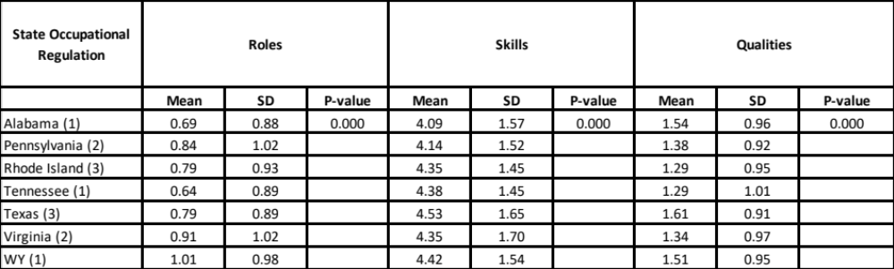

Table 9 ANOVA Results for State Policy Type and CHW Roles, Skills, & Qualities
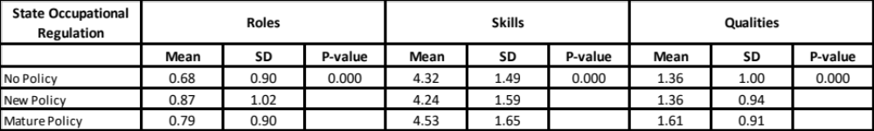

Table 10 Chi-square Results for Roles
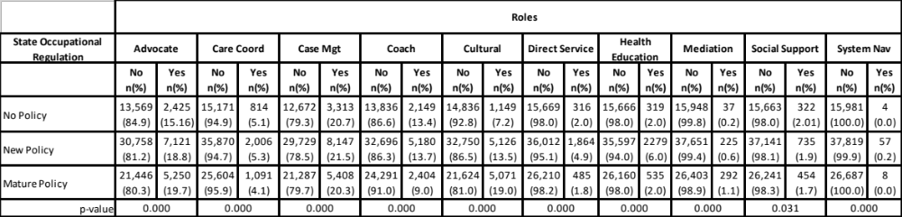
Table 11 Chi-square Results for Skills
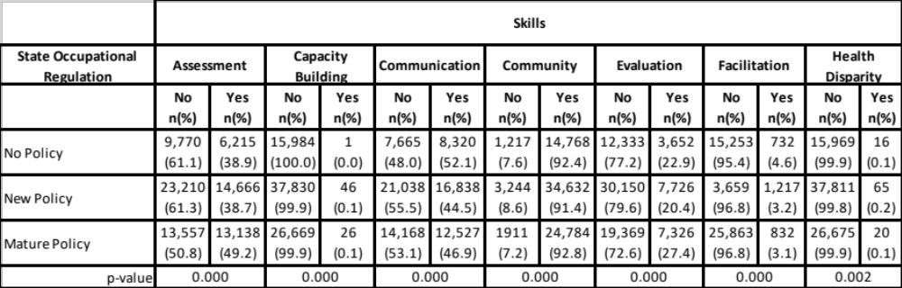
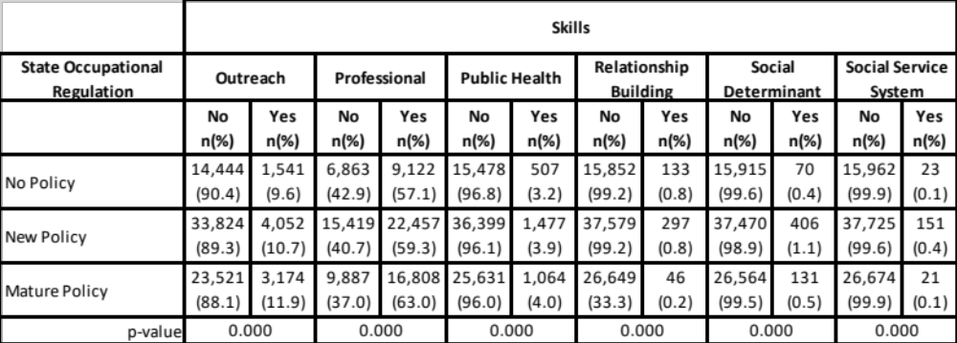
Table 12 Chi-square Results for Qualities

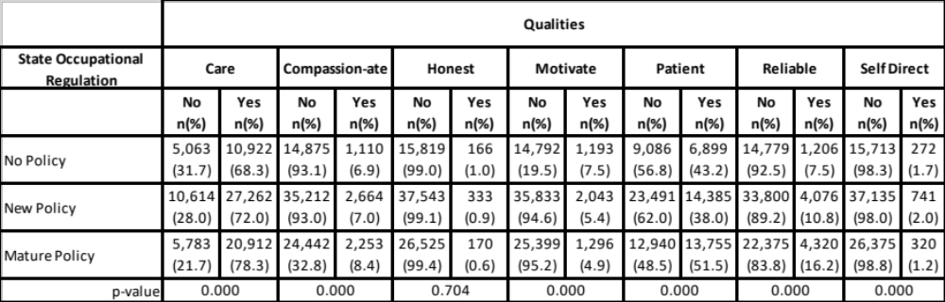
Table 13 ANOVA Results for Employer Type and CHW Roles, Skills, and Qualities in No Policy States
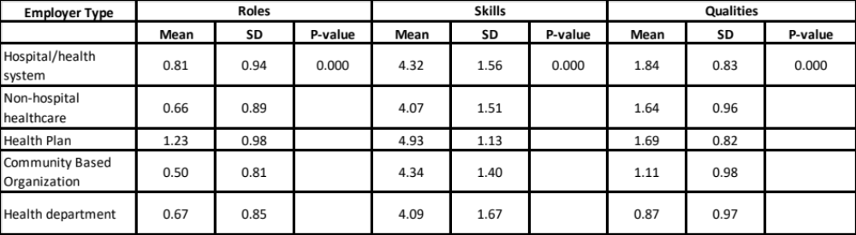
Table 14 ANOVA Results for Employer Type and CHW Roles, Skills, and Qualities in New Policy States
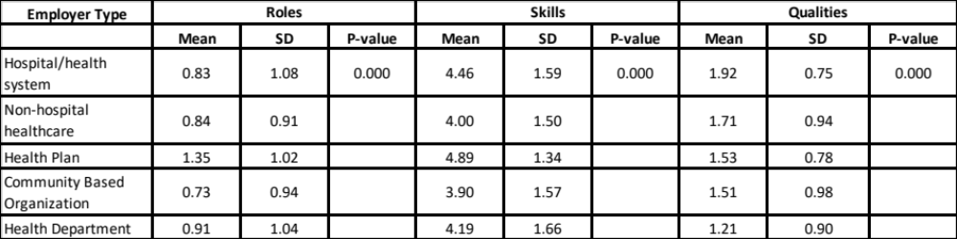
Table 15 ANOVA Results for Employer Type and CHW Roles, Skills, and Qualities in Mature Policy States
