  - Radiation Induced Electrochemistry Suppression Probed by Spatially Resolved Operando X-Ray Diffraction
  - Erlend Tiberg North, Casper Skautvedt, Abilash Kanish Thiagarajan, Marco Di Michiel, Stefano Checchia, Alexey Y. Koposov and David S. Wragg

Supplementary information
Table of Contents
1.1 Data processing. 1
1.2 Dosage Estimation 2
2. Supporting Figures 3

1.1 Data processing.
The synchrotron XRD data (line scan results and operando XRD patterns) were radially integrated using PyFAI¹ to give 1D diffraction patterns which were fitted using TOPAS v7² in the Q-range 1.6 Å to 2.9 Å⁻¹ where the (002) reflection for graphite and the (111) reflection for LiF are observed. The total weight percent of the phases present were calculated for all the scans. For the operando XRD each pattern in the surface refinement was fitted with a 3-term Chebyshev polynomial and a 1/x term for the background; scale factor, c-axis parameter, Gaussian and Lorentzian size broadening parameters for graphite; and a-axis, scale and Lorentzian size broadening parameters for LiF. For the line scans each pattern in the surface refinement was fitted with a 3-term Chebyshev polynomial and a 1/x term for the background; scale factor, c-axis and Gaussian size broadening parameters for graphite/LiC₃₀/LiC₆; and a-axis, scale and Lorentzian size broadening parameters for LiF. Rwp vs time (operando) and position (line scan) are shown in figures S6 and S7. Examples of the fit at various stages and positions are shown in figure S8.

1.2 Dosage Estimation
Table S1. Parameters of beam and sample utilized for dosage calculation. Flux is estimated from scaling of picoamperemeter current.
Energy | 95 keV = 1.52∙10⁻¹⁴ J
Flux | 1.94∙10¹² ph/s
Energy from beam | 0.02953 J/s
Irradiated mass | 9.15∙10⁻¹⁰ kg
Irradiated volume | 8.1∙10⁻⁷ cm⁻³
Dose (excl. absorption) | 3.226∙10⁷ Gy/s =  32.26 MGy/s

$$Irradiated mass of graphite=V_{region} \left(cm^{3}\right) ⋅density \left(g/cm^{3}\right)⋅{10}^{-3}$$
$$Exposed region=30 μm⋅18 μm⋅1500 μm ⋅{10}^{-12} cm^{3}/μm$$
$$ρ≈2.26 g/cm^{3}⋅50\% packing fractoin$$
Irradiated mass:$9.153⋅{10}^{-10} kg$
$$Dose=\frac{Energy from beam}{Irradiated mass of sample}$$

2. Supporting Figures
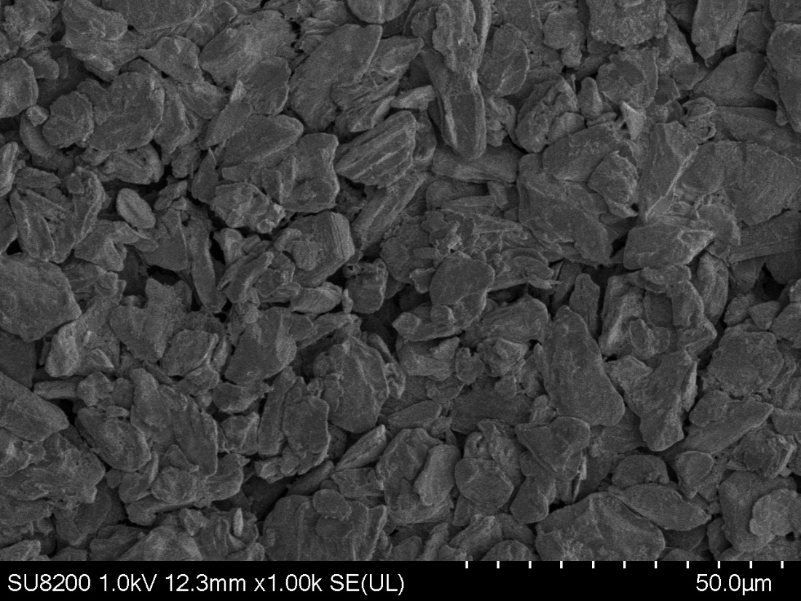

Figure S1. SEM micrograph of the graphite-based electrode.

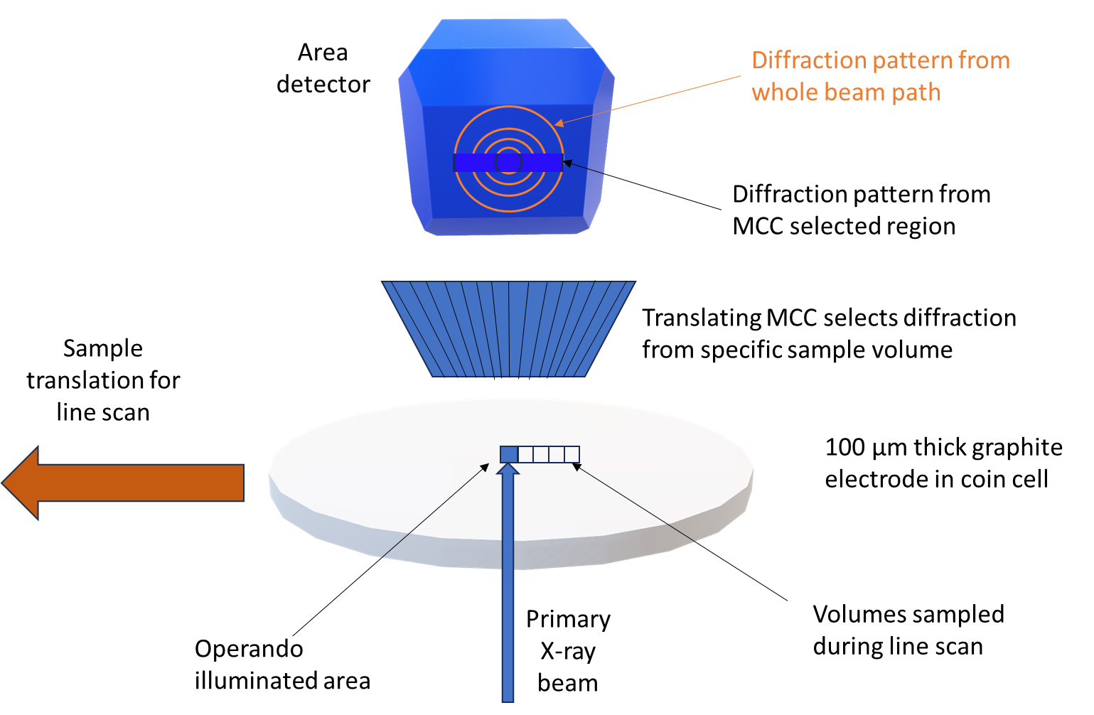
Figure S2 Sketch of the setup for operando diffraction and line scans using the multi-channel collimator. Outside the area of the detector covered by the MCC we see scattering from all the coin cell components the beam passes through, but in the strip covered by the MCC we only see the diffraction pattern from the selected volume inside the electrode (blue square). Some of the additional volumes probed in the line scan after the operando experiment are shown as white squares.

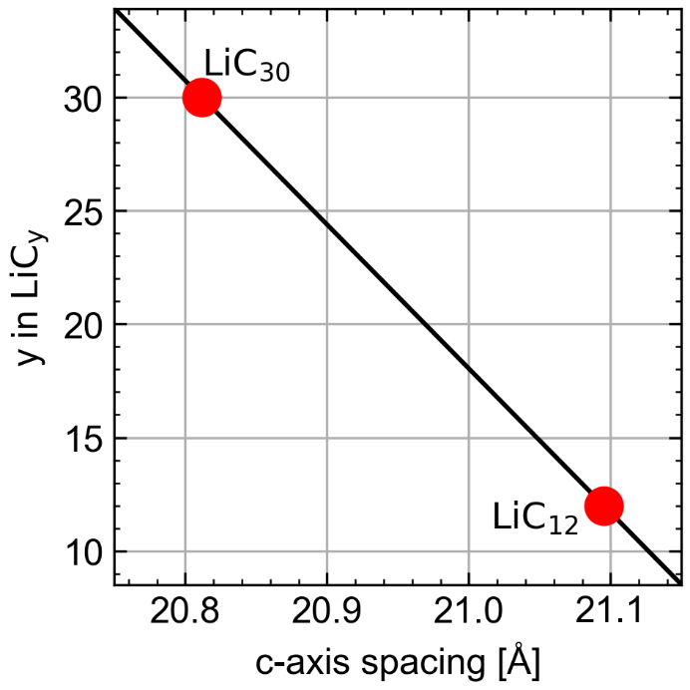
Figure S3. Linear estimation of phase fraction for mixed lithiation of graphite from refined c-axis length.
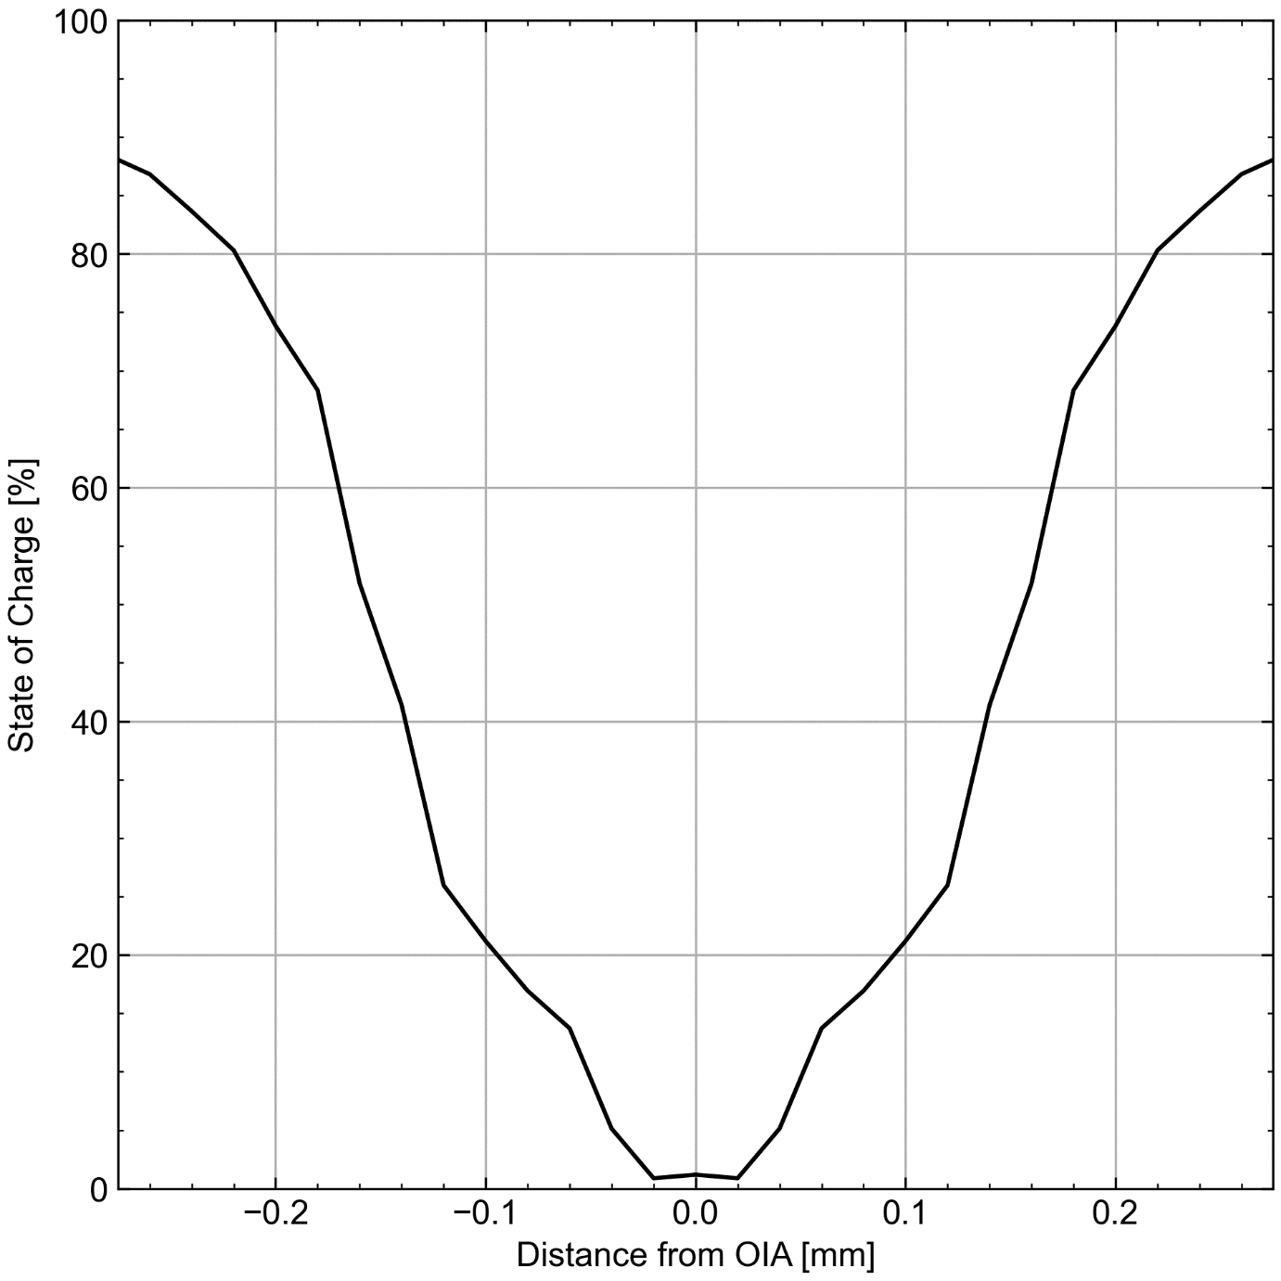
Figure S4. State of Charge (SOC) as a function of measurement position.

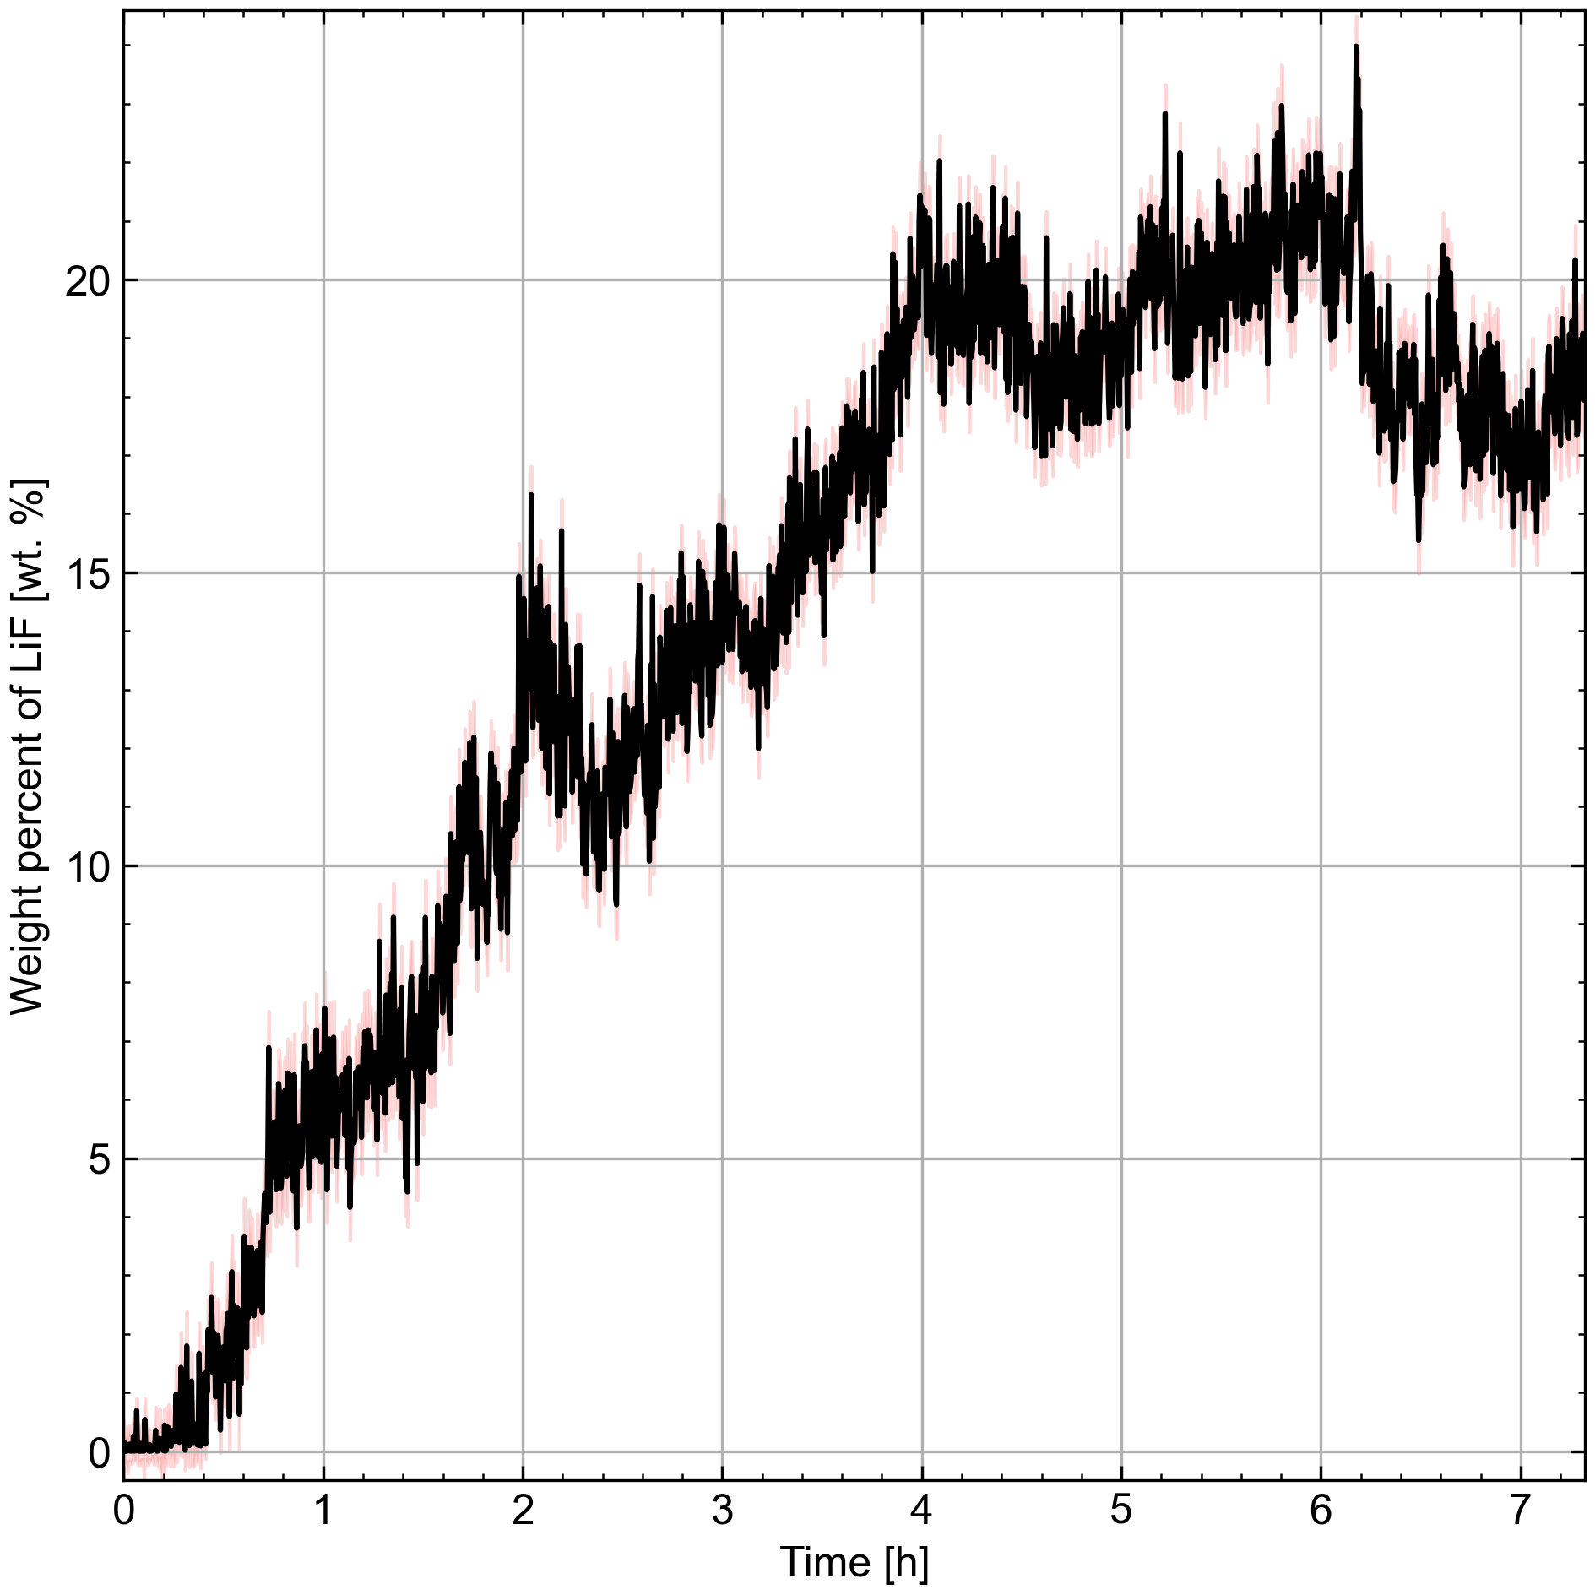
Figure S5. Time evolution of LiF phase fraction from Rietveld refinement of operando XRD data collected during lithiation of graphite in a half cell vs lithium metal. The range of estimated standard deviations is shown in pink.
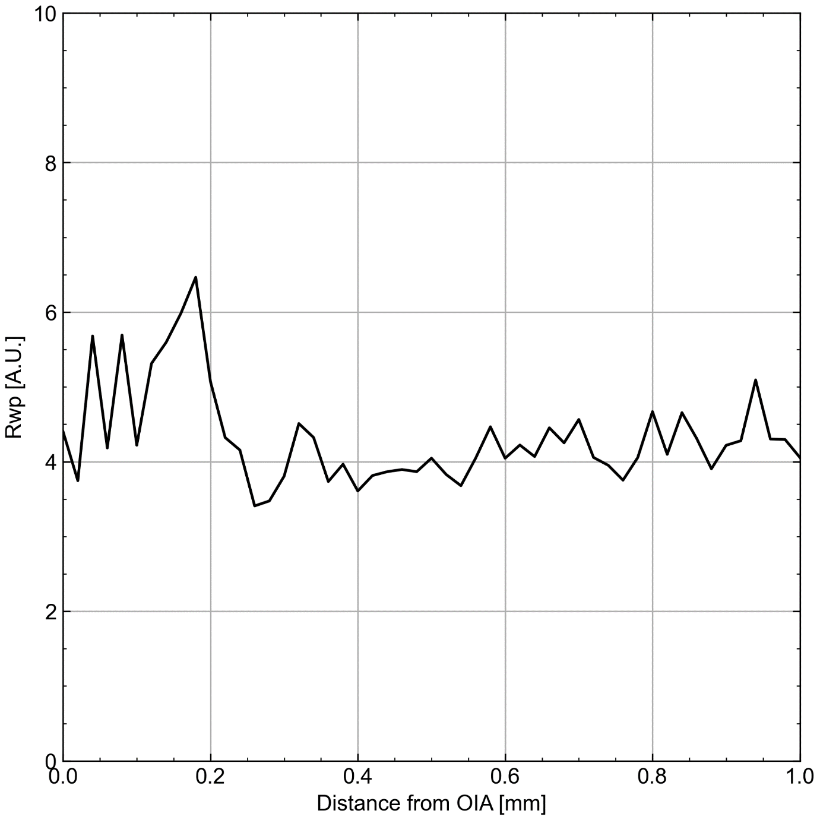
Figure S6. Rwp as a function of measurement position.
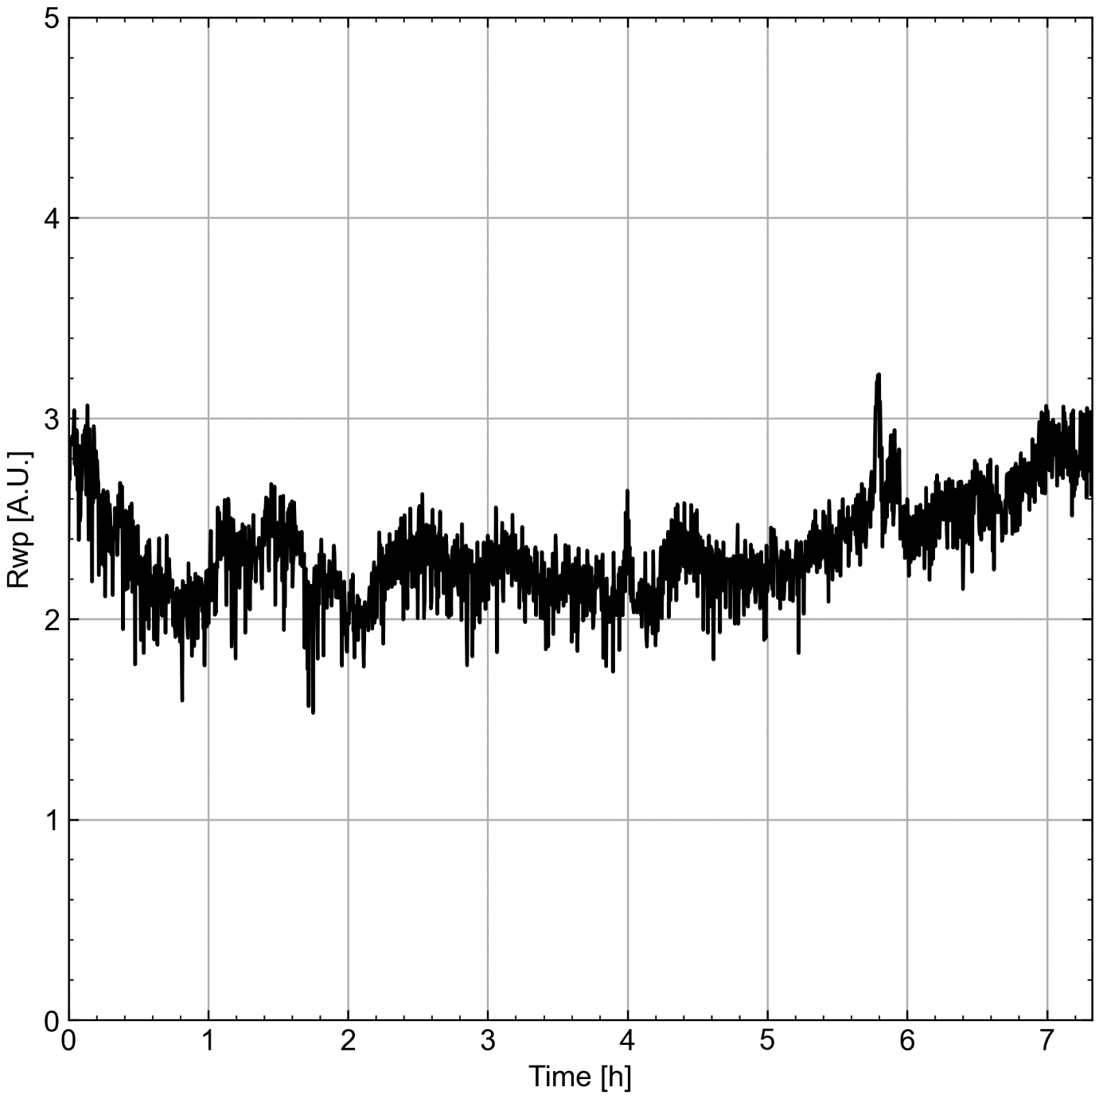
Figure S7. Rwp as a function of time during direct beam operando data collection.

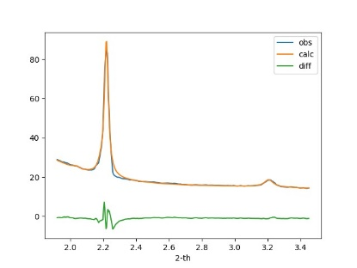 | 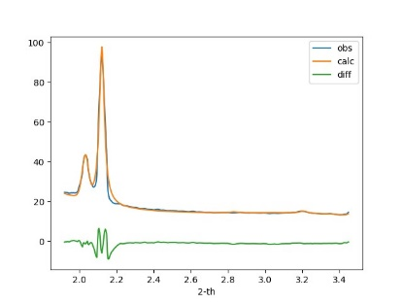 | 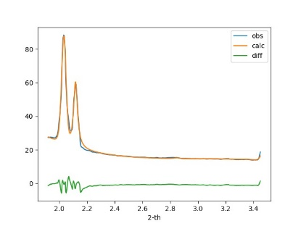
OIA (0 mm) | 0.2 mm | 0.3 mm
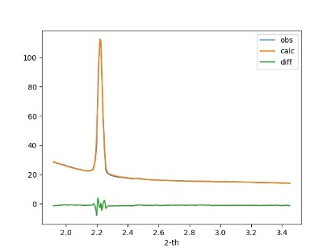 | 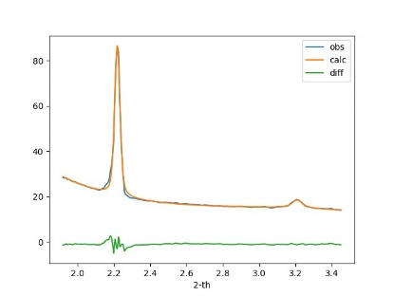
Time = 0 | Time = 7 hours
Figure S8 Rietveld fit plots for exemplary points in the line scan (top) and operando run (bottom).

References
1 Kieffer, J. & Karkoulis, D. PyFAI, a versatile library for azimuthal regrouping. Journal of Physics: Conference Series 425, 202012 (2013). https://doi.org/10.1088/1742-6596/425/20/202012
2 Coelho, A. TOPAS and TOPAS-Academic: an optimization program integrating computer algebra and crystallographic objects written in C++. Journal of Applied Crystallography 51, 210-218 (2018). https://doi.org/doi:10.1107/S1600576718000183

