Table S1: Fluid resuscitation volume in the sBRS and NS groups
 | Sodium bicarbonate ringer's solution  (n=32) | Normal saline  (n=35) | P value
Total liquid volume in the first 3 h (ml) | 1058.1±348.1 | 987.7±450.0 | 0.479
The volume of sodium bicarbonate ringer's solution (ml) | 662.5±231.1 | 0 | <0.001
The volume of normal saline (ml) | 209.8±134.8 | 889.9±430.4 | <0.001
Total liquid volume in the first 24 h (ml) | 3671.3±874.8 | 3440.8±1056.0 | 0.337
The volume of sodium bicarbonate ringer's solution (ml) | 1600.0±491.2 | 0 | <0.001
The volume of normal saline (ml) | 1000.3±523.7 | 2948.0±989.7 | <0.001
The volume of human serum albumin (g) | 25.0±11.0 | 26.8±9.6 | 0.572

Table S2: Incidence of adverse events in the sBRS and NS groups
 | Sodium bicarbonate ringer's solution  (n=32) | Normal saline  (n=35) | P value
Hypernatremia, n (%) | 5 (15.6%) | 12 (34.3%) | 0.080
Hyperchloremia, n (%) | 6 (18.9%) | 18 (51.4%) | 0.005
Alkalosis, n (%) | 10 (31.3%) | 8 (22.9%) | 0.439

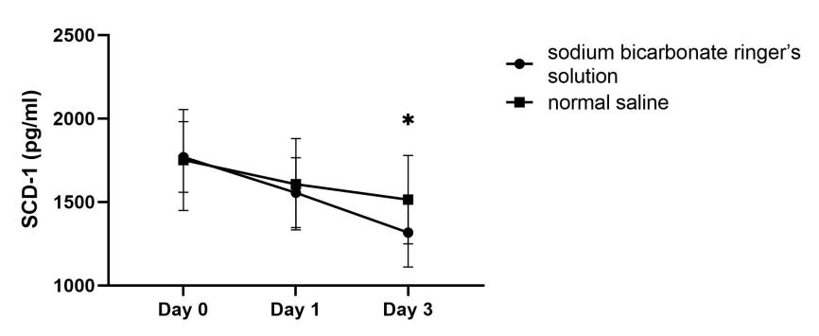
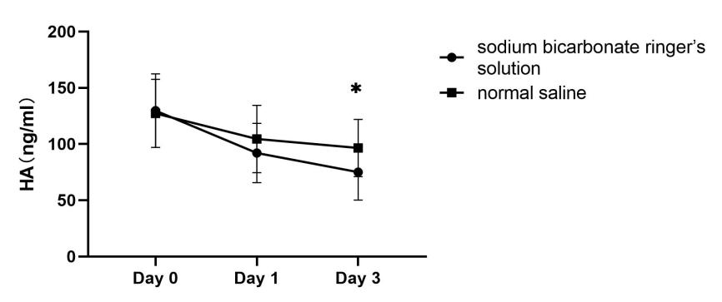
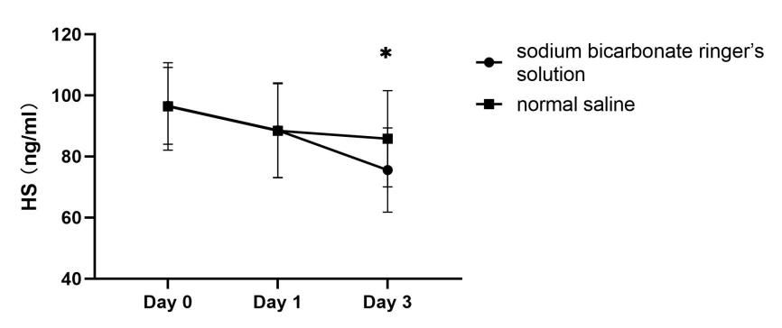
Figure S1: Effect of sBRS or NS on the endothelial glycocalyx
Abbreviations: SCD-1 = Syndecan-1; HA = Hyaluronan; and HS = Heparan Sulfate.

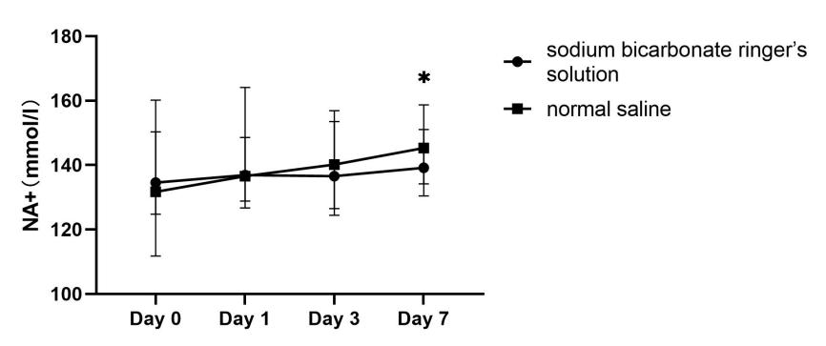
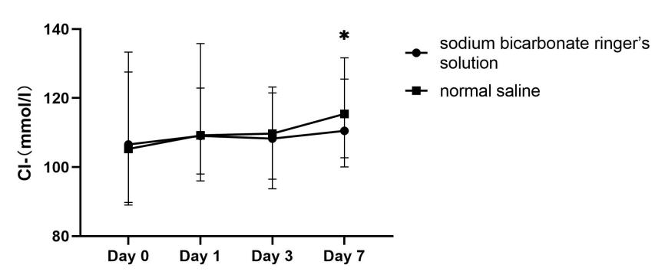
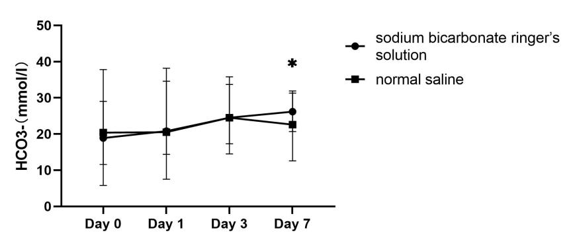
Figure S2: Electrolyte changes in the sBRS and NS groups
Abbreviations: Na⁺ = Sodium ion; Cl⁻ = Chloride ion; and HCO3⁻ = Bicarbonate

