Table S1. The description of different parameters that were analyzed in the present study using the Catwalk XT system.

Parameters | Description
Run_ Average_ Speed | Speed of the animal’s body in the recorded run
Body Speed | Speed is calculated by dividing the distance that  the animal’s body traveled from one initial  contact of one paw to the next by the time to  travel that distance
Mean Intensity | The mean intensity of the complete paw
Coupling_ LF -> RH | The temporal relationship between the placement  of two paws within a step cycle.

Table S2: Effect of KG diet on body weight in experimental groups.
Groups | Body weight (g)
 | 0 h | 24 h | 48 h | 72 h
Sham | 26.54±0.46 | 27.36±0.51 | 27.66±0.57 | 27.34±0.54
pMCAO | 28.12±0.47  (+5.97%) | 27.35±0.52  (-1.41%) | 27.51±0.56  (-2.16%) | 27.34±0.61  (-1.15%)
KG+pMCAO | 30.87±0.47  (+9.76%) | 29.88±0.54  (+11.37%) | 29.87±0.61  (+10.43%) | 29.87±0.61  (+10.53%)
KG | 30.94±0.48 | 30.96±0.56 | 31.02±0.60 | 31.04±0.51

The body weight changes were recorded in all experimental groups at different time intervals before, 24 hours, 48 hours, and 72 hours after stroke. Values are expressed as mean ± SEM (n=6-9).

Figure-S1
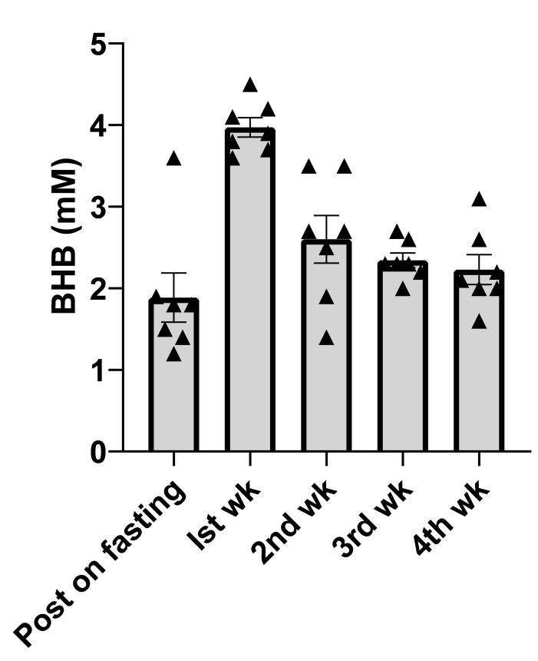
A.

B.
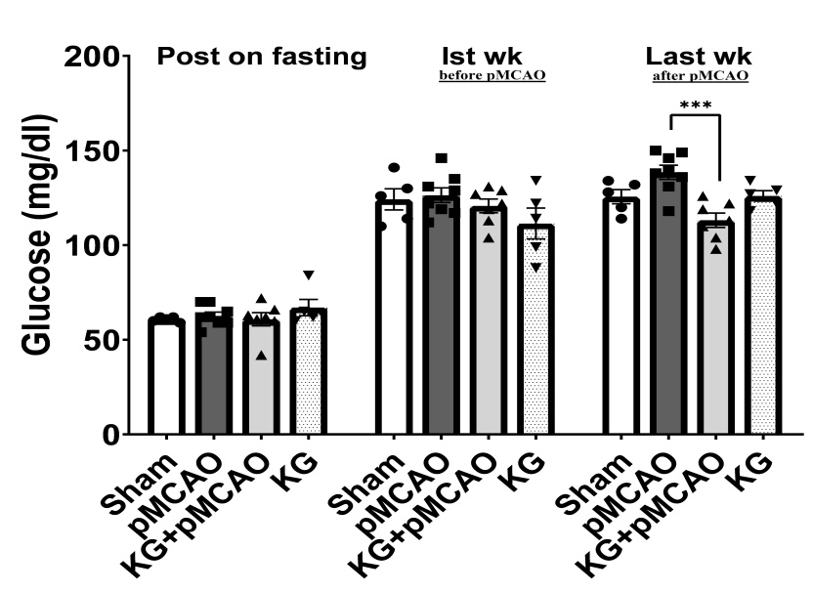

Figure 1S. A. Blood ketones (BHB) in mice fed with the KG diet were measured with Precision Xtra® hand-held keto-monitor. The blood ketone levels in KG-fed mice spiked in the first week and stabilized in the following weeks. B. Blood glucose levels were measured using Precision Xtra® handheld glucometer. Results showed that glucose levels were elevated in the pMCAO compared to the KG+pMCAO mice. The values were presented as the mean ± S.E.M. (n=8-9). *** Denotes statistical significance (p<0.001).

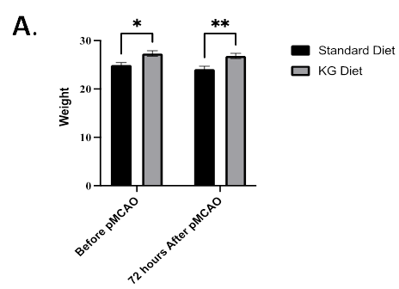
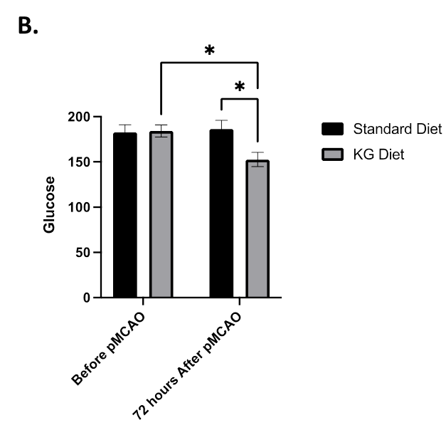

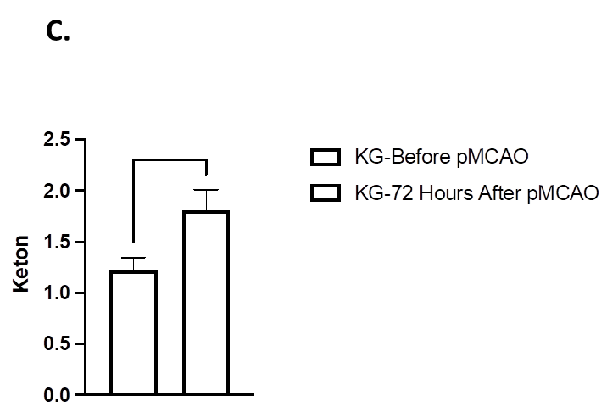

Figure 2S: Effect of genetic manipulation of NLRP3 on the metabolic panel following PMCAO. NLRP3 knock-out mice showed significant restoration of body weight in KG group animals (Figure 2S A). After KG supplementation, body weight was significantly reserved following pMCAO at 72 hrs. We also observed significant changes in body weight before pMCAO in KG-supplemented animals compared to the STD group. Blood ketone level was found to be non-significant in KG group mice compared to STD after 72 hrs (Figure 2S B). Interestingly, the KG diet did not change fasting blood glucose levels (data not shown) before PMCAO in KG group animals. At the same time, blood glucose concentration was significantly lower in the KG group compared to the STD group after 72 hrs (Figure 2S C).

Full uncropped Gels and Blots image
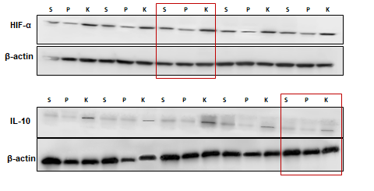

Figure 3S. Effect of KG diet in pMCAO mice. The KG diet modulated HIF-1α, which was associated with high expression of IL-10 in the KG+pMCAO group. The relative intensity of the targeted protein bands was normalized to the β-actin. HIF-1α, Hypoxia-Inducible Factor-1 alpha; interleukin-10, IL-10. S, sham; P, STD diet + photothrombotic stroke (pMCAO group); K, KG diet + photothrombotic stroke (KG+pMCAO). (n=5).
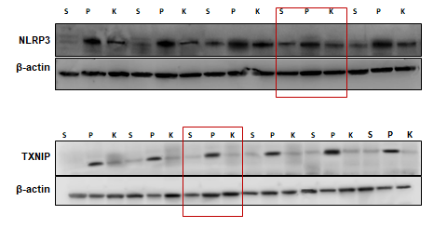

Figure 4S. KG diet downregulated the expression of NLRP3/TXNIP axis in pMCAO mice. The relative intensity of the targeted protein bands was normalized to the β-actin. NLRP3, NOD-like receptor pyrin domain-containing-3; TXNIP, Thioredoxin-interacting protein. S, sham; P, STD diet + photothrombotic stroke (pMCAO group); K, KG diet + photothrombotic stroke (KG+pMCAO). (n= 5-6)
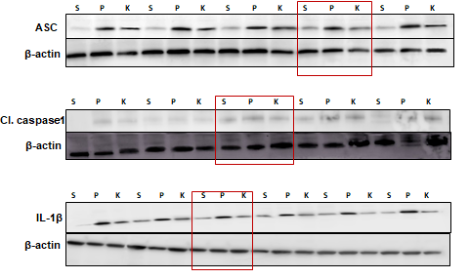

Figure 5S. KG diet modulated NLRP3 inflammasome-associated proteins in pMCAO mice. The relative intensity of the targeted protein bands was normalized to the β-actin. ASC, apoptosis-associated speck-like protein; Cl-caspase-1, cleaved caspase-1; IL-1β, interleukin-1β. The relative intensity of the targeted protein bands was normalized to the β-actin. S, sham; P, STD diet + photothrombotic stroke (pMCAO group); K, KG diet + photothrombotic stroke (KG+pMCAO). (n= 5-6).
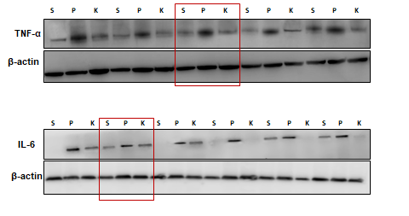

Figure 6S. KG diet preconditioning significantly downregulated the pro-inflammatory cytokines in pMCAO mice. The relative intensity of the targeted protein bands was normalized to the β-actin. TNF-α, tumor necrosis factor alpha; IL-6, interleukin-6. S, sham; P, STD diet + photothrombotic stroke (pMCAO group); K, KG diet + photothrombotic stroke (KG+pMCAO). (n= 5-6).

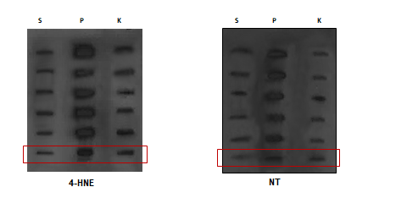
Figure 7S. KG diet attenuates oxidative stress in pMCAO mice. (A) Representative immunoblot indicates the relative intensity of 4-HNE and NT expression levels in the penumbra brain tissue lysate. The relative intensity of the targeted protein bands was normalized to ponceau staining. NT, Nitrotyrosine; 4-HNE, 4-hydroxynonenal. S, sham; P, STD diet + photothrombotic stroke (pMCAO group); K, KG diet + photothrombotic stroke (KG+pMCAO). (n= 6).

