Supplementary Data
 | WADDAICA |  | Rational
Pocket | A1 | A2 | A1 | A2
Substrate ID | NFAI64 | NFAI64 | NF49 | NF30
Water | 24789 | 24790 | 24791 | 24793
Ions | 160 | 160 | 160 | 160
DNA | 759 | 759 | 759 | 759
Protein | 9308 | 9308 | 9308 | 9308
Drug | 28 | 28 | 21 | 26
Total Atoms | 35044 | 35045 | 35039 | 35046

Supplementary Table 1: Molecular simulation system information for different top lead molecules used in this study. Each structure was simulated thrice for 10 ns, totaling 120 ns of simulation time.

Compound | Chain | Mean RMSD (Å) | Std Dev (Å)
Control | p50 | 2.803 | 0.521
Control | p65 | 1.737 | 0.246
NFAI64 (A1) | p50 | 1.90 | 0.198
NFAI64 (A1) | p65 | 2.135 | 0.443
NF49 (A1) | p50 | 2.503 | 0.333
NF49 (A1) | p65 | 1.937 | 0.227
NFAI64 (A2) | p50 | 2.322 | 0.313
NFAI64 (A2) | p65 | 1.791 | 0.218
NF30 (A2) | p50 | 2.849 | 0.391
NF30 (A2) | p65 | 2.302 | 0.262

Supplementary Table 2: Average Root mean square deviation (RMSD) of NF-kB domains over complete course of simulations (3 x 10ns).

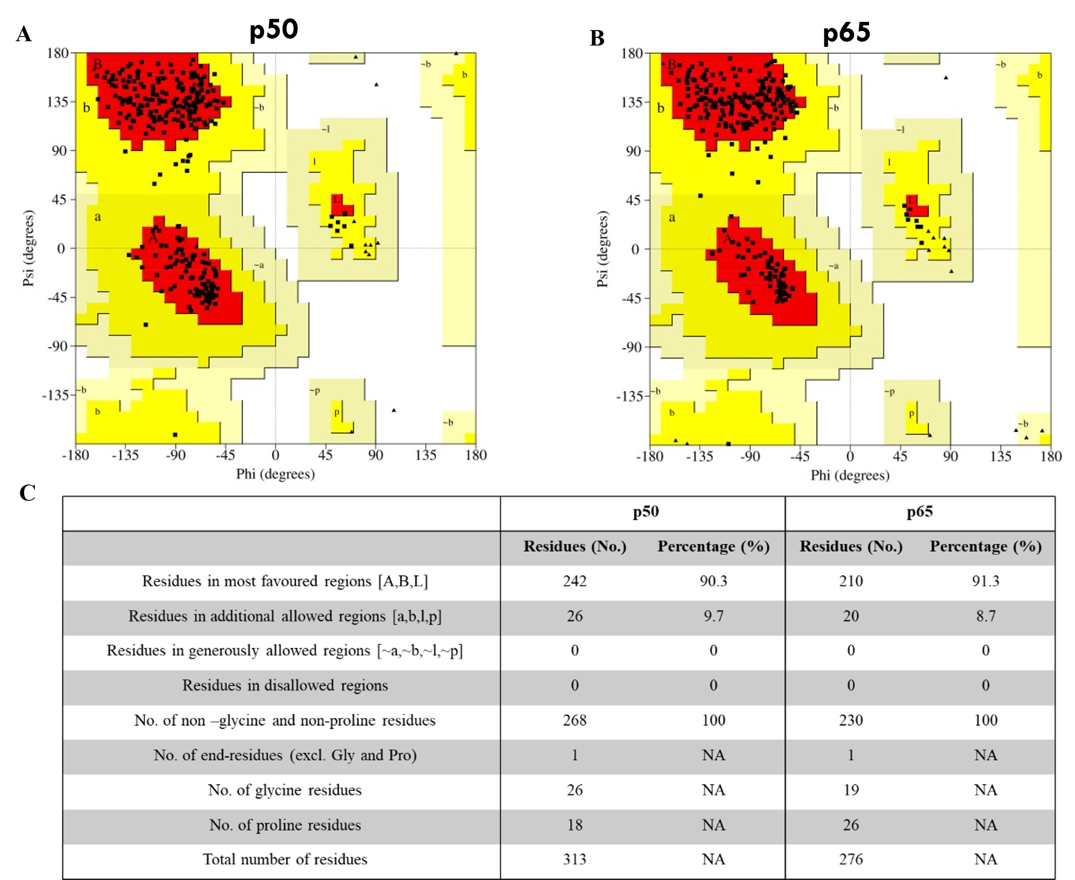
Supplementary Figure S1: The Ramachandran plot for assessment of the overall quality of the p50 and p65 model, indicating up to 90% of the amino acids in the most favored region of Ramachandran plot.

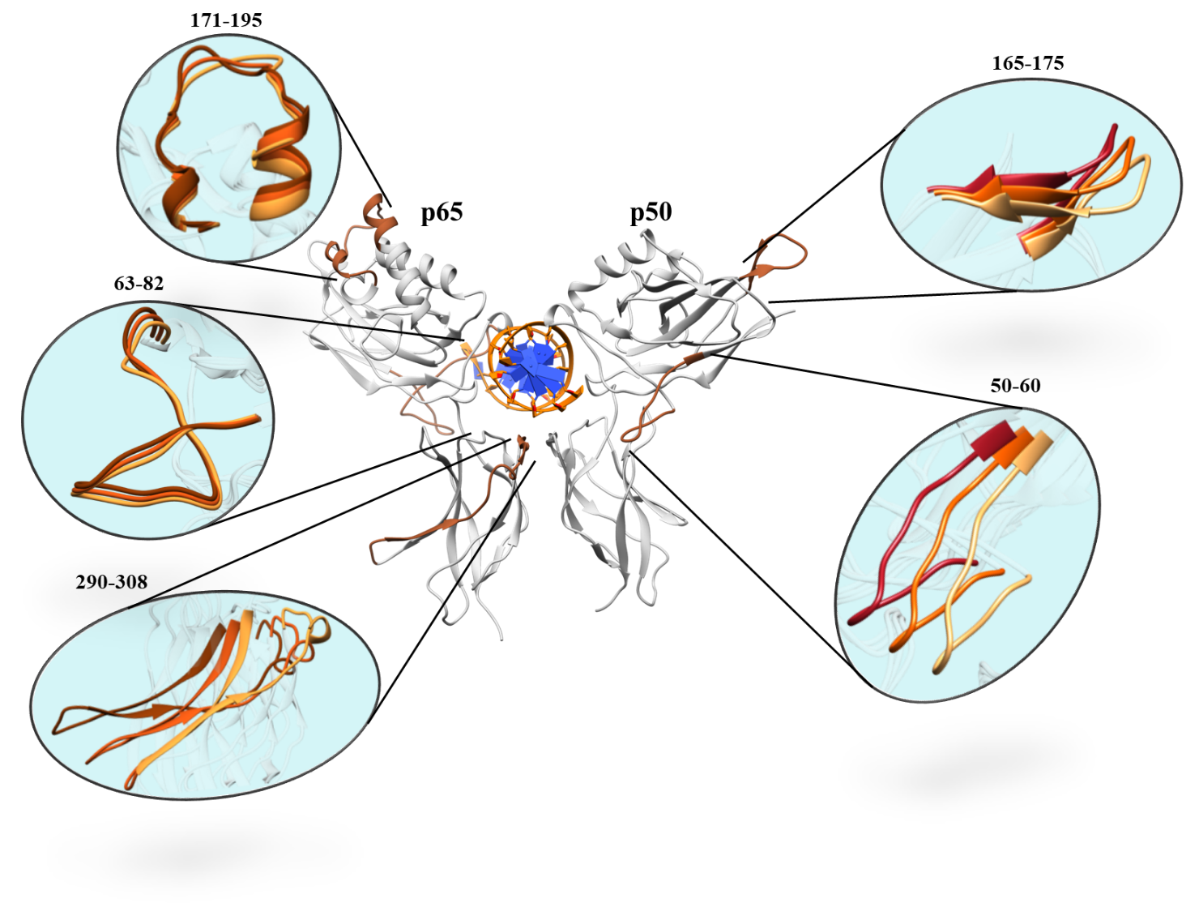
Supplementary Figure S2: Conformations trajectory observed in the NF-kB (p50/p65); the trajectories were derived from morphing of starting frame of the simulation and ending frame of the simulation.

