Table S1. Clinicopathological characteristics for pRCC patients in dependence of TROP-2 expression.
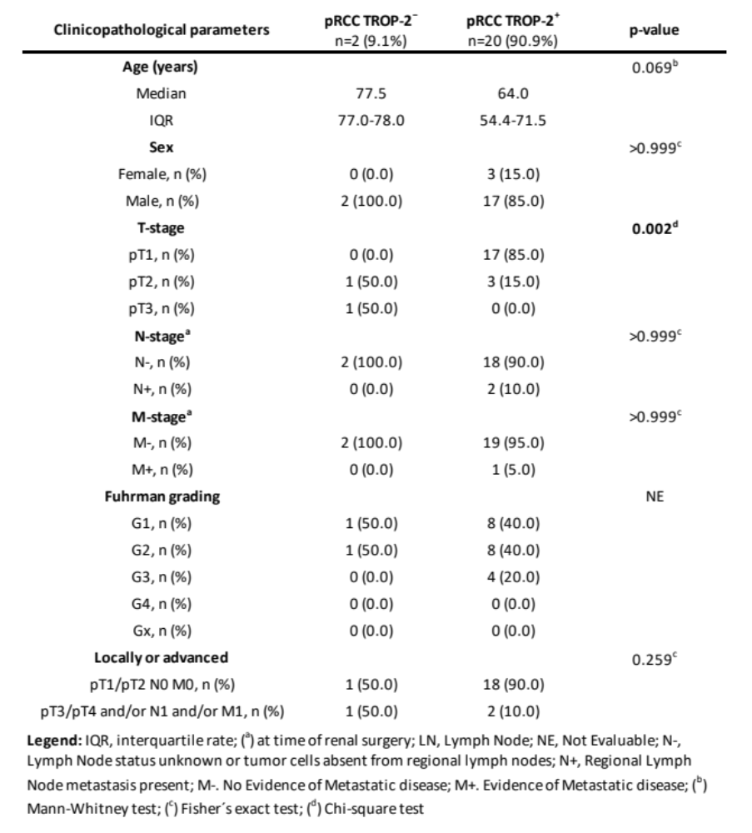

Figure S1. ROC curve analyses demonstrating the strong diagnostic potential of TROP-2.
Figure S2. Spearman correlation and linear regression analyses between TROP-2 mRNA, serum protein levels, and the H-score. Strong positive correlations between TROP-2 mRNA levels and membranous expression, as well as between TROP-2 serum protein levels and H-score, with Spearman coefficients of 0.70 (p=0.0003, R²=0.58), and 0.78 (p=0.0001, R²=0.52).

