Supplementary Information
Investigation of the Free-Radical Polymerization of Vinyl Monomers Using Horseradish Peroxidase (HRP) Nanoflowers
Gulbahar Ozaydin¹, Muge Mirioglu¹, Seyma Dadi², Ismail Ocsoy³, Ersen Gokturk^{1†}
¹Department of Chemistry, Hatay Mustafa Kemal Universitesi, 31001, Hatay, Türkiye
²Department of Nanotechnology Engineering, Abdullah Gul Universitesi, 38080, Kayseri, Türkiye
³Department of Analytical Chemistry, Faculty of Pharmacy, Erciyes Universitesi, 38039, Kayseri, Türkiye
†Corresponding author: Ersen Gokturk (ersengokturk@gmail.com). Tel.: (+90) 326 221 3317 - 11144; fax: (+90) 326 245 5867
Ersen Gokturk (ORCID ID: 0000-0001-6742-2847)
Ismail Ocsoy (ORCID ID: 0000-0002-5991-3934)
FT-IR Spectra
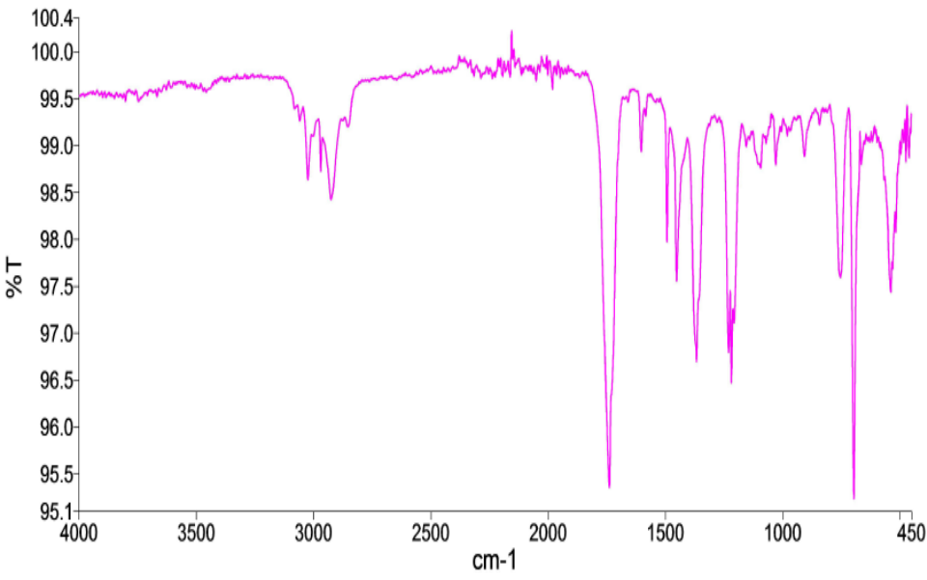
Figure S1. FT-IR spectrum of polymer 2 (Table 1, entry 2).

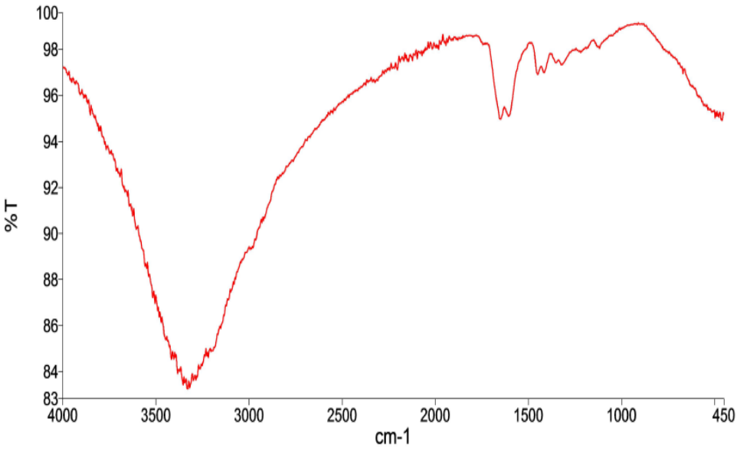
Figure S2. FT-IR spectrum of polymer 15 (Table 2, entry 15).

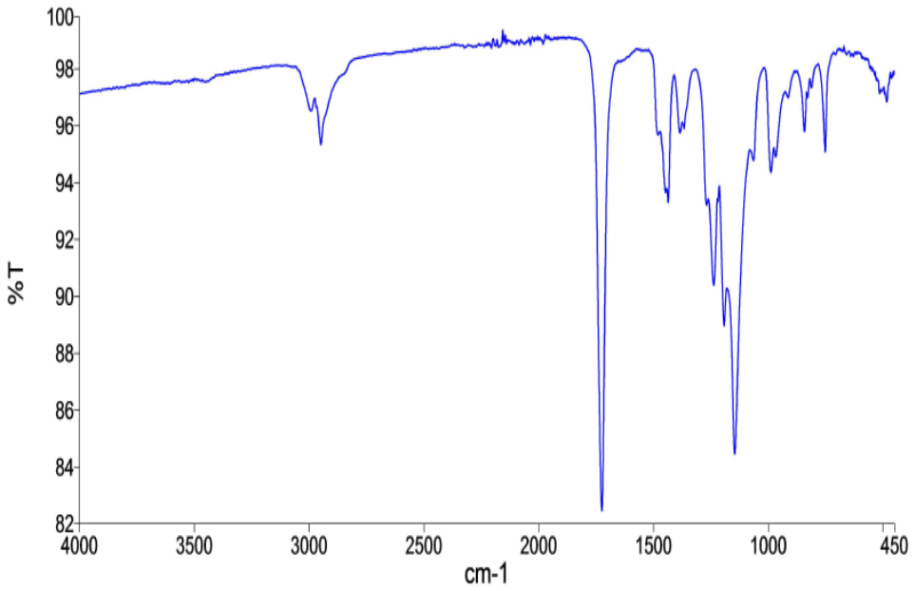
Figure S3. FT-IR spectrum of polymer 18 (Table 2, entry 18).

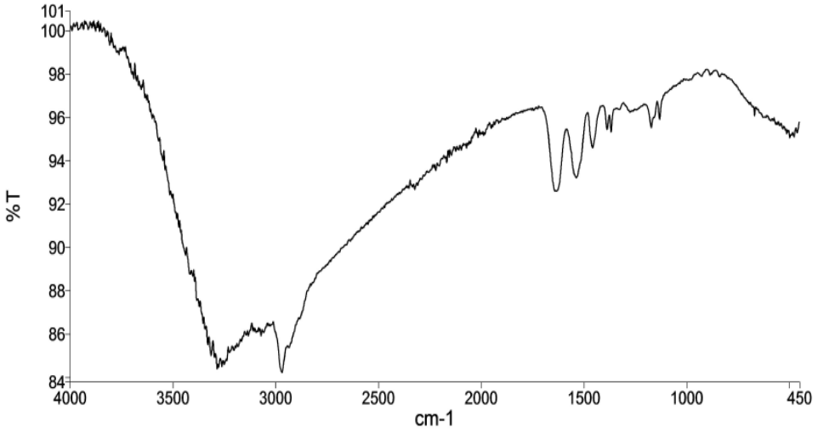
Figure S4. FT-IR spectrum of polymer 19 (Table 2, entry 19).

Thermogravimetric Analyses
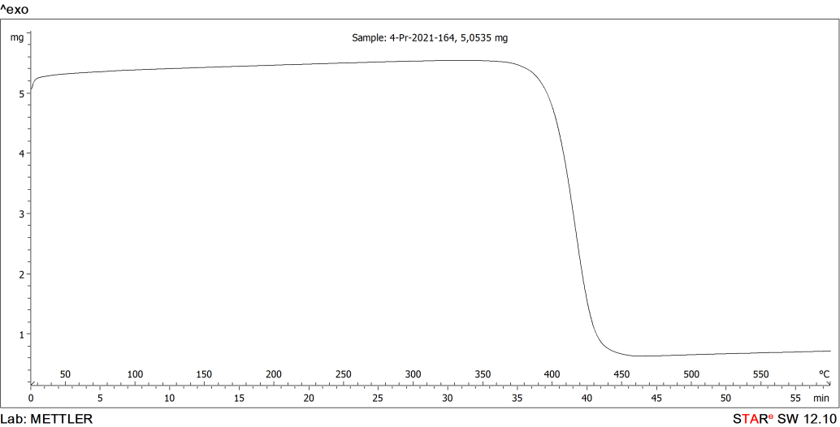
Figure S5. TGA thermogram of polymer 2 (Table 1, entry 2).

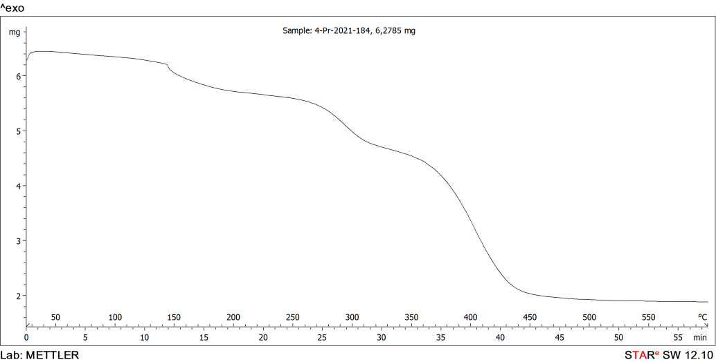
Figure S6. TGA thermogram of polymer 15 (Table 2, entry 15).

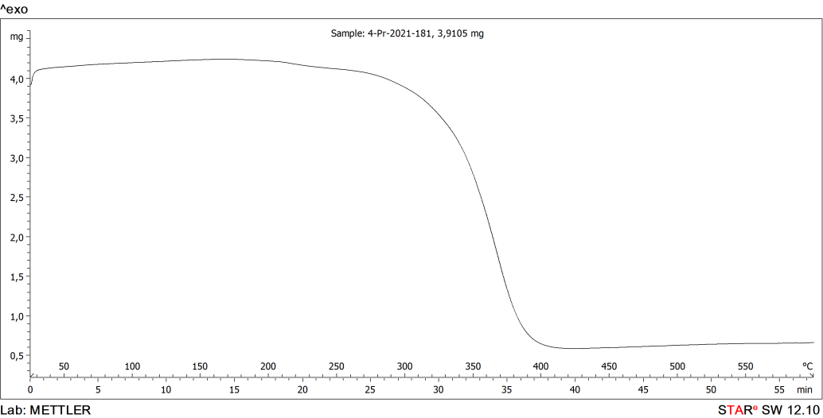
Figure S7. TGA thermogram of polymer 18 (Table 2, entry 18).

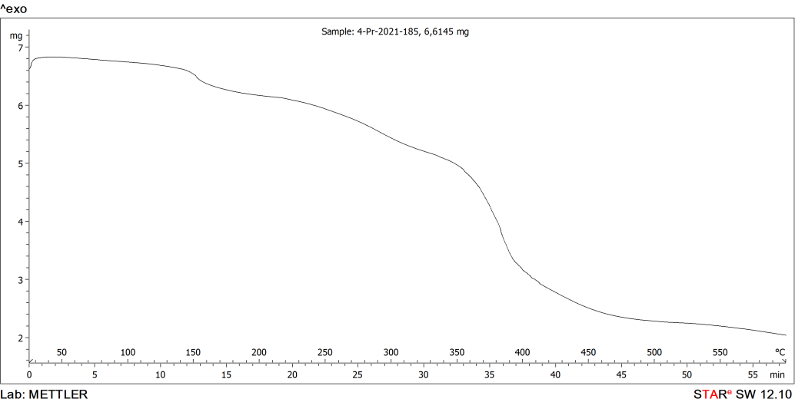
Figure S8. TGA thermogram of polymer 19 (Table 2, entry 19).

Differential Scanning Calorimetry Thermograms

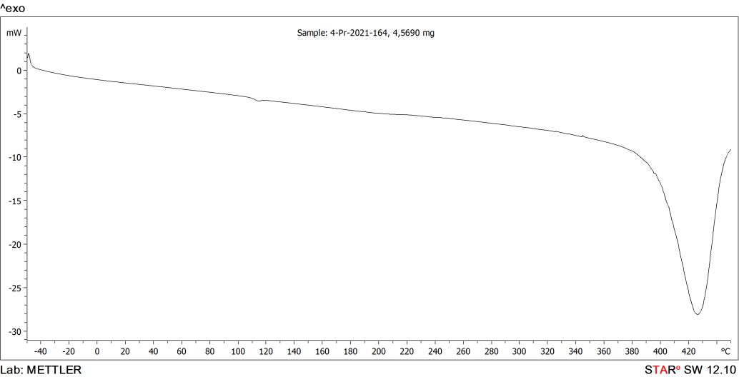
Figure S9. DSC thermogram of polymer 2 (Table 1, entry 2).

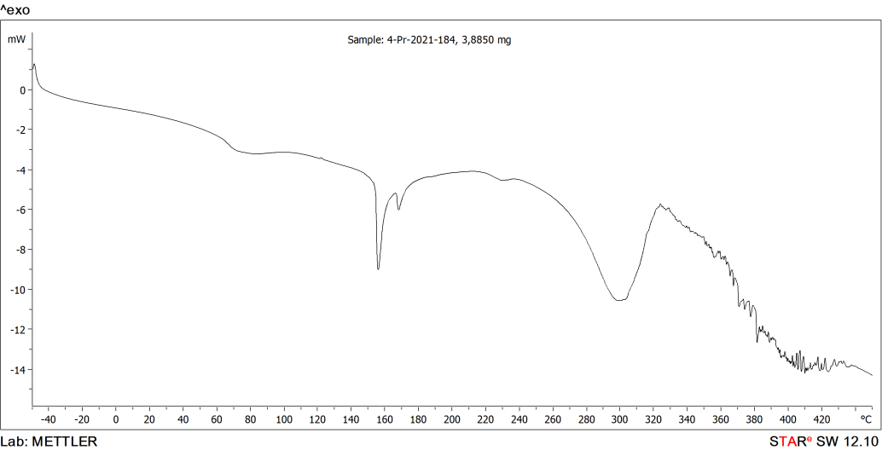
Figure S10. DSC thermogram of polymer 15 (Table 2, entry 15).

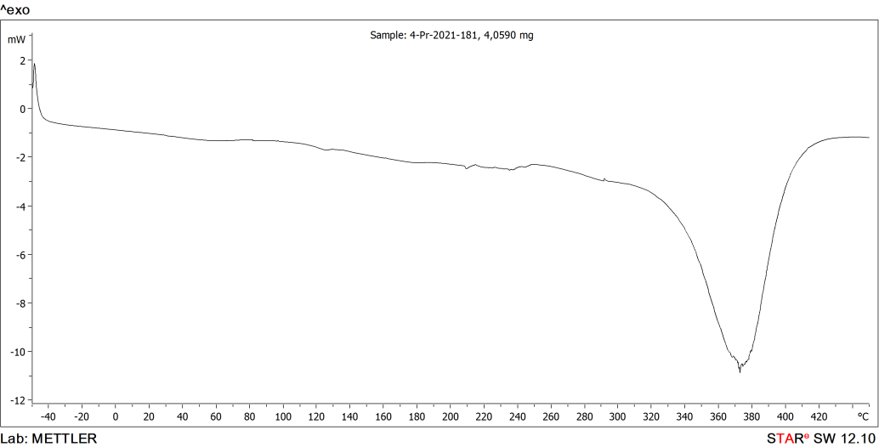
Figure S11. DSC thermogram of polymer 18 (Table 2, entry 18).

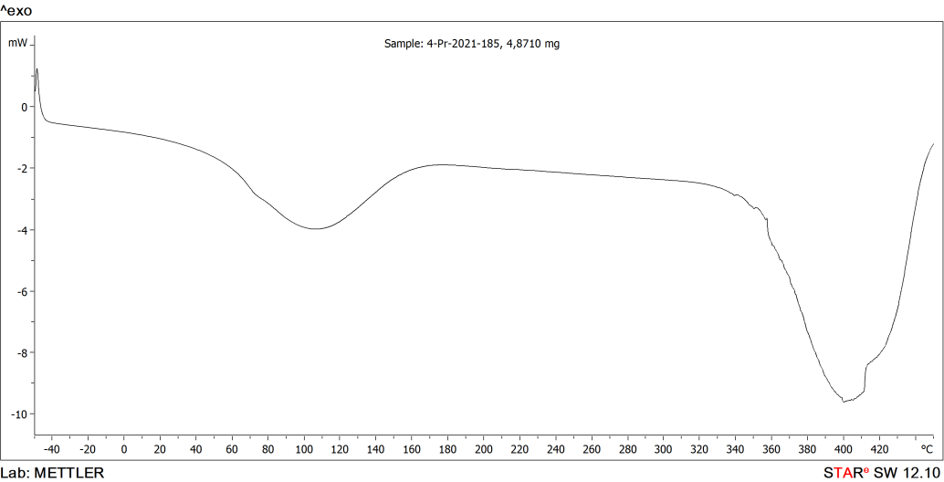
Figure S12. DSC thermogram of polymer 19 (Table 2, entry 19).

Gel Permeation Chromatography (GPC) Data

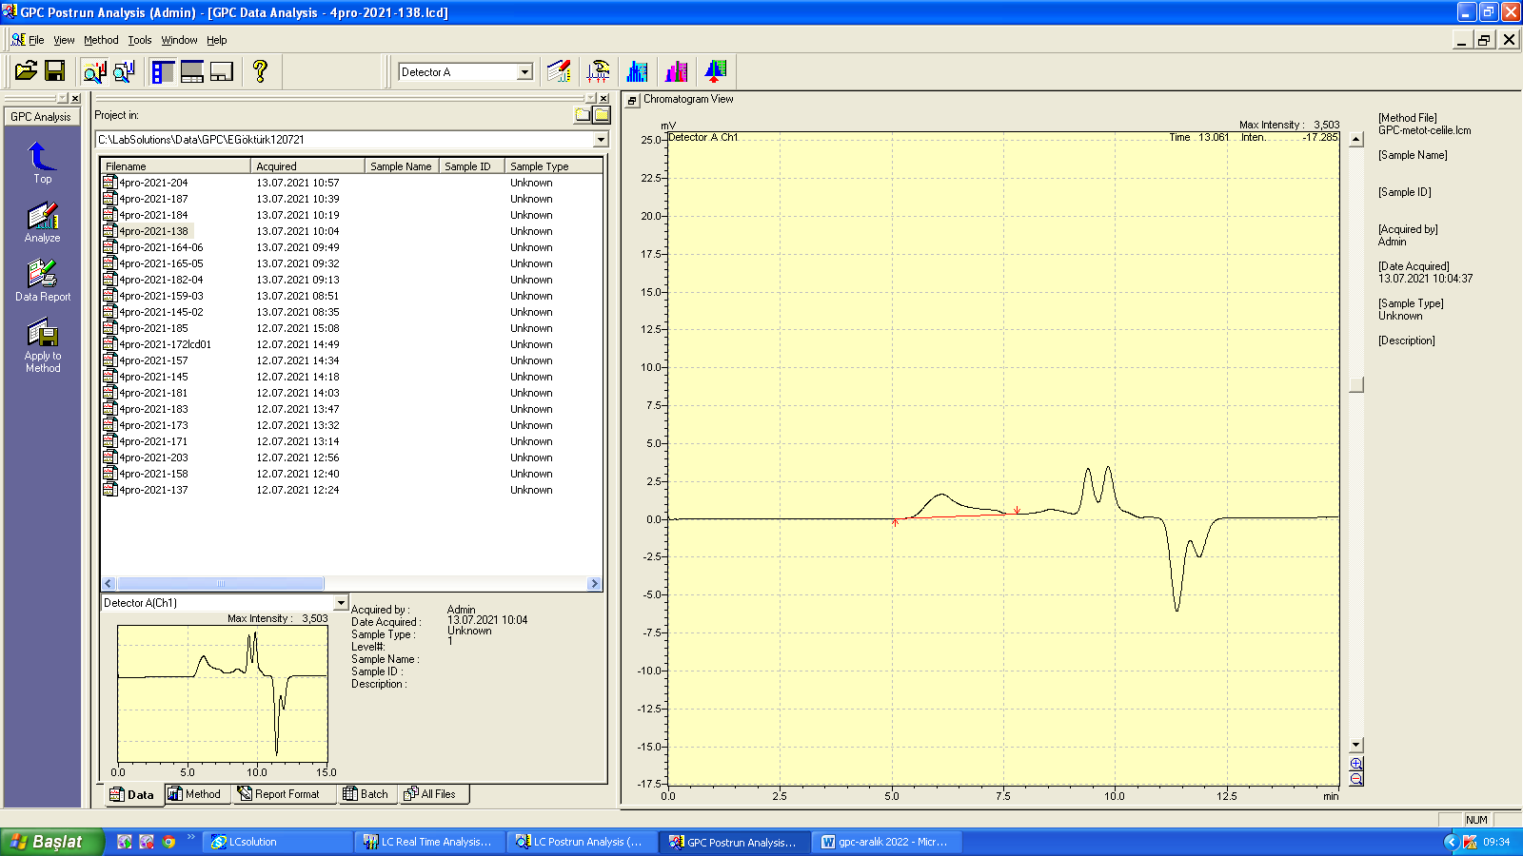
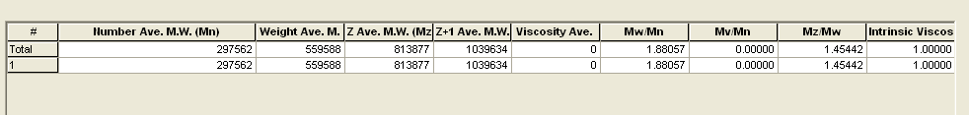
Figure S13. GPC chromatogram of polymer 1 in DMF solvent (Table 1, entry 1).

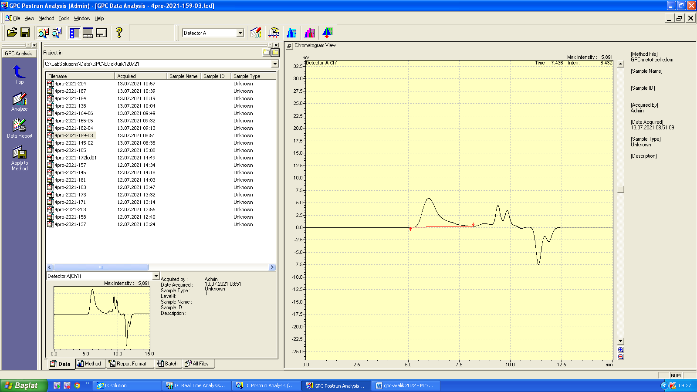
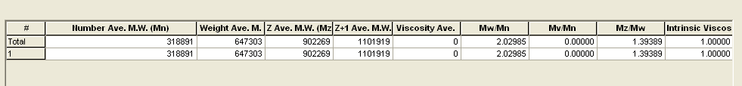
Figure S14. GPC chromatogram of polymer 2 in DMF solvent (Table 1, entry 2).
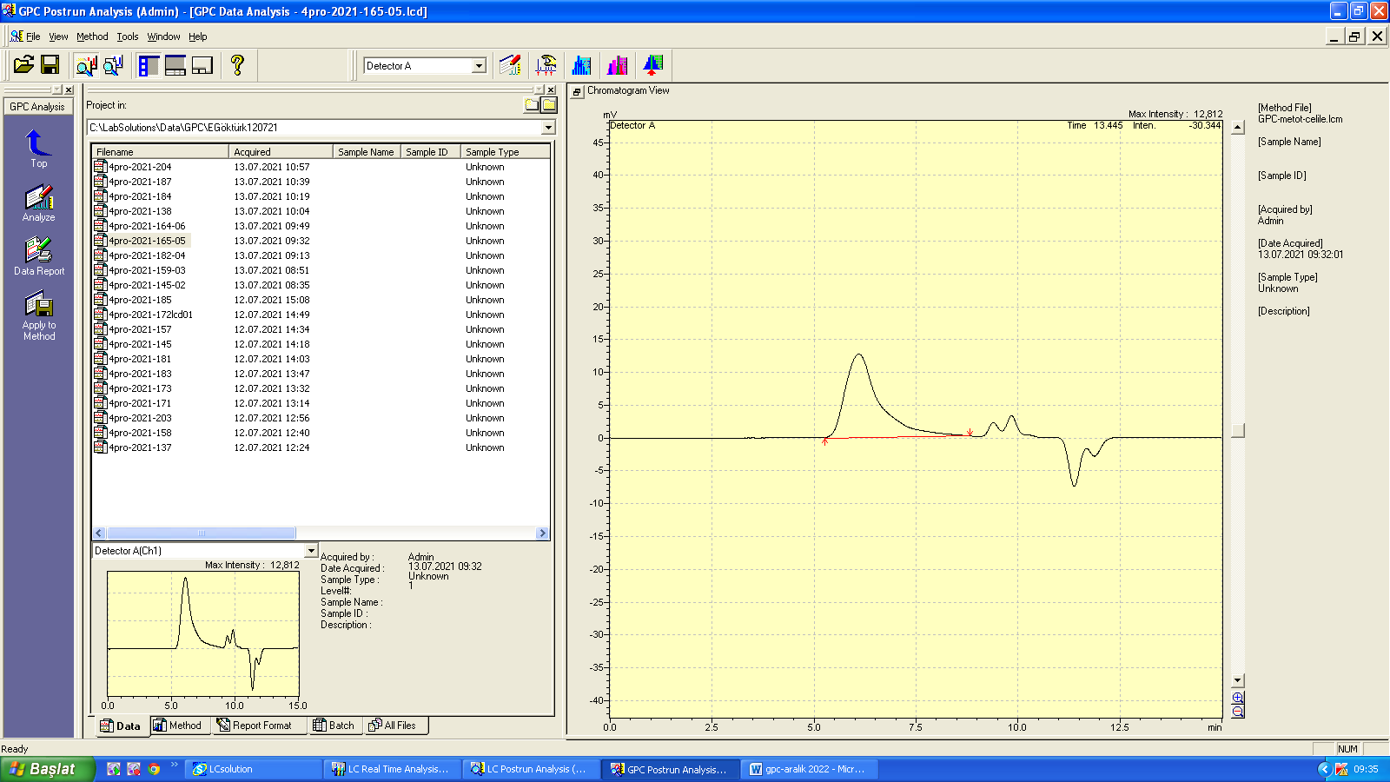
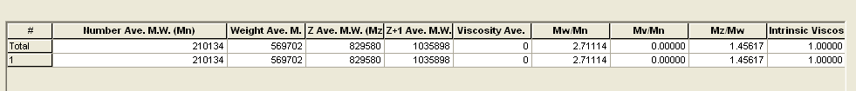
Figure S15. GPC chromatogram of polymer 3 in DMF solvent (Table 1, entry 3).

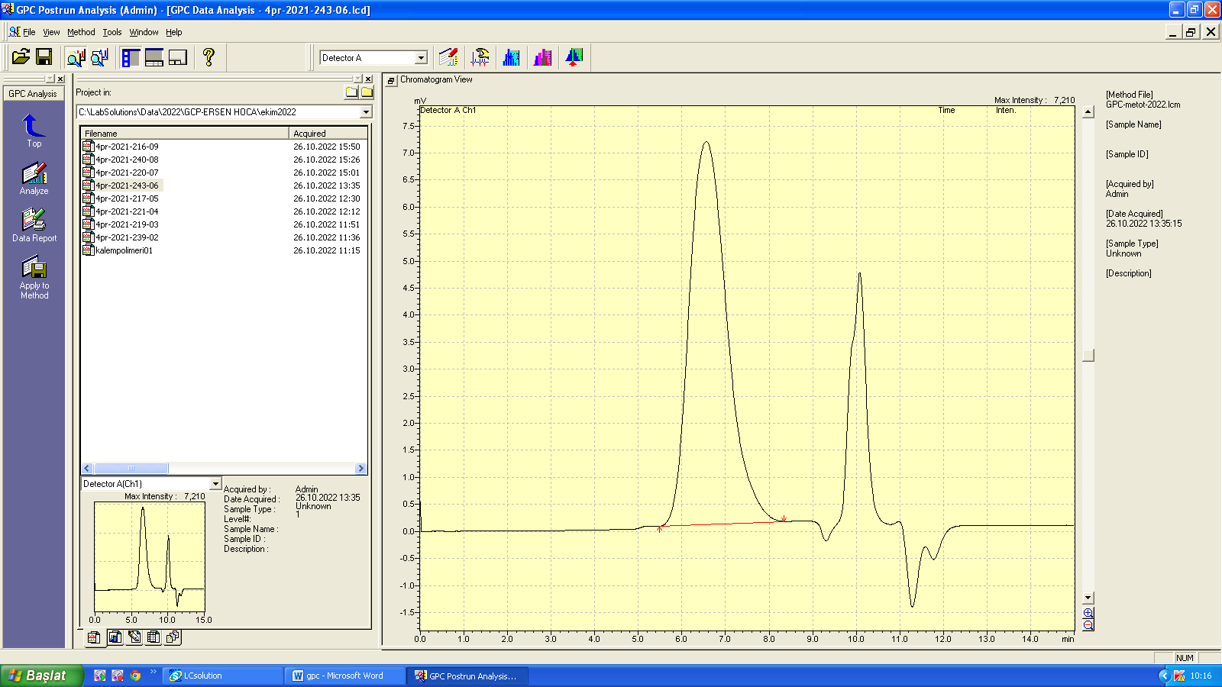
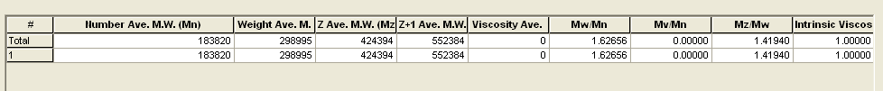
Figure S16. GPC chromatogram of polymer 4 in DMF solvent (Table 1, entry 4).

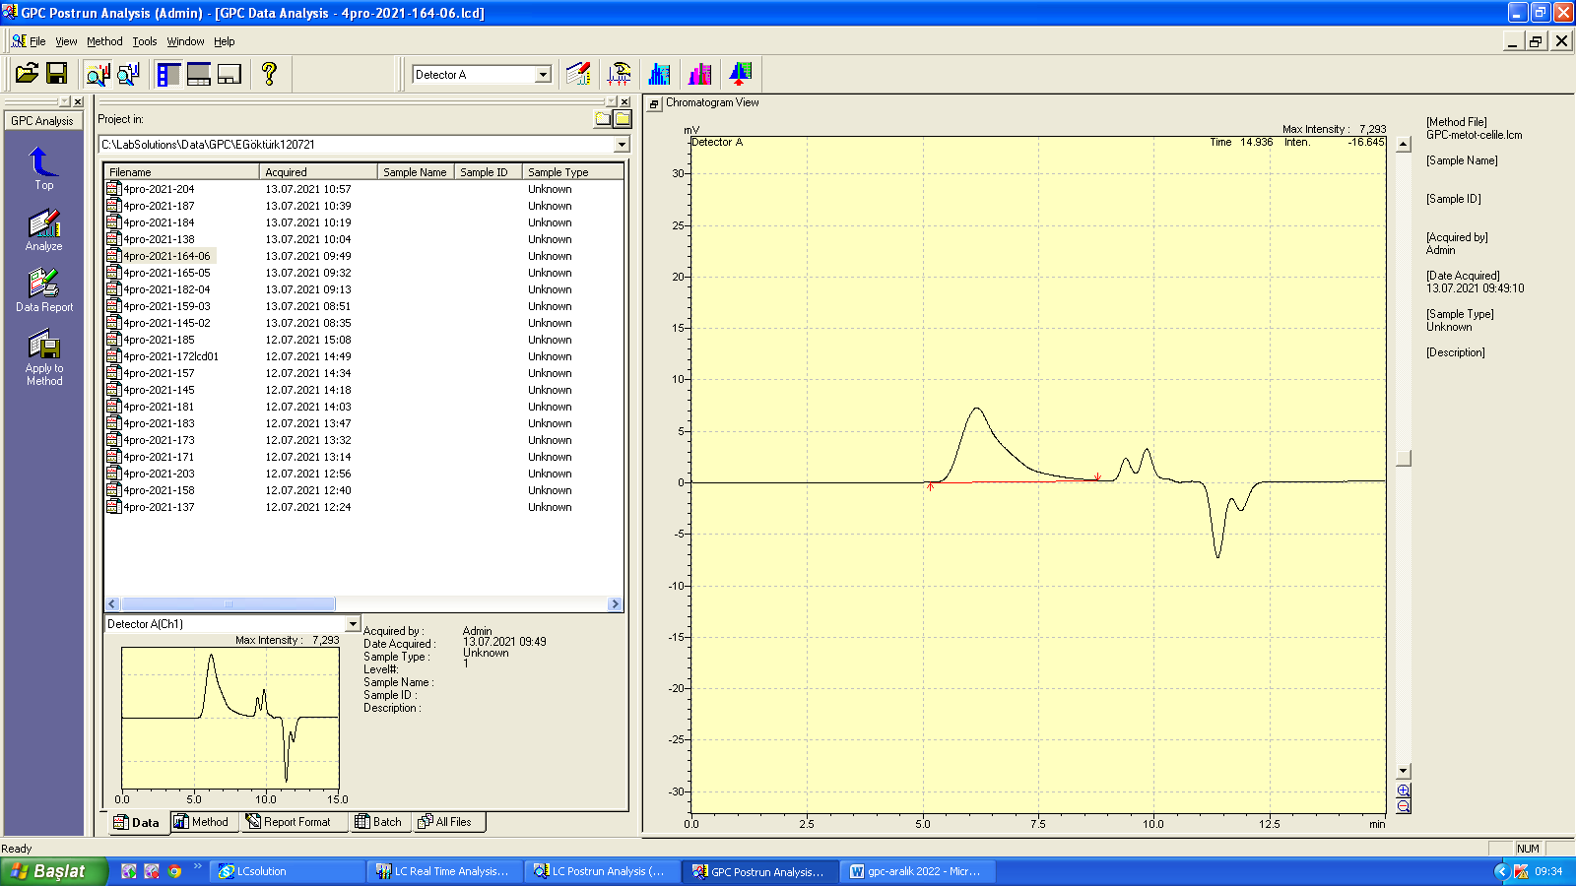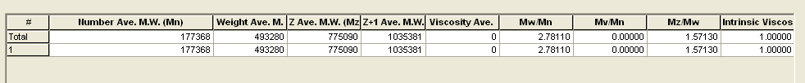
Figure S17. GPC chromatogram of polymer 5 in DMF solvent (Table 1, entry 5).

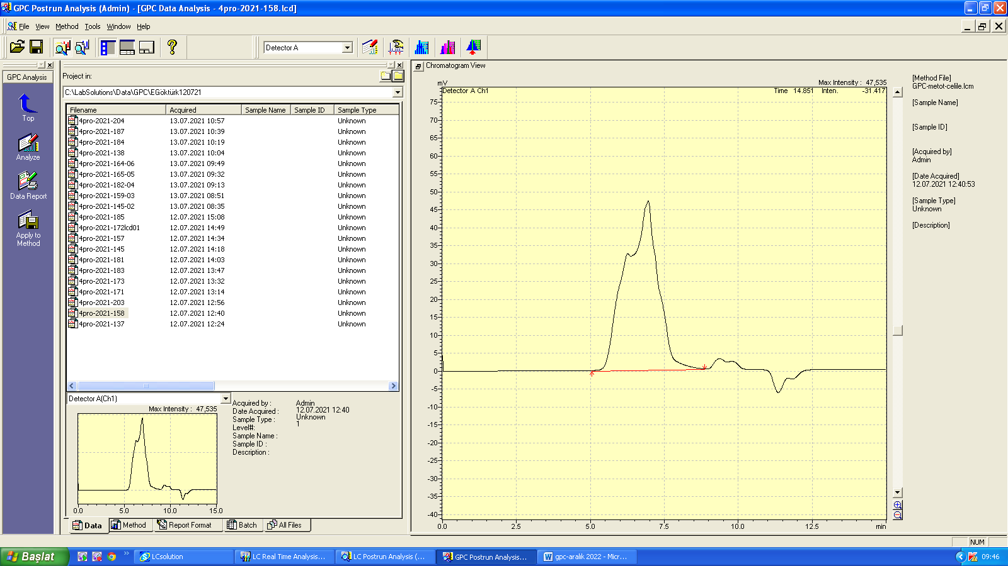
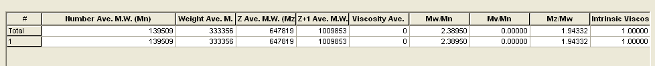
Figure S18. GPC chromatogram of polymer 6 in DMF solvent (Table 1, entry 6).

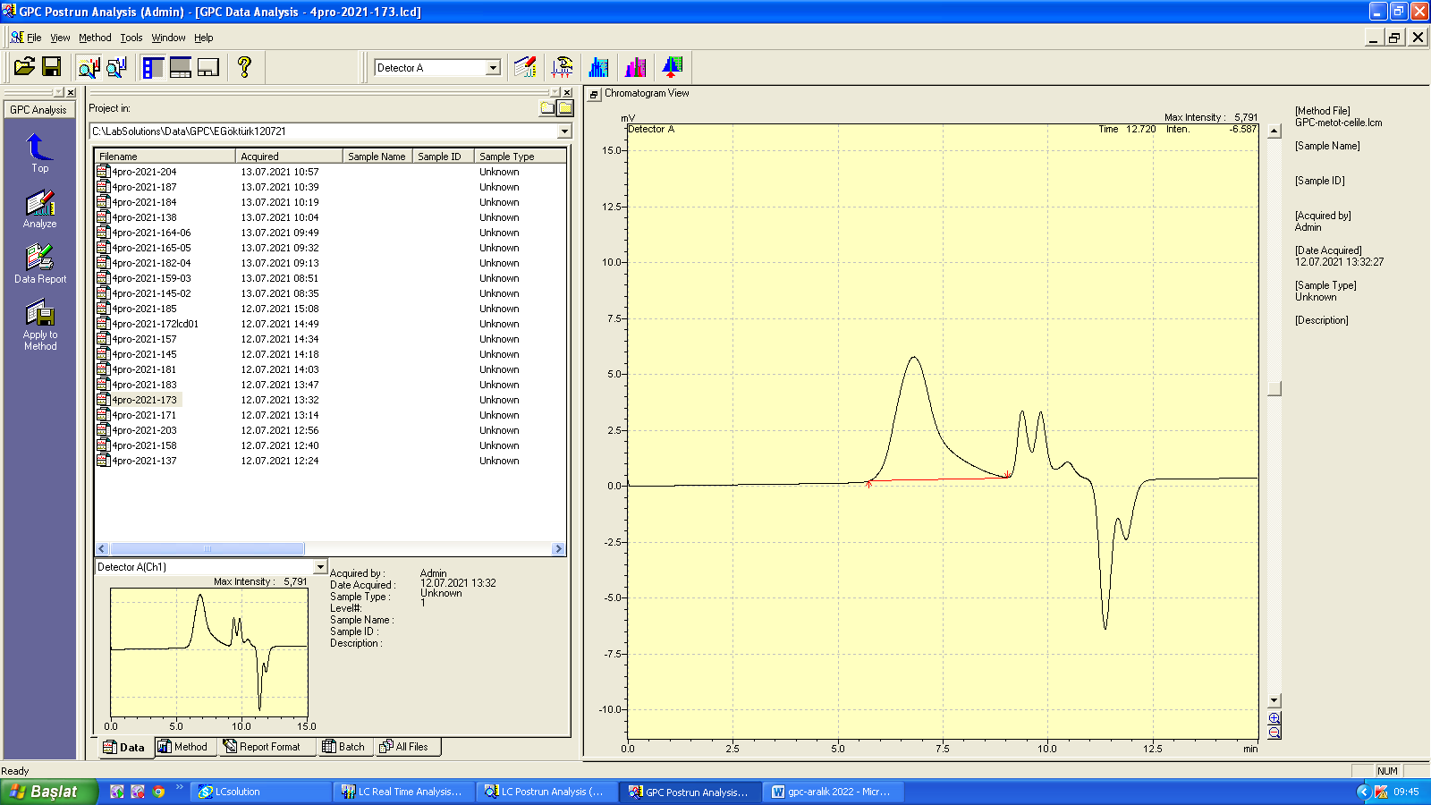
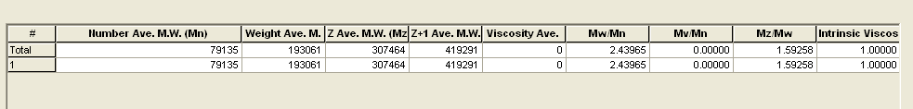
Figure S19. GPC chromatogram of polymer 7 in DMF solvent (Table 1, entry 7).

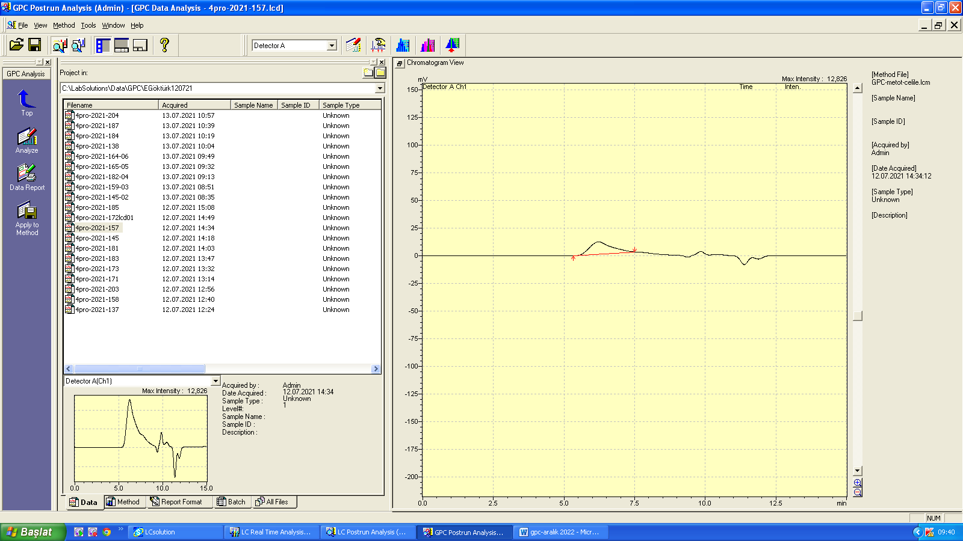
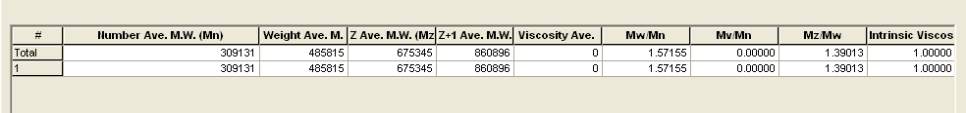
Figure S20. GPC chromatogram of polymer 8 in DMF solvent (Table 1, entry 8).

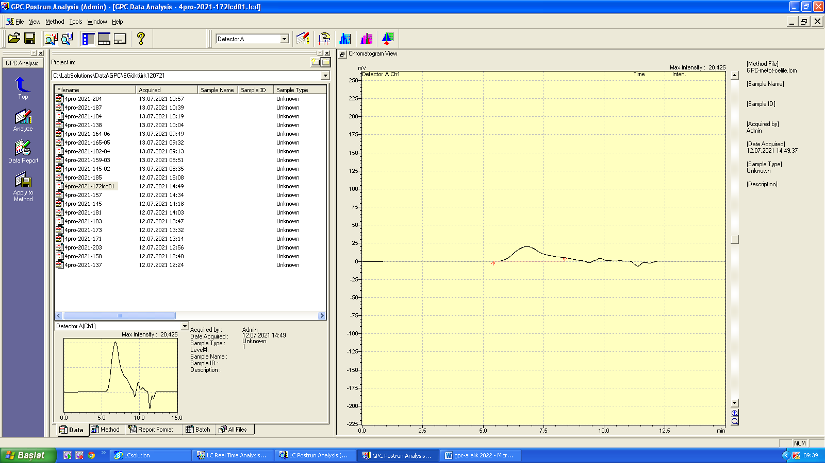
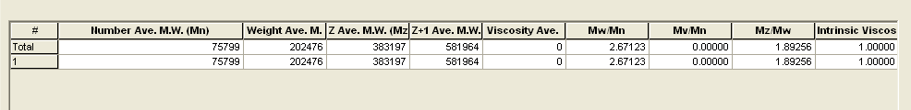
Figure S21. GPC chromatogram of polymer 9 in DMF solvent (Table 1, entry 9).

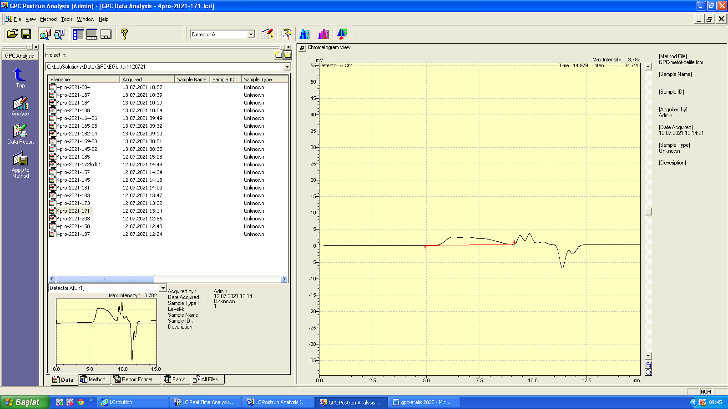
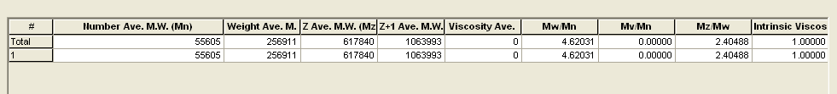
Figure S22. GPC chromatogram of polymer 10 in DMF solvent (Table 1, entry 10).

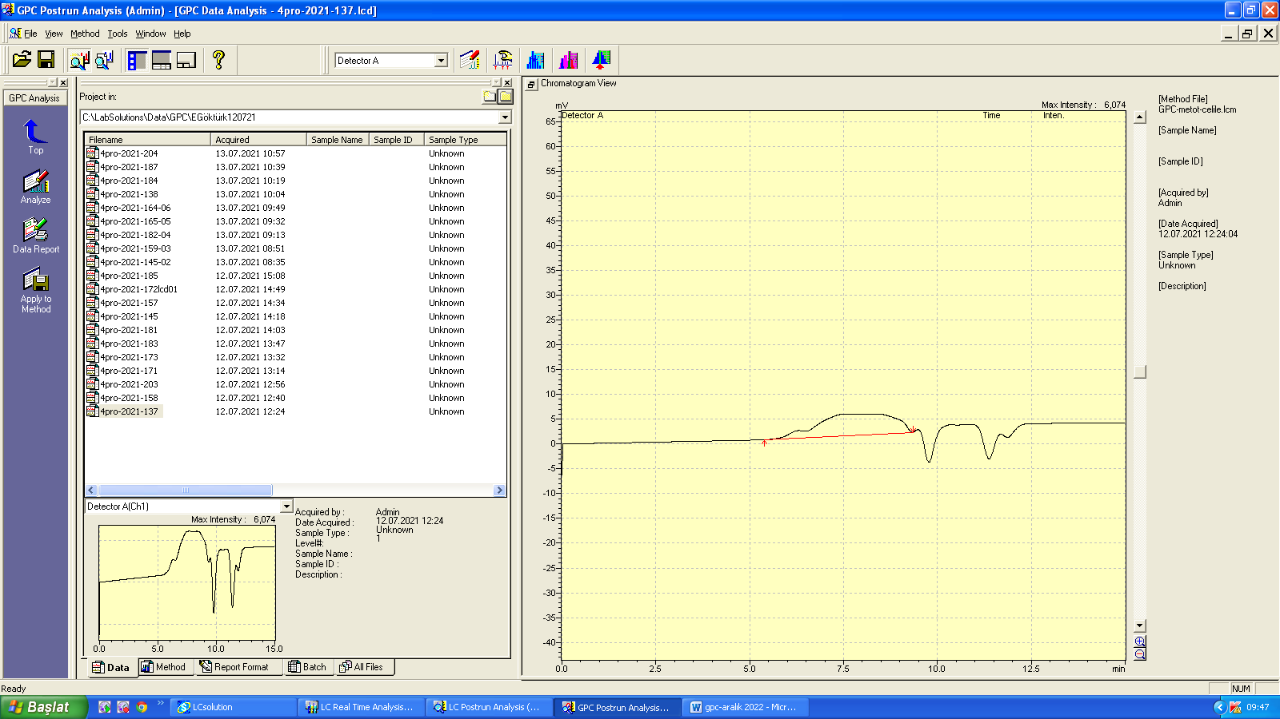
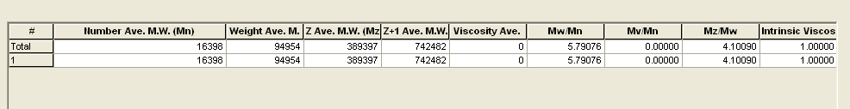
Figure S23. GPC chromatogram of polymer 12 in DMF solvent (Table 1, entry 12).

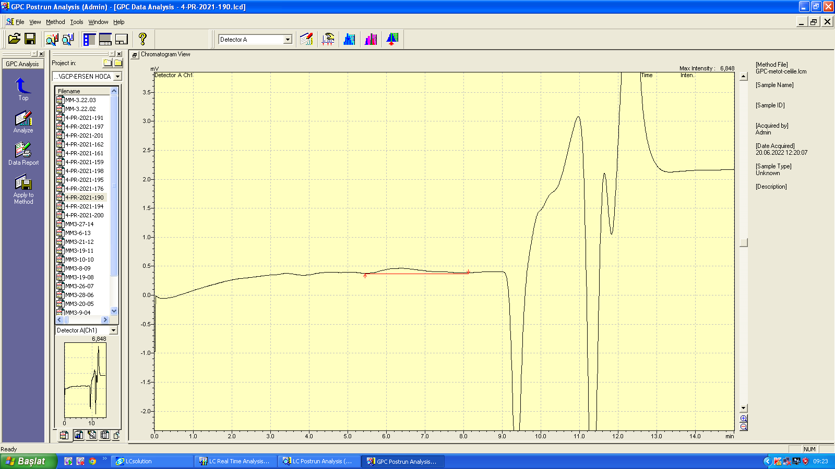
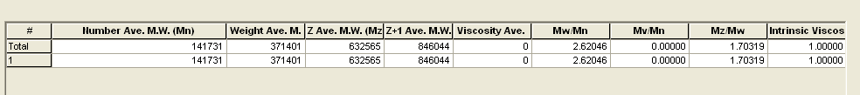
Figure S24. GPC chromatogram of polymer 14 in DMF solvent (Table 2, entry 14).

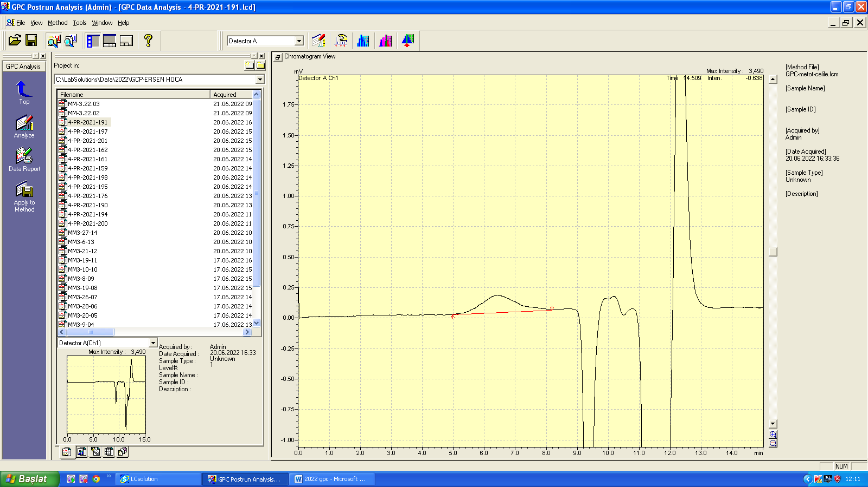
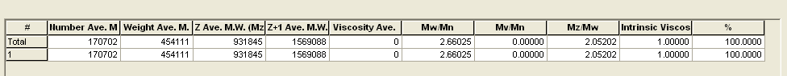
Figure S25. GPC chromatogram of polymer 15 in DMF solvent (Table 2, entry 15).

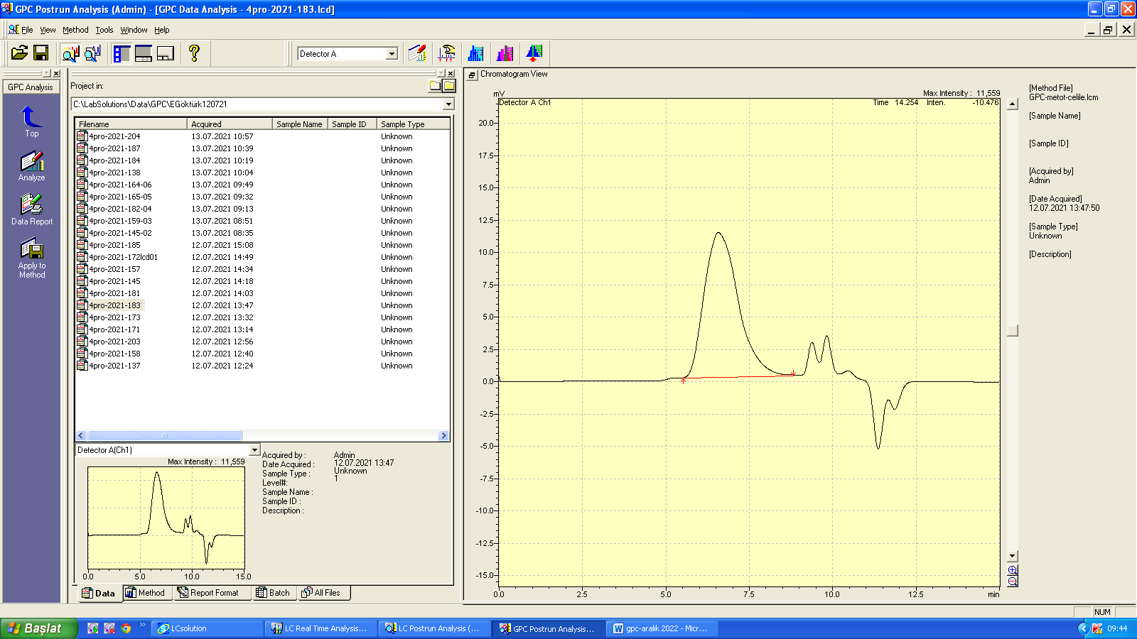
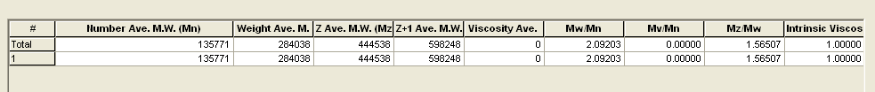
Figure S26. GPC chromatogram of polymer 16 in DMF solvent (Table 2, entry 16).

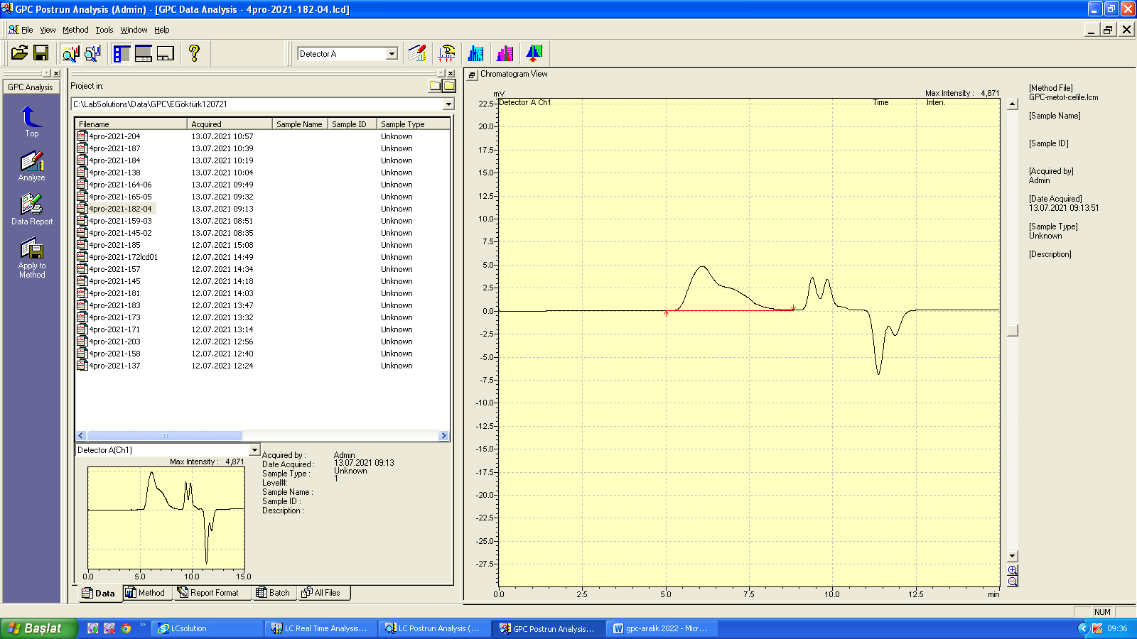
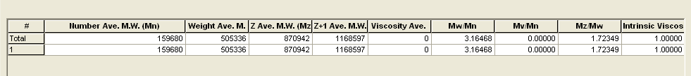
Figure S27. GPC chromatogram of polymer 17 in DMF solvent (Table 2, entry 17).

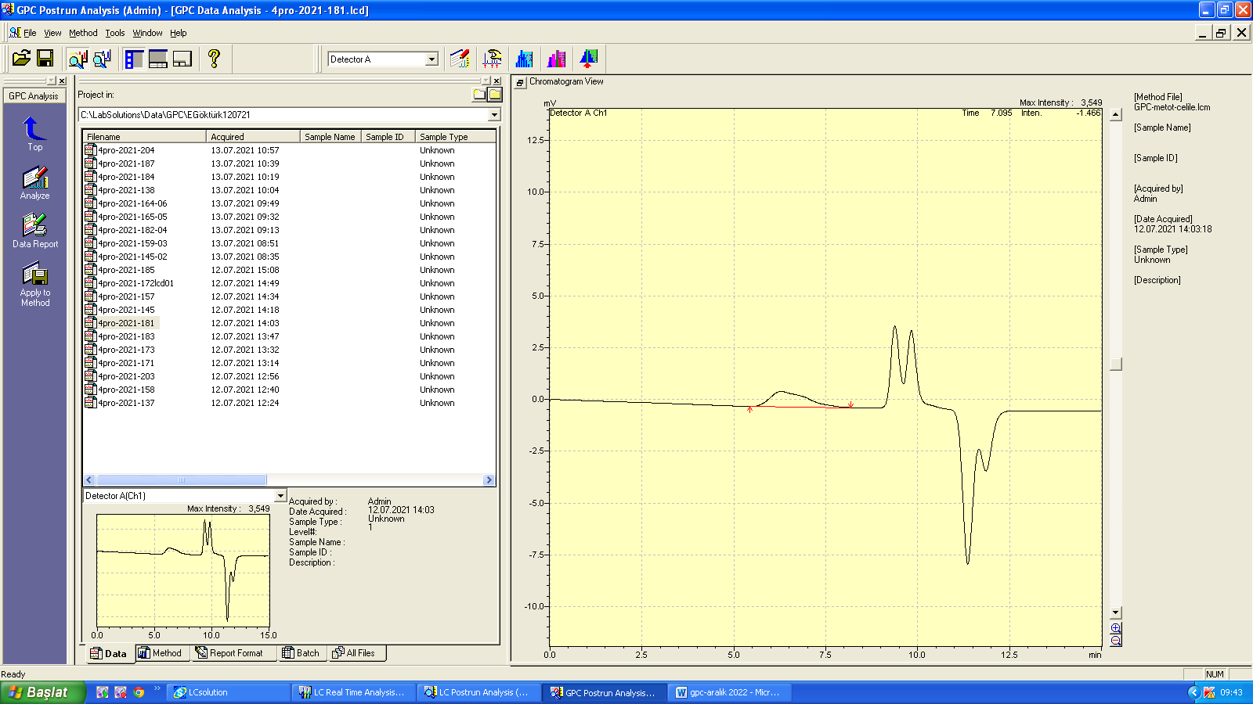
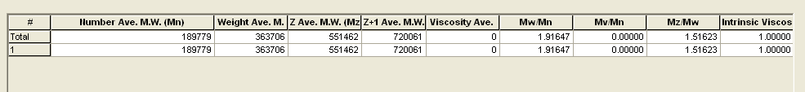
Figure S28. GPC chromatogram of polymer 18 in DMF solvent (Table 2, entry 18).

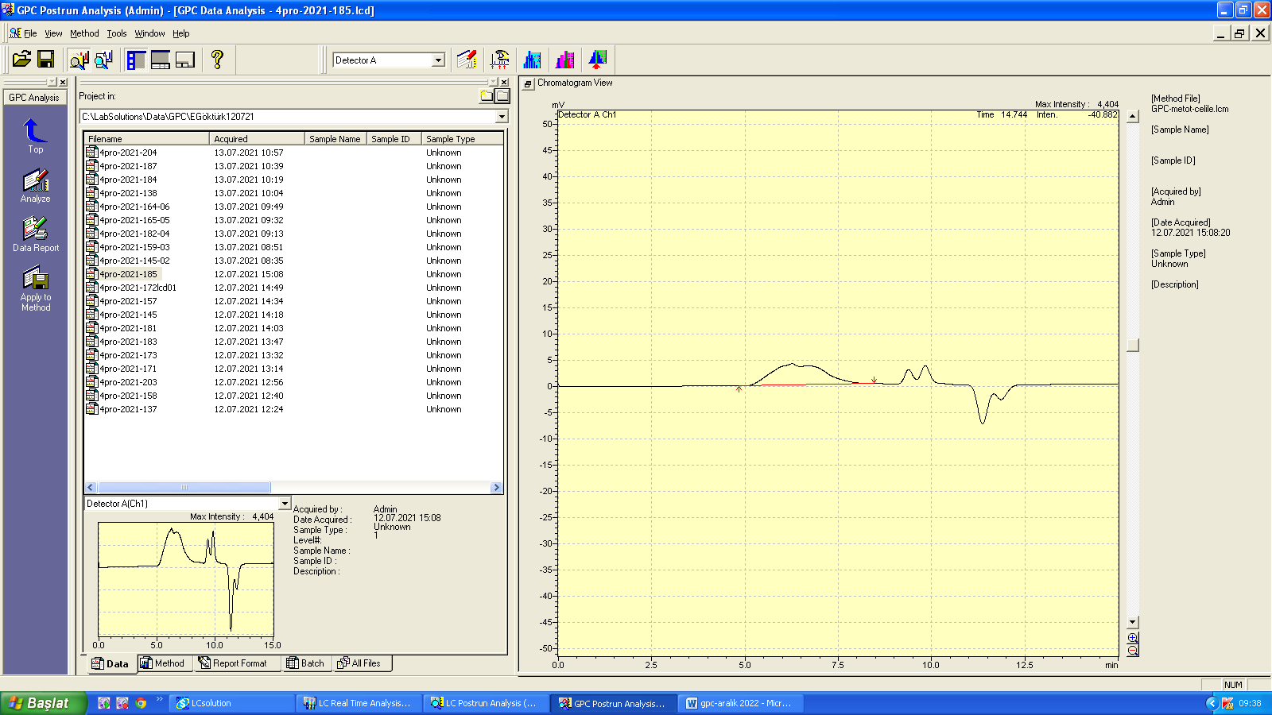
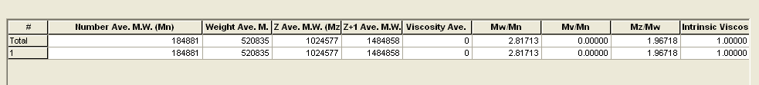
Figure S29. GPC chromatogram of polymer 19 in DMF solvent (Table 2, entry 19).

¹H NMR Spectra

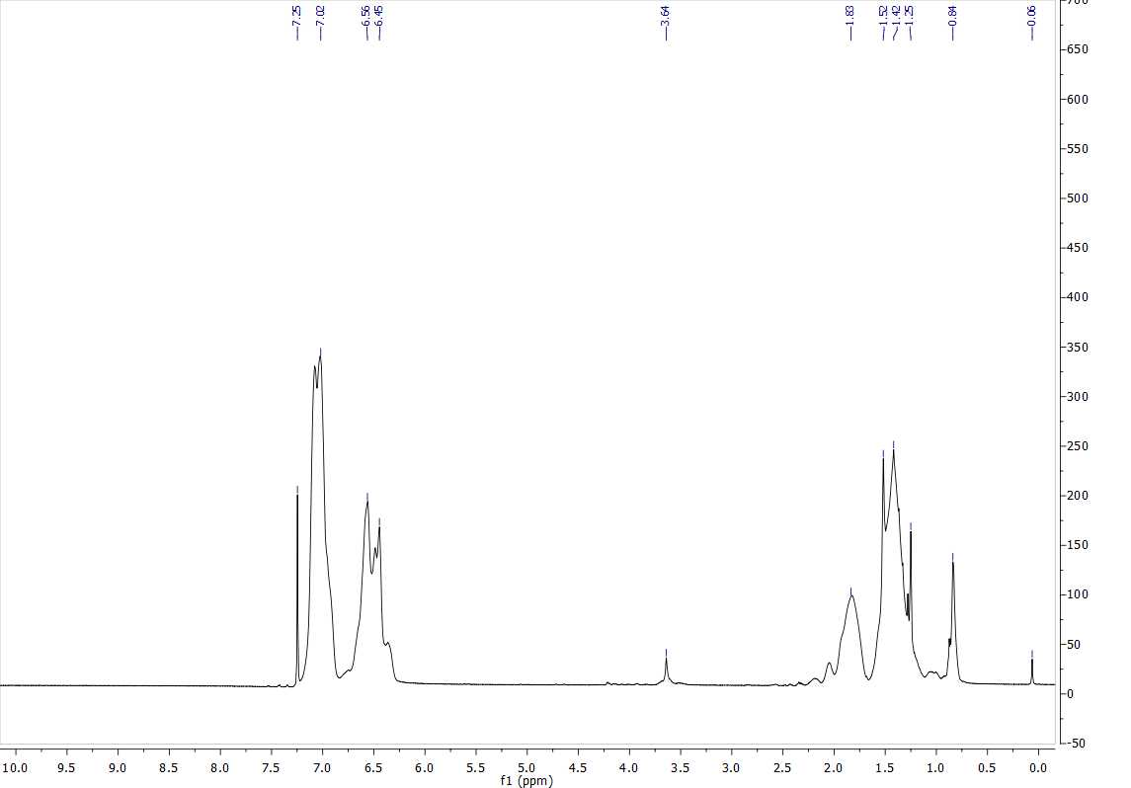
Figure S30. ¹H NMR spectrum of polymer 2 (Table 1, entry 2).

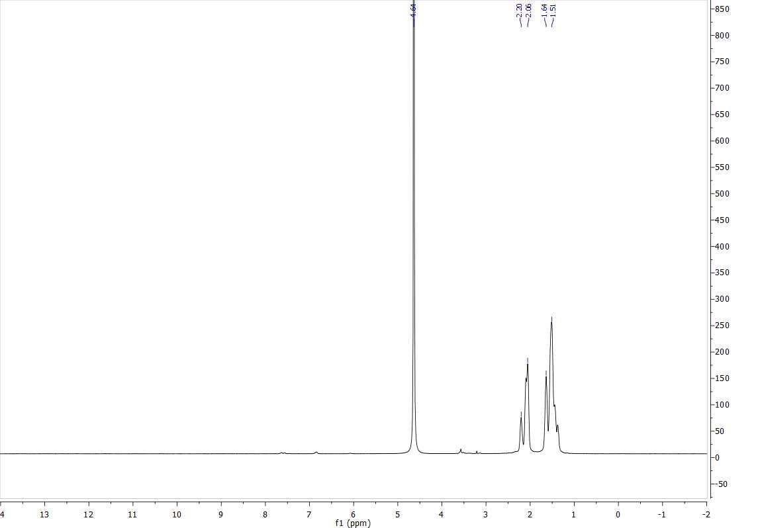
Figure S31. ¹H NMR spectrum of polymer 15 (Table 2, entry 15).

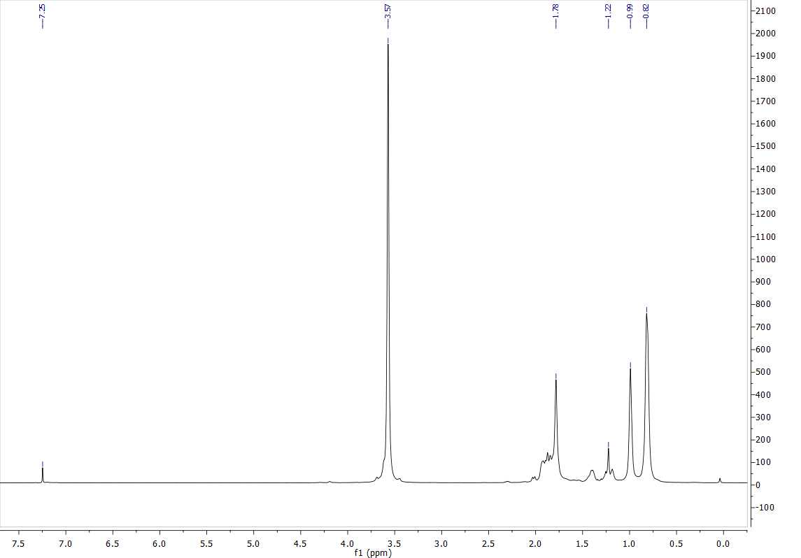
Figure S32. ¹H NMR spectrum of polymer 18 (Table 2, entry 18).

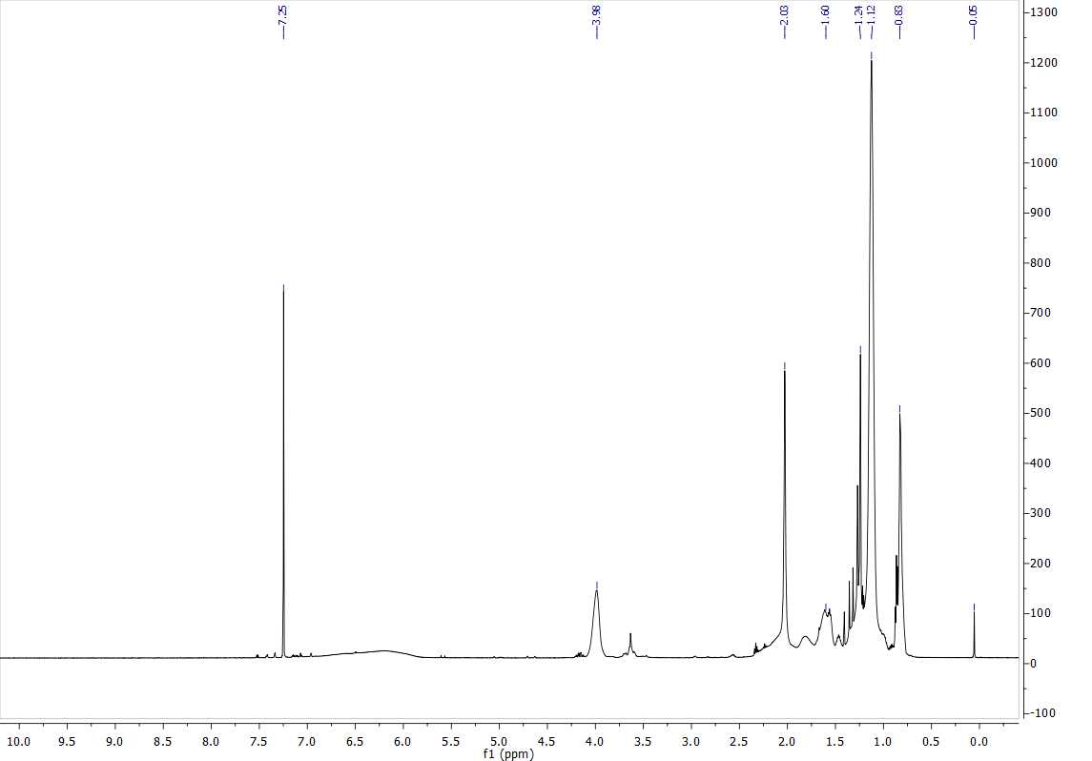
Figure S33. ¹H NMR spectrum of polymer 19 (Table 2, entry 19).

¹³C NMR Spectra

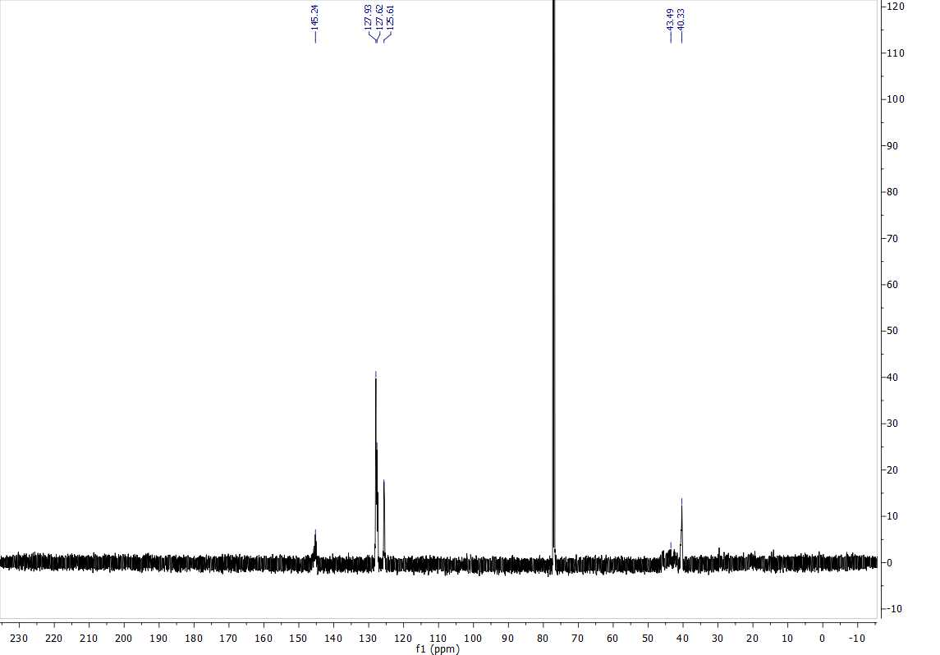
Figure S34. ¹³C NMR spectrum of polymer 2 (Table 1, entry 2).

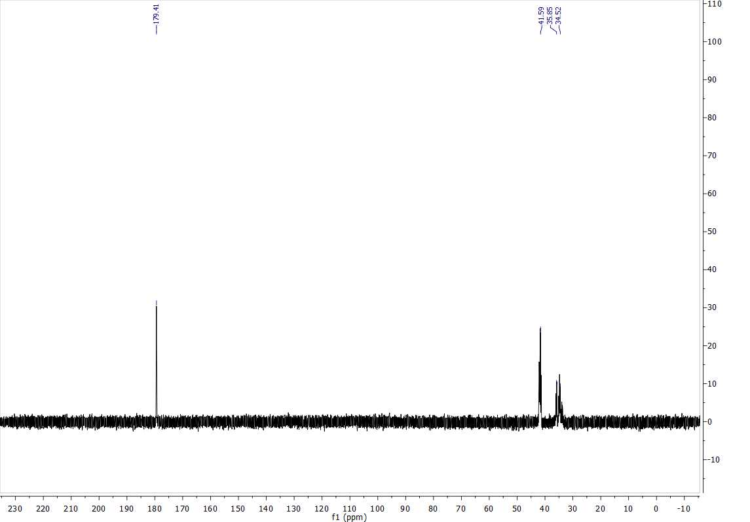
Figure S35. ¹³C NMR spectrum of polymer 15 (Table 2, entry 15).

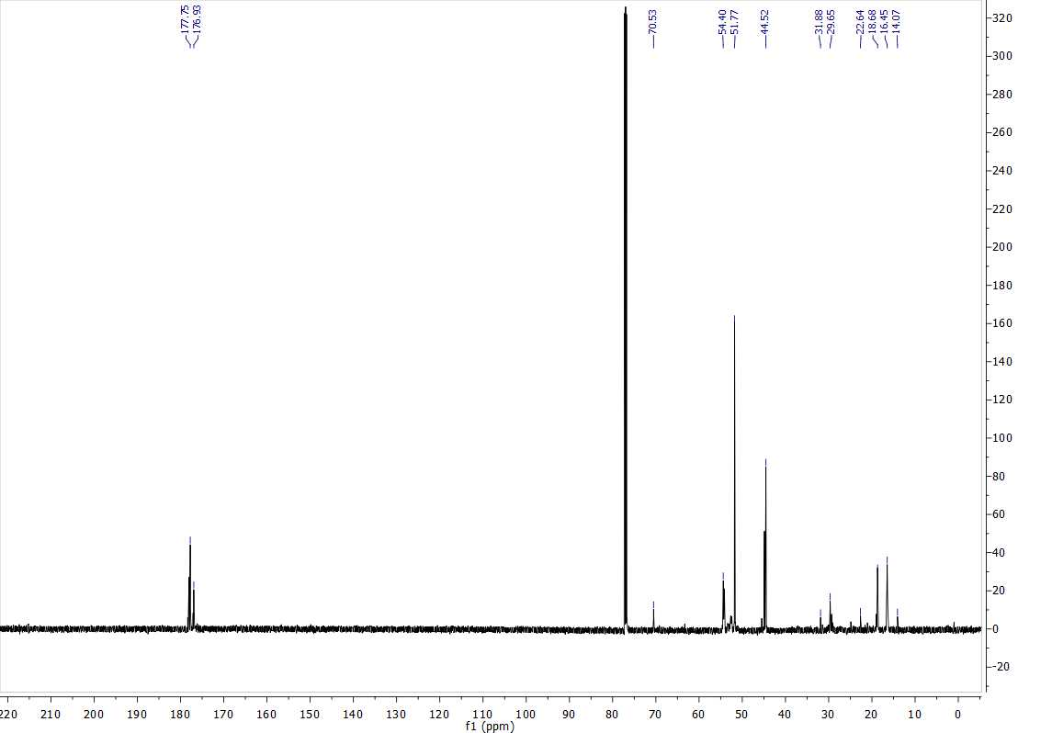
Figure S36. ¹³C NMR spectrum of polymer 18 (Table 2, entry 18).

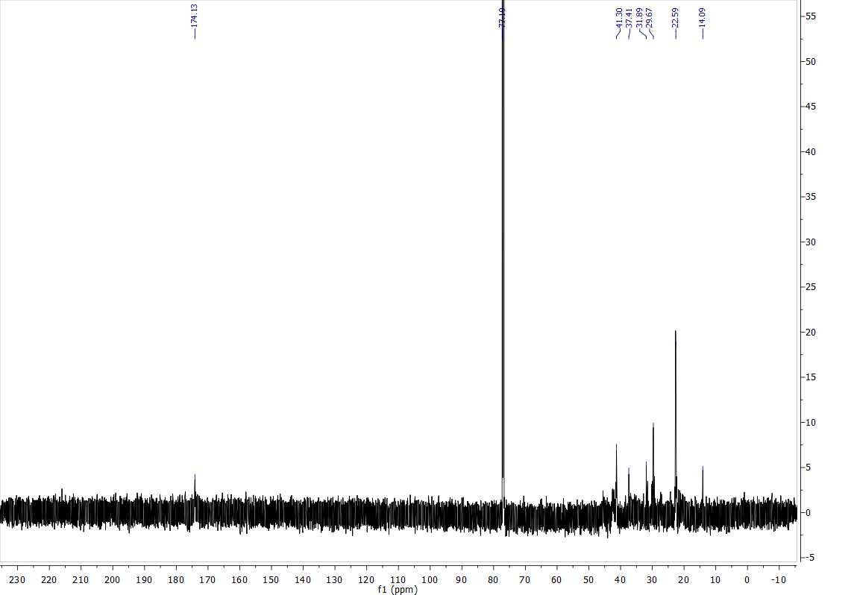
Figure S37. ¹³C NMR spectrum of polymer 19 (Table 2, entry 19).

