Supplement

Table S1
Top two ecoregions and orders within each biogeographic realm (as defined by ⁴⁶) with the most highly exposed species to mean annual temperature in 2023. Such lists prioritize which systems and taxa are most in need of further study. Additionally, we note the number of highly exposed species that are not currently listed as threatened by IUCN (Nnotlisted).

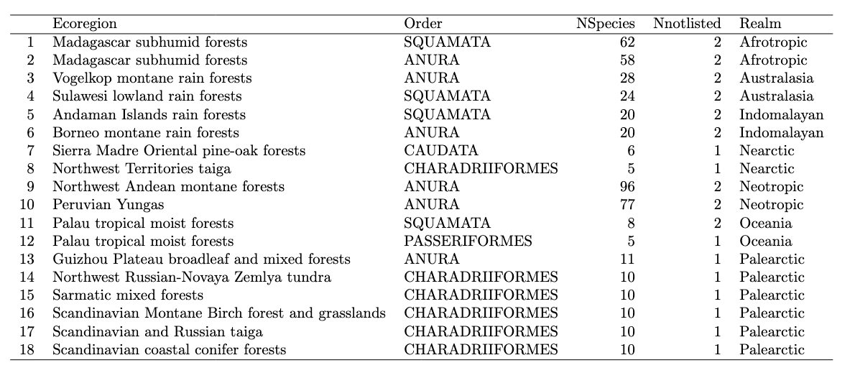

Table S2
Forty largest ranging species with > 50% of their range thermally exposed in 2023 are strong candidates for in situ monitoring because they are widespread and, therefore, may be more easily observed. Range size is measured in quarter-degree pixels (~26km on a side at the equator).

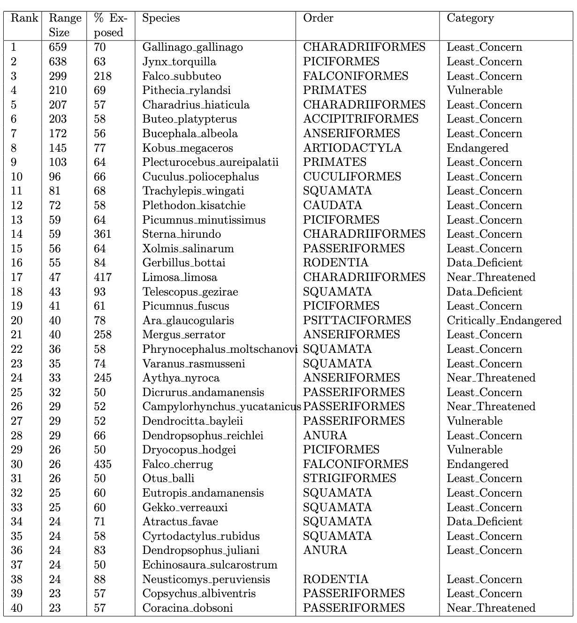

Table S3
Eighteen species were exposed to heatwaves, drought and an unprecedented warm year in 2023 across 25% or more of their range.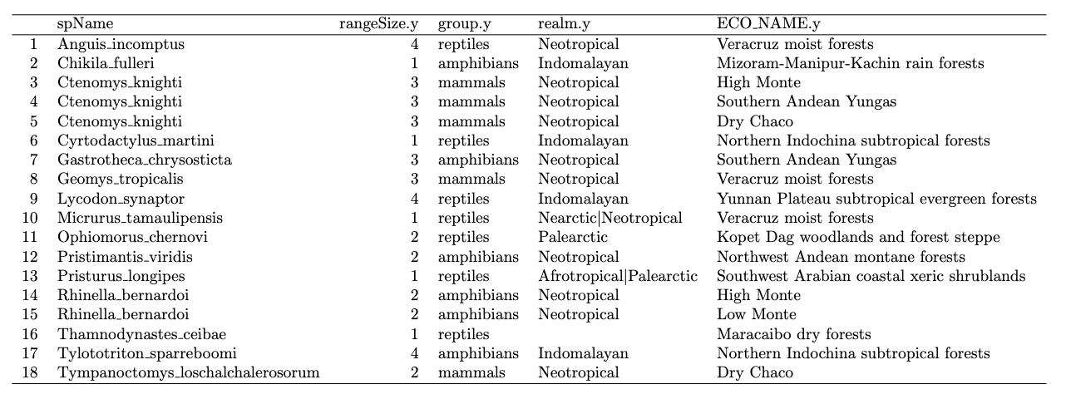

Figure S1
We examined sensitivity to different ways of estimating species niche limits on the number of highly exposed species over time (bars) in relation to mean global terrestrial temperatures (red line) and El Niño events (asterisks denoting large versus small events) as in Figure 2. The key finding is that the relative temporal trends in exposure change little based on underlying methods, however the total number of species impacted increased when more conservative upper thermal niche limits were chosen (e.g., panel a vs b). Upper thermal niche limits were chosen based on two quantiles: (1) within a single 0.25º pixel, the quantile of the given climate value over the historical record is chosen, which we call the ‘climate quantile’; (2) across the pixels in a species range, we chose the quantile over the values from step (1), which we call the ‘niche quantile’ to determine the species upper thermal niche limit (see Methods for further details). (a) Climate quantile = 0.95 and niche quantile = 0.95 correspond to the lowest value we considered for a species thermal limit. (b) Climate quantile = 1 and niche quantile = 0.99 correspond to the highest value we considered for a species thermal limit. If we lowered (raised) the threshold used to define extreme conditions, the magnitude of exposure predictably increased in 2023 by 14% (decreased by 3%). Note that considering a value of niche quantile = 1 is not appropriate for this time series analysis, because it would, by definition, require that no exposure ever occurred prior to 2023. This case is not helpful for determining the context of 2023 relative to the historical record, but may be useful for describing the lower bound on 2023 exposure when mapped across the globe, as in figure S2a.
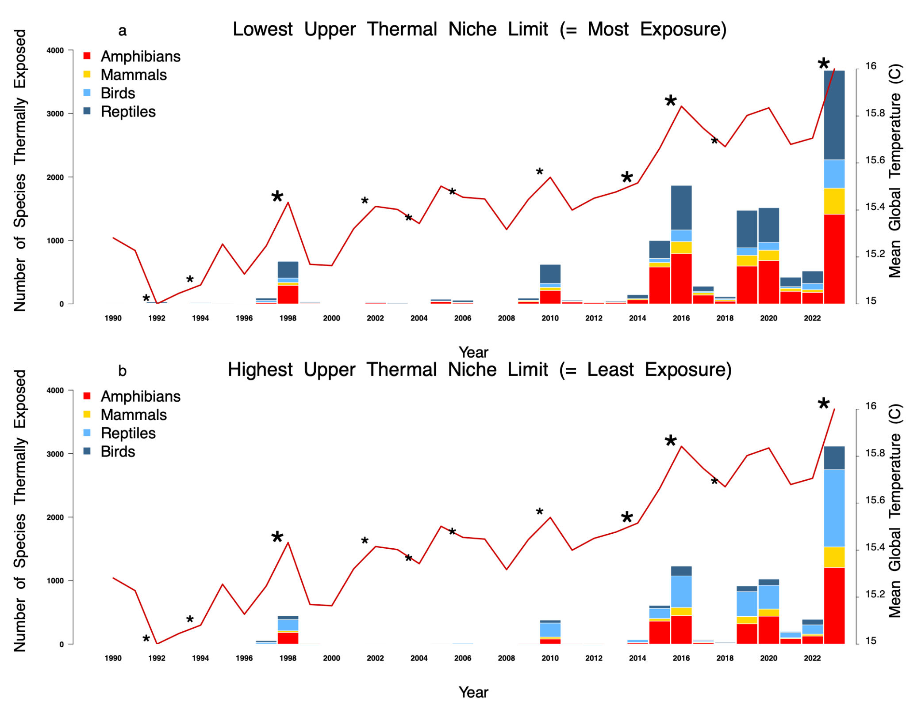

Figure S2
Sensitivity of thermal exposure in 2023 to different choices for defining niche limits. (a) To represent the lower bound on exposure, climate quantile and niche quantile were both set to 1.0, to represent the warmest year known to be experienced by the species prior to 2023. (b) As an upper bound on the number of species exposed to extreme, but not maximum, temperature, climate quantile and niche quantile we both set at 0.95. Note that on the color scale, only the highest exposure bin spanning [569-1000] species denoted in purple differs from the scale in Figure 1 in the main text, making it comparable for all other bins. 79 quarter degree pixels (~60,000 km²) in the Amazon fall into this bin.
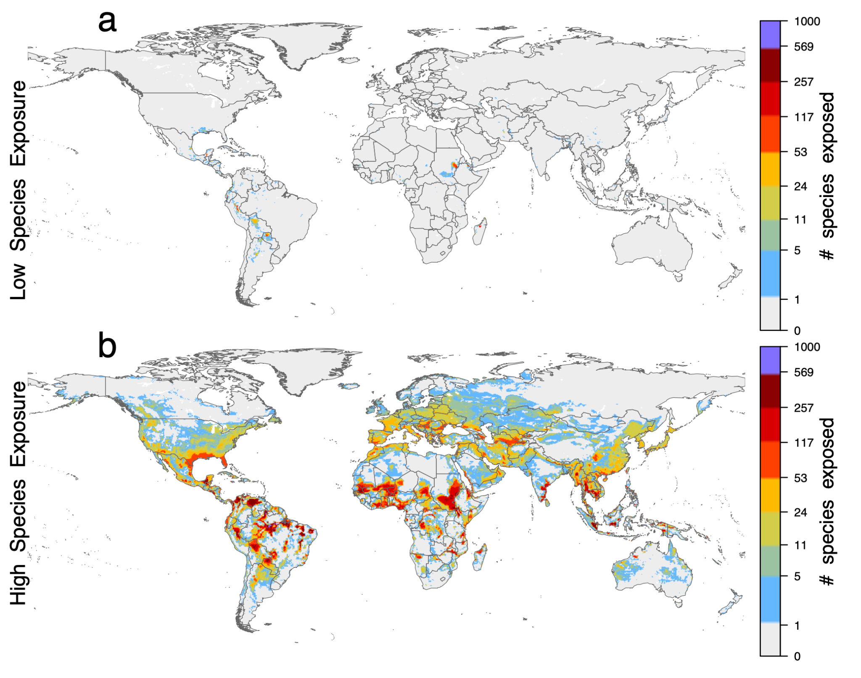

Figure S3
Sensitivity to quantile estimation method. A variety of methods used to estimate quantiles are robust across a range of quantile values, however methods diverge for the most extreme quantiles ⁸⁴, which are the subject of our study. In the main text we used the (likely) most widely used method by R software users ⁷³ (the default method in the quantile function of the stats package; quantile(..., type=7)). However ⁸⁴ recommend alternatives; (a) shows a method that is median-unbiased regardless of the distribution of the variable (quantile(..., type=8)) and (b) shows a method that is unbiased if the variable is normally distributed (quantile(..., type=9)). Since we found low sensitivity of our exposure estimates to this choice, we elected to focus on the most widely used and default method.
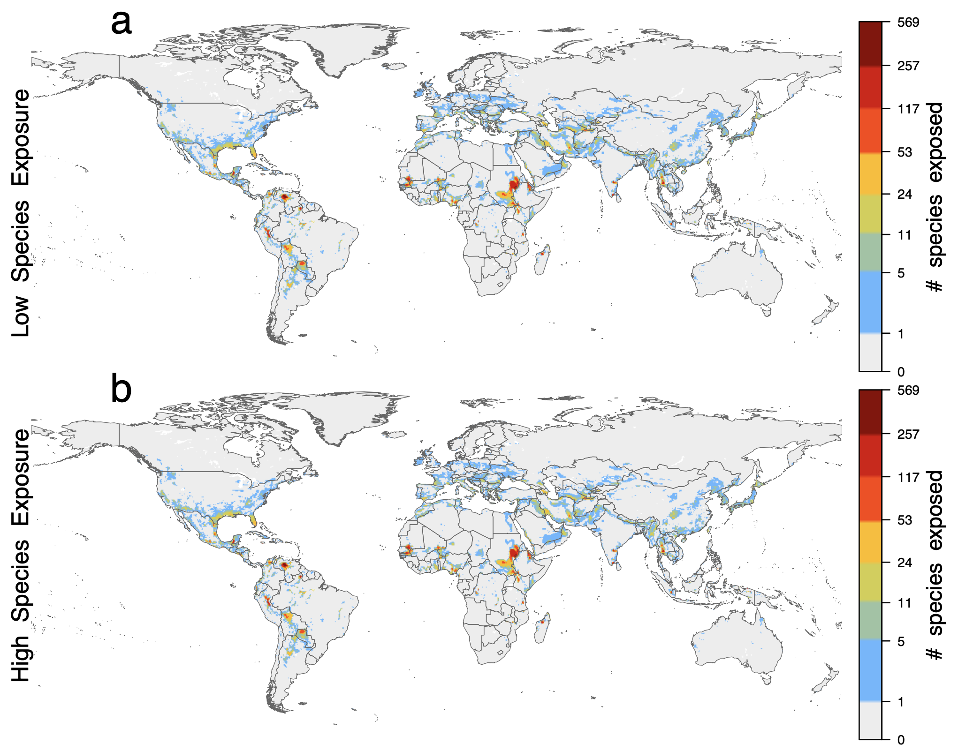

Figure S4
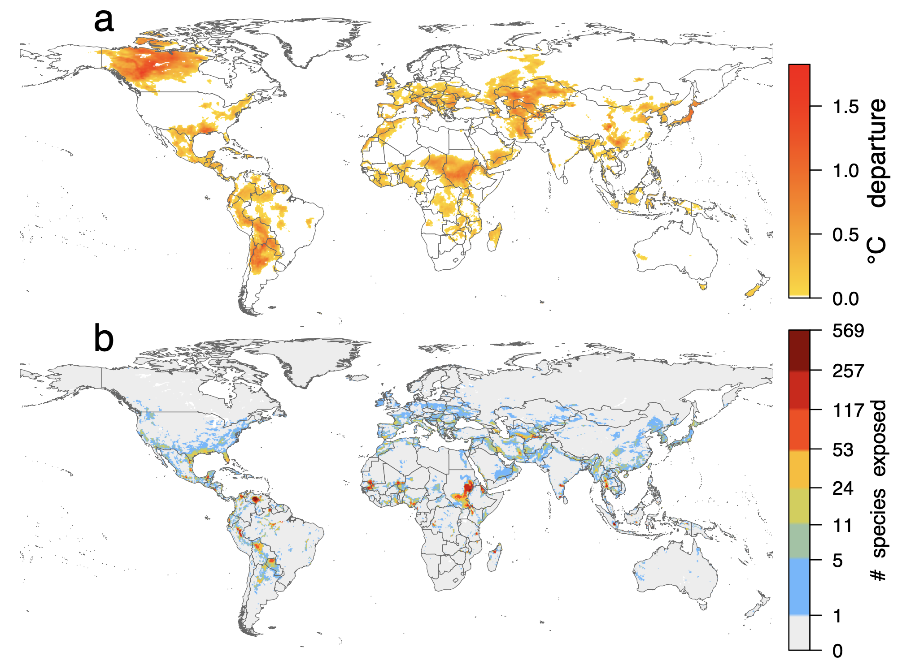
Examination of how climate anomalies in 2023 (a) differ from species exposure (b). Panel (a) shows the magnitude of climate anomaly in 2023 (unadjusted for species) exceeding the 0.99 quantile of the historical record from 1940 - 2022 for mean annual temperature. In this analysis, climate anomaly covered 22.9% of the land surface in 2023 (excluding Antarctica). However, climate anomalies need not equal climate exposure because of the spatiotemporal variation experienced by individual taxa. Panel (b) shows species exposure (adjusted to species ranges and realized historical niche limits). Species exposure had distinctly different spatial patterns than climate anomaly for two reasons. First, niche limits reflect the fact that species are typically adapted to conditions beyond the local range of historical climate variation ⁸⁵. Hence, narrow-ranged species living in more homogenous regions or experiencing more stable climates are predicted to face greater threats than broadly distributed species living in heterogeneous regions with high climatic variability ^{86,87}. Just 44% of pixels experiencing climate departure had at least one species exposed, while 9% had more than 10 exposed species and 4% had more than 20 exposed species. The magnitude of departure is positively related to the number of species exposed in a pixel (r = 0.07), but the relationship is weak. Second, species exposure can occur without local climate departure in locations near niche edges; i.e., locations that more frequently but temporarily exceed niche limits. These locations are likely to already be marginal by a species’ standards, even if not by the historical baseline of the pixel. 45% of cells with at least one species exposed did not experience climate departure, 15% of such cells had >10 exposed species and 7% had >20 exposed species. Hence, by accounting for species’ climate tolerance across their range we find different patterns of exposure both in terms of location and severity. Therefore, even moderate climate change can expose these marginal populations to historically anomalous temperatures relative to a species’ niche limits.

Figure S5
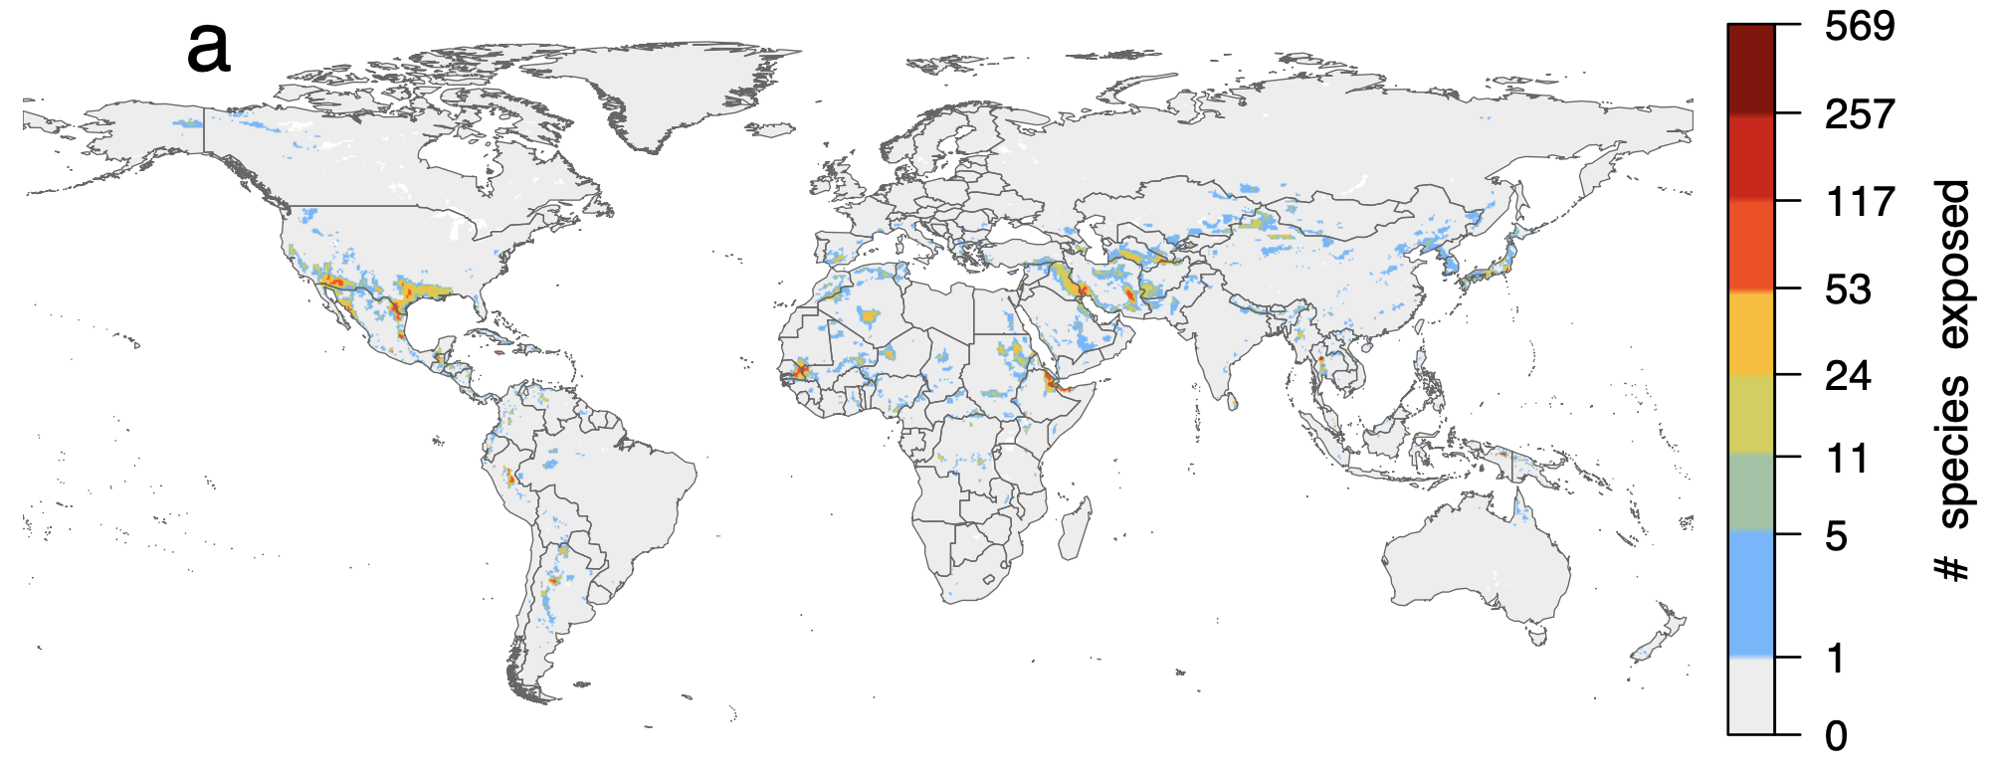
Exposure to other types of extremes in 2023 included (a) historically hot seasons and (b) drought exposure. Drought was quantified based on total annual precipitation falling below the 0.01 quantile of the historical range and hot seasons those above the 0.99 quantile of the mean temperature of the three warmest consecutive months (more details in Methods). We used the water year (October-September) to avoid splitting the southern summer into two separate calendar years. To quantify niche limits, we used the 0.01 quantile among pixels for drought across each species range and above the 0.99 quantile for hot seasons. Locations with at least one species exposed to hot seasons (11.7%) or drought (5.1%) were much less extensive than those with high mean annual temperatures (22.9%) due to the higher historical interannual variability and their more complex relationships to global warming. For comparison, the color scale is the same as in Figure 2.

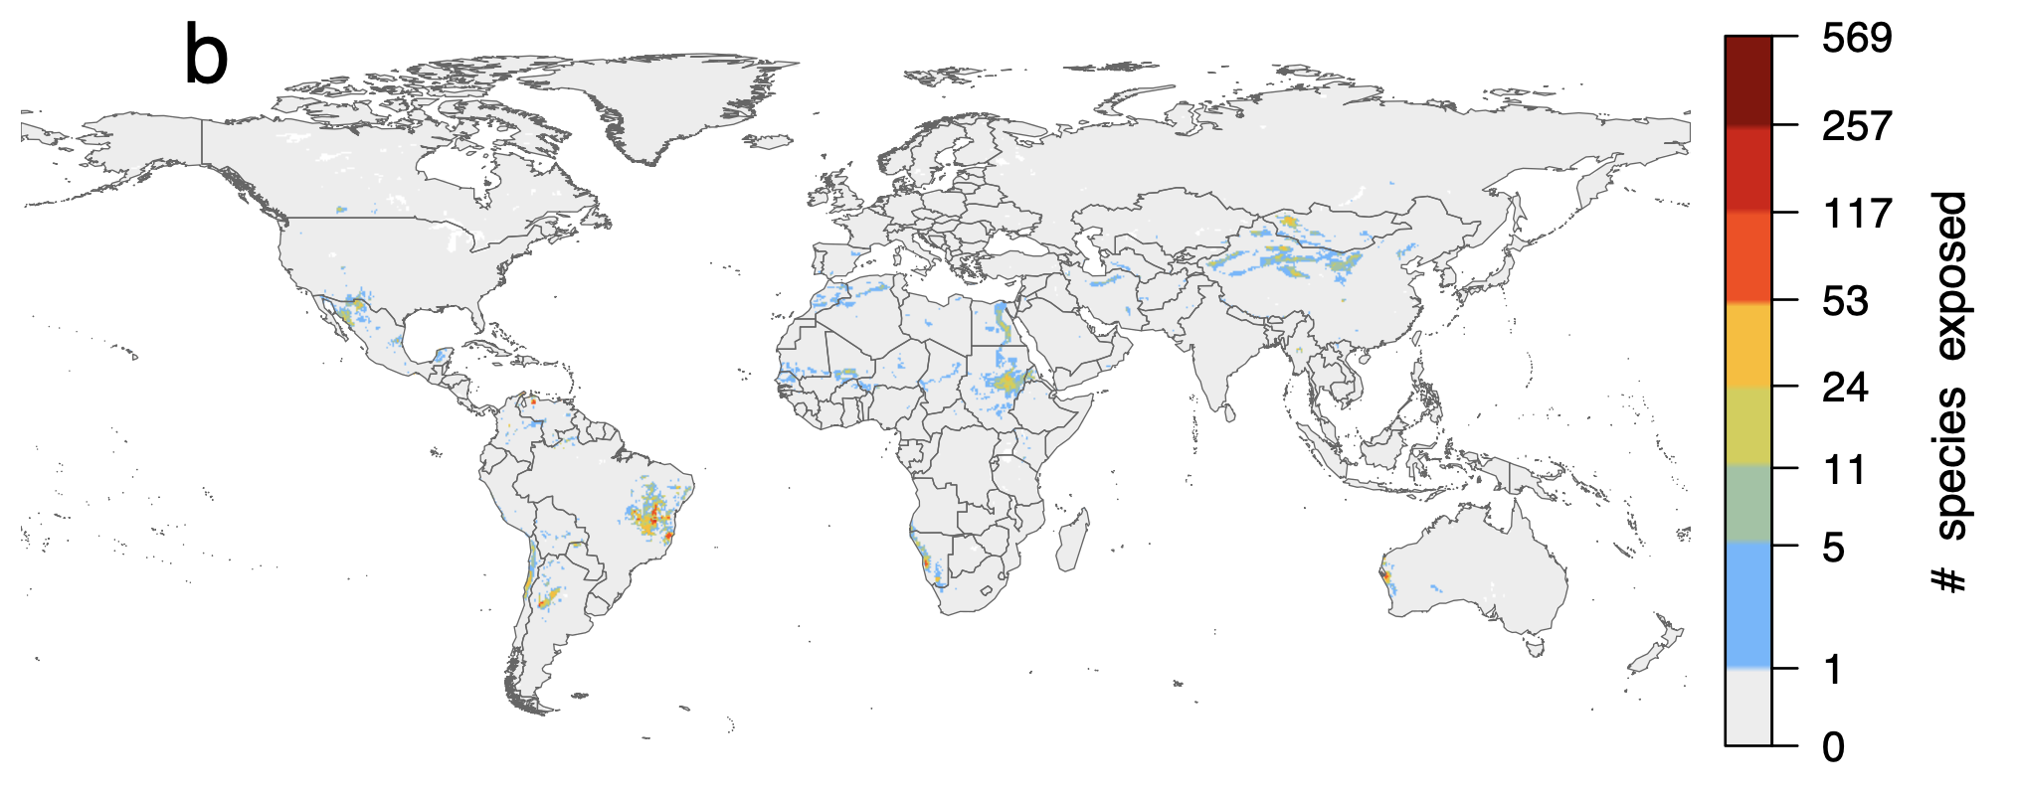

Figure S6
Sensitivity analysis of spatial exposure patterns to extreme mean annual temperature in 2023 illustrates that patterns in Figure 1 in the main text are relatively insensitive to variation in thermal niche limits. For the analysis, observed niche limits were perturbed by adding -0.10, -0.05, +0.05, and +0.10 to each limit, and recomputing exposure estimates. The maximum difference of 0.10 C was chosen because this approximately the amount by which 2023 was warmer than the previous warmest year, 2016 (Fig. 1). This analysis was designed to address whether uncertainty in climate variables might affect our findings, given that absolute values of uncertainty in temperature are not available for the ERA5 reanalysis product we used. We perturbed the niche limits but not the temperature layers to consider the case where uncertainty in the temperature value might impact niche limit estimation (if both were perturbed, no differences would be observed because all values would shift by the same amount). With the relatively coarse bins used for the color scale, no major differences are visually apparent. Considering the raw number of species exposed per pixel, 78% of pixels had no difference in the number of species exposed between the -0.1 and +0.1 perturbation, while 94% had a difference of fewer than 5 species and 97% differed by less than 11 species.

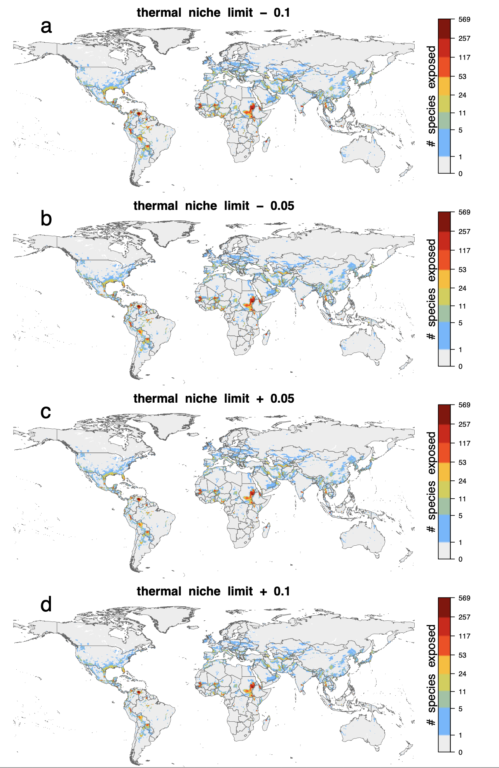

Figure S7

Sensitivity analysis of temporal exposure patterns to extreme mean annual temperature illustrates that patterns in Figure 2 in the main text are relatively insensitive to variation in thermal niche limits. Perturbations to niche limits were conducted as described in Figure S6. While the number of species exposed increases for lower niche limits, general relative trends among years remain consistent with Figure 2.
