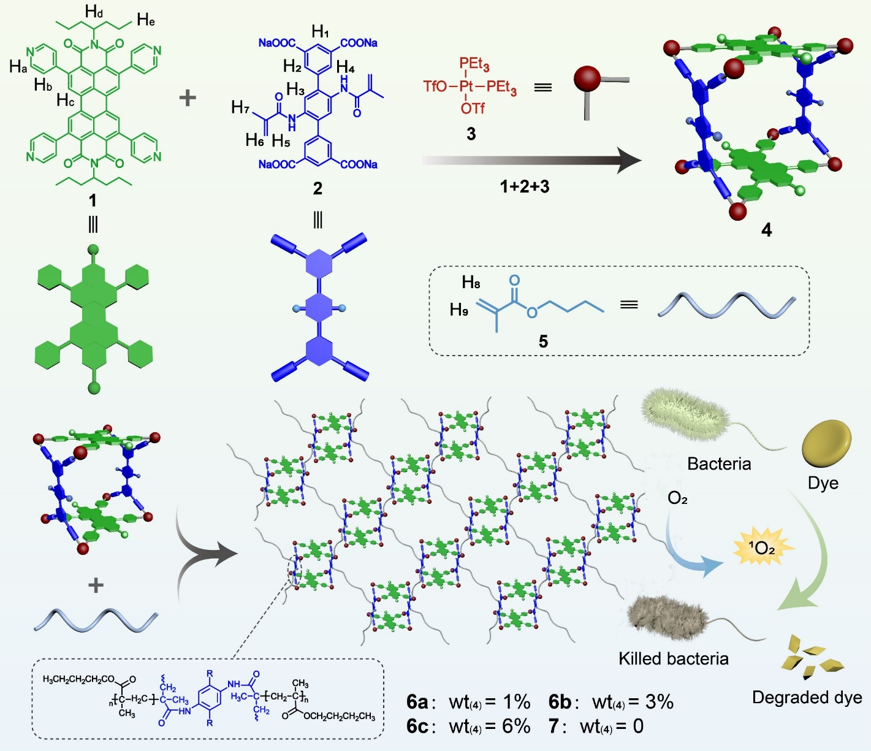
Scheme 1. Synthetic routes and cartoon representations of metallacage-crosslinked supramolecular networks

