Supporting Information
Metallacage-Crosslinked Free-Standing Supramolecular Networks via Photo-induced Copolymerization for Photocatalytic Water Decontamination
Rongrong Li, ^{#,1} Haixin Zhang, ^{#,2} Yali Hou,^{1,3} Lingyan Gao,*^{,2} Dake Chu, *^{,4} and Mingming Zhang*^{,1}
#These authors contributed equally.

- Materials and methods
General materials and instrumentation
Reagents and deuterated solvents were used as received. NMR spectra were recorded with Bruker Avance spectrometers operating at 400 MHz or 600 MHz. ¹H NMR shifts were measured relative to residual solvent signals, while ³¹P{¹H} NMR shifts were referenced to an external 85% H₃PO₄ sample. Mass spectra were obtained using a Micromass Quattro II spectrometer with electrospray ionization, controlled by MassLynx software. UV-Vis spectroscopy was performed with a Lambda 950 spectrophotometer, and fluorescence measurements were conducted using either an Edinburgh FLS9 or a Hitachi F-7000 spectrophotometer. X-ray diffraction was carried out on a Bruker D8 VENTURE PHOTON II MetalJet, with crystal samples cryoprotected in paratone oil and cooled with nitrogen. Data were corrected for absorption with SADABS, and structures were solved and refined using OLEX2 1.2, applying F2 for all reflections. Electron spin resonance (ESR) measurements were conducted with a Bruker EMXplus-6/1 spectrometer. Scanning electron microscopy (SEM) images were acquired with a Hitachi SU8010. Fluorescence titration experiments involved adding varying amounts of guest molecules to CH₃CN/CHCl₃ (1:1) or CH₃CN solutions of metallacages, with the metallacage concentration fixed at 10.0 μM. The data were fitted using the following equation:
δ = (Δδ_{max}/[H]₀) (0.5[G] + 0.5 ([H]₀+1/K_{a}) − (0.5([G]²+(2[G](1/K_{a}–[H]₀)) + (1/K_{a}+[H]₀)²)^{0.5}))
In these equations, δ represents the fluorescence change of the metallacages upon the addition of guest molecules, Δδ_{max} denotes the maximum fluorescence intensity change when the metallacages are fully complexed, [H]₀ is the constant concentration of the metallacages (10.0 μM), and [G] is the concentration of the guest molecules. Each fluorescence titration experiment was conducted in triplicate.
Singlet oxygen measurements
Singlet oxygen generation studies were conducted using electron spin resonance (ESR) with TEMP (0.2 M) as the spin trapping agent under light irradiation. Singlet oxygen quantum yields were measured in acetonitrile with a LED lamp (λ = 520 nm) as the light source. Prior to the experiment, the absorption of the photosensitizers 1, 4, 6a, 6b, 6c and 7 at the excitation wavelength of 520 nm was adjusted to approximately 0.25. Quantum yields for singlet oxygen generation were determined by monitoring the decrease in absorption of 1,3-diphenylisobenzofuran (DPBF) at 410 nm, which is caused by its photooxidation. Time-dependent absorption spectra of DPBF were recorded at 1-minute intervals for the homogeneous phase. Singlet oxygen quantum yields (Φ_{Δ}) were calculated using a relative method with optically matched solutions, comparing the decrease in absorbance of DPBF sensitized by the photosensitizers to that sensitized by rose bengal (RB) (Φ_{Δ} = 0.54) as a reference, according to the following equation:
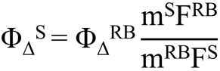
Superscripts “S” and “RB” refer to the photosensitizers and rose bengal, respectively. “Φ_{Δ}” represents the quantum yield of singlet oxygen. The parameter “m” denotes the slope of the plot showing the change in DPBF absorbance at 410 nm over irradiation time, while “F” is the absorption correction factor, defined as F=1-10^{-OD}, where OD is the absorbance of the photosensitizer.
Photocatalytic degradation measurement
Networks 6a, 6b or 6c (0.1 mg) were added to aqueous dye solutions of G₃, G₄, G₅ or G₆ (0.02 g/L, 5 mL) to reach adsorption-desorption equilibrium before irradiation. The distance between the reactor and the UV lamp (λ = 520 nm) was maintained at 5 cm. Samples of the dye solution were collected at 20-min intervals during irradiation. The collected samples were analyzed using a UV/Vis spectrophotometer to measure absorbance and quantify dye concentration based on the maximum absorption wavelength of the dyes. The degradation rate was determined by calculating the percentage of dye concentration remaining relative to the initial dye concentration, using an absorbance standard curve. Degradation performance was evaluated using the following Equations (1) and (2):
η (%) = [(C₀ – C_{t})/C₀)] × 100 (1)
where η represents the degradation rate, C₀ is the initial concentration of dyes (mg/L) and C_{t} is the concentration (mg/L) at the reaction time (t).
ln (C₀/C_{t}) = Kt (2)
where C₀/C_{t} represents the normalized dye concentration, K is the first-order rate constant and t is the reaction time.
Cell culture
In this study, Gram-negative bacterial strain E. coli (E. coli, ATCC25922) and Gram-positive bacterial strain S. aureus (S. aureus, ATCC25923) were utilized. The bacteria were initially streaked from -20 °C glycerol stocks on lysogeny broth (LB or TSB) agar plates. After growth on LB agar plates, the cells were cultured from a fresh single colony in LB. All experiments were conducted at 37 °C, and all glassware used in this study was sterilized prior to testing.
Antibacterial activity of ligands and networks
S. aureus and E. coli bacterial suspensions used in the antibacterial test were prepared at a concentration of 10⁵ CFU/mL in phosphate-buffered saline (PBS) (CFU stands for colony-forming units). Ligands 1, 3 and 4 were dissolved in dimethyl sulfoxide to prepare three initial solutions. Next, 15 μL of each initial solution was added to the wells of a standard 96-well culture plate, then diluted using the double dilution method, and 185 μL of bacterial suspension was added to each well. For network 6a, the corresponding solid samples were cut and placed in a standard 96-well culture plate, followed by the addition of 200 μL of bacterial suspension into each well. For networks 6b and 6c, a specific amount of solid was cut, fully dissolved in ethanol, and a certain volume of the ethanol solution was transferred into the 96-well culture plate. After the ethanol had completely evaporated, 200 μL of bacterial suspension was added to each well. These cultures were either exposed to 520 nm irradiation or left untreated for 30 minutes, after which they were incubated at 37 °C for 24 h. Subsequently, 100 µL of the planktonic bacterial suspensions were serially diluted and plated onto nutrient agar plates. The bacterial colonies were recorded after a 24-hour incubation at 37 °C. Each experiment was repeated three times.
Antibacterial activity of dyes
S. aureus and E. coli bacterial suspensions used in the antibacterial test were prepared at a concentration of 10⁵ CFU/mL in phosphate-buffered saline (PBS). Two dye solutions, G₃ and G₅, were initially prepared at a concentration of 0.1 g/L in water and then diluted with the bacterial suspension to a final concentration of 0.01 g/L in a 96-well culture plate. The cultures were then incubated at 37 °C for 24 h. Following incubation, 100 µL of the planktonic bacterial suspensions were serially diluted and plated onto nutrient agar plates. The bacterial colonies were recorded after 24 h of incubation at 37 °C. Each experiment was performed in triplicate.
Antibacterial activity of dye mixed with network under light irradiation
S. aureus and E. coli bacterial suspensions used in the antibacterial test were prepared at a concentration of 10⁸ CFU/mL in phosphate-buffered saline (PBS) (CFU stands for colony-forming units). A 3 mL portion of the prepared dye solution was mixed with 0.5 mL of the bacterial suspension for illumination. After exposure to light, 100 µL of the planktonic bacterial suspensions were serially diluted and plated onto nutrient agar plates. The bacterial colonies were counted after incubation at 37 °C for 24 h. Each experiment was conducted in triplicate.
Scanning electron microscopy (SEM)
SEM was used to observe the morphological changes in S. aureus and E. coli after treatment with different ligands or networks, with or without 520 nm irradiation for 30 min. The treated bacteria were washed twice with PBS and then fixed with 4 % glutaraldehyde overnight at 4 °C. Following fixation, the bacteria were washed with sterile PBS and sequentially dehydrated using increasing concentrations of ethanol (30 %, 50 %, 70 %, 80 %, 90 %, and 100 %) for 15 min each. The dehydrated bacteria were then placed onto a silicon wafer and dried under vacuum conditions overnight. Prior to observation, the specimens were coated with platinum.
Statistical analysis
Data are represented as mean ± standard deviation (S.D). Group differences were conducted by one-way ANOVA with Tukey’s post-hoc test. P-values < 0.05 were considered as statistically significant (*p < 0.05, **p < 0.01, ***p < 0.001, ****p < 0.0001). All statistical analyses were performed with GraphPad Prism 9.
Plant Cultivation
Green pea seeds were selected as the research subject. First, the seeds were cleaned and any damaged seeds were removed. The remaining seeds were then soaked in an appropriate amount of water for 12 h. Wastewater (G₃, G₄, G₅ and G₆ aqueous solution with the concentration of 0.02 g/L, S. aureus and E. coli solution with the concentration of 10⁸ CFU/mL) and degraded water (wastewater treated by 6c after 520 nm illumination for 30min) were poured into two separate trays, each covered with a perforated grid tray. Equal amounts of the soaked seeds were evenly spread on the two grid trays, ensuring that the seeds did not overlap. The seeds were then sprayed with water and covered with a layer of seedling paper to maintain humidity. After the seeds sprouted to about 1 cm, the seedling papers were removed. The growth of the plants and the condition of the roots were recorded on the 4th and 7th days for both groups.

2. Synthetic procedures and characterization data
Synthesis of compound 8
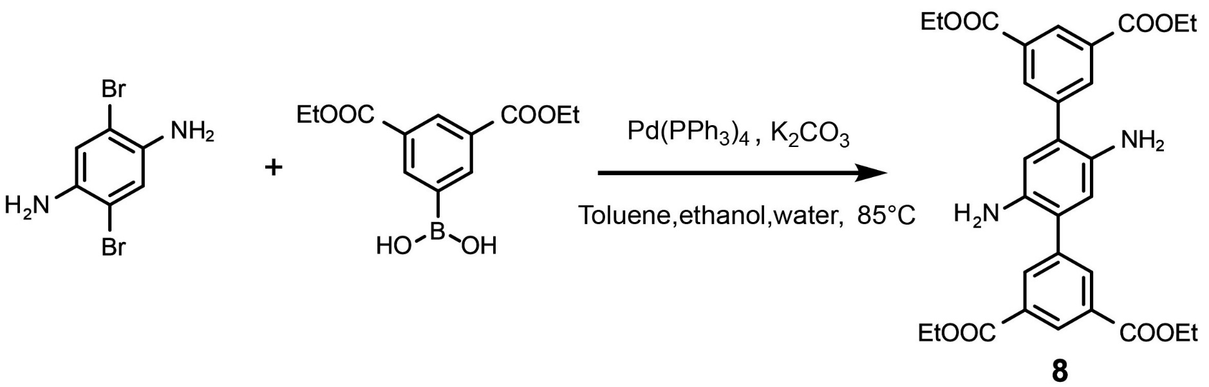
2,5-Dibromobenzene-1,4-diamine (1.00 g, 3.76 mmol), (3,5-bis(ethoxycarbonyl)phenyl) boronic acid (3.00 g, 11.28 mmol), K₂CO₃ (2.08 g, 15.04 mmol), Pd (PPh₃)₄ (0.22 g, 0.19 mmol) were added to a 250 mL flask. Then toluene, ethanol and water (4:1:1, 120 mL) were added to the flask under nitrogen. The system was degassed and purged with nitrogen by freeze-pump-thaw 3 times. The mixture was heated at 85 °C for 2 days. After cooling, the solvents were removed and the residue was washed with acetone to give a crude product which was purified by flash column chromatography (CH₂Cl₂: CH₃OH = 200:1) to give compound 8 (1.82 g, 88.3%) as a solid. ¹H NMR (600 MHz, CDCl₃, 295 K) δ 8.68 (s, 2H), 8.37 (s, 4H), 6.70 (s, 2H), 4.43 (dd, J = 14.1, 7.0 Hz, 8H), 1.43 (t, J = 7.1 Hz, 12H).
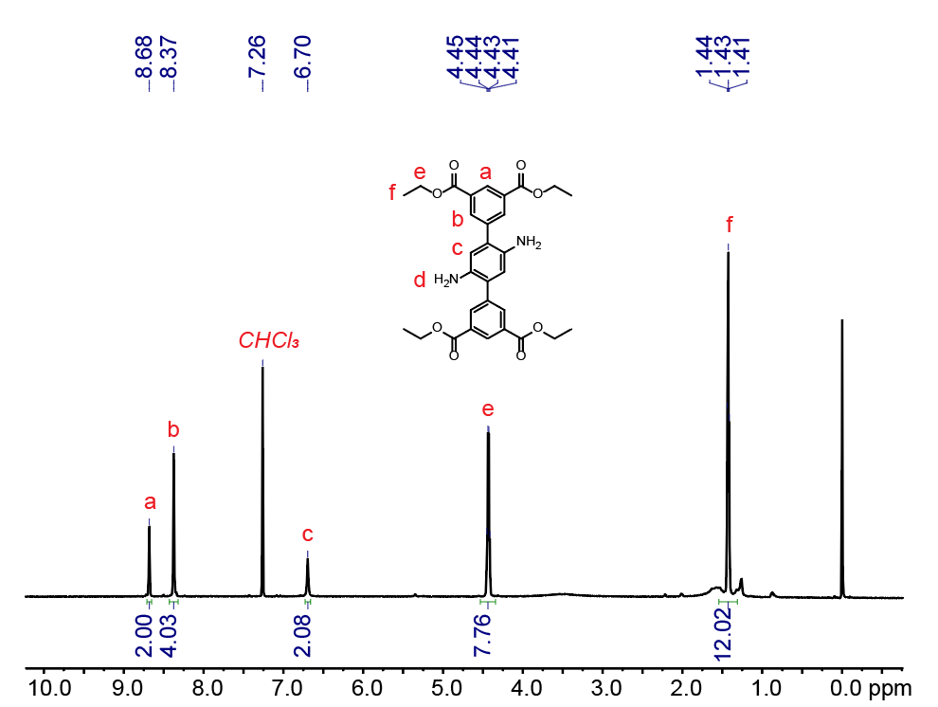
Figure S1. ¹H NMR spectrum (600 MHz, CDCl₃, 295 K) recorded for 8.

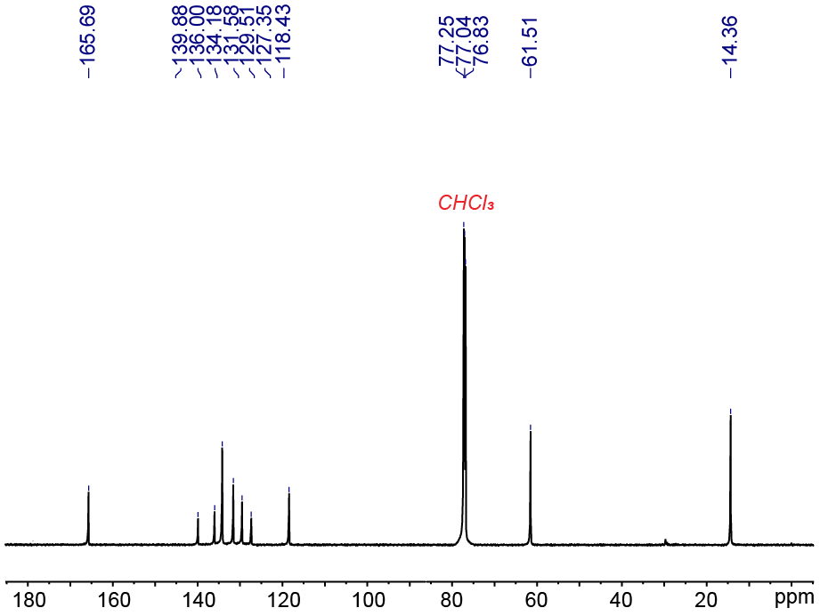
Figure S2. ¹³C NMR spectrum (151 MHz, CDCl₃, 295 K) recorded for 8.
Synthesis of compound 9
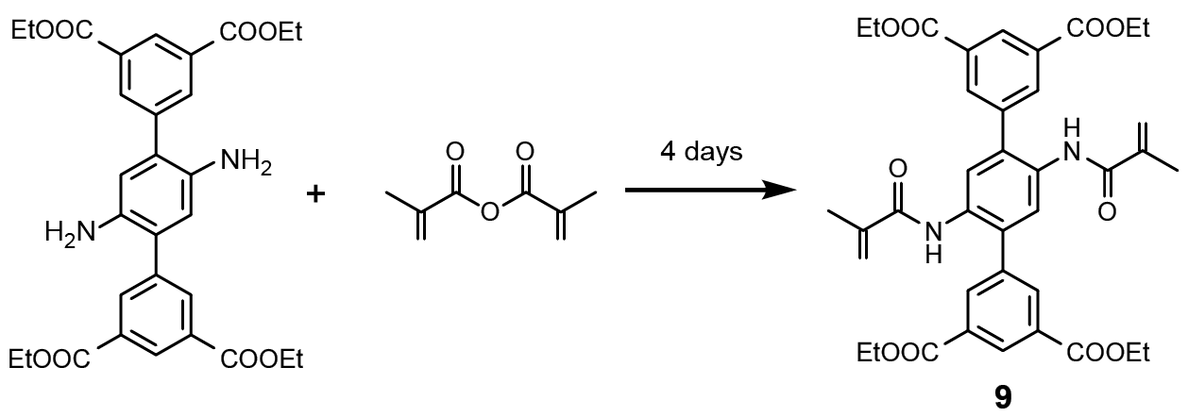
The as-synthesized compound 8 was mixed with methacrylic anhydride in CH₂Cl₂ and kept in a closed vial for 4 days. The solids were washed several times with fresh CH₂Cl₂ and then dried under vacuum at 50 ºC for 12 h to obtain the compound 9. ¹H NMR (600 MHz, CDCl₃, 295 K) δ 8.78 – 8.75 (m, 2H), 8.43 (s, 2H), 8.34 (d, J = 1.5 Hz, 4H), 7.49 (s, 2H), 5.58 (s, 2H), 5.33 (s, 2H), 4.44 (dd, J = 14.3, 7.1 Hz, 8H), 1.86 (s, 6H), 1.42 (t, J = 7.1 Hz, 12H).
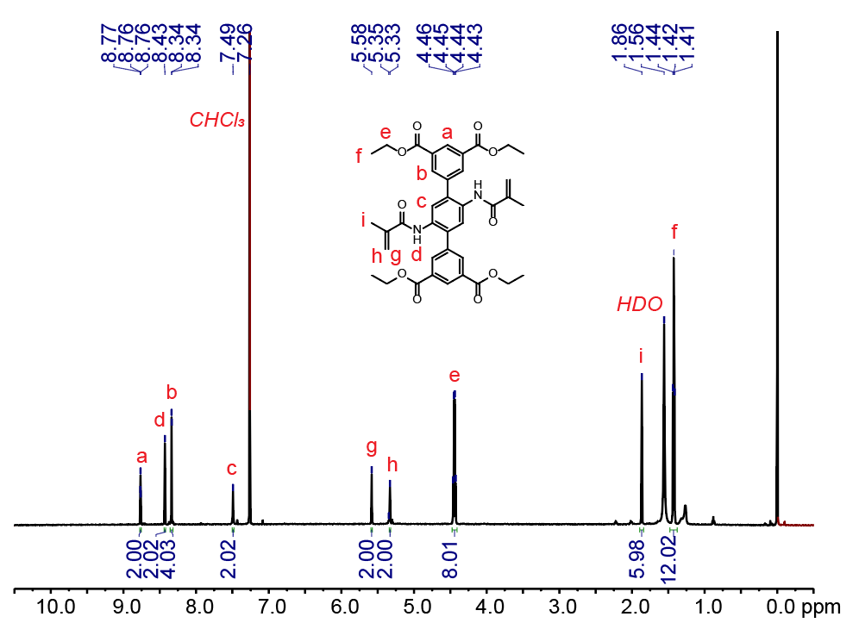
Figure S3. ¹H NMR spectrum (600 MHz, CDCl₃, 295 K) recorded for 9.

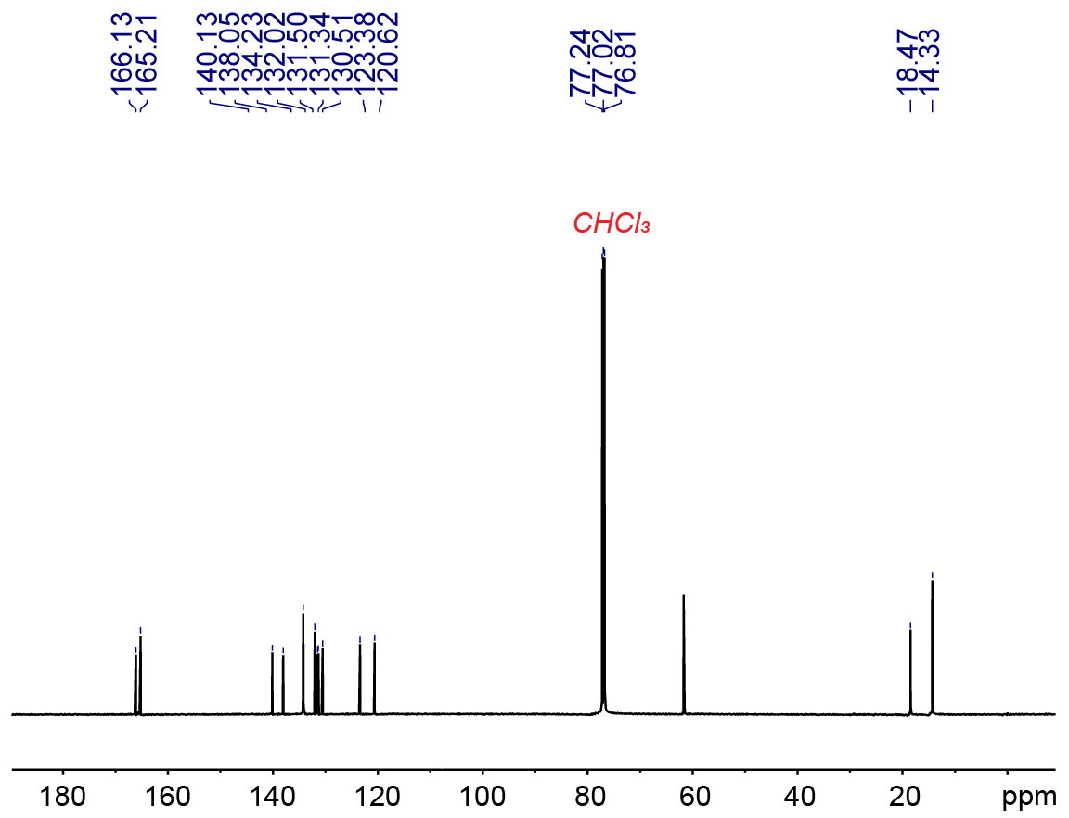
Figure S4. ¹³C NMR spectrum (151 MHz, CDCl₃, 295 K) recorded for 9.
Synthesis of compound 10
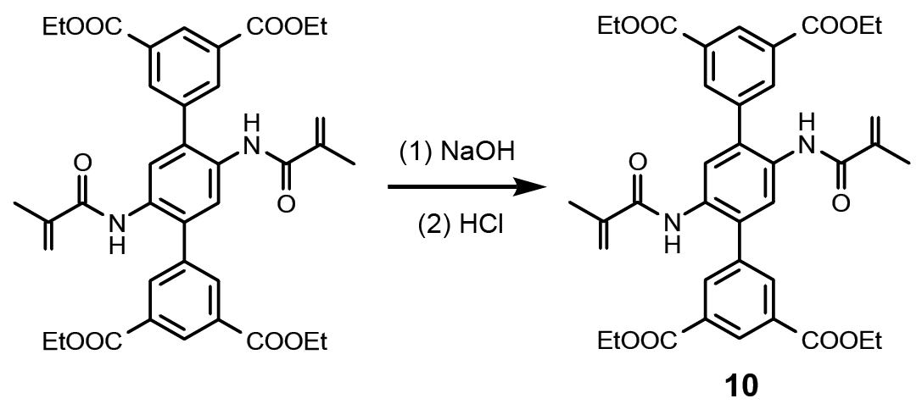
Compound 9 (0.05 g, 0.07 mmol) and NaOH (0.04 g, 1.10 mmol) were added in ethanol (12 mL), THF (12 mL) and H₂O (4 mL). The mixture was stirred in 70 °C for 12 h. Then the solvent were evaporated under reduced pressure and the pH was adjusted to 1 with using 1 M HCl to give a white precipitate. The precipitate was filtered and washed with H₂O to give 10 (0.04 g, 96%) as a white solid. ¹H NMR (600 MHz, DMSO, 295 K) δ 13.35 (s, 4H), 9.71 (s, 2H), 8.45 (s, 2H), 8.23 (d, J = 1.5 Hz, 4H), 7.50 (s, 2H), 5.61 (s, 2H), 5.37 (s, 2H), 1.81 (s, 6H).
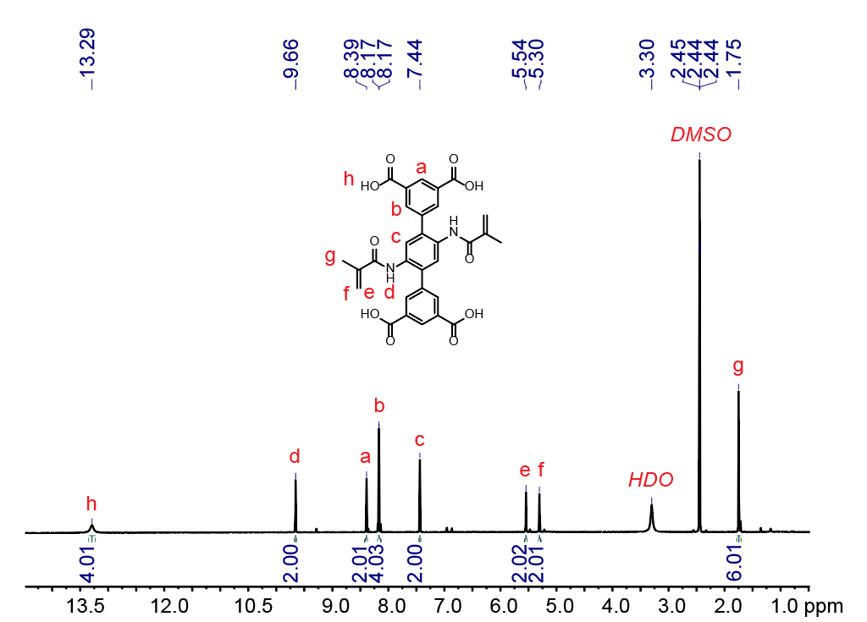
Figure S5. ¹H NMR spectrum (600 MHz, CDCl₃, 295 K) recorded for 10.
Synthesis of compound 2
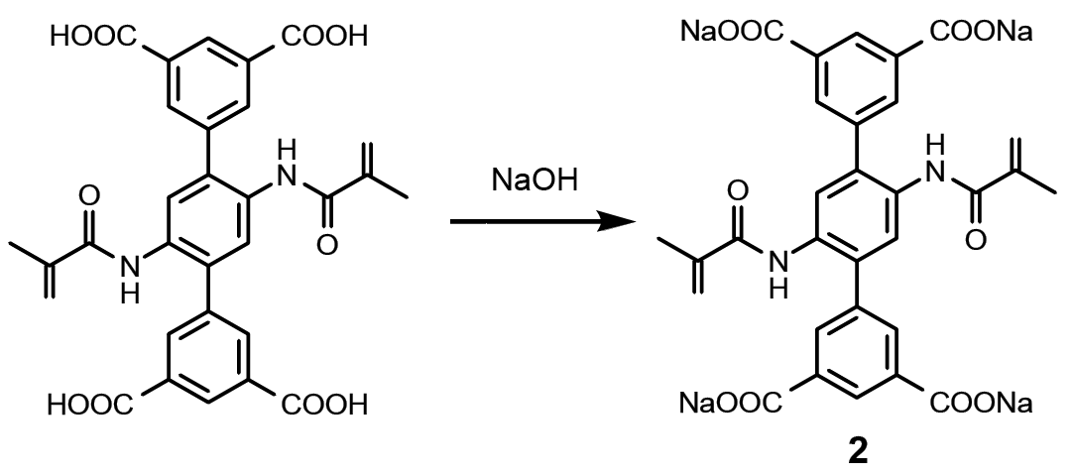
Compound 10 (0.50 g, 0.87 mmol) and NaOH (0.15 g, 3.67 mmol) were added to H₂O (50 mL) and stirred at room temperature for 3 h. Then the mixture was concentrated and washed by acetone to give 2 (0.55 g, 95%) as a white solid. ¹H NMR (600 MHz, MeOD, 295 K) δ 8.65 (s, 4H), 8.65 (s, 3H), 8.19 (s, 8H), 8.19 (s, 6H), 7.85 (s, 4H), 7.85 (s, 3H), 5.68 (s, 5H), 5.68 (s, 3H), 5.35 (s, 5H), 5.35 (s, 3H), 1.90 (s, 6H).
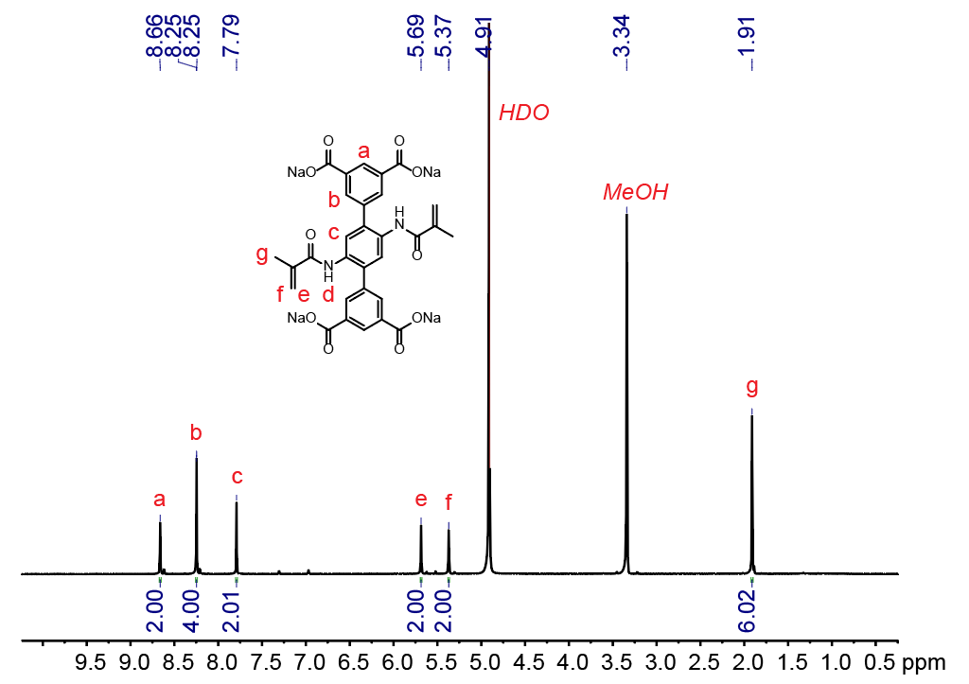
Figure S6. ¹H NMR spectrum (600 MHz, CDCl₃, 295 K) recorded for 2.

Synthesis of metallacage 4
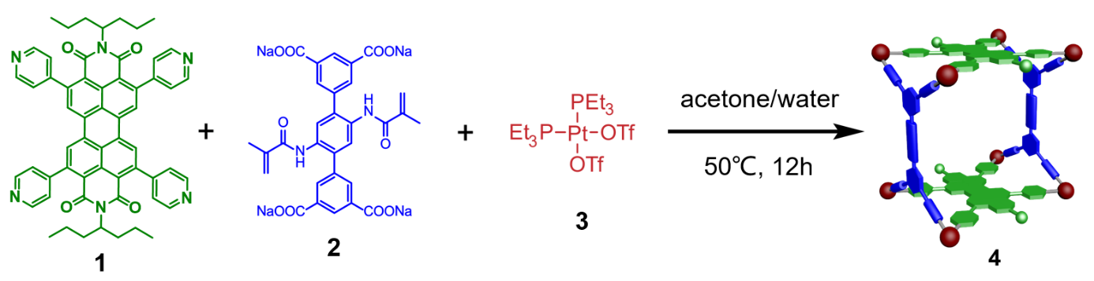
Compound 1 (5.00 mg, 5.59 µmol), tetracarboxylate ligand 2 (3.69 mg, 5.59 µmol), and cis-(PEt3)2Pt(OTf)2 3 (16.30 mg, 22.34 µmol) were mixed in a 1:1:4 molar ratio and dissolved in acetone/water (6.0 mL, 4:1, v/v). The whole reaction mixture was heated at 60 °C for 8 h and then cooled to room temperature. The solvent was removed by nitrogen flow. The residue was redissolved in CH3CN (1.0 mL) and filtered, and the filtrate was poured into ethyl ether (10.0 mL) to give a precipitate, which was collected by centrifugation to give 4 (15.00 mg, 93%) as a red powder. ¹H NMR (600 MHz, CD₃CN, 295 K) δ 9.02 (s, 8H), 8.69 (s, 8H), 8.39 (s, 8H), 8.22 (s, 4H), 8.11 (s, 4H), 8.00 (d, J = 17.0 Hz, 8H), 7.67 (s, 8H), 7.41 (s, 8H), 5.47 (s, 4H), 5.37 (s, 4H), 4.79 (s, 4H), 0.80 (d, J = 6.7 Hz, 12H). ³¹P{¹H}NMR (243 MHz, CD3CN, 295 K): 5.40 ppm (d, ²JP-P =21.9 Hz, ¹⁹⁵Pt satellites, ¹JPt-P = 1636.6 Hz), -0.36 ppm (d, ²JP-P = 21.9 Hz, ¹⁹⁵Pt satellites, ¹JPt-P = 1732.6 Hz). ESI-TOF-MS: m/z 797.8333 [4 – 8OTf]⁸⁺, 932.3615 [4 − 7OTf]⁷⁺, 1365.0142 [4 − 5OTf]⁵⁺ and 1743.5010 [4 − 4OTf]⁴⁺.
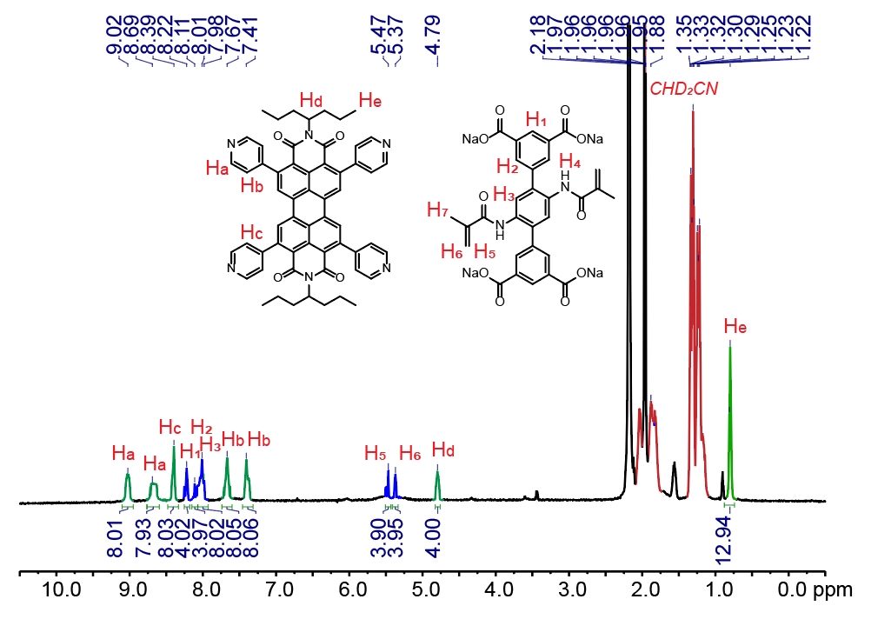
Figure S7. ¹H NMR spectrum (600 MHz, CDCl₃, 295 K) recorded for 4.

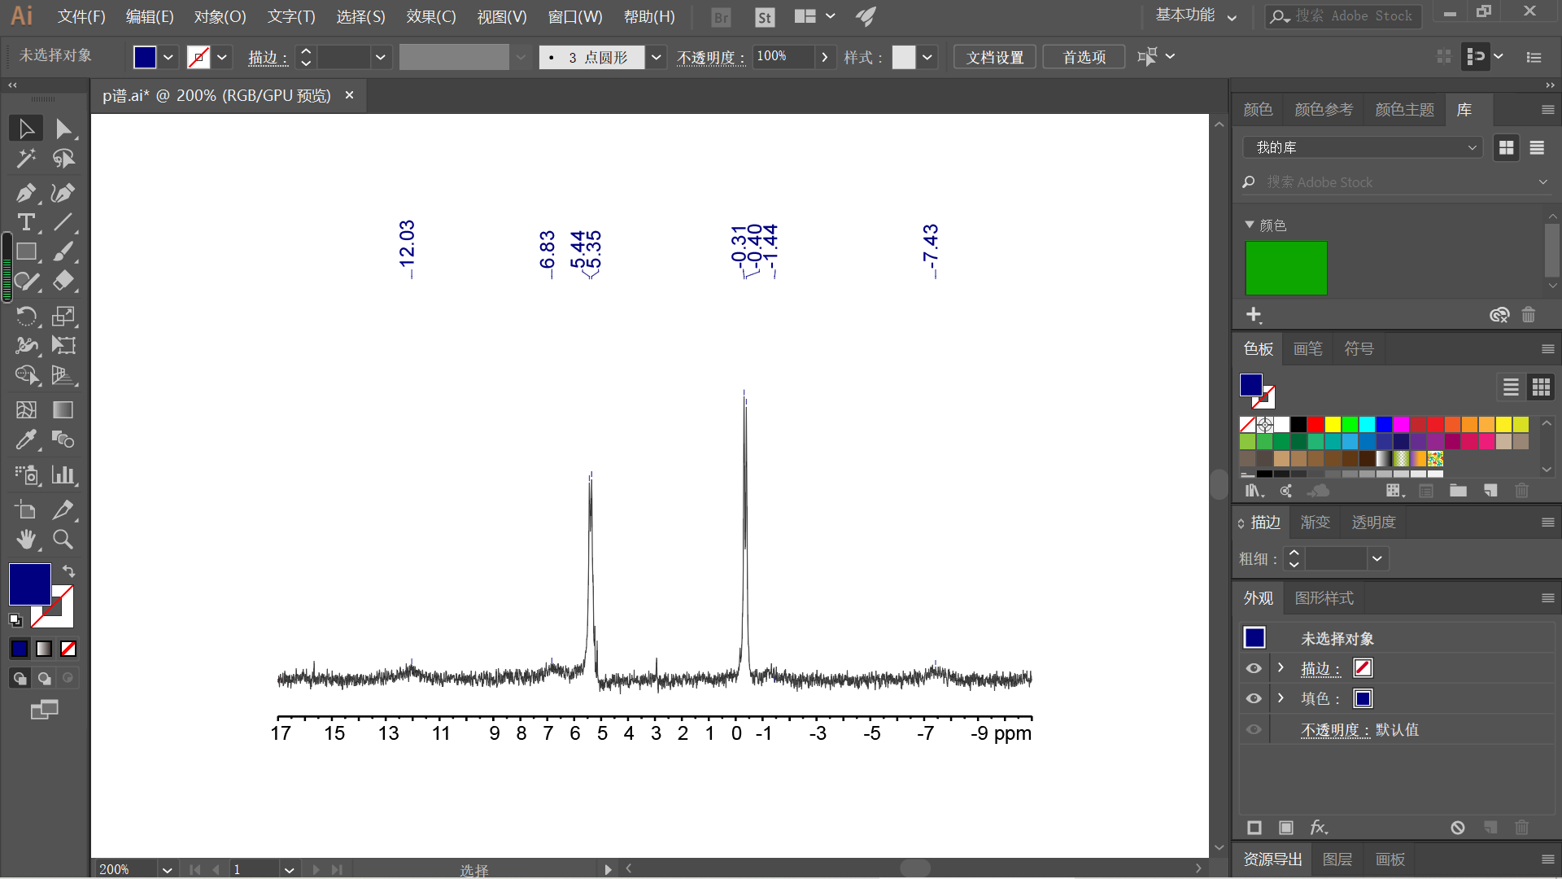
Figure S8. ³¹P{¹H} NMR spectrum (243 MHz, CD3CN, 295 K) recorded for 4.
3. Crystallographic data and refinement details
Table S1. Crystallographic data and refinement details for metallacage 4
Compound | Metallacage 4
Empirical formula | C₂₇₆H₃₇₆F₁₂N₁₆O₄₀P₁₆Pt₈S₄
Formula weight | 6970.39
Temperature/K | 193.00
Crystal system | triclinic
Space group | P-1
a /Å | 17.7584(12)
b /Å | 20.7711(15)
c /Å | 34.884(3)
α /° | 94.939(4)
β /° | 95.437(4)
γ /° | 98.224(4)
Volume /Å³ | 12612.7(15)
Z | 1
D_{calc} /g cm⁻³ | 0.918
μ /mm⁻¹ | 3.434
F (000) | 3500
Theta (max) | 51.669
Reflections collected | 134817
Independent reflns | 41878
R₁;wR₂ [I > 2σ (I)] | 0.0765; 0.1937

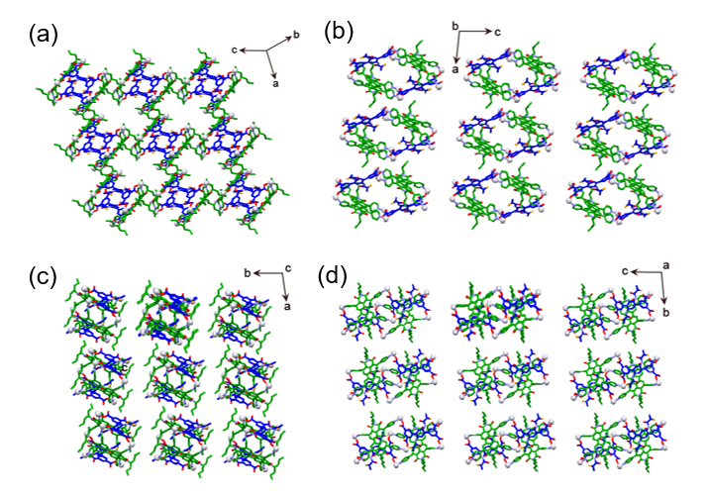
Figure S9. Packing mode of crystal structures of metallcage 4. Hydrogen atoms, counterions and solvent molecules were omitted for clarity.

4. Photophysical property
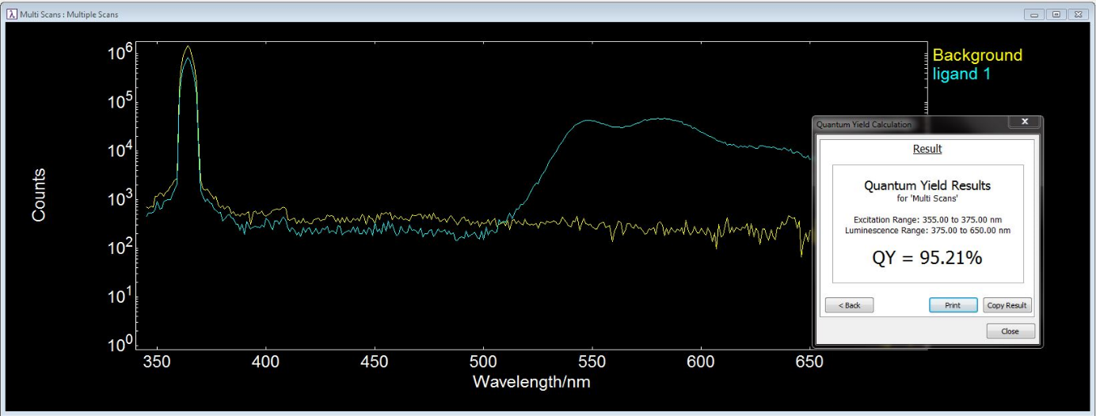
Figure S10. Absolute fluorescence quantum yield of ligand 1.

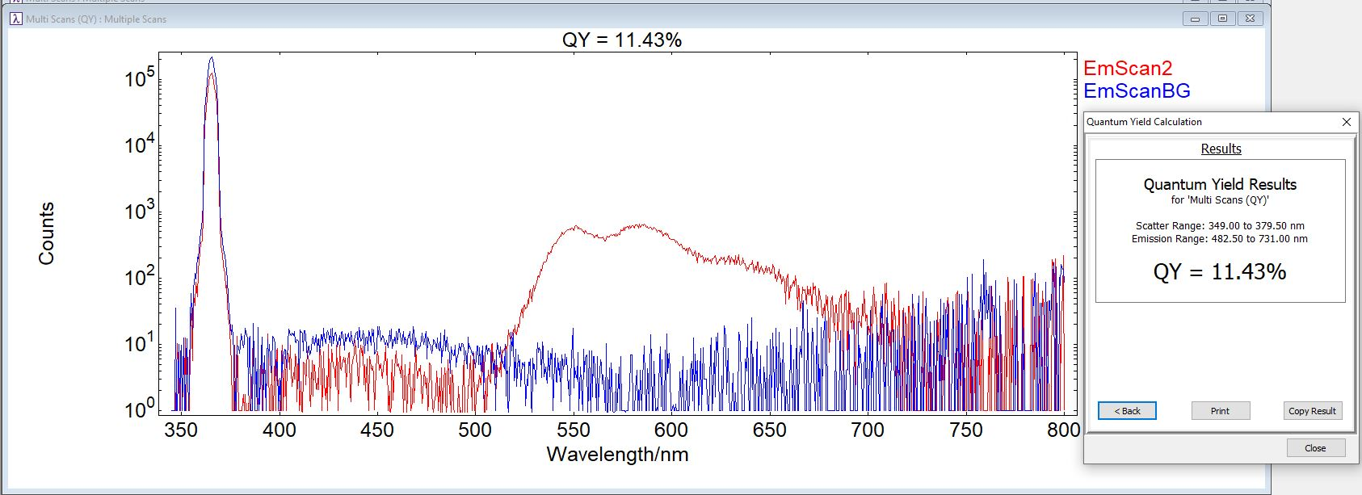
Figure S11. Absolute fluorescence quantum yield of metallacage 4.

5. Host-guest complexation study
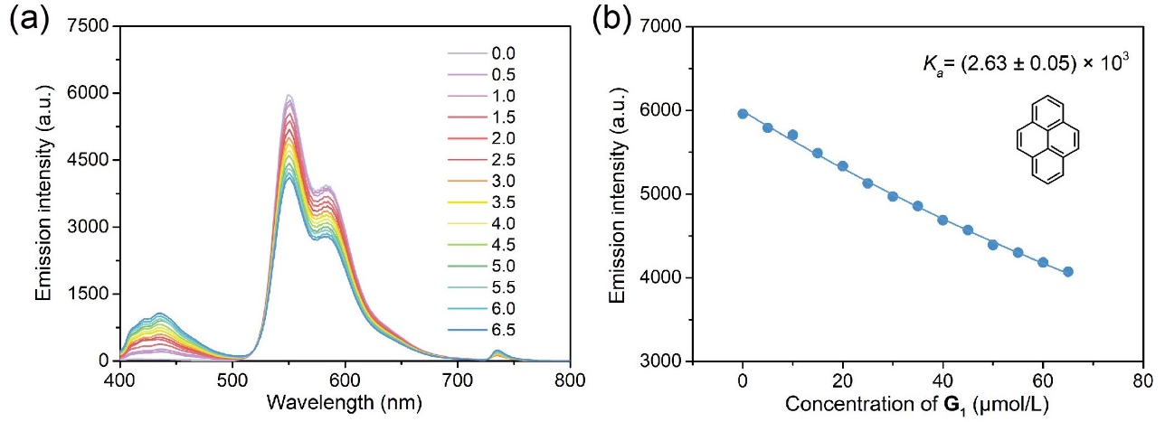
Figure S12. (a) Fluorescence spectra of metallacage 4 at a fixed concentration upon the addition of G₁ in CH₃CN ([Host] = 10 μM, [Guest] = 500 μM). (b) Nonlinear fitting curves of the emission intensity at 365 nm of 4 versus the concentrations of G₁.

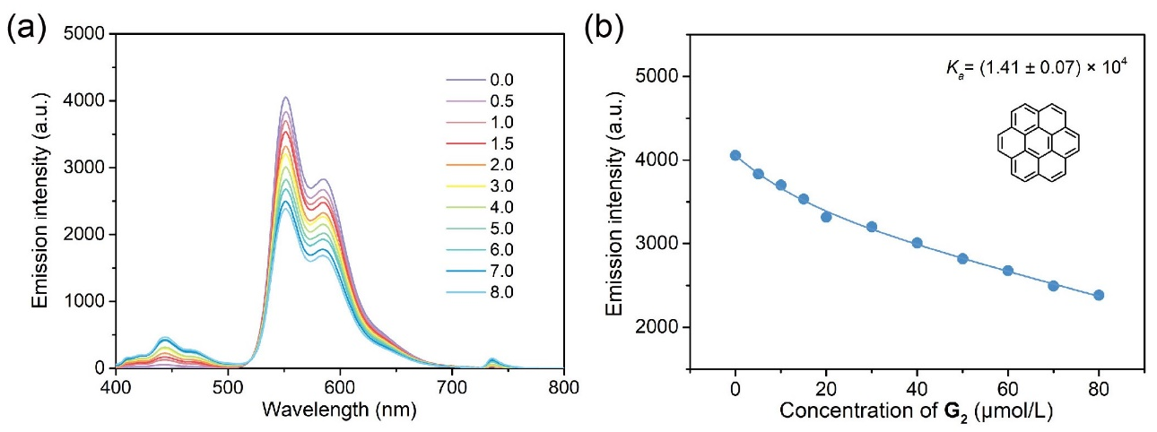
Figure S13. (a) Fluorescence spectra of metallacage 4 at a fixed concentration upon the addition of G₂ in CH₃CN ([Host] = 10 μM, [Guest] = 500 μM). (b) Nonlinear fitting curves of the emission intensity at 365 nm of 4 versus the concentrations of G₂.

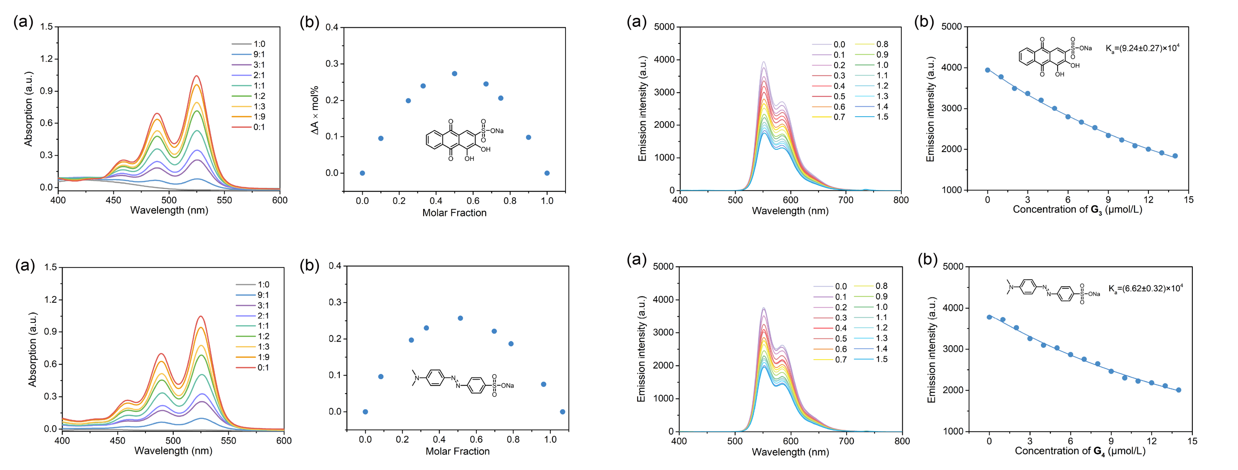
Figure S14. (a) UV-vis absorption of metallacage 4 with guest G₃ in different molar ratios ([4a] + [G₃] = 10 μM). (b) Job’s plot of the complex 4⊃G₃ in CH₃CN, showing a 1:1 stoichiometry.
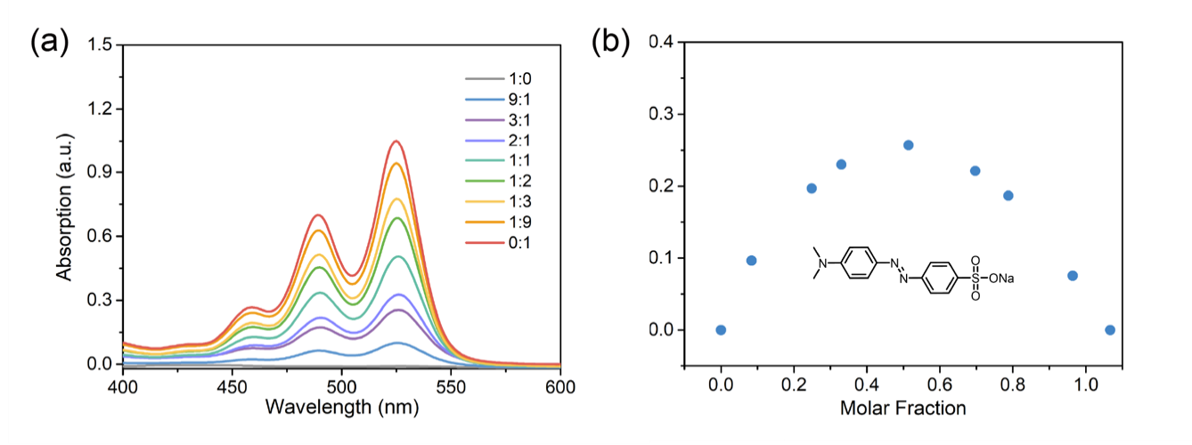
Figure S15. (a) UV-vis absorption of metallacage 4 with guest G₄ in different molar ratios ([4a] + [G₄] = 10 μM). (b) Job’s plot of the complex 4⊃G₄ in CH₃CN, showing a 1:1 stoichiometry.

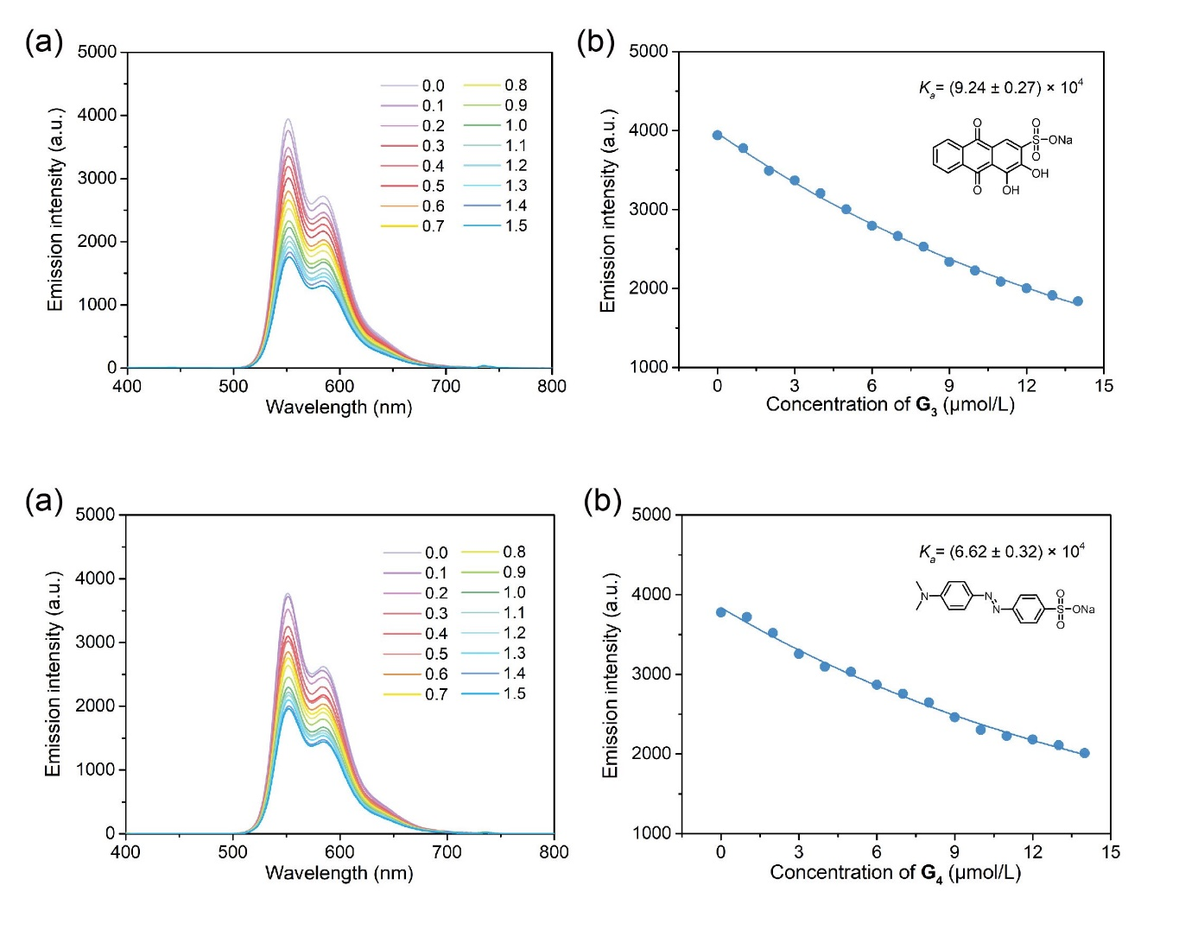
Figure S16. (a) Fluorescence spectra of metallacage 4 at a fixed concentration upon the addition of G₃ in CH₃CN ([Host] = 10 μM, [Guest] = 500 μM). (b) Nonlinear fitting curves of the emission intensity at 365 nm of 4 versus the concentrations of G₃.

Figure S17. (a) Fluorescence spectra of metallacage 4 at a fixed concentration upon the addition of G₄ in CH₃CN ([Host] = 10 μM, [Guest] = 500 μM). (b) Nonlinear fitting curves of the emission intensity at 365 nm of 4 versus the concentrations of G₄.

6. Preparation and characterization of supramolecular networks
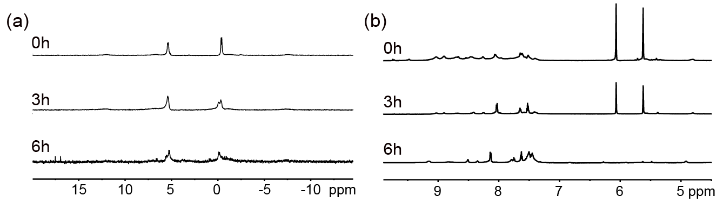
Figure S18. (a) Partial ³¹P{¹H} NMR (right, 150 MHz, CD₃CN, 295 K) spectra and (b) partial ¹H NMR spectra (left, 600 MHz, CD₃CN, 295 K) of network 6a with 1 wt% 4 loading after 0 h, 3 h and 6 h upon light irradiation.

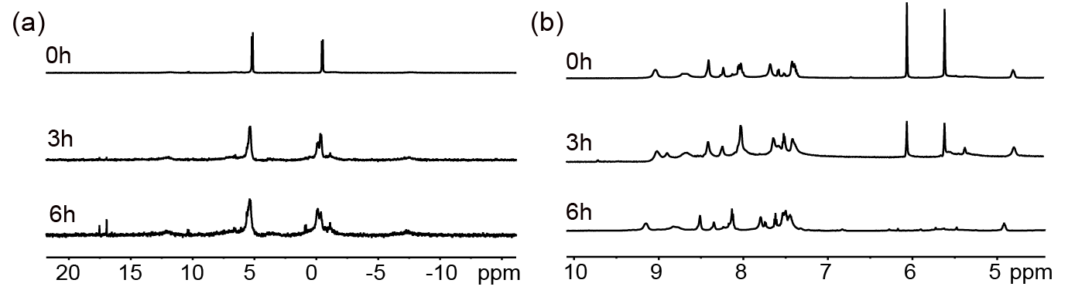
Figure S19. (a) Partial ³¹P{¹H} NMR (150 MHz, CD₃CN, 295 K) spectra and (b) partial ¹H NMR spectra (600 MHz, CD₃CN, 295 K) of network 6b with 3 wt% 4 loading after 0 h, 3 h and 6 h upon light irradiation.

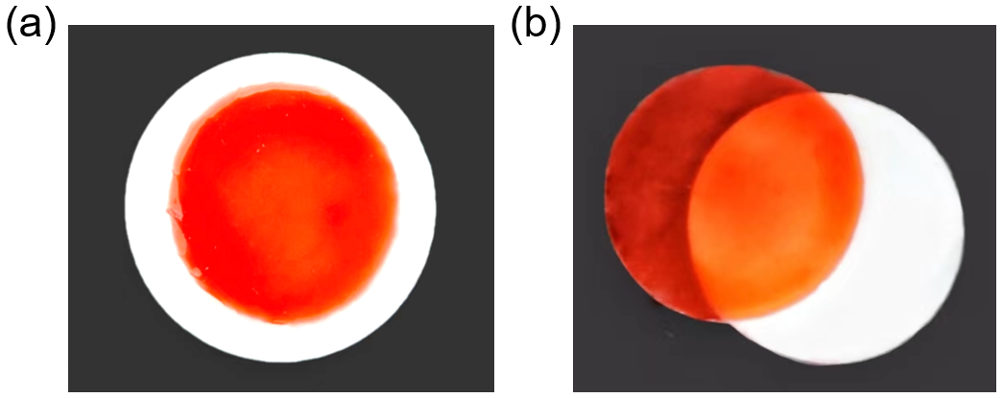
Figure S20. Photographs of (a) 6a and (b) 6b.

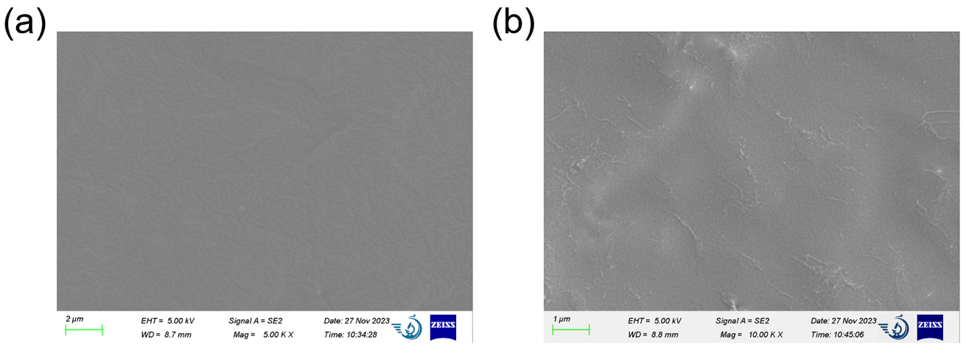
Figure S21. (a) SEM images of (a) 6a and (b) 6b.
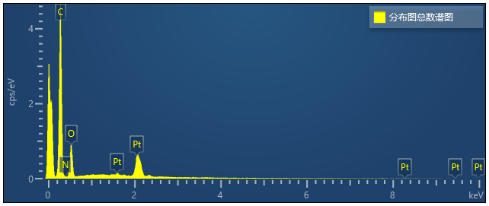
Figure S22. EDS spectroscopy of 6a.
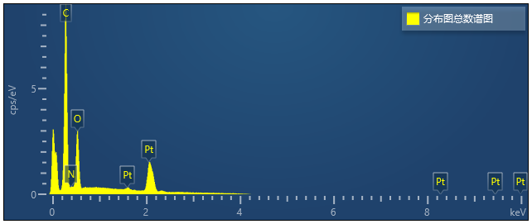
Figure S23. EDS spectroscopy of 6b.
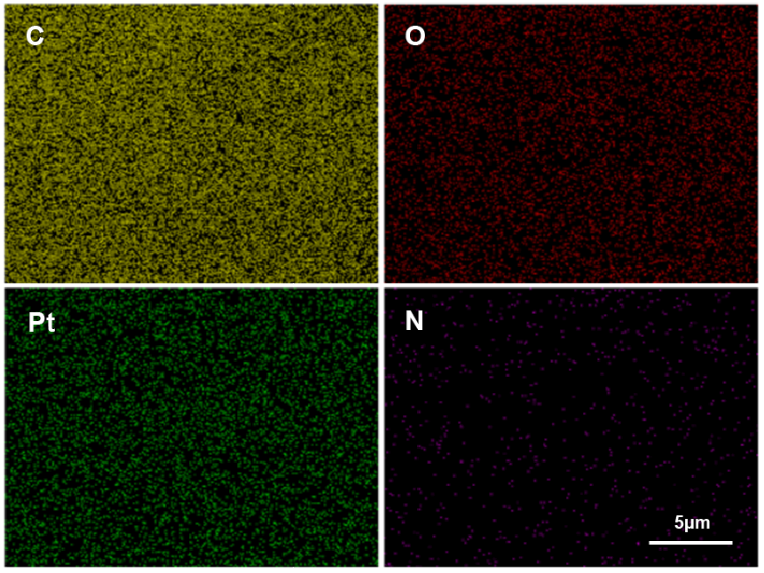
Figure S24. EDS elemental mapping of C, O, Pt, N for 6a.
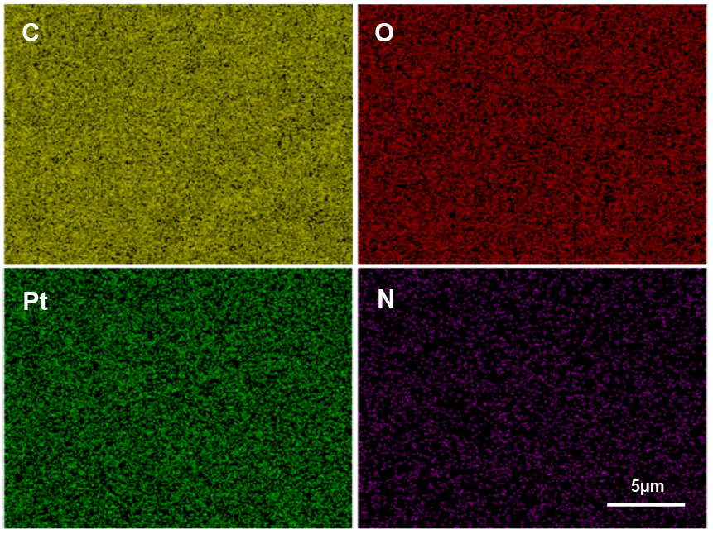
Figure S25. EDS elemental mapping of C, O, Pt, N for 6b.

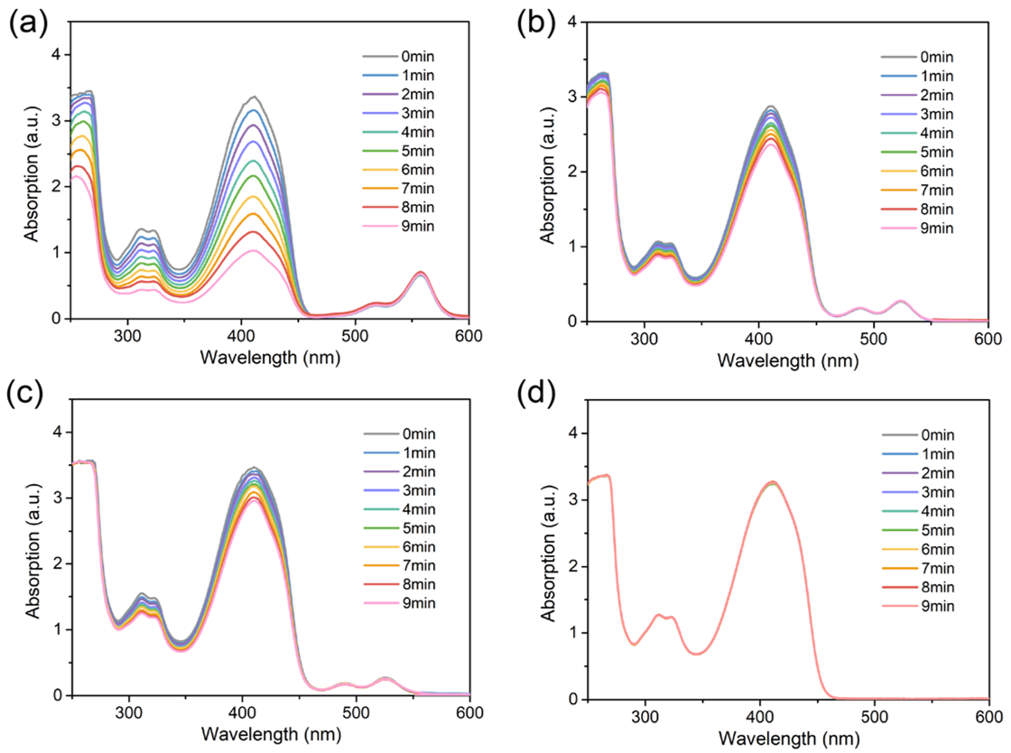
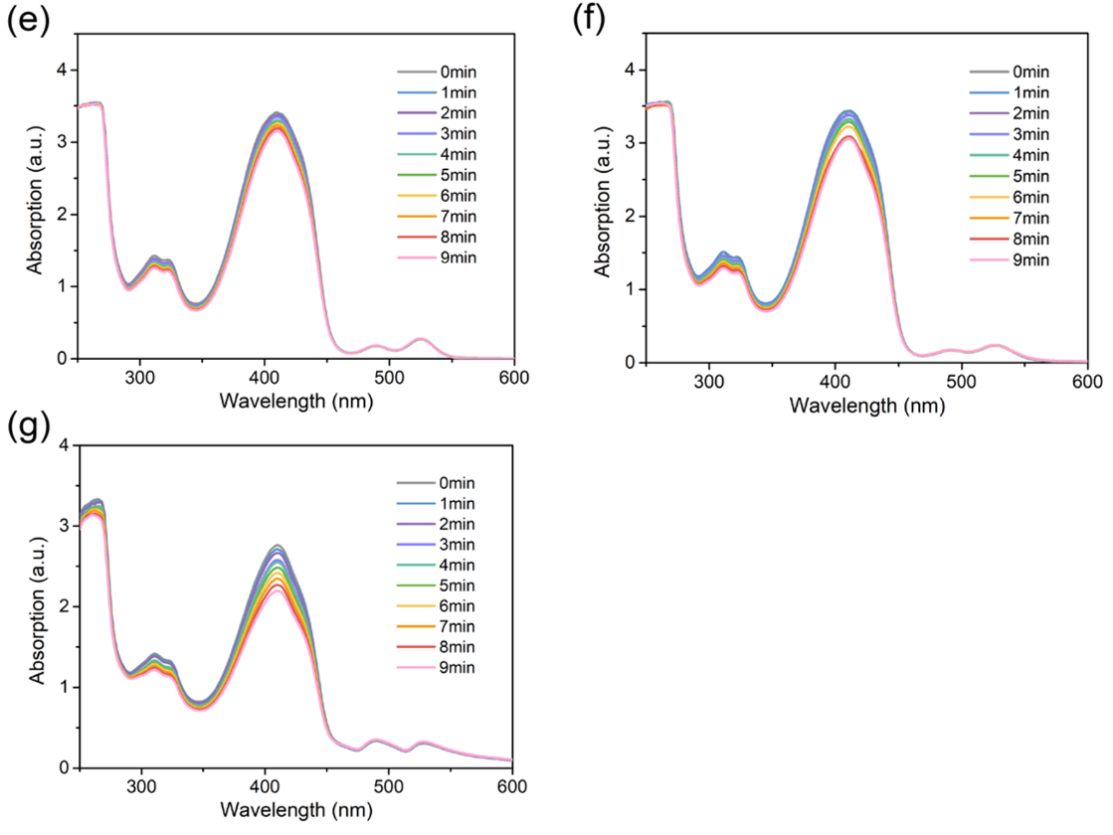
Figure S26. The absorbance of DPBF at 410 nm vs irradiation time in the presence of (a) RB, (b) 1, (c) 4, (d) 7, (e) 6a, (f) 6b, (g) 6c upon irradiation in acetonitrile (λ_{ex} = 520 nm).

7. Photodegradation properties
Figure S27. Adsorption dissociation equilibrium images of G₃, G₄, G₅ and G₆ carried out in aqueous solution using (a) 4, (b) 6a, (c) 6b and (d) 6c in the dark.
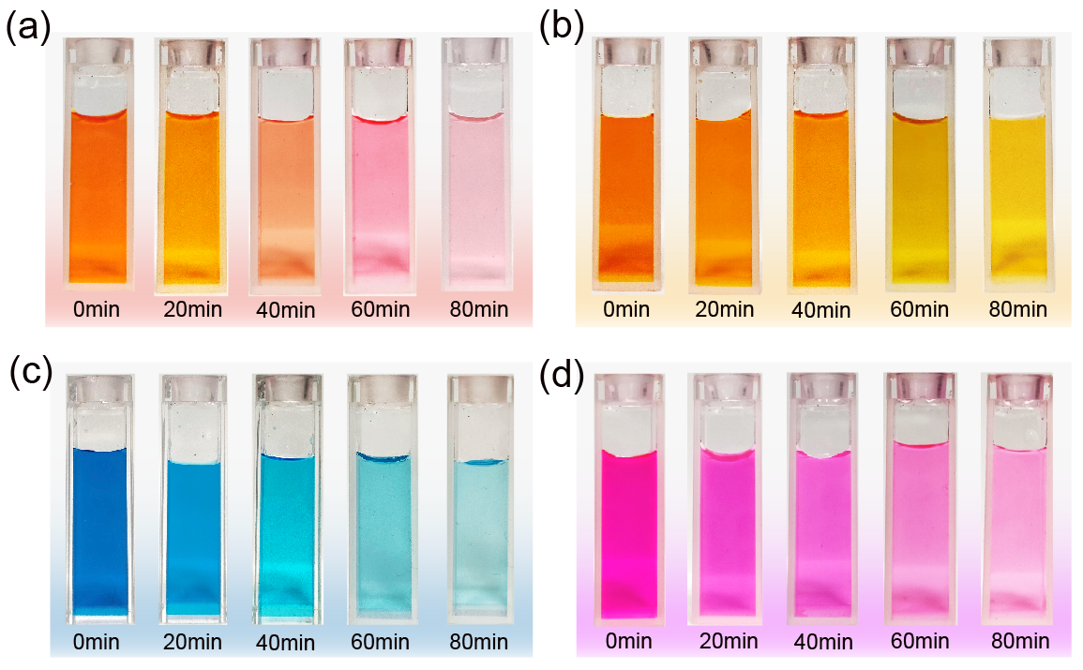
Figure S28. Optical photograph of (a) G₃, (b) G₄, (c) G₅ and (d) G₆ treated by 6c after different times of light irradiation (λ_{ex} = 520 nm).
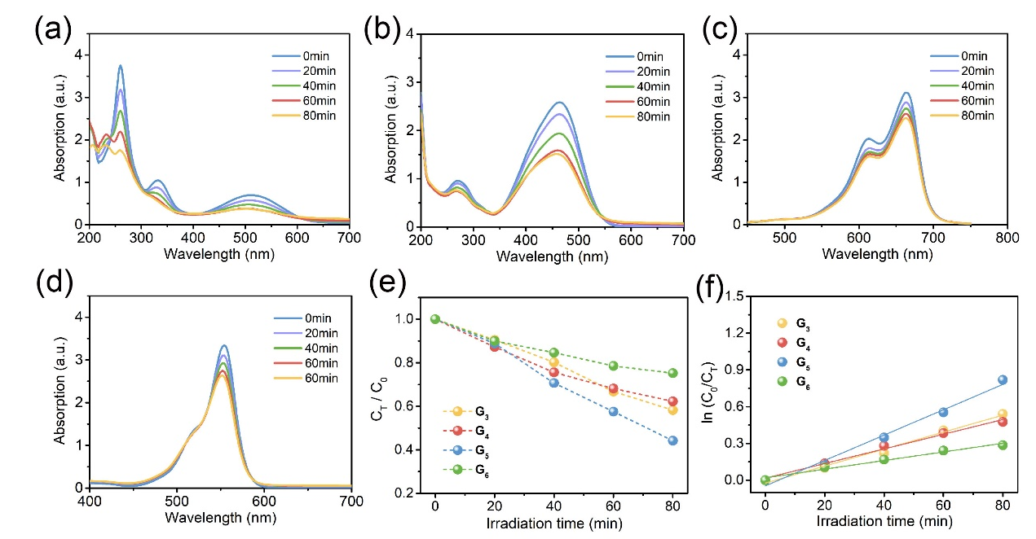
Figure S29. Time-dependent UV/vis absorption spectra following the photodegradation of (a) G₃, (b) G₄, (c) G₅ and (d) G₆ carried out in aqueous solution using 4. (e) Photodegradation performances and (f) degradation kinetics fitted curves of G₃, G₄, G₅ and G₆ with 4 under 520 nm light irradiation. C₀ and C_{T} indicate the initial and intermediate concentrations of dyes, while T is the reaction time.

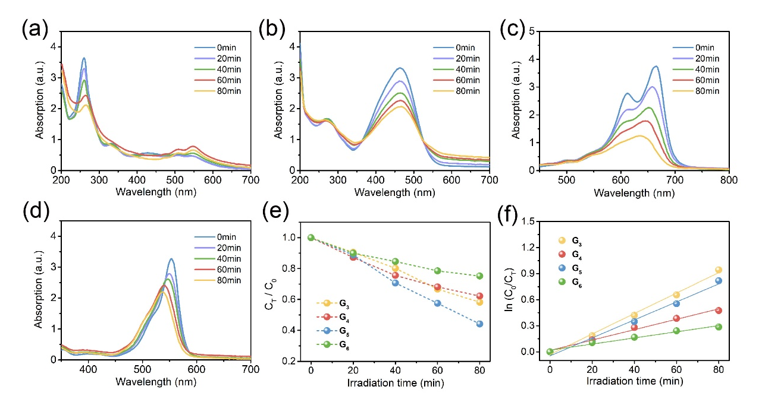
Figure S30. Time-dependent UV/vis absorption spectra following the photodegradation of (a) G₃, (b) G₄, (c) G₅ and (d) G₆ carried out in aqueous solution using 6a. (e) Photodegradation performances and (f) degradation kinetics fitted curves of G₃, G₄, G₅ and G₆ with 6a under 520 nm light irradiation. C₀ and C_{T} indicate the initial and intermediate concentrations of dyes, while T is the reaction time.
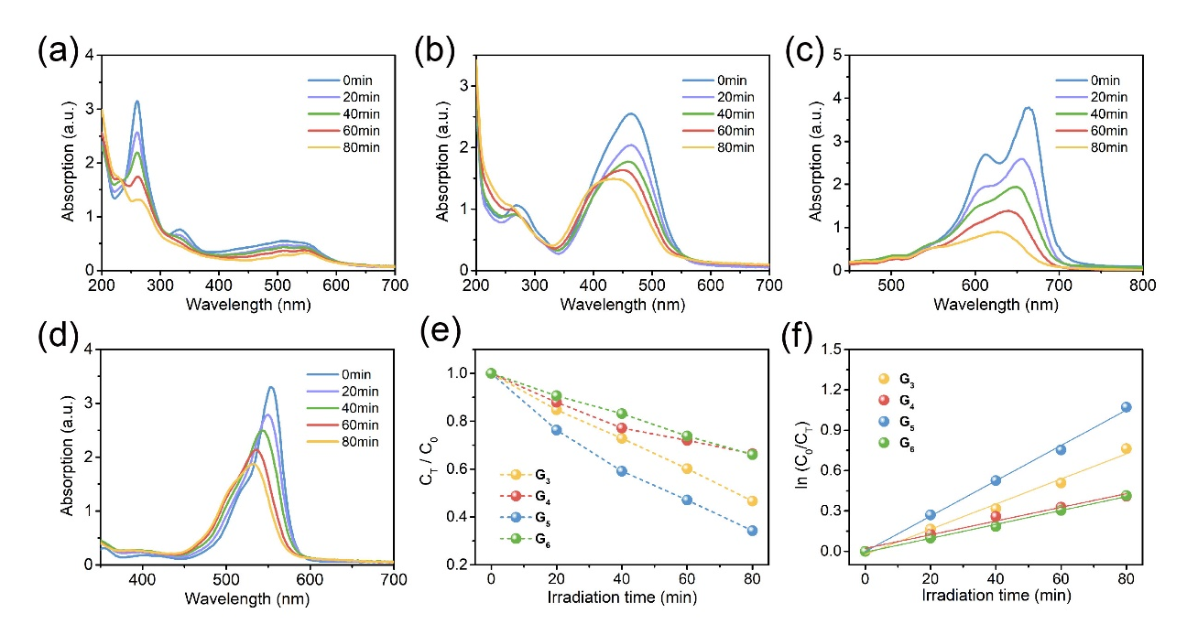
Figure S31. Time-dependent UV/vis absorption spectra following the photodegradation of (a) G₃, (b) G₄, (c) G₅ and (d) G₆ carried out in aqueous solution using 6b. (e) Photodegradation performances and (f) degradation kinetics fitted curves of G₃, G₄, G₅ and G₆ with 6b under 520 nm light irradiation. C₀ and C_{T} indicate the initial and intermediate concentrations of dyes, while T is the reaction time.

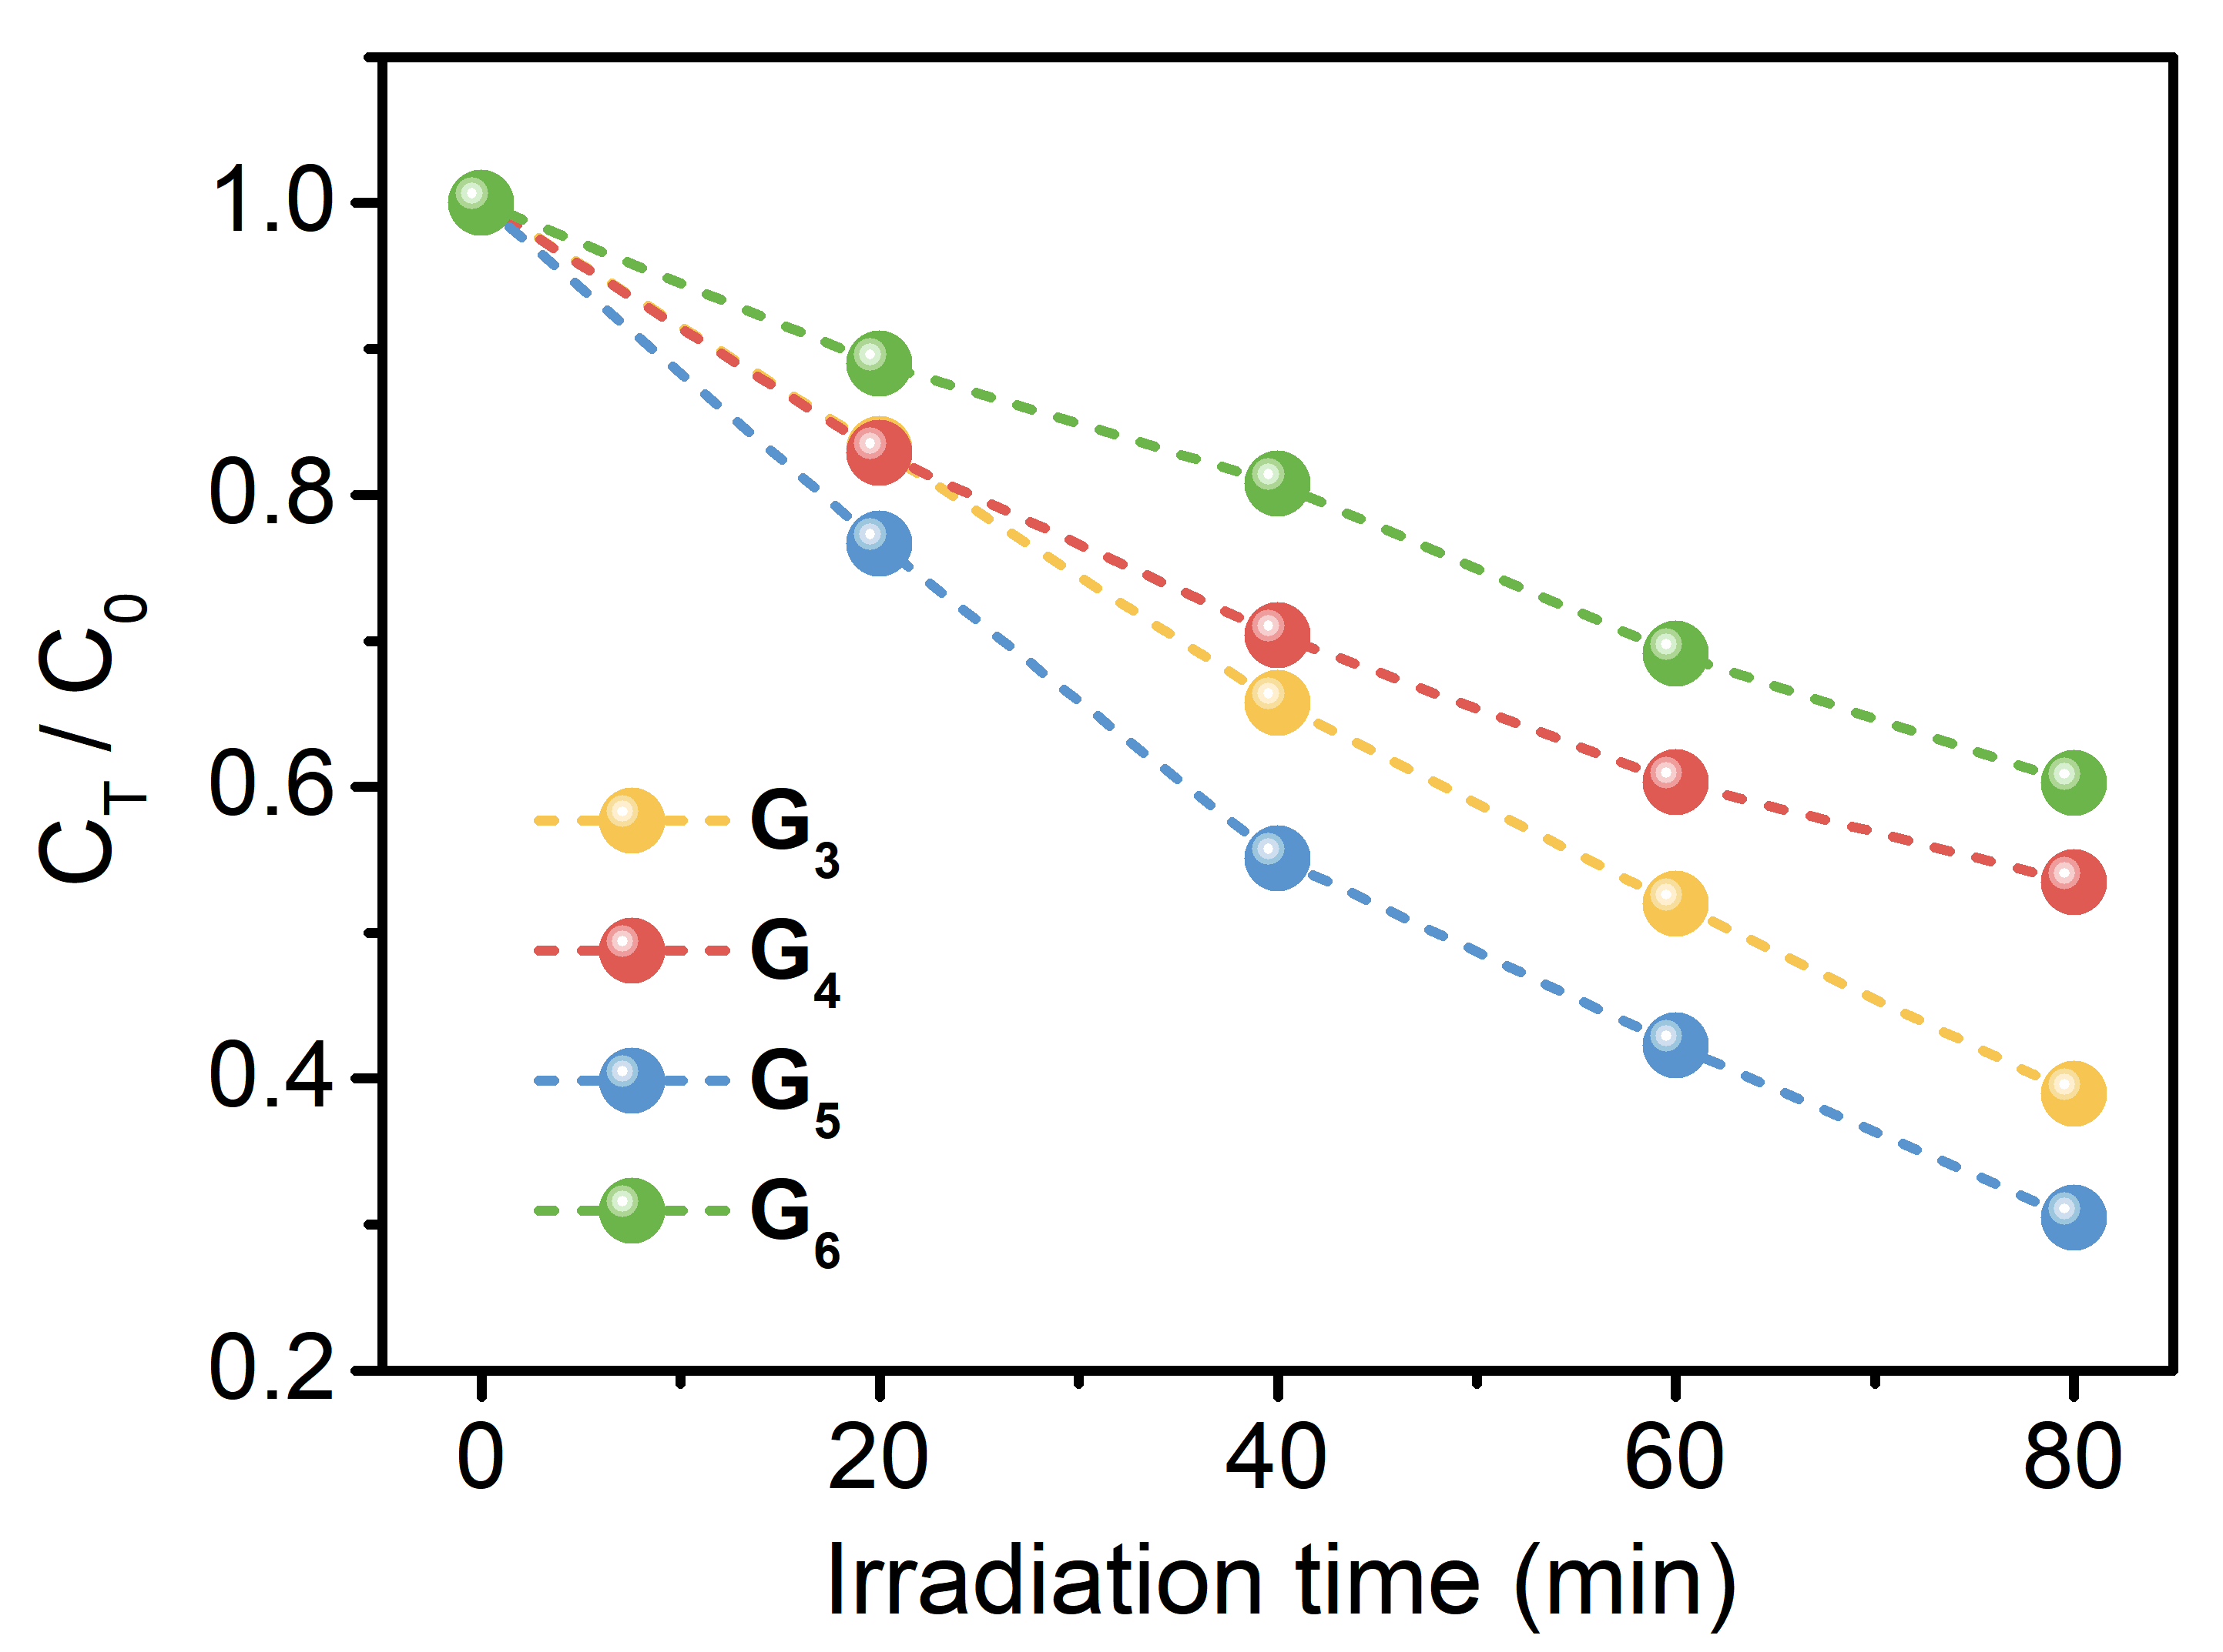
Figure S32. Photodegradation performances of of G₃, G₄, G₅ and G₆ with 6c under 520 nm light irradiation. C₀ and C_{T} indicate the initial and intermediate concentrations of dyes, while T is the reaction time.

8. Antibacterial Activity
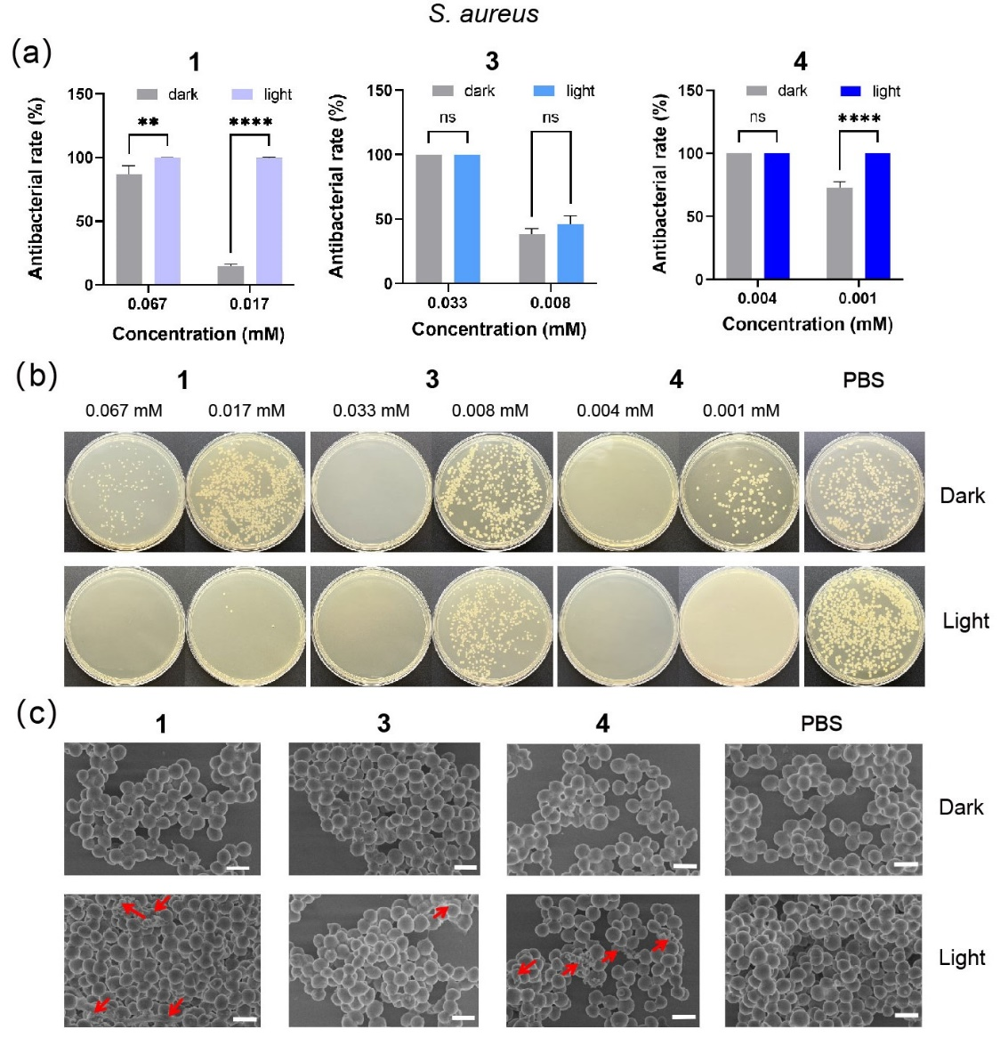
Figure S33. (a) Antibacterial activities of 1, 3 and 4 against S. aureus. (b) The remaining bacterial colony-forming units and (c) SEM images of S. aureus after the treatment with 1, 3, 4 and PBS with or without 520 nm light irradiation for 30 min. Scale bar, 1 μm. ns indicates not significant; P-values < 0.05 were considered statistically significant, **p < 0.01, ****p < 0.0001.
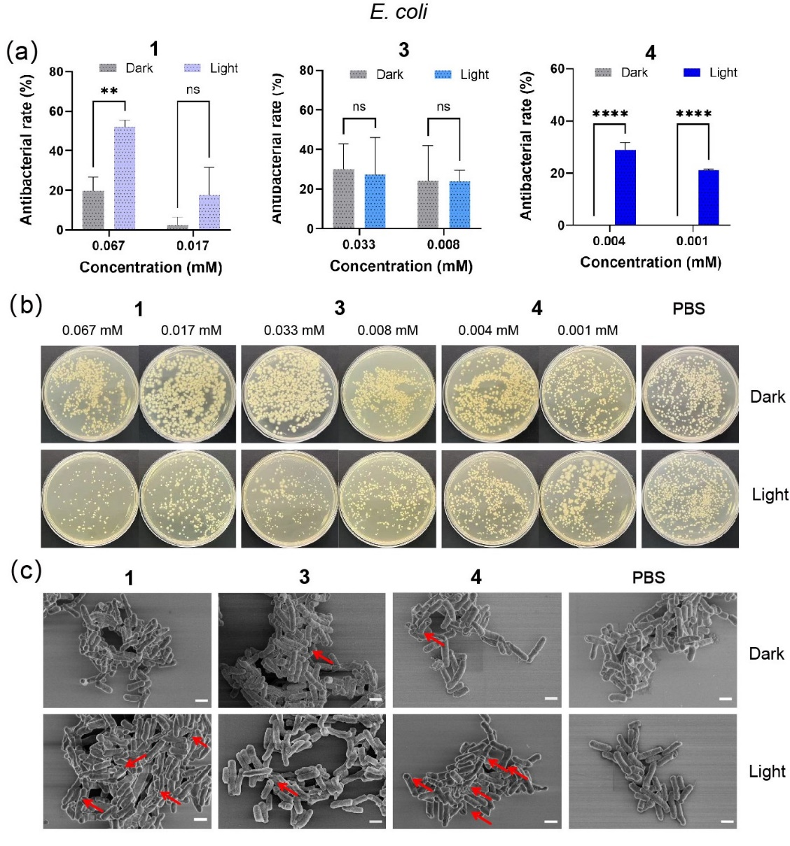
Figure S34. (a) Antibacterial activities of 1, 3 and 4 against E. coli. (b) The remaining bacterial colony-forming units and (c) SEM images of E. coli after the treatment with 1, 3, 4 and PBS with or without 520 nm light irradiation for 30 min. Scale bar, 1 μm. ns indicates not significant; P-values < 0.05 were considered statistically significant, **p < 0.01.

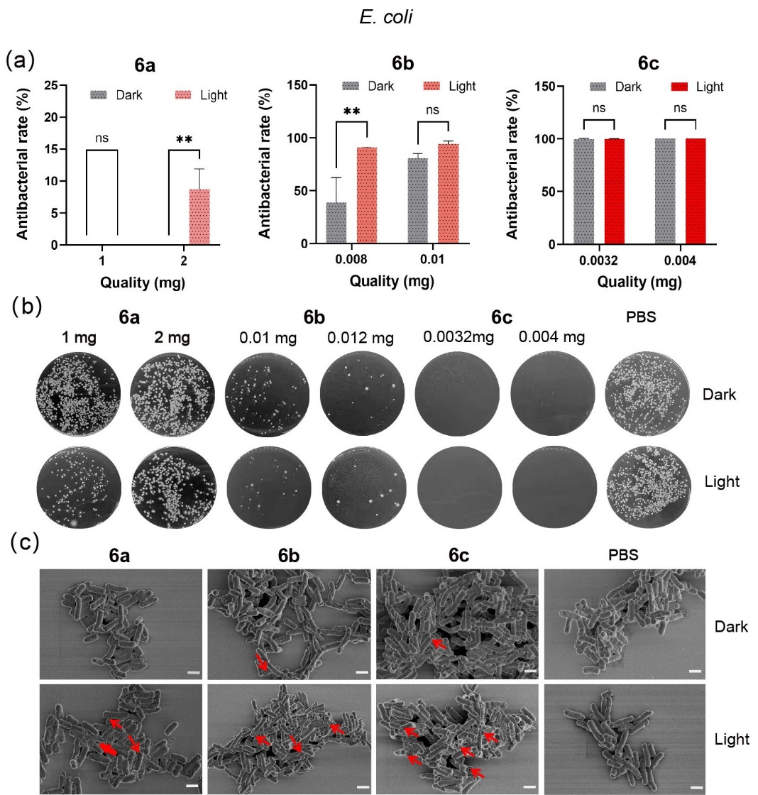
Figure S35. (a) Antibacterial activities of of 6a, 6b and 6c against E. coli. (b) The remaining bacterial colony-forming units and (c) SEM images of E. coli after the treatment with 6a, 6b, 6c and PBS with or without 520 nm light irradiation for 30 min. Scale bar, 1 μm. ns indicates not significant; P-values < 0.05 were considered statistically significant, **p < 0.01, ****p < 0.0001.

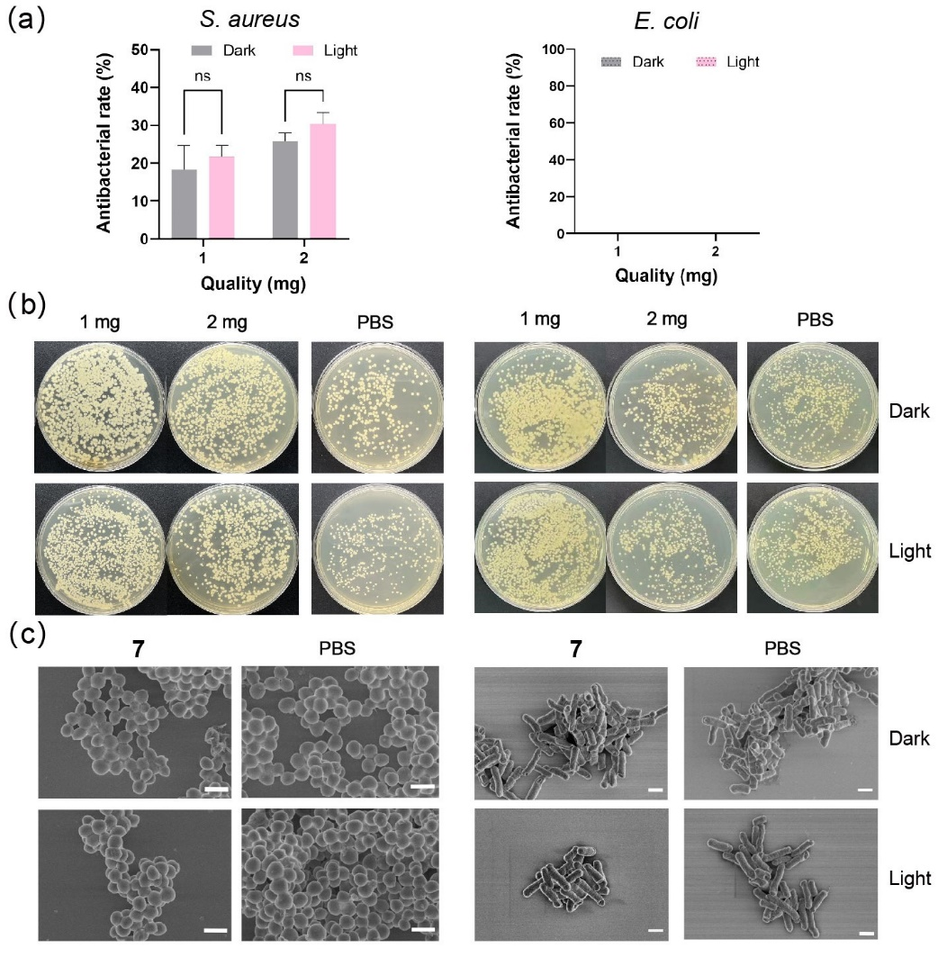
Figure S36. (a) Antibacterial activities of 7 against S. aureus and E. coli. (b) The remaining bacterial colony-forming units and (c) SEM images of S. aureus and E. coli after the treatment with 7 and PBS with or without 520 nm light irradiation for 30 min. Scale bar, 1 μm. ns indicates not significant; P-values < 0.05 were considered statistically significant, **p < 0.01, ****p < 0.0001.

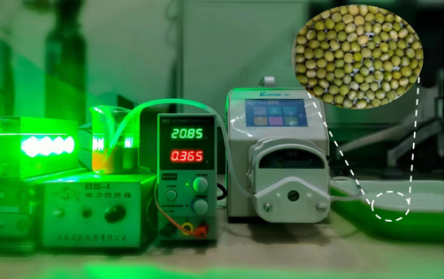
Figure S37. Optical photograph of the water decontamination setup.

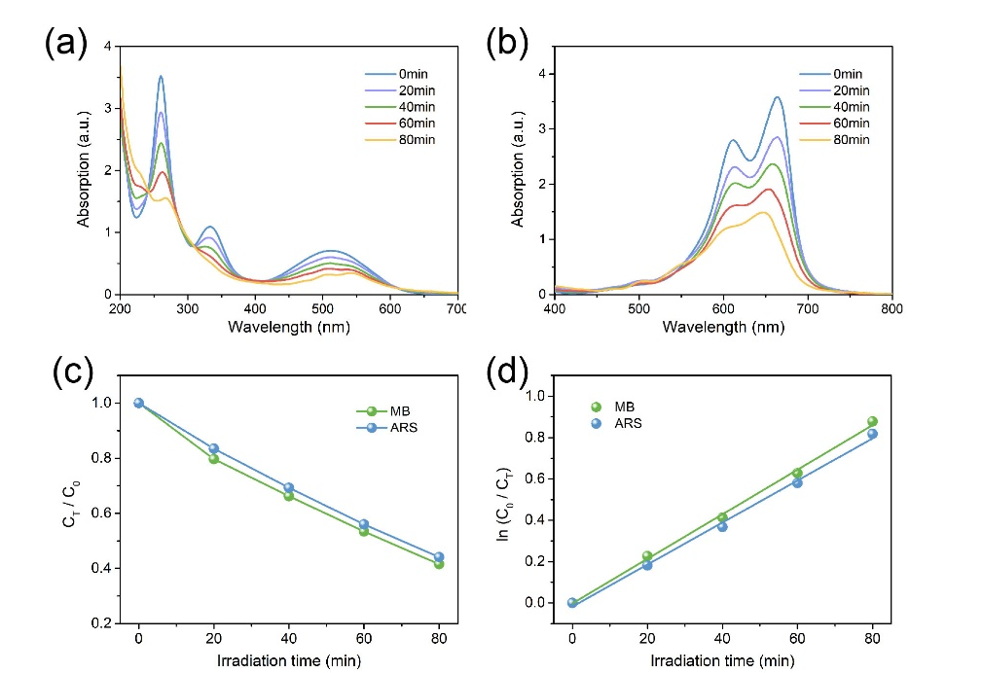
Figure S38. Time-dependent UV/vis absorption spectra following the photodegradation of (a) G₃ and (b) G₅ carried out in S. Aureus and E. coli solution using 6c. (c) Photodegradation performances and (d) degradation kinetics fitted curves of 6c for photodegradation in S. aureus and E. coli solution. C₀ and C_{T} indicate the initial and intermediate concentrations of dyes, while T is the reaction time.
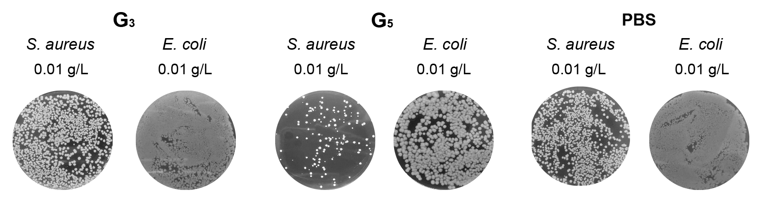
Figure S39. The remaining bacterial colony-forming units of S. aureus or E. coli and dye (G₃ or G₅) solution after the treatment under 520 nm light irradiation for 30 min.

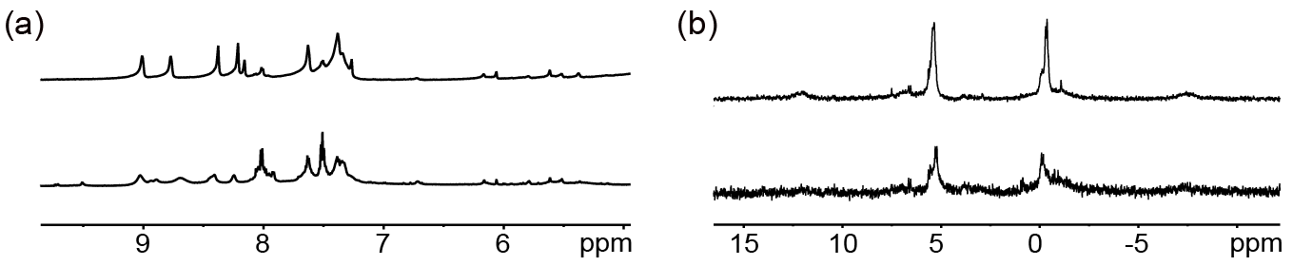
Figure S40 . (a) Partial ¹H NMR spectra (left, 600 MHz, CD₃CN, 295 K) and (b) partial ³¹P{¹H} NMR (right, 150 MHz, CD₃CN, 295 K) spectra of network 6c with 6 wt% 4 loading before (top) and after (bottom) water decontamination.

S1. Hou, Y. et al. Highly emissive perylene diimide-based metallacages and their host-guest Chemistry for information encryption. J. Am. Chem. Soc. 142, 18763-18768 (2020).
S2. Zheng, Y. et al. A facile approach toward multicomponent supramolecular structures: selective self-assembly via charge separation. J. Am. Chem. Soc. 132, 16873 (2010).

