Supplementary

Urban Waste Fertilizer: Effects on Yield, Nutrient Dynamics, and PTE accumulation
Marie Reimer¹*, Kurt Möller^{1,2}, Jakob Magid³, Sander Bruun³

Supplementary Table
Supplementary Table 1: Crop sequence of the CRUCIAL trial. The cover crop column indicates if a mixture of white clover and ryegrass was undersown as a cover crop in spring and to which plots (all plots, in none or only in the green manure (GM) treatments.
Year | Crop | Cover crops | Year | Crop | Cover crops
2002 | Winter wheat | all plots | 2012 | Spring oats | GM plots
2003 | Spring oats | all plots | 2013 | Spring barley | GM plots
2004 | Spring barley (silage) | none | 2014 | Spring wheat | GM plots
2005 | Spring rape | none | 2015 | Spring oats | GM plots
2006 | Spring wheat | all plots | 2016 | Winter wheat | none
2007 | Spring oats | all plots | 2017 | Spring barley | GM plots
2008 | Spring barley | none | 2018 | Spring wheat | GM plots
2009 | Spring barley (silage) | none | 2019 | Spring barley | GM plots
2010 | Ryegrass (silage) | none | 2020 | Spring wheat | GM plots
2011 | Winter wheat | GM plots

Supplementary Table 2: Measurement schema for the Crucial trial. For the treatment abbreviations consult Table 1.
Year | Harvest data |  | Fertilizers |  |  |  | Soil data
Year | yield | N | DM | C & N | NO₃⁻ & NH₄⁺ | PTE | Texture | Bulk density | C_{org} | N | N_{min} | PTE
2001 |  |  |  |  |  |  |  |  | x | x |  | x
2002 | x | x | x | x | x |  |  |  | x | x | x
2003 | x | x | x | x | x | x |  |  |  |  | x
2004 | x | x | x | x | x | x |  |  |  |  | 2x
2005 | x | x | x | x | x | x
2006 | x | x | x | x | x | x |  |  | x | x |  | x
2007 | x | x | x | x | x | x |  |  | x | x
2008 | x | x | x | x | x | x | x
2009 | x | x | x | x |  |  |  |  | x | x |  | x
2010 | x | x | x | x
2011 | x | x | x | x |  |  | x* | x* | x | x |  | x
2012 | x | x | x | x
2013 | x | x | x | x |  |  |  |  | x | x |  | x
2014 | x | x | x | x
2015 | x | x | x | x
2016 | x
2017 | x
2018 | x
2019 | x |  |  |  |  |  |  |  | x* | x*
2020 | x |  | x |  |  |  |  |  | x | x
*only selected plots

Supplementary Table 3: Ratio of N₂O losses to total denitrification (N₂O / (N₂0+N₂)) based on SimDen simulations. Treatment abbreviations: CH= compost from household waste, CHA= accelerated CH, CMA= cattle manure accelerated, CS= cattle slurry, DL= deep litter from cattle, HU= human urine, NPK= mineral nitrogen fertilization, S=sewage sludge, SA= S accelerated, U= unfertilized, GM= green manure
Treatment | N₂O / (N₂0+N₂) ratio
CH | 0.186
CHA | 0.183
CMA | 0.186
CS | 0.191
DL | 0.187
HU | 0.198
NPK | 0.200
S | 0.188
SA | 0.185
U | 0.200
GM | 0.200

Supplementary Table 4: Model fit evaluation parameter (root mean squared error (RMSE), and mean absolute percentage error (MAPE) and index of agreement (IA)) for different measurements for all observed and simulated values and separated by treatment and crop.
Treat. | Measurement | Model fit |  |  | Treat. | Measurement | Model fit |  |  | Crop | Measurement | Model fit
Treat. | Measurement | RMSE | MAPE | IA | Treat. | Measurement | RMSE | MAPE | IA | Crop | Measurement | RMSE | MAPE | IA
All | Grain DM yield | 4653.71 | 51.25 | 0.59 | DL | Grain DM yield | 1949.28 | 30.74 | 0.68 | Oats | Grain DM yield | 2212.81 | 40.56 | 0.54
All | Grain N % | 0.73 | 17.75 | 0.92 | DL | Grain N yield | 59.41 | 73.09 | 0.04 | Oats | Grain N % | 0.29 | 15.13 | 0.68
All | Grain N yield | 41.69 | 52.11 | 0.6 | DL | Soil Carbon | 5297.44 | 6.94 | 0.9 | Oats | Grain N yield | 44.84 | 47.79 | 0.45
All | Whole crop DM yield | 3417.01 | 89.56 | 0.62 | DL | Soil N | 483.48 | 4.84 | 0.83 | Spring barley | Grain DM yield | 2088.83 | 60.5 | 0.72
All | Whole crop N % | 81.3 | 4924.59 | 0.01 | CMA | Grain DM yield | 1491.83 | 25.42 | 0.84 | Spring barley | Grain N % | 0.61 | 22.23 | 0.53
All | Whole crop N yield | 88.49 | 97.14 | 0.4 | CMA | Grain N yield | 33.28 | 36.91 | 0.22 | Spring barley | Grain N yield | 22.83 | 19.91 | 0.8
CH | Grain DM yield | 1884.5 | 42.73 | 0.76 | CMA | Soil Carbon | 7351.7 | 8.96 | 0.89 | Spring rape | Grain DM yield | 492.75 | 63.32 | 0.43
CH | Grain N yield | 60.21 | 82.09 | 0.13 | CMA | Soil N | 763.03 | 10.12 | 0.85 | Spring rape | Grain N % | 1.93 | 41.46 | 0.22
CH | Soil Carbon | 8281.43 | 8.42 | 0.93 | CS | Grain DM yield | 1955.48 | 26.64 | 0.67 | Spring rape | Grain N yield | 46.56 | 128.28 | 0.3
CH | Soil N | 1855.25 | 15.65 | 0.6 | CS | Grain N yield | 35.37 | 30.97 | 0.19 | Spring wheat | Grain DM yield | 1397.91 | 35.52 | 0.82
CHA | Grain DM yield | 1628.46 | 52.67 | 0.83 | CS | Soil Carbon | 5020.08 | 7.05 | 0.4 | Spring wheat | Grain N % | 0.29 | 10.76 | 0.87
CHA | Grain N yield | 58.61 | 106.17 | 0.45 | CS | Soil N | 753.78 | 9.13 | 0.38 | Spring wheat | Grain N yield | 42.81 | 51.58 | 0.65
CHA | Soil Carbon | 35546.59 | 24.9 | 0.9 | NPK | Grain DM yield | 1970.74 | 29.84 | 0.73 | Winter barley | Grain DM yield | 1096.61 | 37.83 | 0.78
CHA | Soil N | 5253.33 | 21.92 | 0.67 | NPK | Grain N yield | 36.43 | 38.68 | 0.37 | Winter barley | Grain N % | NA | NA | NA
S | Grain DM yield | 1370.59 | 28.85 | 0.84 | NPK | Soil Carbon | 5453.96 | 7.62 | 0.37 | Winter barley | Grain N yield | NA | NA | NA
S | Grain N yield | 28.6 | 32.91 | 0.42 | NPK | Soil N | 754.86 | 10.23 | 0.31 | Winter wheat | Grain DM yield | 1689.2 | 23.59 | 0.88
S | Soil Carbon | 6611.6 | 7.29 | 0.5 | U | Grain DM yield | 935.78 | 29.81 | 0.68 | Winter wheat | Grain N % | 0.29 | 16.19 | 0.49
S | Soil N | 1157.42 | 11.22 | 0.43 | U | Grain N yield | 8.52 | 19.63 | 0.64 | Winter wheat | Grain N yield | 43.32 | 34.41 | 0.75
SA | Grain DM yield | 1413.08 | 26.07 | 0.86 | U | Soil Carbon | 4750.03 | 7.03 | 0.69 | Spring barley silage | Grain DM yield | 3442.68 | 78.72 | 0.5
SA | Grain N yield | 41.88 | 36.6 | 0.48 | U | Soil N | 623.34 | 9.54 | 0.53 | Spring barley silage | Grain N % | 0.56 | 26.81 | 0.45
SA | Soil Carbon | 10850.44 | 11.62 | 0.58 | GM | Grain DM yield | 1787.08 | 70.67 | 0.63 | Spring barley silage | Grain N yield | 44.86 | 59.81 | 0.49
SA | Soil N | 1340.66 | 13.44 | 0.48 | GM | Grain N yield | 51.06 | 197.95 | 0.08 | Ryegrass | Grain DM yield | 4195.84 | 64 | 0.45
HU | Grain DM yield | 1592.01 | 25.61 | 0.82 | GM | Soil Carbon | 6372.59 | 9.23 | 0.18 | Ryegrass | Grain N % | 1.03 | 99.17 | 0.28
HU | Grain N yield | 33.71 | 34.53 | 0.23 | GM | Soil N | 671.6 | 7.36 | 0.56 | Ryegrass | Grain N yield | 47.46 | 58.49 | 0.48
HU | Soil Carbon | 8346.4 | 12.85 | 0.29
HU | Soil N | 820.56 | 11.51 | 0.33
Abbreviations: DM yield =dry matter kg ha⁻¹, N%=nitrogen content in percentage, N yield=nitrogen yield in kg N ha⁻¹; CH=compost from household wastes, CHA= accelerated CH, S=sewage sludge, SA= S accelerated, HU=human urine, DL=deep litter, CMA=cattle manure accelerated, CS=cattle slurry, NPK=mineral fertilization, U=unfertilized, GM=green manure

Supplementary Table 5: Yield levels measured in the CRUCIAL trial by year. Shown are the averages over all treatments and the average of the mineral fertilization treatment (NPK) as a reference.
Year | Crop | Measured | Year average in kg ha⁻¹ | NPK average in kg ha⁻¹
2003 | Oats | grain yield | 5948 | 6942
2004 | Spring barley silage | whole crop yield | 4441 | 4894
2005 | Spring rape | grain yield | 896 | 1120
2006 | Spring wheat | grain yield | 3011 | 3095
2007 | Oats | grain yield | 3066 | 3242
2008 | Spring barley | grain yield | 5609 | 6387
2009 | Spring barley silage | whole crop yield | 6026 | 6915
2010 | Ryegrass | whole crop yield | 4790 | 8095
2011 | Winter wheat | grain yield | 5768 | 8383
2012 | Oats | grain yield | 5621 | 6503
2013 | Spring barley | grain yield | 5862 | 7389
2014 | Spring wheat | grain yield | 4626 | 6046
2015 | Oats | grain yield | 5508 | 6785
2016 | Winter barley | grain yield | 3489 | 3937
2017 | Spring barley | grain yield | 5235 | 7234
2018 | Spring wheat | grain yield | 2007 | 2285
2019 | Spring barley | grain yield | 6356 | 7739
2020 | Spring wheat | grain yield | 5505 | 6577

Supplementary Table 6: Results of the statistical analysis of influences on relative dry matter yield (% in relation to year average yield) and N content of the grains (%).
 | Df | Sum Sq | Mean Sq | F value | Pr(>F)
Effect on relative dry matter yield (% in relation to year average yield)
Treatment | 10 | 347331 | 34733 | 116.3 | <0.001
Years of application | 1 | 0.1 | 0.1 | 0.0004 | 0.983
Crop | 7 | 2 | 0.3 | 0.0009 | 1.00
Block | 3 | 1483 | 494 | 1.7 | 0.175
Treatment:Years of application | 10 | 20118 | 2012 | 6.7 | <0.001
Treatment:Crop | 70 | 87594 | 1251 | 4.2 | <0.001
Residuals | 594 | 177361 | 299
Effect on grain N content (%)
Treatment | 10 | 5.40 | 0.54 | 7.21 | <0.001
Years of application | 1 | 52.10 | 52.10 | 695.37 | <0.001
Crop | 4 | 232.77 | 58.19 | 776.64 | <0.001
Block | 3 | 0.19 | 0.06 | 0.82 | 0.48
Treatment:Years of application | 10 | 0.69 | 0.07 | 0.92 | 0.51
Treatment:Crop | 40 | 4.07 | 0.10 | 1.36 | 0.08
Residuals | 243 | 18.21 | 0.07
Model: relative yield (%) / N grain content (%)~ treatment + experiment duration (years) + cropped culture + experiment duration : treatment+ cropped culture : treatment + block

Supplementary Table 7: Results of the ANOVA on influences on agronomic efficiency. Bold font represents significance (α=0.05).
Results of the ANOVA on effects on agronomic efficiency
 | Df | Sum Sq | Mean Sq | F value | Pr(>F)
Years of application | 1 | 6344.9 | 6344.9 | 15.0 | 1.30E-04
Applied N amount | 1 | 194569.6 | 194569.6 | 459.9 | 2.54E-64
Treatment | 8 | 143710.2 | 17963.8 | 42.5 | 2.66E-46
Crop | 5 | 6353.3 | 1270.7 | 3.0 | 1.15E-02
Block | 3 | 825.1 | 275.0 | 0.7 | 5.83E-01
Treatment : Years of application | 8 | 11538.6 | 1442.3 | 3.4 | 8.85E-04
Treatment : Crop | 40 | 25154.5 | 628.9 | 1.5 | 3.44E-02
Treatment : Applied N amount | 8 | 45964.1 | 5745.5 | 13.6 | 5.29E-17
Residuals | 327 | 138342.0 | 423.1
Model: Agronomic efficiency (%) ~ treatment + years of application + amount of applied N + cropped culture + years of application : treatment + amount of applied N : treatment + cropped culture : treatment + block

Supplementary Table 8: Results of the ANOVA on influences on the agronomic efficiency for each fertilization scheme separately in a submodel. Bold font represents significance (α=0.05).
Treat | factor | Df | Sum Sq | Mean Sq | F value | Pr(>F)
CH | Years of application | 1 | 147 | 147 | 2.1 | 1.53E-01 | n.s.
CH | Applied N amount | 1 | 1361 | 1361 | 19.8 | 7.96E-05 | ***
CH | Crop | 5 | 1010 | 202 | 2.9 | 2.52E-02 | *
CH | Years of application:Applied N amount | 1 | 0 | 0 | 0.0 | 9.58E-01 | n.s.
CH | Residuals | 36 | 2475 | 69
CHA | Years of application | 1 | 203 | 203 | 18.8 | 1.10E-04 | ***
CHA | Applied N amount | 1 | 5 | 5 | 0.4 | 5.08E-01 | n.s.
CHA | Crop | 5 | 635 | 127 | 11.8 | 8.49E-07 | ***
CHA | Years of application:Applied N amount | 1 | 141 | 141 | 13.1 | 8.89E-04 | ***
CHA | Residuals | 36 | 387 | 11
S | Years of application | 1 | 3911 | 3911 | 8.0 | 7.60E-03 | *
S | Applied N amount | 1 | 15631 | 15631 | 32.0 | 2.02E-06 | ***
S | Crop | 5 | 6881 | 1376 | 2.8 | 3.03E-02 | *
S | Years of application:Applied N amount | 1 | 230 | 230 | 0.5 | 4.97E-01 | n.s.
S | Residuals | 36 | 17602 | 489
SA | Years of application | 1 | 212 | 212 | 3.9 | 5.61E-02 | .
SA | Applied N amount | 1 | 1303 | 1303 | 24.0 | 2.07E-05 | ***
SA | Crop | 5 | 1832 | 366 | 6.7 | 1.59E-04 | ***
SA | Years of application:Applied N amount | 1 | 164 | 164 | 3.0 | 9.11E-02 | .
SA | Residuals | 36 | 1957 | 54
HU | Years of application | 1 | 5260 | 5260 | 23.9 | 2.14E-05 | ***
HU | Applied N amount | 1 | 14696 | 14696 | 66.6 | 1.04E-09 | ***
HU | Crop | 5 | 4074 | 815 | 3.7 | 8.42E-03 | *
HU | Years of application:Applied N amount | 1 | 2315 | 2315 | 10.5 | 2.57E-03 | *
HU | Residuals | 36 | 7938 | 220
DL | Years of application | 1 | 19 | 19 | 0.2 | 6.83E-01 | n.s.
DL | Applied N amount | 1 | 1369 | 1369 | 12.5 | 1.15E-03 | *
DL | Crop | 5 | 1482 | 296 | 2.7 | 3.56E-02 | *
DL | Years of application:Applied N amount | 1 | 41 | 41 | 0.4 | 5.43E-01 | n.s.
DL | Residuals | 36 | 3946 | 110
CMA | Years of application | 1 | 262 | 262 | 1.9 | 1.75E-01 | n.s.
CMA | Applied N amount | 1 | 1214 | 1214 | 8.9 | 5.34E-03 | *
CMA | Crop | 5 | 1400 | 280 | 2.1 | 9.69E-02 | .
CMA | Years of application:Applied N amount | 1 | 547 | 547 | 4.0 | 5.35E-02 | .
CMA | Residuals | 33 | 4505 | 137
CS | Years of application | 1 | 9520 | 9520 | 8.3 | 6.76E-03 | *
CS | Applied N amount | 1 | 22788 | 22788 | 19.8 | 8.03E-05 | ***
CS | Crop | 5 | 9109 | 1822 | 1.6 | 1.90E-01 | n.s.
CS | Years of application:Applied N amount | 1 | 17499 | 17499 | 15.2 | 4.07E-04 | ***
CS | Residuals | 36 | 41486 | 1152
Model: agronomic efficiency ~ Years of application*Applied N amounts +Crop for each fertilizer treatment separately
Abbreviations: CH=compost from household wastes, CHA= accelerated CH, S=sewage sludge, SA= S accelerated, HU=human urine, DL=deep litter, CMA=cattle manure accelerated, CS=cattle slurry, NPK=mineral fertilization, U=unfertilized, GM=green manure
Supplementary Table 9: Nutrient and potentially toxic elements (PTE) input, offtake and budget as averages over the years 2002-2020. Values for the nutrients (N, P, K, Mg, S) and biological nitrogen fixation (BNF) are given in kg ha⁻¹ year⁻¹, while values for the PTE (Cu, Cd, Zn) are given in g ha⁻¹ year⁻¹.
Treatment | Nutrient or PTE offtake in kg or g ha⁻¹ year⁻¹
Treatment | N | P | K | Mg | S | Cu | Cd | Zn
CH | 97.6 | 22.3 | 83.1 | 10.1 | 10.6 | 30.3 | 0.452 | 155.4
CHA | 134.2 | 25.5 | 97.1 | 11.6 | 12.1 | 35.2 | 0.528 | 179.3
CMA | 120.8 | 25.6 | 96.7 | 11.6 | 12.3 | 34.6 | 0.517 | 177.2
CS | 90.9 | 22.0 | 82.0 | 10.0 | 10.6 | 29.7 | 0.445 | 150.8
DL | 95.2 | 22.2 | 83.5 | 10.1 | 10.7 | 30.3 | 0.456 | 152.7
GM | 60.6 | 15.2 | 59.9 | 7.1 | 7.6 | 20.7 | 0.319 | 102.4
HU | 116.6 | 25.0 | 95.6 | 11.4 | 12.0 | 34.3 | 0.518 | 174.3
NPK | 118.0 | 26.2 | 99.1 | 11.9 | 12.5 | 35.3 | 0.526 | 182.8
S | 104.6 | 23.4 | 88.6 | 10.7 | 11.2 | 31.6 | 0.474 | 161.3
SA | 143.2 | 26.0 | 96.4 | 11.8 | 12.2 | 35.5 | 0.530 | 181.7
U | 48 | 12.3 | 47.2 | 5.7 | 6.0 | 16.8 | 0.257 | 83.4
 | Applied Nutrients or PTE from fertilization in kg or g ha⁻¹ year⁻¹
 | N | P | K | Mg | S | Cu | Cd | Zn | BNF
CH | 387.8 | 126.2 | 160.2 | 51.5 | 60.2 | 1725.1 | 11.2 | 4191.0 | 9.3
CHA | 1164.3 | 377.9 | 479.7 | 154.4 | 180.4 | 5218.7 | 33.3 | 12642.3 | 9.3
CMA | 378.3 | 154.2 | 231.7 | 66.8 | 75.9 | 1174.1 | 10.7 | 3546.1 | 9.3
CS | 113.8 | 68.9 | 113.8 | 29.3 | 33.6 | 555.1 | 4.9 | 1679.1 | 9.3
DL | 308.0 | 129.5 | 260.7 | 60.0 | 64.2 | 1009.1 | 10.0 | 3552.5 | 9.3
GM | 0.0 | 0.0 | 0.0 | 0.0 | 0.0 | 0.0 | 0.0 | 0.0 | 26.3
HU | 149.7 | 2.4 | 2.6 | 1.0 | 1.0 | 20.8 | 0.2 | 57.1 | 9.3
NPK | 108.2 | 0.0 | 0.0 | 0.0 | 2.2 | 0.0 | 0.0 | 0.0 | 9.3
S | 199.9 | 88.9 | 34.7 | 32.2 | 22.4 | 720.9 | 7.9 | 1852.6 | 9.3
SA | 577.4 | 251.3 | 101.4 | 91.6 | 64.3 | 2038.7 | 22.9 | 5234.6 | 9.3
U | 0 | 0 | 0 | 0 | 0 | 0 | 0 | 0 | 0
 | Nutrients or PTE budgets in kg or g ha⁻¹ year⁻¹
 | N | P | K | Mg | S | Cu | Cd | Zn | N incl. BNF
CH | 290.2 | 103.9 | 77.1 | 50.1 | 40.9 | 1702.2 | 11.0 | 4021.0 | 299.5
CHA | 1030.0 | 352.4 | 382.6 | 168.8 | 142.3 | 5137.8 | 33.4 | 12227.4 | 1039.4
CMA | 257.6 | 128.6 | 134.9 | 64.3 | 54.5 | 1184.9 | 10.5 | 3469.4 | 266.9
CS | 22.9 | 46.9 | 31.9 | 23.6 | 18.7 | 551.4 | 4.7 | 1598.2 | 32.2
DL | 212.8 | 107.3 | 177.2 | 54.0 | 49.3 | 1019.0 | 9.9 | 3555.2 | 222.1
GM | -60.6 | -15.2 | -59.9 | -7.1 | -7.6 | -20.7 | -0.3 | -102.4 | -31.7
HU | 33.1 | -22.6 | -93.0 | -10.4 | -11.0 | -12.2 | -0.3 | -113.8 | 42.4
NPK | -9.8 | -26.2 | -99.1 | -9.7 | -12.5 | -35.3 | -0.5 | -182.8 | -0.5
S | 95.4 | 65.5 | -53.9 | 11.7 | 21.0 | 657.9 | 6.6 | 1624.0 | 104.7
SA | 434.2 | 225.4 | 4.9 | 52.6 | 79.4 | 1868.8 | 19.2 | 4753.6 | 443.5
U | -48.0 | -12.3 | -47.2 | -5.7 | -6.0 | -16.8 | -0.3 | -83.4 | -46.6
Abbreviations: CH=compost from household wastes, CHA= accelerated CH, S=sewage sludge, SA= S accelerated, HU=human urine, DL=deep litter, CMA=cattle manure accelerated, CS=cattle slurry, NPK=mineral fertilization, U=unfertilized, GM=green manure

Supplementary Table 10: Nitrogen balances for all fertilization schemes divided by input, output, nitrogen losses and change in soil N (positive values mean an increase). Given are the proportion of the total input and means in kg N ha⁻¹ year⁻¹.
Treat. | Type | Sum | Sub-type | % Input | Mean | Treat. | Type | Sum | Sub-type | % Input | Mean | Treat. | Type | Sum | Sub-type | % Input | Mean
CH | Input | 409 | Deposition | 3.3 | 14 | HU | Input | 189 | Deposition | 7.2 | 14 | NPK | Input | 143 | Deposition | 9.6 | 14
CH | Input | 409 | Seed | 1.0 | 4 | HU | Input | 189 | Seed | 2.1 | 4 | NPK | Input | 143 | Seed | 2.8 | 4
CH | Input | 409 | Fixated | 3.1 | 13 | HU | Input | 189 | Fixated | 7.2 | 14 | NPK | Input | 143 | Fixated | 11.9 | 17
CH | Input | 409 | Fertilizer | 92.6 | 378 | HU | Input | 189 | Fertilizer | 83.5 | 158 | NPK | Input | 143 | Fertilizer | 75.8 | 108
CH | Loss | 185 | Leaching | 25.0 | 102 | HU | Loss | 99 | Leaching | 22.2 | 42 | NPK | Loss | 69 | Leaching | 28.2 | 40
CH | Loss | 185 | Surface loss | 8.6 | 35 | HU | Loss | 99 | Surface loss | 11.9 | 23 | NPK | Loss | 69 | Surface loss | 0.0 | 0
CH | Loss | 185 | N2O | 3.5 | 14 | HU | Loss | 99 | N2O | 5.7 | 11 | NPK | Loss | 69 | N2O | 5.9 | 8
CH | Loss | 185 | N2 Denitri. | 8.1 | 33 | HU | Loss | 99 | N2 Denitri. | 12.5 | 24 | NPK | Loss | 69 | N2 Denitri. | 13.8 | 20
CH | Out | 123 | Harvest | 30.0 | 123 | HU | Out | 106 | Harvest | 55.8 | 106 | NPK | Out | 98 | Harvest | 68.4 | 98
CH | Soil N | 101 | organic N | 22.0 | 90 | HU | Soil N | -15 | organic N | -14.1 | -27 | NPK | Soil N | -22 | organic N | -19.9 | -29
CH | Soil N | 101 | mineral N | 2.8 | 11 | HU | Soil N | -15 | mineral N | 6.4 | 12 | NPK | Soil N | -22 | mineral N | 4.3 | 6
CHA | Input | 1158 | Deposition | 1.2 | 14 | DL | Input | 368 | Deposition | 3.7 | 14 | U | Input | 20 | Deposition | 69.8 | 14
CHA | Input | 1158 | Seed | 0.3 | 4 | DL | Input | 368 | Seed | 1.1 | 4 | U | Input | 20 | Seed | 19.5 | 4
CHA | Input | 1158 | Fixated | 0.7 | 9 | DL | Input | 368 | Fixated | 3.6 | 13 | U | Input | 20 | Fixated | 10.7 | 2
CHA | Input | 1158 | Fertilizer | 97.7 | 1132 | DL | Input | 368 | Fertilizer | 91.6 | 337 | U | Input | 20 | Fertilizer | 0.0 | 0
CHA | Loss | 636 | Leaching | 39.0 | 452 | DL | Loss | 139 | Leaching | 22.8 | 84 | U | Loss | 31 | Leaching | 70.7 | 14
CHA | Loss | 636 | Surface loss | 9.2 | 106 | DL | Loss | 139 | Surface loss | 0.3 | 1 | U | Loss | 31 | Surface loss | 0.2 | 0
CHA | Loss | 636 | N2O | 2.3 | 26 | DL | Loss | 139 | N2O | 4.2 | 16 | U | Loss | 31 | N2O | 25.0 | 5
CHA | Loss | 636 | N2 Denitri. | 4.5 | 52 | DL | Loss | 139 | N2 Denitri. | 10.3 | 38 | U | Loss | 31 | N2 Denitri. | 61.4 | 12
CHA | Out | 149 | Harvest | 12.9 | 149 | DL | Out | 115 | Harvest | 31.3 | 115 | U | Out | 47 | Harvest | 237.6 | 47
CHA | Soil N | 375 | organic N | 28.0 | 324 | DL | Soil N | 114 | organic N | 27.7 | 102 | U | Soil N | -54 | organic N | -277.6 | -54
CHA | Soil N | 375 | mineral N | 4.4 | 51 | DL | Soil N | 114 | mineral N | 3.3 | 12 | U | Soil N | -54 | mineral N | 2.5 | 0
S | Input | 215 | Deposition | 6.4 | 14 | CMA | Input | 363 | Deposition | 3.8 | 14 | GM | Input | 98 | Deposition | 13.9 | 14
S | Input | 215 | Seed | 1.9 | 4 | CMA | Input | 363 | Seed | 1.1 | 4 | GM | Input | 98 | Seed | 4.4 | 4
S | Input | 215 | Fixated | 4.8 | 10 | CMA | Input | 363 | Fixated | 4.7 | 17 | GM | Input | 98 | Fixated | 81.7 | 80
S | Input | 215 | Fertilizer | 87.0 | 187 | CMA | Input | 363 | Fertilizer | 90.4 | 328 | GM | Input | 98 | Fertilizer | 0.0 | 0
S | Loss | 100 | Leaching | 25.5 | 55 | CMA | Loss | 125 | Leaching | 14.8 | 54 | GM | Loss | 43 | Leaching | 20.9 | 21
S | Loss | 100 | Surface loss | 2.2 | 5 | CMA | Loss | 125 | Surface loss | 3.3 | 12 | GM | Loss | 43 | Surface loss | 0.0 | 0
S | Loss | 100 | N2O | 5.7 | 12 | CMA | Loss | 125 | N2O | 4.4 | 16 | GM | Loss | 43 | N2O | 7.6 | 7
S | Loss | 100 | N2 Denitri. | 13.2 | 28 | CMA | Loss | 125 | N2 Denitri. | 12.0 | 44 | GM | Loss | 43 | N2 Denitri. | 15.1 | 15
S | Out | 106 | Harvest | 49.1 | 106 | CMA | Out | 101 | Harvest | 28.0 | 101 | GM | Out | 61 | Harvest | 62.0 | 61
S | Soil N | 6 | organic N | -0.4 | -1 | CMA | Soil N | 139 | organic N | 35.7 | 129 | GM | Soil N | -7 | organic N | -8.8 | -9
S | Soil N | 6 | mineral N | 3.0 | 7 | CMA | Soil N | 139 | mineral N | 2.8 | 10 | GM | Soil N | -7 | mineral N | 2.0 | 2
SA | Input | 507 | Deposition | 2.7 | 14 | CS | Input | 132 | Deposition | 10.4 | 14
SA | Input | 507 | Seed | 0.8 | 4 | CS | Input | 132 | Seed | 3.0 | 4
SA | Input | 507 | Fixated | 1.9 | 10 | CS | Input | 132 | Fixated | 18.0 | 24
SA | Input | 507 | Fertilizer | 94.6 | 479 | CS | Input | 132 | Fertilizer | 68.6 | 90
SA | Loss | 281 | Leaching | 41.2 | 209 | CS | Loss | 62 | Leaching | 18.1 | 24
SA | Loss | 281 | Surface loss | 2.4 | 12 | CS | Loss | 62 | Surface loss | 4.6 | 6
SA | Loss | 281 | N2O | 4.0 | 20 | CS | Loss | 62 | N2O | 6.8 | 9
SA | Loss | 281 | N2 Denitri. | 8.0 | 40 | CS | Loss | 62 | N2 Denitri. | 17.1 | 23
SA | Out | 138 | Harvest | 27.2 | 138 | CS | Out | 78 | Harvest | 59.5 | 78
SA |  |  | organic N | 10.2 | 52 | CS | Soil N | -5 | organic N | -5.3 | -7
SA |  |  | mineral N | 6.4 | 32 | CS | Soil N | -5 | mineral N | 1.1 | 1
Abbreviations: CH=compost from household wastes, CHA= accelerated CH, S=sewage sludge, SA= S accelerated, HU=human urine, DL=deep litter, CMA=cattle manure accelerated, CS=cattle slurry, NPK=mineral fertilization, U=unfertilized, GM=green manure

Supplementary Figures
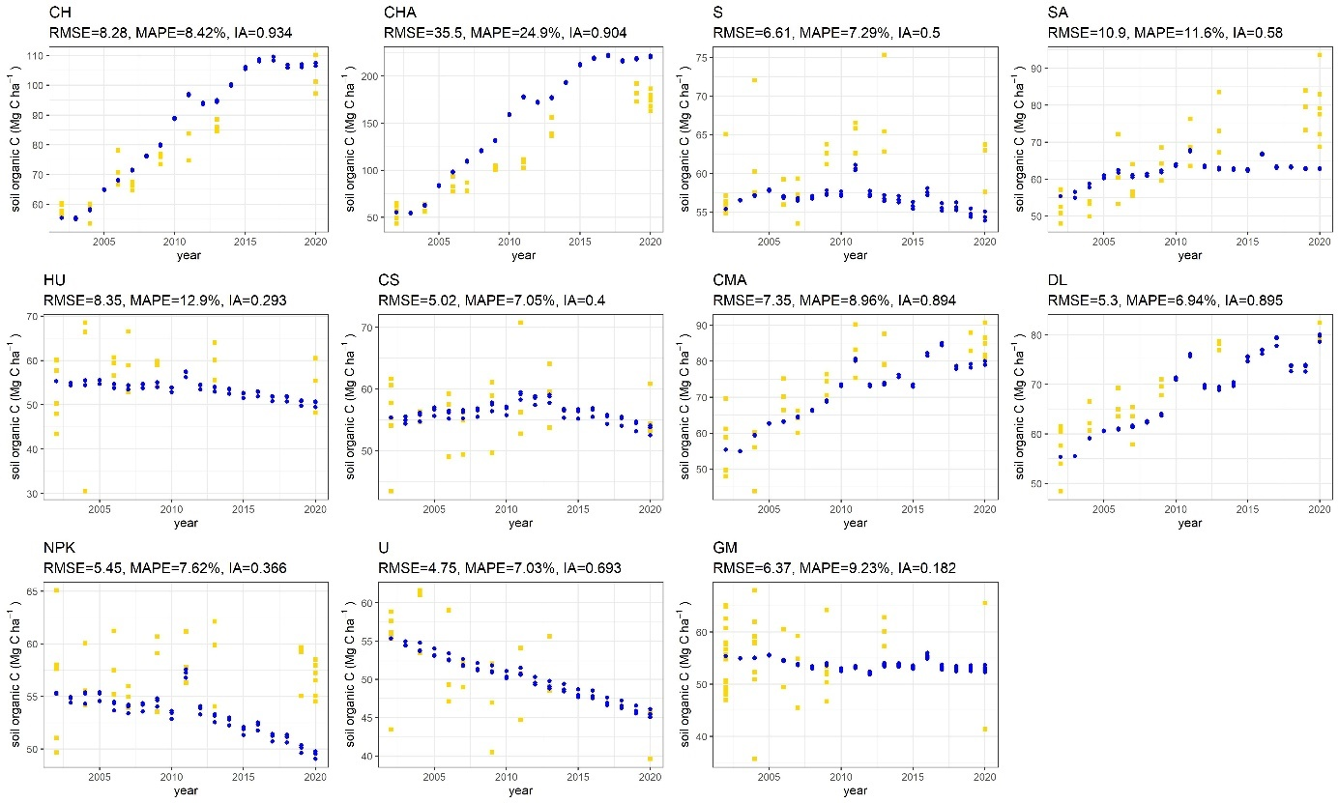
Supplementary Figure 1: Fit of the predicted model values (blue) and measured field data (yellow) for soil organic matter in the layer of 0-25 cm. Each dot represents one plot. Estimates for the fit are given for each treatment in the form of RMSE, MAPE, and index of agreement (IA). For the treatment abbreviations consult Supplementary Table 3.

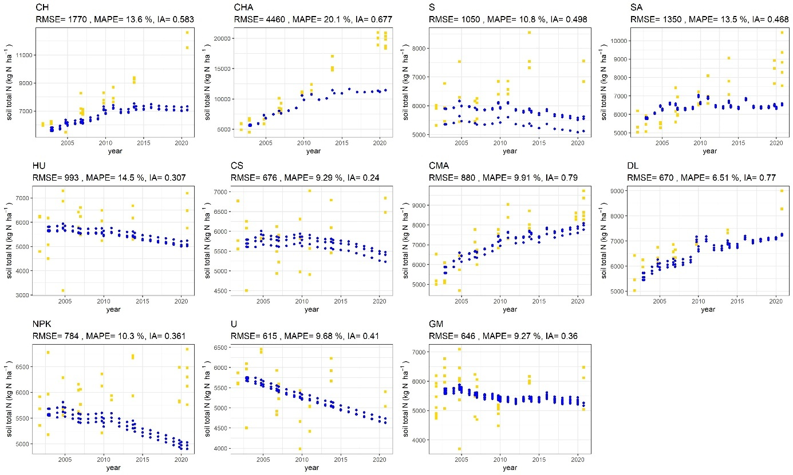
Supplementary Figure 2: Fit of the predicted model values (blue) and measured field data (yellow) for soil total nitrogen in the layer of 0-25 cm. Each dot represents one plot. Estimates for the fit are given for each treatment in the form of RMSE, MAPE, and index of agreement (IA). For the treatment abbreviations consult Supplementary Table 3.

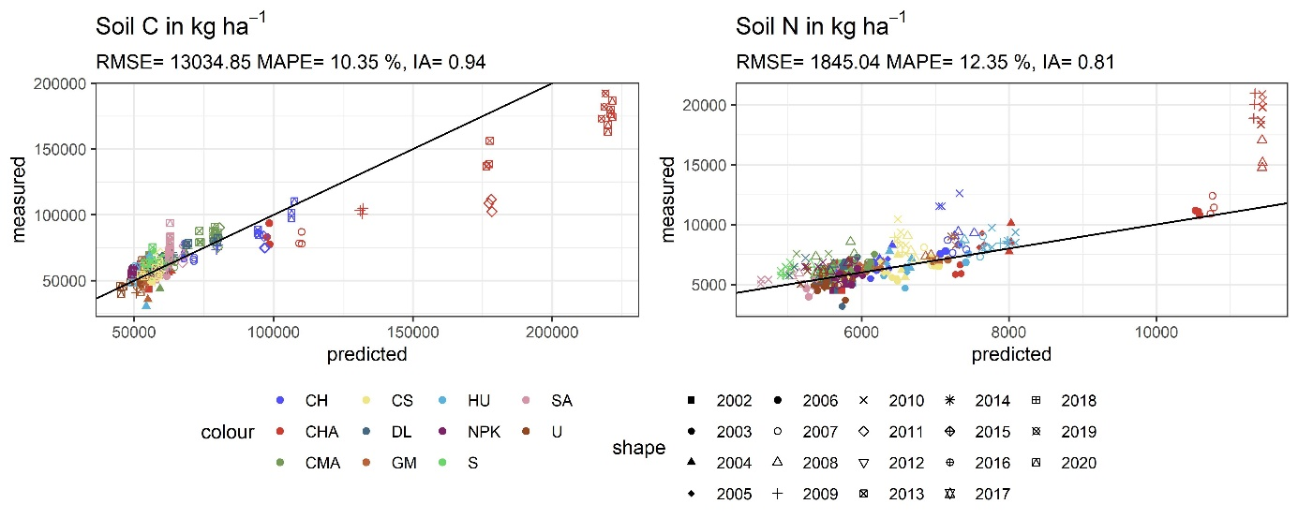
Supplementary Figure 3: Fit of the predicted model values (x-axis) to the measured data (y-axis) for soil carbon (C; in kg ha⁻¹) and soil total nitrogen (N; in kg ha⁻¹). Estimates for the overall fit are given in the form of RMSE, MAPE, and index of agreement (IA). Dots represent a value pair of measured and predicted data, shape the year of measurement and color the fertilization treatment.
For the treatment abbreviations consult Supplementary Table 3.

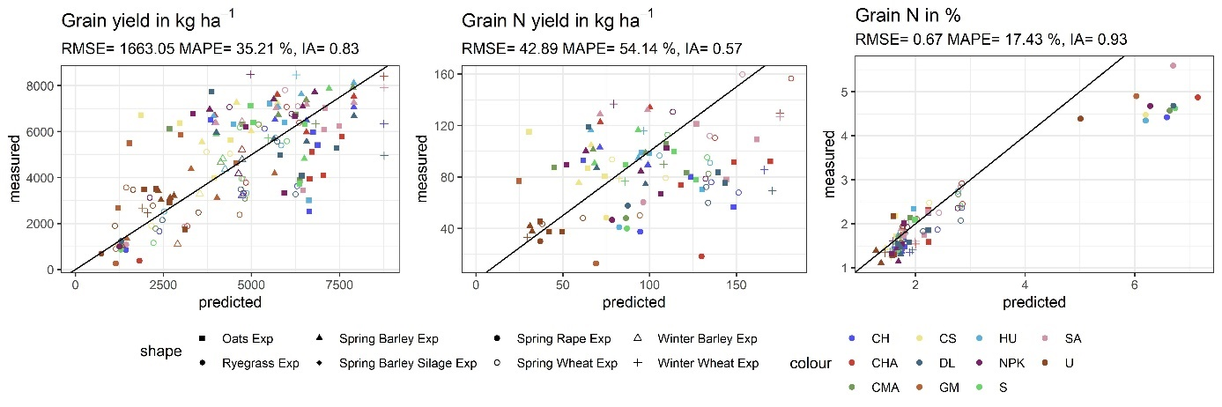
Supplementary Figure 4: Predicted values vs. the measured data for grain yield (kg DM ha⁻¹), grain nitrogen content (in %) and whole crop yield (kg DM ha⁻¹). Estimates for the fit are given in the form of RMSE, MAPE, and index of agreement (IA). Dots represent a value pair of measured and predicted data, shape the crop species and color the fertilization treatment. For the treatment abbreviations consult Supplementary Table 3.

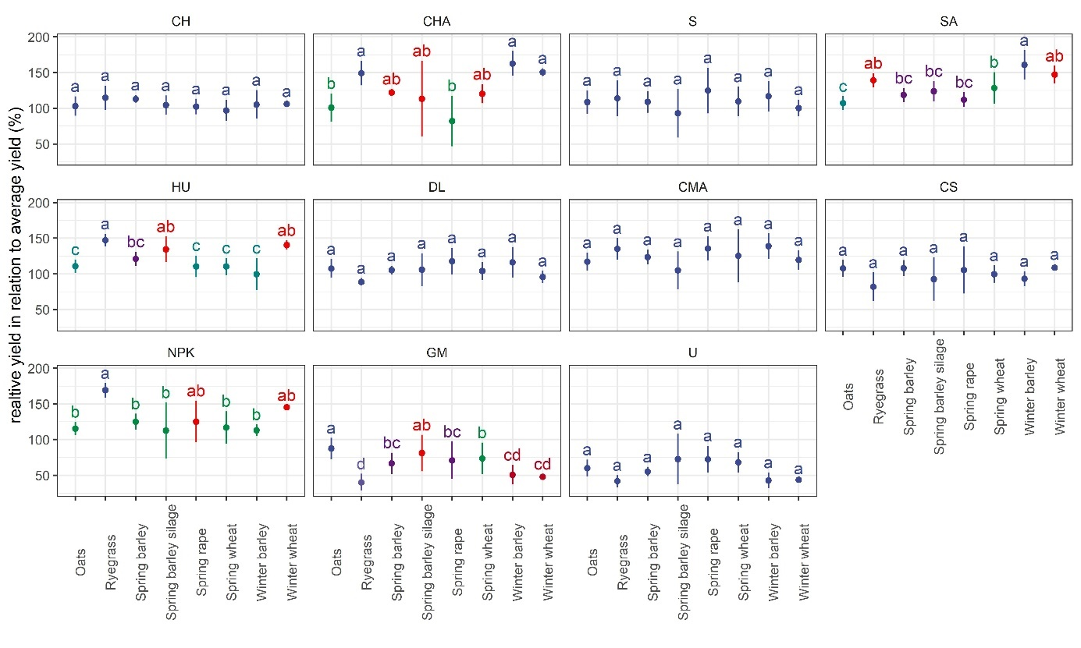Supplementary Figure 5: Effect of the cultivated crop on the relative DM yield in relation to the year’s average yield (in %) for each fertilizer scheme separately. Letters indicate significant differences, dots represent the mean and bars the standard deviation. For the treatment abbreviations consult Supplementary Table 3.

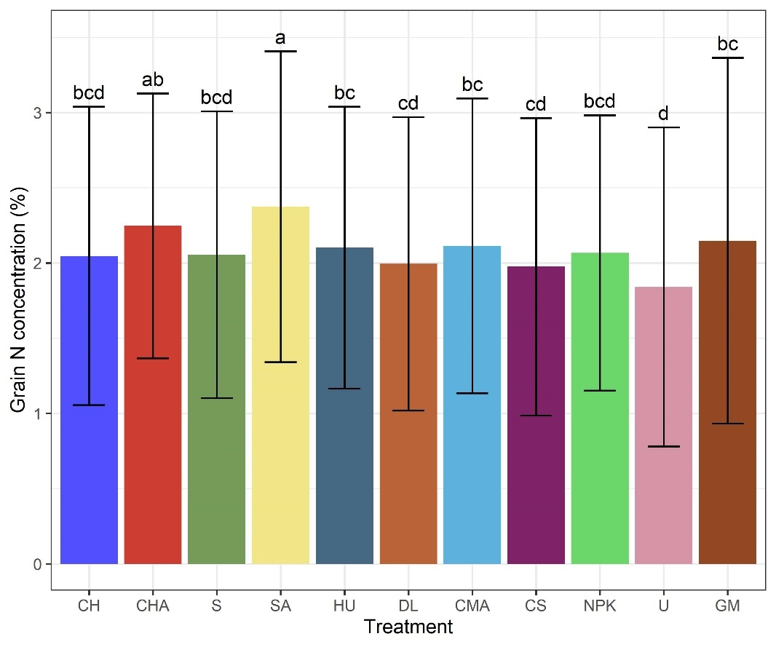
Supplementary Figure 6: Influence of the fertilization treatment on the grain N content (in %) overall years and crops. Letters indicate significant differences, bars the means and error bars the standard deviation. For the treatment abbreviations consult Supplementary Table 3.

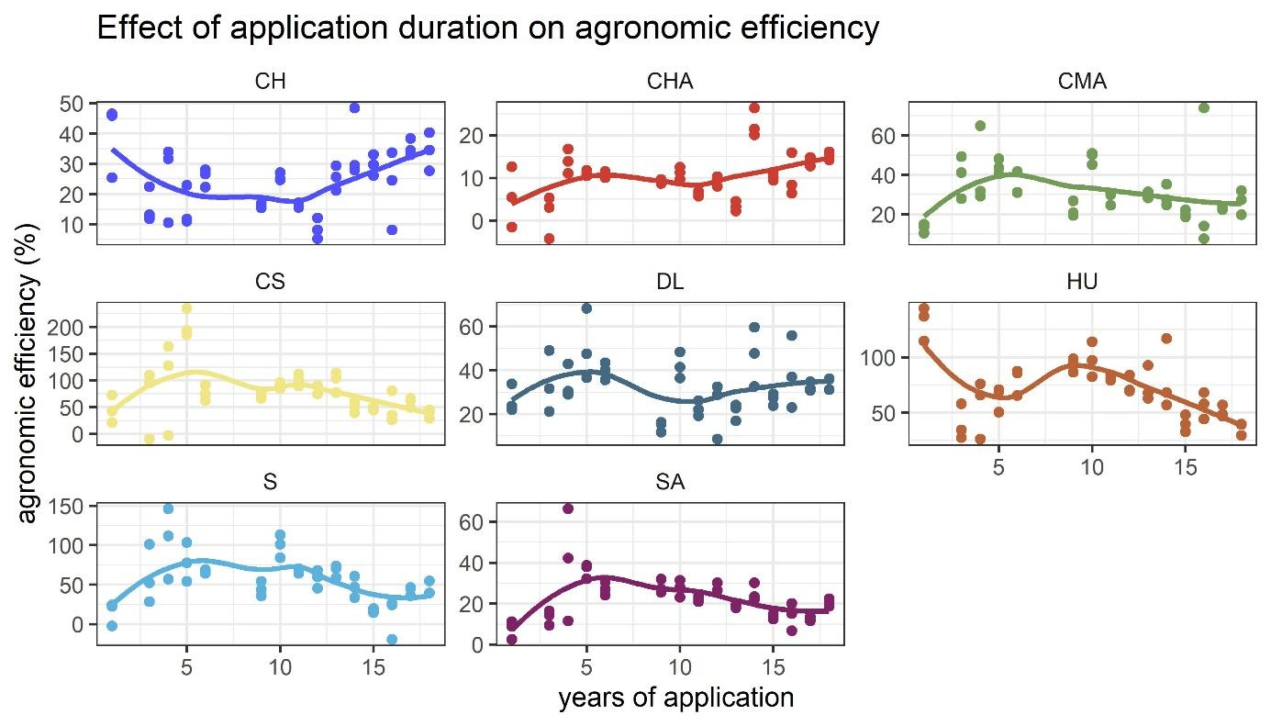
Supplementary Figure 7: Agronomic efficiency throughout the duration of the experiment. Dots represent the agronomic efficiency for each repetition of the treatment; lines represent the trend as predicted by the LOESS method. For the treatment abbreviations consult Supplementary Table 3.

