Biomimetic intelligent nanoplatform with cascade amplification effect for tumor synergy therapy
Ying Wang,^{2*} Qing Ji,^{1*} Chao Yan,² Pang Ji¹
- Department of Clinical Laboratory, The Affiliated People's Hospital of Jiangsu University, Zhenjiang, 212002, Jiangsu, China.
- The Affiliated Huai’an Hospital of Xuzhou Medical University and The Second People’s Hospital of Huai’an, No. 62, Huaihai Road (S.), Huai’an, 223002, China.
- Department of Anesthesia, Kunming Hospital of Traditional Chinese Medicine, the Third Affiliated Hospital of Yunnan University of Traditional Chinese Medicine, Kunming, 650200, China.

* These authors contributed equally to this work
Corresponding author email: pangji910313@163.com (Pang Ji)

Experimental section

Materials
Zn(NO₃)₂·6H₂O, 2-methylimidazole, imiquimod (IQ), doxorubicin (DOX), glutathione (GSH, reduced), serotonin and hydrogen peroxide were purchased from Aladdin Reagent Company (Shanghai, China). 1,2-distearoyl-sn-glycero-3-phosphoethanolamine-N-[folate (polyethylene glycol)-2000] (DSPE-PEG-FA), cell counting kit-8 (CCK-8), phosphate buffered saline (PBS), Fetal bovine serum (FBS), Trypsin, RPMI Medium Modified (RPMI-1640), and penicillin-streptomycin were procured from Hyclone (Logan, UT, USA). Sodium hydroxide, and hydrochloric acid were purchased from Sinopharm Chemical Reagent (Beijing, China). Deionized water was used in the experiments. All chemicals were used in this work without further purification.

Apparatus and Procedures
Transmission electron microscopy (TEM) images were obtained by a transmission electron microscope (JEOL 2100, Japan). X-ray powder diffraction (XRD) measurement was performed by an X-ray diffractometer (GBC MMA Instrument). N₂ adsorption-desorption isotherms was tested through NanoBrook Omni (Brookhaven, USA). The ζ-potential measurement was applied by a NanoBrook Omni (Brookhaven, USA). X-ray photoelectron spectroscopy (XPS) of all samples were tested through XPS spectrometer (Thermo Kalpha). Fourier transform infrared (FTIR) spectra were acquired by a NicoletNexus 470 spectrometer (USA). Infrared thermal photos and temperature changes were recorded on the infrared thermal camera (HT-19, Guangzhou, China). 808 nm near-infrared irradiation was performed by a fiber-coupled NIR laser (MDL-N-808 nm-10W, Beijing Laserwave OptoElectronics Technology Co., Ltd., Beijing, China). Confocal laser scanning microscopy (CLSM, Nikon, Japan) was performed to detect cytophagocytic behavior.

Synthesis Process of ZIF-8
Firstly, 0.2 g of Zn(NO₃)₂·6H₂O was added to 7.5 mL of water and fully dissolved to obtain solution A. Then, 2-methylimidazole (MIM) was added to 10 mL of water and fully dissolved to obtain solution B. Finally, solution B was slowly added to the mixed solution A and stirred with a magnetic stirrer at 1000 rpm for 15 min. The precipitate was collected by centrifugation (10000 rpm, 10 min). Subsequently, the collected precipitate was thoroughly washed with water and ethanol and placed in a vacuum dryer. After 12 h, the resulting powder, namely ZIF-8, was collected.¹⁻²

Synthesis process of ZIF-8/DOX
ZIF-8/DOX was synthesized according to the previous synthesis process with corresponding modifications. Firstly, 0.2 g of Zn(NO₃)₂·6H₂O was added to 7.5 mL of ultrapure water and fully dissolved. Subsequently, 1 mg of DOX was added to the above solution and fully dissolved to obtain the mixed solution A. Then, 2-methylimidazole (MIM) was added to 10 mL of water and fully dissolved to obtain the solution B. Finally, the solution B was slowly added to the mixed solution A and stirred at 1000 rpm for 15 min using a magnetic stirrer. The precipitate was collected by centrifugation (10000 rpm, 10 min). Subsequently, the collected precipitate was thoroughly washed with water and ethanol and placed in a vacuum dryer. After 12 h, the obtained powder, namely ZIF-8/DOX, was collected.³⁻⁴

Synthesis process of PST&ZIF-8/DOX
100 mg of ZIF-8/DOX was added into 10 mL of ultrapure water to make it fully dispersed. Subsequently, 100 mg of serotonin and 200 µL of ammonia water were added to the above dispersion liquid respectively and the mixture was stirred with a magnetic stirrer (1000 rpm). After 1 h, the precipitate was collected by centrifugation and washed with ultrapure water for 3 times. After freezing, it was vacuum-dried and stored for future use.⁵⁻⁶

Synthesis process of IQ/PST&ZIF-8/DOX
100 mg of PST&ZIF-8/DOX was added into 10 mL of ultrapure water to make it fully dispersed. Subsequently, 100 mg of imiquimod was added to the above dispersion and the mixture was stirred continuously at 1000 rpm using a magnetic stirrer. After 24 h, the precipitate was collected by centrifugation and washed with ultrapure water for three times. After freezing, it was vacuum-dried and stored for future use.⁷⁻⁸

Cell culture

Macrophage cells (RAW264.7), murine breast cancer cells (4T1 cells) and anthropogenic gastric mucosa epithelial cells (GES-1 cells) were obtained from Jiangsu University. The cells were incubated with fresh 1640 media containing 10% heat-inactivated FBS. All the cell lines were approved by the Jiangsu University.

Animal welfare
All animal experiments were performed based on the protocol approved by the Institutional Animal Care and Use Committee of Jiangsu University. 5-week-old BALB/c mice were purchased from Biological science and technology co., LTD (Zhenjiang, China) and feed in specific pathogen-free-conditions. And the animal study is reported in accordance with ARRIVE guidelines.

Statistical analysis
OriginPro, SPSS 17.0 and Graphpad Prism5 were applied to analyze the experimental data. And all the experiment data were repeated at least three times and the results were recorded with the mean value ± standard deviation. The student’s t-test was utilized for statistical analysis. The p value of < 0.05 was considered statistically significant. *p < 0.05, **p < 0.01, ***p < 0.001.

Results
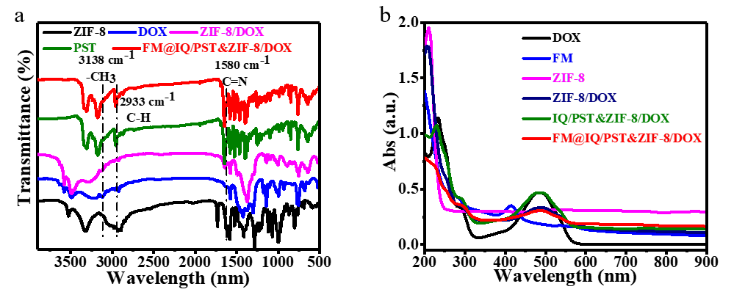
Figure S1. (a) FTIR of ZIF-8, DOX, ZIF-8/DOX, PST and FM@IQ/PST&ZIF-8/DOX. (b) UV-vis absorption of DOX, FM, ZIF-8, ZIF-8/DOX, IQ/PST&ZIF-8/DOX and FM@IQ/PST&ZIF-8/DOX.

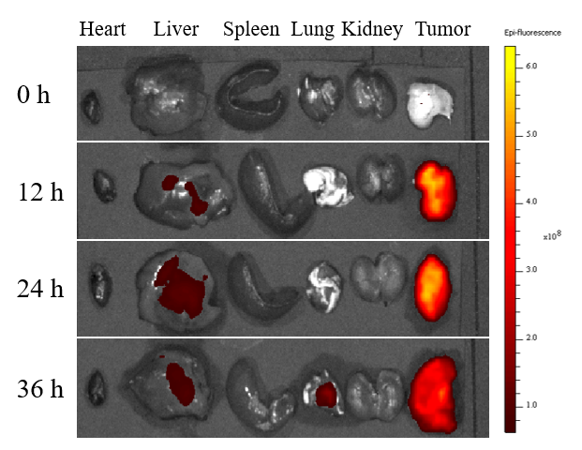
Figure S2. Ex vivo fluorescence images of 4T1-bearing mice at designed time after treated with FM@IQ/PST&ZIF-8/DOX.

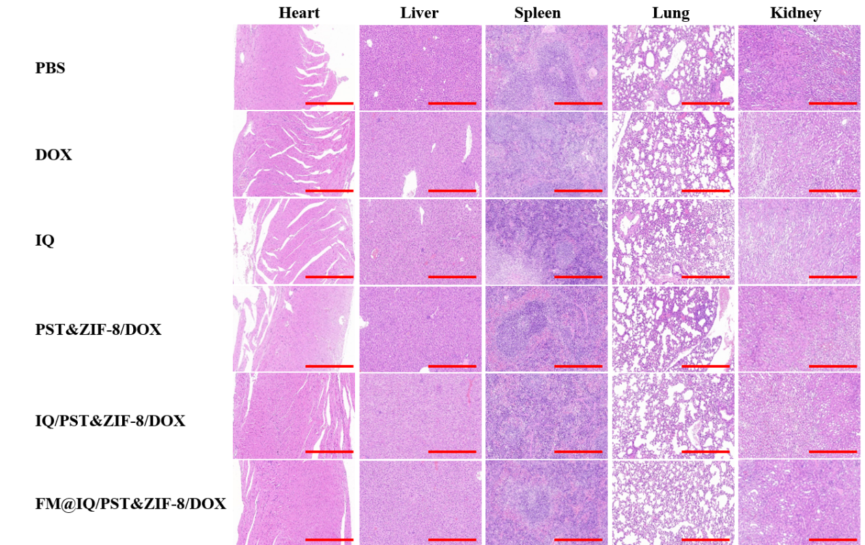
Figure S3. H&E-stained images of the major organs (Heart, Liver, Spleen, Lung and Kidney) in the different groups. Scale bar: 100 μm.

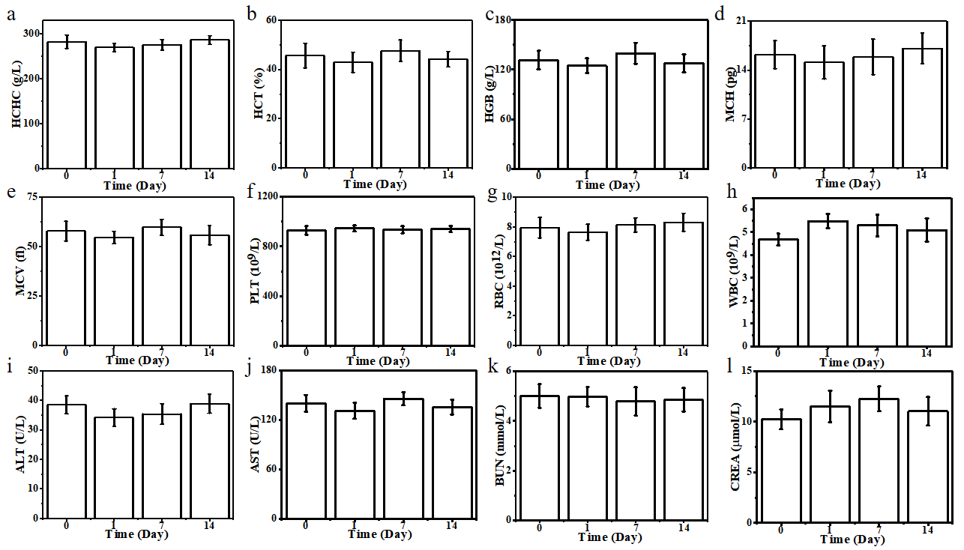
Figure S3. The blood tests (a-h) and the serum biochemistry index (i -l) of the mice on the 0st, 1th, 7th and 28th day after the treatment of FM@IQ/PST&ZIF-8/DOX.

Reference:
- Xiaoqing Ren, Rui Zheng, Xiaoling Fang, et al. Red blood cell membrane camouflaged magnetic nanoclusters for imaging-guided photothermal therapy. Biomaterials, 2016. 92: 13-24.
- Shi-Ying Li , Hong Cheng, Wen-Xiu Qiu, et al. Cancer cell membrane-coated biomimetic platform for tumor targeted photodynamic therapy and hypoxia-amplifified bioreductive therapy. Biomaterials, 2017. 142: 149-161.
- Jiabao Dong, Xupeng Chai, Yucheng Xue, et al. ZIF-8-Encapsulated Pexidartinib Delivery via Targeted Peptide-Modifified M1 Macrophages Attenuates MDSC-Mediated Immunosuppression in Osteosarcoma. Small, 2024. 2309038: 1-14.
- Kai Dong, Zhenzhen Wang, Yan Zhang, et al. Metal-Organic Framework-Based Nanoplatform for Intracellular Environment-Responsive Endo/Lysosomal Escape and Enhanced Cancer Therapy. ACS Appl. Mater. Interfaces, 2018. 10: 31998-32005.
- Ting-Ting Chen, Jin-Tao Yi, Yan-Yan Zhao, et al. Biomineralized Metal-Organic Framework Nanoparticles Enable Intracellular Delivery and Endo-Lysosomal Release of Native Active Proteins. J. Am. Chem. Soc., 2018. 140: 9912-9920.
- Ting-Ting Chen, Jin-Tao Yi, Yan-Yan Zhao, et al. Biomineralized Metal-Organic Framework Nanoparticles Enable Intracellular Delivery and Endo-Lysosomal Release of Native Active Proteins. J. Am. Chem. Soc., 2018. 140: 9912-9920.
- Nako Nakatsuka, Mohammad Mahdi Hasani-Sadrabadi, Kevin M. Cheung, et al. Polyserotonin Nanoparticles as Multifunctional Materials for Biomedical Applications. ACS Nano, 2018. 12: 4761-4774.
- Yingcai Meng, Jiaojiao Zhu, Jinsong Ding, et al. Polyserotonin as a versatile coating with pH-responsive degradation for anti-tumor therapy. Chem. Commun., 2022. 58: 6713-6716.

