SUPPLEMENTAL FILES

New 5-methylisatin-thiosemicarbazones: preparation, spectroscopic elucidation and antioxidant properties

Temel Kan Bakır^{1,}*

¹ Department of Chemistry, Faculty of Science, Kastamonu University, Kastamonu, Turkey
*Correspondence: temelkan@kastamonu.edu.tr
Temel Kan BAKIR: https://orcid.org/0000-0002-7447-1468

Experimental
Measurement and reagents
All chemicals and solvents were purchased from Merck, Sigma or Aldrich Chemical Company. They were used without further purification. A Stuart SMP30 melting point apparatus was used to determine melting points. Infrared (IR) spectra recorded a Bruker Alpha Fourier transform IR (FT–IR) spectrometer. NMR spectra were taken on a Bruker Avance DPX–400 (400 MHz) spectrophotometer in dimethyl sulfoxide-d₆ (DMSO–d₆) as solvent. A Eurovector EA3000 elemental analyser was used for elemental analysis. UV–Vis spectra and absorption data obtain a Shimadzu UVM-1240 UV–Visible spectrophotometer.
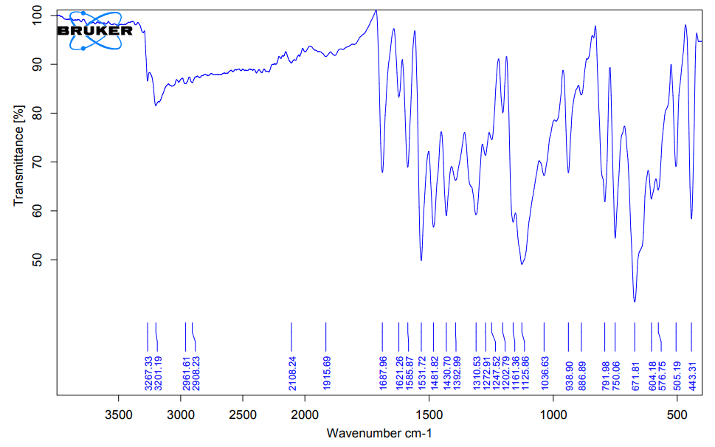
- IR spectrum of compound 1
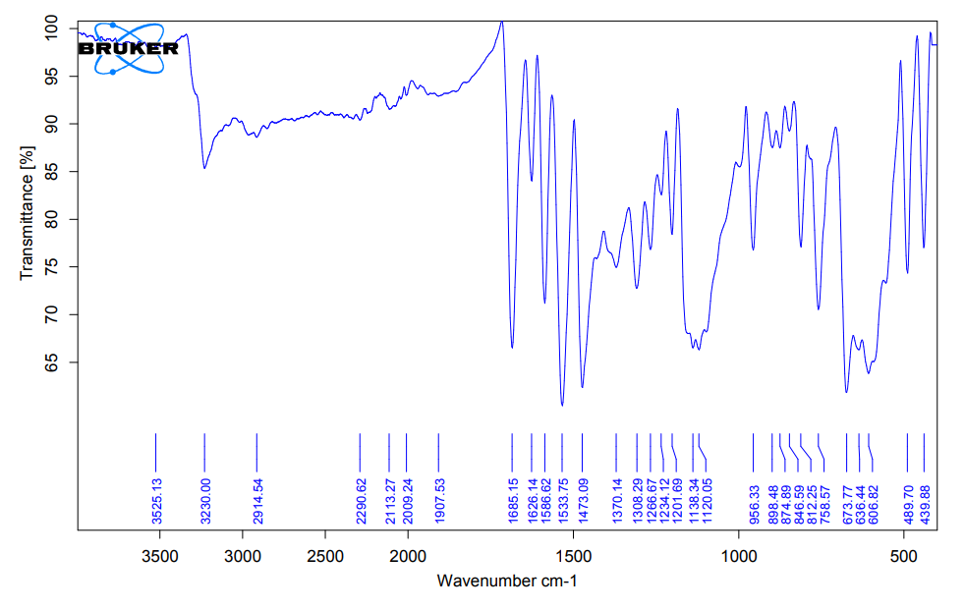
- IR spectrum of compound 2

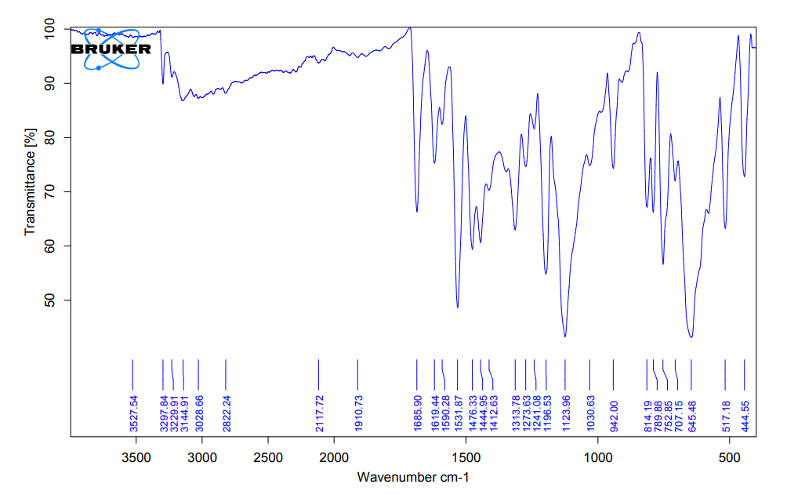
- IR spectrum of compound 3
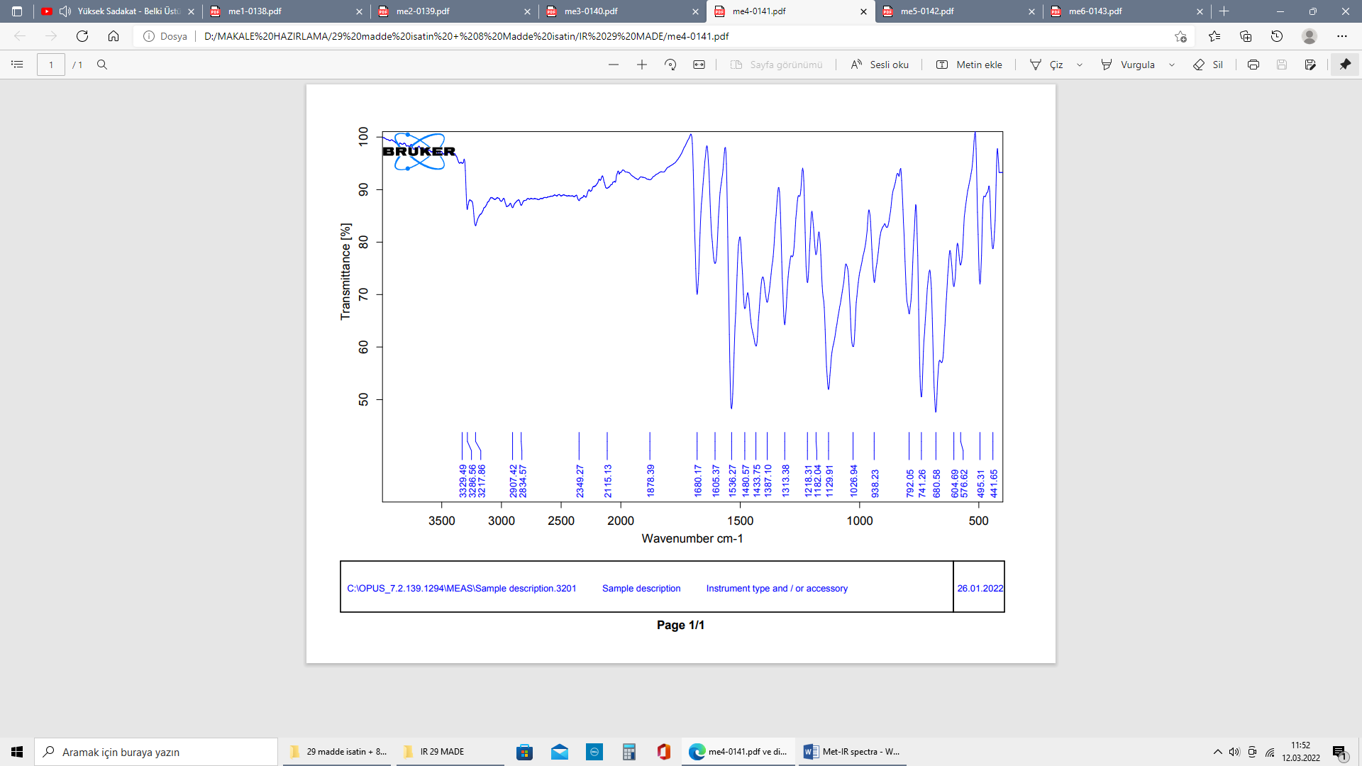
- IR spectrum of compound 4

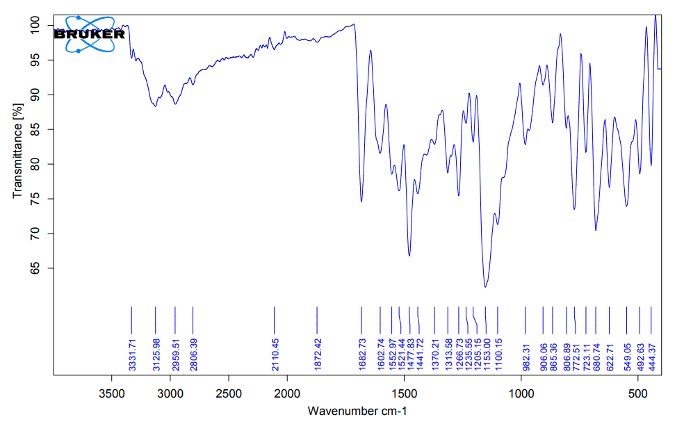
- IR spectrum of compound 5
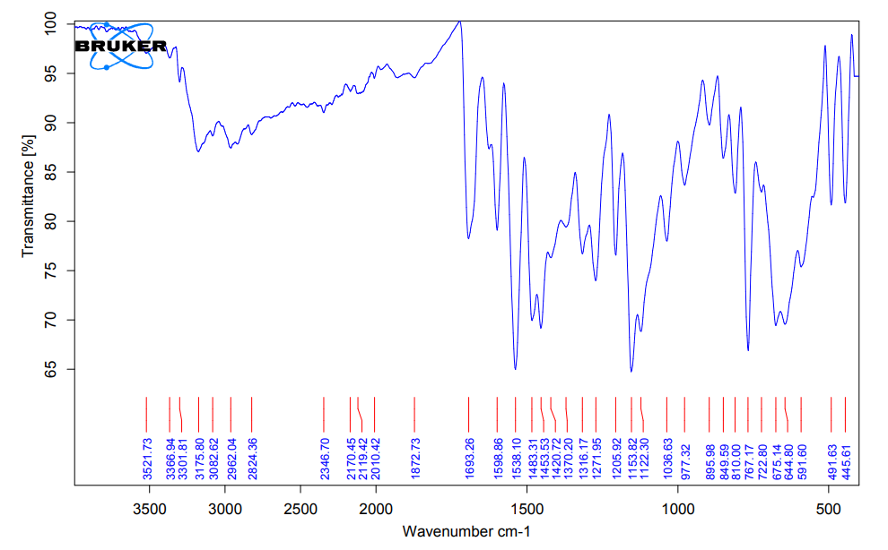
- IR spectrum of compound 6

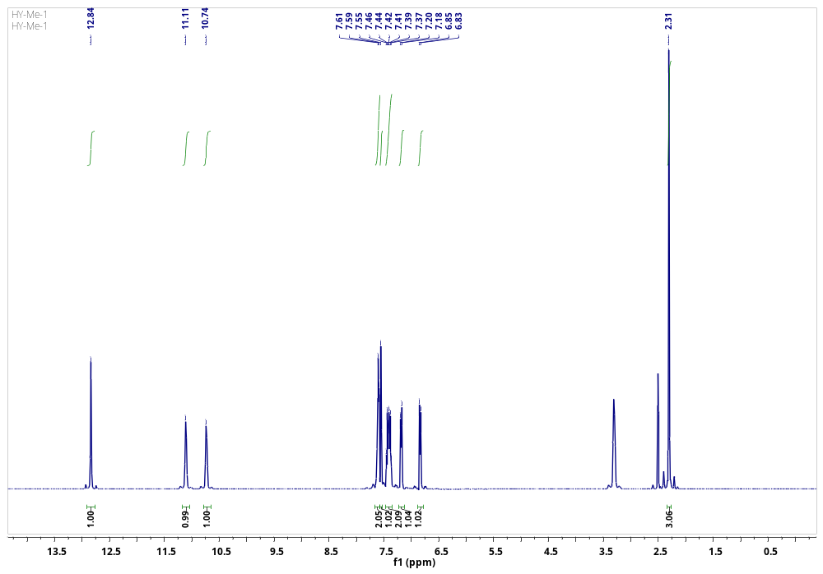
- ¹H NMR spectrum of compound 1
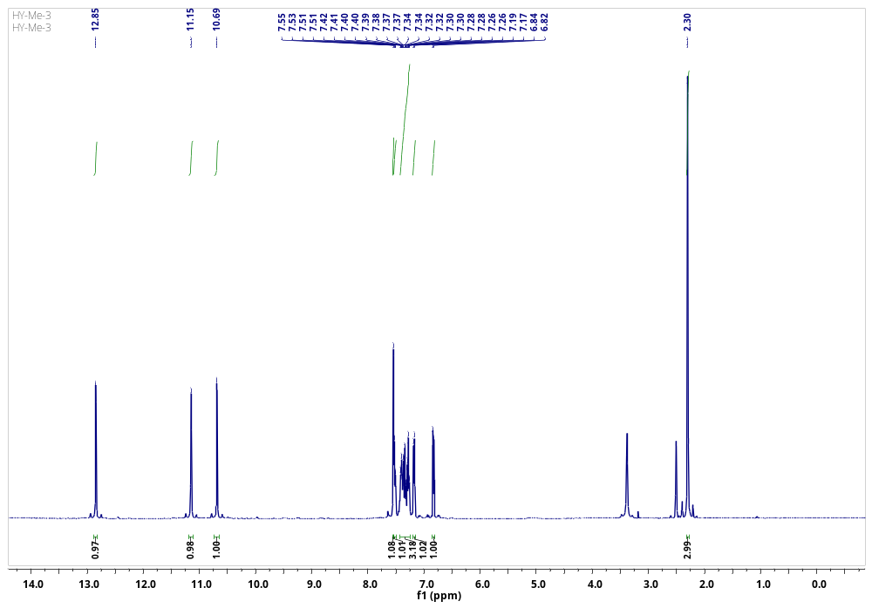
- ¹H NMR spectrum of compound 2
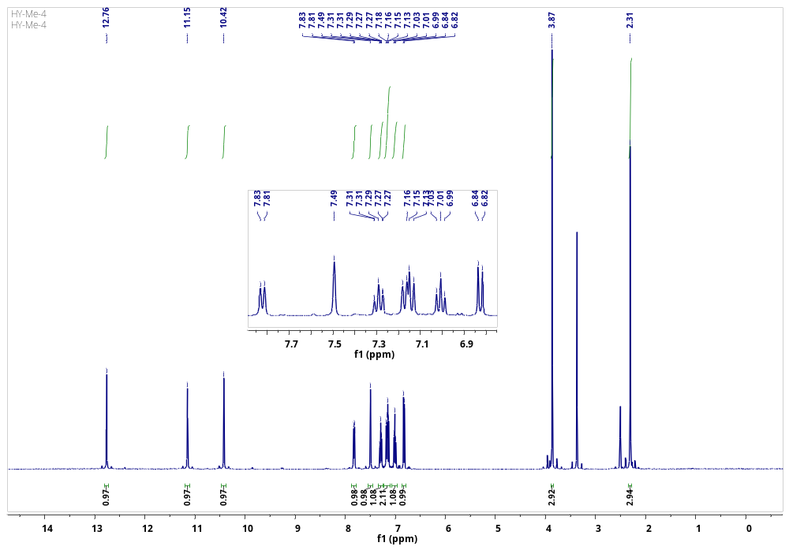
- ¹H NMR spectrum of compound 3
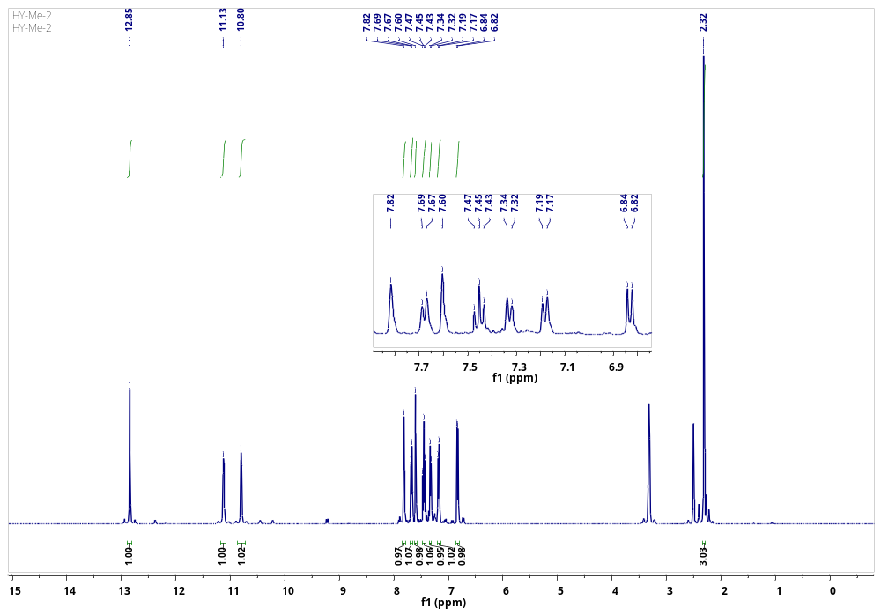
- ¹H NMR spectrum of compound 4

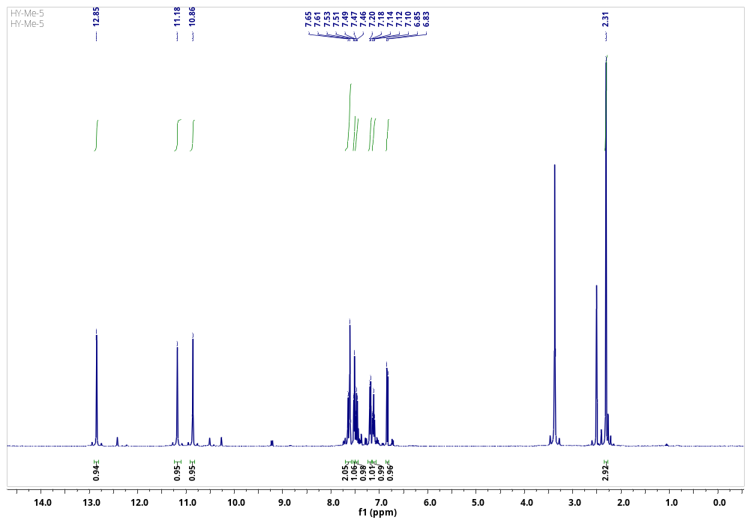
- ¹H NMR spectrum of compound 5
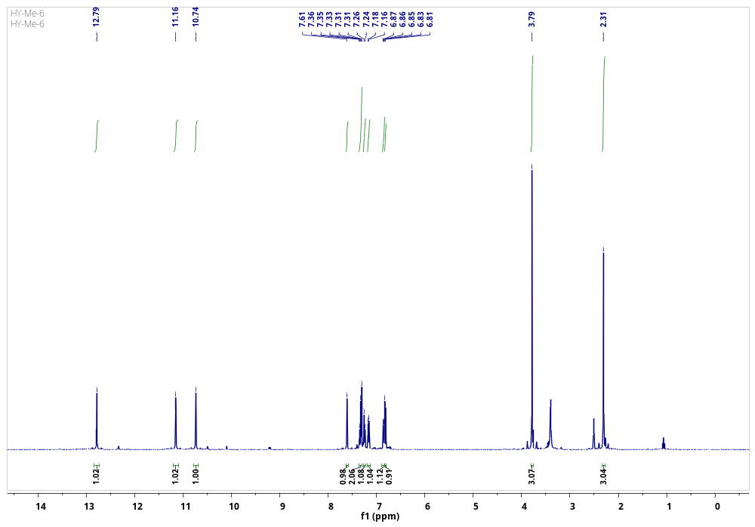
- ¹H NMR spectrum of compound 6
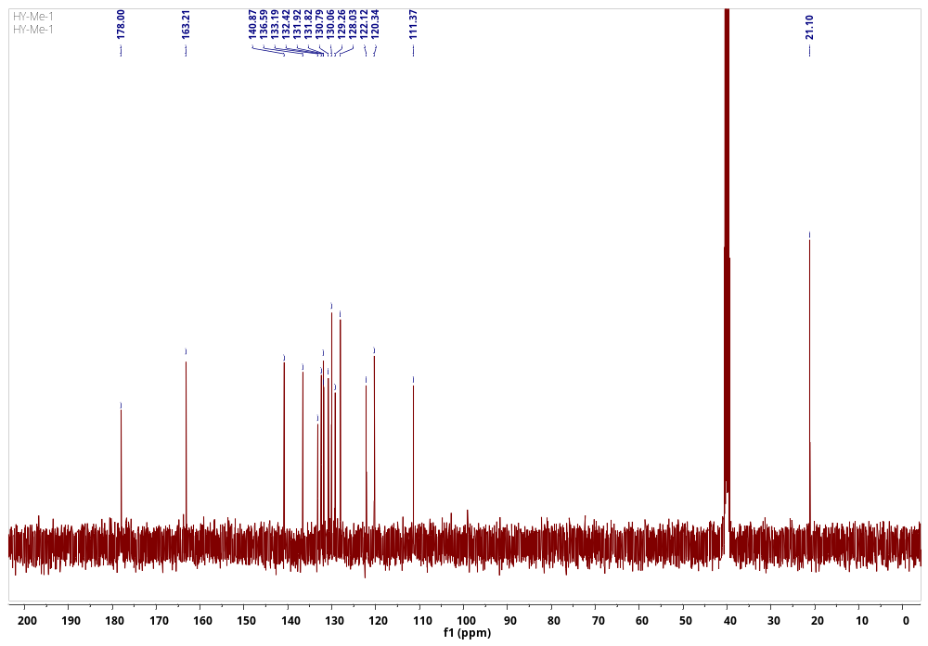
- ¹³C NMR spectrum of compound 1
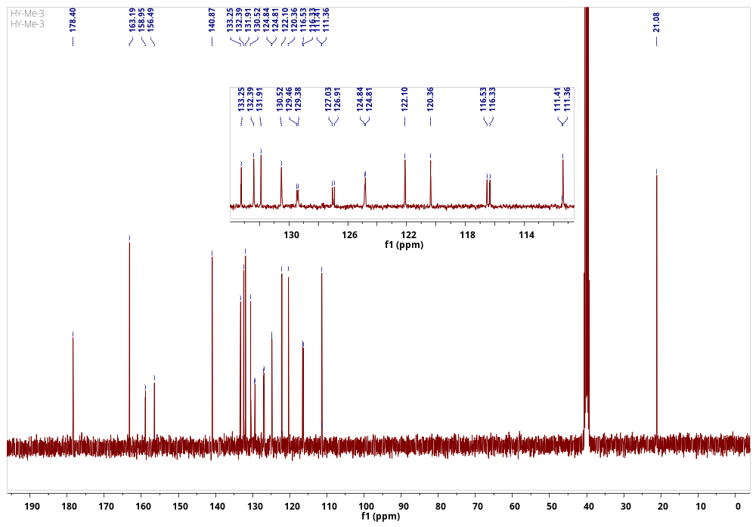
- ¹³C NMR spectrum of compound 2
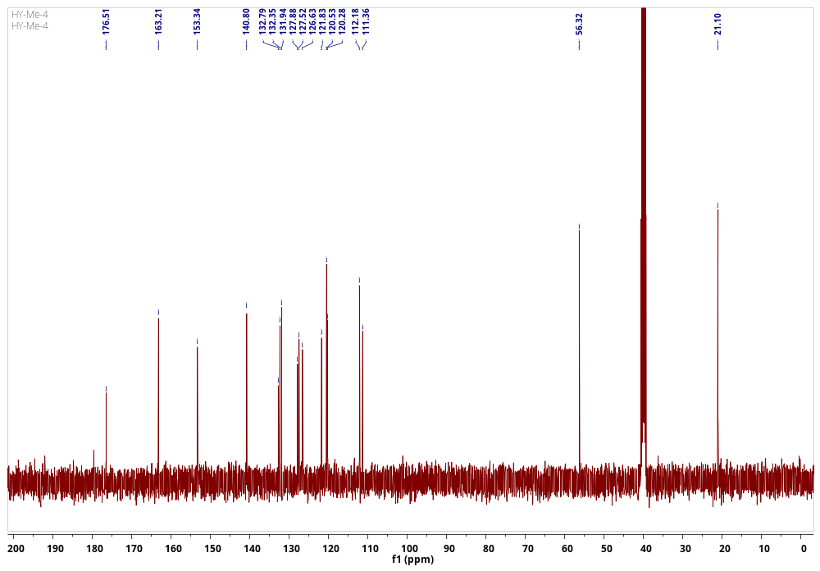
- ¹³C NMR spectrum of compound 3
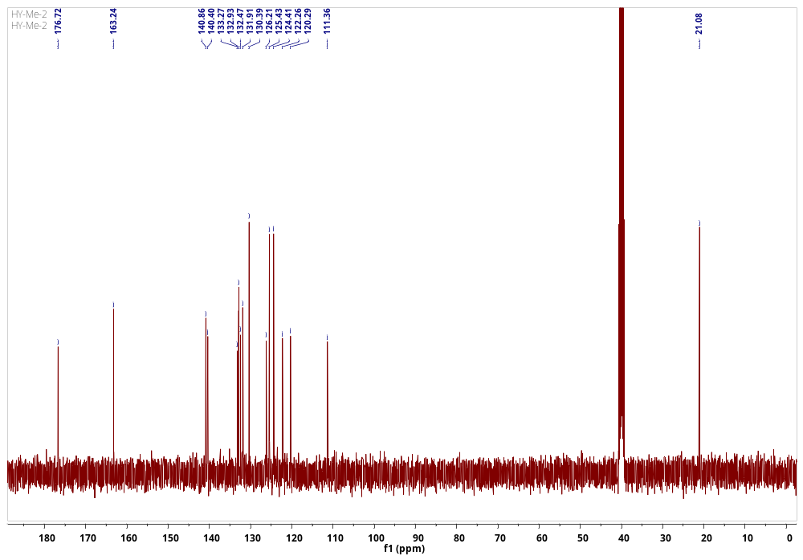
- ¹³C NMR spectrum of compound 4
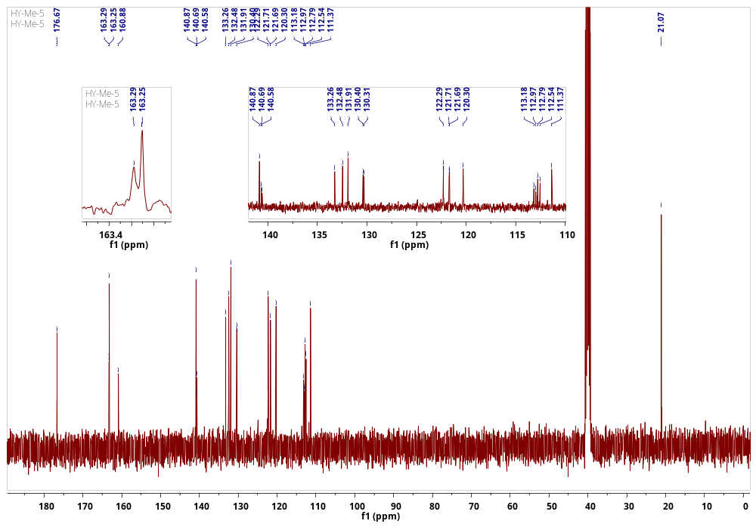
- ¹³C NMR spectrum of compound 5
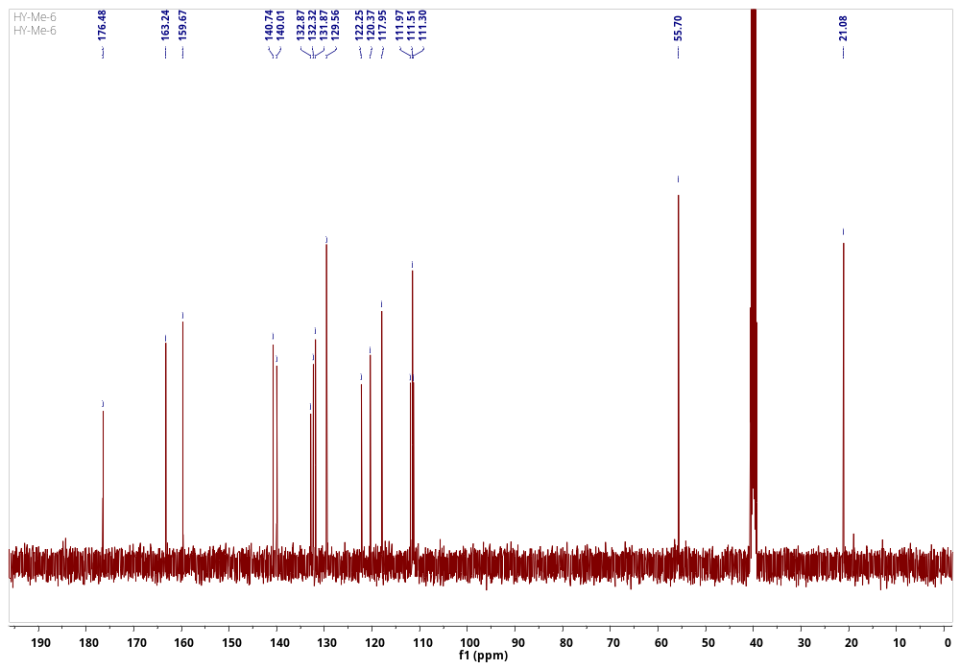
- ¹³C NMR spectrum of compound 6
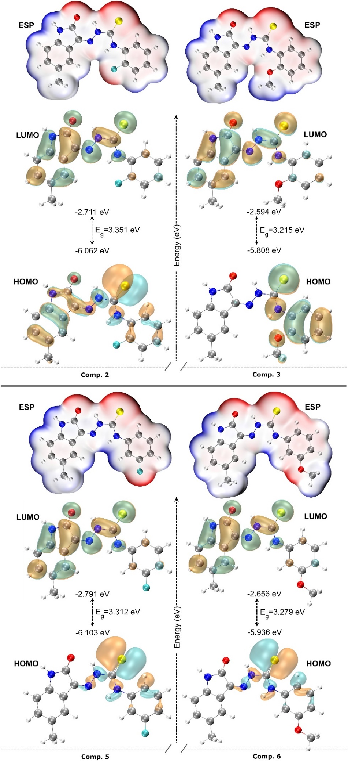
Figure S19. HOMO-LUMO and ESP surface of the compounds.
Table S1. Calculated electronic parameters of the compounds.
Comp. | $$E_{HOMO}$$  (eV) | $$E_{LUMO}$$  (eV) | $E_{g}$ (eV) | $$η$$  (eV) | $$χ$$  (eV) | ω  (eV) | 𝝁  Debye | ω⁺  (eV) | ω⁻  (eV)
1 | -6.067 | -2.718 | 3.349 | 1.675 | 4.392 | 5.760 | 5.41378 | 1.102 | 5.495
2 | -6.062 | -2.711 | 3.351 | 1.675 | 4.387 | 5.743 | 5.57763 | 1.097 | 5.484
3 | -5.808 | -2.594 | 3.215 | 1.607 | 4.201 | 5.490 | 7.62422 | 1.046 | 5.248
4 | -6.122 | -2.801 | 3.321 | 1.660 | 4.462 | 5.995 | 5.91201 | 1.182 | 5.643
5 | -6.103 | -2.791 | 3.312 | 1.656 | 4.447 | 5.971 | 5.91656 | 1.176 | 5.623
6 | -5.936 | -2.656 | 3.279 | 1.640 | 4.296 | 5.628 | 6.40833 | 1.076 | 5.372

$E_{g}$: $E_{LUMO}-E_{HOMO}$, $η$: Chemical Hardness, $χ:$Electronegativity, ω: Electrophilic index, 𝝁: Dipole moment, ω⁺ : electroaccepting power, ω⁻ : electrodonating power.

