ADDITIONAL FILES
Vaccination in pregnancy against pertussis and seasonal influenza: Key learnings and components from high-performing vaccine programmes in three countries: United Kingdom, the United States and Spain

ADDITIONAL FILE 1
Table SI 1: Search terms used for the scientific literature review on Embase
Disease | Vaccination | Population
Pertussis | Vaccination | Pregnant women
Tetanus | Immunisation | Pregnancy
Diphtheria | Vaccine uptake
Influenza | Vaccine Coverage
 | Drivers
 | Barriers
 | Incidence
 | Knowledge
 | Attitudes
 | Perceptions
 | Determinants
 | Predictors
 | Factors
 | Reasons

Figure SI 1: Pregnancy VCR components for the US based on the 5 pillars of the Pregnancy VCR framework
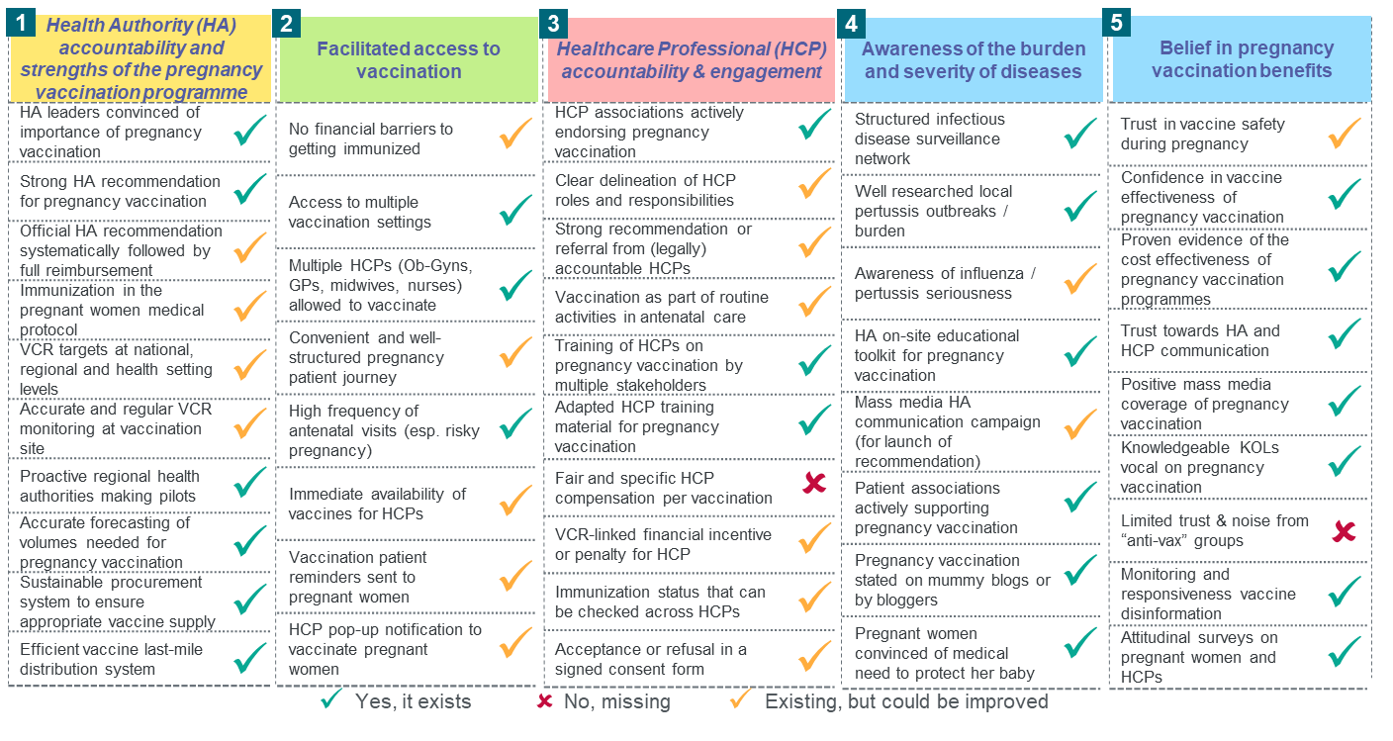
Figure SI 2: Pregnancy VCR components for the UK based on the 5 pillars of the Pregnancy VCR framework
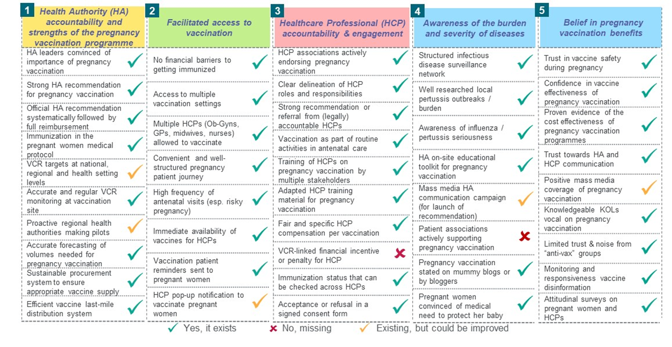
Figure SI 3: Pregnancy VCR components for Spain based on the 5 pillars of the Pregnancy VCR framework
