Supplementary Material 4
RNA Structure Prediction using UNAFOLD server

Fig. S1(a): 16S rRNA secondary structure of Klebsiella pneumoniae strain ABSKSLAB01

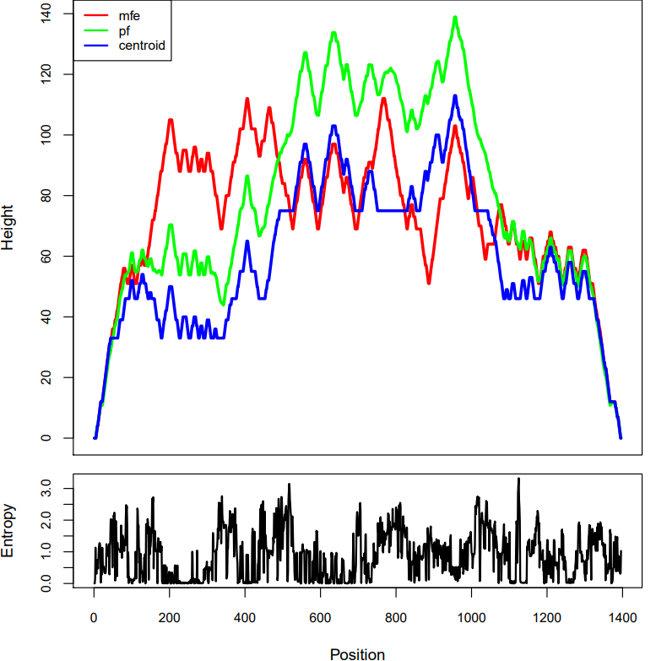

Fig. S1(b): Hill plot representing sequence wise energy and entropy distribution of 16S rRNA for Klebsiella pneumoniae strain ABSKSLAB01

Fig. S2(a): 16S rRNA secondary structure of Klebsiella quasipneumoniae strain ABSKSLAB02

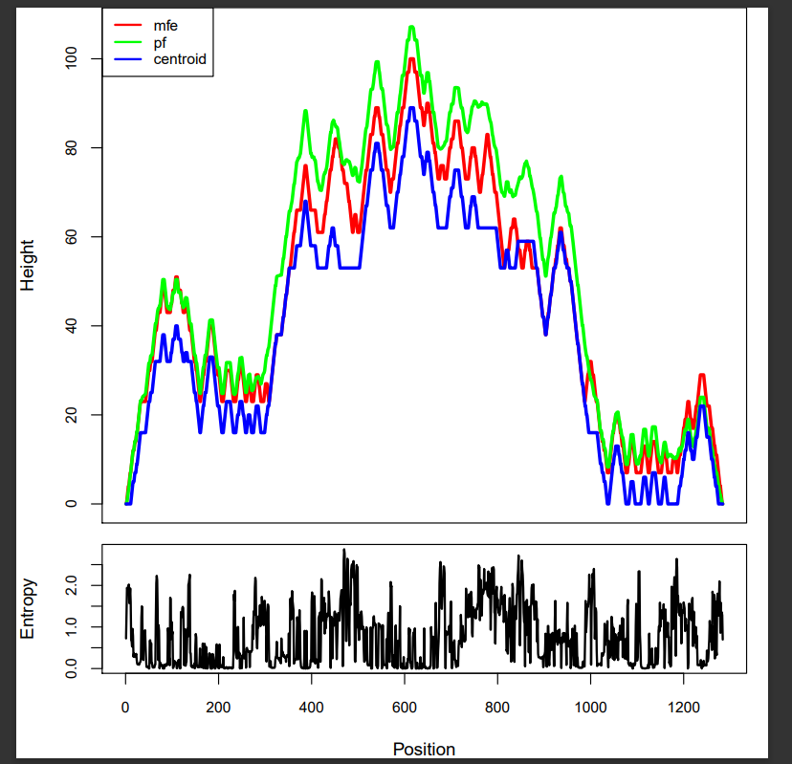
Fig. S2(b): Hill plot representing sequence wise energy and entropy distribution of 16S rRNA for Klebsiella quasipneumoniae strain ABSKSLAB02

Fig. S3(a): 16S rRNA secondary structure of Streptomyces minutiscleroticus strain ABSKSLAB03

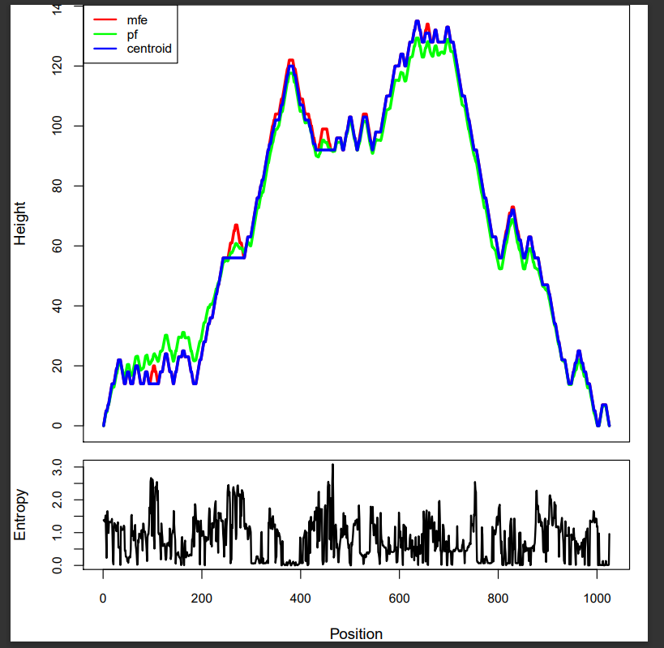

Fig. S3(b): Hill plot representing sequence wise energy and entropy distribution of 16S rRNA for Streptomyces minutiscleroticus strain ABSKSLAB03

