Supplementary Material 3

Plackett Burman Experimental Design

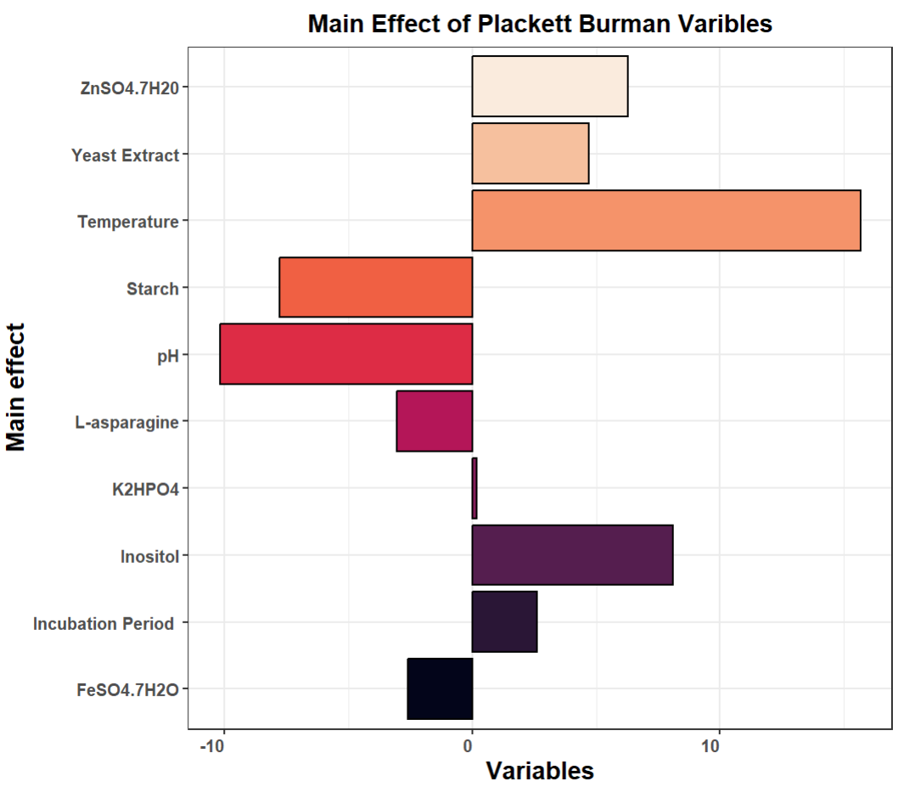
Fig. S1: Pareto Chart for Coefficient Main Effects of Plackett Burman Design

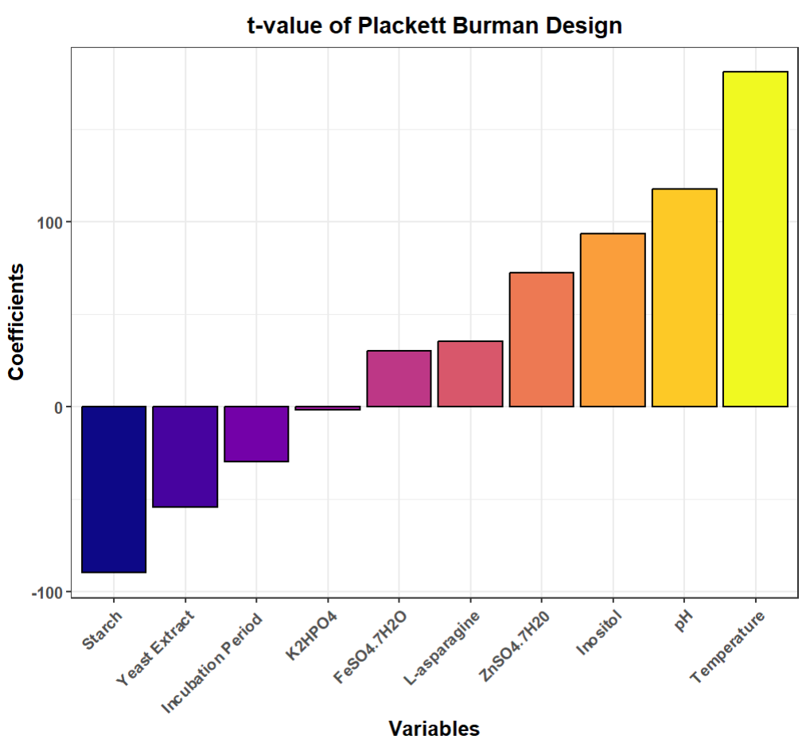
Fig. S2: t-value plot for Plackett Burman Design

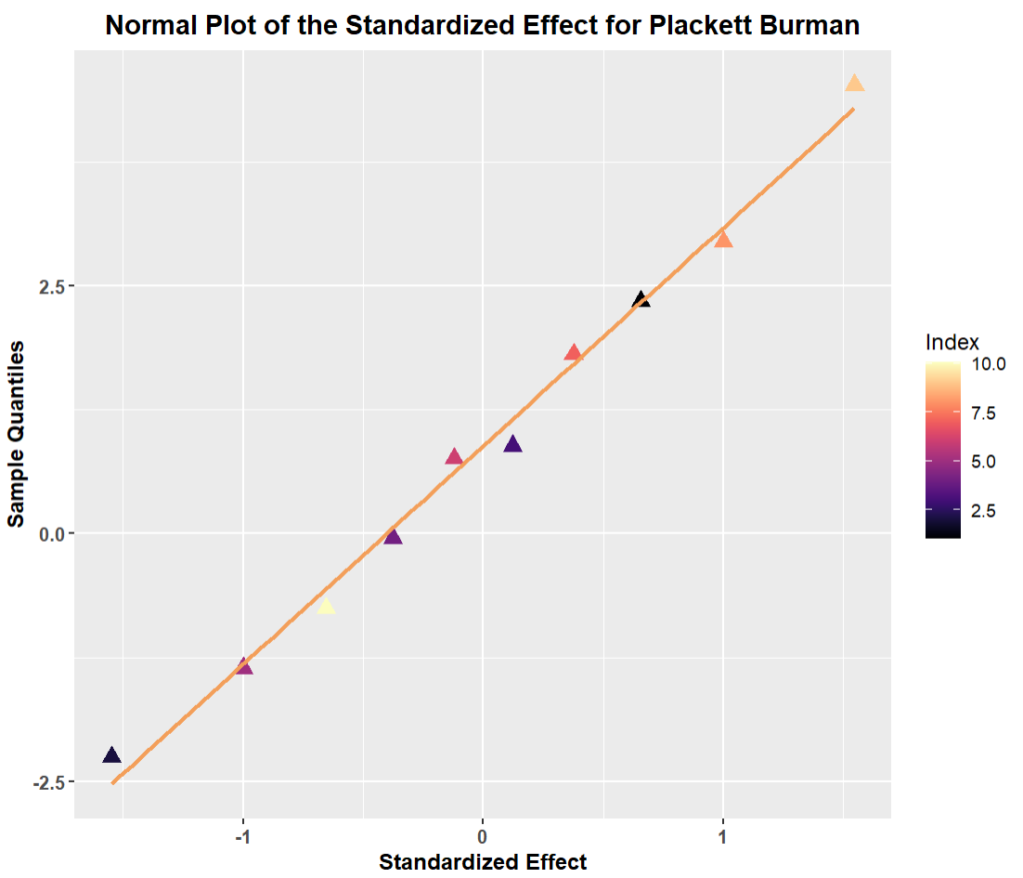
Fig. S3: Normal Plot of Standardized Effect for Plackett Burman Design

Box ‒ Behnken Experimental Design

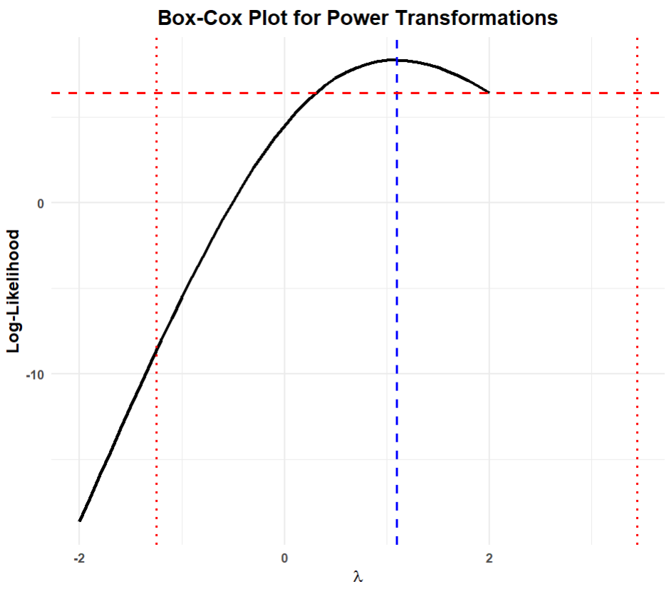
Fig. S4: Box-cox plot for power transform for RSM-BBD

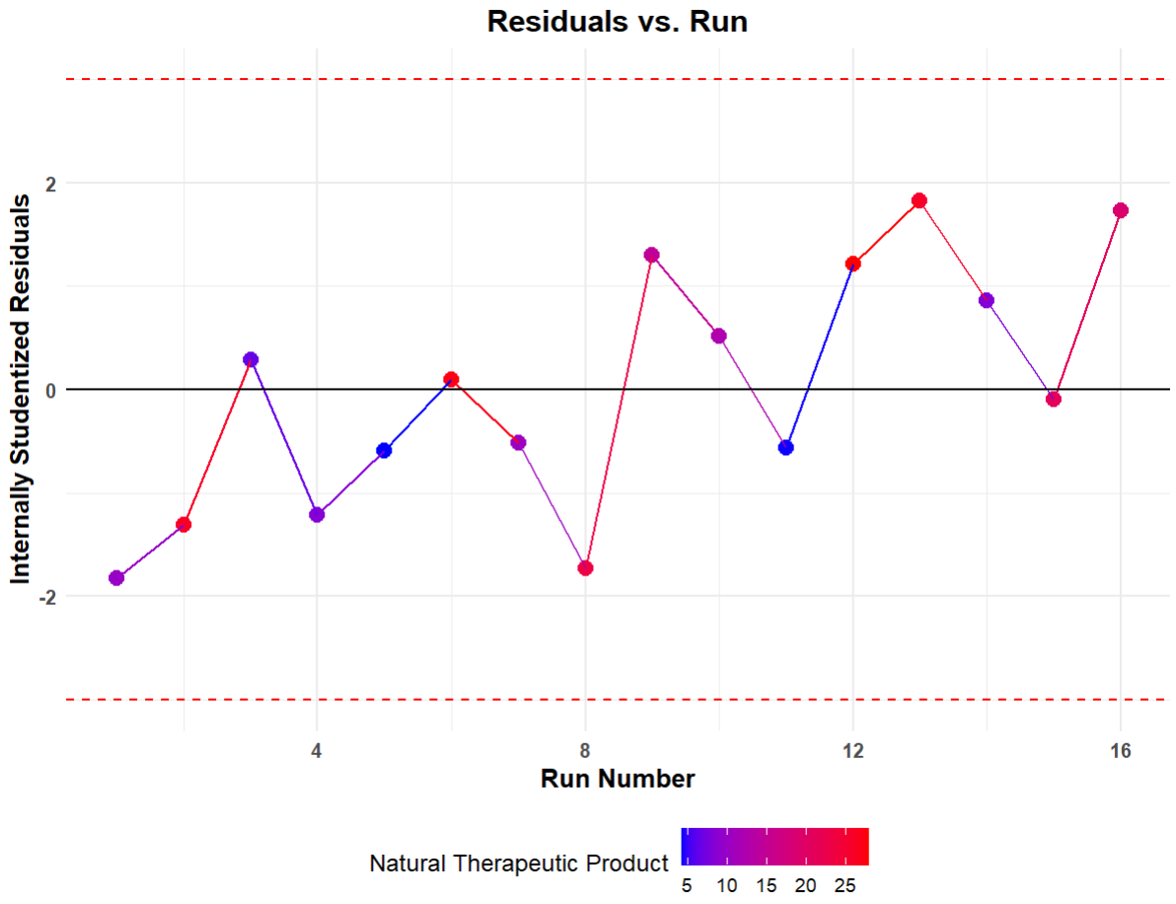
Fig. S5: Residuals v/s Run Plot for RSM-BBD

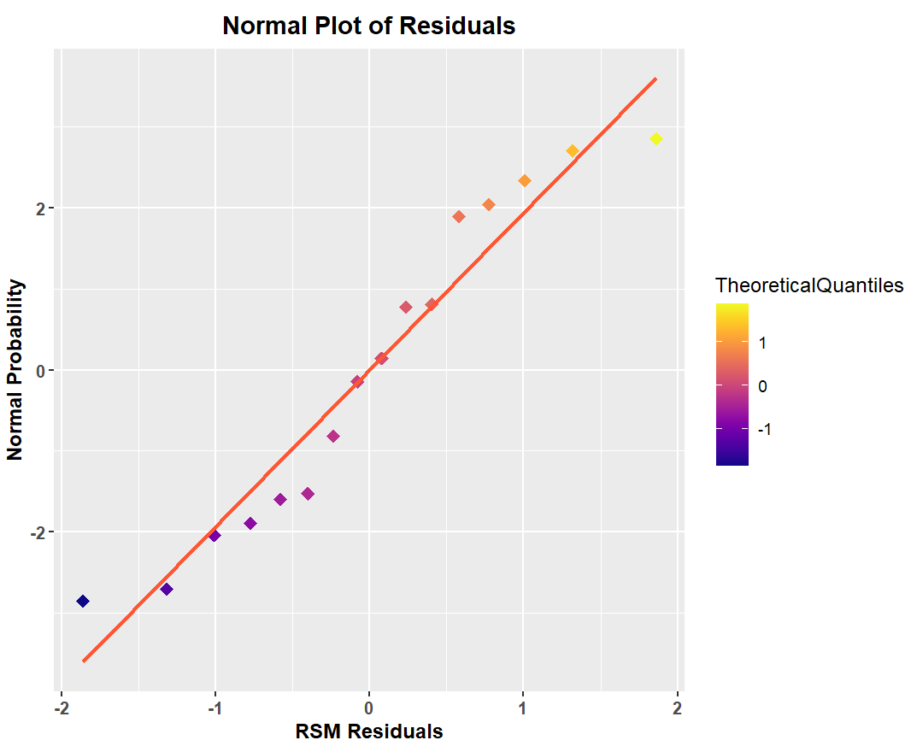

Fig. S6: Normal Plot of Residuals for RSM-BBD

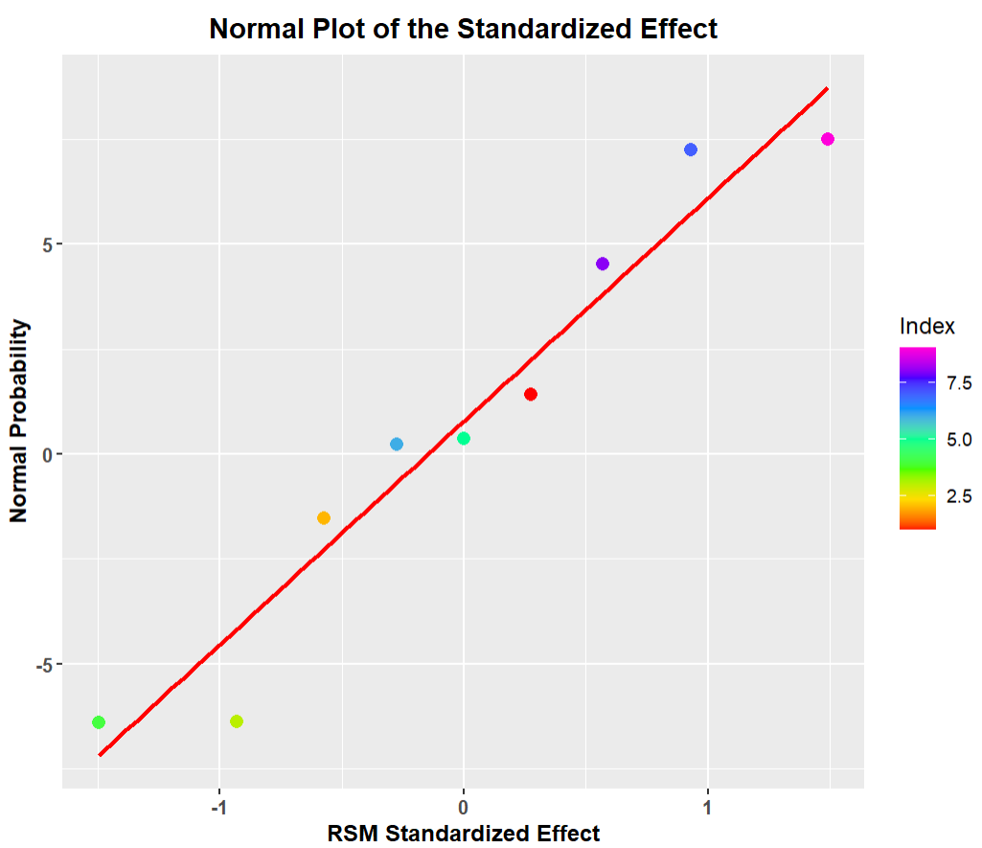
Fig. S7: Normal Plot of Standardised Effect for RSM-BBD

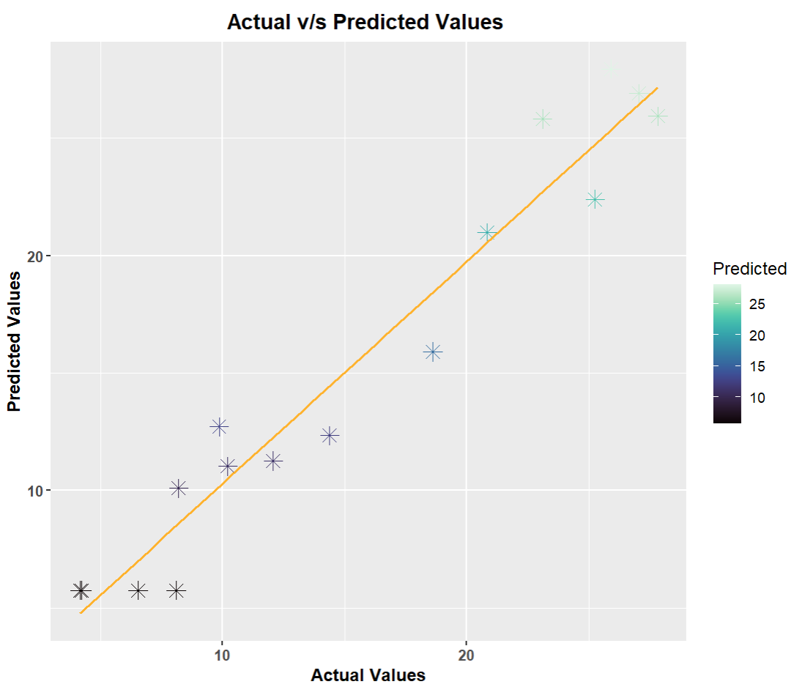
Fig. S8: Predicted v/s Actual Values for RSM-BBD

Artificial Neural Network Design

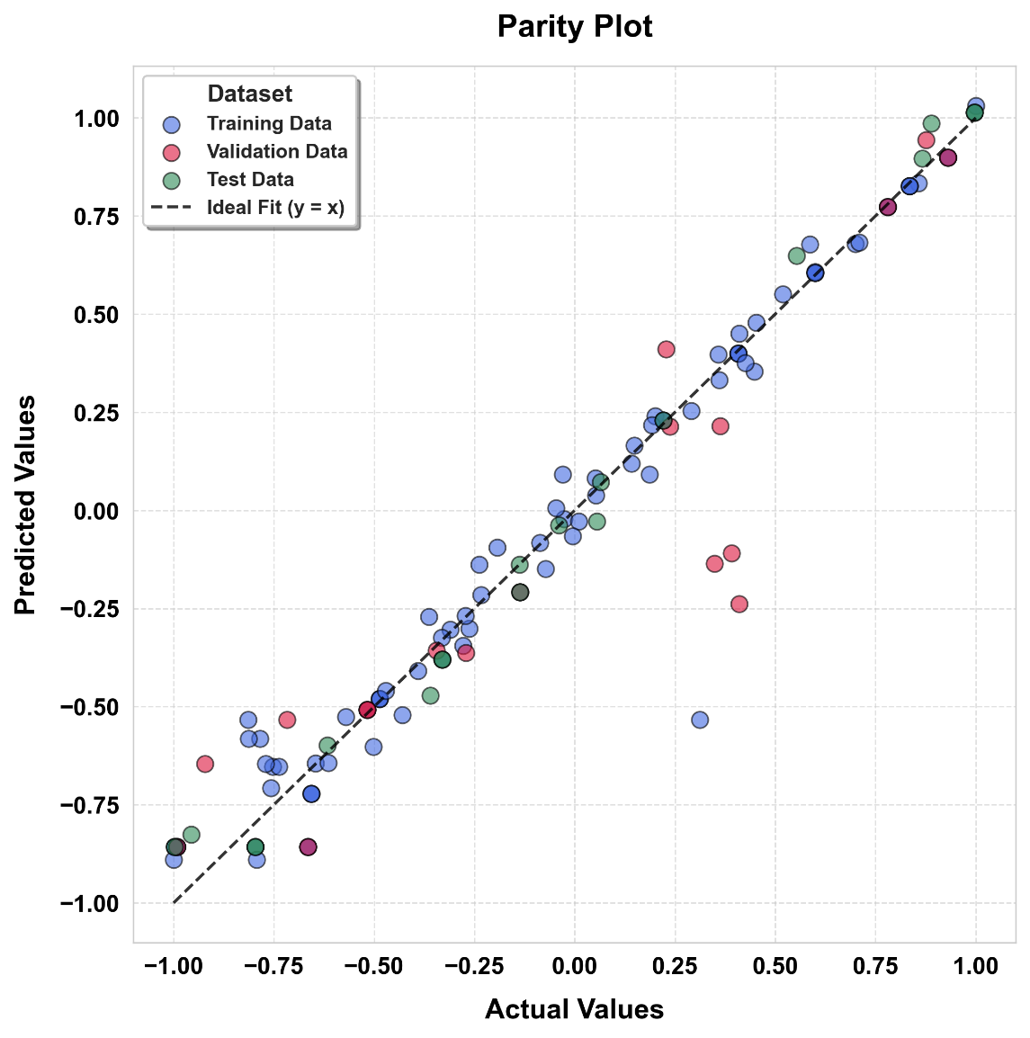
Fig. S9: Parity Plot for ANN model

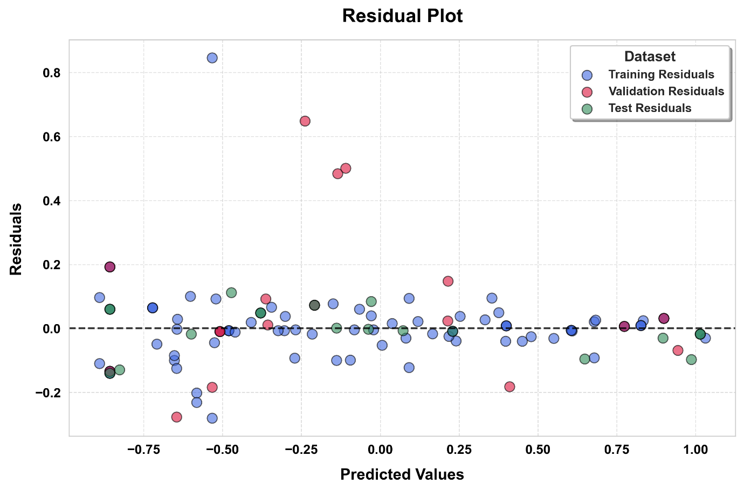
Fig. S10: Residual Plot for ANN model

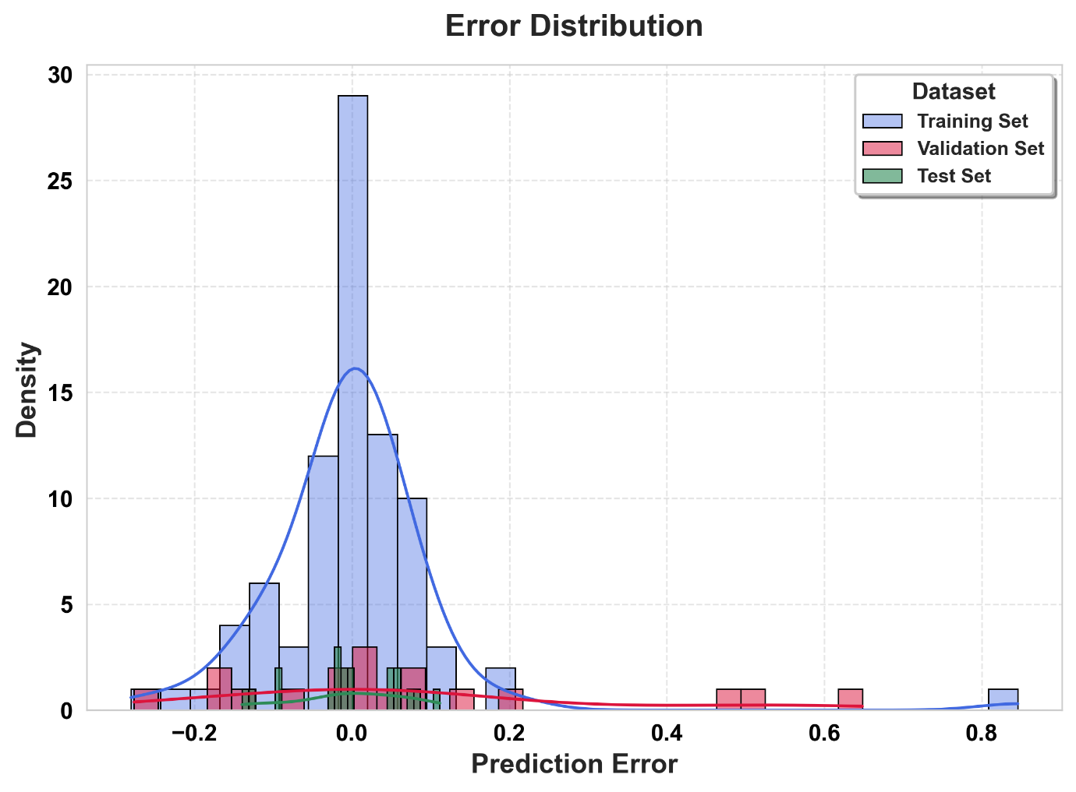
Fig. S11: Error Histogram Plot for ANN model

Validation of the ANN model
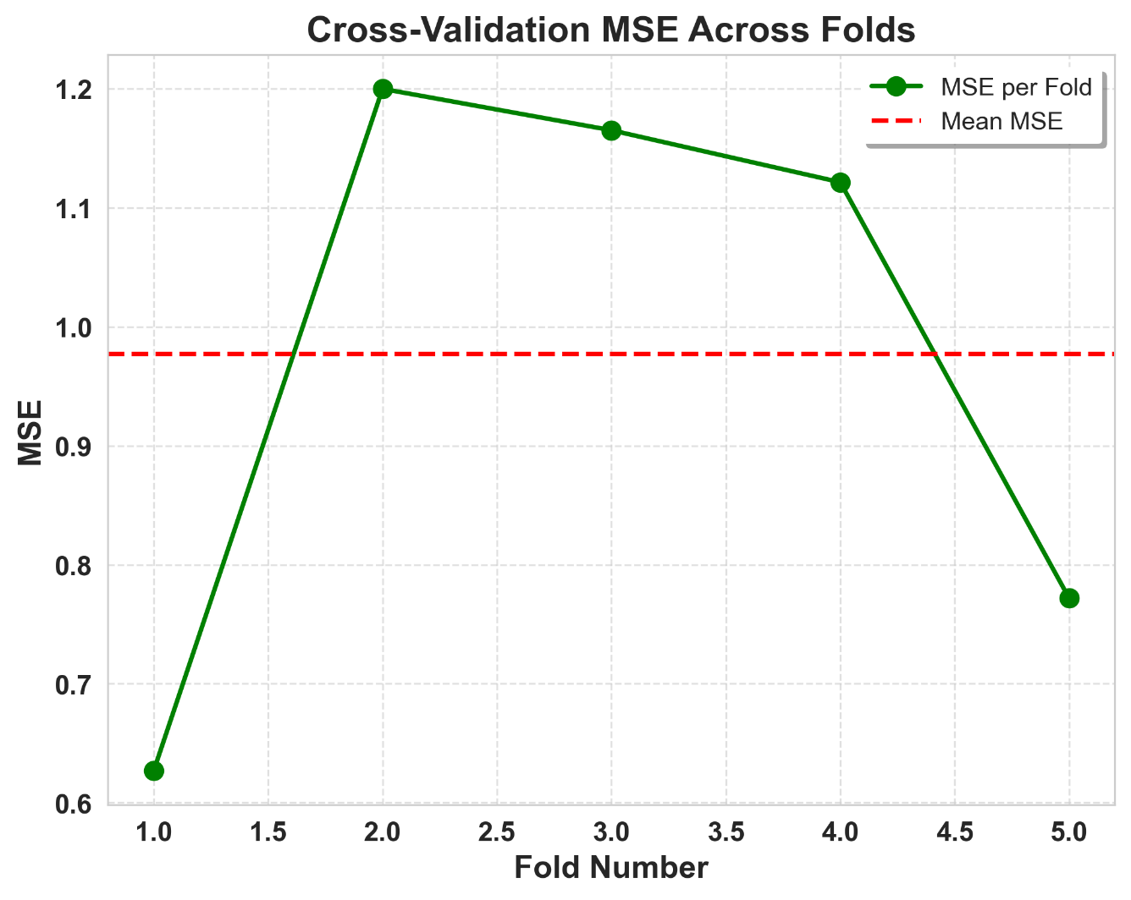
Fig. S12: MSE values using K-fold Cross Validation

