Supplementary Material 2
Phylogenetic Analysis

1. Klebsiella pneumoniae strain ABSKSLAB01:

Table S1: Maximum Likelihood Estimate of Substitution Matrix

 | A | T/U | C | G
A | - | 3.75 | 4.33 | 13.28
T/U | 4.79 | - | 20.57 | 6.01
C | 4.79 | 17.79 | - | 6.01
G | 10.58 | 3.75 | 4.33 | -

Each entry is the probability of substitution (r) from one base (row) to another base (column). Substitution pattern and rates were estimated under the Tamura-Nei model. Rates of different transitional substitutions are shown in bold and those of transversionsal substitutions are shown in italics. Relative values of instantaneous r were considered during evaluation. For simplicity, sum of r values is made equal to 100, The nucleotide frequencies are A = 25.37%, T/U = 19.85%, C = 22.94%, and G = 31.84%. This analysis involved 20 nucleotide sequences. There were a total of 1397 positions in the final dataset.

Table S2: Maximum Composite Likelihood Estimate of the Pattern of Nucleotide Substitution

 | A | T | C | G
A | - | 4.07 | 4.71 | 13.81
T | 5.21 | - | 18.31 | 6.53
C | 5.21 | 15.85 | - | 6.53
G | 11 | 4.07 | 4.71 | -

Each entry shows the probability of substitution (r) from one base (row) to another base (column). For simplicity, the sum of r values is made equal to 100. Rates of different transitional substitutions are shown in bold and those of transversional substitutions are shown in italics. The nucleotide frequencies are 25.38% (A), 19.85% (T/U), 22.93% (C), and 31.85% (G). This analysis involved 20 nucleotide sequences. All ambiguous positions were removed for each sequence pair (pairwise deletion option). There were a total of 1397 positions in the final dataset.

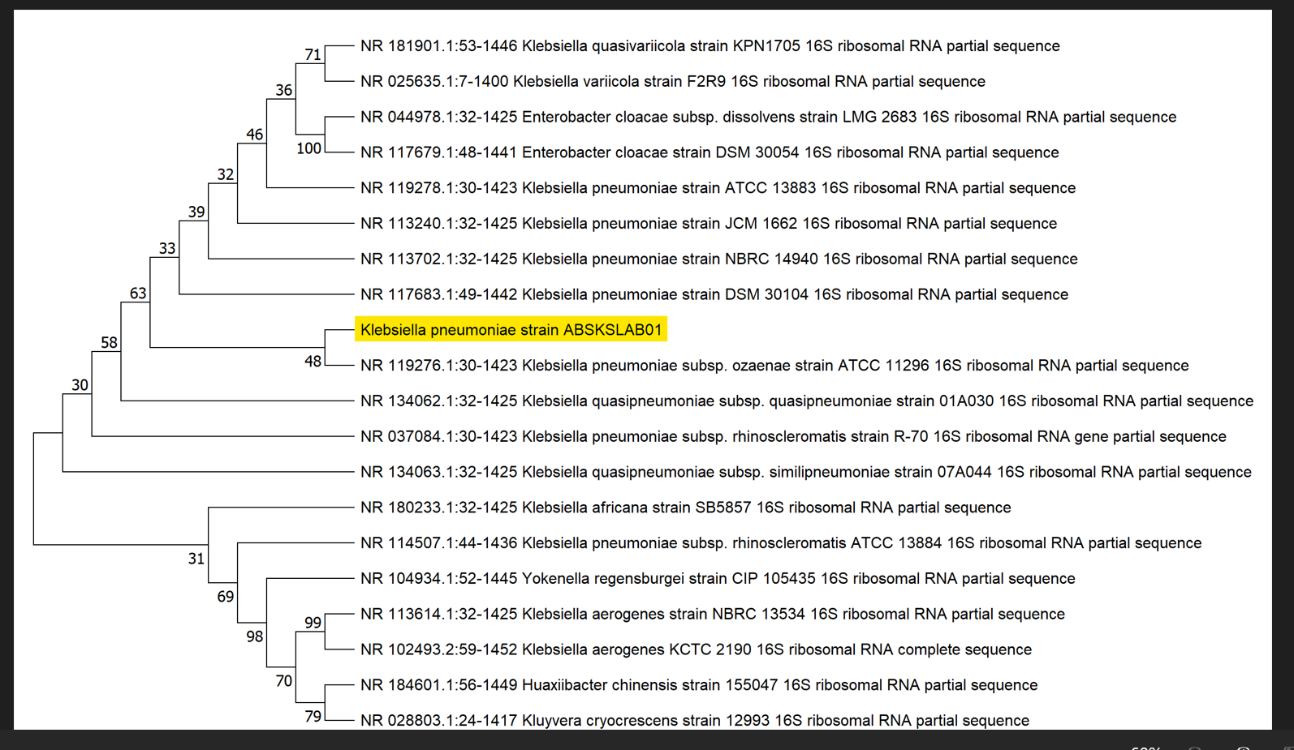
Fig. S1(a): Phylogenetic Tree for Klebsiella pneumoniae strain ABSKSLAB01

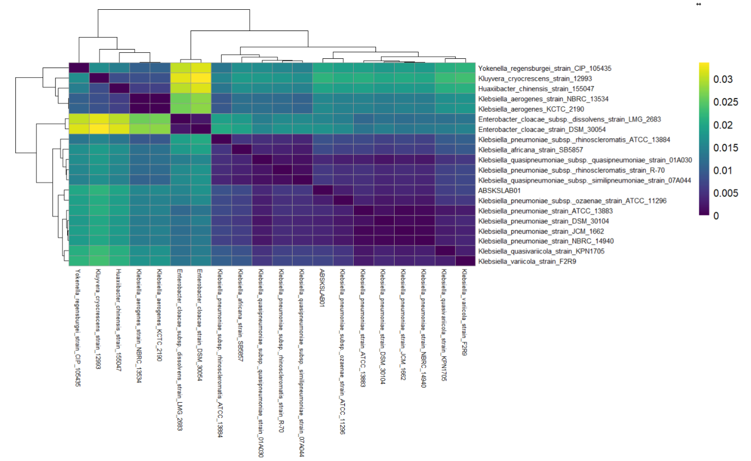
Fig. S1(b): Phylogenetic Heat Map for Klebsiella pneumoniae strain ABSKSLAB01

2. Klebsiella quasipneumoniae strain ABSKSLAB02:

Table S3: Maximum Likelihood Estimate of Substitution Matrix

 | A | T/U | C | G
A | - | 3.97 | 4.53 | 10.92
T/U | 5.05 | - | 21.62 | 6.38
C | 5.05 | 18.95 | - | 6.38
G | 8.65 | 3.97 | 4.53 | -

The nucleotide frequencies are A = 25.35%, T/U = 19.93%, C = 22.74%, and G = 31.99%. For estimating ML values, a tree topology was automatically computed. This analysis involved 20 nucleotide sequences. There were a total of 1285 positions in the final dataset.

Table S4: Maximum Composite Likelihood Estimate of the Pattern of Nucleotide Substitution

 |  | A | T | C | G
A |  | - | 4.55 | 5.19 | 12.09
T |  | 5.79 | - | 17.4 | 7.3
C |  | 5.79 | 15.25 | - | 7.3
G |  | 9.58 | 4.55 | 5.19 | -

The nucleotide frequencies are 25.36% (A), 19.92% (T/U), 22.73% (C), and 31.99% (G). This analysis involved 20 nucleotide sequences. All ambiguous positions were removed for each sequence pair (pairwise deletion option). There were a total of 1285 positions in the final dataset.

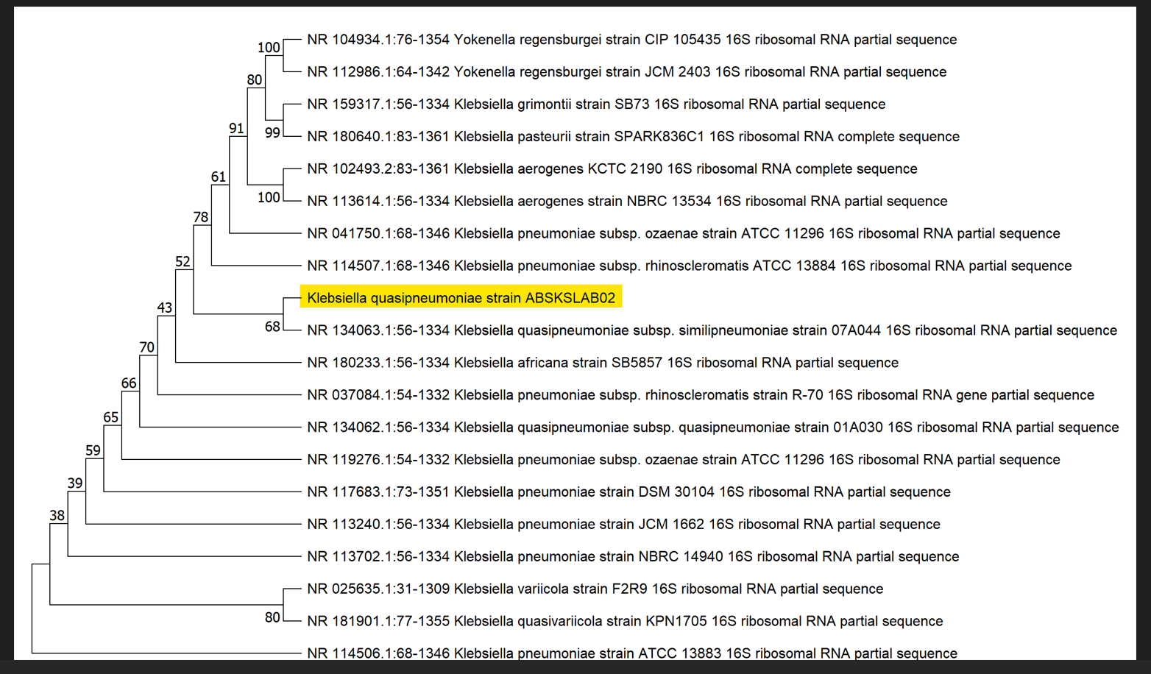
Fig. S2(a): Phylogenetic Tree for Klebsiella quasipneumoniae strain ABSKSLAB02

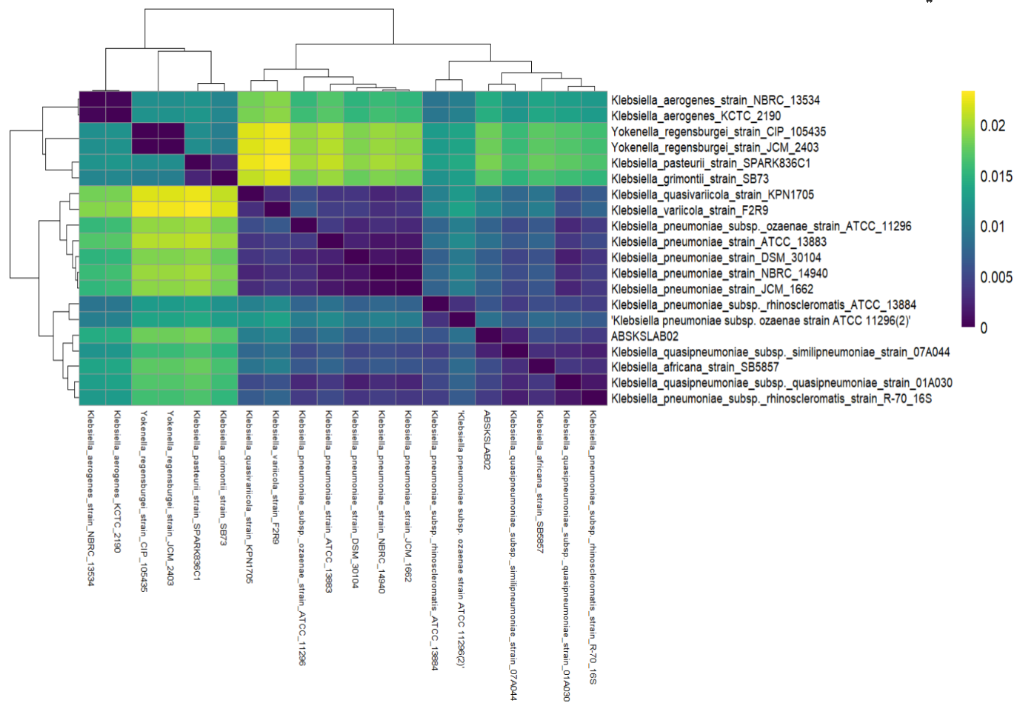
Fig. S2(b): Phylogenetic Heat Map for Klebsiella quasipneumoniae strain ABSKSLAB02

3. Streptomyces minutiscleroticus strain ABSKSLAB03:

Table S5: Maximum Likelihood Estimate of Substitution Matrix

 | A | T/U | C | G
A | - | 5.22 | 7.30 | 14.38
T/U | 6.49 | - | 10.72 | 9.87
C | 6.49 | 7.66 | - | 9.87
G | 9.46 | 5.22 | 7.30 | -

The nucleotide frequencies are A = 22.47%, T/U = 18.07%, C = 25.28%, and G = 34.17%. For estimating ML values, a tree topology was automatically computed. This analysis involved 20 nucleotide sequences. There were a total of 1025 positions in the final dataset.

Table S6: Maximum Composite Likelihood Estimate of the Pattern of Nucleotide Substitution

 | A | T | C | G
A | - | 4.73 | 6.62 | 14.78
T | 5.88 | - | 13.51 | 8.95
C | 5.88 | 9.65 | - | 8.95
G | 9.71 | 4.73 | 6.62 | -

The nucleotide frequencies are 22.47% (A), 18.07% (T/U), 25.28% (C), and 34.17% (G). This analysis involved 20 nucleotide sequences. All ambiguous positions were removed for each sequence pair (pairwise deletion option). There were a total of 1025 positions in the final dataset.

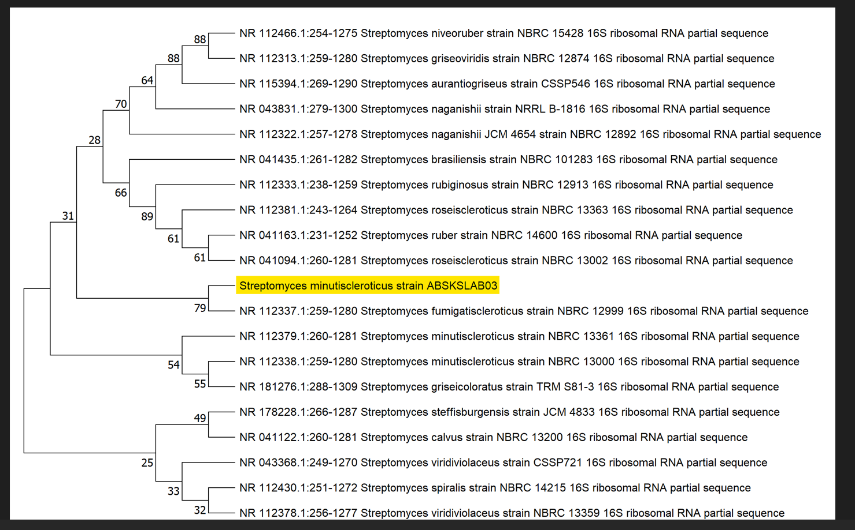
Fig. S3(a): Phylogenetic Tree for Streptomyces minutiscleroticus strain ABSKSLAB03

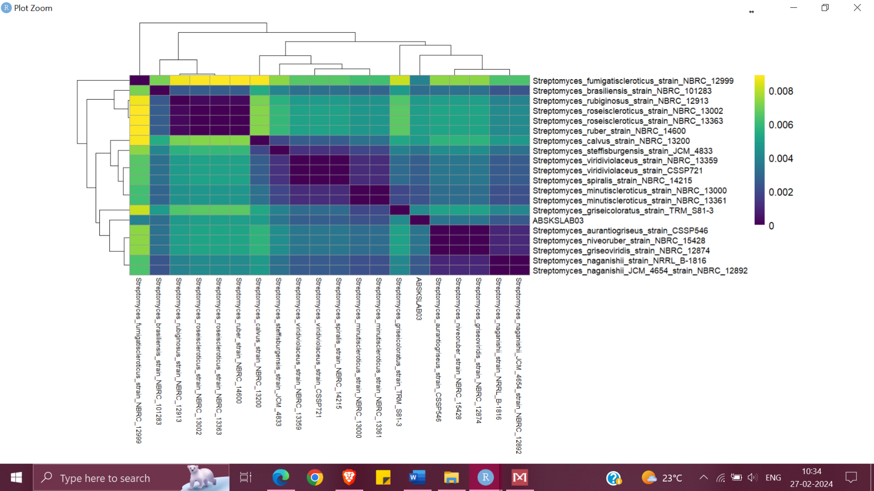
Fig. S3(b): Phylogenetic Heat Map for Streptomyces minutiscleroticus strain ABSKSLAB03

