Supplementary Material 1
Biochemical Studies
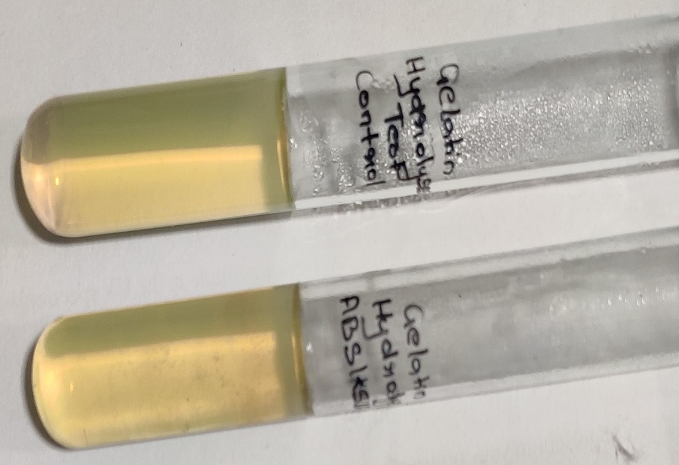  Fig. S1: Gelatin Hydrolyzation Test | 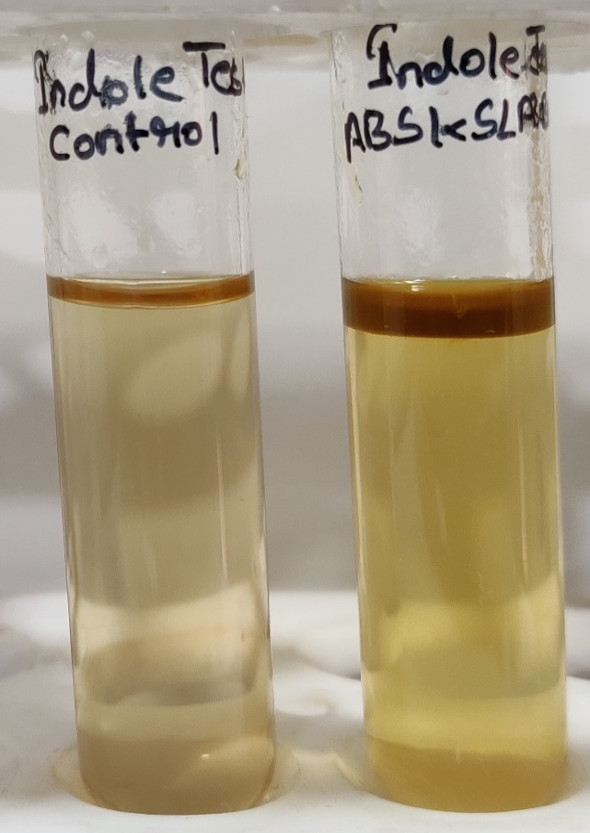  Fig. S2: Indole Test
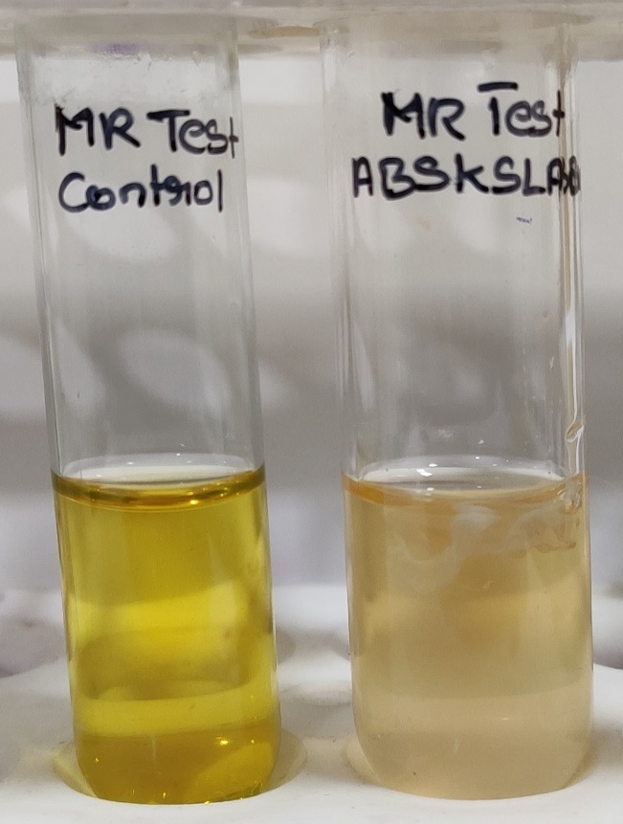  Fig. S3: Methyl-Red Test | 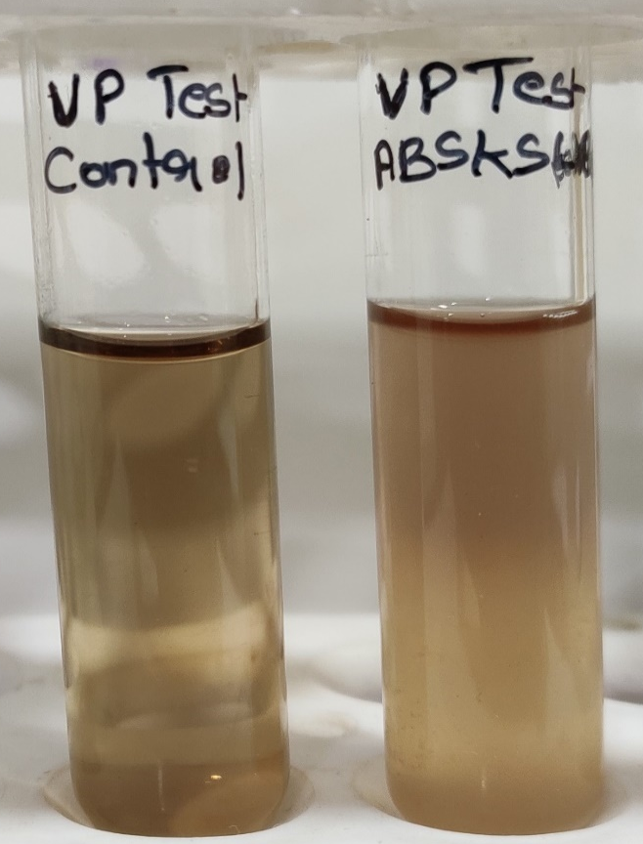  Fig. S4: Voges Proskauer Test
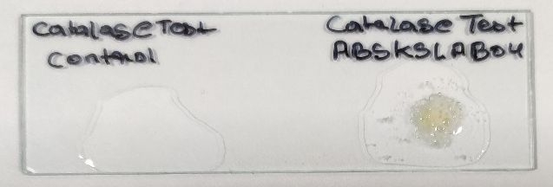  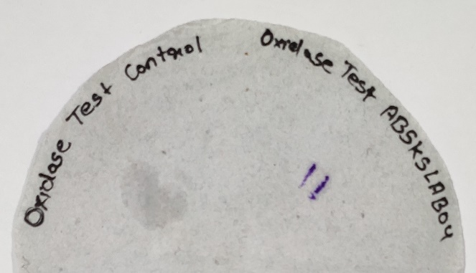  Fig. S5: Oxidase Test  Fig. S6: Catalase Test | 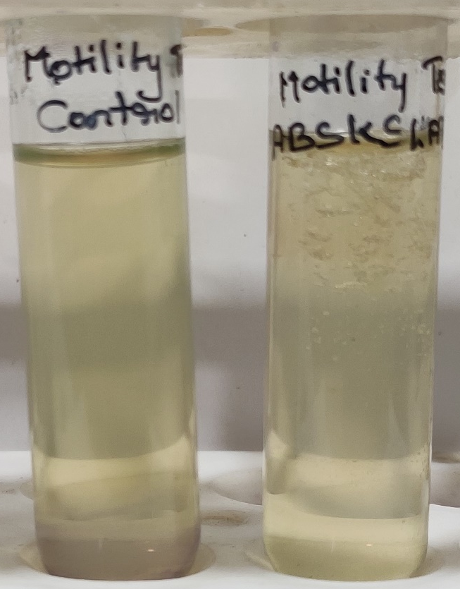  Fig. S7: Motility Test
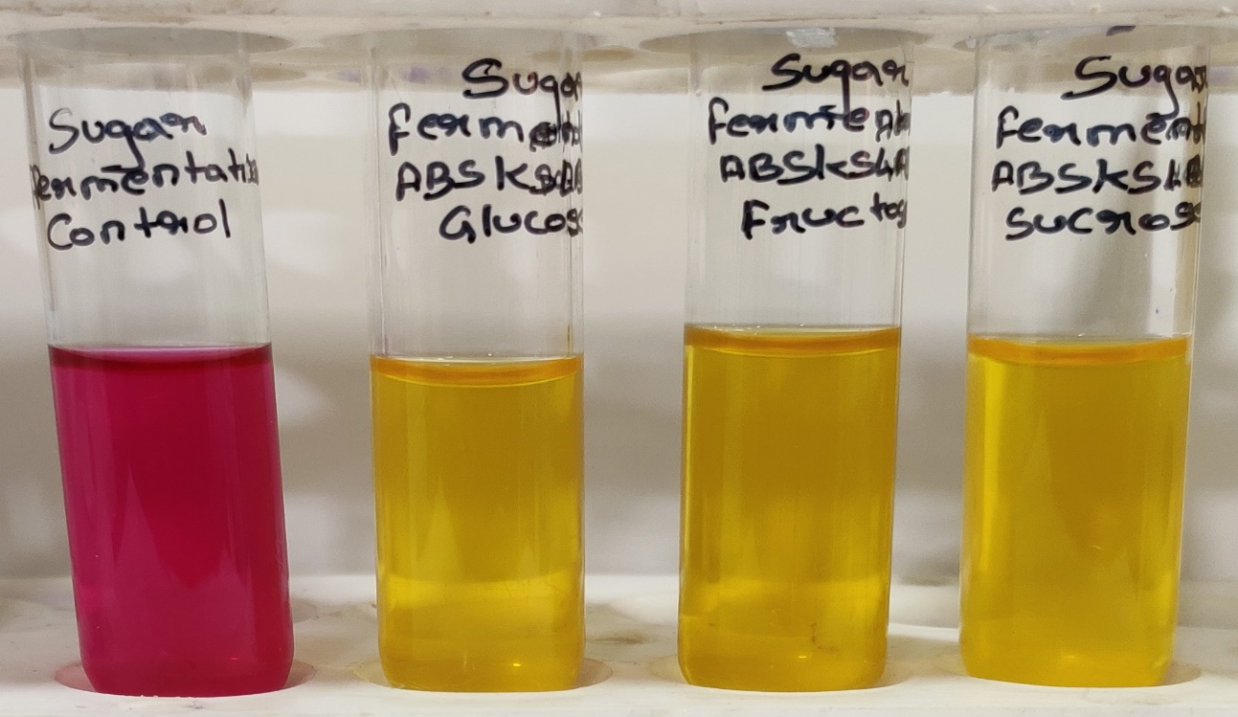
Fig. S8: Sugar Fermentation Test
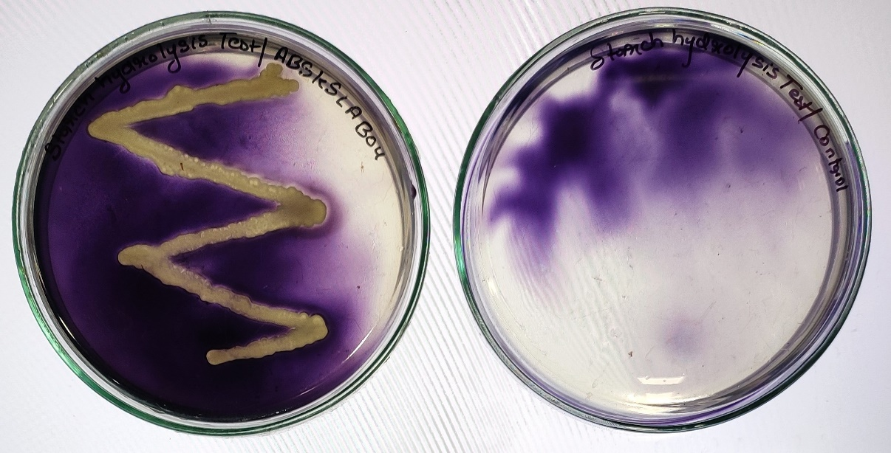
Fig. S9: Starch Hydrolysis Test

Screening tests for antagonistic activity

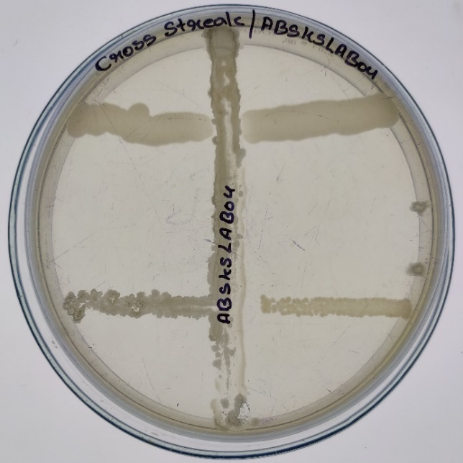  A) | 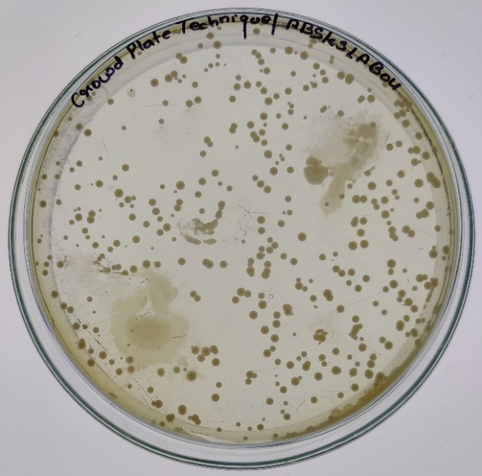  B)
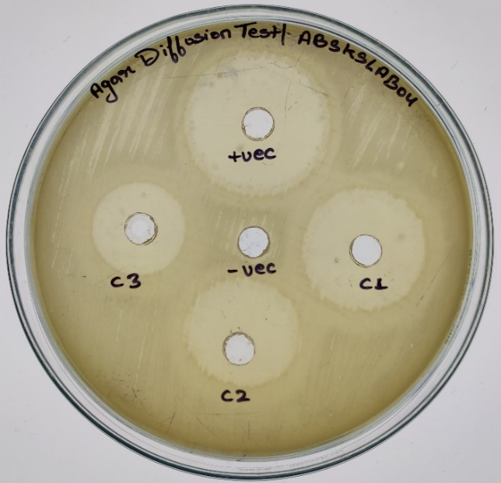  C) | 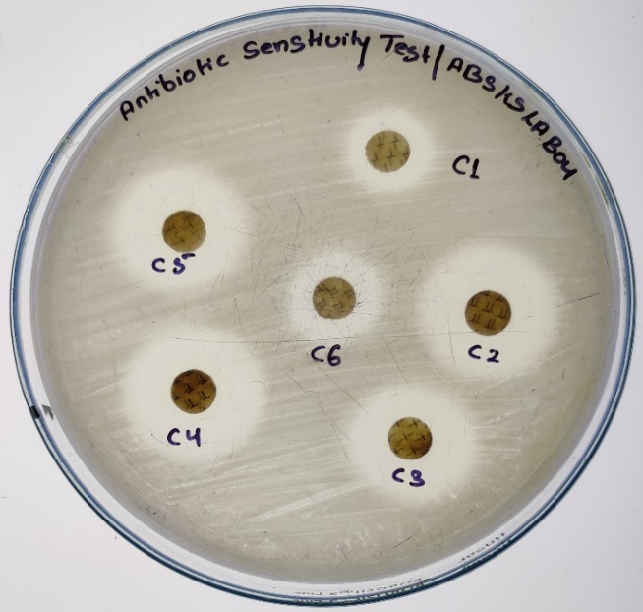  D)

Fig. S10: Antagonistic behaviour of Streptomyces peucetius; A: Cross- streaking (transverse streaking), B: Seed overlay assay, C: Agar diffusion assay, and D: Antibiotic sensitivity assay

