Supplementary Material 3

Plackett Burman Experimental Design

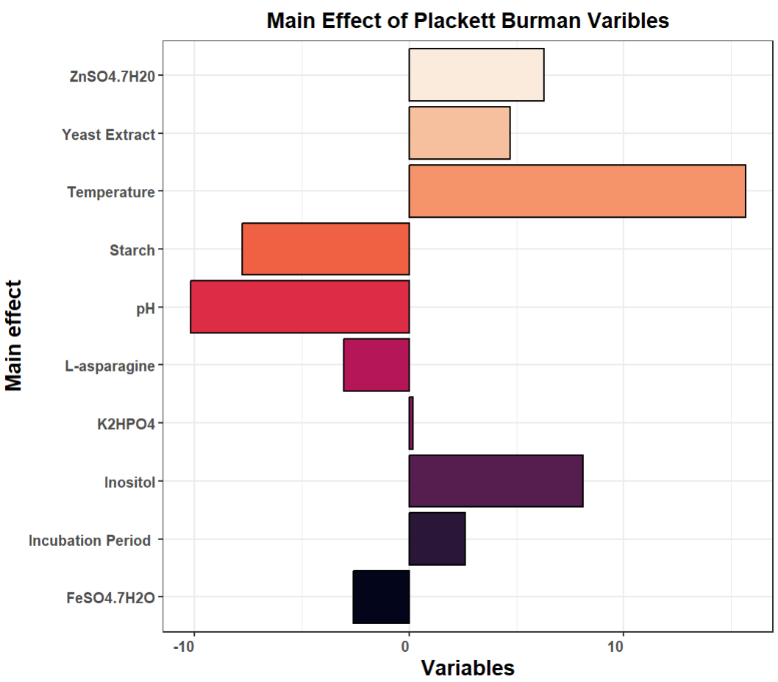
Fig. S1: Pareto Chart for Coefficient Main Effects of Plackett Burman Design

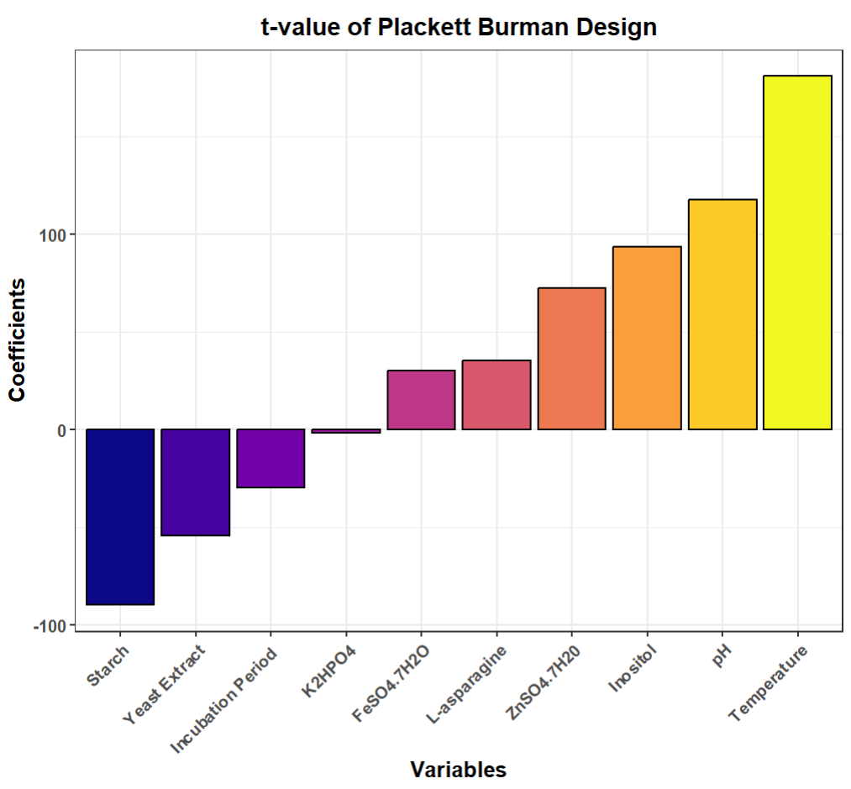
Fig. S2: t-value plot for Plackett Burman Design

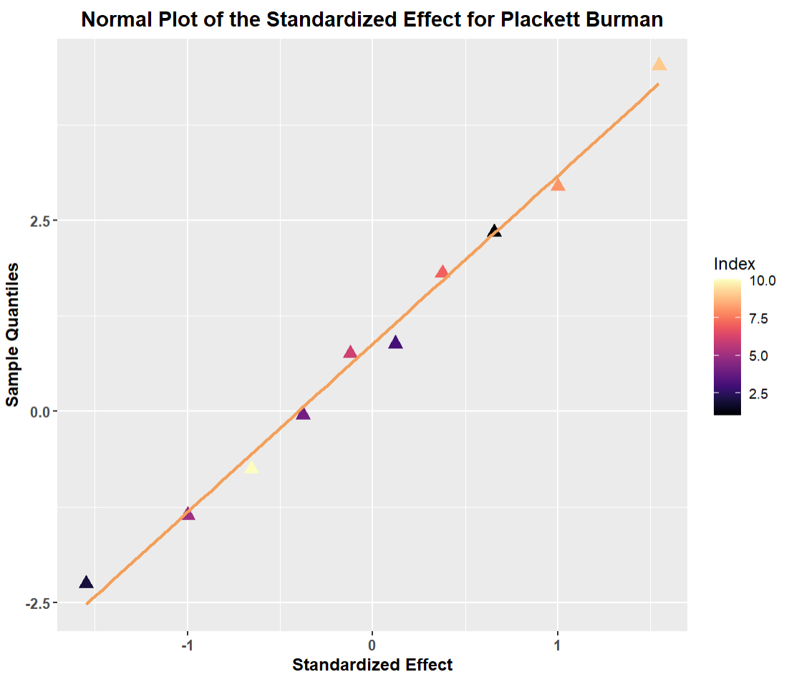
Fig. S3: Normal Plot of Standardized Effect for Plackett Burman Design

Box ‒ Behnken Experimental Design

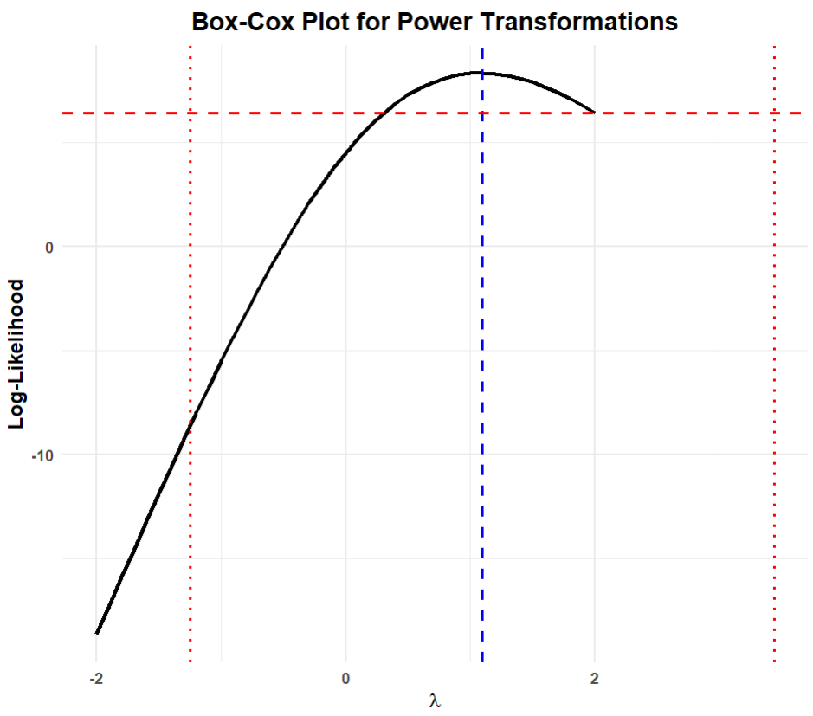
Fig. S4: Box-cox plot for power transform for RSM

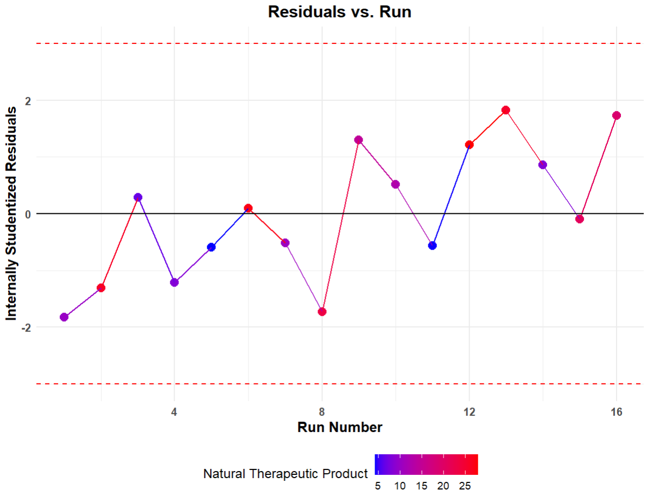
Fig. S5: Residuals v/s Run Plot

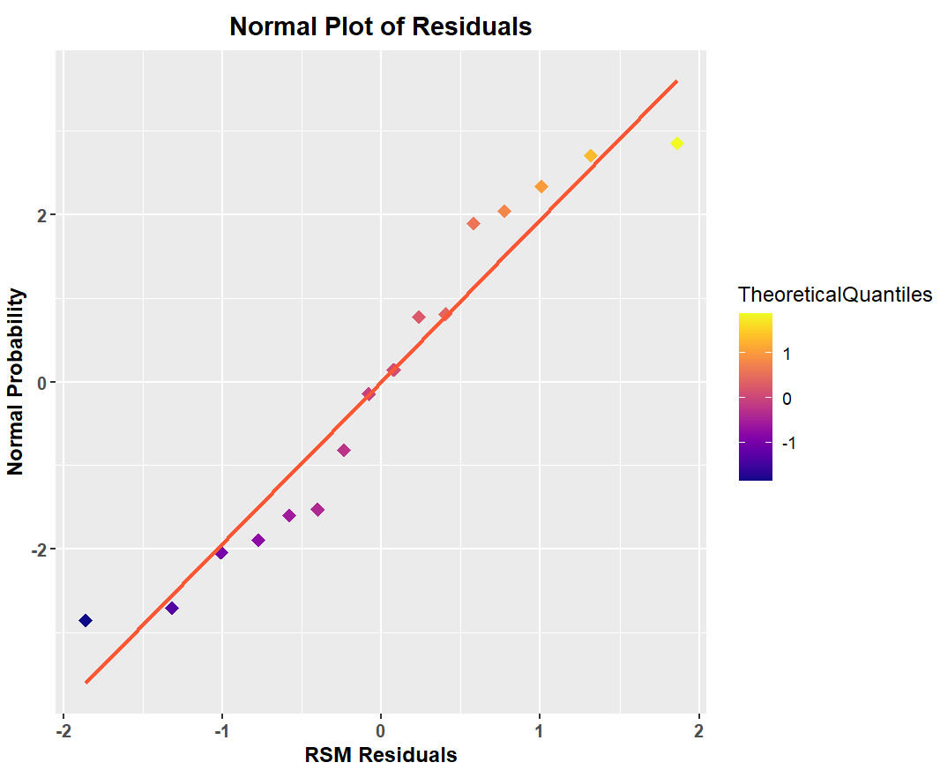

Fig. S6: Normal Plot of Residuals

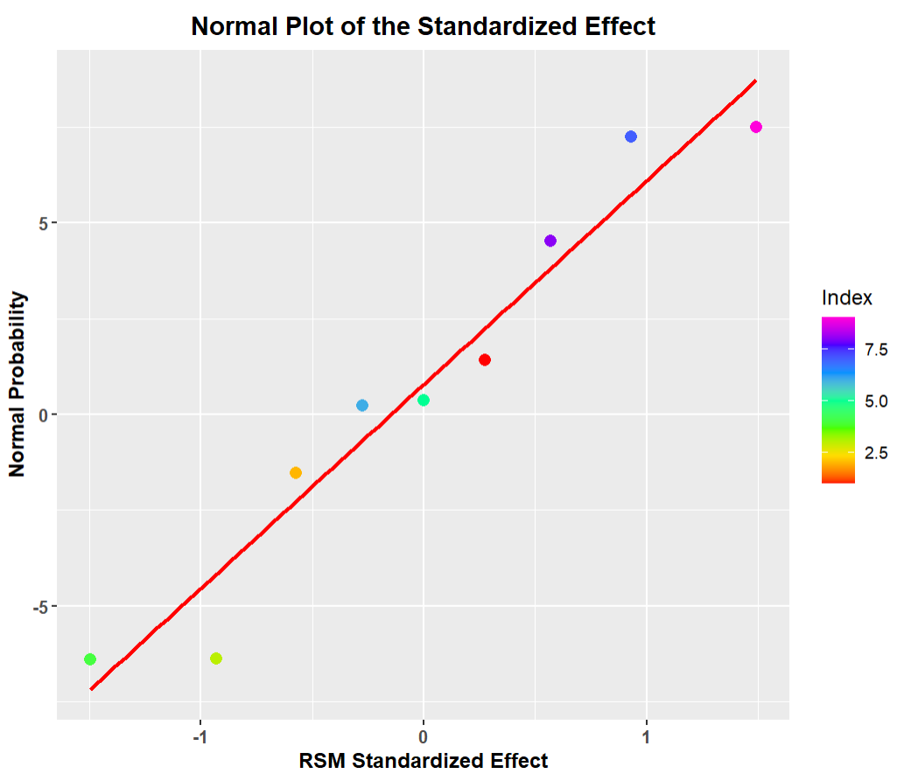
Fig. S7: Normal Plot of Standardised Effect

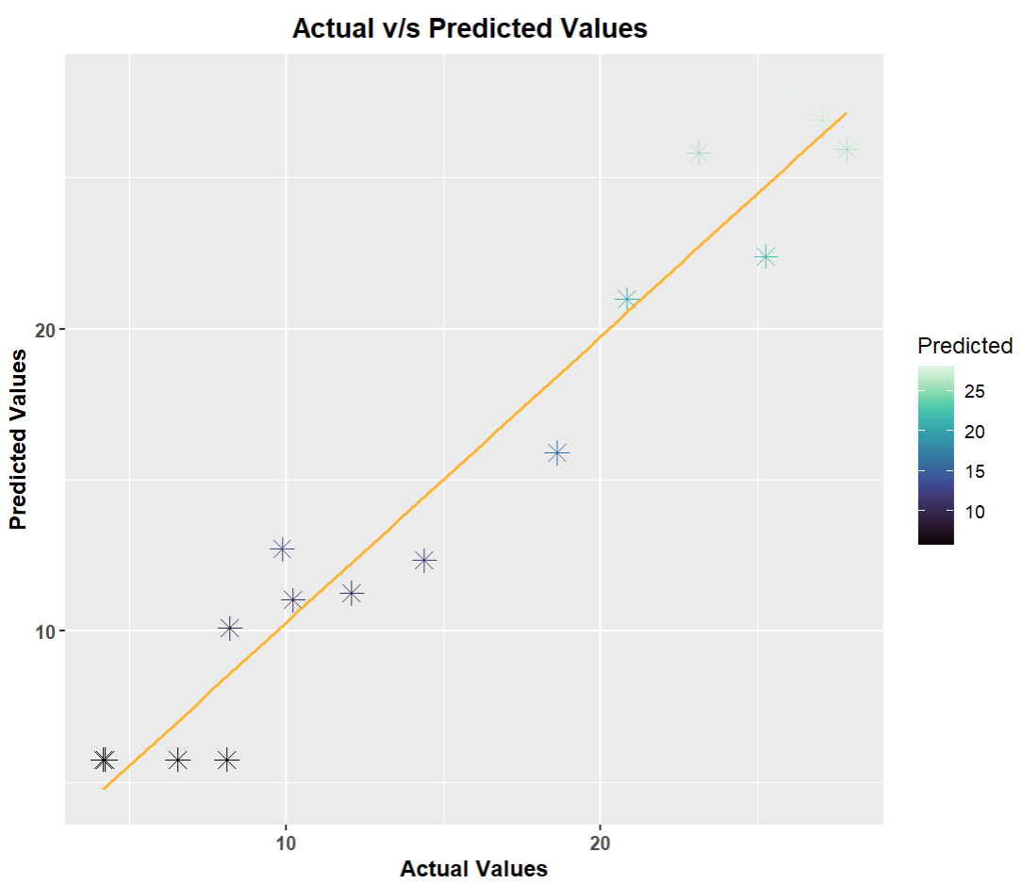
Fig. S8: Predicted v/s Actual Values

