Supplementary Material

Thrombin induces degradation of murine intervertebral discs via angiogenesis and M1-like polarization of macrophages
Rikito Tatsuno¹, Takashi Ando^{1, 2,} *, Taro Fujimaki¹, Yoshihiro Takayama³, Tetsuro Ohba¹, and Hirotaka Haro¹

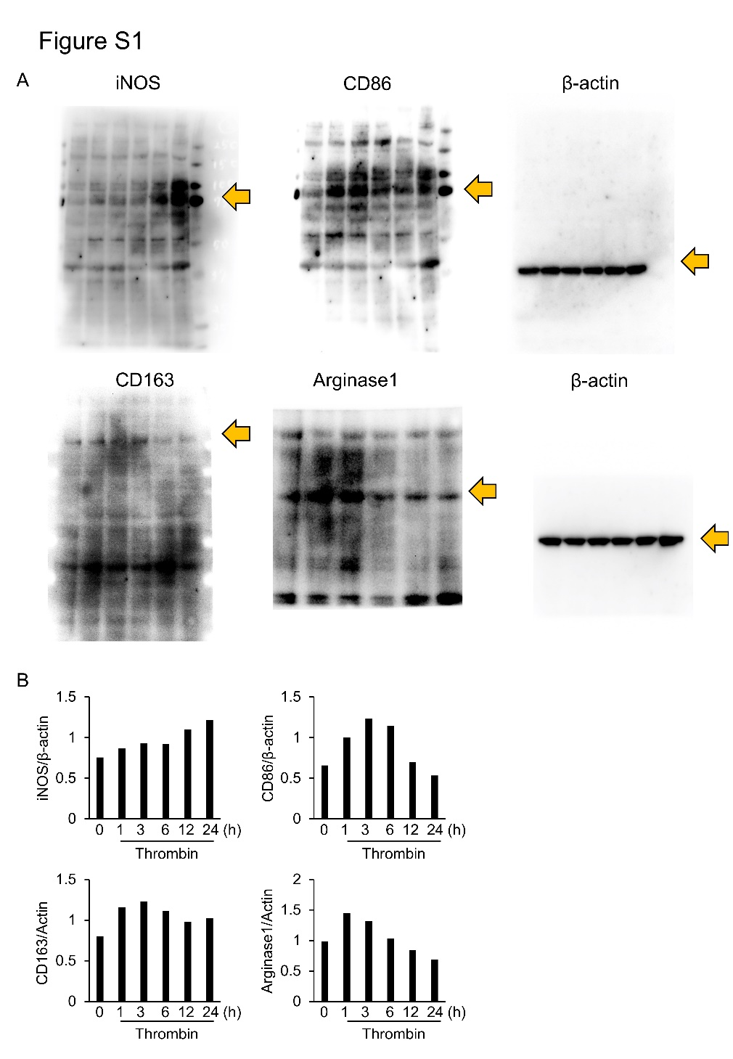

Supplementary Figure legends

Figure S1
(a) Examples of uncropped western blots of macrophage cells for iNOS, CD86, CD163, arginase, and actin (Fig. 2B). (b) Western blots were quantified using the ImagJ software and normalized antin (Fig. 2B).
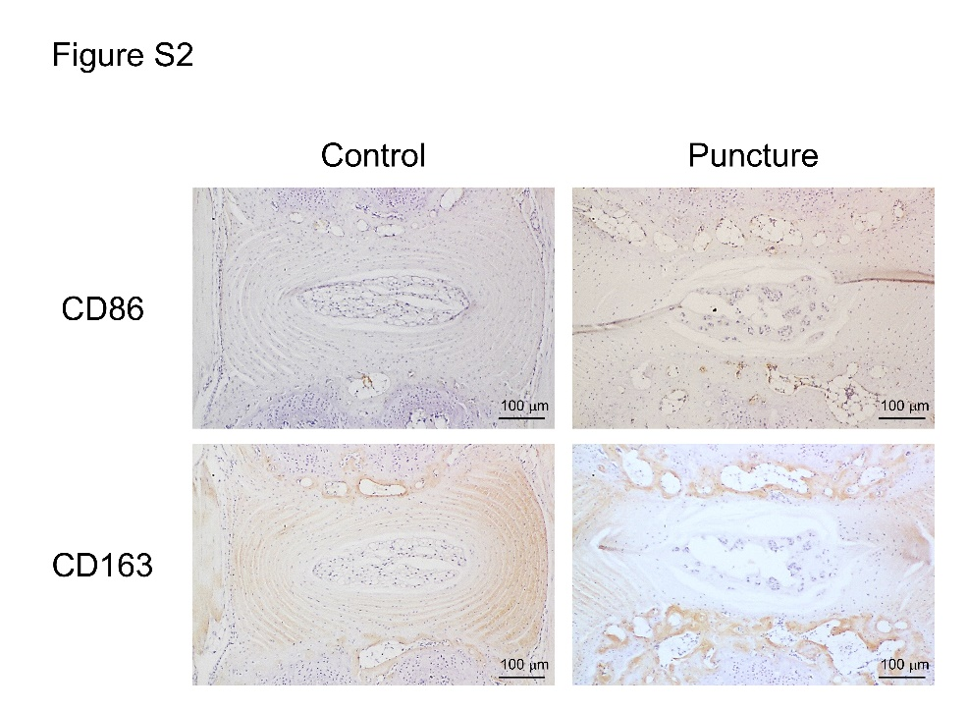

Figure S2

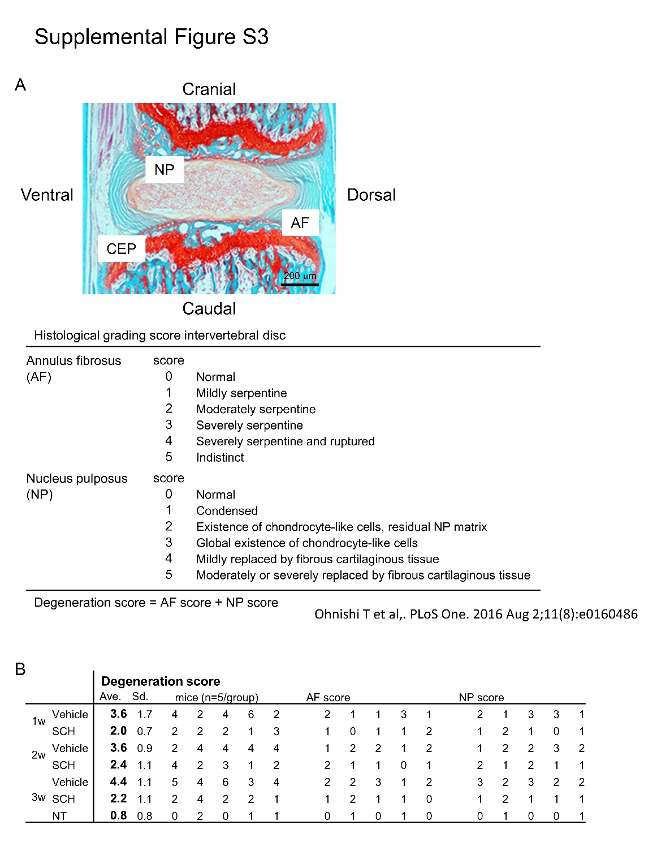
Intervertebral disc tissue was obtained 3 weeks after puncture from the model mice and healthy controls. Immunostaining was performed using antibodies for CD86 and CD163.
Figure S3
(a) Histological grading score for mouse intervertebral discs (Fig. 4A). (b) Raw degeneration-score data for the mouse intervertebral discs (mIVDs) [Fig. 4B].

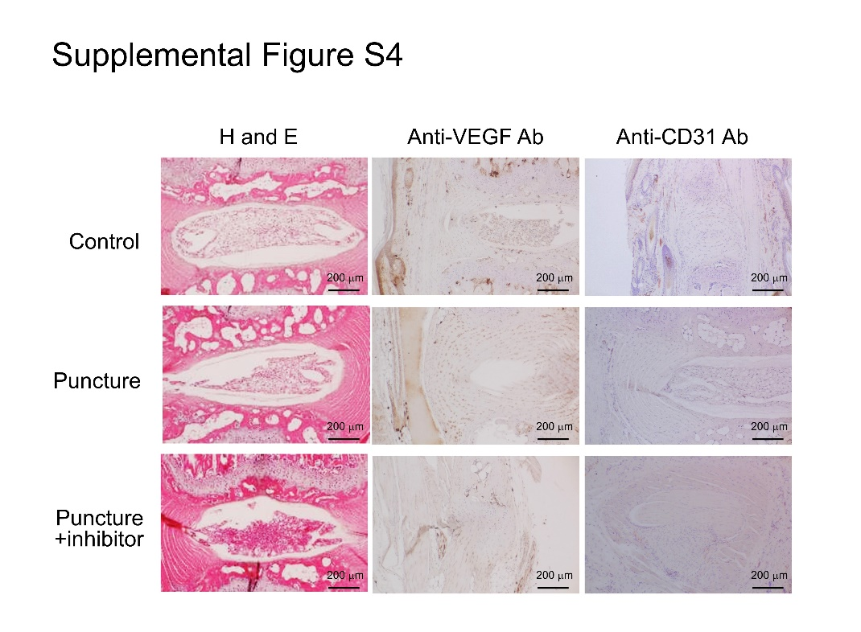
Figure S4
(a) Mouse intervertebral disc tissue was obtained 3 weeks after puncture, with or without PAR1-antagonist treatment. H&E staining and immunostaining were performed using antibodies for VEGF and CD31.

