Supporting Information
Survival of Escherichia coli O157:H7 in soils along a natural pH gradient
Guangze Lyu^{1,2}, Huiru Li², Jiayang Hu ², Jincai Ma^{2*}

- Key Laboratory of Ground Water Resource and Environment, Ministry of Education, Jilin University, Changchun 130021, China
- Jilin Provincial Key Laboratory of Water Resources and Environment, Jilin University, Changchun 130021, China
* Correspondence author
Dr. Jincai Ma
E-mail: jincaima@jlu.edu.cn
Phone: +86-431-85168429
College of New Energy and Environment
Jilin University

Table S1. Soil properties of 24 samples. EC, electrical conductivity, NH₄⁺-N, ammonium nitrogen, NO₃⁻-N, nitrate nitrogen, WSOC, water soluble organic carbon, TN, soluble total nitrogen, TP, total phosphorus.

 | pH | EC (mS/cm) | NH₄⁺-N  (mg/kg) | NO₃⁻-N  (mg/kg) | TP  (mg/kg) | WSOC  (mg/kg) | Clay  （%）
T1 | 5.61 | 0.72 | 1.21 | 6.80 | 6.30 | 94.15 | 4.21
T2 | 5.70 | 0.17 | 1.18 | 13.70 | 2.70 | 97.35 | 4.93
T3 | 5.75 | 0.04 | 2.15 | 5.86 | 8.90 | 190.75 | 5.37
T4 | 5.76 | 0.11 | 0.77 | 6.14 | 23.00 | 58.10 | 6.49
T5 | 5.82 | 0.06 | 1.41 | 5.08 | 3.05 | 26.65 | 6.82
T6 | 5.82 | 0.07 | 1.11 | 7.82 | 2.30 | 96.88 | 7.88
T7 | 6.30 | 0.17 | 2.59 | 28.90 | 30.00 | 203.75 | 8.33
T8 | 6.40 | 0.19 | 1.41 | 1.06 | 19.00 | 137.20 | 8.09
T9 | 6.81 | 1.20 | 1.21 | 0.12 | 17.00 | 171.83 | 6.03
T10 | 7.08 | 0.11 | 0.76 | 2.28 | 25.50 | 111.20 | 6.89
T11 | 7.28 | 0.17 | 1.46 | 6.11 | 5.75 | 162.45 | 6.98
T12 | 7.36 | 0.07 | 1.73 | 6.34 | 5.55 | 133.10 | 2.80
T13 | 7.43 | 0.08 | 2.82 | 8.92 | 3.15 | 158.50 | 2.88
T14 | 7.52 | 0.06 | 1.65 | 1.52 | 2.80 | 92.08 | 4.62
T15 | 7.55 | 0.16 | 1.25 | 5.43 | 2.05 | 201.50 | 5.39
T16 | 7.61 | 0.09 | 0.63 | 2.64 | 4.65 | 124.83 | 5.26
T17 | 7.72 | 0.62 | 3.33 | 16.71 | 26.05 | 231.03 | 6.98
T18 | 8.07 | 0.17 | 16.25 | 7.18 | 3.80 | 188.20 | 7.01
T19 | 9.26 | 8.57 | 0.55 | 240.02 | 8.08 | 658.13 | 6.50
T20 | 9.56 | 0.47 | 1.62 | 60.07 | 3.95 | 278.90 | 3.11
T21 | 9.67 | 0.99 | 10.92 | 65.58 | 18.05 | 855.98 | 21.07
T22 | 9.79 | 1.16 | 1.61 | 27.19 | 7.82 | 91.13 | 6.28
T23 | 9.8 | 0.81 | 17.31 | 0.70 | 8.41 | 454.15 | 6.54
T24 | 9.92 | 1.49 | 40.79 | 130.58 | 36.10 | 2182.40 | 9.91

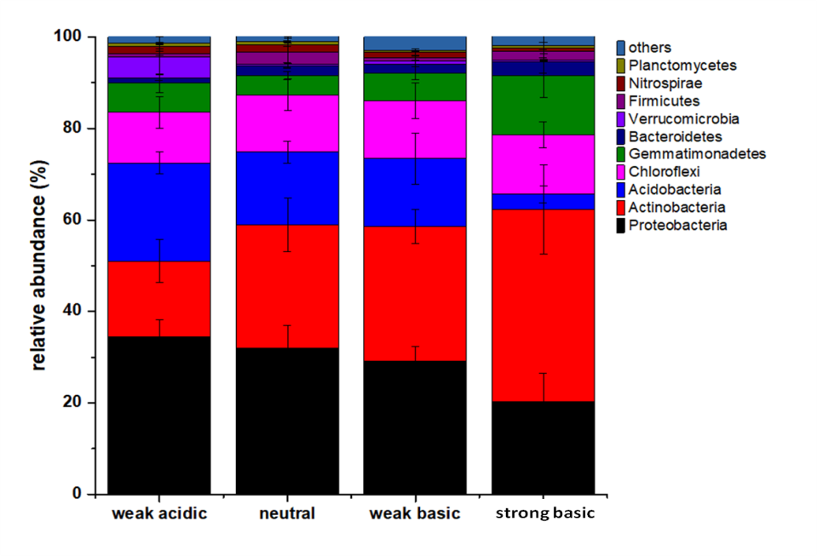
Figure S1. Bacterial community composition (abundance >1%) at phylum level in weak acidic, neutral, weak basic, and strong basic soils, respectively.

Figure S2. Relative abundance of dominant bacterial phyla in 24 soil samples (abundance >1%).

