Supplemental Data

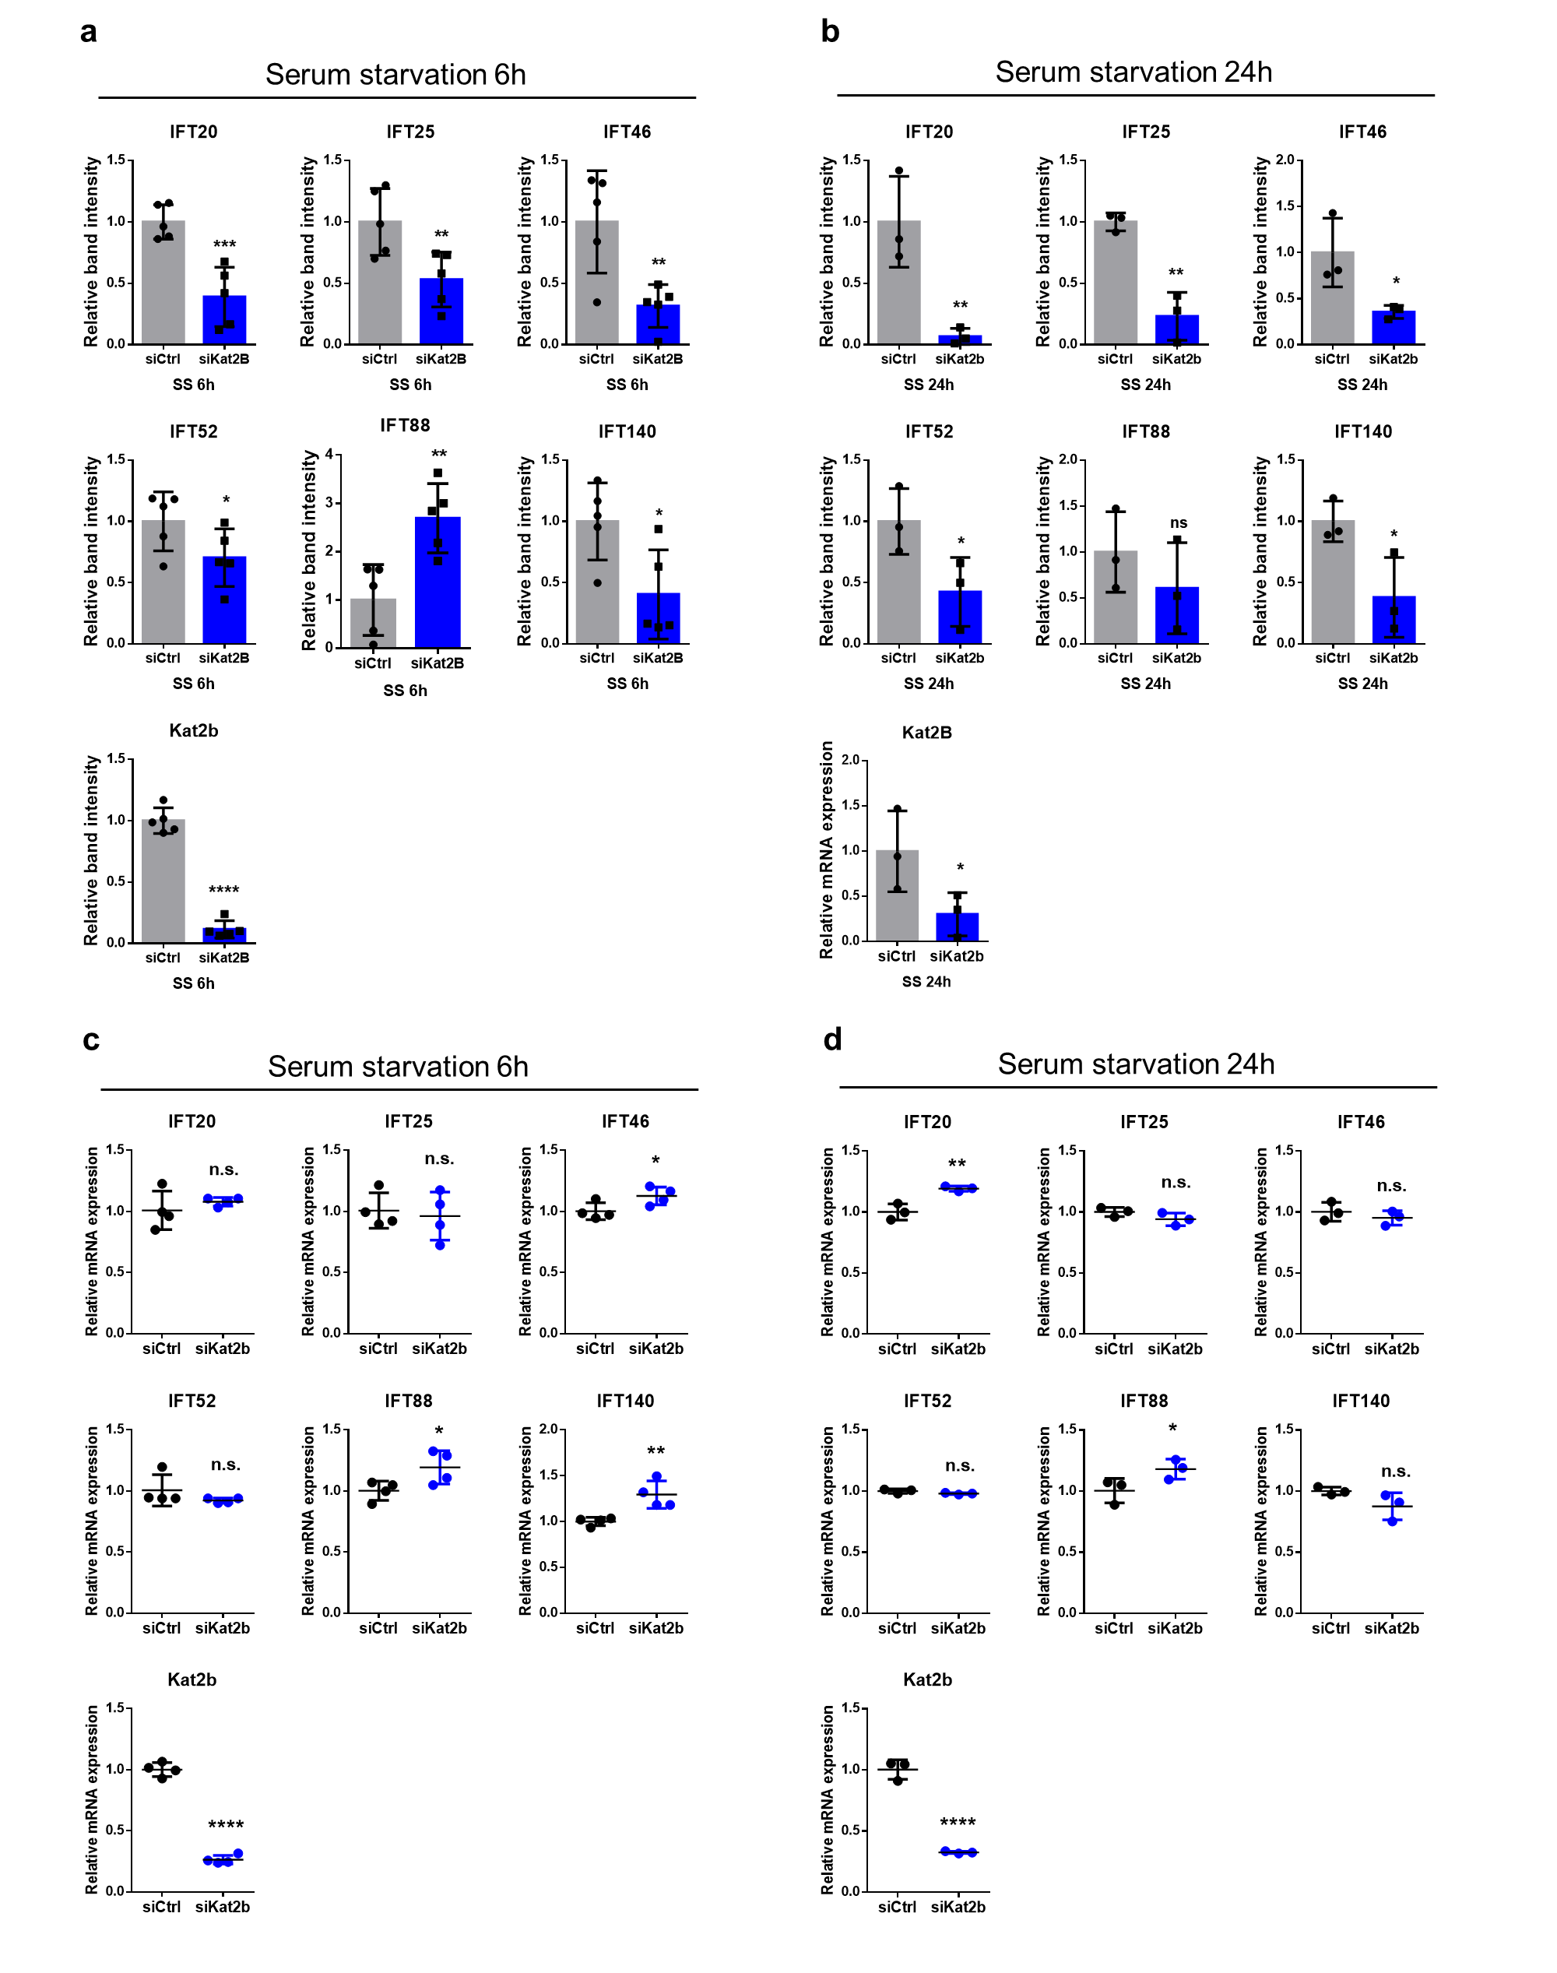

Supplementary Figure 1. The defect in Kat2b does not impair the mRNA level of IFT components but decreases IFT protein expression during ciliogenesis. (a-b) Graphs showed that relative western blot band intensity of IFT components in Kat2b-depleted cells during ciliogenesis. NIH/3T3 cells treated with control or Kat2b siRNA were serum-starved and harvested. (a) Early stage of ciliogenesis (b) Maturation of ciliogenesis (c-d) qRT-PCR data revealed the transcriptional levels of IFT components in Kat2b-depleted NIH/3T3 cells after 6 h or 24 h of serum starvation.

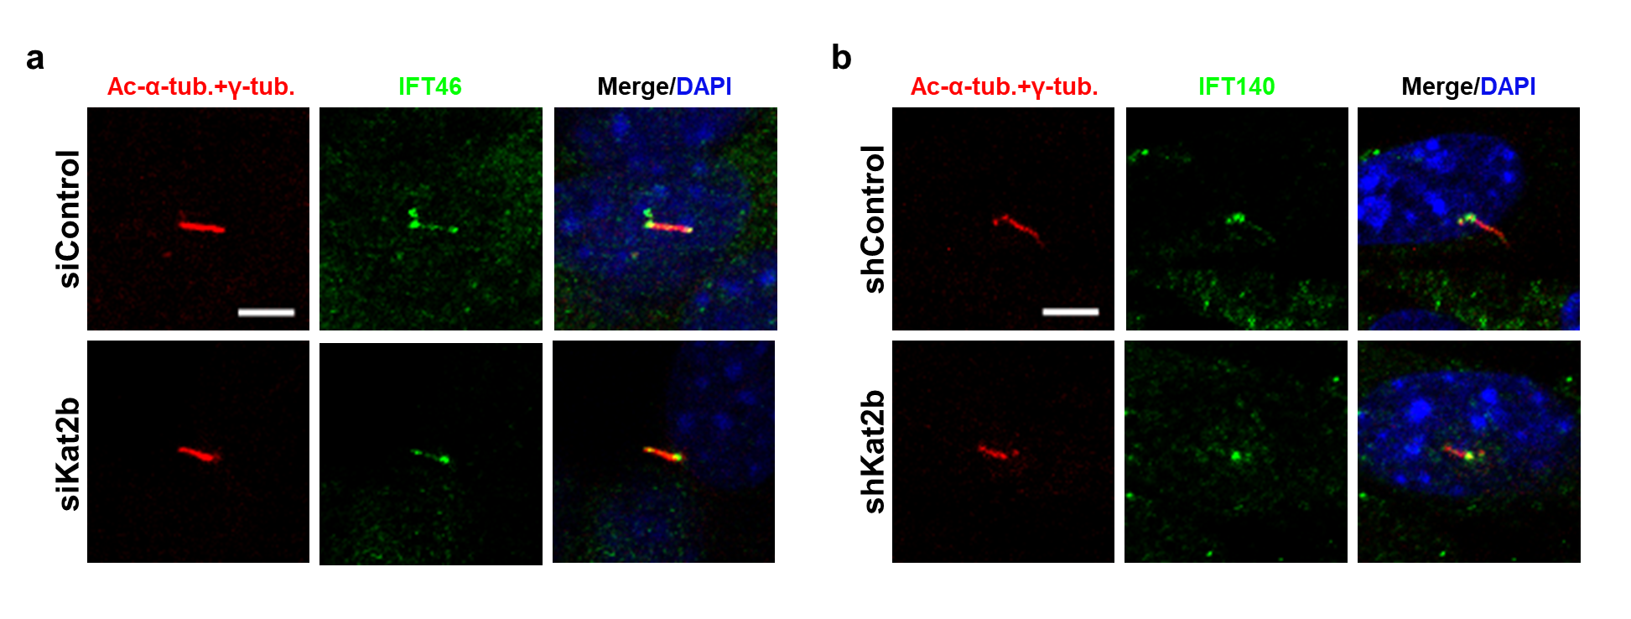
Supplementary Figure 2. Kat2b depletion does not impair the intensity of IFT46 and IFT140. (a-b) Immunofluorescence experiment results show that the intensity of IFT46 or IFT140 (green) does not decrease in Kat2b-depleted stable cell lines. Acetylated α-tubulin was stained for primary cilia (green). Nuclei were stained with DAPI (blue). Scale bar: 5 μm.

