Supplementary Information

Supplementary Table 1. Description of administrative databased used in the study
Database | Details | Source
Provincial Laboratory Data (LAB) | Included details on nearly all general lab tests in Alberta. Major tests included clinical chemistry, toxicology, hematology, serology, urinalysis, and immunology. Data came from both inpatient and outpatient labs. | Alberta Provincial Labs
Vital Statistics (VS) | Processed Death Registration forms, medical certificates of death, and medical examiners' certificates of death. Used to identify death times and cardiovascular deaths. | Alberta Vital Statistics
Discharge Abstract Database (DAD) | Provided statistics on discharges or separations from all acute care facilities in Alberta. | Acute care facilities in Alberta
National Ambulatory Care Reporting System (NACRS) | Recorded all visits to ambulatory care facilities in Alberta, including emergency department, urgent care, and day surgery visits, as well as some non-abstracted data from other specialty clinics. | Ambulatory care facilities in Alberta
Pharmaceutical Information Network (PIN) | Listed all prescription medicine dispensations from pharmacies in Alberta. Data was provided by each pharmacy system and forwarded to AHS. | Pharmacies in Alberta

Supplementary Table 2. Models' features and their properties
Feature | Variable Type | Missing Data (%) | Description
Age at catheterization time | Float
Sex: Female | Binary
Facility: FMC | Binary
Facility: RAH | Binary
Facility: UAH | Binary
Height (cm) | Float | 15.07
Weight (kg) | Float | 14.77
CCS grading of angina pectoris: None | Binary
CCS grading of angina pectoris: Atypical | Binary
CCS grading of angina pectoris: I Strenuous | Binary
CCS grading of angina pectoris: II Slight Limit | Binary
CCS grading of angina pectoris: III Marked Limit | Binary
CCS grading of angina pectoris: IVa Hosp. with ACS | Binary
CCS grading of angina pectoris: IVb | Binary
CCS grading of angina pectoris: IVc | Binary
CCS grading of angina pectoris: Not Entered | Binary
Priority: Emergency | Binary
Priority: Emergent Salvage | Binary
Priority: Out Patient | Binary
Priority: Urgent In Hospital/Transfer | Binary
Priority: Urgent Out of Hospital | Binary
Procedures completed, Diagnostic: Coronary Angiogram | Binary
Procedures completed: LV Angiogram | Binary
Procedures completed: Left Heart Cath | Binary
Procedures completed: Graft Angiogram | Binary
Procedures completed: Right Heart Catheterization | Binary
Procedures completed: Radial Angiogram | Binary
Procedures completed, Adjunct: Pressure Wire Measurements | Binary
Procedures completed: Aortic Root | Binary
Procedures completed: Iliac/Femoral Angiogram | Binary
Procedures completed: Cardiac Output-Thermal | Binary
Indication Type: Acute Coronary Syndrome | Binary
Indication Type: Congestive Heart Failure | Binary
Indication type: Other | Binary
Indication Type: Stable Angina | Binary
Indication Type: Valvular Heart Disease | Binary
Indication Type: Missing | Binary
ACS Indication: NSTEMI | Binary
ACS Indication: Not Entered | Binary
ACS Indication: Unstable Angina | Binary
Symptoms: Arrhythmia | Binary
Symptoms: CHF | Binary
Symptoms: Not Entered | Binary
Symptoms: Ongoing | Binary
Symptoms_Re-MI | Binary
Symptoms: Recurrent pain | Binary
Smoking: Current | Binary
Smoking: Never | Binary
Smoking: Past | Binary
No Diabetes | Binary
Diabetes: Type I | Binary
Diabetes: Type II | Binary
Diabetes Therapy: Insulin | Binary
Diabetes Therapy: Oral | Binary
Diabetes Therapy: Other | Binary
Prior Shock | Binary
Prior Cardiac Arrest | Binary
Prior Congestive Heart Failure | Binary
Prior Integerubation | Binary
Prior Inotrope Use | Binary
Prior Integerra-Aortic Balloon Pump | Binary
No Prior Conditions | Binary
Syncope | Binary
Dyslipedimia | Binary
Heart Failure | Binary
Heart Failure in the past 2 weeks | Binary
Atrial Fibrillation | Binary
Pulmonary Hypertension | Binary
Hypertension | Binary
Angina | Binary
Family History | Binary
Infective Endocarditis | Binary
Pulmonary Embolism | Binary
Radiation Therapy | Binary
Sleep Apnea | Binary
Home Oxygen Use | Binary
Chronic Lung Disease | Binary
Cerebrovascular Event | Binary
Delirium | Binary
Psychiatric Disorder | Binary
Cerebrovascular Disease | Binary
Renal Disease | Binary
Chronic Kidney Disease | Binary
Acute Kidney Injury | Binary
Dialysis | Binary
Peripheral Artery Disease | Binary
Venous Disease | Binary
Varicose Veins | Binary
Vein Stripping | Binary
Deep Vein Thrombosis | Binary
Peptic Ulcer Disease | Binary
Liver Disease | Binary
Hypothyroidism | Binary
Hyperthyroidism | Binary
Metabolic Disorder | Binary
Immunocompromised | Binary
Steroid Use | Binary
Rheumatoid Arthritis | Binary
Coagulopathy | Binary
Malignant Disease | Binary
Drug Use | Binary
HIV/AIDS | Binary
Alcohol Use Disorder | Binary
Acetylsalicylic Acid (Aspirin) Use | Binary
1 Vessel Disease (> 75% Proximal LAD) | Binary
1 Vessel Disease (> 75%) | Binary
1 Vessel Disease (50% - 75%) | Binary
2 Vessel Disease (> 75% LAD) | Binary
2 Vessel Disease (> 75% Proximal LAD) | Binary
2 Vessel Disease (Both > 75%) | Binary
2 Vessel Disease | Binary
3 Vessel Disease (> 75% Proximal LAD) | Binary
3 Vessel Disease (One > 75%) | Binary
3 Vessel Disease (Proximal LAD) | Binary
3 Vessel Disease | Binary
Left Main Disease | Binary
Severe Left Main Disease | Binary
Days Since Prior Catheterization | Integer
Time Since Prior PCI | Integer
Time Since Prior CABG | Integer
Time Since Prior MI | Integer
Left Coronary Dominance | Binary | 0.06
Mixed Coronary Dominance | Binary | 0.06
Right Coronary Dominance | Binary | 0.06
Duke Jeopardy Score | Float | 1.59
Approach Jeopardy Score | Float | 1.56
Duke Coronary Index | Float | 1.59
Blockage of Left Ventricle Segment 1 | Float | 1.56
Blockage of Left Ventricle Segment 2 | Float | 1.56
Blockage of Left Ventricle Segment 3 | Float | 1.56
Blockage of Left Ventricle Segment 4 | Float | 1.56
Blockage of Left Ventricle Segment 5 | Float | 1.56
Blockage of Left Ventricle Segment 6 | Float | 1.56
Blockage of Left Ventricle Segment 7 | Float | 1.56
Blockage of Left Ventricle Segment 8 | Float | 1.56
Blockage of Left Ventricle Segment 9 | Float | 1.56
Blockage of Left Ventricle Segment 10 | Float | 1.56
Blockage of Left Ventricle Segment 11 | Float | 1.56
Blockage of Left Ventricle Segment 12 | Float | 1.56
Blockage of Left Ventricle Segment 13 | Float | 1.56
Blockage of Left Ventricle Segment 14 | Float | 1.56
Blockage of Left Ventricle Segment 15 | Float | 1.56
Blockage of Left Ventricle Segment 16 | Float | 1.56
Blockage of Left Ventricle Segment 17 | Float | 1.56
Serum Creatinine | Float | 17.05
Hemoglobin Level | Float | 17.08
Red Blood Cell Count | Float | 17.22
Hematocrit Level | Float | 17.22
Platelet Count | Float | 17.24
White Blood Cell Count | Float | 17.21
Serum Potassium | Float | 17.68
Serum Sodium | Float | 17.75
Serum Chloride | Float | 19.56
Serum Carbon Dioxide | Float | 22.39
Estimated Glomerular Filtration Rate | Float | 29.04
Alanine Aminotransferase (ALT) | Float | 29.21
Total Cholesterol | Float | 28.12
HDL Cholesterol | Float | 28.57
Prothrombin Time Integerernational Ratio | Float | 29.80
ICD-10 code: I | Binary |  | Certain infectious and parasitic diseases
ICD-10 code: A30-A49 | Binary |  | Other bacterial diseases
ICD-10 code: B95-B98 | Binary |  | Bacterial, viral and other infectious agents
ICD-10 code: II | Binary |  | Neoplasms
ICD-10 code: C76-C80 | Binary |  | Malignant neoplasms of ill-defined, secondary and unspecified sites
ICD-10 code: C81-C96 | Binary |  | Malignant neoplasms, stated or presumed to be primary, of lymphoid, haematopoietic and related tissue
ICD-10 code: D10-D36 | Binary |  | Benign neoplasms
ICD-10 code: D50-D53 | Binary |  | Nutritional anaemias
ICD-10 code: III | Binary |  | Diseases of the blood and blood-forming organs and certain disorders involving the immune mechanism
ICD-10 code: E00-E07 | Binary |  | Disorders of thyroid gland
ICD-10 code: E10 | Binary |  | Type 1 diabetes mellitus
ICD-10 code: E11 | Binary |  | Type 2 diabetes mellitus
ICD-10 code: E1152 | Binary |  | Type 2 DM w certain circ comp
ICD-10 code: E117 | Binary |  | Type 2 diabetes mellitus with multiple complications
ICD-10 code: E14 | Binary |  | Unspecified diabetes mellitus
ICD-10 code: E20-E35 | Binary |  | Disorders of other endocrine glands
ICD-10 code: E65-E68 | Binary |  | Obesity and other hyperalimentation
ICD-10 code: E70-E90 | Binary |  | Metabolic disorders
ICD-10 code: E87 | Binary |  | Other disorders of fluid, electrolyte and acid-base balance
ICD-10 code: V | Binary |  | Mental and behavioural disorders
ICD-10 code: F10-F19 | Binary |  | Mental and behavioural disorders due to psychoactive substance use
ICD-10 code: VI | Binary |  | Diseases of the nervous system
ICD-10 code: G40-G47 | Binary |  | Episodic and paroxysmal disorders
ICD-10 code: G99 | Binary |  | Other disorders of nervous system in diseases classified elsewhere
ICD-10 code: VII | Binary |  | Diseases of the eye and adnexa
ICD-10 code: VIII | Binary |  | Diseases of the ear and mastoid process
ICD-10 code: I100 | Binary |  | Benign hypertension
ICD-10 code: I10-I15 | Binary |  | Hypertensive diseases
ICD-10 code: I20 | Binary |  | Angina pectoris
ICD-10 code: I21 | Binary |  | Acute myocardial infarction
ICD-10 code: I24 | Binary |  | Other acute ischaemic heart diseases
ICD-10 code: I25 | Binary |  | Chronic ischaemic heart disease
ICD-10 code: I2510 | Binary |  | Ath hrt dis native coron art
ICD-10 code: I26-I28 | Binary |  | Pulmonary heart disease and diseases of pulmonary circulation
ICD-10 code: I35 | Binary |  | Nonrheumatic aortic valve disorders
ICD-10 code: I42 | Binary |  | Cardiomyopathy
ICD-10 code: I44 | Binary |  | Atrioventricular and left bundle-branch block
ICD-10 code: I47 | Binary |  | Paroxysmal tachycardia
ICD-10 code: I480 | Binary |  | Paroxysmal atrial fibrillation
ICD-10 code: I489 | Binary |  | Atrial fibrillation and atrial flutter, unspecified
ICD-10 code: I49 | Binary |  | Other cardiac arrhythmias
ICD-10 code: I50 | Binary |  | Heart failure
ICD-10 code: I51 | Binary |  | Complications and ill-defined descriptions of heart disease
ICD-10 code: I60-I69 | Binary |  | Cerebrovascular diseases
ICD-10 code: I70-I79 | Binary |  | Diseases of arteries, arterioles and capillaries
ICD-10 code: I95-I99 | Binary |  | Other and unspecified disorders of the circulatory system
ICD-10 code: X | Binary |  | Diseases of the respiratory system
ICD-10 code: J09-J18 | Binary |  | Influenza and pneumonia
ICD-10 code: J44 | Binary |  | Other chronic obstructive pulmonary disease
ICD-10 code: J95-J99 | Binary |  | Other diseases of the respiratory system
ICD-10 code: XI | Binary |  | Diseases of the digestive system
ICD-10 code: K20-K31 | Binary |  | Diseases of oesophagus, stomach and duodenum
ICD-10 code: K40-K46 | Binary |  | Hernia
ICD-10 code: K55-K64 | Binary |  | Other diseases of Integerestines
ICD-10 code: K80-K87 | Binary |  | Disorders of gallbladder, biliary tract and pancreas
ICD-10 code: XII | Binary |  | Diseases of the skin and subcutaneous tissue
ICD-10 code: M00-M25 | Binary |  | Arthropathies
ICD-10 code: M17 | Binary |  | Gonarthrosis [arthrosis of knee]
ICD-10 code: M40-M54 | Binary |  | Dorsopathies
ICD-10 code: M60-M79 | Binary |  | Soft tissue disorders
ICD-10 code: M80-M94 | Binary |  | Osteopathies and chondropathies
ICD-10 code: N00-N08 | Binary |  | Glomerular diseases
ICD-10 code: N10-N16 | Binary |  | Renal tubulo-Integererstitial diseases
ICD-10 code: N17 | Binary |  | Acute renal failure
ICD-10 code: N18 | Binary |  | Chronic kidney disease
ICD-10 code: N20-N23 | Binary |  | Urolithiasis
ICD-10 code: N30-N39 | Binary |  | Other diseases of urinary system
ICD-10 code: N40-N51 | Binary |  | Diseases of male genital organs
ICD-10 code: N80-N98 | Binary |  | Noninflammatory disorders of female genital tract
ICD-10 code: N99 | Binary |  | Postprocedural disorders of genitourinary system, not elsewhere classified
ICD-10 code: XVII | Binary |  | Congenital malformations, deformations and chromosomal abnormalities
ICD-10 code: R00-R09 | Binary |  | Symptoms and signs involving the circulatory and respiratory systems
ICD-10 code: XVIII | Binary |  | Symptoms, signs and abnormal clinical and laboratory findings, not elsewhere classified
ICD-10 code: R10-R19 | Binary |  | Symptoms and signs involving the digestive system and abdomen
ICD-10 code: R25-R29 | Binary |  | Symptoms and signs involving the nervous and musculoskeletal systems
ICD-10 code: R30-R39 | Binary |  | Symptoms and signs involving the urinary system
ICD-10 code: R40-R46 | Binary |  | Symptoms and signs involving cognition, perception, emotional state and behaviour
ICD-10 code: R50-R69 | Binary |  | General symptoms and signs
ICD-10 code: R70-R79 | Binary |  | Abnormal findings on examination of blood, without diagnosis
ICD-10 code: R9430 | Binary |  | Ecg suggests STEMI
ICD-10 code: S00-S09 | Binary |  | Injuries to the head
ICD-10 code: XIX | Binary |  | Injury, poisoning and certain other consequences of external causes
ICD-10 code: T36-T50 | Binary |  | Poisoning by drugs, medicaments and biological substances
ICD-10 code: XXII | Binary |  | Codes for special purposes
ICD-10 code: V01-V99 | Binary |  | Transport accidents
ICD-10 code: V01-X59 | Binary |  | Accidents
ICD-10 code: Y40-Y59 | Binary |  | Drugs, medicaments and biological substances causing adverse effects in therapeutic use
ICD-10 code: Y60-Y69 | Binary |  | Misadventures to patients during surgical and medical care
ICD-10 code: Y83 | Binary |  | Surgical operation and other surgical procedures as the cause of abnormal reaction of the patient, or of later complication, without mention of misadventure at the time of the procedure
ICD-10 code: Y83-Y84 | Binary |  | Surgical and other medical procedures as the cause of abnormal reaction of the patient, or of later complication, without mention of misadventure at the time of the procedure
ICD-10 code: Z20-Z29 | Binary |  | Persons with potential health hazards related to communicable diseases
ICD-10 code: Z40-Z54 | Binary |  | Persons encountering health services for specific procedures and health care
ICD-10 code: Z54 | Binary |  | Convalescence
ICD-10 code: Z55-Z65 | Binary |  | Persons with potential health hazards related to socioeconomic and psychosocial circumstances
ICD-10 code: Z70-Z76 | Binary |  | Persons encountering health services in other circumstances
ICD-10 code: Z80-Z99 | Binary |  | Persons with potential health hazards related to family and personal history and certain conditions influencing health status
ICD-10 code: Z82 | Binary |  | Family history of certain disabilities and chronic diseases leading to disablement
ICD-10 code: Z85 | Binary |  | Personal history of malignant neoplasm
ICD-10 code: Z86 | Binary |  | Personal history of certain other diseases
ICD-10 code: Z95 | Binary |  | Presence of cardiac and vascular implants and grafts
ICD-10 code: E115 | Binary |  | Type 2 diabetes mellitus with peripheral circulatory complications
ICD-10 code: E78 | Binary |  | Disorders of lipoprotein metabolism and other lipidaemias
ICD-10 code: H25-H28 | Binary |  | Disorders of lens
ICD-10 code: H30-H36 | Binary |  | Disorders of choroid and retina
ICD-10 code: IX | Binary |  | Diseases of the circulatory system
ICD-10 code: I10 | Binary |  | Essential (primary) hypertension
ICD-10 code: I20-I25 | Binary |  | Ischaemic heart diseases
ICD-10 code: I251 | Binary |  | Atherosclerotic heart disease
ICD-10 code: I30-I52 | Binary |  | Other forms of heart disease
ICD-10 code: I48 | Binary |  | Atrial fibrillation and flutter
ICD-10 code: I509 | Binary |  | Heart failure, unspecified
ICD-10 code: I80-I89 | Binary |  | Diseases of veins, lymphatic vessels and lymph nodes, not elsewhere classified
ICD-10 code: J40-J47 | Binary |  | Chronic lower respiratory diseases
ICD-10 code: K57 | Binary |  | Diverticular disease of Integerestine
ICD-10 code: K63 | Binary |  | Other diseases of Integerestine
ICD-10 code: K90-K93 | Binary |  | Other diseases of the digestive system
ICD-10 code: K929 | Binary |  | Disease of digestive system, unspecified
ICD-10 code: XIV | Binary |  | Diseases of the genitourinary system
ICD-10 code: N17-N19 | Binary |  | Renal failure
ICD-10 code: N28 | Binary |  | Other disorders of kidney and ureter, not elsewhere classified
ICD-10 code: R07 | Binary |  | Pain in throat and chest
ICD-10 code: R90-R94 | Binary |  | Abnormal findings on diagnostic imaging and in function studies, without diagnosis
ICD-10 code: S60-S69 | Binary |  | Injuries to the wrist and hand
ICD-10 code: T80-T88 | Binary |  | Complications of surgical and medical care, not elsewhere classified
ICD-10 code: W00-W19 | Binary |  | Falls
ICD-10 code: W20-W49 | Binary |  | Exposure to inanimate mechanical forces
ICD-10 code: Y40-Y84 | Binary |  | Complications of medical and surgical care
ICD-10 code: Z01 | Binary |  | Other special examinations and investigations of persons without complaInteger or reported diagnosis
ICD-10 code: Z018 | Binary |  | Other specified special examinations
ICD-10 code: Z03 | Binary |  | Medical observation and evaluation for suspected diseases and conditions, ruled out
ICD-10 code: Z08 | Binary |  | Follow-up examination after treatment for malignant neoplasms
ICD-10 code: Z09 | Binary |  | Follow-up examination after treatment for conditions other than malignant neoplasms
ICD-10 code: Z12 | Binary |  | Special screening examination for neoplasms
ICD-10 code: Z13 | Binary |  | Special screening examination for other diseases and disorders
ICD-10 code: Z45 | Binary |  | Adjustment and management of implanted device
ICD-10 code: Z47 | Binary |  | Other orthopaedic follow-up care
ICD-10 code: Z48 | Binary |  | Other surgical follow-up care
ICD-10 code: Z49 | Binary |  | Care involving dialysis
ICD-10 code: Z50 | Binary |  | Care involving use of rehabilitation procedures
ICD-10 code: Z501 | Binary |  | Other physical therapy
ICD-10 code: Z51 | Binary |  | Other medical care
ICD-10 code: Z713 | Binary |  | Dietary counselling and surveillance
ICD-10 code: Z718 | Binary |  | Other specified counselling
ATC code: A01 | Binary |  | Stomatological Preparations
ATC code: A02 | Binary |  | Drugs For Acid Related Disorders
ATC code: A02BA | Binary |  | H2-Receptor Antagonists
ATC code: A02BC02 | Binary |  | Pantoprazole
ATC code: A03 | Binary |  | Drugs For Functional GastroIntegerestinal Disorders
ATC code: A04 | Binary |  | Antiemetics And Antinauseants
ATC code: A06A | Binary |  | Drugs For Constipation
ATC code: A07 | Binary |  | Antidiarrheals, Integerestinal Antiinflammatory/Antiinfective Agents
ATC code: A10A | Binary |  | Insulins And Analogues
ATC code: A10BA02 | Binary |  | Metformin
ATC code: A10BB | Binary |  | Sulfonylureas
ATC code: A10BD | Binary |  | Combinations Of Oral Blood Glucose Lowering Drugs
ATC code: A10BH | Binary |  | Dipeptidyl Peptidase 4 (Dpp-4) Inhibitors
ATC code: A10BK | Binary |  | Sodium-Glucose Co-Transporter 2 (Sglt2) Inhibitors
ATC code: A10BX | Binary |  | Other Blood Glucose Lowering Drugs, Excl. Insulins
ATC code: A11 | Binary |  | Vitamins
ATC code: A12 | Binary |  | Mineral Supplements
ATC code: B01 | Binary |  | Antithrombotic Agents
ATC code: B01AA | Binary |  | Vitamin K Antagonists
ATC code: B01AC04 | Binary |  | Clopidogrel
ATC code: B01AC06 | Binary |  | Acetylsalicylic Acid
ATC code: B01AF | Binary |  | Direct Factor Xa Inhibitors
ATC code: B03 | Binary |  | Antianemic Preparations
ATC code: C01AA | Binary |  | Digitalis Glycosides
ATC code: C01B | Binary |  | Antiarrhythmics, Class I And Iii
ATC code: C01D | Binary |  | Vasodilators Used In Cardiac Diseases
ATC code: C02 | Binary |  | Antihypertensives
ATC code: C03AA | Binary |  | Thiazides, Plain
ATC code: C03BA | Binary |  | Sulfonamides, Plain
ATC code: C03C | Binary |  | High-Ceiling Diuretics
ATC code: C03D | Binary |  | Potassium-Sparing Agents
ATC code: C03EA01 | Binary |  | Hydrochlorothiazide And Potassium-Sparing Agents
ATC code: C05 | Binary |  | Vasoprotectives
ATC code: C07 | Binary |  | Beta Blocking Agents
ATC code: C07AB02 | Binary |  | Metoprolol
ATC code: C07AG | Binary |  | Alpha And Beta Blocking Agents
ATC code: C08C | Binary |  | Selective Calcium Channel Blockers With Mainly Vascular Effects
ATC code: C08D | Binary |  | Selective Calcium Channel Blockers With Direct Cardiac Effects
ATC code: C09A | Binary |  | Ace Inhibitors, Plain
ATC code: C09AA04 | Binary |  | Perindopril
ATC code: C09AA05 | Binary |  | Ramipril
ATC code: C09B | Binary |  | Ace Inhibitors, Combinations
ATC code: C09CA | Binary |  | Angiotensin Ii Receptor Blockers (Arbs), Plain
ATC code: C09D | Binary |  | Angiotensin Ii Receptor Blockers (Arbs), Combinations
ATC code: C10AA | Binary |  | Hmg Coa Reductase Inhibitors
ATC code: C10AA05 | Binary |  | Atorvastatin
ATC code: C10AB | Binary |  | Fibrates
ATC code: C10AX | Binary |  | Other Lipid Modifying Agents
ATC code: D | Binary |  | Dermatologicals
ATC code: D01 | Binary |  | Antifungals For Dermatological Use
ATC code: D05 | Binary |  | Antipsoriatics
ATC code: D06 | Binary |  | Antibiotics And Chemotherapeutics For Dermatological Use
ATC code: D07A | Binary |  | Corticosteroids, Plain
ATC code: G03 | Binary |  | Sex Hormones And Modulators Of The Genital System
ATC code: G04B | Binary |  | Urologicals
ATC code: G04CA | Binary |  | Alpha-Adrenoreceptor Antagonists
ATC code: G04CB | Binary |  | Testosterone-5-Alpha Reductase Inhibitors
ATC code: H02 | Binary |  | Corticosteroids For Systemic Use
ATC code: H03 | Binary |  | Thyroid Therapy
ATC code: J01A | Binary |  | Tetracyclines
ATC code: J01C | Binary |  | Beta-Lactam Antibacterials, Penicillins
ATC code: J01D | Binary |  | Other Beta-Lactam Antibacterials
ATC code: J01E | Binary |  | Sulfonamides And Trimethoprim
ATC code: J01F | Binary |  | Macrolides, Lincosamides And Streptogramins
ATC code: J01MA | Binary |  | Fluoroquinolones
ATC code: J01X | Binary |  | Other Antibacterials
ATC code: J02 | Binary |  | Antimycotics For Systemic Use
ATC code: J05A | Binary |  | Direct Acting Antivirals
ATC code: J07 | Binary |  | Vaccines
ATC code: L | Binary |  | Antineoplastic And Immunomodulating Agents
ATC code: M | Binary |  | Musculo-Skeletal System
ATC code: M01 | Binary |  | Antiinflammatory And Antirheumatic Products
ATC code: M01AB | Binary |  | Acetic Acid Derivatives And Related Substances
ATC code: M03 | Binary |  | Muscle Relaxants
ATC code: M04A | Binary |  | Antigout Preparations
ATC code: M05 | Binary |  | Drugs For Treatment Of Bone Diseases
ATC code: N02A | Binary |  | Opioids
ATC code: N02AA | Binary |  | Natural Opium Alkaloids
ATC code: N02B | Binary |  | Other Analgesics And Antipyretics
ATC code: N03 | Binary |  | Antiepileptics
ATC code: N04 | Binary |  | Anti-Parkinson Drugs
ATC code: N05A | Binary |  | Antipsychotics
ATC code: N05B | Binary |  | Anxiolytics
ATC code: N05C | Binary |  | Hypnotics And Sedatives
ATC code: N06 | Binary |  | Psychoanaleptics
ATC code: N06AB | Binary |  | Selective Serotonin Reuptake Inhibitors
ATC code: N07 | Binary |  | Other Nervous System Drugs
ATC code: N07CA | Binary |  | Antivertigo Preparations
ATC code: P | Binary |  | Antiparasitic Products, Insecticides And Repellents
ATC code: R01 | Binary |  | Nasal Preparations
ATC code: R03A | Binary |  | Adrenergics, Inhalants
ATC code: R03B | Binary |  | Other Drugs For Obstructive Airway Diseases, Inhalants
ATC code: R03D | Binary |  | Other Systemic Drugs For Obstructive Airway Diseases
ATC code: R05 | Binary |  | Cough And Cold Preparations
ATC code: R06 | Binary |  | Antihistamines For Systemic Use
ATC code: S | Binary |  | Sensory Organs
ATC code: S01AE | Binary |  | Fluoroquinolones
ATC code: S01E | Binary |  | Antiglaucoma Preparations And Miotics
ATC code: S02 | Binary |  | Otologicals
ATC code: V | Binary |  | Various

Supplementary Table 3. Chosen hyperparameters for DQN and CQL models.
Hyperparameter Search Space:
Number of layers: [1, 2, 3, 4]
Number of Neurons in Hidden Layers: [8, 16, 32, 64]
Activation Function: ['relu', 'leaky_relu', 'tanh']
Learning Rate: [0.01, 0.001, 0.0001]
Number of Steps: [100000, 1000000]
 | Number of Layers | Number of Neurons in Hidden Layers | Activation Function | Learning Rate
DQN Policy (α=0) | 1 | 64 | tanh | 0.01
CQL Policy (α=0.001) | 1 | 32 | tanh | 0.01
CQL Policy (α=0.01) | 2 | 8 | relu | 0.001
CQL Policy (α=0.1) | 1 | 8 | tanh | 0.01
CQL Policy (α=0.5) | 1 | 64 | leaky_relu | 0.01

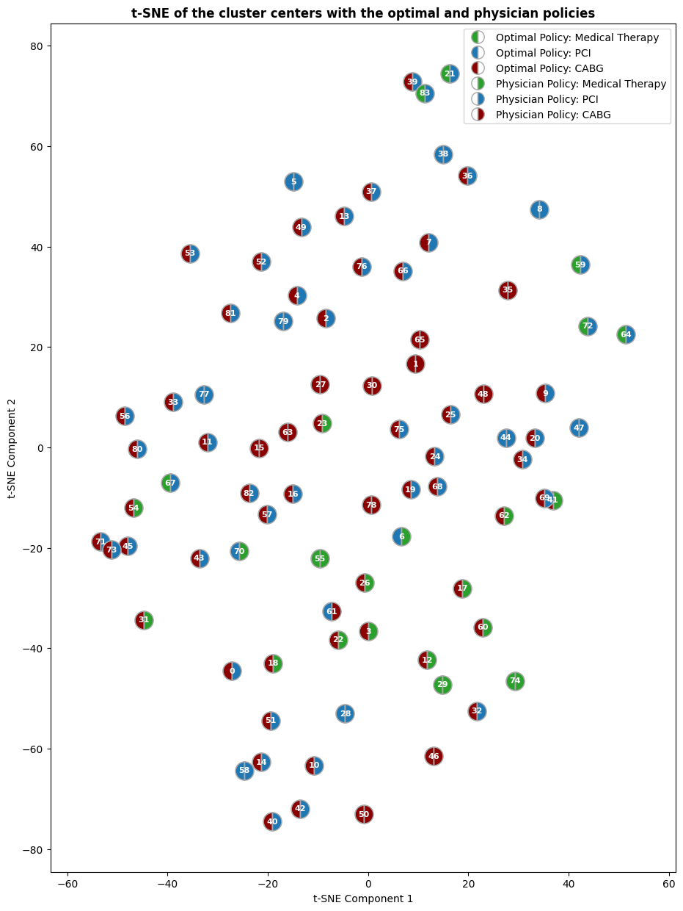
Supplementary Figure 1. Comparison of the optimal and physician policies (greedy) in different cluster level (k=84) visualized by t-SNE

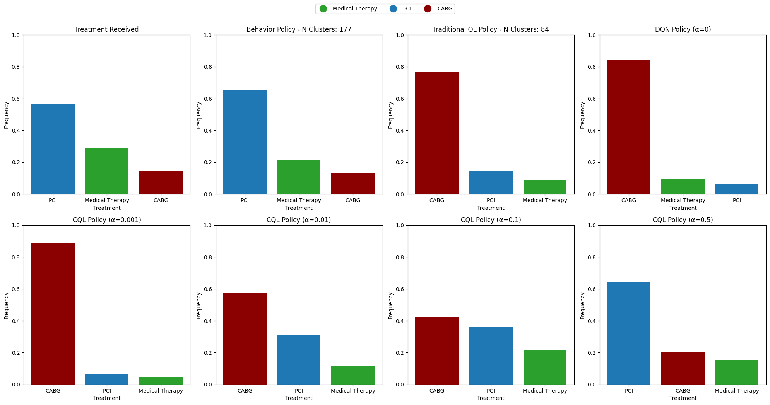
Supplementary Figure 2. Frequency of selecting each action as optimal in different policies

