Supplementary Information
A novel electrochemiluminescent cytosensor using dual-target magnetic probe recognition and nanozymes-catalyzed cascade signal amplification for precise phenotypic enumeration of CTCs
Congcong Shen^{1*}, Simin Fan¹, Xiaoqing Li², Fanshu Guo¹, Junru Li¹, Minghui Yang^{2,*}
¹ Key Laboratory of Green Chemical Media and Reactions, Ministry of Education, School of Chemistry and Chemical Engineering, Henan Normal University, Xinxiang, Henan 453007, China
² College of Chemistry and Chemical Engineering, Central South University, Changsha, 410083
* Corresponding authors:
E-mail: shencongcong@htu.edu.cn
yangminghui@csu.edu.cn
1. Materials and Reagents S-2
2. Apparatus S-2
3. Supporting information figures S-3
S1. Characterization of PPy@Fe₃O₄/Au S-3
S2. Characterization of GO@PB/Pt S-4
S3. XPS spectra of GO@HMPB/Pt S-4
S4. Zeta potential characterization of cell capture processes S-5
S5. Optimization of catalytic performance S-5
S6. Zeta potential analysis during the preparation of GO@HMPB/Pt-luminol S-6
S7. UV spectrum and calibration plots of different concentration of luminol S-6
S8. The histogram of ECL response during the cytosensor construction S-7
S9. Optimization of pH and different compounds concentration during the test S-8
S10. The long-term stability and reproducibility of cytosensor S-9

1. Materials and reagents
HL-7702 (normal liver cells), DU145 (human prostate cancer cells), BEAS-2B (human lung epithelial cells), Hepg2 (human liver cancer cells), Hela (human cervical carcinoma cell) and MCF-7 (human breast cancer cells) were purchased from the Cell Bank of the Chinese Academy of Sciences (Shanghai, China). Cell culture reagents include 1640 medium, Dulbecco’s Modified Eagle’s medium (DMEM), fetal bovine serum, penicillin−streptomycin solution, and trypsin were acquired from Gibco BRL, Invitrogen Corp. (Carlsbad, CA, USA). 1-ethyl-3-[3-(dimethylamino) propyl] carbodiimide hydrochloride (EDC), N-hydroxysuccinimide (NHS) were obtained from Sigma-Aldrich. Anti-epithelial cell adhesion molecule (anti-EpCAM) and N-cadherin was acquired from Abcam Co., Ltd. (Cambridge, MA). Sulfhydryl modified DNA aptamers SYL3 (sequence: 5’-HS-(CH₂)₆-CACTACAGAGGTTGCGTCTGTCCCACGTTGTCATGGGGGGTTGGCCTG-3’) and NC3S (sequence: 5’-HS-(CH₂)₆-TTGCACTATGTTTTAGCTAGGGTTCCCTCCGGAGATAGTAAGTGCAA-3’) were synthesized and purified by Sangon Biotech Co., Ltd. (Shanghai, China). Ammonium molybdate tetrahydrate [(NH₄)₆Mo₇O₂₄⋅4H₂O], ferric chloride (FeCl₃), ethylene glycol (EG), pyrrole (Py), chloroauric acid (HAuCl₄), polyvinylpyrrolidone (PVP), potassium ferricyanide (K₃Fe(CN)₆), potassium chloroplatinate (K₂PtCl₆), glucose, glutathione (GSH), ascorbic acid (AA), dopamine (DA), uric acid (UA) and luminol were acquired from Aladdin Reagent Company (Shanghai, China). The normal whole blood was obtained from the third affiliated hospital of Xinxiang medical college and the other chemicals were of analytical purity and used without further purification.
2. Apparatus
The electrochemical and ECL measurements were performed on CHI electrochemical station (760E, Shanghai, China) and multifunctional ECL analysis system (MPI-E, Xi’an Remex Analytical Instrument Co., Ltd, China). The morphology and microstructure were investigated with a field emission scanning electron microscope (JSM-6701M, Hitachi High-Technologies Corporation, Japan) and a transmission electron microscopy (JEM 2100, JEOL Ltd., Japan). The X-ray diffraction (XRD) studies were carried out on X’ Pert3 Powder, (PANalytical B.V.). X-ray photoelectron spectroscopy (XPS, Thermo Fisher Scientific K-Alpha), laser confocal high-resolution Raman spectrometer (LabRAM HR Evolution, Villeneuve d'Ascq) and Fourier transform infrared spectrometer (Spectrum 400F, PerkinElmer Inc., USA) were used to analysis the phase and element distribution and bonding of materials. The surface charge was measured on a Malvern Zetasizer Nano-ZS instrument (ZEN3600, Malvern Instruments). The load capacity of luminol was analyzed through UV-visible spectrophotometer (Agilent Cary 100, Agilent Technologies, USA).

3. Supplementary information figures
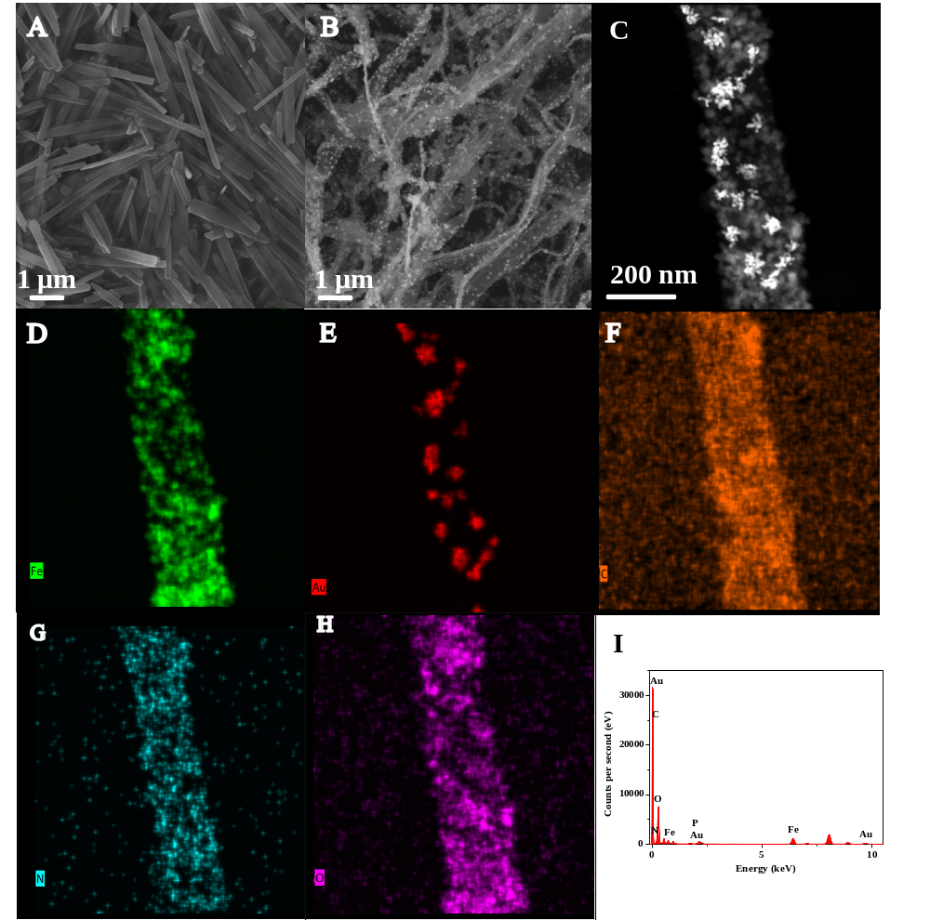
Figure S1. Characterization of PPy@Fe₃O₄/Au: SEM images of MoO₃ nanorod (A) and PPy@Fe₃O₄/Au (B), HAADF images (C) and the corresponding mapping (D-H), EDS spectra (I).
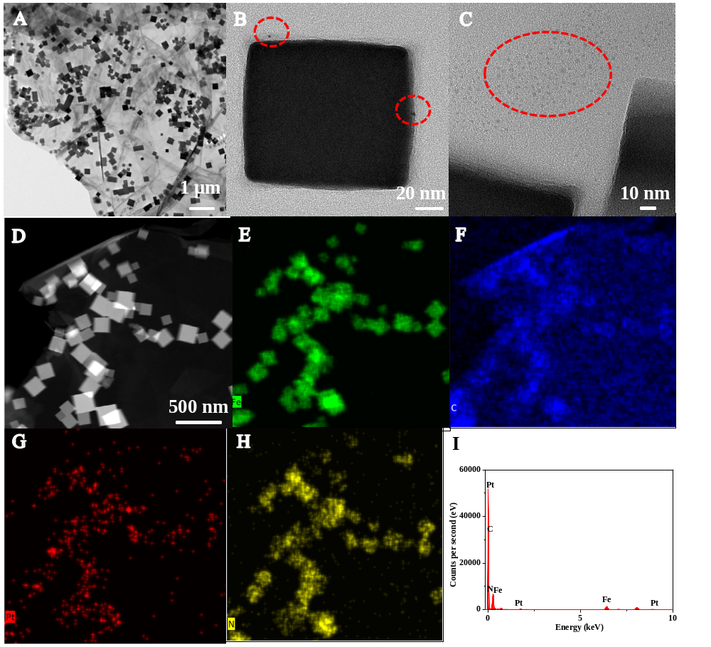
Figure S2. Characterization of GO@PB/Pt: TEM images with different magnifications (A, B and C), HAADF images (D), and the elemental mapping (E-H), EDS spectra (I)

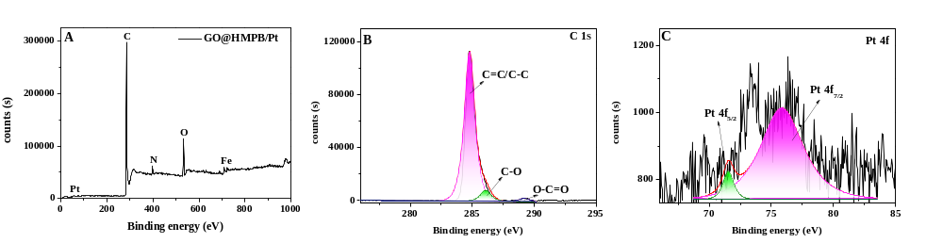
Figure S3. XPS full spectra of GO@HMPB/Pt (A) and high-resolution XPS spectra of C1s (B) and Pt 4f (C).

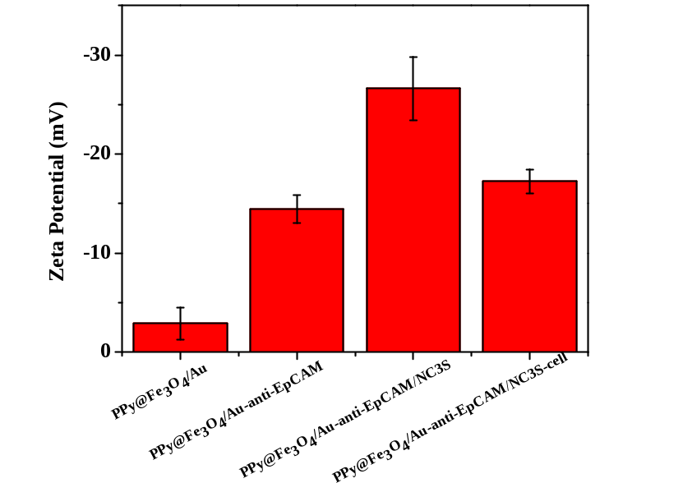
Figure S4. The Zeta potential characterization of cell capture processes.

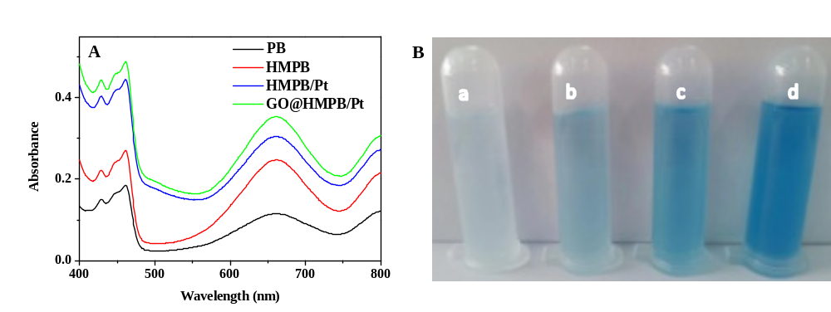
Figure S5. UV−vis absorption spectra and the optical images of TMB+H₂O₂+catalyst reaction system (A, B): (a) PB, (b) HMPB, (c) HMPB/Pt, (d) GO@HMPB/Pt.

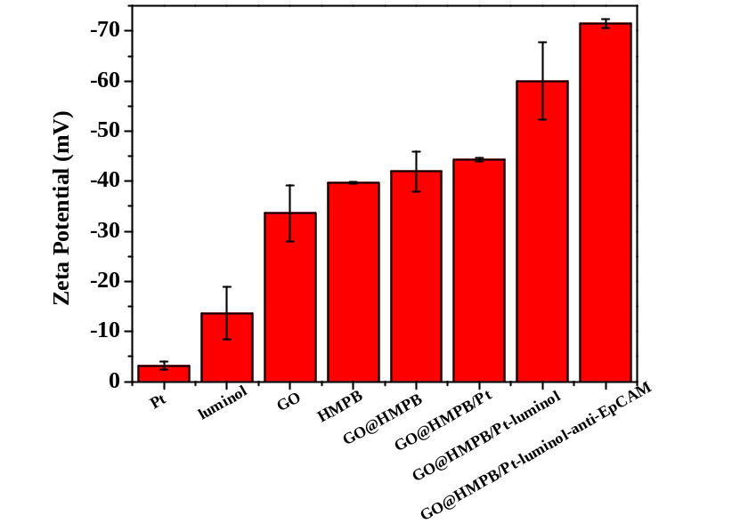
Figure S6. The Zeta potential analysis during the preparation of GO@HMPB/Pt-luminol signal report.

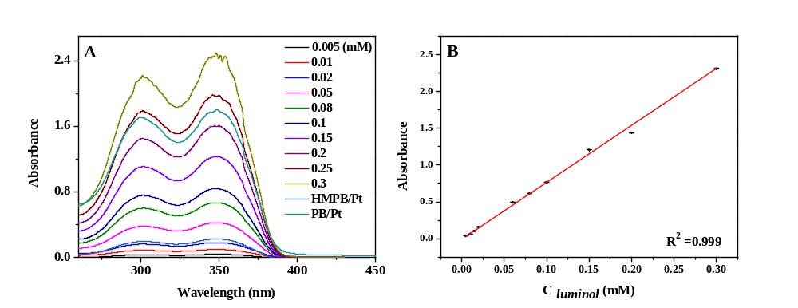
Figure S7. Absorbance response (A) and the corresponding linear relationship curve (B) of various concentrations of luminol.
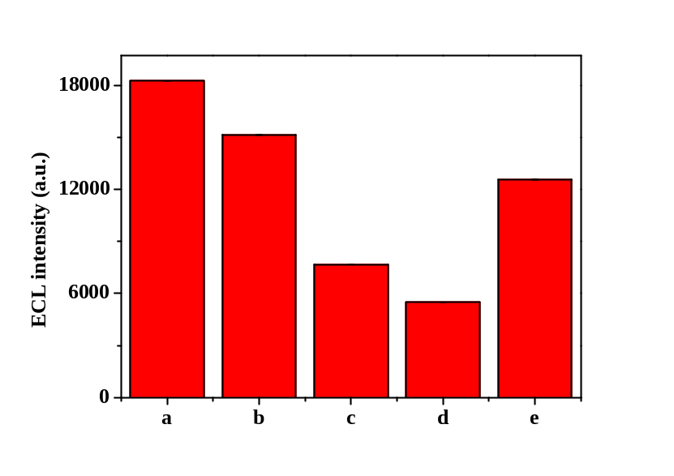
Figure S8. The histogram of ECL response during the immunosensor construction, (a) GO@HMPB/Pt-luminol, (b) GO@HMPB/Pt-luminol+PPy@Fe₃O₄/Au-anti-N-Cadherin/SYL3C (c) GO@HMPB/Pt-luminol+PPy@Fe₃O₄/Au-anti-N-Cadherin/SYL3C-MCF-7, (d) GO@HMPB/Pt-luminol+PPy@Fe₃O₄/Au-anti-N-Cadherin/SYL3C-MCF-7/Hela, (e) GO@HMPB/Pt-luminol+PPy@Fe₃O₄/Au-anti-N-Cadherin/SYL3C-MCF-7/Hela+GSH.

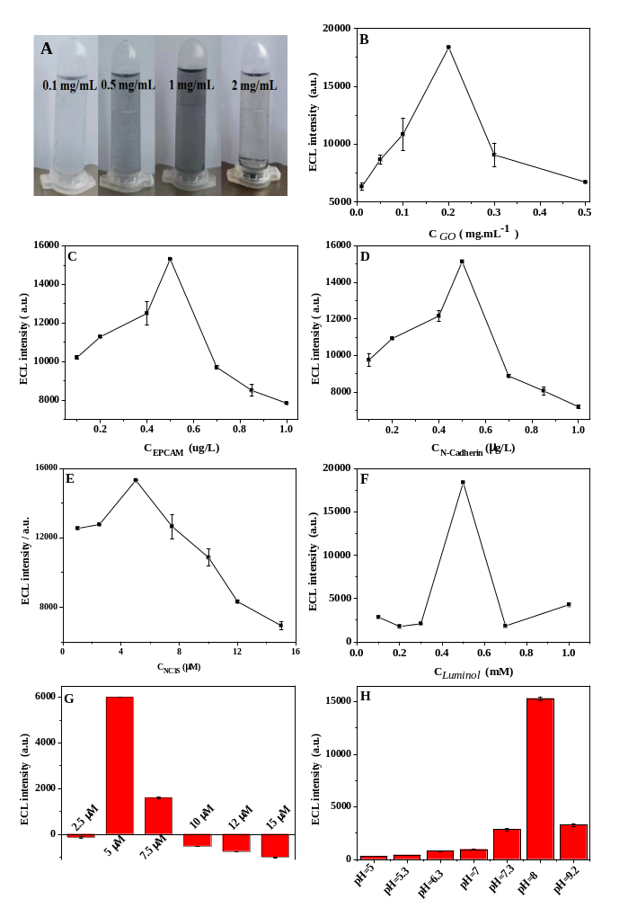
Figure S9. The diagram illustrates the optimization of pH and different compounds concentration during the test. (A) PPy@Fe₃O₄/Au, (B) GO, (C) EpCAM antibody, (D) N-Cadherin antibody, (E) NC3S aptamer, (F) luminol, (G) GSH, (H) pH.
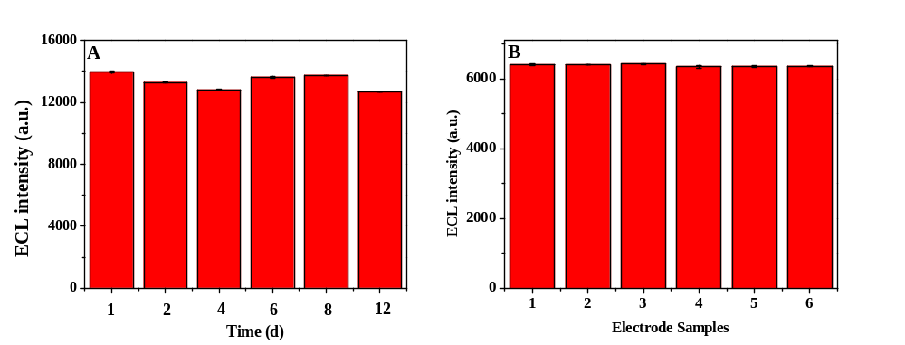
S10 (A) The long-term stability test of sensor for 8 cell/mL of Hela cells, (B) the reproducibility of sensor for 2000 cell/mL of Hela cells.

