1.LC-MS analyses
1.1 Sample preparation
60 mg accurately weighed sample was transferred to a 1.5 mL Eppendorf tube. Two small steel balls were added to the tube. 4 μg/mL of L-2-chlorophenylalanine dissolved in methanol as internal standard and 600 μL mixture of methanol and water (7/3, vol/vol) were added to each sample, samples were placed at -40 °C for 2min. Then grinded at 60 HZ for 2 min, and the whole samples were extracted by ultrasonic for 30 min in ice-water bath, then placed at -20°C for 20 min. Samples were centrifuged at 4°C (13,000 rpm) for 10 min prior to decanting of 150 μL supernatants from each tube were collected using crystal syringes, filtered through 0.22 μm microfilters and transferred to LC vials. The vials were stored at -80°C until LC -MS analysis. QC were prepared by mixing aliquot of the all samples to be a pooled sample.
1.2 LC-MS analysis
A Dionex Ultimate 3000 RS UHPLC fitted with Q-Exactive plus quadrupole-Orbitrap mass spectrometer equipped with heated electrospray ionization (ESI) source (Thermo Fisher Scientific, Waltham, MA, USA) was used to analyze the metabolic profiling in both ESI positive and ESI negative ion modes. An ACQUITY UPLC HSS T3 column (1.8 μm, 2.1 × 100 mm) were employed in both positive and negative modes. The binary gradient elution system consisted of (A) water (containing 0.1 % formic acid, v/v) and (B) acetonitrile and separation was achieved using the following gradient: 0 min, 5% B; 2min, 5% B; 4min, 25% B; 8min, 50% B; 10min, 80% B; 14min, 100% B; 15 min, 100% B; 15.1 min, 5% and 16 min, 5%B. The flow rate was 0.35 mL/min, and column temperature was 45 ℃. All the samples were kept at 4℃ during the analysis. The injection volume was 2 μL.
1.3 Data preprocessing
The original LC-MS data were processed by software Progenesis QI V2.3 (Nonlinear, Dynamics, Newcastle, UK). Main parameters of 5 ppm precursor tolerance, 10 ppm product tolerance, and 5% product ion threshold were applied. Compound identification were based on precise mass-to-charge ratio (M/z), secondary fragments, and isotopic distribution.
The extracted data were then further processed by removing any peaks with a missing value (ion intensity = 0) in more than 50% in groups, by replacing zero value by half of the minimum value, and by screening according to the qualitative results of the compound. Compounds with resulting scores below 36 (out of 60) points were also deemed to be inaccurate and removed. A data matrix was combined from the positive and negative ion data.
2. GC-MS analyses
2.1 Sample preparation
60 mg accurately weighed sample was transferred to a 1.5 mL Eppendorf tube. Two small steel balls were added to the tube. 4 μg/mL of L-2-chlorophenylalanine (0.3 mg/mL) dissolved in 600 μL mixture of methanol and water (7/3, vol/vol), samples were placed at -40 °C for 2 min. Then grinded at 60 HZ for 2 min, and the whole samples were extracted by ultrasonic for 30 min in ice-water bath, then placed at -40°C for 20 min. Samples were centrifuged at 4°C (13,000 rpm) for 10 min. 150 μL of supernatant in a glass vial was dried in a freeze concentration centrifugal dryer. And 80 μL of 15 mg/mL methoxylamine hydrochloride in pyridine was subsequently added. The resultant mixtures were incubated at 37 °C for 60 min. 50 μL of BSTFA (with 1% TMCS) and 20 μL nhexane was added into the mixture, which was vortexed vigorously for 2 min and then derivatized at 70 °C for 60 min. The samples were placed at ambient temperature for 30 min before GC-MS analysis.
2.2 GC–MS analysis
The derivatived samples were analyzed on an Agilent 7890B gas chromatography system coupled to an Agilent 5977A MSD system (Agilent Technologies Inc., CA, USA). A DB-5MS fused-silica capillary column (30 m × 0.25 mm × 0.25 μm, Agilent J & W Scientific, Folsom, CA, USA) was utilized to separate the derivatives. Helium (> 99.999%) was used as the carrier gas at a constant flow rate of 1 mL / min through the column. The injector temperature was maintained at 260 °C. Injection volume was 1 μL by splitess mode. The initial oven temperature was 60 °C held at 60 °C for 0.5 min, ramped to 125 °C at a rate of 8 °C/min, to 210 °C at a rate of 4 °C/min, to 270 °C at a rate of 5 °C/min, to 305 °C at a rate of 10 °C/min, and finally held at 305 °C for 3 min. The temperature of MS quadrupole, and ion source (electron impact) was set to 150, and 230 °C, respectively. The collision energy was 70 eV. Mass data was acquired in a full -scan mode (m/z 50-500), and the solvent delay time was set to 5 min. The QCs were injected at regular intervals (every 24 samples) throughout the analytical run to provide a set of data from which repeatability can be assessed.
2.3 Data preprocessing
The obtained GC/MS raw data in. D format were transferred to .abf format via software Analysis Base File Converter for quick retrieval of data. Then, data were imported into software MS-DIAL, which performs peak detection, peak identification, MS2Dec deconvolution, characterization, peak alignment, wave filtering, and missing value interpolation. Metabolite characterization is based on LUG database. A data matrix was derived. The three-dimensional matrix includes: sample information, the name of the peak of each substance, retention time, retention index, mass-to-charge ratio, and signal intensity. In each sample, all peak signal intensities were segmented and normalized according to the internal standards with RSD greater than 0.3 after screening. After the data was normalized, redundancy removal and peak merging were conducted to obtain the data matrix.
3. Multivariate statistical analyses
The matrix was imported in R to carry out Principle Component Analysis (PCA) to observe the overall distribution among the samples and the stability of the whole analysis process. Orthogonal Partial Least-Squares-Discriminant Analysis (OPLS-DA) and Partial Least-Squares-Discriminant Analysis (PLS-DA) were utilized to distinguish the metabolites that differ between groups. To prevent overfitting, 7-fold cross-validation and 200 Response Permutation Testing (RPT) were used to evaluate the quality of the model.
Variable Importance of Projection (VIP) values obtained from the OPLS-DA model were used to rank the overall contribution of each variable to group discrimination. A two-tailed Student’s T-test was further used to verify whether the metabolites of difference between groups were significant. Differential metabolites were selected with VIP values greater than 1.0 and p-values less than 0.05.

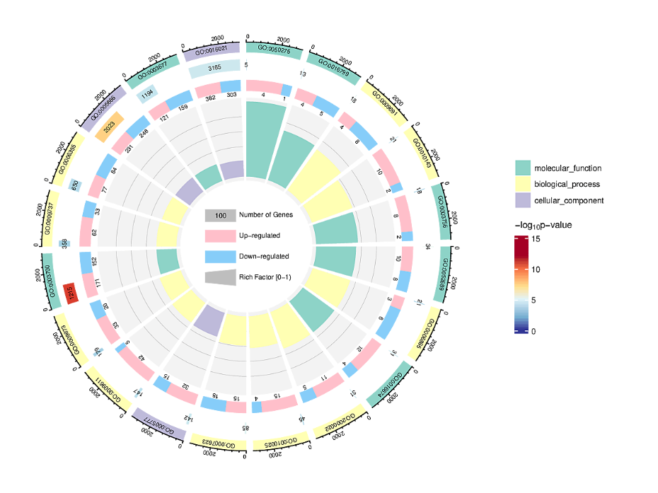 A
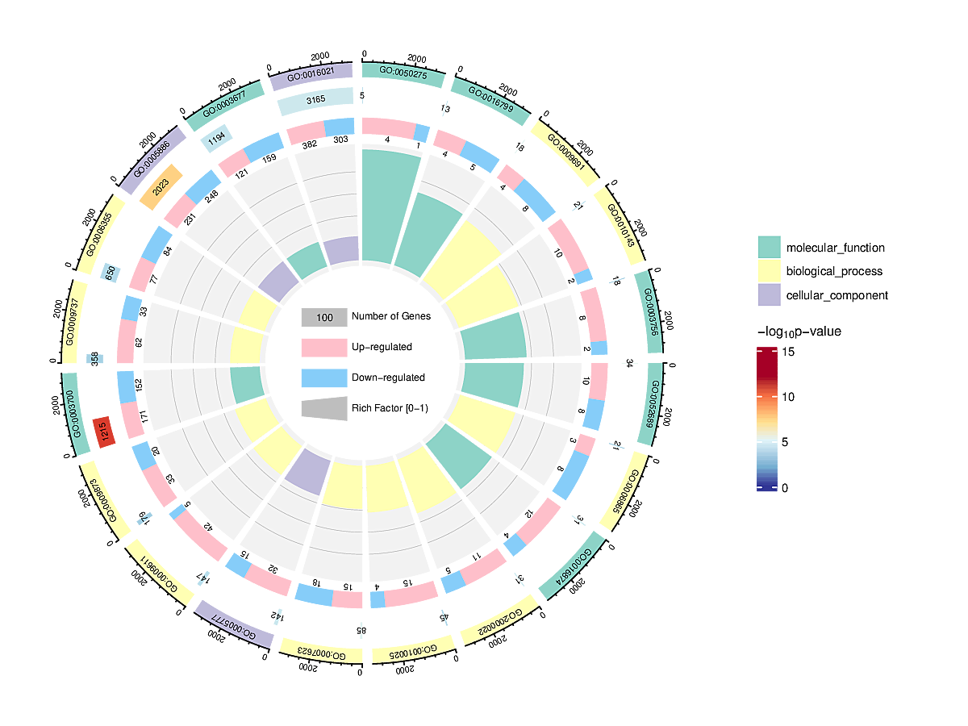 B

Fig.S1 A. GO analysis of DEGs in ‘5A’ 12 h vs ‘5A’ 0 h, B. GO analysis of DEGs in the ‘162’ 12 h vs ‘162’ 0 h comparison,
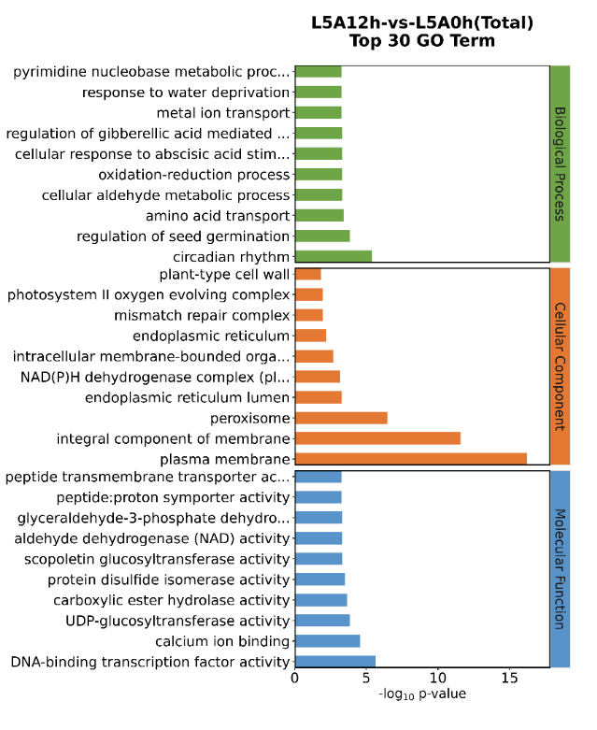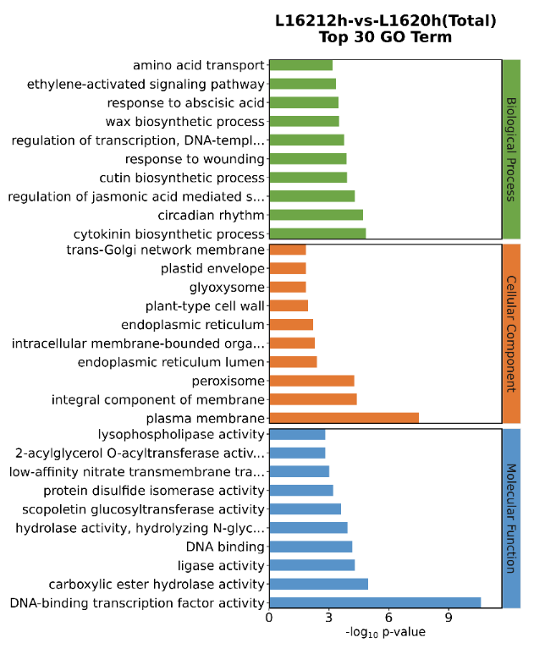
Fig.S2 TOP 20 GO analysis of DEGs in ‘5A’ 12 h vs ‘5A’ 0 h and ‘162’ 12 h vs ‘162’ 0 h.

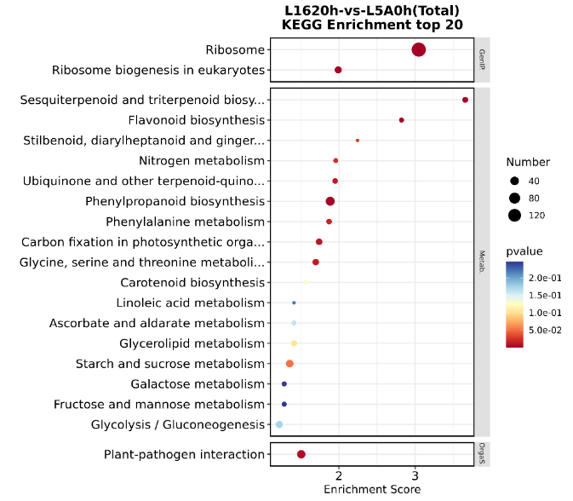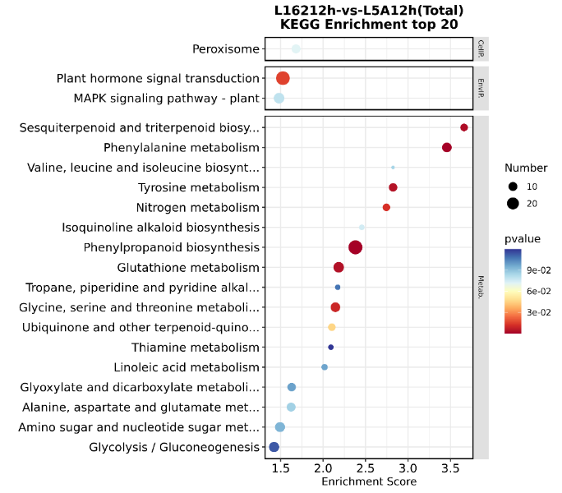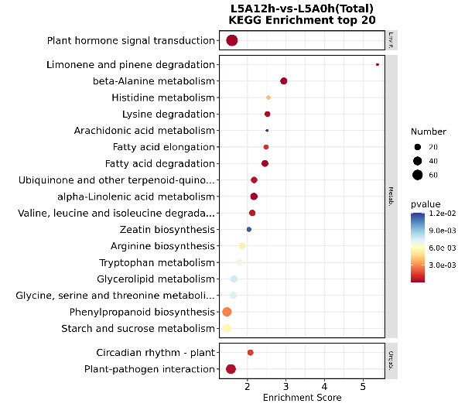

Fig.S3 KEGG analysis of DEGs in ‘162’ 0 h vs ‘5A’ 0 h, ‘162’ 12 h vs ‘5A’ 12 h, and ‘5A’ 12 h vs ‘5A’ 0 h comparison.

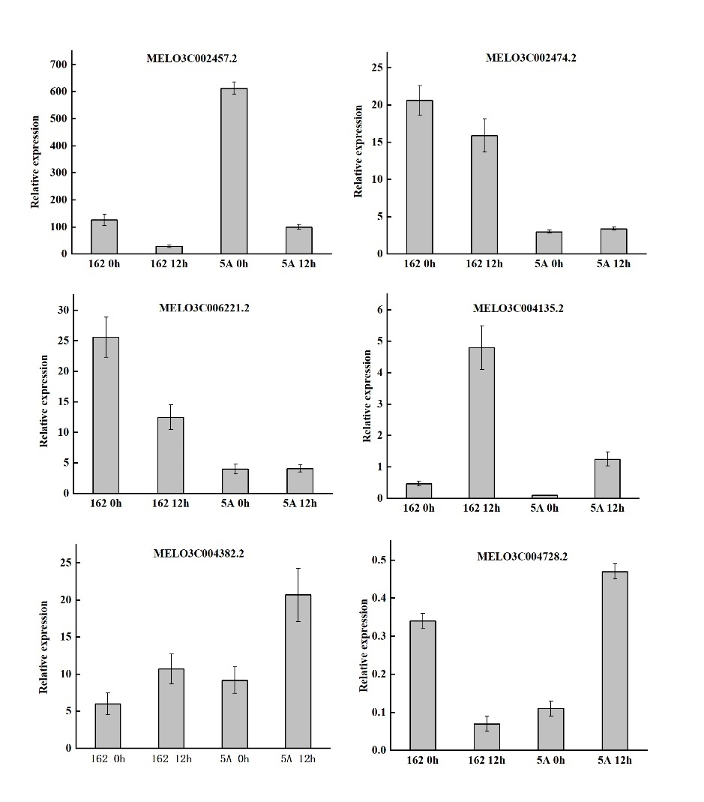
Fig.S4 The expression analysis of differentially expressed genes using qRT-PCR.

LC GC
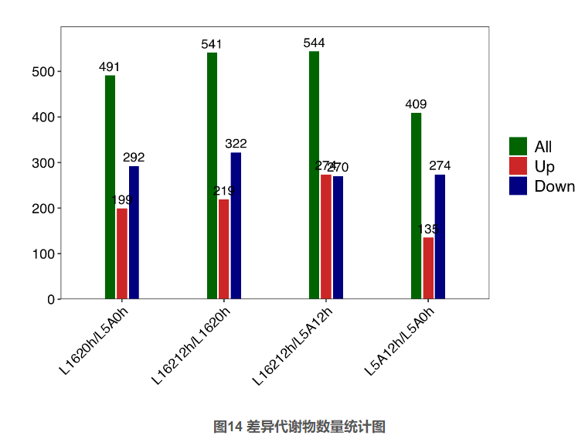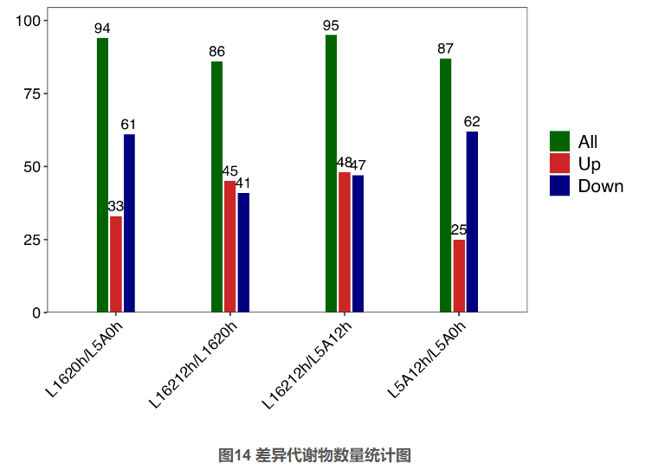

Fig.S5 Analysis of DAMs in melon leaves under chilling stress.
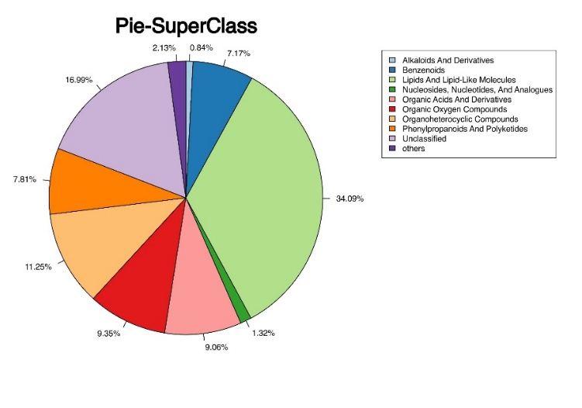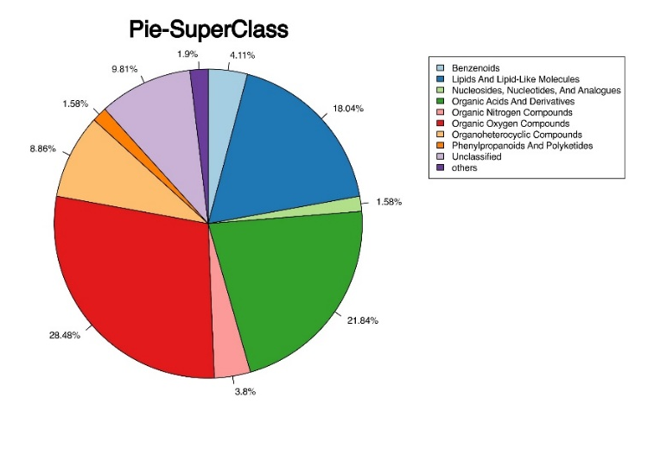
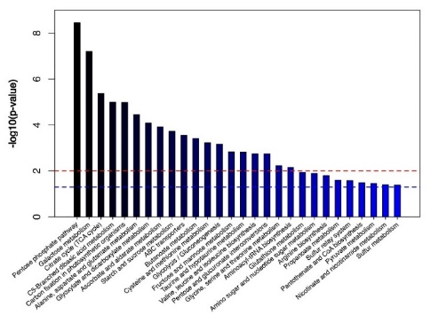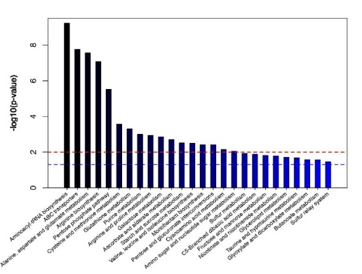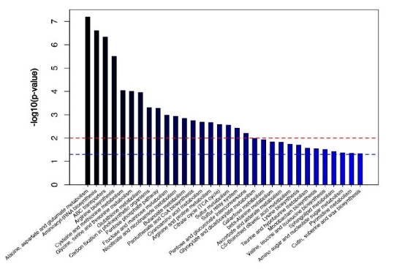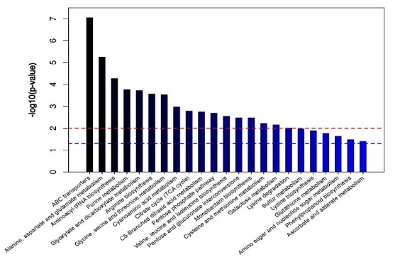

Fig.S6 KEGG analysis of DEMs in four comparison.

Table S1 Primer sequences of genes selected for qRT-PCR
Num | Gene Symbol | Forward primer(5->3) | Reverse primer(5->3)
1 | 18S-RNA | CTTTCTCTTCATCCCTTTGTTC | CTCTGCAAGGCGACTCTA
2 | MELO3C002457.2 | CTTCAAGTTGTGTGGATTGGTTG | CTCAGGAATTGACCCTGTGAC
3 | MELO3C002474.2 | CCACTTGCAAGAACTCGTTGAC | TGGTGTATAGAACCACACGTTCCT
4 | MELO3C006221.2 | ATTGCTTCCTGATCTCACCCTTAG | AGTTCACTAGGGCAATCCAGATCT
5 | MELO3C004135.2 | CTAAGCAAAGTGCACATCACAATGT | AGGAGATTTTCTCTGACACTGATGGT
6 | MELO3C004382.2 | CTCTGCAAGGCGACTCTA | CTTTCTCTTCATCCCTTTGTTC
7 | MELO3C004728.2 | GCTCCAGTCGATGAGCTAC | TTTGGGCCGTTACGAATGT

Table S2 Screened list of differentially expressed genes related to TFs
gene_id | 5A 12H | 5A 0H | 162 12H | 162 0H | gene_id | 5A 12H | 5A 0H | 162 12H | 162 0H
MELO3C009097.2 | 4.61521 | 39.80736 | 4.153486 | 43.68564 | MELO3C007330.2 | 10.04396 | 4.204708 | 20.58857 | 6.427528
MELO3C002292.2 | 1.248852 | 4.611977 | 0.31569 | 4.494595 | MELO3C013925.2 | 153.9829 | 42.05271 | 216.729 | 41.14662
MELO3C002090.2 | 38.23048 | 4.297634 | 74.73035 | 4.672556 | MELO3C032396.2 | 41.01726 | 9.970756 | 119.62 | 21.24673
MELO3C030739.2 | 5.866581 | 17.8572 | 3.025616 | 19.44336 | MELO3C006700.2 | 0.018528 | 12.1618 | 0.058338 | 7.513612
MELO3C007400.2 | 0.523027 | 0.128489 | 0.603486 | 0.062594 | MELO3C030958.2 | 0.384203 | 0 | 0.200789 | 0
MELO3C034933.2 | 6.851165 | 0.749945 | 6.042235 | 1.857921 | MELO3C022963.2 | 4.369161 | 0.364816 | 8.298117 | 1.40476
MELO3C026896.2 | 14.86749 | 37.18989 | 19.12269 | 55.40783 | MELO3C012890.2 | 21.09425 | 5.850714 | 77.02148 | 20.14084
MELO3C022542.2 | 0.441434 | 0.095277 | 0.723938 | 0.152062 | MELO3C015456.2 | 4.772629 | 36.273 | 0.740599 | 6.100433
MELO3C035029.2 | 11.773 | 32.27713 | 9.648219 | 48.79516 | MELO3C006728.2 | 0.346497 | 0.03465 | 0.542552 | 0.104887
MELO3C006313.2 | 0.878653 | 2.301347 | 0.268776 | 1.752256 | MELO3C010893.2 | 12.70319 | 2.099667 | 49.31713 | 9.136848
MELO3C013364.2 | 6.222755 | 2.302477 | 16.57598 | 4.319011 | MELO3C008549.2 | 0 | 0.493332 | 0 | 0.496169
MELO3C022003.2 | 0.190979 | 4.279909 | 0.331263 | 4.581245 | MELO3C010784.2 | 0.179203 | 0.544529 | 0.344578 | 1.167224
MELO3C007988.2 | 15.31276 | 66.8377 | 11.85345 | 36.831 | MELO3C023484.2 | 14.43183 | 0.794353 | 28.03483 | 3.329497
MELO3C007586.2 | 132.0366 | 45.23043 | 136.1318 | 67.53405 | MELO3C007657.2 | 0.349053 | 0.922769 | 0.689114 | 1.925803
MELO3C002228.2 | 21.57598 | 123.4338 | 33.1728 | 81.05963 | MELO3C006431.2 | 0.289866 | 2.059406 | 0.068997 | 2.582861
MELO3C008331.2 | 85.96392 | 7.831702 | 132.1583 | 10.23301 | MELO3C022281.2 | 0.301936 | 1.959044 | 1.111822 | 4.353828
MELO3C017591.2 | 0.383708 | 1.81779 | 0.644901 | 3.246038 | MELO3C016980.2 | 0.092074 | 1.397959 | 0.042409 | 0.929283
MELO3C015377.2 | 15.12204 | 2.073867 | 9.988426 | 1.234952 | MELO3C020448.2 | 0.861784 | 3.967458 | 1.035548 | 4.017166
MELO3C020847.2 | 5.968732 | 2.579699 | 13.55345 | 5.225032 | MELO3C026158.2 | 9.436242 | 0.09245 | 12.37707 | 1.325987
MELO3C011287.2 | 0.095695 | 0.634092 | 0.263628 | 1.946207 | MELO3C017645.2 | 28.64002 | 1.930597 | 8.075792 | 1.136477
MELO3C024989.2 | 127.834 | 14.86293 | 89.26224 | 26.6008 | MELO3C005466.2 | 127.787 | 42.01639 | 52.3265 | 147.7189
MELO3C019590.2 | 8.08098 | 3.079542 | 22.89014 | 5.277872 | MELO3C013593.2 | 3.69509 | 0.577062 | 13.10357 | 0.436383
MELO3C022179.2 | 4.020559 | 1.46056 | 5.989834 | 1.641448 | MELO3C022358.2 | 72.0834 | 13.49498 | 95.92631 | 18.81575
MELO3C015910.2 | 50.29378 | 9.898175 | 54.13213 | 10.38939 | MELO3C016780.2 | 44.28605 | 5.171864 | 46.10517 | 6.731061
MELO3C005937.2 | 0.507296 | 1.768863 | 0.595883 | 3.976529 | MELO3C018744.2 | 2.071166 | 0.158836 | 2.337518 | 0.374672
MELO3C007157.2 | 3.235839 | 1.192943 | 4.437009 | 1.10816 | MELO3C022520.2 | 19.86068 | 107.3043 | 18.25365 | 70.99937
MELO3C006037.2 | 10.73511 | 31.21373 | 97.09795 | 321.7392 | MELO3C025049.2 | 2.152926 | 9.714244 | 2.476084 | 12.71757
MELO3C012932.2 | 16.99914 | 3.075261 | 21.10109 | 3.058605 | MELO3C019745.2 | 0.145597 | 2.532376 | 0.061451 | 1.113622
MELO3C017743.2 | 3.027691 | 0.230868 | 3.548867 | 0.87547 | MELO3C011835.2 | 27.16178 | 4.796747 | 14.28265 | 7.175521
MELO3C015776.2 | 5.610207 | 1.539261 | 6.635227 | 2.599645 | MELO3C011754.2 | 9.185406 | 19.38341 | 5.369856 | 13.98285
MELO3C025357.2 | 2.940352 | 11.15391 | 1.976681 | 23.03588 | MELO3C010371.2 | 200.1139 | 65.20911 | 263.3288 | 75.64451
MELO3C006863.2 | 16.80076 | 7.39547 | 13.30388 | 6.212707 | MELO3C018845.2 | 0.872234 | 2.164367 | 0.183288 | 5.038277
MELO3C022062.2 | 0.556179 | 1.246148 | 0.67597 | 1.878032 | MELO3C015754.2 | 34.2745 | 11.78194 | 39.28543 | 14.61908
MELO3C005173.2 | 12.18903 | 3.665611 | 29.49209 | 8.706318 | MELO3C016400.2 | 9.46136 | 3.556866 | 3.890588 | 2.058904

Table S3 Numbers of DEMs in each comparison
 | GC | up | down |  | LC | up | down
L5A12h_L5A0h | 87 | 25 | 62 |  | 409 | 135 | 274
L16212h_L1620h | 86 | 45 | 41 |  | 541 | 219 | 322
L1620h_L5A0h | 94 | 33 | 61 |  | 491 | 199 | 292
L16212h_L5A12h | 95 | 48 | 47 |  | 544 | 274 | 270
total | 362 | 151 | 211 |  | 1985 | 827 | 1158

Table S4 Numbers of DEMs in 5A 12h and 5A 0h

Dataclass | ID | m/z | Retention time (min) | Metabolites | Compound ID | Super Class | Class | Sub Class | VIP | P-value | adj.P-value | log2(FC) | FC | average(L5A12h) | average(L5A0h)
GC | 332 | 171.1 | 17.509 | Beta-Glycerophosphoric Acid | HMDB0002520 | Lipids and lipid-like molecules | Glycerophospholipids | Glycerophosphates | 1.725305 | 0.011191 | 0.030226 | 2.375774 | 5.190143 | 0.025445 | 0.004902
LC | 6.01_214.1801m/z | 214.1801 | 6.0066 | 7Z,9E-dodecadienoic acid | LMFA01030237 | Lipids and lipid-like molecules | Fatty Acyls | Fatty Acids and Conjugates | 1.300448 | 8.37E-05 | 0.001712 | 1.763257 | 3.394636 | 26952.46 | 7939.722
LC | 5.71_729.1874m/z | 729.1874 | 5.705767 | Chrysosplenol C 6,4'-diglucoside | LMPK12112935 | Lipids and lipid-like molecules | Polyketides | Flavonoids | 1.336119 | 7.09E-08 | 2.98E-05 | 1.655159 | 3.149578 | 26514.93 | 8418.565
LC | 11.46_571.2900m/z | 571.29 | 11.46405 | Ganoderic acid H | HMDB0035987 | Lipids and lipid-like molecules | Prenol lipids | Triterpenoids | 1.120661 | 0.002492 | 0.015089 | 1.574941 | 2.979234 | 23683.95 | 7949.676
LC | 11.48_452.2788m/z | 452.2788 | 11.4805 | 1-(2-methoxy-13-methyl-6Z-tetradecenyl)-sn-glycero-3-phosphoethanolamine | LMGP02060010 | Lipids and lipid-like molecules | Glycerophospholipids | Glycerophosphoethanolamines | 1.499496 | 8.68E-05 | 0.001752 | 1.349845 | 2.548847 | 42429.28 | 16646.46
LC | 12.34_623.2723m/z | 623.2723 | 12.33907 | Dihydrotestosterone diglucuronide | HMDB0251334 | Lipids and lipid-like molecules | Steroids and steroid derivatives | Steroidal glycosides | 1.076722 | 0.00124 | 0.009201 | 1.207434 | 2.309266 | 24402.78 | 10567.33
LC | 11.47_454.2923m/z | 454.2923 | 11.4738 | PE(16:0/0:0) | 40776 | Lipids and lipid-like molecules | Glycerophospholipids | Glycerophosphoethanolamines | 1.885386 | 7.39E-06 | 0.00042 | 1.20699 | 2.308555 | 67765.6 | 29354.13
LC | 12.34_655.2103m/z | 655.2103 | 12.33907 | Ptilosaponoside A | LMST05050001 | Lipids and lipid-like molecules | Sterol Lipids | Steroid conjugates | 1.652892 | 0.000843 | 0.007126 | 1.185781 | 2.274866 | 57595.6 | 25318.24
LC | 10.75_593.2741m/z | 593.2741 | 10.74755 | PI(18:3(6Z,9Z,12Z)/0:0) | LMGP06050016 | Lipids and lipid-like molecules | Glycerophospholipids | Glycerophosphoinositols | 2.336871 | 0.009352 | 0.038071 | 1.118919 | 2.171842 | 135475.9 | 62378.35
LC | 0.71_176.0543n | 177.0616 | 0.7112 | Allantoic acid | HMDB0001209 | Organic acids and derivatives | Carboxylic acids and derivatives | Amino acids, peptides, and analogues | 1.2608 | 0.011137 | 0.043149 | 3.214132 | 9.280049 | 25865.69 | 2787.236
GC | 54 | 147.1 | 7.867 | Carbonate | HMDB0031453 | Organic acids and derivatives | Organic carbonic acids and derivatives | Organic carbonic acids | 1.855288 | 0.00113 | 0.004249 | 2.584712 | 5.998959 | 0.017359 | 0.002894
LC | 0.65_163.0665n | 164.0738 | 0.649083 | S-Propyl-L-cysteine | HMDB0034324 | Organic acids and derivatives | Carboxylic acids and derivatives | Amino acids, peptides, and analogues | 2.511393 | 9.46E-08 | 3.47E-05 | 1.301492 | 2.464837 | 110023.7 | 44637.29
GC | 202 | 176.1 | 13.997 | L-Methionine | HMDB0000696 | Organic acids and derivatives | Carboxylic acids and derivatives | Amino acids, peptides, and analogues | 1.309903 | 2.02E-07 | 1.07E-05 | 1.075386 | 2.107285 | 0.039841 | 0.018906
GC | 429 | 287.1043 | 19.561 | 2-Methylcitric Acid | HMDB0000379 | Organic acids and derivatives | Carboxylic acids and derivatives | Tricarboxylic acids and derivatives | 1.132499 | 0.01379 | 0.035143 | 0.918615 | 1.8903 | 0.017038 | 0.009013
GC | 65 | 130.1 | 8.305 | 2s-Amino-Butanoic Acid | HMDB0000452 | Organic acids and derivatives | Carboxylic acids and derivatives | Amino acids, peptides, and analogues | 1.135053 | 0.000101 | 0.000601 | 0.875127 | 1.834169 | 0.006169 | 0.003364
GC | 481 | 344.1444 | 20.836 | 2,4'-Methylenediphenol | Benzenoids |  | Benzene and substituted derivatives | Diphenylmethanes | 3.465728 | 0.00015 | 0.000846 | -7.48853 | 0.005568 | 8.89E-05 | 0.015958
LC | 5.86_280.1099n | 281.1172 | 5.86025 | Asparenyol | HMDB0041304 | Benzenoids | Phenol ethers | Anisoles | 1.026974 | 0.000419 | 0.004604 | -1.07149 | 0.475827 | 11420.78 | 24001.96
GC | 552 | 285.0833 | 22.733 | Cannabidiol | Lipids and lipid-like molecules |  | Prenol lipids | Monoterpenoids | 3.164694 | 8.17E-07 | 1.99E-05 | -6.13871 | 0.014193 | 8.89E-05 | 0.006261
LC | 4.76_639.1208m/z | 639.1208 | 4.756567 | Quercetin 3-glucuronide-7-glucoside | LMPK12112201 | Lipids and lipid-like molecules | Polyketides | Flavonoids | 1.293811 | 5.11E-06 | 0.00035 | -3.30891 | 0.100906 | 1954.409 | 19368.52
LC | 11.25_756.4280n | 774.4618 | 11.24627 | (25S)-Spirostane-3b,5b,6a-triol 3-[4''-rhamnosylglucoside] | HMDB0035488 | Lipids and lipid-like molecules | Steroids and steroid derivatives | Steroidal glycosides | 1.414734 | 0.004774 | 0.023952 | -2.52972 | 0.173173 | 5736.584 | 33126.39
LC | 14.73_765.4106m/z | 765.4106 | 14.73382 | PGP(a-13:0/18:2(9Z,11Z)) | HMDB0116513 | Lipids and lipid-like molecules | Glycerophospholipids | Glycerophosphoglycerophosphates | 1.485281 | 0.000403 | 0.00454 | -2.12841 | 0.22871 | 7859.838 | 34366.03
GC | 113 | 201.1143 | 10.584 | 1-Nonanol | HMDB0031265 | Lipids and lipid-like molecules | Fatty Acyls | Fatty alcohols | 1.889036 | 4.78E-05 | 0.00036 | -1.98651 | 0.252349 | 0.000575 | 0.00228

