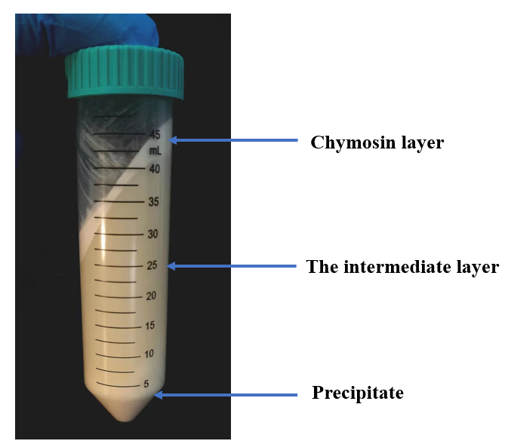
SUPPLEMENTAL FIGURE 1
The liquid layers obtained after the precipitation prffrocessing of camel milk.

SUPPLEMENTAL TABLE 1 The quantification of protein concentration in exosomes obtained through various extraction techniques（mg / mL）
 | test 1 | test 2 | test 3 | mean | Standard Deviation
Chymosin-Assisted | 34.20 | 32.60 | 31.60 | 32.80 | 1.07
PI-Assisted | 32.40 | 30.80 | 31.30 | 31.50 | 0.67
EDTA-Assisted | 30.80 | 31.20 | 30.20 | 30.73 | 0.41

