SUPPLEMENTARY METHODS

Participant Data Sources

As noted in the main text, we gathered de-identified information from the US Oncology Network (USON) Electronic Health Record (EHR), known as iKnowMed (iKM), and the Limited Access Death Master File (LADMF), associated with USON patients who: 1. Participated in USON phase IA and phase IB clinical trials between 4/2007-6/2018, with follow-up through 12/2018 or until date of the participant’s last record. These trials include USON’s phase IA (single agent set) and phase IB (combination phase IB data set) trials; 2. Received care at a USON site utilizing the full EHR capacities of iKnowMed (iKM) at the time of treatment; and 3. Were ≥ 18 years of age at trial participation. Any participant who had previously opted out of their results being kept in the USON database were not included. The LADMF, which was our principal source of vital status (death) of the participants, is overseen by the Social Security Administration (SSA). The SSA maintains a public death master file that was used to generate the LADMF and includes records of deaths reported by family members, funeral homes, hospitals, financial institutions, postal authorities, and federal agencies for persons issued a social security card.

2362 USON participants were identified with relevant data from a total of 252 different Phase I clinical trials. These participants were identified though an index date reflecting the start date of the phase I trial they participated in. Given differences in the participants’ trial initiation dates and the date of the last contact with them, there was a great deal of variation in the completeness of clinical measures, the cancers of focus in these trials, as well as the overall length of time for which we had data, on each participant. All study variables and outcomes were assessed irrespective of maximum follow-up. The USON iKM EHR system ultimately captures outpatient practice encounter history information for participants under care, including (but not limited to) laboratory tests, diagnosis, therapy administration, line of therapy, staging, comorbidities, and performance status information within the USON Network. More broadly, the USON iKM captures data on outpatient medical oncology care for participants treated across the United States (19 states). The geographic dispersion of the USON network is broad, with all regions of the country receiving some coverage in the system. Overall, the iKM EHR system captures data on approximately 10% of new participants diagnosed with cancer in the United States. The phase I trials we drew from considered participants with different cancers, creating potential for heterogeneity in responses and this is reflected in the data ultimately available for study on the 2362 participants in the 252 trials we drew from (Supplementary Tables 2-4). Note that the iKM EHR contains information on participants only when they are seen by US Oncology physicians or as reported to their US Oncology physician and recorded in the EHR. Services and procedures provided outside of the US Oncology network (e.g., hospitalizations, bone marrow transplants, radiation therapies) are not necessarily documented in the database.

While the use of a large geographically dispersed cohort of community-based participants instills confidence that results will be generalizable, patterns of care within the US Oncology Network, given its encouragement of evidence-based treatment guidelines, may differ to some degree from community-based treatment patterns in general. The health information data used for McKesson Specialty Health (MSH)’s services, from which data were drawn, may vary in accordance with the data rights available to MSH under agreements with physician practices. Therefore, data from some practices that are part of the USON network, or the related Onmark Select Program which is a Group Purchasing Organization (GPO) used by USON, may not have been available for MSH’s services. Note also that since we used the LADMF for death record information, persons never issued a social security number or whose death was not reported to the Social Security Administration by a non-state agency would not be reflected in our study.

Imputing Missing Data

To accommodate missing data, we imputed values for missing variables using the Multiple Imputation with Chained Equation (MICE) method [33]. To determine how sensitive our results were to imputation, we pursued sensitivity analyses in which we compared analysis results generated on both the complete and imputed data sets.

Responses and Candidate Prognostic Biomarkers

The independent variables we considered included (see also Supplementary Tables 2 and 3): Age, Agent type (cytotoxic vs. non-cytotoxic), trial index coded as 1 if a participant was enrolled in a specific trial, 0 otherwise, to account for the fact that some study subjects may have been in the same trial and therefore on an intervention with greater efficacy than other trials’ interventions, ECOG performance status closest to initiation of clinical trial phase I, albumin levels, body mass index (BMI), disease (i.e., cancer/tumor) type, sex, weight, height, hematocrit, hemoglobin, white blood cell count (WBC), lymphocyte count, platelet count, lactate dehydrogenase (LDH), uric acid, duration of prior therapy time (in days) from prior therapy to date of phase I trial (DOPT), a variable indicating if phase 1/1b agent type targeted therapy or not, and survival status. Although we had data on some individuals for cancer serum biomarkers, such as CA-19, CA-125, CA-27.29, and CA-15.3, we did not have enough individuals (i.e., n<200) with these measures to be considered in our analyses (Supplementary Table 2). These variables were all measured prior to enrollment in the trials. All continuous variables (e.g., BMI) were standardized to have zero mean and unit standard deviation. Categorical variables were recoded as dummy variables (e.g., sex: 0=female, 1=male).

Analytical Methods

Descriptive Statistics. We used standard descriptive statistics (mean, standard deviation, frequencies, etc.) to characterize the responses and candidate prognostic biomarkers. We also used standard Pearson parametric and Spearman non-parametric correlation analyses to assess the basic relationships between the biomarkers.

Regression and Mixed Model Analysis. We focused our analyses on mixed effects (or random effects) models given that we wanted to control for variation in biomarker and response relationships across the trials [31, 32]. However, to reduce variables used in these mixed model analyses, and to compare results with and without accounting for inter-trial variation, we also used standard linear and logistic regression, including stepwise linear and logistic regression. We pursued analyses using imputed values for the candidate biomarkers when the data were not complete for all participants. Since two of the four outcome variables were categorical, we used logistic regression-based mixed models to analyze them and linear regression-based mixed models for the continuous outcome variables. We also used survival analyses to analyze time on trial response [34]. Trial index was considered a grouping (i.e., random effect) factor in these mixed model analyses. Note that ‘trial index’ is simply a number indicating if each participant was a participant in each of the trials). We also considered the trial indices as fixed effects in initial analyses to assess each trial’s association with the responses relative to the other trials. Only trial indices with >5 individuals were considered as covariates in these analyses. We also only used dummy variables for cancer types with > 24 individuals. To carry out the mixed model analyses we used the modules ‘lme4’, ‘GLMMAdaptive,’ and ‘Coxph,’ in the R computing environment [35]. We tested both the significance of the candidate biomarker’s fixed effects on the response variables as well as the significance of the mixed or random effects terms in these models. Since there were many different potential prognostic biomarkers, we first fit standard stepwise linear and logistic regression models to the data to identify which prognostic biomarkers were significantly associated with the response variables. We then tested to see if the relationships of these prognostic biomarkers to the response variables exhibited significant variation across the trials using mixed effects models with those significant variables as fixed effects. Since the trials had different numbers of participants, some with only 1 or very few participants, we fit the mixed effects models to the entire data set instead of, e.g., using a test and training data set, since we would not have representation of some trials in a test or training set. We did, however, use randomly created test and training sets in separate analyses using machine learning (ML) techniques as discussed below. Thus, random effects of any predictor were only included in the final multiple regression-based mixed effects models if a univariate mixed effects model suggested there was a significant random effect for that predictor. In addition, random effects can encompass intercept terms or slope terms in a regression model. We evaluated univariate models with and without both intercept and slope random effects and found them to be highly correlated. We therefore considered only including significant random intercept terms in the final multiple regression based mixed models.

Prediction Modeling. We used some example participant profiles to show how the development of our mixed effects models’ results can be used to make individual predictions of response in Phase I studies for the categorical outcome. Logistic regression models corrected for the imbalance in the categorial outcomes using the SMOTE procedure (see above and the Supplementary Methods) were used. Four randomly chosen participants profiles were used, along with the average (or modal) value of each prognostic biomarker. In addition, we created two extreme participant profiles by using values of the prognostic biomarkers that were either all 1 standard deviation below the mean (or the non-modal value of dichotomous variables) or all 1 standard deviation above the mean (or the modal value of dichotomous variables). Finally, we also provide example predictions using the average or median values of the predictor variables for continuous and dichotomous variables, respectively. We removed variables for the predictions that were not significant to reduce noise in the predictions and focused on the final set of significant prognostic model values using the estimated regression coefficients. Note that including trial index variables as grouping factors representing random effects in these analyses raises important questions about how to pursue predictions for a target individual, since we would have no information about the regression coefficient for the participant’s ‘new’ trial index (since there would be no historical data on drug being tested in a new clinical trial) so we used the standard practice of making predictions using just the fixed effects. We further consider this issue in the Discussion section.

Machine Learning (ML) Models. We used the following well-known ML methods for the analysis of the continuous outcome variables (i.e., Time on Study and Time on Prior Therapy Ratio) as implemented in the Sci-kit learn package [36]. These methods are discussed in many excellent references [37] and included: standard linear regression (LR); Elastic net model (Elastic_Net); KNeighboursregressor (KNN); support Vector machine analysis (SVR); decision tree analysis (DT); adaptive boosting (AdaBoost) analysis; Bagging Regressor (Bagging), Extra Tree regressor (ExtraTree) ; random forest analysis (RF). For the categorical outcome variables (i.e., 90-day mortality and overall grade 5 toxicity) we used the following ML classification algorithms also implemented in the Sci-kit learn package: Logistic Regression (LR); decision tree classifier (DTC); support vector machine classifier (SVC); Gaussian naïve Bayes (GNB); KNN classifier (KNN); AdaBoost classifier (ABC); Bagging Classifier (Bagging); Extra Tree classifier (ExtraTree); random forest classifier (RF); quadratic discriminant analysis (QDA).

As a way of aggregating the results of the different ML methods to build an ensemble model, we used the ‘Super Learner’ (SL) technique [38]. The SL aggregates the different individual model results and as a result, in theory, should provide predictions and classifications at least as good as any of the individual models. Technically, the underlying SL model is an application of stacked generalization designed to determine the optimal combination of a collection of prediction models [39]. For the ML analyses we considered trial indices as fixed effects, but only for those trials that were significant in the initial stepwise regression analysis and that had enough participants. This was also the case for tumor type. More information on the SL modeling is provided in the Supplementary Methods section. Many of the ML techniques that we applied to the data require different hyperparameter settings that could impact the overall fit and interpretability of the models. These settings are discussed in the Supplementary Methods section and include specific hyperparameters, choice of test and training sets. In addition, the Supplementary Methods section also describes how we handled imbalances in the data for the ML models using the ‘Synthetic Minority Over-sampling Technique (SMOTE)’ [40-42], how we evaluated the performance of each model using standard metrics [37, 43] and Cohen’s Kappa [40] for area-under-the-curve (AUC) from receiver-operator characteristics (ROC) curve analysis, and how we explored the sensitivity of our modeling.

Hyperparameter Settings. Many of the ML techniques that we applied to the data require different parameter settings that could impact the overall fit and interpretability of the models. The hyperparameter settings that we used for the different models that required them were (using parameter names associated with their implementations in the Sci-kit learn package [36]): SVM: gamma='scale'; boosting: n estimators=10; random forest: n estimators=10; extra trees: n estimators=10; Logistic regression: solver='liblinear;' decision tree classifier: max_depth=None, min_samples_split=2; SVM classifer: C=1.0,
decision_function_shape='ovr', gamma=1.5, kernel='rbf', probability=True; AdaBoost classifier: DecisionTreeClassifier(max_depth=5), n_estimators=600, learning_rate=.25, algorithm='SAMME', random_state=seed; bagging classifier: n_estimators=10; random forest classifier: n_estimators=100, max_depth=5, criterion='gini;’ extra trees classifier: n_estimators=10; quadratic discriminant analysis: priors=None, reg_param=0.0, store_covariance=False, tol=0.0001.

Test and Training Set Analyses. To avoid overfitting with the ML models, we took advantage of a training/test set approach to our prediction model constructions and the evaluation of their performance. We randomly chose 70% of our data as a training set for which prediction models were created and reserved 30% of the data as a test set for which we could evaluate the predictive and classification performance of the models. This was pursued for each of the ML methods, including the Super Learner, and repeated 20 times. By repeating the creation of a randomly chosen training and test set for each ML technique, we could compute standard errors for different performance metrics to facilitate their comparison.

Handling Imbalance in the Data

As noted, our data set does have missing values. In fact, only 503 individuals had all the variables of interest, but after imputation the total number sample size was 1386. In addition, due of imbalances in the number of participants exhibiting different outcomes, as well as imbalances among the independent variables, we pursued analyses of the categorical outcomes (i.e., ’90-day mortality’ and ‘general grade 5 toxicity’) through the application of a popular method for oversampling the class with the fewest observations termed ‘Synthetic Minority Over-sampling Technique (SMOTE)’ [40, 41]. The basic principle behind SMOTE is that it selects individuals that have similar profiles in the feature space (i.e., independent variable profiles or specific independent variable values), and uses them to draw new simulated samples from the feature space to enable more balanced comparisons [40, 41]. The use of the oversampling technique allowed us to pursue analyses with an effective sample size of ~2324 (90 days mortality) and 2604 (Grade 5 toxicity).

Performance Evaluation Metrics

To evaluate the performance of each model we considered the use of a number of standard metrics [43]. For those involving categorical outcomes we used a number derived form a ‘confusion’ matrix, which is basically a 2 x 2 table with the true classifications as columns and predicated classifications as rows. The table entries therefore reflect true positives (TP), false positives (FP), false negatives (FN) and true negatives (TN). The metrics used were: Accuracy = (TP+TN)/(TP+TN+FP+FN); Precision = TP/(TP+FP); Recall/Sensitivity = TP/(TP+FN); Specificity = TN/(TN+FP); and F1 score = 2TP/(2TP+FP+FN). We also considered Cohen’s Kappa [45] and the standard area-under-the-curve (AUC) from receiver-operator characteristics (ROC) curve analysis [43]. For continuous outcomes we evaluated the performance of the models using mean-squared error (MSE), Maximum Error (MaxErr), Mean Absolute Error (MAE), and Median Absolute Error (Med Abserr) [37, 43].

Sensitivity and Heterogeneity Analyses

To determine the impact of imputed data on our modeling and results, we compared the distribution of values for the complete and imputed data. We also compared results using the complete and imputed data in different settings. To explore potential cryptic heterogeneity in our dataset that may have reflected biases in our data and/or that could impact the interpretation of our results, we compared the distributions of different predictor/independent variables for those participants who were classified correctly in our analyses vis those who were not for the categorical outcome variables. Differences between the correctly and incorrectly classified individuals could reflect underlying differences in participants in our study that may preclude valid inferences from their combined analysis without accounting for these differences. We also compared different predictive models and algorithms using the original data set and the data after imputation (See Methods and Supplementary Figure 10).

Table 1: Trial indices that were significant predictors (p<0.05) of response across the 252 Phase I trials based on stepwise logistic regression for the dichotomous outcomes.

90-day Mortality |  |  |  | Grade 5 Toxicity
Trial Index | Coef | Std | p-value | Trial Index | Coef | Std | p-value
51 | 2.733 | 0.840 | 0.001 | 23 | 2.298 | 0.687 | <0.001
0 | 1.016 | 0.270 | <0.001 | 0 | 1.467 | 0.393 | <0.001
7 | 1.063 | 0.436 | 0.015 | 41 | 2.298 | 0.833 | 0.006
50 | 1.529 | 0.768 | 0.047 | 38 | 2.298 | 0.833 | 0.006
3 | -1.441 | 0.725 | 0.047 | 31 | 2.144 | 0.819 | 0.009
 |  |  |  | 1 | 1.184 | 0.431 | 0.006

Key: Each entry provides the trial index (1-190), number of subjects in the trial, regression coefficient+/-standard error, and p-value; Time on therapy = time on the experimental therapy; Relative time = time on the study agent relative to time on the agent during which the participant’s cancer progressed.

Table 2a. Final Mixed Effect Models for the Continuous Outcomes.

Time on Treatment |  |  |  | Relative Time on Treatment
Biomarker | Coeff | SE | p-val | Biomarker | Coeff | SE | p-val
Hemoglobin | 11.876 | 5.287 | 0.025 | DOPT | 2.123 | 0.251 | 7.97E-17
WBC | -14.517 | 5.409 | 0.007 | WBC | 2.240 | 0.881 | 0.012
Lymphocytes | 13.542 | 6.828 | 0.057 | Albumin | -0.613 | 0.255 | 0.016
LDH | -15.834 | 4.956 | 0.001 | Uric acid | 0.751 | 0.248 | 0.003
Albumin | 10.705 | 5.371 | 0.046
Breast Cancer | 33.460 | 16.808 | 0.047
ECOG score | -51.145 | 18.645 | 0.006

Table 2b. Final Mixed Effect Models for the Dichotomous Outcomes.

90-day mortality |  |  |  | Grade 5 toxicity
Biomarker | Coeff | SE | p-val | Biomarker | Coeff | SE | p-val
WBC | 0.539 | 0.082 | 4.35E-11 | Albumin | -0.476 | 0.194 | 0.014
Albumin | -0.354 | 0.113 | 0.001 | WBC | 0.483 | 0.140 | 0.0005
LDH | 0.260 | 0.072 | 0.0002 | Hemoglobin | -0.324 | 0.758 | 0.670
Hemoglobin | -0.281 | 0.095 | 0.003 | ECOG score | 1.218 | 0.521 | 0.019
BMI | -0.228 | 0.091 | 0.0125
DOPT | -0.355 | 0.126 | 0.005
Lymphocytes | -0.331 | 0.125 | 0.008

Table 3: Significance of the inter-trial heterogeneity based on treating the y-intercept for each prognostic biomarker and outcome as a random effect.

Prognostic Factor | Time on Therapy | Relative Time | 90-day Mortality | Grade 5 Toxicity
Albumin | 5.897936e-21 | 3.340707e-30 | 0.078 | 1.169658e-06
WBC | 1.341636e-23 | 2.961202e-79 | NA | 1.218731e-06
LDH | 2.45875e-21 | NA | NA | NA
Hemoglobin | NA | NA | NA | 6.569533e-07
Lymphocytes | 3.733162e-25 | NA | 0.066 | NA

Key: Each entry provides the p-value testing the significance of variation in the y-intercept across the trials with respect to each prognostic factor and each outcome; Time on therapy = time on the experimental therapy; Relative time = time on the study agent relative to time on the agent during which the participant’s cancer progressed; WBC = White Blood Cells; LDH = Lactate dehydrogenase. NA = Not applicable since the prognostic factor did not exhibit significant or near significant random effects.

Supplementary Table 1. Summary of Prior Studies Exploring Predictive Models for Survival in Early Phase Clinical Trials.
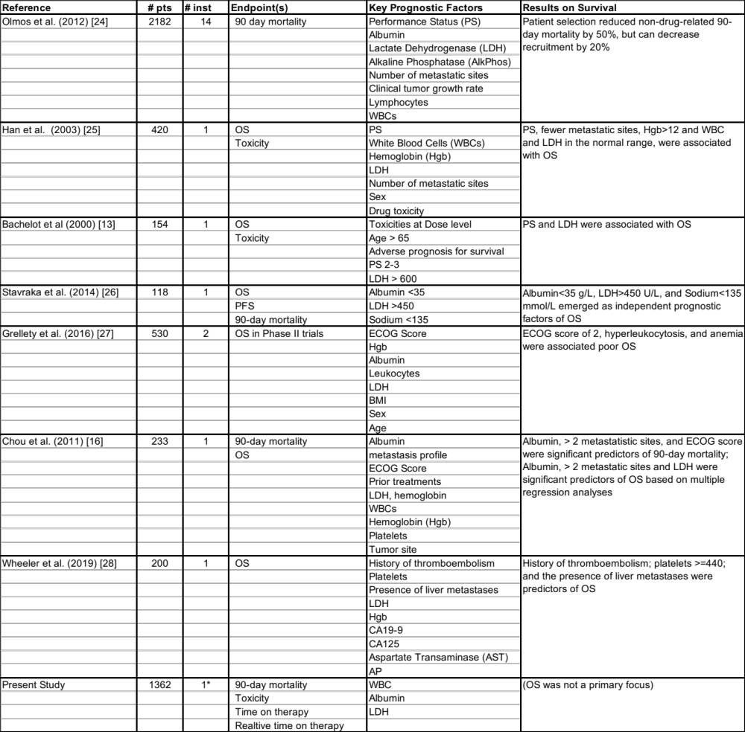

Key: * = 1 institution (US Oncology) but with 252 different trials run under its auspices; # pts = the number of participants studied; # inst = the number of institutions which had participant participants; OS = Overall survival; PFS = Progression Free Survival; LDH = Lactate Dehydrogenase; AP = Alkaline phosphatase; WBC = White blood cells; PS = Performance status; Hgb = Hemoglobin; GI = Gastrointenstinal tract; AST = Aspartate aminotransferase; CA = Carbohydrate antigen; ECOG = Eastern Cooperative Oncology Group. Note: Only key prognostic factors for each study are provided in the ‘Key Prognostic Factors’ column; in addition, all studies except Grellety et al (2016) focused on Phase I trials.

Supplementary Table 2. Demographic, clinical and trial variables obtained from the 1386 participants entering into phase 1 trial

Variables | P/O | Details | N
Age | P | Age (integer, years) at date of initiation of clinical phase I. | 1386
Agent Type | P | Type of agent (cytotoxic, non-cytotoxic, or not documented) | 1386
Albumin | P | Albumin value closest to initiation of clinical trial phase I | 1311
AST/ALT | P | Aspartate transaminase (AST) to alanine transaminase (ALT)  concentration ratio | 1308
Body Mass Index | P | Body mass index value closest to initiation of clinical trial phase I(BMI) | 1346
CA-19 | P | Amount CA 19-9 (cancer antigen 19-9) protein in the blood | 128
CA-125 | P | Amount CA 19-125 (cancer antigen 125) protein in the blood | 104
CA-27.29 | P | Amount CA 19-27.29 (cancer antigen 27.29) protein in the blood | 108
CA-15.3 | P | Amount CA 15.3 (cancer antigen 15.3) protein in the blood | 73
Death | O | Indication of death during the trial period | 1386
Disease Type | P | Disease type as recorded | 1386
Duration of Prior Tx | O | Duration of prior therapy time (in days) from prior therapy to date  of phase I trial (DOPT) | 998
Duration of Trial | O | Duration of clinical trial phase I time (in days) from start to end of the trial  or death (DOCT) | 1386
ECOG | P | ECOG performance status closest to initiation of clinical trial phase I. | 1386
Gender | P | Gender of the participant (male, female) | 1386
Grade 5 Toxicity | O | Indicates participants who died during trial (yes/no) | 1386
Height | P | Height (meters) of participant closest to initiation of clinical trial phase I | 1346
Hematocrit | P | Hematocrit value closest to clinical trial phase I | 1313
Hemoglobin | P | Hemoglobin value closest to initiation of clinical trial phase I | 1316
LDH | P | Lactate dehydrogenase value closest to initiation of clinical trial phase I | 1123
Liver Metastasis | P | Indication of whether there was evidence of tumor growth in the liver | 1386
Lymphocytes | P | Lymphocyte count value closest to initiation of clinical trial phase I | 1294
Ninety Day Mortality | O | Indicates participants who died within 90 days of phase 1 initiation | 1386
Platelets | P | Platelet count value closest to initiation of clinical trial phase I (PLT) | 1322
Sodium | P | Levels of Na in based on a standard serum chemistry panel | 1309
Stage at Diagnosis | P | Indication of the cancer stage (I, II, III, IV) at entry into the trial | 1386
Targeted Therapy | P | Is phase 1/1b agent type targeted therapy (Yes/No) | 1386
Trial Group | P | Generic numeric indicator of which phase 1 trial participant was on | 1386
Uric Acid | P | Uric acid value closest to initiation of clinical trial phase I | 841
WBCs | P | White blood cell count value closest to initiation of clinical trial  phase I | 1296
Weight | P | Weight in kilograms | 1361
Survival time | O | Overall survival time (in days) from initiation of phase 1 trial (OSCT) | 1386
TTNTCT | O | Time to next treatment from initiation of phase 1 trial (in days) (ttntct) | 1386
TTNTPT | O | Time to next treatment from initiation of therapy prior to phase 1 trial (if prior therapy in the network practice) in days (ttntpt) | 998
OSPT | O | Overall survival time (in days) from initiation of therapy prior to phase 1 trial (if prior therapy in the network practice) | 998
Carcinoembryonic antigen level | P | Carcinoembryonic antigen level value closest to initiation of clinical trial phase I (CEA) | 319
Neutrophil to lymphocyte ratio | P | Neutrophil to lymphocyte ratio closes to initiation of clinical trial phase I(NLR) | 1259
Alkaline phosphatase | P | Alkaline phosphatase value closest to initiation of clinical trial phase I (ALP) | 1281

Key: P/O = Predictor (Independent) vs. Outcome (Dependent) Variable; Tx= Treatment.

Supplementary Table 3. Descriptive Statistics for the Quantitative Variables.

Variable | N | Mean | Std Dev | Minimum | 1st Pctl | 10th Pctl | Lower Quartile | Median | Upper Quartile | 90th Pctl | 99th Pctl | Max
age | 1368 | 62.73 | 11.42 | 21 | 30 | 48 | 56 | 63 | 71 | 77 | 84 | 87
doct | 1368 | 131.53 | 192.54 | 1 | 1 | 16 | 29 | 64 | 146 | 302 | 955 | 1820
ttntct | 1368 | 242.52 | 338.67 | 1 | 7 | 35 | 64.5 | 125.5 | 257.5 | 563 | 1770 | 3289
osct | 1368 | 418.88 | 519.95 | 1 | 7 | 42 | 103 | 230.5 | 527 | 1051 | 2623 | 3402
dopt | 980 | 151.55 | 150.61 | 1 | 1 | 34.5 | 62.5 | 107.5 | 187 | 315 | 800 | 1303
ttntpt | 980 | 277.66 | 287.69 | 29 | 31 | 71 | 107 | 186.5 | 325.5 | 595 | 1513 | 2838
ospt | 980 | 659.35 | 602.73 | 43 | 85 | 173 | 261 | 446 | 833.5 | 1386.5 | 2951 | 4537
bmi | 1328 | 26.83 | 5.53 | 15.37 | 17.07 | 20.36 | 22.78 | 26.08 | 30.11 | 34.17 | 42.78 | 48.45
ca_125 | 86 | 539.95 | 1046.69 | 4.21 | 4.21 | 11.4 | 25.1 | 106.5 | 407.9 | 1609.7 | 4324 | 4324
ca_15_3 | 55 | 267.05 | 452.97 | 12 | 12 | 19 | 33.5 | 83.2 | 248 | 916 | 2170 | 2170
ca_19_9 | 110 | 2477.21 | 3564.09 | 2 | 3 | 8.35 | 61 | 537.3 | 4065.4 | 7776.5 | 14095 | 14332.5
ca_27_29 | 90 | 252.75 | 460.31 | 8.6 | 8.6 | 17 | 29.4 | 68 | 251.08 | 603.62 | 2530 | 2530
cea | 301 | 169.95 | 454.84 | 0.5 | 0.5 | 1.6 | 3.45 | 17 | 91.3 | 358.7 | 2589 | 2952.5
height | 1328 | 1.7 | 0.09 | 1.5 | 1.52 | 1.57 | 1.63 | 1.69 | 1.77 | 1.83 | 1.91 | 1.93
weight | 1343 | 77.32 | 17.84 | 42.46 | 44.59 | 55.52 | 63.78 | 75.93 | 88.9 | 101.6 | 124.74 | 129.5
hematocrit | 1295 | 36.56 | 4.82 | 21.02 | 25.68 | 30.28 | 33.13 | 36.62 | 39.75 | 42.81 | 47.65 | 50.63
hgb | 1298 | 12.1 | 1.71 | 7.4 | 8.3 | 9.8 | 10.9 | 12.1 | 13.3 | 14.4 | 16 | 16.4
ldh | 1105 | 237.28 | 135.31 | 93 | 107 | 138 | 158 | 192 | 261 | 389 | 822 | 932
lymphocyte | 1276 | 1.27 | 0.96 | 0.2 | 0.3 | 0.57 | 0.8 | 1.1 | 1.5 | 2.06 | 4.4 | 13.92
plt | 1304 | 257.38 | 101.84 | 34 | 60 | 141 | 185 | 244 | 312.5 | 391 | 545 | 598
sodium | 1291 | 137.84 | 7.14 | 29 | 104.5 | 133 | 136 | 139 | 141 | 142 | 145 | 151.5
uric_acid | 823 | 5.13 | 1.49 | 2.2 | 2.5 | 3.3 | 4.1 | 5 | 6.1 | 7.1 | 9.2 | 9.7
wbc | 1278 | 7.3 | 3.27 | 1.5 | 2.41 | 4 | 5.1 | 6.6 | 8.65 | 11.2 | 19 | 25.1
neutrophil | 1263 | 5.08 | 2.67 | 0.8 | 1.2 | 2.43 | 3.3 | 4.5 | 6.2 | 8.3 | 15.3 | 17.4
nlr | 1241 | 5.5 | 5.39 | 0.16 | 0.63 | 1.76 | 2.67 | 3.95 | 6.66 | 10.33 | 24 | 86.5
alp | 1263 | 122 | 78.77 | 36 | 39 | 58 | 73 | 98 | 138 | 223 | 427 | 475
alt | 1290 | 27.51 | 17.42 | 6 | 6 | 11 | 15 | 23 | 34 | 48 | 93 | 125
ast | 1293 | 29.75 | 18.24 | 10 | 10 | 15 | 18 | 24 | 34 | 52 | 107 | 116

Supplementary Table 4. Frequency of Cancers Among Those Participating in Phase I Trials in Our Data Set.

Cancer | Frequency | Percent | Cumulative Total | Cumulative Frequency
NSCLC | 227 | 16.59 | 227 | 16.59
Breast Cancer | 170 | 12.43 | 397 | 29.02
Pancreatic Cancer | 131 | 9.58 | 528 | 38.6
Colon Cancer | 126 | 9.21 | 654 | 47.81
Non-Hodgkin's lymphoma | 87 | 6.36 | 741 | 54.17
SCLC | 56 | 4.09 | 797 | 58.26
Head & Neck Cancer | 53 | 3.87 | 850 | 62.13
Ovarian Cancer | 48 | 3.51 | 898 | 65.64
Rectal Cancer | 46 | 3.36 | 944 | 69.01
Colorectal Cancer | 36 | 2.63 | 980 | 71.64
Endometrial Cancer | 31 | 2.27 | 1011 | 73.9
Prostate Cancer | 31 | 2.27 | 1042 | 76.17
Multiple myeloma | 29 | 2.12 | 1071 | 78.29
Renal cell carcinoma | 28 | 2.05 | 1099 | 80.34
Liver Cancer | 27 | 1.97 | 1126 | 82.31
Melanoma | 23 | 1.68 | 1149 | 83.99
CLL | 20 | 1.46 | 1169 | 85.45
Brain Cancer | 19 | 1.39 | 1188 | 86.84
Esophageal Cancer | 16 | 1.17 | 1204 | 88.01
Myelodysplastic syndrome | 14 | 1.02 | 1218 | 89.04
Sarcoma | 14 | 1.02 | 1232 | 90.06
Other | 13 | 0.95 | 1245 | 91.01
Neuroendocrine carcinoma | 12 | 0.88 | 1257 | 91.89
Stomach Cancer | 12 | 0.88 | 1269 | 92.76
Hodgkins lymphoma | 9 | 0.66 | 1278 | 93.42
Mesothelioma | 9 | 0.66 | 1287 | 94.08
Bile Duct Cancer | 8 | 0.58 | 1295 | 94.66
Cervical Cancer | 6 | 0.44 | 1301 | 95.1
Acute myeloid leukemia | 5 | 0.37 | 1306 | 95.47
Adrenocortical cancer | 5 | 0.37 | 1311 | 95.83
Immune thrombocytopenia | 5 | 0.37 | 1316 | 96.2
Uterine Cancer | 5 | 0.37 | 1321 | 96.56
Anal Cancer | 4 | 0.29 | 1325 | 96.86
Gallbladder Cancer | 4 | 0.29 | 1329 | 97.15
Leiomyosarcoma | 4 | 0.29 | 1333 | 97.44
Thyroid Cancer | 4 | 0.29 | 1337 | 97.73
Carcinoid tumor | 3 | 0.22 | 1340 | 97.95
Skin Cancer | 3 | 0.22 | 1343 | 98.17
AML | 2 | 0.15 | 1345 | 98.32
CIA | 2 | 0.15 | 1347 | 98.46
Carcinoma of the ampulla of Vater | 2 | 0.15 | 1349 | 98.61
Chondrosarcoma | 2 | 0.15 | 1351 | 98.76
Renal pelvis carcinoma | 2 | 0.15 | 1353 | 98.9
Squamous cell carcinoma | 2 | 0.15 | 1355 | 99.05
Thrombocytopenia | 2 | 0.15 | 1357 | 99.2
Vulvar Cancer | 2 | 0.15 | 1359 | 99.34
Waldenstrom's macroglobulinemia | 2 | 0.15 | 1361 | 99.49
Appendix Cancer | 1 | 0.07 | 1362 | 99.56
Fibrosarcoma | 1 | 0.07 | 1363 | 99.63
Gastrointestinal stromal tumor | 1 | 0.07 | 1364 | 99.71
Gestational trophoblastic tumor | 1 | 0.07 | 1365 | 99.78
Small intestine cancer | 1 | 0.07 | 1366 | 99.85
Thymoma | 1 | 0.07 | 1367 | 99.93
Transitional cell carcinoma of the ureter | 1 | 0.07 | 1368 | 100

Supplementary Table 5: Trial indices that were significant predictors (p<0.05) of response across the 252 Phase I trials based on stepwise regression for the continuous outcomes.

Time on therapy ratio |  |  |  | Time on Study
Trial No | Coef | Std | p-value | Trial No | Coef | Std | p-value
24 | 12.917 | 3.474 | 0.0002 | 0 | -51.614 | 22.271 | 0.021
 |  |  |  | 1 | 183.217 | 22.271 | 4.48E-16
 |  |  |  | 2 | -53.029 | 23.548 | 0.024
 |  |  |  | 3 | 165.706 | 25.319 | 8.43E-11
 |  |  |  | 4 | 83.581 | 26.258 | 0.001
 |  |  |  | 9 | -72.179 | 36.655 | 0.049
 |  |  |  | 10 | 83.114 | 37.392 | 0.026
 |  |  |  | 17 | 146.968 | 45.602 | 0.001
 |  |  |  | 21 | -103.450 | 50.510 | 0.041
 |  |  |  | 29 | -105.919 | 57.498 | 0.066
 |  |  |  | 41 | 168.905 | 64.216 | 0.009
 |  |  |  | 55 | 207.447 | 74.071 | 0.005

Supplementary Table 6a. Estimated regression coefficients from the multiple linear and stepwise multiple linear regression analyses for the two continuous outcome variables, as well as survival analysis for time on study.

 | Regression analyses |  |  |  |  |  |  |  | Survival Analyses
Dependent Variable | Time on study |  |  |  | Time on therapy ratio |  |  |  | Time on study
Independent Variable | Coeff | SE | p-val | step | Coeff | SE | p-val | step | Coeff | SE | p-val | step
Age | 0.0004 | 0.03 | 0.99 | No | -0.002 | 0.03 | 0.94 | No | 0.02 | 0.03 | 0.50 | No
Weight | 0.20 | 0.29 | 0.49 | No | 0.13 | 0.28 | 0.63 | No | -0.59 | 0.36 | 0.10 | No
Height | -0.09 | 0.14 | 0.54 | No | -0.15 | 0.14 | 0.30 | No | 0.27 | 0.18 | 0.13 | No
Gender | 0.02 | 0.09 | 0.84 | No | -0.11 | 0.09 | 0.20 | No | -0.18 | 0.11 | 0.11 | No
DOPT | 0.01 | 0.03 | 0.78 | No | 0.22 | 0.03 | 0.00 | Yes | -0.16 | 0.04 | 0.00 | No
Hemoglobin | 0.17 | 0.11 | 0.11 | Yes | -0.01 | 0.11 | 0.94 | No | -0.61 | 0.14 | 0.00 | No
Hematocrit | -0.09 | 0.10 | 0.41 | No | -0.01 | 0.10 | 0.89 | No | 0.46 | 0.14 | 0.00 | No
WBC | -0.08 | 0.03 | 0.02 | No | 0.12 | 0.03 | 0.00 | Yes | 0.15 | 0.04 | 0.00 | No
Lymphocytes | 0.08 | 0.03 | 0.00 | Yes | -0.02 | 0.03 | 0.55 | No | -0.22 | 0.05 | 0.00 | No
Platelets | 0.00 | 0.03 | 0.91 | No | -0.06 | 0.03 | 0.04 | No | -0.02 | 0.04 | 0.55 | No
LDH | -0.07 | 0.03 | 0.02 | No | -0.03 | 0.03 | 0.32 | No | 0.18 | 0.03 | 0.00 | No
Albumin | 0.07 | 0.03 | 0.02 | Yes | -0.08 | 0.03 | 0.01 | No | -0.23 | 0.04 | 0.00 | Yes
Uric Acid | -0.04 | 0.03 | 0.12 | No | 0.08 | 0.03 | 0.00 | Yes | -0.03 | 0.04 | 0.43 | No
BMI | -0.15 | 0.25 | 0.54 | No | -0.15 | 0.25 | 0.53 | No | 0.46 | 0.32 | 0.14 | No
Cyto vs. Non-Cyto | 0.07 | 0.09 | 0.43 | No | 0.09 | 0.09 | 0.33 | No | -0.20 | 0.11 | 0.09 | No
Targeted therapy | -0.01 | 0.09 | 0.93 | No | -0.10 | 0.09 | 0.27 | No | 0.09 | 0.11 | 0.41 | No
Cancer: SCLC | -0.20 | 0.15 | 0.18 | No | -0.08 | 0.15 | 0.60 | No | 0.88 | 0.18 | 0.00 | No
Cancer: Renal cell | 0.39 | 0.20 | 0.05 | Yes | -0.23 | 0.20 | 0.23 | No | -0.29 | 0.32 | 0.35 | No
Cancer: Rectal cancer | -0.35 | 0.16 | 0.03 | Yes | -0.10 | 0.16 | 0.53 | No | 0.82 | 0.19 | 0.00 | No
Cancer: Prostate cancer | 0.02 | 0.19 | 0.90 | No | -0.18 | 0.19 | 0.35 | No | 0.11 | 0.22 | 0.61 | No
Cancer: Pancreatic cancer | -0.22 | 0.11 | 0.05 | No | -0.09 | 0.11 | 0.40 | No | 0.90 | 0.15 | 0.00 | No
Cancer: Ovarian cancer | -0.19 | 0.16 | 0.23 | No | -0.07 | 0.16 | 0.64 | No | 0.10 | 0.21 | 0.63 | No
Cancer: Non-Hodgkin's | -0.06 | 0.12 | 0.64 | No | 0.09 | 0.12 | 0.47 | No | -0.56 | 0.19 | 0.00 | No
Cancer: NSCLC | -0.06 | 0.09 | 0.50 | No | 0.04 | 0.09 | 0.67 | No | 0.35 | 0.12 | 0.01 | No
Cancer: Multiple myeloma | -0.09 | 0.20 | 0.65 | No | -0.12 | 0.20 | 0.54 | No | -0.68 | 0.31 | 0.03 | No
Cancer: Liver Cancer | -0.35 | 0.20 | 0.09 | No | -0.15 | 0.20 | 0.47 | No | 1.03 | 0.24 | 0.00 | No
Cancer: Head/Neck | 0.07 | 0.15 | 0.64 | No | -0.09 | 0.15 | 0.56 | No | 0.38 | 0.18 | 0.03 | No
Cancer: Endometrial | 0.34 | 0.19 | 0.08 | Yes | -0.02 | 0.19 | 0.90 | No | -0.28 | 0.29 | 0.34 | No
Cancer: Colon Cancer | -0.35 | 0.11 | 0.00 | Yes | -0.12 | 0.11 | 0.26 | No | 0.65 | 0.14 | 0.00 | No
Cancer: Breast Cancer | 0.02 | 0.11 | 0.82 | No | -0.02 | 0.11 | 0.85 | No | 0.18 | 0.14 | 0.18 | No
Cancer: Bladder Cancer | 0.02 | 0.18 | 0.92 | No | 0.22 | 0.18 | 0.22 | No | 0.39 | 0.23 | 0.09 | No
\
Key: Coeff = estimated regression coefficient; SE = standard error of the regression coefficient; p-val = p-value for the regression coefficient; step = whether the independent variable was retained the stepwise regression analyses. Note that ‘Trial’ is an index assigned to each trial whose association reflects variation in the outcome attributed to variation in efficacy of the tested drugs across the trials. ‘Cyto vs. Non-Cyto’ reflects the use of cytotix agent or not in the trials.

Supplementary Table 6b. Estimated regression coefficients from the multiple logistic and stepwise multiple logistics regression analyses for the two dichotomous outcome variables.

Dependent variable | 90-day mortality |  |  |  | Grade 5 toxicity
Independent variable | Coeff | SE | p-val | Step | Coeff | SE | p-val | Step
Age | -0.09 | 0.09 | 0.31 | No | -0.03 | 0.13 | 0.82 | No
Weight | -2.07 | 0.94 | 0.03 | No | -2.45 | 1.56 | 0.12 | No
Height | 1.01 | 0.46 | 0.03 | No | 1.22 | 0.74 | 0.10 | No
Gender | -0.08 | 0.27 | 0.78 | No | -0.13 | 0.43 | 0.76 | No
DOPT | -0.34 | 0.13 | 0.01 | Yes | -0.14 | 0.17 | 0.41 | No
Hemoglobin | -0.79 | 0.33 | 0.02 | Yes | -0.80 | 0.53 | 0.13 | Yes
Hematocrit | 0.47 | 0.33 | 0.15 | No | 0.41 | 0.52 | 0.43 | No
WBC | 0.48 | 0.09 | 0.00 | Yes | 0.28 | 0.12 | 0.03 | Yes
Lymphocyte | -0.29 | 0.12 | 0.02 | Yes | -0.06 | 0.13 | 0.63 | No
Platelets | -0.08 | 0.09 | 0.34 | No | -0.01 | 0.13 | 0.97 | No
LDH | 0.29 | 0.08 | 0.00 | Yes | 0.19 | 0.11 | 0.08 | Yes
Albumin | -0.39 | 0.09 | 0.00 | Yes | -0.19 | 0.14 | 0.18 | Yes
Uric Acid | 0.13 | 0.09 | 0.15 | Yes | 0.11 | 0.15 | 0.45 | No
BMI | 1.60 | 0.82 | 0.05 | Yes | 1.87 | 1.37 | 0.17 | Yes
Cyto vs. Non-Cyto | 0.03 | 0.29 | 0.92 | No | 0.33 | 0.50 | 0.50 | No
Targeted therapy | -0.24 | 0.28 | 0.38 | No | 0.10 | 0.46 | 0.83 | No
Cancer: SCLC | -0.16 | 0.46 | 0.72 | No | -16.78 | 1390.09 | 0.99 | Yes
Cancer: Renal cell | -14.43 | 412.15 | 0.97 | Yes | -16.79 | 1934.92 | 0.99 | Yes
Cancer: Rectal | 0.06 | 0.46 | 0.90 | No | -0.61 | 0.79 | 0.44 | No
Cancer: Prostate | -0.63 | 0.79 | 0.42 | No | -16.84 | 1872.51 | 0.99 | Yes
Cancer: Pancreatic | 0.26 | 0.32 | 0.43 | No | 0.03 | 0.45 | 0.95 | No
Cancer: Ovarian | 0.13 | 0.48 | 0.78 | No | -0.29 | 0.72 | 0.69 | No
Cancer: Non-Hodgkin's lymph | -0.69 | 0.48 | 0.15 | Yes | -0.75 | 0.68 | 0.27 | No
Cancer: NSCLC | 0.08 | 0.29 | 0.77 | No | -0.51 | 0.43 | 0.23 | No
Cancer: Multiple myeloma | -1.19 | 1.07 | 0.26 | Yes | -0.69 | 1.09 | 0.53 | No
Cancer:_Liver | 0.78 | 0.54 | 0.15 | Yes | 1.18 | 0.63 | 0.06 | Yes
Cancer: Head/Neck | 0.47 | 0.42 | 0.26 | Yes | -1.59 | 1.06 | 0.13 | Yes
Cancer: Endometrial | -0.48 | 0.67 | 0.47 | No | -17.19 | 1810.55 | 0.99 | Yes
Cancer: Colon | -0.36 | 0.35 | 0.31 | No | -0.74 | 0.53 | 0.16 | No
Cancer: Breast | -0.39 | 0.37 | 0.29 | Yes | -1.11 | 0.67 | 0.10 | Yes
Cancer: Bladder | 0.41 | 0.51 | 0.42 | No | -0.41 | 0.81 | 0.61 | No

Key: See Supplementary Table 6a.

Supplementary Table 7a. Performance of Different Models in Predicting the 2 Quantitative Outcomes

 | Time on study |  |  |  | Prolong time on therapy Ratio
 | MSE | MaxErr | MAE | Med_abserr | MSE | MaxErr | MAE | Med_abserr
LR | 0.771 | 6.109 | 0.570 | 0.422 | 202.323 | 226.419 | 3.955 | 1.970
Elastic_Net | 0.804 | 6.408 | 0.579 | 0.462 | 202.936 | 227.283 | 3.772 | 1.689
SVR | 0.894 | 6.707 | 0.507 | 0.236 | 204.174 | 228.584 | 3.159 | 0.964
DT | 2.283 | 9.397 | 0.838 | 0.350 | 254.451 | 224.141 | 4.956 | 1.598
KNN | 0.963 | 6.351 | 0.646 | 0.436 | 202.623 | 220.023 | 3.905 | 1.566
AdaBoost | 1.402 | 6.065 | 0.969 | 0.858 | 211.190 | 220.240 | 5.317 | 3.659
Bagging | 1.061 | 4.012 | 0.696 | 0.432 | 222.531 | 228.206 | 4.175 | 1.629
ExtraTree | 0.962 | 4.187 | 0.647 | 0.402 | 215.438 | 227.349 | 4.081 | 1.470
RF | 1.139 | 4.142 | 0.712 | 0.417 | 211.899 | 226.641 | 4.065 | 1.573
SL | 0.805 | 5.727 | 0.587 | 0.412 | 201.8989 | 227.935 | 3.891 | 1.955

Key: MSE = Mean Squared Error; MaxErr = maximum residual error; MAE = Mean absolute error; Med_abserr = Median absolute error.

Supplementary Table 7b. Performance of Different Models in Predicting the 2 Categorical Outcomes

Outcome | Grade 5 Toxicity |  | 90-Day Mortality
Method | Accuracy | AUC | Accuracy | AUC
LR | 0.84 | 0.84 | 0.80 | 0.80
DTC | 0.90 | 0.90 | 0.81 | 0.81
SVC | 0.94 | 0.94 | 0.86 | 0.86
GNB | 0.74 | 0.75 | 0.69 | 0.70
KNN | 0.84 | 0.85 | 0.80 | 0.80
ABC | 0.97 | 0.97 | 0.92 | 0.92
Bagging | 0.93 | 0.93 | 0.86 | 0.86
ExtraTree | 0.89 | 0.89 | 0.83 | 0.83
RF | 0.97 | 0.97 | 0.88 | 0.87
QDA | 0.78 | 0.78 | 0.76 | 0.76
SL | 0.99 | 0.99 | 0.95 | 0.95

Key: For the Methods: LR=Logistic Regression; DT=Decision Tree; SVC=Support Vector Machine; GNB=Gaussian Naive bayes ; KNN=k-Nearest Neighbour; ABC=Adaptive boosting classifier; Bagging=Bagging classifier; ExtraTree=Extra trees classifier; RF= Random Forest; QDA=Quadratic Discriminant Algorithm; SL=Super Learner.

Supplementary Table 8. Performance Metric Scores for Grade 5 Toxicity for Each Analytical Method.

ML algorithm | Accuracy | f_1 | Recall | Precision | AUC | Cohen Kappa Score
LR | 0.84 | 0.84 | 0.83 | 0.84 | 0.84 | 0.68
DT | 0.90 | 0.90 | 0.92 | 0.87 | 0.90 | 0.80
SVC | 0.94 | 0.94 | 0.88 | 1.00 | 0.94 | 0.88
GNB | 0.74 | 0.78 | 0.94 | 0.66 | 0.75 | 0.48
KNN | 0.84 | 0.86 | 1.00 | 0.75 | 0.85 | 0.69
ABC | 0.97 | 0.97 | 0.98 | 0.96 | 0.97 | 0.94
Bagging | 0.93 | 0.93 | 0.93 | 0.92 | 0.93 | 0.86
ExtraTree | 0.89 | 0.89 | 0.92 | 0.86 | 0.89 | 0.78
RF | 0.97 | 0.97 | 0.97 | 0.96 | 0.97 | 0.94
QDA | 0.78 | 0.80 | 0.92 | 0.71 | 0.78 | 0.56
SL | 0.99 | 0.99 | 0.99 | 0.99 | 0.99 | 0.98

Supplementary Table 9. Performance Metric Scores for 90-Day Mortality for Each Analytical Method.

ML algorithm | Accuracy | f_1 | Recall | Precision | AUC | Cohen Kappa score
LR | 0.80 | 0.79 | 0.76 | 0.83 | 0.80 | 0.61
DT | 0.81 | 0.80 | 0.79 | 0.81 | 0.81 | 0.61
SVC | 0.86 | 0.84 | 0.73 | 0.99 | 0.86 | 0.72
GNB | 0.69 | 0.73 | 0.84 | 0.65 | 0.70 | 0.39
KNN | 0.80 | 0.83 | 0.98 | 0.72 | 0.80 | 0.61
ABC | 0.92 | 0.92 | 0.92 | 0.92 | 0.92 | 0.85
Bagging | 0.86 | 0.85 | 0.83 | 0.88 | 0.86 | 0.72
ExtraTree | 0.83 | 0.83 | 0.83 | 0.82 | 0.83 | 0.66
RF | 0.88 | 0.87 | 0.83 | 0.91 | 0.87 | 0.75
QDA | 0.76 | 0.78 | 0.83 | 0.73 | 0.76 | 0.53
SL | 0.95 | 0.94 | 0.91 | 0.98 | 0.95 | 0.89

Supplementary Table 10. Accuracy metrics for different AI/ML prediction models on the test sets (i.e., see Methods and the split data strategy) using the original data set and the data set after imputation for the 90-day mortality outcome.
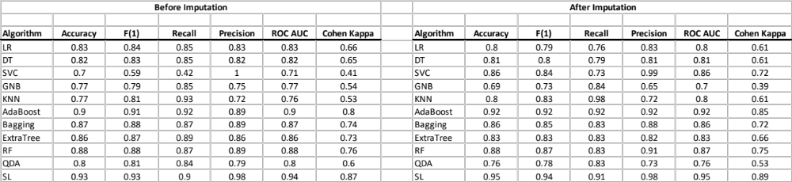

Supplementary Table 11. Example Predictions Using the Logistic Regression-Based with Outcome Frequency Imbalance Correction.
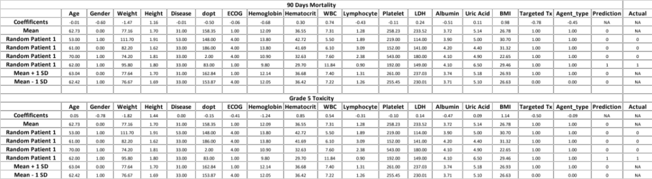
Key: The coefficients used for the prediction modeling are provided in the row labeled ‘Coefficient’. Mean, Minimum, Maximum, Sample 2 and Sample 3 reflect example values of the predictors from the data used to make predictions (mean=mean of each predictor variable; minimum=minimum value of all each predictor; maximum=maximum value of all each predictor; Sample 2 and Sample 3=predictor values from randomly chosen individuals from the trials). The ‘prediction’ column provides the predictions (0=no, 1=yes) and the ‘actual’ column shows the actual outcomes for the scenarios involving participant data.
Figure 1. Correlations Among the Predictor Variables. Pearson correlations are below the diagonal and Spearman non-parametric rank correlations are above the diagonal.

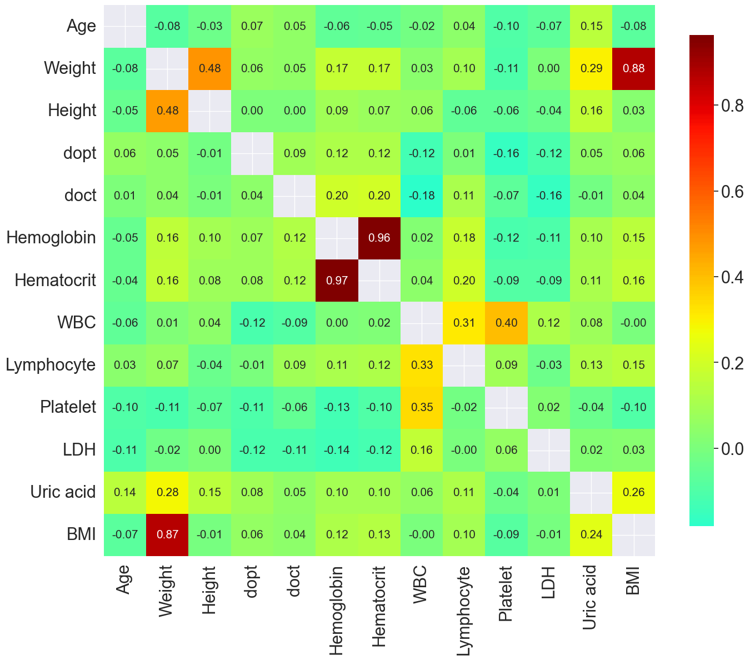

Figure 2. Example ROC Curves for Predicting Outcome Variables: Left panel = Grade 5 toxicity; Right panel = Overall grade 5 toxicity.

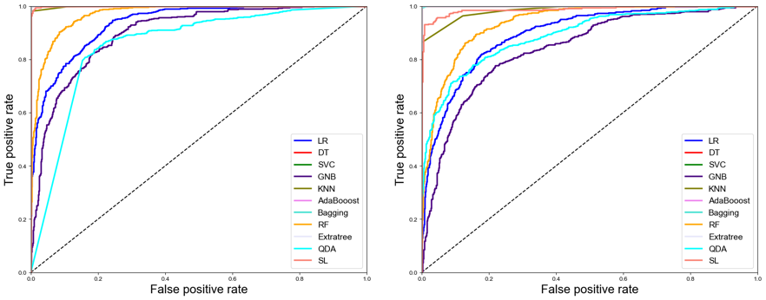

Figure 3. Left panel: Random effects plot of the y-intercept terms in a univariate random effects logistic regression model exploring the relationship between lymphocyte levels and 90-day mortality outcome across the Phase I trials; Right panel: Random effects plot of the slope terms in a separately fit univariate random effects logistic regression model

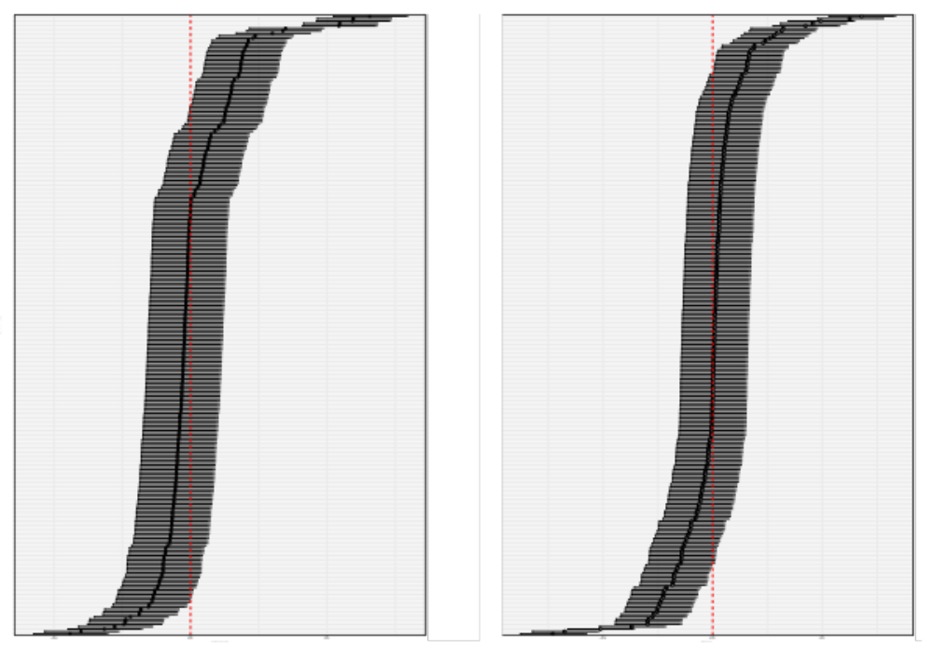

Key: Each horizontal bar reflects a different trial and its 95% confidence interval relative to a 0.0 value depicted by the red horizontal line. Trails are ordered by their confidence interval difference from 0.0 with some trials having negative y- lymphocyte/90 day mortality relationships (bottom part of the figure) and some positive (top part of the figure) for the y-intercept (left panel) or slope (right panel). Note: since many trials only had 1 or a few participants in the analysis, their effects confidence limits encompass the 0.0 value.
Supplementary Figure 1. Relative Importance of Each Independent Variable for Predicting 90-Day Mortality (Upper Panel) and Grade 5 Toxicity (Lower Panel) Based on Random Forest Analysis.

Supplementary Figure 2. Density plots of the imputed (red) and non-imputed (blue) values from the MICE analyses (see Methods).

