Supplementary Material

Supplementary Figures and Tables

Supplementary Figures
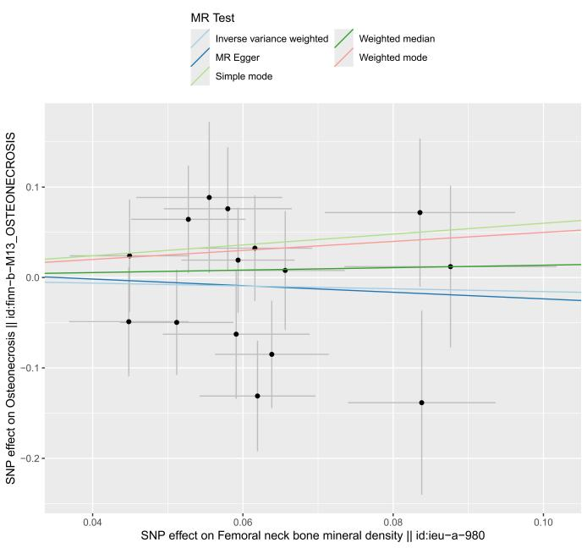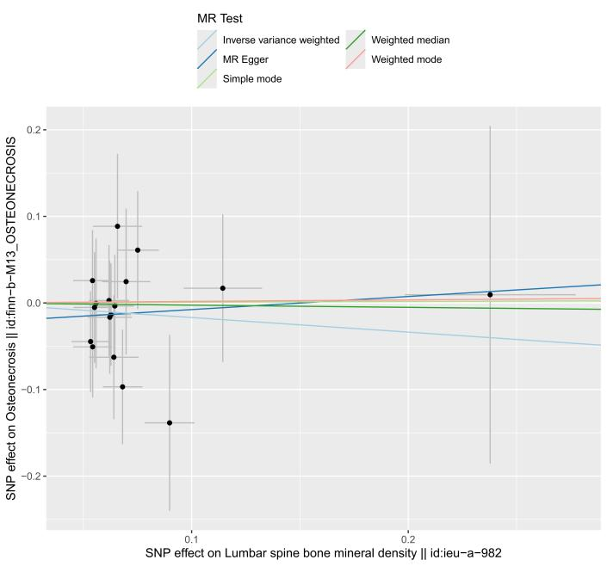
A B

Figure S1 The scatter plot of forward Mendelian randomization analysis:A. The scatter plot of the impact of femoral neck bone mineral density on osteonecrosis. B. The scatter plot of the impact of lumbar spine bone mineral density on osteonecrosis.
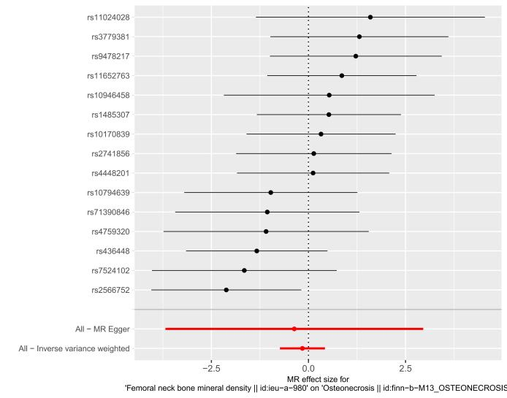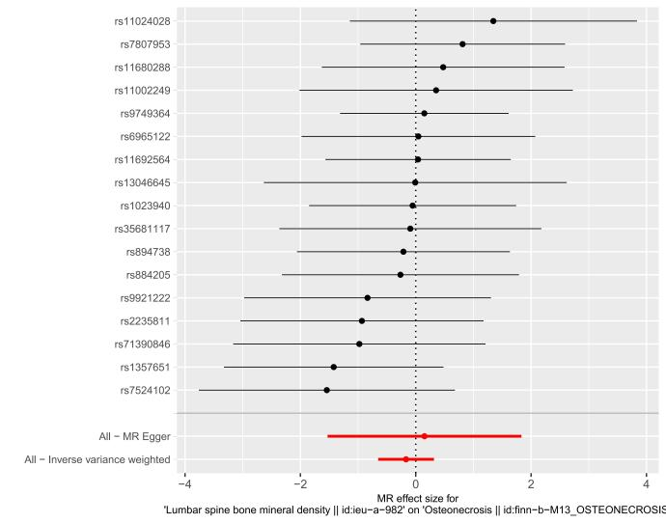
A B

Figure S2 The forest plot of forward Mendelian randomization analysis:A. The forest plot of the impact of femoral neck bone mineral density on osteonecrosis. B. The forest plot of the impact of lumbar spine bone mineral density on osteonecrosis.
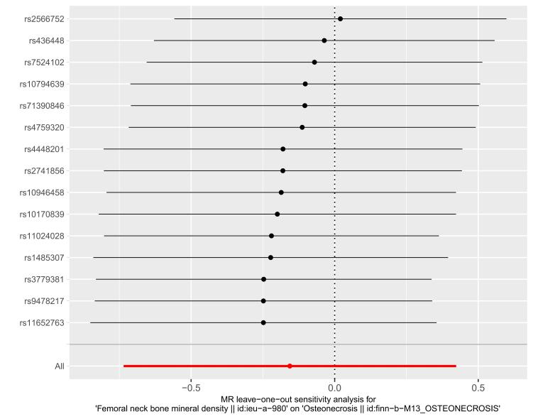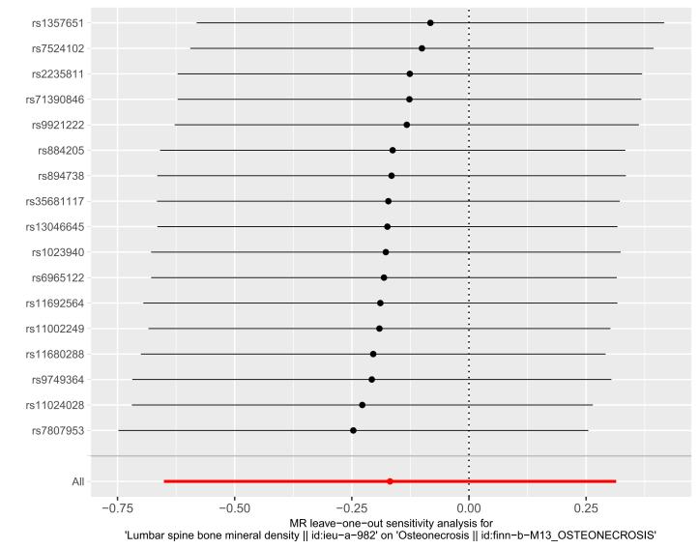
A B

Figure S3 The leave-one-out plot of forward Mendelian randomization analysis:A. The leave-one-out plot of the impact of femoral neck bone mineral density on osteonecrosis. B. The leave-one-out plot of the impact of lumbar spine bone mineral density on osteonecrosis.
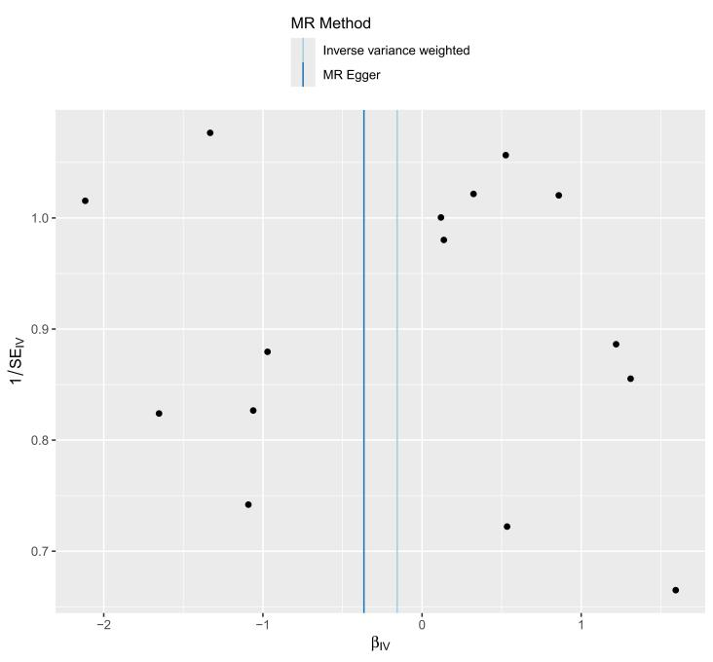 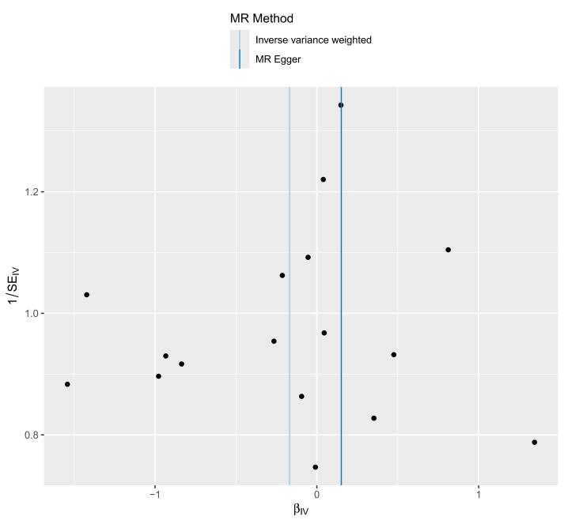 A B

Figure S4 The funnel plot of forward Mendelian randomization analysis:A. The funnel plot of the impact of femoral neck bone mineral density on osteonecrosis. B. The funnel plot of the impact of lumbar spine bone mineral density on osteonecrosis.
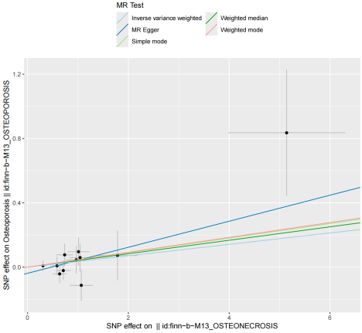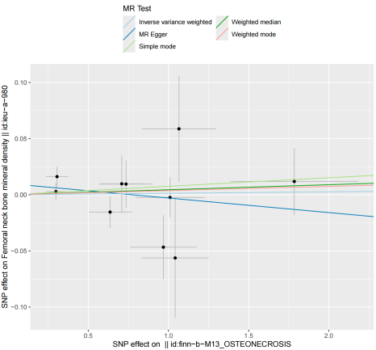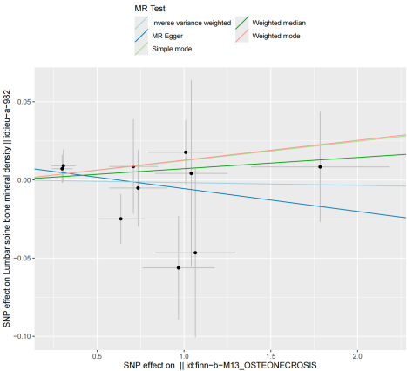
A B C

Figure S5 The scatter plot of reverse Mendelian randomization analysis:A. The scatter plot of the impact of osteonecrosis on osteoporosis. B. The scatter plot of the impact of osteonecrosis on femoral neck bone mineral density. C. The scatter plot of the impact of osteonecrosis on lumbar spine bone mineral density.
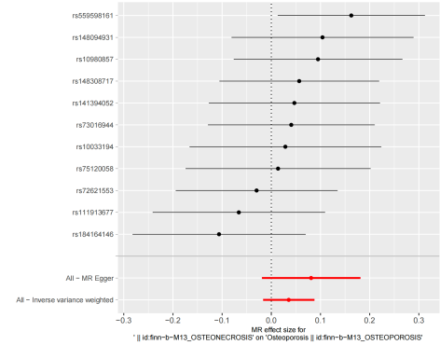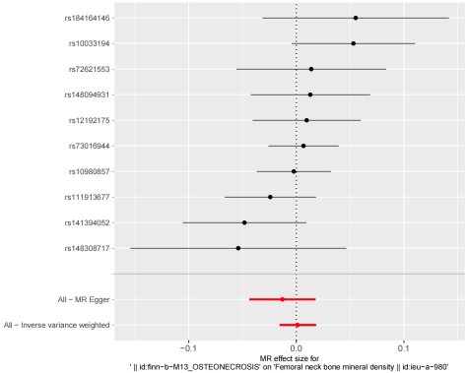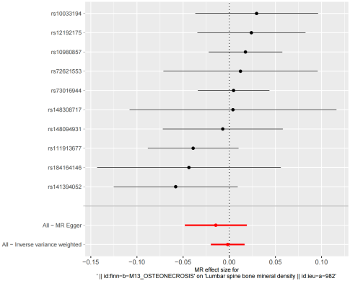
A B C

Figure S6 The forest plot of reverse Mendelian randomization analysis:A. The forest plot of the impact of osteonecrosis on osteoporosis. B. The forest plot of the impact of osteonecrosis on femoral neck bone mineral density. C. The forest plot of the impact of osteonecrosis on lumbar spine bone mineral density.

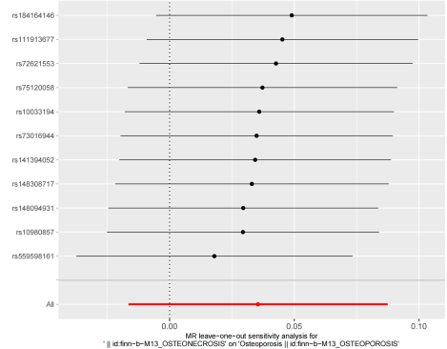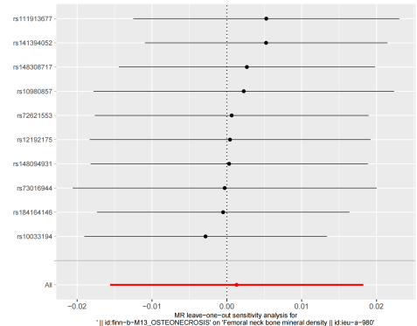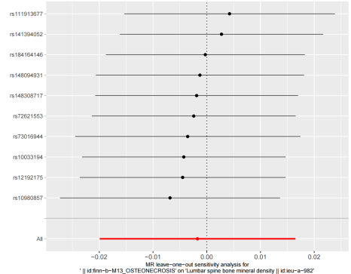
A B C

Figure S7 The leave-one-out plot of reverse Mendelian randomization analysis:A. The leave-one-out plot of the impact of osteonecrosis on osteoporosis. B. The leave-one-out plot of the impact of osteonecrosis on femoral neck bone mineral density. C. The leave-one-out plot of the impact of osteonecrosis on lumbar spine bone mineral density.
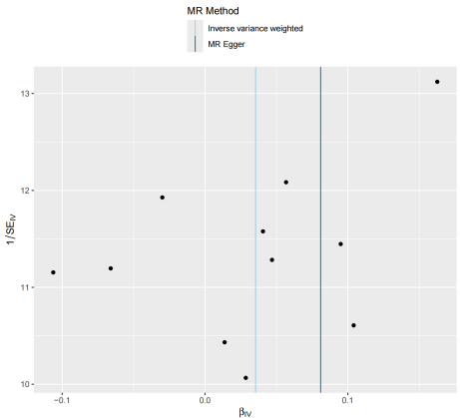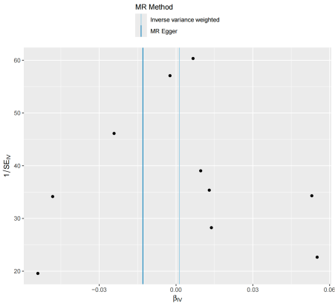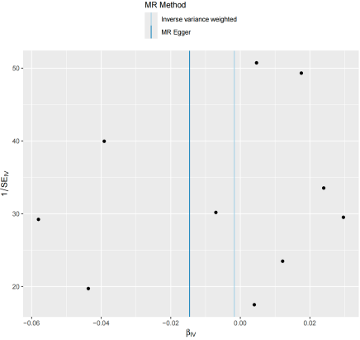
A B C

Figure S8 The funnel plot of reverse Mendelian randomization analysis:A. The funnel plot of the impact of osteonecrosis on osteoporosis. B. The funnel of the impact of osteonecrosis on femoral neck bone mineral density. C. The funnel of the impact of osteonecrosis on lumbar spine bone mineral density.

Supplementary Tables

Table S1 Heterogeneity for Reverse Mendelian Randomization Analysis
Exposure | Outcome | IVW |  | MR Egger
Exposure | Outcome | Cochran’s Q | Q-P value | Cochran’s Q | Q-P value
ON | OP | 8.318 | 0.598 | 7.224 | 0.614
ON |  | 10.601 | 0.304 | 9.237 | 0.322
  FN BMD
ON |  | 8.378 | 0.497 | 7.572 | 0.476
  LS BMD
Abbreviation: OP,Osteoporosis;ON,Osteonecrosis;FN BMD,Femoral neck bone mineral density; LS BMD,Lumbar spine bone mineral density.

Table S2 Pleiotropy for Reverse Mendelian Randomization Analysis
Exposure | Outcome | MR-PRESSO Global test-p | MR Egger—intercept | intercept  -P value
ON | OP | 0.622 | -0.038 | 0.323
ON |  | 0.337 | 0.010 | 0.309
  FN BMD
ON |  | 0.519 | 0.009 | 0.396
  LS BMD
Abbreviation: OP,Osteoporosis;ON,Osteonecrosis;FN BMD,Femoral neck bone mineral density; LS BMD,Lumbar spine bone mineral density.

