Supplemental files:

Table S1. Main variables Involved
Level | Variable Name | Variable Type | Measurement/Generation Method
Provincial Level | Annual Income Level of Residents | Categorical (≥60,000 Yuan; 40,000-59,999 Yuan; <40,000 Yuan) | Obtained from the 2022 National Bureau of Statistics database
Provincial Level | Number of General Practitioners per 10,000 Residents | Continuous | China Social Statistics Yearbook 2023
Individual Level | Gender | Categorical (Female/Male) | Observed by investigator
Individual Level | Age | Categorical (18-34 years; 35-64 years; ≥65 years) | Survey
Individual Level | Ethnicity | Categorical (Han/Minority) | Survey
Individual Level | Household Registration (Hukou) | Categorical (Urban/Rural) | Survey
Individual Level | Education | Categorical (Elementary school or less, Middle school, High school, College or above) | Survey
Individual Level | Per Capita Annual Household Income | Categorical (<18,000 yuan; 18,000-53,999 yuan; ≥54,000 yuan) | Survey
Individual Level | Subjective Social Status | Categorical (Levels 1-2; 3-5; 6-7) | Survey, utilizing the MacArthur Scale which has been translated into Chinese and locally validated.
Individual Level | Marital Status | Categorical (Yes, No) | Survey
Individual Level | Health Insurance | Categorical (Low copay, Medium copay, High copay, No insurance) | Survey; low copay refers to public or commercial insurance, medium copay refers to urban employee medical insurance, and high copay refers to urban and rural resident medical insurance
Individual Level | Using Social Media to Find Information | Categorical (Likert scale from very unlikely to very likely) | Survey
Individual Level | Behavioral Health | Continuous (Scores 0-5) | The survey calculates scores based on smoking, drinking, BMI, exercise, and junk food consumption, with each category rated from 0 to 1. Smoking is evaluated using the Fagerström Test for Nicotine Dependence; non-smokers receive a score of 0, while low, medium, and high dependency are scored as 0.33, 0.66, and 1, respectively. For drinking, non-drinkers receive a score of 0, whereas moderate and heavy drinkers are scored 0.5 and 1, respectively. In terms of BMI, a normal BMI receives a score of 0, underweight or overweight earns 0.5, and obesity is scored as 1. Regarding exercise, adhering to WHO exercise guidelines results in a score of 0, while failing to meet them scores 1. Finally, consuming junk food three times a week or more scores 1, otherwise it scores 0.
Individual Level | Chronic Disease Status | Categorical (Yes/No) | Survey, residents self-reporting conditions such as hypertension, diabetes, hyperlipidemia, coronary heart disease, stroke, respiratory diseases, urinary diseases, digestive diseases, osteoporosis, arthritis, cancer, chronic obstructive pulmonary disease, asthma, chronic bronchitis considered as having a chronic disease
Individual Level | Self-perceived Health | Continuous | Measured using Chinese Version EQ-5D-5L and EQ-VAS scales, scores range from 0-100.

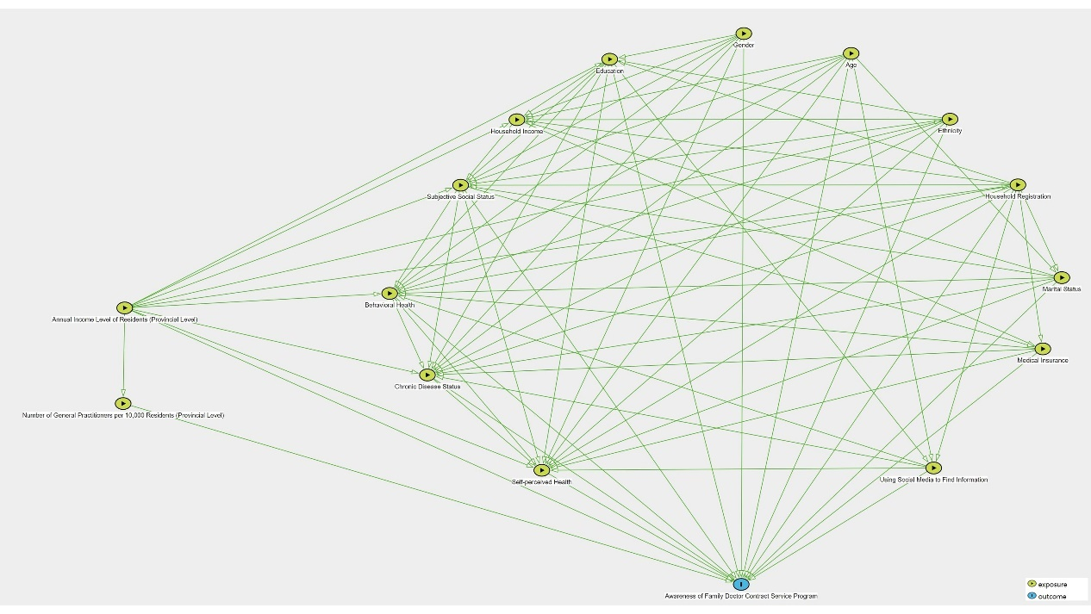
Figure S1. Causal Directed Acyclic Graph
Note: Building upon the Minimal Sufficient Adjustment Sets (MSAS) determined to estimate both total and direct effects, which are derived from causal directed acyclic graphs (DAGs), the results indicate that no adjustment is necessary to estimate the total and direct effects.

