SUPPLEMENTARY INFORMATION

Novel Function of TREK-1 in Regulating Adipocyte Differentiation and Lipid Accumulation

Running title: TREK-1-Mediated Calcium Signalling Controls Adipogenic Fate

Ajung Kim^{2*}, Seoyeong Jung^{1,3*}, Yongeun Kim^{1*}, Hojin Lee^{1,3}, Jonghun Jung¹, Jae-Yong Park³, Eun Mi Hwang^{2†}, and Jaekwang Lee^{1†}

¹ Research Division of Food Functionality, Korea Food Research Institute, Wanju, 55365, Korea
² Center for Brain Function, Brain Science Institute, Korea Institute of Science and Technology, Seoul, 02792, Korea
³ School of Biosystems and Biomedical Sciences, College of Health Sciences, Korea University, Seoul 02841, Korea
* These authors contributed equally to this work

SUPPLEMENTARY METHODS

Generation and Genotyping of TREK-1 Knock-out Mice
TREK-1 knock-out (KO) mice were generated using the CRISPR/Cas9 system. In brief, Cas9 mRNA and sgRNAs were microinjected into fertilized embryos of C57BL/6 mice (Korea Bio Co.Inc, Korea). Mutations in Kcnk2 were confirmed by sequencing analysis (Korea Bio Co.Inc). TREK-1 KO mice were genotyped with genomic DNA PCR analysis using genomic DNA prepared from their tails. And wild type littermate mice were used as a control. TREK-1 KO forward: 5’-aatccttagccatccatgc-3’, TREK-1 KO reverse: 5’-ctatctcagatggctttgacc-3’.

Western Blots
For western blotting, tissues were lysed with lysis buffer (50 mM HEPES, 0.1% Sodium deoxycholate, 1% Triton X-100, 1 mM PMSF and 0.1% SDS containing protease inhibitor cocktail, pH 7.4). Total protein was subjected to SDS-PAGE and transferred to PVDF membranes. The membranes were blocked using 5% non-fat milk, and then, blotted with the appropriate antibodies : anti-TREK-1 (Santa Cruz, sc-11556), anti-Actin (Sigma-Aldrich, A5441). The membranes were then washed several times and incubated with HRP-conjugated secondary antibodies (Jackson ImmunoResearch, West Grove, PA, USA).

ShRNA transfection
The target region of shRNA as follows: mouse TREK-1: 5′-GCGTGGAGATCTACGACAAGT-3’

Ref : Mi Hwang, E., Kim, E., Yarishkin, O. et al. A disulphide-linked heterodimer of TWIK-1 and TREK-1 mediates passive conductance in astrocytes. Nat Commun 5, 3227 (2014). https://doi.org/10.1038/ncomms4227

Supplementary Figure 1.

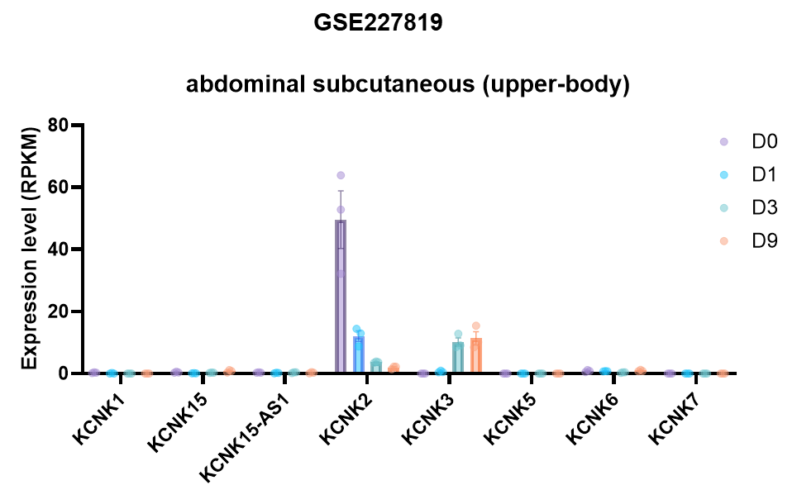
Supplementary Figure 1. Changes in mRNA expression of K2P ion channels over time in adipocytes differentiated from human adipose stem cells. The mRNA expression of K2P ion channels was reanalyzed from the RNAseq dataset of GSE227819 and plotted as RPKM values.

Supplementary Figure 2.

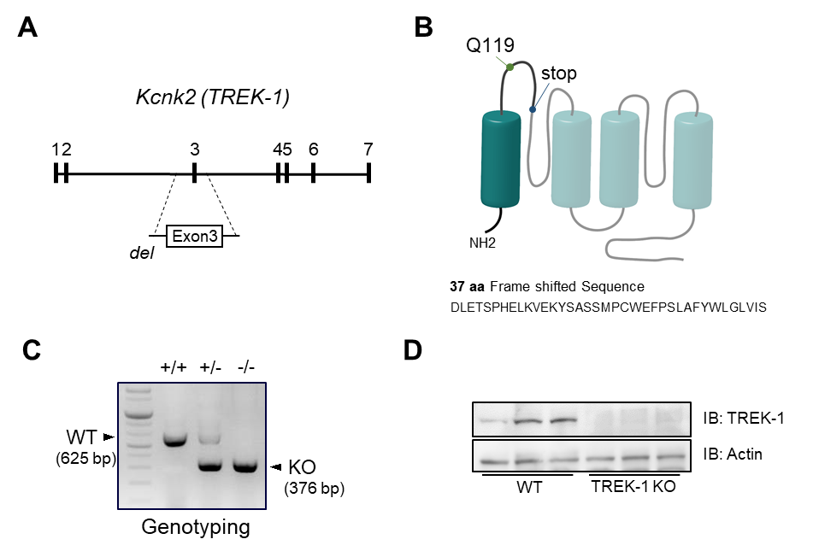

Supplementary Figure 2. Generation of TREK-1 knockout (KO) mice. (A) Schematic representation of the TREK-1 genomic structure: Exon1-7 are represented by the numbered, filled boxes. Exon 3 was removed for KO construction. (B) Schematic diagram of proteins predicted to be expressed by knockout of TREK-1. (C) Genotyping analysis of wild-type, heterozygous, or homozygous TREK-1 KO mice. (D) Western blot analysis to verify protein expression in WT and TREK-1 KO mice.

