Supplementary Note 1

There is an inherent structure in the cells in a tissue probed by different sources of measurements, such as imaging and genomic sequencing. Spatial transcriptomics is one of the most pursued technologies as it reveals the physical tissue structure and molecular characteristics simultaneously. There are two sources of complementary information: the whole slide image (WSI) is of high subcellular spatial resolution but of low dimension, while the spatial transcriptome (ST) is of high dimension but lower spatial resolution (spot level). In this note, we show the two sources of information are consistent and complementary, so that it is plausible to improve the ST resolution from the spot-level to cell-level by integrating the image information.

As a proof of concept, we compared the histological features and spatial transcriptomic features in the following samples, a ductal carcinoma in situ (DCIS; 10x Genomics Visium data) a human heart failure tissue with myocardial infarction (sample name: GT_IZ_P9_rep2 from paper¹; 10x Genomics Visium data), mouse olfactory bulb (MOB; 10x Genomics Visium data), and the hippocampus region in mouse brain cerebellum (MERFISH data). The detailed sample information can be found in the Data Availability section in the main text. We extracted the histological features from H&E staining image patches surrounding the identified nuclei and subsequently applied principal component analysis (PCA) to capture essential variations within the histological features. Specifically, for the DCIS tissue, human heart failure tissue and mouse olfactory bulb tissue, the following nine image features were extracted: mean and standard deviation of the pixel colors intensities (red, green, blue, and gray), as well as the entropy of the image patches. For the mouse brain cerebellum tissue, the following six histological features were used: cell volume, mean and standard deviation of the gray color, logarithm of mean and standard variation of the gray intensity, and the entropy of the image patches. For obtaining the spatial transcriptomic features, we applied PCA to the expression levels of highly variable genes.

First, we show that at individual feature level, the histological and transcriptomic features capture cell organizations in a tissue. On the one hand, the first two principal components (PCs) of the histological features exhibit distinct spatial patterns (Supplementary Note Figure 1a). Specifically, in the tumor region of the DCIS tissue, high PC1 values marks cells near the boundary of the tumor regions and high PC2 values generally marks the interior of tumor regions (Supplementary Note Figure 1b). On the other hand, gene expression levels carry essential information about the cell type and cell-cell interaction in the tissue. For example, expression levels of CD4 and TDP52 can reflect the immune activity and the invasion of carcinoma in the tissue (Supplementary Note Figure 1c). The spatial expression patterns of CD4 and TDP52 in general agree with the patterns captured by PC1 and PC2 of histological features, respectively.

Next, we move on to cluster the cells/spots based on all the histological features or all the transcriptomic features. We clustered the cells using the PCA embeddings from the histological features with the Leiden algorithm². The major cell clusters based on the histological features categorizes cells in regions such as tumor interior, boundary, and necrotic regions (Supplementary Note Figure 1d). Similarly, we also applied PCA analysis to the spatial transcriptomics data, and projection to the top 10 principal components (PCs) were included for Leiden clustering. The spot clusters capture more patterns due to the high dimensionality in ST yet at the spot resolution. Across all the four samples, generally the dissection of tissue regions (layers) by major cell clusters based on merely the histological features agrees with the pattern based on merely the transcriptomic features (Supplementary Note Figures 1d-e).
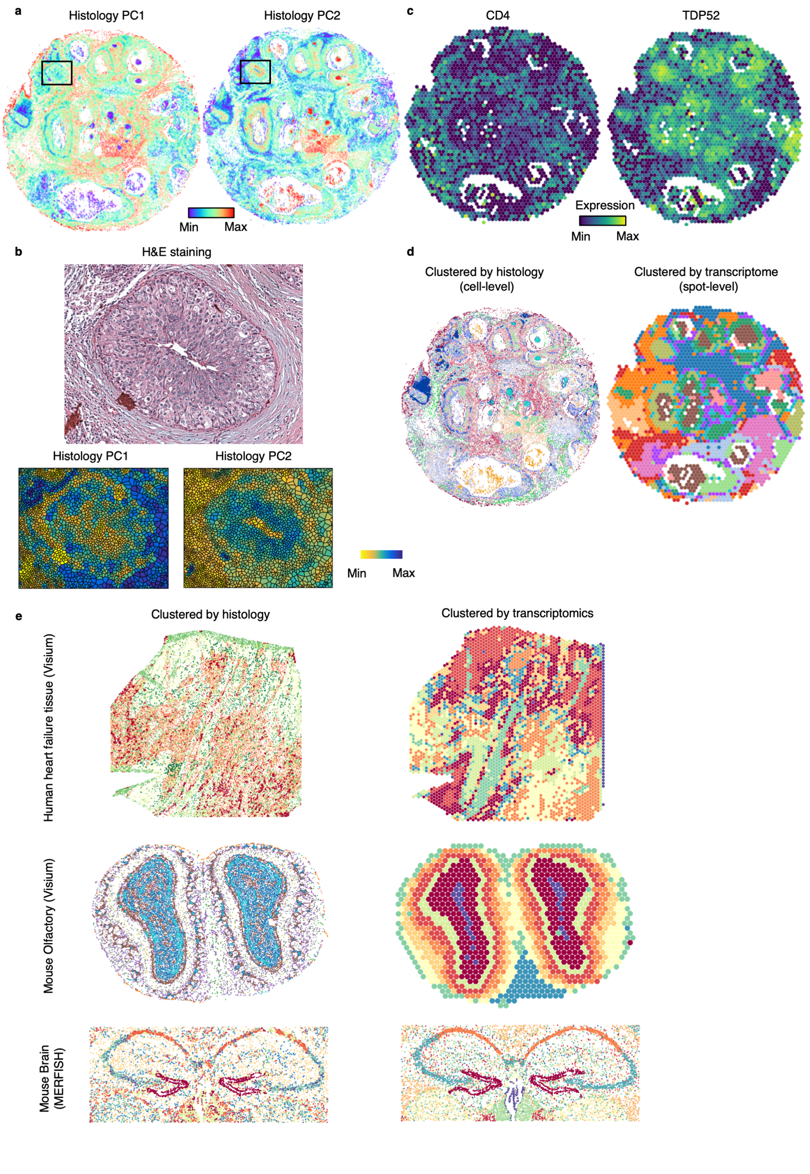
Supplementary Note Figure 1. Histology and spatial transcritomics reveal tissue structure in respected resolutions.
(a) Projection of image features to the first two principal components (PCs) in the DCIS tissue image. The black boxes mark the region of interest (ROI).
(b) Projection of histological features to the first two PCs in a tumor region in DCIS tissue.
(c) Spot-level gene expression of CD4 and TDP52 from the DCIS Visium data.
(d) Histology feature clusters and transcriptome clusters of DCIS Visium data. The cells or spots are colored according to the clusters.
(e) Histology feature clusters and transcriptome clusters of human heart failure tissue (Visium data), mouse olfactory bulb (Visium data) and mouse brain cerebellum (MERFISH). The cells or spots are colored according to the clusters.

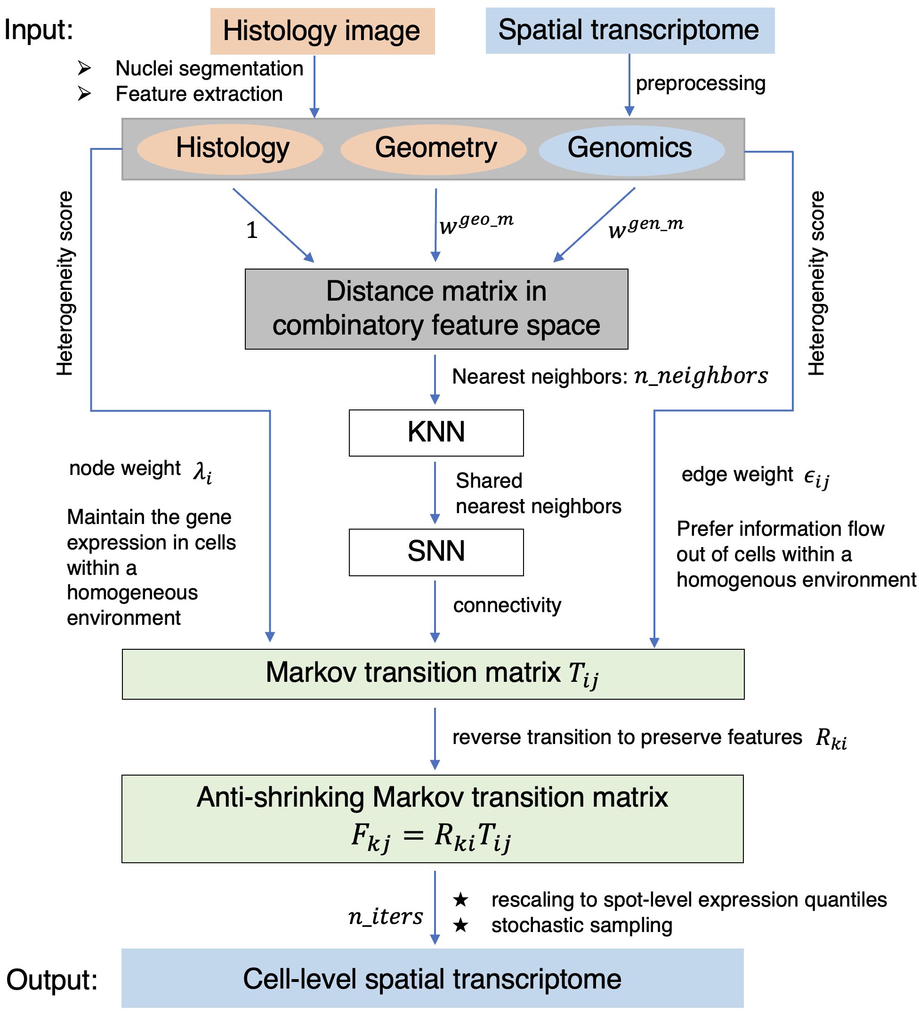

Supplementary Note Figure 2. Workflow of Thor inference. First, extract image features from the histology image, including locations of in silico cells and contextual features of each cell in their spatial neighborhood. Meanwhile, the spatial transcriptome data is preprocessed and the gene expression on the segmented cells is initialized according to the nearest spot. Second, compute multi-modal distances between cells and construct the cell-cell network SNN based on their morphological features, geometrical locations, and the reduced-dimension transcriptome weighted by user inputs. Third, convert the distances into affinities using a Gaussian kernel, so that similarity between two cells decreases exponentially with their distance. Fourth, construct a Markov transition matrix for transitioning information between similar cells and prohibiting information flow from cells within a heterogenous environment. A reverse diffusion transition matrix is constructed to prevent the shrinking of the data space. Fifth, the cell-level spatial transcriptome is inferred by multi-step diffusion with the constructed transition matrix.

Supplementary references
1. Kuppe, C. et al. Spatial multi-omic map of human myocardial infarction. Nature 608, 766-777 (2022).
2. Traag, V.A., Waltman, L. & van Eck, N.J. From Louvain to Leiden: guaranteeing well-connected communities. Sci Rep 9, 5233 (2019).

