Supplementary Files

Dissecting the Population Structure, Diversity and Genetic Architecture of Disease Resistance in Wild Emmer Wheat (Triticum turgidum subsp. dicoccoides) through Comprehensive Whole-Genome Sequencing
Laxman Adhikari^{1,2,5}, Pablo Olivera³, Guotai Yu^{1,5}, John Raupp², Hanan Sela⁴, Assaf Distelfeld⁴, Brande Wulff^{1,5}*, Brian Steffenson^{3*}, Jesse Poland^{1,2,5*}

¹Plant Breeding and Genetics Lab, Center for Desert Agriculture, Biological and Environmental Science and Engineering Division, King Abdullah University of Science and Technology (KAUST), Thuwal, 23955, Saudi Arabia.
²Wheat Genetics Resource Center, Department of Plant Pathology, Kansas State University, Manhattan, KS, 66502, USA.
³Department of Plant Pathology, University of Minnesota, Saint Paul, MN, 55108, USA
⁴ Department of Evolutionary and Environmental Biology, University of Haifa, Haifa, 3498838, Israel.
⁵Plant Science Program, Biological and Environmental Science and Engineering Division, King Abdullah University of Science and Technology (KAUST), Thuwal, 23955, Saudi Arabia.
*Corresponding: Brande Wulff (brande.wulff@kaust.edu.sa); Brian Steffenson (bsteffen@umn.edu) and Jesse Poland (jesse.poland@kaust.edu.sa)

Supplementary Tables

Supplementary Table S1. A list of wild emmer wheat (WEW) whole-genome sequencing (WGS) panel, including the passport information of accessions and the score data for diseases (stem, leaf, and stripe rusts), is provided in a separate Excel file.

Supplementary Table S2

Pathogen | Raceª | Isolate | Virulence | Avirulence
Puccinia graminis f. sp. tritici | TTKSK | 04KEN156-/4 | Sr5, 6, 7b, 8a, 9a, 9b, 9d, 9e, 9g, 10, 11, 17, 21, 30, 31, 38, McN | Sr24, 36, Tmp
P. graminis f. sp. tritici | JRCQC | 09ETH08-1 | Sr5, 6, 7b, 9a, 9d, 9g, 11, 17, McN | Sr8a, 9b, 9e, 10, 21, 24, 30, 31, 36, 38, Tmp
P. graminis f. sp. tritici | TTRTF | 18GEO189-1 | Sr5, 6, 7b, 8a, 9a, 9b, 9d, 9e, 9g, 10, 11, 17, 21, 36, 38, McN, Tmp | Sr24, 30, 31
P. graminis f. sp. tritici | TKTTF | 13ETH18-1 | Sr5, 6, 7b, 8a, 9a, 9b, 9d, 9e, 9g, 10, 17, 21, 30, 36, 38, McN, Tmp | Sr11, 24, 31
P. graminis f. sp. tritici | TTTTF | 02MN84-A-1-2 | Sr5, 6, 7b, 8a, 9a, 9b, 9d, 9e, 9g, 10, 11, 17, 21, 30, 36, 38, McN, Tmp | Sr24, 31
P. triticina | BBBQD | 13US83-2-1 | Lr10, 39, B | Lr1, 2a, 2c, 3, 3ka, 9, 11, 14a, 16, 17, 18, 21, 24, 26, 28, 30, 42
P. triticina | MFPSB | 12US154-1 | Lr1, 3a, 3ka, 10, 14a, 17, 24, 26, B | Lr2a, 2c, 9, 11, 16, 18, 21, 28, 30, 39, 42
P. triticina | TBBGS | 14US154-1 | Lr1, 2a, 2c, 3, 10, 21,28, 39 | Lr3ka, 9, 11, 14a, 16, 17, 18, 24, 26, 30, 42, B
P. triticina | TFBGQ | 11US1-2 | Lr1, 2a, 2c, 3, 10, 21, 24, 26, 28 | Lr3ka, 9, 11, 14a, 16, 17, 18, 30, 39, 42, B
P. triticina | TNBGJ | 11US1-2 | Lr1, 2a, 2c, 3, 9, 14a, 24, 21, 42 | Lr3ka, 10, 11, 16, 17, 18, 26, 28, 30, 39, B
P. striiformis f. sp. tritici | PSTv-14 |  | 1, 6, 7, 8, 9, 17, 27, 43, 44, 76, Tr1, Exp2 | Yr5, 10, 15, 24, 32, SP, Tye
P. striiformis f. sp. tritici | PSTv-37 | 10-106 | Yr6, 7, 8, 9, 17, 27, 43, 44, Tr1, Exp2 | Yr1, 5, 10, 15, 24, 32, SP, Tye
P. striiformis f. sp. tritici | PSTv-143 |  | Yr1, 6, 9, SP, Tr1, Tye | Yr5, 7, 8, 10, 15, 24, 27, 32, 43, 44, Exp2, Tr1
P. striiformis f. sp. tritici | PSTv-221 |  | Yr6, 7, 27, 43, 44, Exp2 | Yr1, 5, 8, 9, 10, 15, 24, 32, 43, SP, Tr1,Tye
P. striiformis f. sp. tritici | PST5004 |  | Yr6,7,8,9,11,12,17,19,sk,18,A | Yr1, 5, 10, 15, 24, 26, sp

Supplementary Table S3. Wild emmer wheat (WEW) SNP variants under different conditions of filtration. The variants were computed for each of the 14 chromosomes using the Zavitan reference (v2.1) with the bcftools software. A total of 3.4 million SNPs were used for population analysis.
Filtration  Criteria | Zavitan Chromosomes |  |  |  |  |  |  |  |  |  |  |  |  |  | Total  SNPs
Filtration  Criteria | 1A | 1B | 2A | 2B | 3A | 3B | 4A | 4B | 5A | 5B | 6A | 6B | 7A | 7B | Total  SNPs
Raw Variants (No Filter) | 62249798 | 70738454 | 77222520 | 79915432 | 75708989 | 83822528 | 68426795 | 59576648 | 71195726 | 71011431 | 62408989 | 68742280 | 74916176 | 73894997 | 999830763
QUAL>=30 INFO/DP>=20 | 14206642 | 14203713 | 17835968 | 16656155 | 17022158 | 17969056 | 16954186 | 15287984 | 16292428 | 14890214 | 14411772 | 13938816 | 17182894 | 15243615 | 206630996
MAF >= 0.05; Miss < 20 %; Het < 10 % | 4371692 | 4556683 | 5554174 | 5072529 | 5342525 | 5805169 | 5025290 | 5594423 | 4392013 | 4405888 | 4436535 | 4062264 | 5046633 | 4694731 | 68360549
Subset 5% | 218255 | 227335 | 277093 | 252970 | 266452 | 289625 | 250655 | 279082 | 219286 | 219976 | 221441 | 202745 | 251697 | 234065 | 3410677

Supplementary Table S4. List of duplicated accessions in the panel. The allele matching threshold (≥ 99%) was used to confirm the duplication.

S.N. | Accessions | Duplicate1 | Duplicate 2
1 | TA10666 | TA11184
2 | TA11202 | TA11203 | TA119
3 | TA117 | TA1459
4 | TA131 | TA132 | TA133
5 | TA134 | TA135

Supplementary Table S5. The number of segregating loci and Nei’s diversity indices computed for the entire collection and the subgroups within the wild emmer wheat (WEW) panel.

Subgroup | # Accession | Segregating Loci | Nei’s Index
WEW panel | 191 | 3410676 | 0.27
Northern Population | 88 | 2008940 | 0.15
Southern Levant (SL) Population | 168 | 3000957 | 0.17
judaicum | 35 | 1070077 | 0.06

Supplementary Table S6. Pairwise F_{ST} coefficients among the subgroups among wild emmer wheat subgroups.

 | Southern Levant [SL] | Northern Population
Northern Population | 0.05 |  | Weir and Cockerham
judaicum | 0.17 | 0.19 | Weir and Cockerham
Northern Population | 0.046 |  | beta
judaicum | 0.18 | 0.197 | beta
Northern Population | 0.05 |  | Nei’s
judaicum | 0.19 | 0.204 | Nei’s

Supplementary Table S7. The genomic regions that are statistically significant (p < 0.05) after Bonferroni correction for the marker-trait association for leaf rust (LR) resistance in the WEW. The phenotypic variance explained (PVE%) and P-value was reported for the GWAS model represented by the bold characters (Γ, ς, Φ, β). The Zavitan genome (v2.1) positions were used to track the annotated genes for the position. The loci naming in the second column follows the chromosome position.

Pathogen Races | Loci in the Peak | GWAS model | PVE  % | P-value | Pop | Leaf rust QTL and functional genes on Zavitan [WEW_v2.1] around the GWAS peak marker region, and the literature cited for the known genes
TBBGS | 1A_84213105 | Γ | 10 | 2.3e⁻¹⁰ | To, SL | Putative F-box/LRR-repeat protein At5g02700 at 83.78 and F-box/LRR-repeat protein At3g59190-like at 83.84 Mb
TBBGS | 2A_639981192 | Φ | 9.5 | 8.2e⁻¹⁰ | To | Salt tolerance receptor-like cytoplasmic kinase 1 at 639.68 Mb; Trihelix transcription factor GTL1-like, transcript variant X1 at 640.1 Mb; homeobox-leucine zipper protein HOX22-like at 640.46 Mb and probable serine/threonine-protein kinase PBL19 at 641.28 Mb
TBBGS | 5A_599149960 | Γ, ς | 6.1 | 5.8e⁻⁹ | To, SL | Cytochrome P450 81Q32-like[1] at 599.13 Mb; disease resistance protein PIK5-NP-like, transcript variant X1 at 598.23
TBBGS | 4B_573574038 | Γ | 5 | 2.4e⁻¹⁰ | SL, To | Probable 3-ketoacyl-CoA synthase 20 at 573.77 Mb, disease related gene[2]
TBBGS | 4B_70064098 | Γ | 5 | 2.4e⁻¹⁰ | SL, To | Receptor protein kinase-like protein ZAR1 at 69.91 Mb, a NLR gene [3]
TBBGS | 4A_748016987 | β | 3 | 3.7e⁻²¹ | SL | Putative disease resistance protein RGA3 at 748.94 Mb; zealexin A1 synthase-like at 748.02 Mb;  kinase Lr10-like at 751.4 Mb
TBBGS | 3A_724098541 | Φ, β | 3 | 1.9e⁻¹⁰ | SL | Putative serine/threonine-protein kinase-like protein CCR3 at 724.64 Mb
BBBQD | 3B_159110029 | Γ, β | 55.7 | 1.3e⁻¹⁹ | SL | Ubiquitin carboxyl-terminal hydrolase 2-like ruvB-like 2 at 158.99 Mb; and NF-X1-type zinc finger protein NFXL2-like 159.48 Mb (wheat leaf rust related gene)[4]
BBBQD | 6B_407945574 | β | 9.7 | 4.6e⁻¹¹ | SL | S-QLr6B.3; seedling leaf rust resistance QTL in durum wheat at 6BL[5] and photosynthetic NDH subunit of lumenal location 2, chloroplastic-like, transcript variant X2 at 408.6 Mb
BBBQD | 4B_411500464 | β | 8 | 1.1e⁻¹⁰ | SL | Uncharacterized protein at 411.52 Mb; mitogen-activated protein kinase kinase kinase 11-like (411.6Mb)
BBBQD | 3B_728918232 | β | 7.4 | 2.4e⁻¹⁰ | SL | S-QLr3B.1; QTL for BBBQD race in durum wheat at 3B[5],[6]; small ubiquitin-related modifier 1-like at 728.7; uncharacterized protein at 728.9 Mb
BBBQD | 2A_8574713 | Φ, β,Γ | 6 | 1.2e⁻¹³ | To | Transcription factor TB1-like at 8.65 Mb and Uncharacterized protein at 8.54 Mb
BBBQD | 1A_155714419 | Γ, β | 4 | 3.2e⁻⁹ | To | Proline-rich receptor-like protein kinase PERK2[7]
TFBGQ | 3B_564234386 | β | 30.7 | 5.8e⁻¹⁷ | SL | Serine/threonine-protein phosphatase 7 long form homolog, transcript variant X1 at 564.21 Mb and uncharacterized protein at 564.25 Mb
TFBGQ | 6B_120678268 | β | 14.4 | 1.8e⁻¹⁴ | SL | Uncharacterized protein at 120.9 Mb
MFPSB | 2A_733147249 | Γ, β | 14.9 | 4.8e⁻¹² | SL, To | RING-H2 finger protein ATL43-like at 733.14 Mb; role in plant defense[8]; many functional genes nearby
MFPSB | 2B_477627826 | β | 9.4 | 2.3e⁻¹⁴ | SL | U-box domain-containing protein 26-like at 477.82 Mb, this is a plant defense related protein
MFPSB | 3B_26624763 | Φ | 6.5 | 2.4e⁻⁹ | SL | E3 ubiquitin-protein ligase SIRP1-like, transcript variant X2 at 266.46 Mb
MFPSB | 7B_68229888 | β | 6.3 | 1.9e⁻¹² | SL | Serine/arginine-rich splicing factor RSZ21A, transcript variant X1 at 68.42 Mb; 85% similarity with Thinopyrum ag15(NLR) at 73.12 Mb at 7B
TNBGJ | 2A_257997411 | β | 46 | 1.5e⁻¹² | To | rRNA-processing protein UTP23 homolog at 25.73 Mb; uncharacterized protein at 25.8 Mb
TNBGJ | 2B_498243667 | Φ, β | 28.4 | 2.1e⁻¹⁷ | SL | Serine/arginine repetitive matrix protein 1-like at 498.39 Mb
TNBGJ | 3B_87851560 | Φ | 9.5 | 5.3e⁻¹⁰ | To | RST1-like, transcript variant X1 at 87.89 Mb; putative F-box protein At4g22660 at 87.7 Mb
TNBGJ | 1B_7587135 | β | 7 | 8.5e⁻⁰⁹ | SL | Leaf rust QTL in diverse hexaploid wheat at 1BS for this race[9]; MDIS1-interacting receptor like kinase 2-like at 7.52 Mb; gamma-gliadin-like at 7.57 Mb and protein NEN4-like at 7.59 Mb
TNBGJ | 2A_31044800 | Φ | 5.3 | 9.6e⁻¹² | To | ABC transporter C family member 4-like at 31.044 Mb
TNBGJ | 2A_733237700 | Φ | 3.5 | 5.3e⁻¹⁰ | To | Ribulose bisphosphate carboxylase/oxygenase activase, chloroplastic-like at 733.23 Mb

Γ = rrBLUP; ς = CMLM; Φ = FarmCPU and β = Blink
SL = Southern Levant population except for judaicum
Pop = Population
To = Total population in the panel

Supplementary Table S8. The genomic regions that are statistically significant (p < 0.05) after Bonferroni correction for the marker-trait association for stripe/yellow rust (YR) resistance in the WEW. The phenotypic variance explained (PVE %) and P-value was reported for the GWAS model represented by the bold characters (Γ, ς, Φ, β). The Zavitan genome (v2.1) positions were used to track the annotated genes for the position. The loci naming at the second column follows the chromosome position.

Pathogen races | Loci in the Peak | GWAS model | PVE  % | P-value | POP | Stripe rust QTL and functional genes on Zavitan [WEW_v2.1] around the GWAS peak marker region, and the literature cited for the known genes
PSTv-221 | 1B_99349879 | Γ, β | 16 | 2.8e⁻¹⁶ | SL, To | Yr15[10] at 97.94 Mb; MN756016.1 Triticum dicoccoides isolate WEW110846 wheat tandem kinase 1 (Wtk1) aligned (93%) at 97.9 Mb; wall-associated receptor kinase 1-like at 97.9 Mb; disease resistance protein RPM1-like at 99.5 Mb[11]
PSTv-221 | 1A_321955692 | β, Φ | 11.8 | 6.9e⁻¹¹ | To, SL | Membrane steroid-binding protein 1-like at 322.1 Mb
PSTv-221 | 3A_633834064 | β | 11.7 | 4.7e⁻⁹ | To, SL | Protein PSK SIMULATOR 1-like at 633.83 Mb; myb-related protein 308-like at 633.91 Mb
PSTv-221 | 6B_444225156 | Γ, ς | 10.6 | 1.1e⁻⁸ | To | Pentatricopeptide repeat-containing protein At1g01970-like at 444.35 MB
PSTv-221 | 5A_563398244 | Γ, β | 7.7 | 5.6e⁻⁹ | To | T. urartu stripe rust resistance gene aligned at YrU1 ~ 554 Mb at 5AL
PSTv-221 | 7A_221300495 | Φ, β | 5 | 1.8e⁻¹⁵ | To, SL | Probable galacturonosyltransferase 4 at 220.28 Mb[12]
PSTv-14 | 1B_96368365 | Γ, β | 16.7 | 9.3e⁻⁹ | To, SL | *** location overlapped with the loci for PSTv-221 at 1BS*** (Yr15)
PSTv-14 | 7A_638642386 | Φ, β | 12.7 | 3.4e⁻²³ | To, SL, | Ethylene-responsive transcription factor 3-like at 638.77 Mb; an AP2/ERF transcription factor, is positively involved in wheat resistance to puccinia striiformis f. sp. tritici [12]
PSTv-14 | 7B_666691074 | β | 10.8 | 1.2e⁻⁰⁹ | SL | F-box protein At2g16450-like at 666.74 Mb
PSTv-14 | 2A_750240783 | Φ, β | 3.5 | 1.8e⁻¹⁰ | SL | TB/POZ domain-containing protein At5g03250-like at 750.22 Mb
PSTv-14 | 4B_442518036 | β | 3.3 | 2.1e⁻¹³ | To | QTL at 4BL for this race in durum wheat[13] and cultivated emmer[14]; receptor-like protein kinase HERK1 at 442.28 Mb
PSTv-14 | 1A_76425506 | β | 3.2 | 1.8e⁻⁹ | To | QTL at 1AS for this race in durum wheat[13] and cultivated emmer[14]; acyl transferase 4-like at 76.51 Mb
PSTv-14 | 5B_721602826 | Γ, ς | 3 | 5.7e⁻⁰⁷ | To | QTL at 5BL for this race in durum [13] and wheat[15]; protein EXPORTIN 1A-like at 721.71 Mb;  receptor-like protein EIX2 at 721.43 Mb and probable cytokinin riboside 5'-monophosphate phosphoribohydrolase LOGL5 at 721.48 Mb
PSTv-143 | 1A_301060972 | Γ, β | 22.2 | 1.4e⁻⁰⁸ | SL | Endoribonuclease Dicer homolog 3b-like, transcript variant X2
PSTv-143 | 3B_252159443 | Φ, β | 16.5 | 3.8e⁻¹² | To | Uncharacterized proteins; putative F-box protein At2g02030, transcript variant X1 at 252.89 Mb
PSTv-143 | 5B_428949214 | Γ, β | 12.3 | 1.4e⁻¹¹ | SL | RHOMBOID-like protein 10, chloroplastic at 428.98 Mb
PSTv-143 | 1B_123847300 | Γ, β | 10 | 7.9e⁻¹⁰ | To, SL | Probable WRKY transcription factor 26[16] at 122.19, gene involved in the wheat resistance to stripe rust [16]; Putative serine/threonine-protein kinase-like protein CCR3 at 122.4 Mb
PSTv-143 | 4A_69650501 | β | 7.5 | 2.8e⁻¹¹ | To | Cytochrome P450 90B2-like at 69.43 MB; glucan endo-1, 3-beta-glucosidase 7-like, transcript variant X1 AT 69.91 MB
PSTv-143 | 2A_145061360 | Γ, Φ, β | 6.9 | 8.9e⁻¹³ | To | LRR receptor-like serine/threonine-protein kinase RPK2 at 145.5 Mb; ninja-family protein 1 at 145.3 Mb and glycerophosphodiester phosphodiesterase GDPD6-like at 145.49 Mb
PST5006 | 6B_155315249 | Γ, ς | 20.4 | 3.8e⁻⁰⁹ | To | Yr36[17] wheat ortholog INRA7011 NAM-B1 flanking sequence c_Yr36_3 aligned (98%) at 149.3 Mb. Although Yr36 is adult plant resistance gene, when pyramiding with other adult plant resistance genes such as Yr18 and Yr28 also conferred seedling stage resistance[18]
PST5006 | 2A_632825419 | Φ | 12 | 6.1e⁻⁰⁹ | SL | Uncharacterized proteins
PST5006 | 1B_117463450 | Γ, Φ | 5 | 1.1e⁻¹¹ | To, SL | ADP-ribosylation factor-like protein 1 at 117.63 Mb
PST5006 | 1A_279322034 | Φ | 3 | 2.5e⁻¹⁰ | To, SL | Small nucleolar RNA Z247 at 279.32 Mb and uncharacterized protein at 279.5 Mb
PST5006 | 4B_644596264 | β | 3 | 7.1e⁻¹⁰ | SL | Cycloartenol-C-24-methyltransferase 1 at 644.65 Mb and several other uncharacterized proteins
PST5006 | 7A_699033352 | Φ | 3 | 3.8e⁻²¹ | SL | Protein GLUTAMINE DUMPER 1-like gene at 699.1 Mb; probable histidine kinase 1 at 699.13 Mb
PSTv-37 | 3A_716607327 | Γ, β | 59.1 | 5.2e⁻¹³ | To | QTL for this race has been reported at 3AL[19]; B3 domain-containing protein Os03g0620400-like at 716.60 Mb
PSTv-37 | 1B_123573903 | Γ, β | 19.1 | 3.6e⁻⁰⁹ | SL | *** location overlapped with the loci for PSTv-143 at 1BS***
PSTv-37 | 1A_297644460 | Φ | 3 | 7.9e⁻¹³ | SL | Putative receptor-like protein kinase At4g00960, transcript variant X2 at 298.16 Mb
PSTv-37 | 4B_672177316 | Φ, β | 3 | 1.9e⁻¹¹ | To | QTL at 4BL for durum wheat[13],[14]; expansin-B4-like at 671.99 Mb and putative inactive G-type lectin S-receptor-like serine/threonine-protein kinase SRK at 672.18 Mb
PSTv-37 | 6A_100686164 | Φ | 3 | 1.7e⁻¹³ | To | QTL at 6AL for this race in cultivated emmer[14] and bread wheat[15]
PSTv-37 | 2A_24756708 | Γ, Φ | 3 | 1.4e⁻⁹ | To | Cytosolic sulfotransferase 5-like at 24.87 Mb, receptor-like serine/threonine-protein kinase SD1-8 at 25.67 Mb
PSTv-37 | 6B_149592528 | Γ, ς | 3 | 9.5e⁻⁷ | To | *** location overlapped with the loci for race 5006 at 6BS***
Γ = rrBLUP; ς = CMLM; Φ = FarmCPU and β = Blink
SL = Southern Levant population except for judaicum
Pop = Population
To = Total population in the panel

Supplementary Table S9. Candidate genes alignment stats when aligned to the Zavitan [WEW_v2.1] genome.

Disease | Query Gene and Source Species | Sequence/Locus ID | Sequence  Length (bp) | Aligned Chr | Identity % | Alignment Position Range on genome | Bit Score | E-value
Stem Rust | TBL, Wheat | XM_044592034.1 | 879 | 1B | 95% | 54291683 - 54292558 | 1360 | 0
Stem Rust | Sr13, Triticum turgidum subsp. durum | MW033594.1 | 2320 | 6A | 96 | 628901992 - 628904304 | 3707 | 0
Stem Rust | Sr13, Triticum turgidum subsp. durum | MW033594.1 | 2320 | 6B | 91 | 717023519 - 717025814 | 3057 | 0
Leaf Rust | Lr10-like, Triticum dicoccoides | XM_037569178.1  (LOC119290055) | 1092 | 4A | 99 | 751466518 - 751467608 | 1980 | 0
Stripe/Yellow  Rust | Yr15, Wheat | MN756016.1 | 1241 | 1B | 93 | 97947813 - 97949029 | 1773 | 0
Stripe/Yellow  Rust | YrU1, Urartu | MT018453.1 | 8014 | 5A | 99 | 554990932 - 554998938 | 14388 | 0
Stripe/Yellow  Rust | Yr36, Wheat | MG587373.1  (c_Yr36_3) | 792 | 6B | 98 | 149305793 - 149306582 | 1352 | 0

Supplementary Figures

Supplementary Figure S1. Bar chart displaying the sequencing coverage for the 291 wild emmer wheat whole-genome sequencing (WGS) panel, which averaged 9.5x across all accessions. The single bar indicates the single accession. The FASTQ files containing this sequencing data are available on NCBI-SRA under BioProject accession # PRJNA1007489.

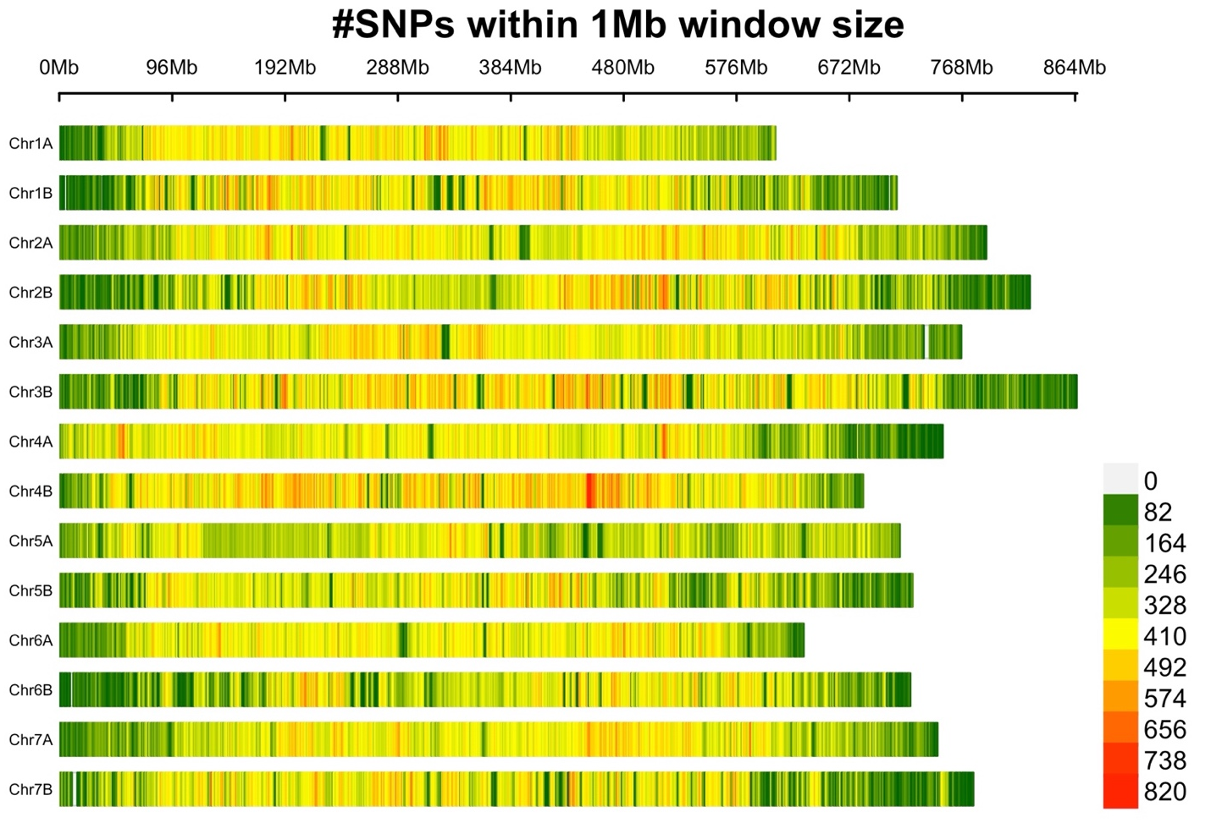

Supplementary Figure S2. The SNP density as the number of SNPs within a 1 Mb window size. Each horizontal bar represents one of the 14 different chromosomes of wild emmer wheat and extends to its physical length as shown on the x-axis at the top. The colors of the bars indicate the level of SNP density.

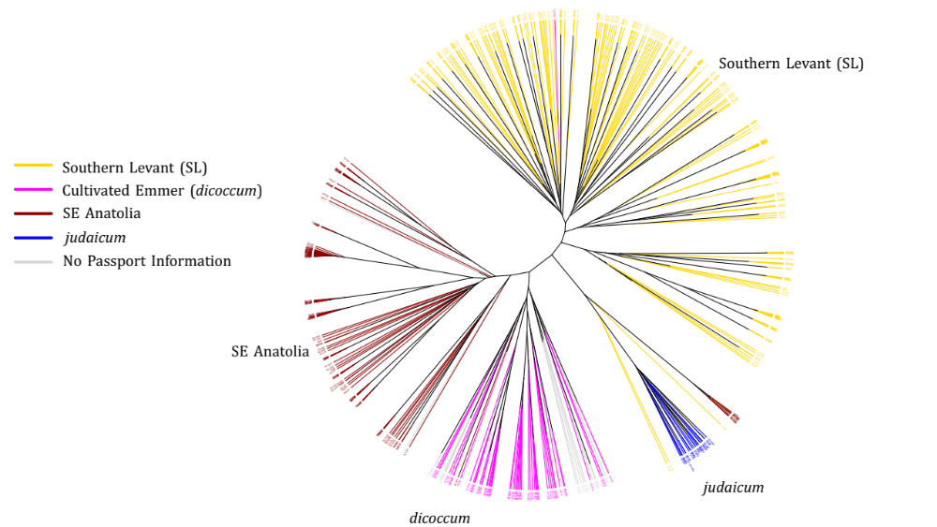

Supplementary Figure S3. Clustering of WEW accessions and the cultivated emmer wheat (Triticum turgidum ssp. dicoccum) within a neighbor-joining (NJ) tree as constructed using genotyping-by-sequencing (GBS) SNP markers. The SE Anatolia subgroups within the wild population clustered closer to the cultivated emmer.

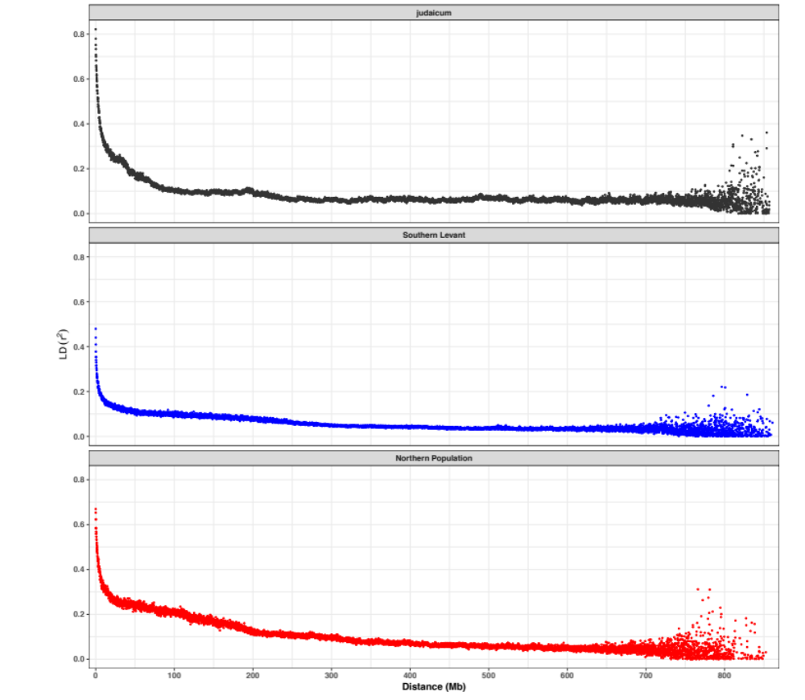
Supplementary Figure S4. Genome-wide linkage disequilibrium (LD) decay curves for three subpopulations: judaicum, Southern Levant, and the Northern Population of wild emmer wheat. The Y-axis represents pairwise LD (r2), while the X-axis represents physical length (Mb). Genome-wide LD was computed for all pairs of SNPs (20K SNPs for each subpopulation), and mean LD (r2) was computed using a 100 kb window, then plotted as a dot plot. LD decayed rapidly in all three subpopulations, with a marked decline observed at approximately 250 kb for each.

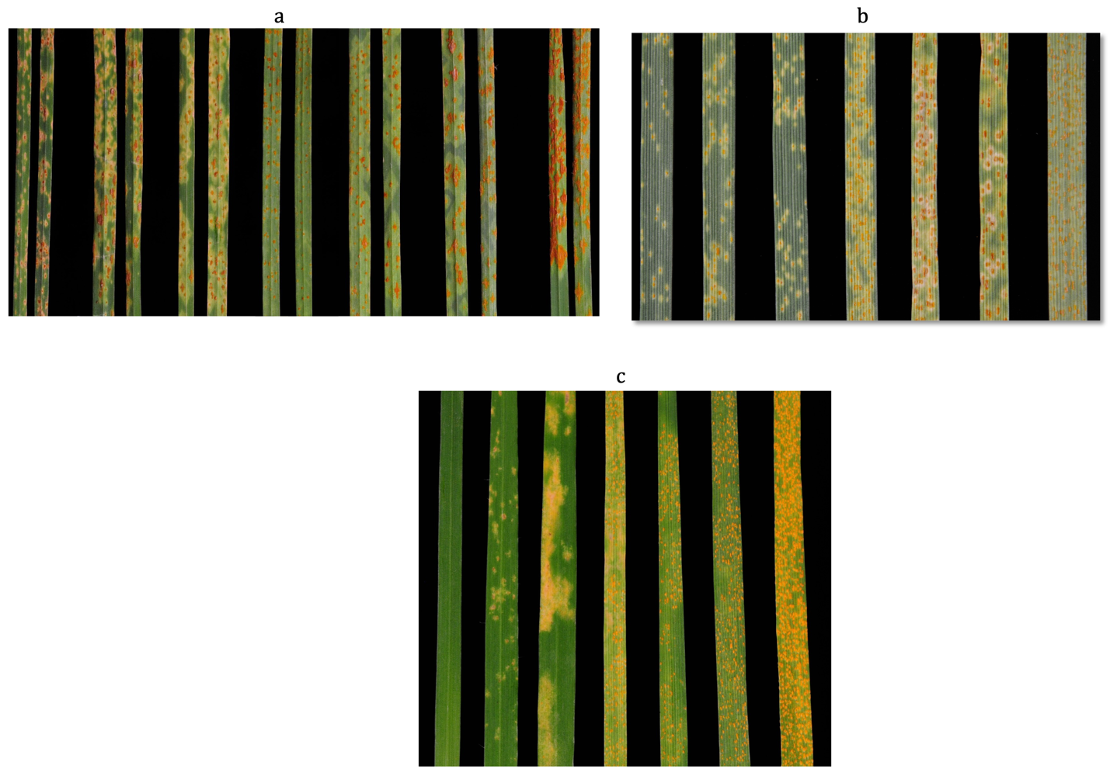
Supplementary Figure S5. disease symptoms on wild emmer wheat (WEW): the stem rust symptoms variability (a), the leaf rust symptoms variability (b) and yellow/stripe rust symptoms variability (c) in the leaves of screened accessions.

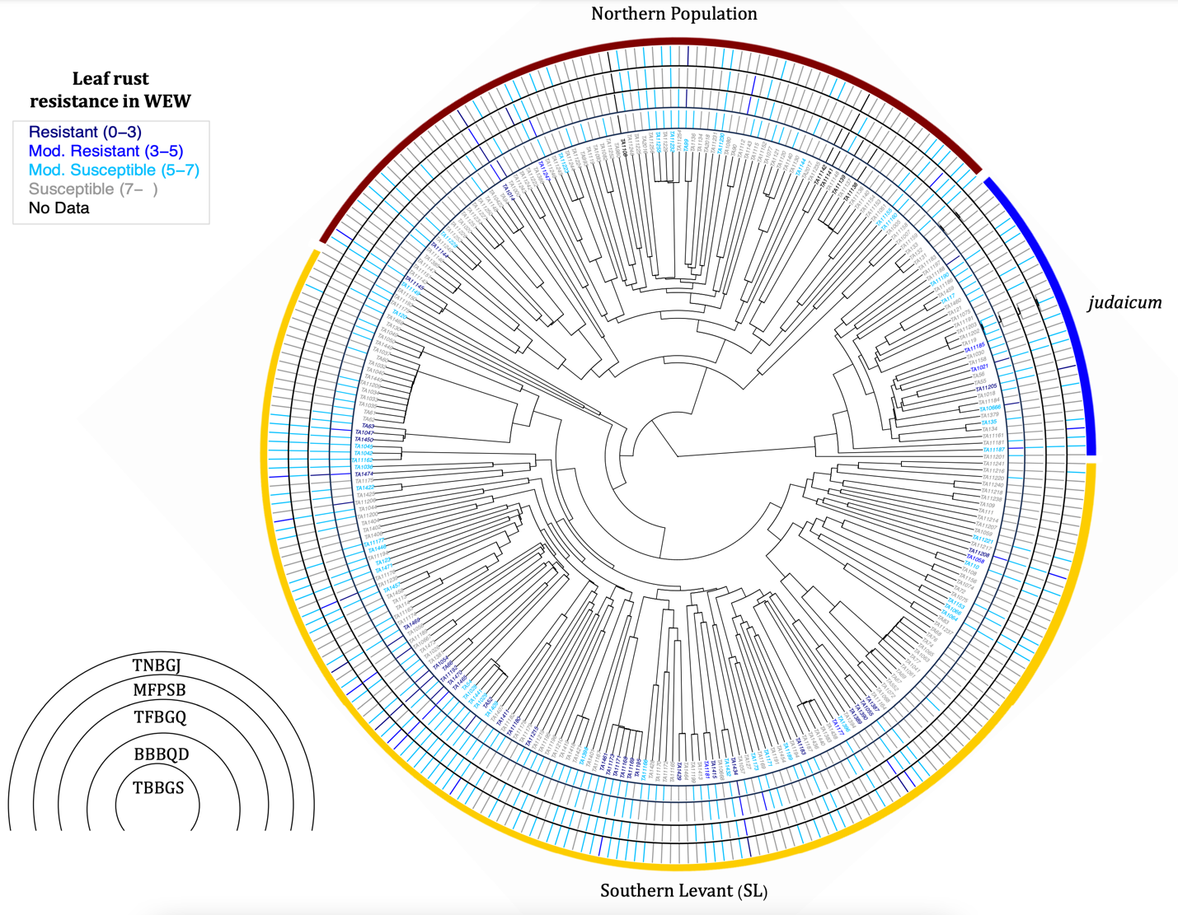
Supplementary Figure S6. Clustering of WEW accessions within a neighbor-joining (NJ) tree, showcasing their geographic origins and levels of resistance to leaf rust pathogen races at the seedling stage. The resistance levels were differentiated based on disease scores, with corresponding colors on the tree matching the legend color on the top left. The innermost tree features labels of accessions as TA#, while the outer tree branches are represented by colors only. The outer colored circle’s segments within the NJ tree delineate subgroups: SL, northern population, and judaicum.

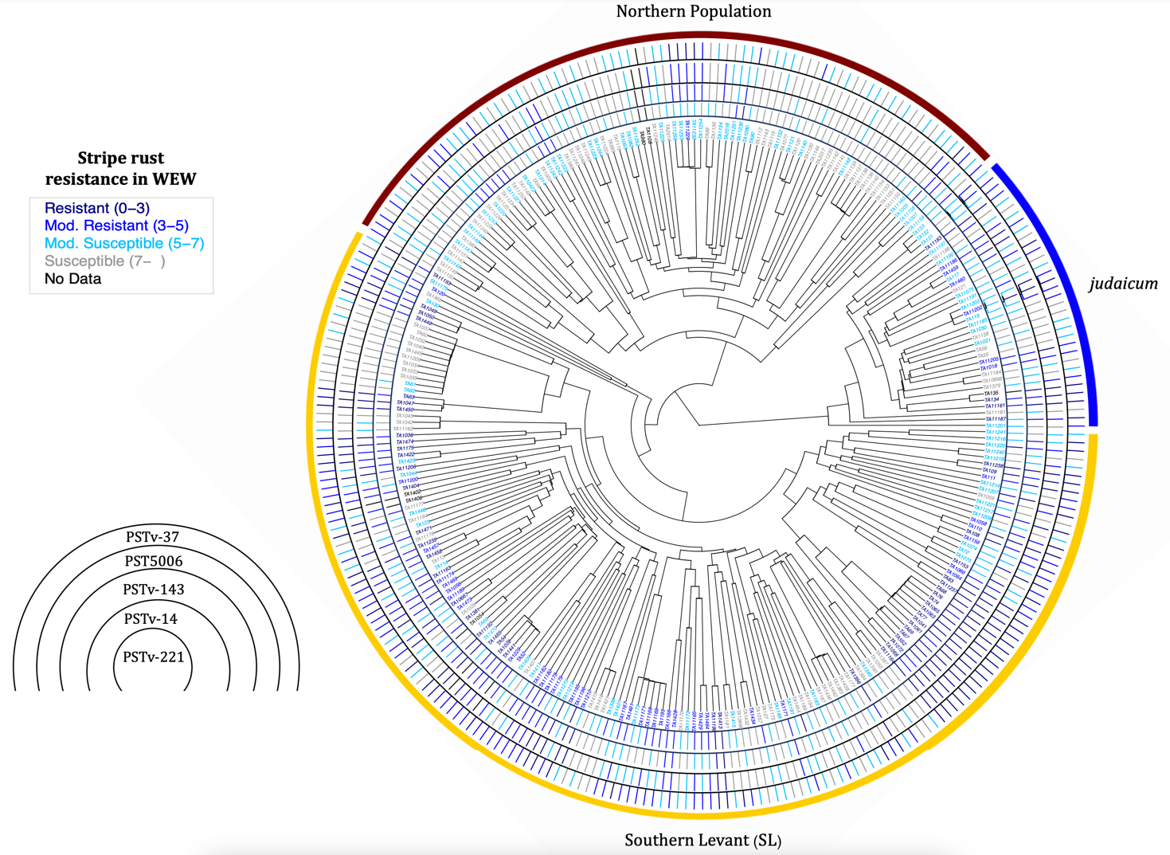
Supplementary Figure S7. Clustering of WEW accessions within a neighbor-joining (NJ) tree, showcasing their geographic origins and levels of resistance to stripe rust pathogen races at the seedling stage. The resistance levels were differentiated based on disease scores, with corresponding colors on the tree matching the legend color on the top left. The innermost tree features labels of accessions as TA#, while the outer tree branches are represented by colors only. The outer colored circle’s segments within the NJ tree delineate subgroups: SL, northern population, and judaicum.

Supplementary Notes
Supplementary Note S1
2.6 Pathogen Isolates
The WEW panel was phenotyped at the seedling stage against five races each of the stem rust (Puccinia graminis f. sp. tritici), leaf rust (Puccinia triticina), and stripe rust (Puccinia striiformis f. sp. tritici) pathogens of wheat (Supplementary Table S2). The selection of races of P. graminis f. sp. tritici aimed to cover the four major genetic groups described for this pathogen and capture a broad virulence spectrum. Race TTKSK (isolate 04KEN156-04, genetic clade I) has the same virulence spectrum as the original isolate Ug99 identified in Uganda in 1998 [20]. Races JRCQC (isolate 09ETH08-3, clade II) and TTRTF (isolate 13GEO189-1, clade III) are virulent on the ‘b’ allele of the Sr13 gene [21], the most important stem rust resistance gene in durum wheat [22]. Race TKTTF (isolate 13ETH18-1, clade IV) is a widely distributed race that caused significant epidemics in East Africa [23] and outbreaks in Europe [24]. Race TTTTF (isolate 02MN84A-1-2) is the most widely virulent race reported in the U.S., producing high infection types (ITs) on all but Sr24 and Sr31 in the 20-line wheat stem rust differential set [20]. Among the races of the leaf rust pathogen screened in the study, the race BBBQD (isolate) is highly virulent to durum wheat cultivars but mostly avirulent to bread wheat [25]. The remaining four races (MFPSB, TBBGS, TFBGQ, and TNBGJ) are bread-wheat-type races predominant in the U.S. The race TBBGS, virulent on Lr21 and Lr39, was one of the predominant races in the U.S. from 2018 to 2020 [25]. The race TNBGJ, virulent on Lr2a, Lr24, and Lr39, was a common phenotype in the southern and northern Great Plains in the early 2010s [25]. For Puccinia striiformis f. sp. tritici, we used four races of the U.S. origin (Pst-14, Pst-37, Pst-143, and Pst-221) and one race 38E134 from Israel. The race 38E134 represents the Pst isolate PST5006 (PST5006 hereafter). Races Pst-14 and Pst-37 were selected based on their high virulence phenotype as they possess virulence to 12 and 10 out of the 18 lines of the stripe rust differential set [26]. Pst-37 is also a predominant race in the United States [26, 27]. Races Pst-143 and Pst-221 have been identified more recently in the U.S. and have a lower virulence phenotype [27]. The PST5006 is a prevalent race in Israel with a high virulence profile [28, 29].

2.7 Inoculation and Disease Assessments
Rust inoculations followed standard protocols used at the USDA-ARS Cereal Disease Laboratory and the University of Minnesota. On the day of inoculation, urediniospores of the rust pathogens were taken from the –80°C freezer, heat-shocked in a 45°C water bath for 15 minutes, and then rehydrated in an 80% relative humidity chamber for at least 4 hours. Ten milligrams (mg) of urediniospores were placed into individual size 00 gelatin capsules filled with 800 μl of mineral oil. The inoculum suspension was applied to 10-day-old plants (with the first leaf fully expanded and 2 cm of the second leaf developed) using custom atomizers (Tallgrass Solutions, Inc., Manhattan, KS) pressurized by a pump set at 30 kPa. Approximately 0.15 mg of urediniospores were applied per plant. After inoculation, plants were left for 30 minutes to allow the oil carrier to evaporate from leaf surfaces before being placed inside a mist chamber. They were kept in darkness for 16 hours under 100% humidity conditions maintained with ultrasonic humidifiers (Vick’s model V5100NSJUV; Proctor & Gamble Co., Cincinnati, OH). For stem rust evaluations, light (400W high-pressure sodium lamps emitting 300 μmol photon s−1 m−2) was provided for 4-6 hours after the dark period. After drying inside the dew chamber, plants were transferred to a greenhouse with a day/night temperature of 22/19°C and a 14-hour photoperiod provided by 400W high-pressure sodium lamps emitting a minimum of 300 μmol photons s−1 m−2.

Leaf rust protocols were identical to stem rust procedures except that no light was provided after the 16-hour dew period. For stripe rust evaluations, procedures were similar to leaf rust with two modifications: 1) during the infection period, plants were placed inside a dew chamber at 10°C and 100% RH for 24 hours, and 2) the incubation period was conducted in a growth chamber set at a 16-hour photoperiod and a temperature regime of 18°C day / 15°C night. All rust phenotyping experiments followed a completely randomized design and were repeated at least once over time. For stem rust and leaf rust evaluations, plants were scored for infection type (IT) 14 days after inoculation using a 0-4 scale [30]. Stem rust and leaf rust phenotype data were categorized into resistant (ITs ranging from 0 to 2+) and susceptible (ITs ranging from 3- to 4) classes. For stripe rust, plants were scored 18 days after inoculation using the 0-9 scale developed by A Wan and X Chen [26]. Stripe rust phenotype data were classified as resistant (ITs ranging from 0 to 3), moderately resistant (ITs ranging from 3 to 5), moderately susceptible (5 to 7) and susceptible (ITs ranging from 7 to 9).

References

1. Chakraborty P, Biswas A, Dey S, Bhattacharjee T, Chakrabarty S: Cytochrome P450 Gene Families: Role in Plant Secondary Metabolites Production and Plant Defense. Journal of Xenobiotics 2023, 13(3):402-423.
2. Weidenbach D, Jansen M, Franke RB, Hensel G, Weissgerber W, Ulferts S, Jansen I, Schreiber L, Korzun V, Pontzen R et al: Evolutionary conserved function of barley and Arabidopsis 3-KETOACYL-CoA SYNTHASES in providing wax signals for germination of powdery mildew fungi. Plant Physiol 2014, 166(3):1621-1633.
3. Gu J, Sun J, Liu N, Sun X, Liu C, Wu L, Liu G, Zeng F, Hou C, Han S et al: A novel cysteine-rich receptor-like kinase gene, TaCRK2, contributes to leaf rust resistance in wheat. Molecular Plant Pathology 2020, 21(5):732-746.
4. Satapathy L, Singh D, Ranjan P, Kumar D, Kumar M, Prabhu KV, Mukhopadhyay K: Transcriptome-wide analysis of WRKY transcription factors in wheat and their leaf rust responsive expression profiling. Molecular Genetics and Genomics 2014, 289(6):1289-1306.
5. Lhamo D, Sun Q, Zhang Q, Li X, Fiedler JD, Xia G, Faris JD, Gu Y-Q, Gill U, Cai X et al: Genome-wide association analyses of leaf rust resistance in cultivated emmer wheat. Theoretical and Applied Genetics 2023, 136(1):20.
6. Aoun M, Breiland M, Kathryn Turner M, Loladze A, Chao S, Xu SS, Ammar K, Anderson JA, Kolmer JA, Acevedo M: Genome-Wide Association Mapping of Leaf Rust Response in a Durum Wheat Worldwide Germplasm Collection. The Plant Genome 2016, 9(3):plantgenome2016.2001.0008.
7. Shumayla, Mendu V, Singh K, Upadhyay SK: Insight into the Roles of Proline-Rich Extensin-like Receptor Protein Kinases of Bread Wheat (Triticum aestivum L.). Life (Basel) 2022, 12(7).
8. Aguilar-Hernández V, Aguilar-Henonin L, Guzmán P: Diversity in the architecture of ATLs, a family of plant ubiquitin-ligases, leads to recognition and targeting of substrates in different cellular environments. PLoS One 2011, 6(8):e23934.
9. Kaur S, Gill HS, Breiland M, Kolmer JA, Gupta R, Sehgal SK, Gill U: Identification of leaf rust resistance loci in a geographically diverse panel of wheat using genome-wide association analysis. Frontiers in Plant Science 2023, 14.
10. Klymiuk V, Chawla HS, Wiebe K, Ens J, Fatiukha A, Govta L, Fahima T, Pozniak CJ: Discovery of stripe rust resistance with incomplete dominance in wild emmer wheat using bulked segregant analysis sequencing. Commun Biol 2022, 5(1):826.
11. Wang J, Tian W, Tao F, Wang J, Shang H, Chen X, Xu X, Hu X: TaRPM1 Positively Regulates Wheat High-Temperature Seedling-Plant Resistance to Puccinia striiformis f. sp. tritici. Front Plant Sci 2019, 10:1679.
12. Hawku MD, Goher F, Islam MA, Guo J, He F, Bai X, Yuan P, Kang Z, Guo J: TaAP2-15, An AP2/ERF Transcription Factor, Is Positively Involved in Wheat Resistance to Puccinia striiformis f. sp. tritici. Int J Mol Sci 2021, 22(4).
13. Liu W, Maccaferri M, Rynearson S, Letta T, Zegeye H, Tuberosa R, Chen X, Pumphrey M: Novel Sources of Stripe Rust Resistance Identified by Genome-Wide Association Mapping in Ethiopian Durum Wheat (Triticum turgidum ssp. durum). Front Plant Sci 2017, 8:774.
14. Liu W, Maccaferri M, Chen X, Laghetti G, Pignone D, Pumphrey M, Tuberosa R: Genome-wide association mapping reveals a rich genetic architecture of stripe rust resistance loci in emmer wheat (Triticum turgidum ssp. dicoccum). Theor Appl Genet 2017, 130(11):2249-2270.
15. Muleta KT, Chen X, Pumphrey M: Genome-wide mapping of resistance to stripe rust caused by Puccinia striiformis f. sp. tritici in hexaploid winter wheat. Crop Science 2020, 60(1):115-131.
16. Wang J, Tao F, Tian W, Guo Z, Chen X, Xu X, Shang H, Hu X: The wheat WRKY transcription factors TaWRKY49 and TaWRKY62 confer differential high-temperature seedling-plant resistance to Puccinia striiformis f. sp. tritici. PLoS One 2017, 12(7):e0181963.
17. Fu D, Uauy C, Distelfeld A, Blechl A, Epstein L, Chen X, Sela H, Fahima T, Dubcovsky J: A kinase-START gene confers temperature-dependent resistance to wheat stripe rust. Science 2009, 323(5919):1357-1360.
18. Wang F, Zhang M, Hu Y, Gan M, Jiang B, Hao M, Ning S, Yuan Z, Chen X, Chen X et al: Pyramiding of Adult-Plant Resistance Genes Enhances All-Stage Resistance to Wheat Stripe Rust. Plant Disease 2023, 107(3):879-885.
19. Tene M, Adhikari E, Cobo N, Jordan KW, Matny O, del Blanco IA, Roter J, Ezrati S, Govta L, Manisterski J et al: GWAS for Stripe Rust Resistance in Wild Emmer Wheat (Triticum dicoccoides) Population: Obstacles and Solutions. Crops 2022, 2(1):42-61.
20. Jin Y, Szabo LJ, Pretorius ZA, Singh RP, Ward R, Fetch T, Jr.: Detection of Virulence to Resistance Gene Sr24 Within Race TTKS of Puccinia graminis f. sp. tritici. Plant Dis 2008, 92(6):923-926.
21. Olivera PD, Jin Y, Rouse M, Badebo A, Fetch T, Jr., Singh RP, Yahyaoui A: Races of Puccinia graminis f. sp. tritici with Combined Virulence to Sr13 and Sr9e in a Field Stem Rust Screening Nursery in Ethiopia. Plant Dis 2012, 96(5):623-628.
22. Klindworth DL, Miller JD, Jin Y, Xu SS: Chromosomal Locations of Genes for Stem Rust Resistance in Monogenic Lines Derived from Tetraploid Wheat Accession ST464. Crop Science 2007, 47(4):1441-1450.
23. Olivera P, Newcomb M, Szabo LJ, Rouse M, Johnson J, Gale S, Luster DG, Hodson D, Cox JA, Burgin L et al: Phenotypic and Genotypic Characterization of Race TKTTF of Puccinia graminis f. sp. tritici that Caused a Wheat Stem Rust Epidemic in Southern Ethiopia in 2013–14. Phytopathology® 2015, 105(7):917-928.
24. Olivera Firpo PD, Newcomb M, Flath K, Sommerfeldt-Impe N, Szabo LJ, Carter M, Luster DG, Jin Y: Characterization of Puccinia graminis f. sp. tritici isolates derived from an unusual wheat stem rust outbreak in Germany in 2013. Plant Pathology 2017, 66(8):1258-1266.
25. Kolmer JA, Fajolu O: Virulence Phenotypes of the Wheat Leaf Rust Pathogen, Puccinia triticina, in the United States from 2018 to 2020. Plant Disease 2022, 106(6):1723-1729.
26. Wan A, Chen X: Virulence Characterization of Puccinia striiformis f. sp. tritici Using a New Set of Yr Single-Gene Line Differentials in the United States in 2010. Plant Dis 2014, 98(11):1534-1542.
27. Wang M, Wan A, Chen X: Race Characterization of Puccinia striiformis f. sp. tritici in the United States from 2013 to 2017. Plant Dis 2022, 106(5):1462-1473.
28. Cheng J, Yan J, Sela H, Manisterski J, Lewinsohn D, Nevo E, Fahima T: Pathogen race determines the type of resistance response in the stripe rust-Triticum dicoccoides pathosystem. Physiol Plant 2010, 139(3):269-279.
29. Millet E, Manisterski J, Ben-Yehuda P, Distelfeld A, Deek J, Wan A, Chen X, Steffenson BJ: Introgression of leaf rust and stripe rust resistance from Sharon goatgrass (Aegilops sharonensis Eig) into bread wheat (Triticum aestivum L.). Genome 2014, 57(6):309-316.
30. Identification of physiological races of Puccinia graminis f. sp. tritici

