Supplementary Material
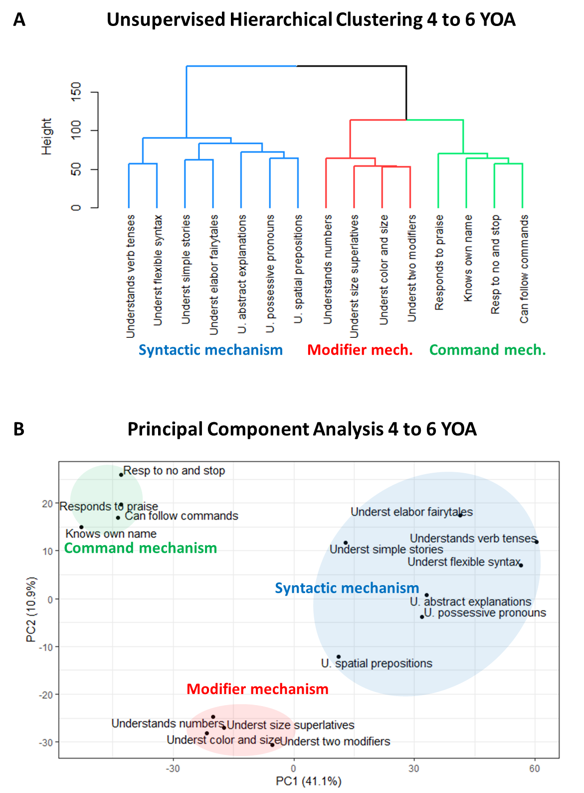
Figure S1. Clustering analysis of language comprehension items limited to 7,971 participants (4 to 6 years of age. (A) The dendrogram representing the hierarchical clustering of language comprehension abilities. (B) Principal component analysis of the 15 language comprehension abilities shows a clear separation between command, modifier, and syntactic items.

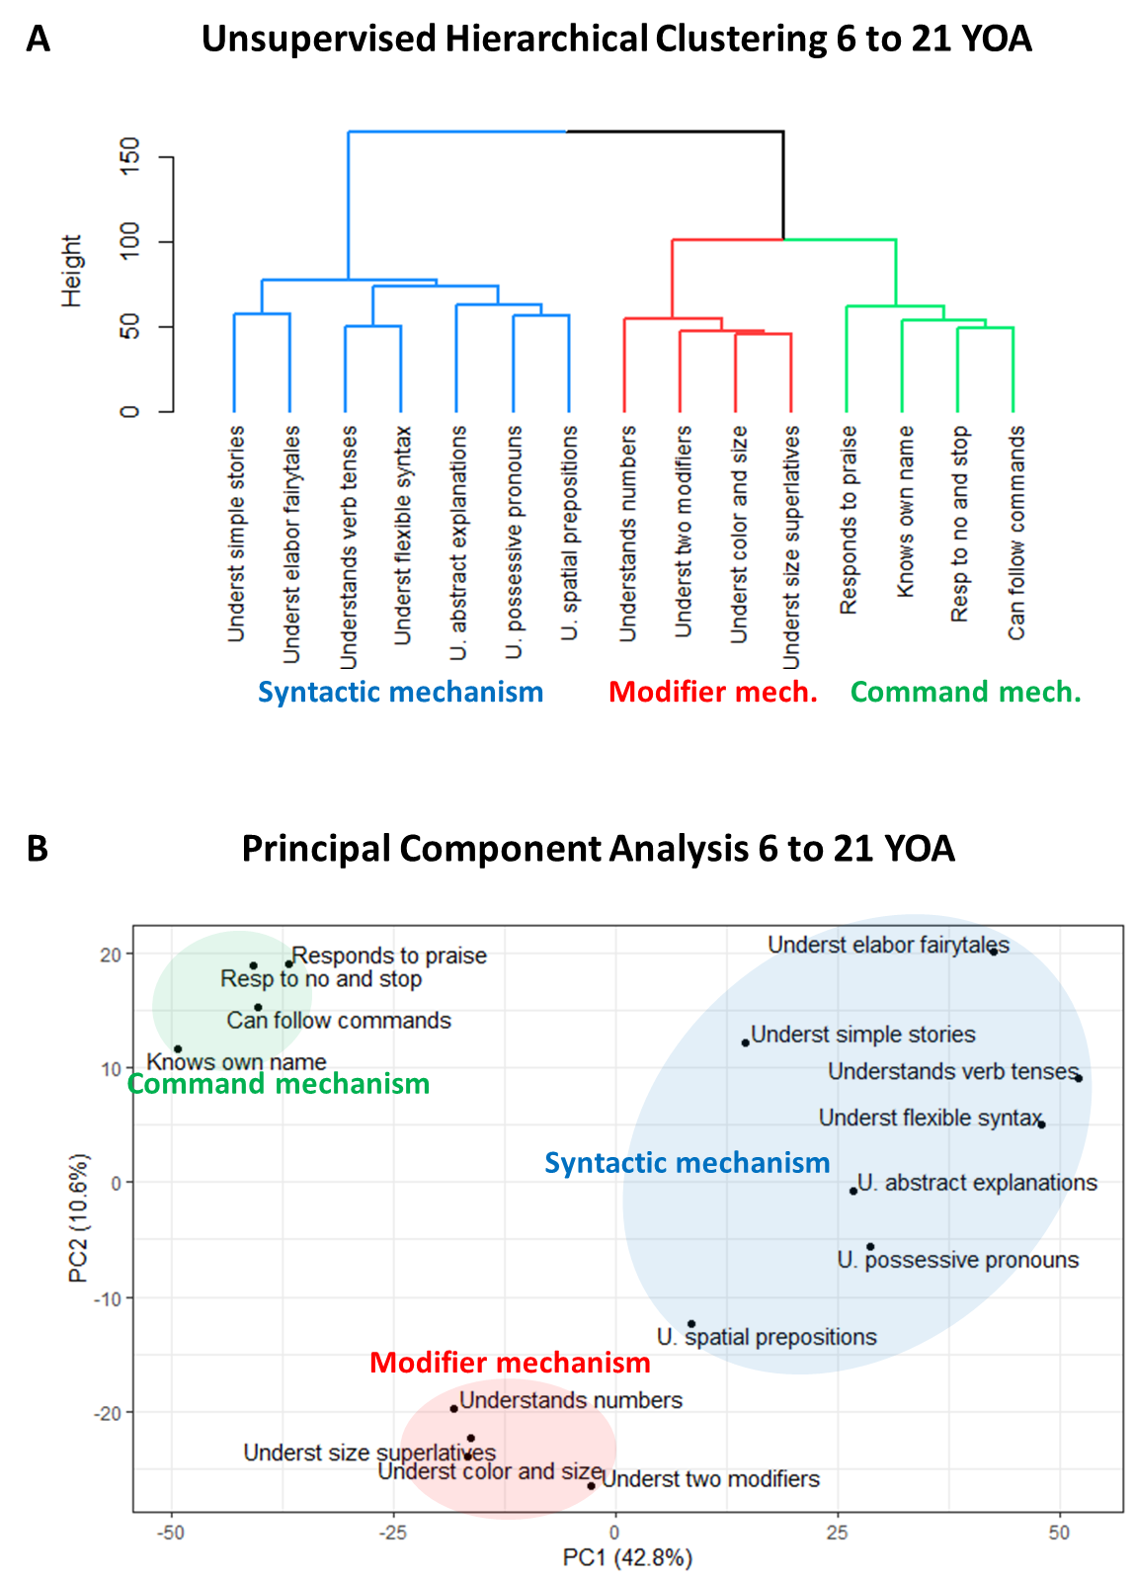
Figure S2. Clustering analysis of language comprehension items limited to 6,308 participants (6 to 21 years of age). (A) The dendrogram representing the hierarchical clustering of language comprehension abilities. (B) Principal component analysis of the 15 language comprehension abilities shows a clear separation between command, modifier, and syntactic items.

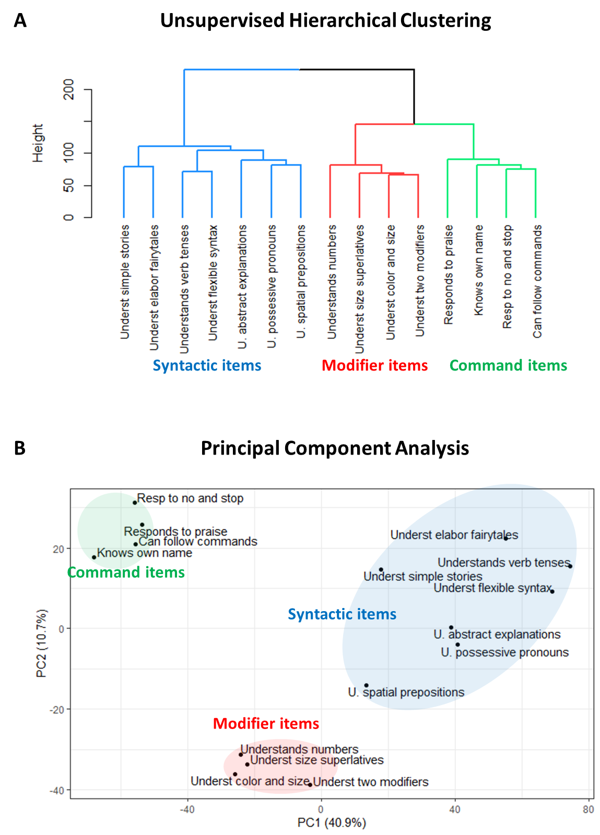
Figure S3. Clustering analysis of language comprehension items (14,279 participants, 4 to 21 years of age, first evaluation). (A) The dendrogram representing the hierarchical clustering of language comprehension abilities. (B) Principal component analysis of the 15 language comprehension abilities shows a clear separation between command, modifier, and syntactic items.

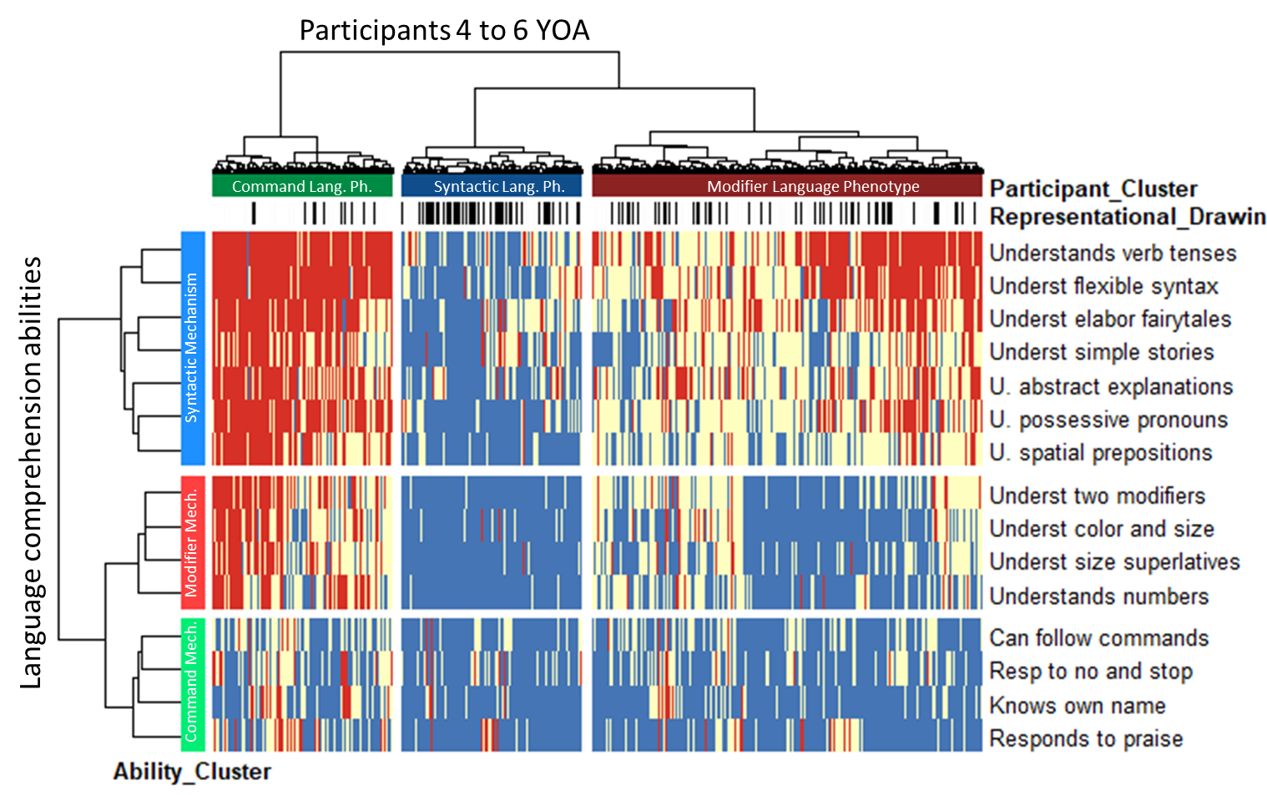

Figure S4. Two-dimensional heatmap relating 7,971 participants (4 to 6 years of age) to their language comprehension abilities. The 15 language comprehension abilities are shown as rows. The dendrogram representing language comprehension abilities is shown on the left. Participants are shown as 7,971 columns. The dendrogram representing participants is shown on the top. Blue color indicates the presence of a skill (the “very true” answer), red indicates the lack of skill (the “not true” answer), and white indicates the “somewhat true” answer. The representational drawing ability is indicated by short black vertical marks above the heatmap (marked Representational_drawing).

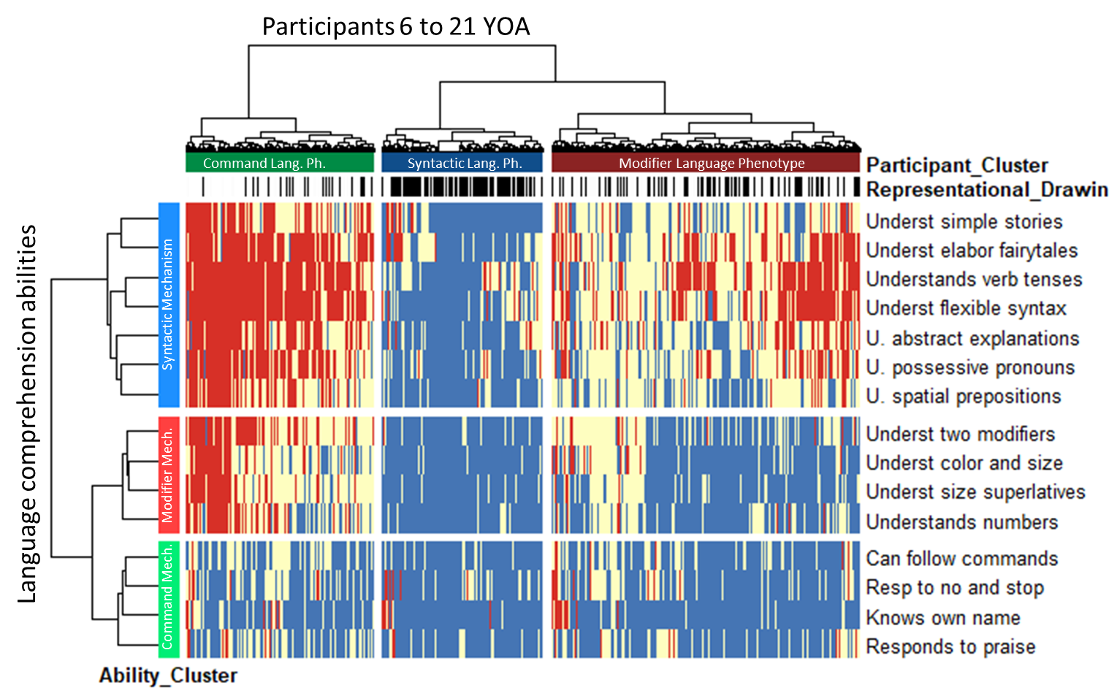

Figure S5. Two-dimensional heatmap relating 6,308 participants (6 to 21 years of age) to their language comprehension abilities. The 15 language comprehension abilities are shown as rows. The dendrogram representing language comprehension abilities is shown on the left. Participants are shown as 6,308 columns. The dendrogram representing participants is shown on the top. Blue color indicates the presence of a skill (the “very true” answer), red indicates the lack of skill (the “not true” answer), and white indicates the “somewhat true” answer. The representational drawing ability is indicated by short black vertical marks above the heatmap (marked Representational_drawing).

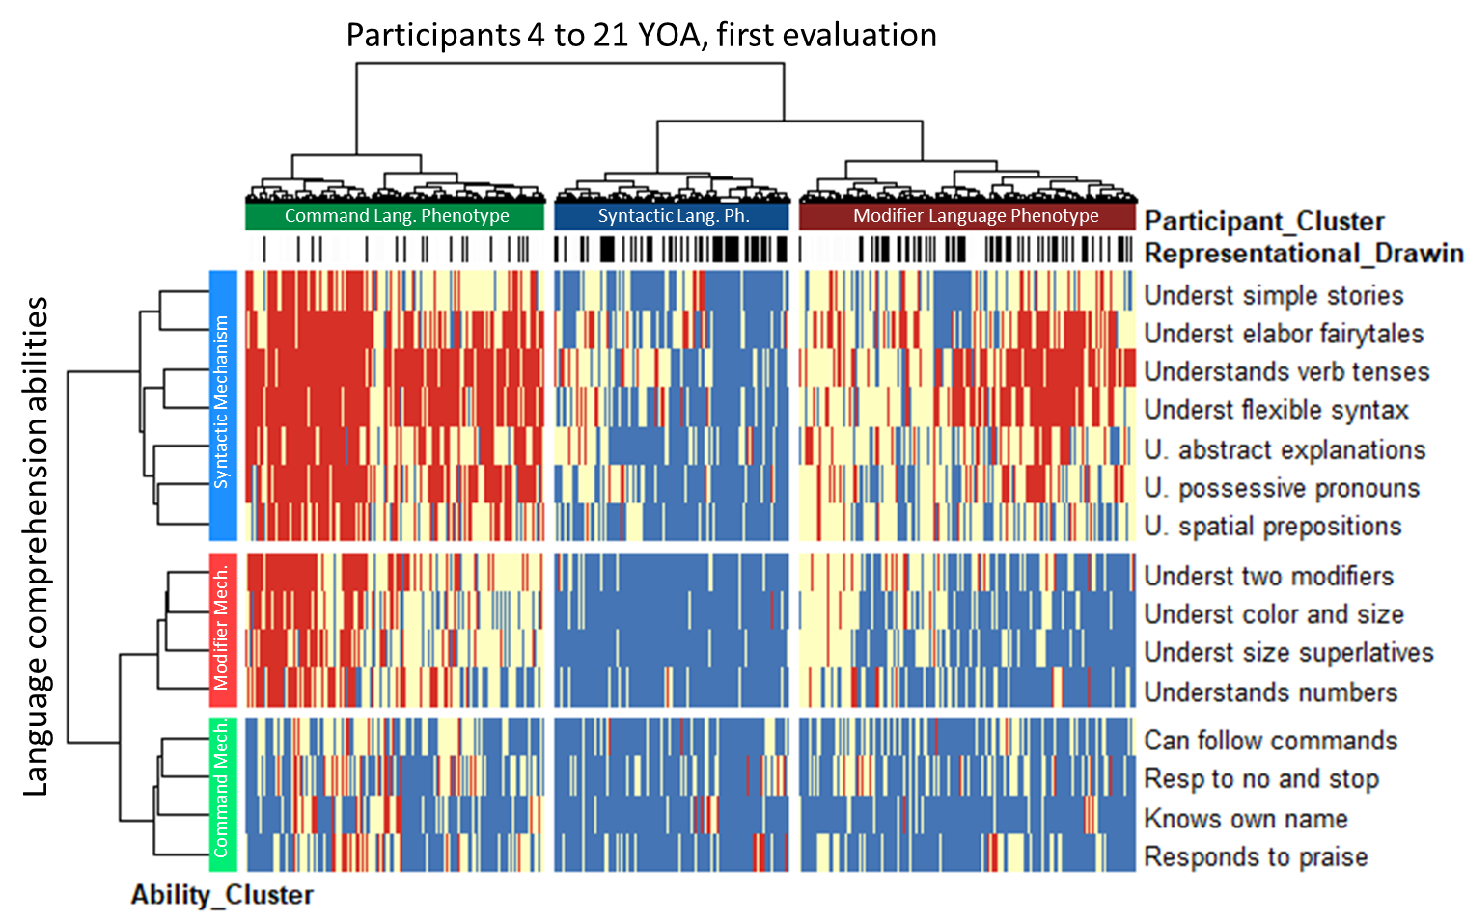
Figure S6. Two-dimensional heatmap relating 14,279 participants (4 to 21 years of age, first evaluations) to their language comprehension abilities. The 15 language comprehension abilities are shown as rows. The dendrogram representing language comprehension abilities is shown on the left. Participants are shown as 14,279 columns. The dendrogram representing participants is shown on the top. Blue color indicates the presence of a skill (the “very true” answer), red indicates the lack of skill (the “not true” answer), and white indicates the “somewhat true” answer. The representational drawing ability is indicated by short black vertical marks above the heatmap (marked Representational_drawing).

 | Syntactic Language Phenotype | Modifier Language Phenotype | Command Language Phenotype | Total
Number of participants per cluster | 1908 | 4141 | 1922 | 7971
Number of participants with the representational drawing ability | 925 | 1018 | 195 | 2138
Percent (%) | 48.5 | 24.6 | 10.1 | 26.8
Table S1. In children 4 to 6 years of age, the representational drawing ability, determined by a caregiver answering “very true” to the question “[My child] draws a VARIETY of RECOGNIZABLE images (objects, people, animals, etc.).

 | Syntactic Language Phenotype | Modifier Language Phenotype | Command Language Phenotype | Total
Number of participants per cluster | 1541 | 2959 | 1808 | 6308
Number of participants with the representational drawing ability | 982 | 1039 | 305 | 2326
Percent (%) | 63.7 | 35.1 | 16.9 | 36.9
Table S2. In children 6 to 21 years of age, the representational drawing ability, determined by a caregiver answering “very true” to the question “[My child] draws a VARIETY of RECOGNIZABLE images (objects, people, animals, etc.).

 | Syntactic Language Phenotype | Modifier Language Phenotype | Command Language Phenotype | Total
Number of participants per cluster | 1908 | 4141 | 1922 | 7971
Number of participants with the drawing-to-description ability | 541 | 274 | 37 | 852
Percent (%) | 28.4 | 6.6 | 1.9 | 10.7
Table S3. In children 4 to 6 years of age, the drawing-to-description ability, determined by a caregiver answering “very true” to the question “[My child] can draw a NOVEL image following YOUR description (e.g. a three-headed horse).”

 | Syntactic Language Phenotype | Modifier Language Phenotype | Command Language Phenotype | Total
Number of participants per cluster | 1541 | 2959 | 1808 | 6308
Number of participants with the drawing-to-description ability | 697 | 346 | 60 | 1103
Percent (%) | 45.2 | 11.7 | 3.3 | 17.5
Table S4. In children 6 to 21 years of age, the drawing-to-description ability, determined by a caregiver answering “very true” to the question “[My child] can draw a NOVEL image following YOUR description (e.g. a three-headed horse).”

