Supplementary Materials for
Increasing endogenous PPARγ ligand 15-keto-PGE₂ improves insulin sensitivity and protects against diet-induced obesity without side effects of thiazolidinediones

Yi-Cheng Chang, Meng-Lun Hsieh, Lun Kelvin Tsou, Shih-Yi Chen, Ming-Shiu Hung, Yi-Yu Ke, Siow-Wey Hee, Hsiao-Lin Lee, Jiun-Yi Nong, Fu-Hsin Hung, Jing-Yong Huang, Fang-Chi Kao, Wei-Shun Yang, Chu-Hsuan Chiu, Shih-Yao Lin, Bi-Yu Liu, Chi-Ming Tai, Fu-An Li, Yet-Ran Chen, Ya-Wen Chou, Jamie Cheng, Yvonne Shih, Chih-Neng Hsu, Juey-Jen Hwang, Teng-Kuang Yeh, Ting-Jen Rachel Cheng, Tzu-Yu Chen,Yu-Hua Tseng, Lee-Ming Chuang
*Corresponding author, e-mail: leeming@ntu.edu.tw
*Co-corresponding author, e-mail: yu-hua.tseng@joslin.harvard.edu

Supplementary information
Supplementary Methods
Supplementary Figure 1
Supplementary Figure 2
Supplementary Figure 3
Supplementary Figure 4
Supplementary Figure 5
Supplementary Figure 6
Supplementary Figure 7
Supplementary Figure 8
Supplementary Figure 9
Supplementary Figure 10
Supplementary Figure 11
Supplementary Figure 12
Supplementary Table 1
Supplementary Table 2
Supplementary Table 3
Supplementary Table 4
Supplementary Table 5
Supplementary Methods
Pharmacokinetic studies
Male ICR mice weighing 25-30 g each were obtained from BioLASCO, Taiwan Co., Ltd., Ilan, Taiwan for pharmacokinetic study. Briefly, a single dose of BRRPT245 was given intravenously at 2 mg/kg or oral gavage at 10 mg/kg to the mice. Blood samples were taken at 0 (immediately before dosing), 2, 5 (iv only), 15 and 30 min and at 1, 2, 4, 6, 8, 16 and 24 hr after administration. The T_{1/2} (half-life), Cl (clearance), Vss (steady-state volume of distribution), AUC (area under curve), C_{max} (maximum plasma concentration), T_{max} (time taken to reach C_{max}), and F (bioavailability,%)were calculated according to the published formula (1).
The steady levels of 15-keto-PGE₂ and BPRPT245 in plasma and fat tissue were performed by giving C57BL6/J mice 4 doses of BPRPT245 (100 mg/kg/day) once daily for4 days. Blood and perfused fat tissues were harvested 2 hours after the last dose.
The levels of 15-keto-PGE₂ and BPRPT245 were determined by high-performance liquid chromatography and tandem mass spectrometry. The HPLC system consisted of an Agilent 1200 series LC System with BinPump (Waldbronn, Germany) and a Agilent Eclipse XDB C8 (3.0*150 mm, 5 µm) interfaced to a Sciex API 4000 tandem mass spectrometer. Mobile phase consisted of 10 mM ammonium acetate containing 0.1% of formic acid (Solvent A) and acetonitrile (Solvent B). For determination of BPTPT245, the following stepwise gradient system was used: 85% A (0-0.5 min), 85% A to 15% A (0.6-3.0 min), 5% A (3.1-5.0 min). Total running time was 5 min. The retention times of BPRPT245 and BPR0L187 (internal standard) (IS) were 2.21 and 2.42 min, respectively. Data acquisition was via selected ion monitoring (SIM). The collision energy was +37V for the analyte and +38.5V for IS, respectively. The ions monitored for BPRPT245 were m/z 447/189 and m/z 357/195, respectively. For determination of 15-keto-PGE2, the gradient system was used: 90% A (0-0.5 min), 90% A to 10% A (0.5-4.5 min), 90% A (4.5-6 min). Total running time was 6 min. The retention times of 15-keto-PGE₂ and 13,14-dihydro-15-keto PGE₂-D4were3.27 and 3.33 min, respectively. Data acquisition was via SIM. The collision energy was -37V for 15-keto-PGE₂ and -20V for 13,14-dihydro-15-keto PGE2-D4, respectively. The ions monitored for 15-keto-PGE₂ and 13,14-dihydro-15-keto PGE₂-D4 were m/z 349.0/331.2 and m/z 355.1/337, respectively.
Sample preparation
To prepare 15-keto-PGE₂ serum samples, aliquot (60 µL) of serum was mixed with 120 µL of acetonitrile/0.1% formic acid;0.005%butylated hydroxytoluene solution containing 20 ng/mL of 13,14-dihydro-15-keto PGE₂-D4 as the IS. The mixture was vortexed for 30 seconds and then centrifuged at 15,000 rpm for 20 min in an Eppendorf Model 5417c centrifuge at room temperature. An aliquot (25 µL) of the mixture was then injected onto to LC-MS/MS.
To prepare the BPRPT245 plasma samples, 50 µL of the plasma sample mixed with 100 µL acetonitrile containing 250 µL of BPR0L187. The mixture was vortexed for 30 seconds and then centrifuged at 15,000 rpm for 20 min in an Eppendorf Model 5417c centrifuge at room temperature. An aliquot (5 µL) of the mixture was then injected onto to LC-MS/MS.
Necropsy, gross Examinations, and Histopathological examination :
The animals were sacrificed by exsanguination under anesthesia with pure carbon dioxide.
At necropsy, tissue samples of the submitted mice were collected and preserved in 10% neutral buffered formalin. The required tissues/organs of animals were trimmed, processed, and embedded in paraffin. Sections 3-5 μm in thickness were cut and put on slides for hematoxylin and eosin (H&E) staining. The histopathological evaluation was performed on the submitted tissues. Severity of lesions was graded according to the methods described by Shackelford et al (2). Degrees of lesions were graded histopathologically from one to five depending on severity (1 = minimal; 2 = slight; 3 = moderate; 4 = moderately severe; 5 = severe/high).

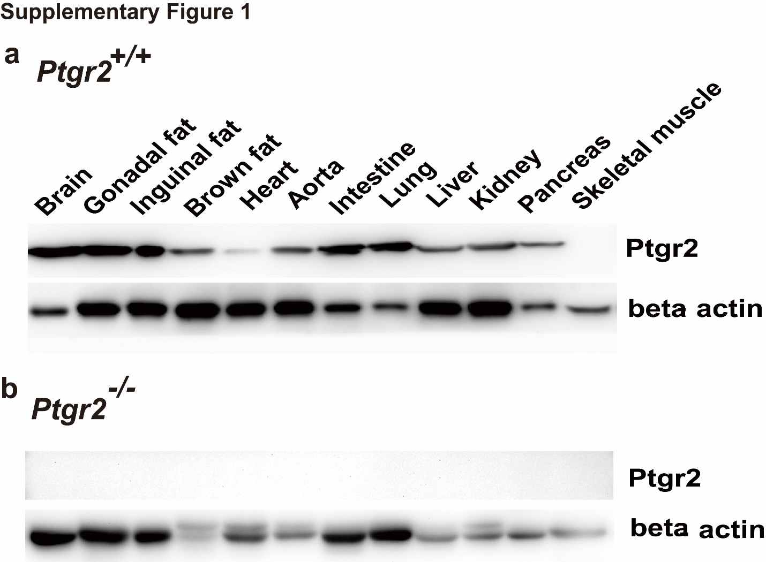
Supplementary Figure 1. PTGR2 expression in various tissues of a Ptgr2 ^{+/+} and b Ptgr2 ^{-/-} mice.
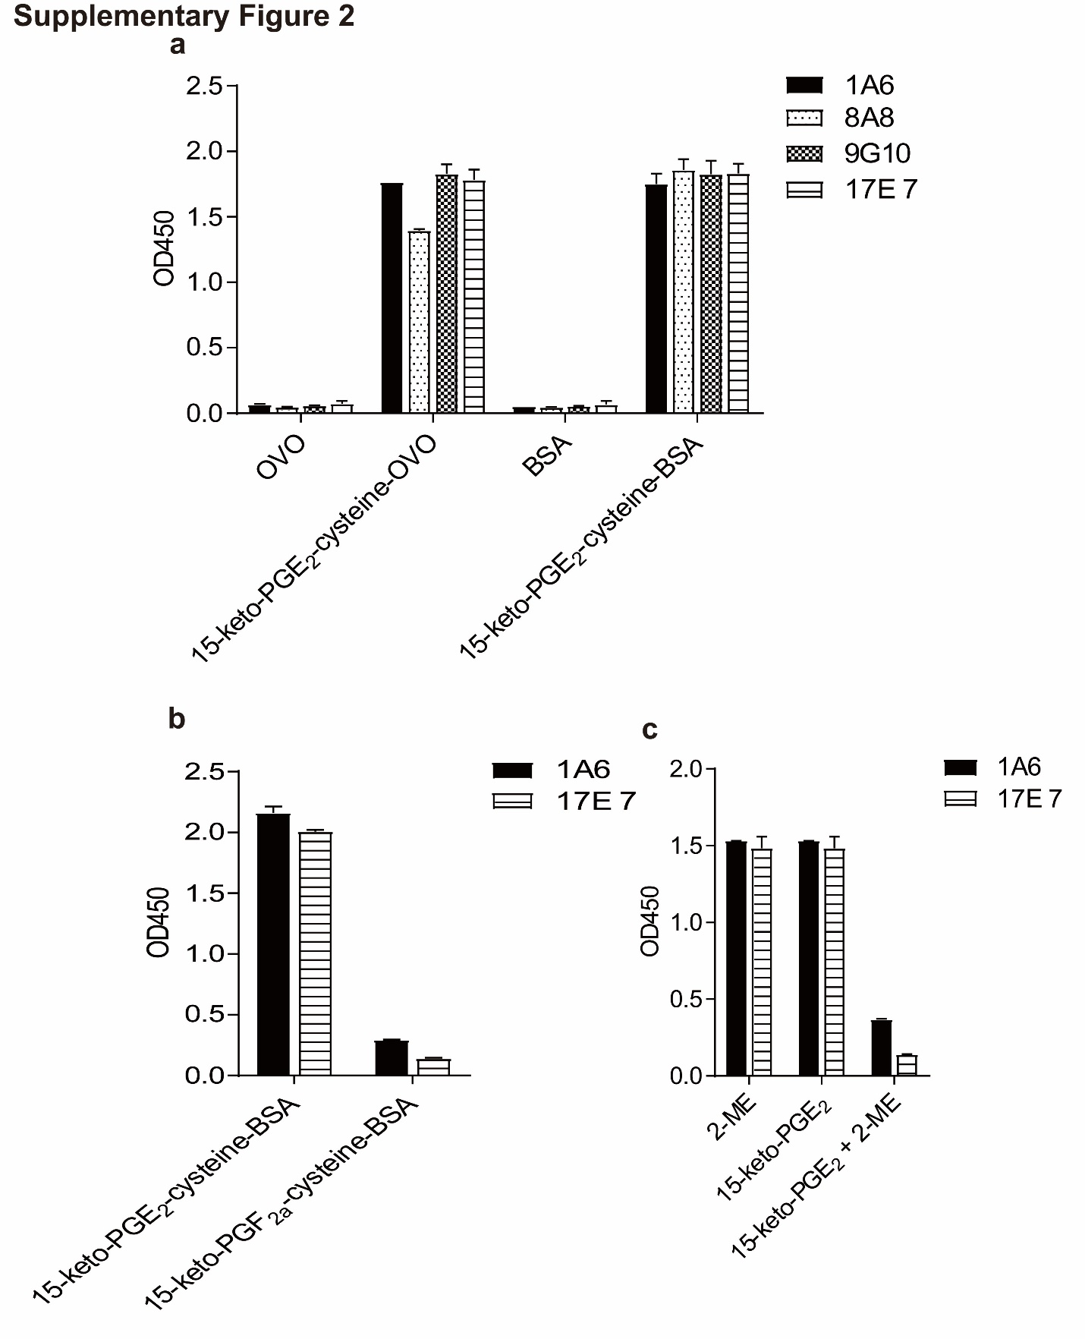
Supplementary Figure 2. Four anti-cysteine-coupled 15-keto-PGE₂ hybridoma clones were identified. a Clone 1A6 and 17E7 have superior specificity and b react only to cysteine-coupled 15-keto-PGE_{2.} c The specificity of monoclonal antibodies were examined using ELISA assays. Hybridoma culture supernatants were tested for the reactivity to different antigens coated onto micro-wells. To further test specificity, 10 nM 15-keto-PGE₂ was reduced with 2-ME. Reduced 15-keto-PGE₂ (10 nM), 15-keto-PGE₂ (10 nM), and 2-ME (20 nM) were mixed with 1 nM purified antibodies in PBS containing 1% BSA, respectively, and incubated at room temperature for 30 min. The antibody mixtures were then added into wells coated with 15-keto-PGE₂-cysteine-BSA for assays.
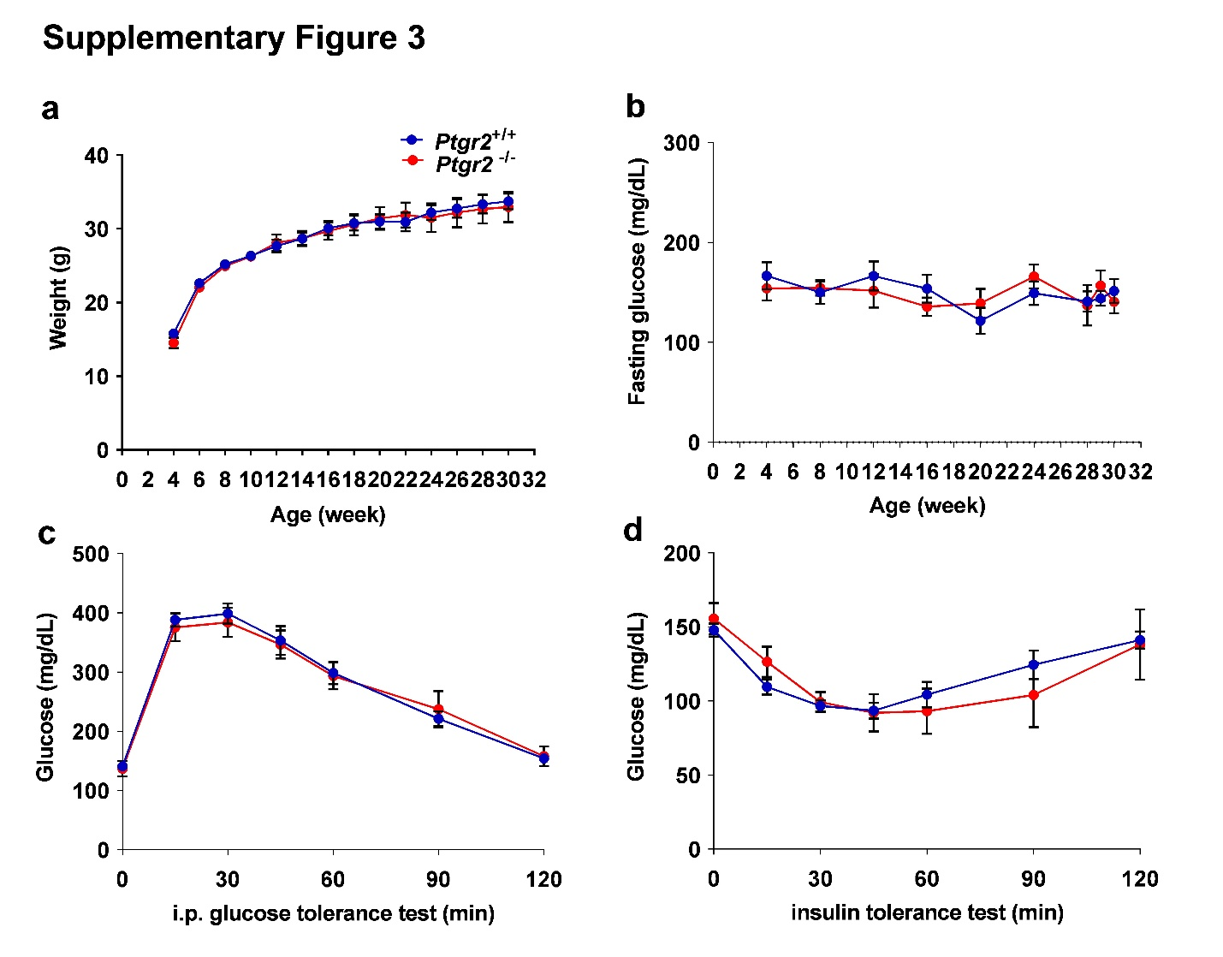
Supplementary Figure 3. a Body weight (n=44:42) , b fasting glucose (n=25:26), c glycemic level during intraperitoneal glucose tolerance test a (n=25:26) and d insulin tolerance test of Prgr2 ^{-/-} and Prgr2 ^{+/+} mice on chow diet (n=25:26) at the age of 30 weeks. * P < 0.05
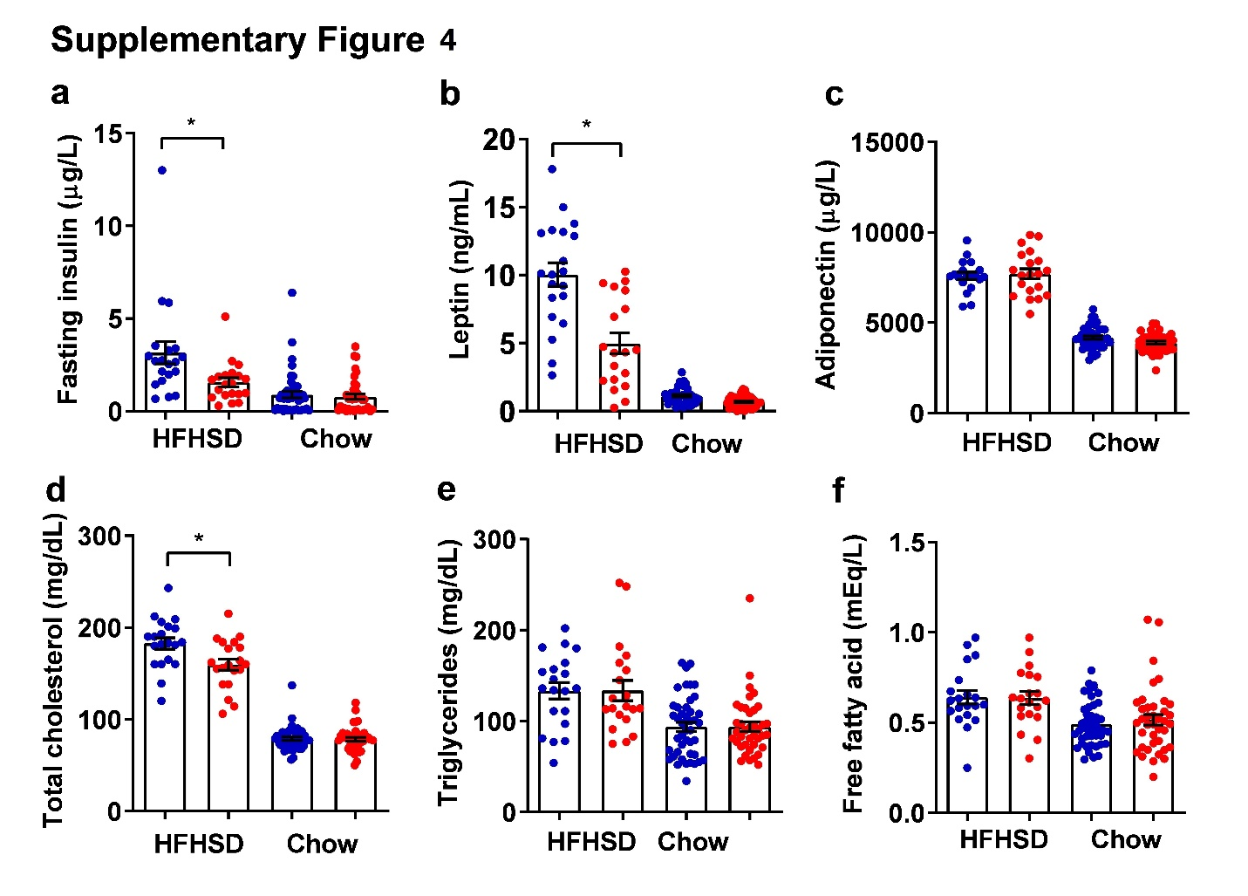
Supplementary Figure 4. a Fasting serum insulin, b leptin, c adiponectin, d total cholesterol, e triglycerides, and f free fatty acid of Ptgr2 ^{-/-} and Ptgr2 ^{+/+} mice on chow (n=44:38) or high-fat high-sucrose diet (HFHSD) (n=20:20) at the age of 30 weeks. The blue dot represents Ptgr2 ^{+/+} and the red dot represents Ptgr2^{-/-}. * P < 0.05.
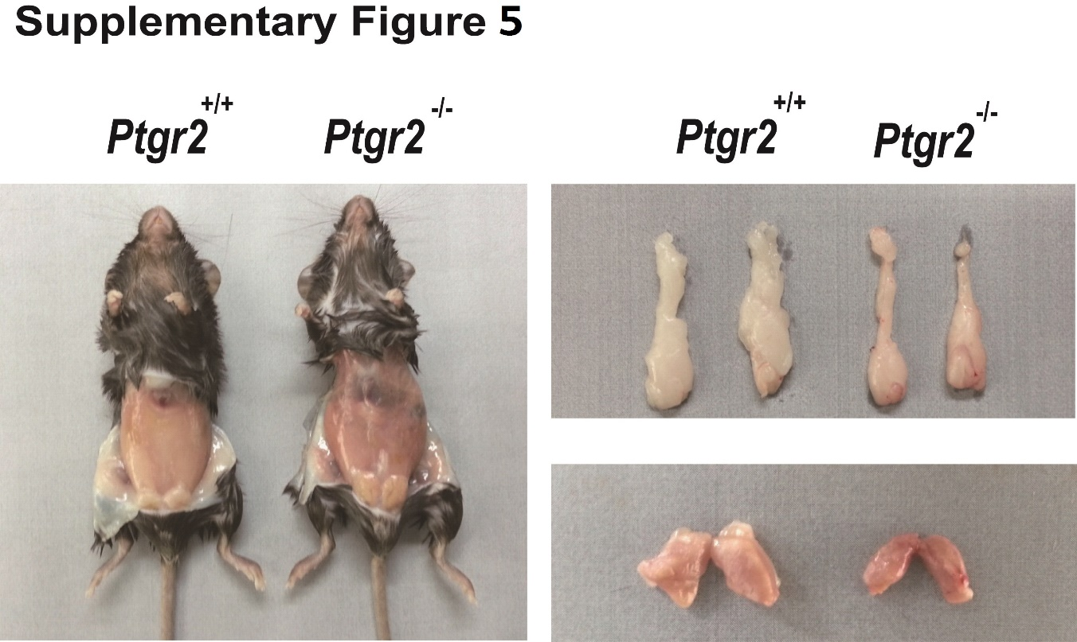
Supplementary Figure 5. Gross appearance (left panel), perigonadal fat (right upper), and brown fat (right lower panel) of Ptgr2 ^{-/-} mice and Ptgr2 ^{+/+} mice on high-fat high-sucrose diet.

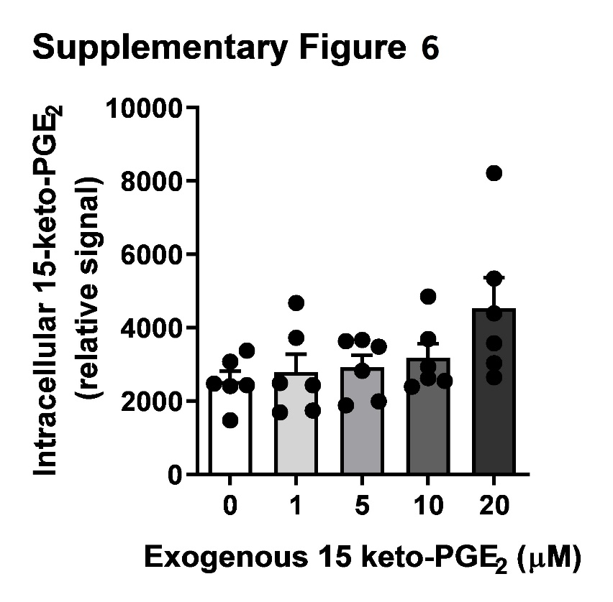
Supplementary Figure 6. Relative intracellular 15-keto-PGE₂ levels in cultured 3T3-L1 cells treated with exogenous 15-keto-PGE₂ of different concentrations.
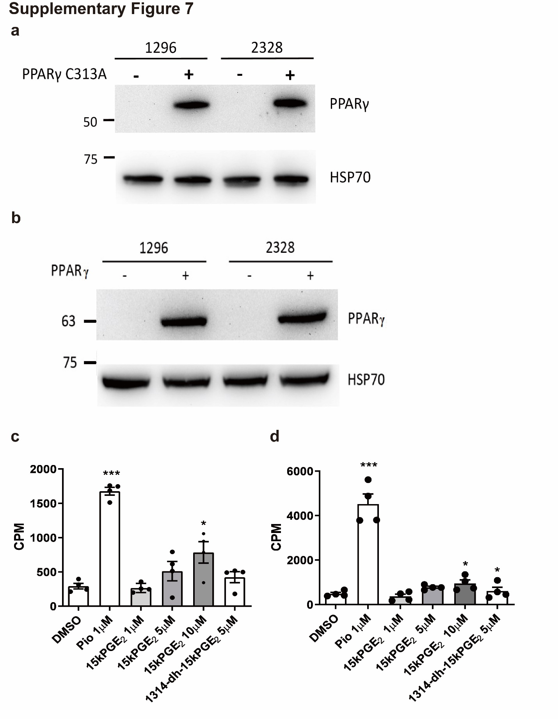
Supplementary Figure 7. a Immunoblots showing PPARγ expression in PPARγ-null 3T3-L1 clones #1296 and #2328 using the CRISPR techniques and then overexpress mutant PPARγ2 (C313A) or b wild-type PPARγ2. c 15-keto-PGE₂ enhanced insulin-stimulated glucose uptake in clone #2328 rescue with wild-type PPARγ but not in d #2328 clones rescued with mutant PPARγ (C313A) (n=4 per group). * P < 0.05, ***P<0.001

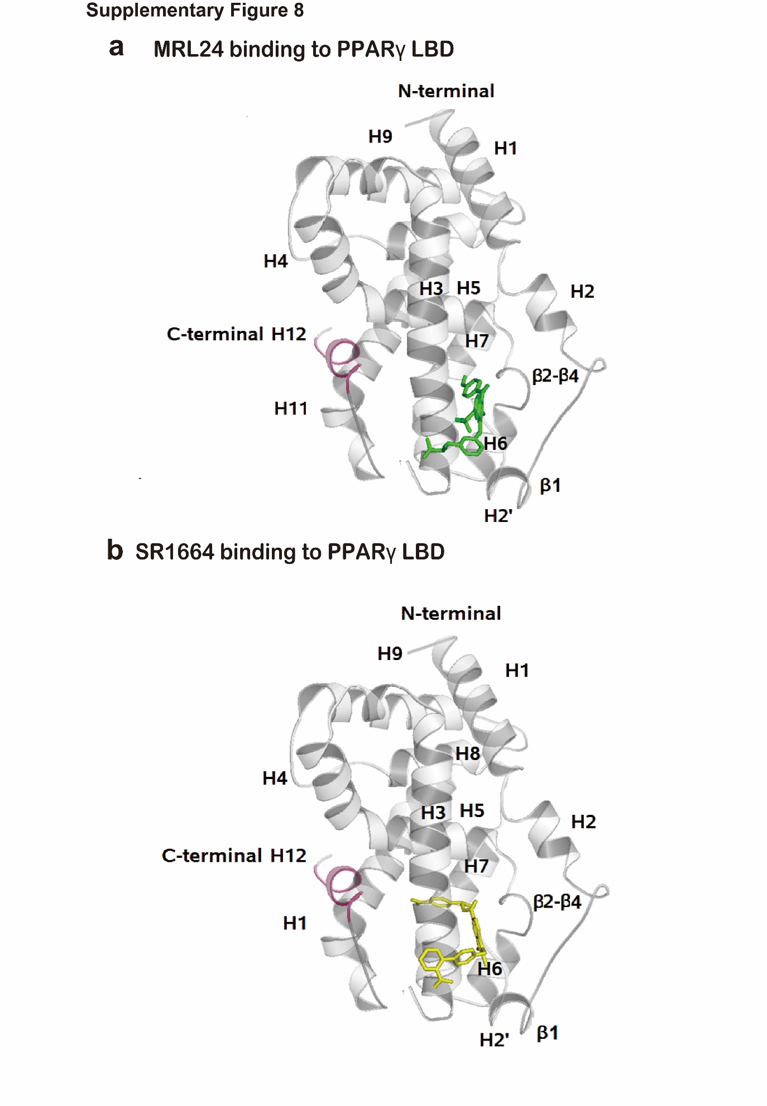
Supplementary Figure 8. Molecular docking using human PPARγ shows the binding pocket of the selective or partial PPARγ agonist a MRL24 (colored by green) and a SR1664 (colored by yellow) to the binding domain (LBD) of PPARγ. The C-terminal helix 12 is colored by purple.
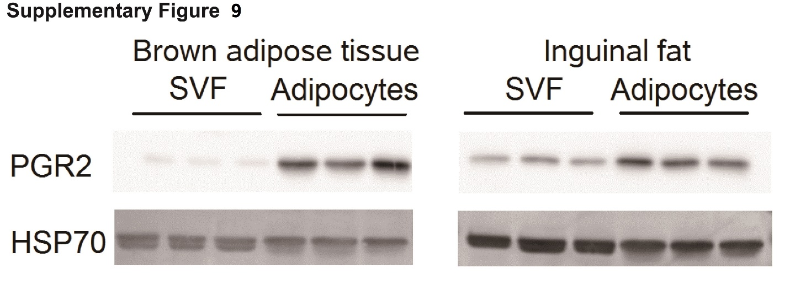
Supplementary Figure 9. Immunoblots showed the expression of Ptgr2 in the stromal vascular fraction (SVF) and adipocyte portions isolated from brown adipose tissue (left panel) and inguinal fat (right panel).
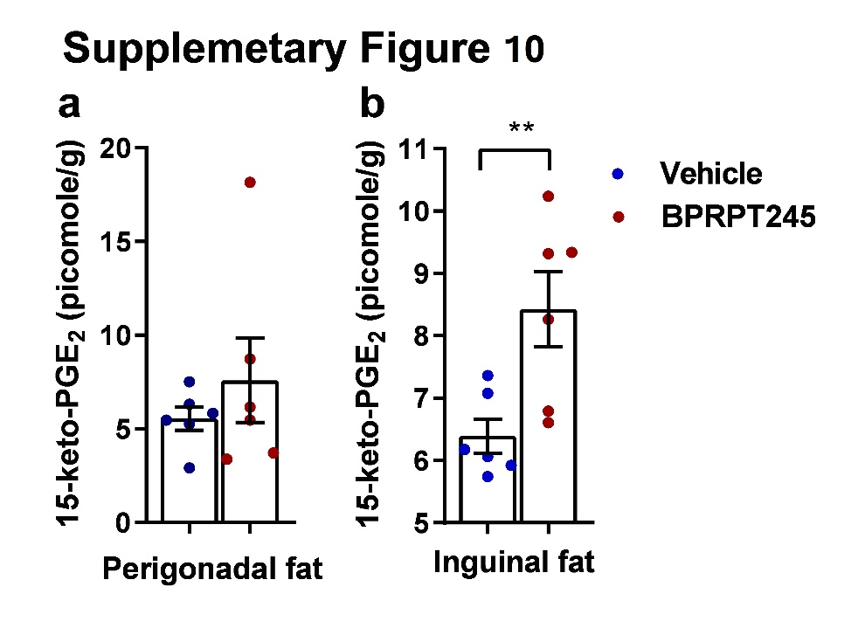
Supplementary Figure 10. 15-keto-PGE₂ concentration in perigonadal fat (n=6:6) and inguinal fat (n=6:6) after oral gavage of BPRPT245 100 mg/kg/day for 4 days. Samples are harvested 2 hours after the latest dose after perfusion.
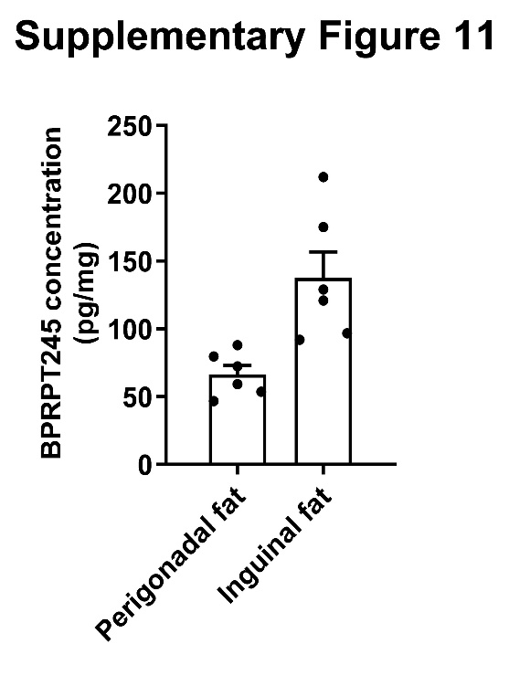
Supplementary Figure 11. BPRPT245 concentration in perigonadal fat (n=6:6) and inguinal fat (n=6:6) after oral gavage of BPRPT245 100 mg/kg/day for 4 days. Samples are harvested 2 hours after the latest dose after perfusion.
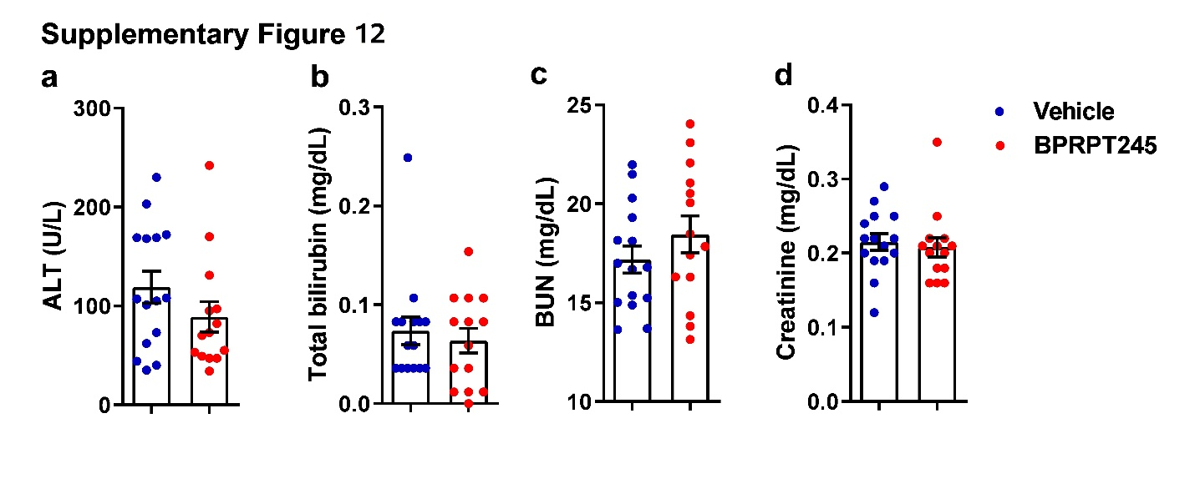
Supplementary Figure 12. Serum a alanine aminotransferase (ALT) b total bilirubin c blood urea nitrogen (BUN) d creatinine levels of C57BL6/J receiving vehicle and BPRPT (100mg/kg/day) (n=15:14)

Supplementary Table 1. RT-qPCR primer sequences
Gene | Gene ID | Forward primer (5’-3’) | Reverse primer (5’-3’)
Glut4  (Slc2a4) | 20528 | ACATACCTGACAGGGCAAGG | CGCCCTTAGTTGGTCAGAAG
Irs2 | 384783 | CACAATTCCAAGCGCCACAA | CATCACCTCCTCCCAGGGTA
Sorbs1 | 20411 | TGGACCAGACAAAGACATGGA | TTCCCCTGTAGGAAGACGAGG
Cd36 | 12491 | ATGGGCTGTGATCGGAACTG | GTCTTCCCAATAAGCATGTCTCC
Acs | 60525 | GCTGCCGACGGGATCAG | TCCAGACACATTGAGCATGTCAT
Cebpα | 12606 | GAACAGCAACGAGTACCGGGTA | GCCATGGCCTTGACCAAGGAG
Adipq | 11450 | TCCTGGAGAGAAGGGAGAGAAAG | CCCTTCAGCTCCTGTCATTCC
Ppia | 268373 | GCATACGGGTCCTGGCATCTTGTCC | ATGGTGATCTTCTTGCTGGTCTTGC

Supplementary Table 2. Primers for site-directed mutagenesis
 | Sequence (5’-3’)
Forward | CATCCGAATTTTTCAAGGGGCCCAGTTTCGATCCGTAGAA
Reverse | TTCTACGGATCGAAACTGGGCCCCTTGAAAAATTCGGATG

Supplementary Table 3. Sequence of sgRNAs
 | Sequence (5’-3’)
sgRNA1 | CGGCTTCTACGGATCGAAAC
sgRNA2 | GCACCCTTGAAAAATTCGGA

Supplementary Table 4. Pharmacokinetic study of BPRPT245 in mice.
Mouse IV (dose: 2mg/kg) |  |  |  | Mouse PO (dose: 10 mg/kg)
T_{1/2} (hr) | Cl  (mL/min/kg) | Vss  (L/kg) | AUC (0-inf)  (ng/mL*hr) | T_{1/2} (hr) | C_{max}  (ng/ml) | T_{max}  (hr) | AUC (0-inf)  (ng/mL*hr) | F(%)
2 | 79.5 | 5 | 480 | 2.5 | 398 | 0.4 | 725 | 30.2
T_{1/2}: half-life, Cl: clearance, Vss: steady-state volume of distribution, AUC: area under curve, C_{max}: maximum serum concentration, T_{max}: time take to reach C_{max}, F(%): bioavailability. (Unpublished data)

Supplementary Table 5. Pathological examination of major organs between mice receiving BPRPT245 and vehicles
Group | Control
Animal ID | C1 | C2 | C3 | C4 | C5
Brain, Forebrain | X | X | X | X | X
Brain, Midbrain | X | X | X | X | X
Brain, Cerebellum and Pons | X | X | X | X | X
Heart
Inflammatory cell infiltration/Cardiomyopathy | 1 | 1 | 1 | 1 | 1
Vacuolation, cardiomyocyte | 1 | 1 | 1 | - | 1
Lung
Inflammatory cell infiltration, perivascular | 2 | 2 | 2 | 1 | X
Alveolar epithelium hyperplasia | - | - | 2 | - | X
Chronic inflammation, focal | - | 1 | - | 1 | X
Liver
Steatosis | 3 | 3 | 3 | 3 | 4
Inflammation | 2 | 1 | 2 | 2 | 2
Lymphocytic cell infiltration, perivascular | - | 2 | 2 | - | 1
Hepatocellular adenoma, multiple | - | - | + | - | -
Kidney
Tubular degeneration/regeneration with inflammatory cell infiltration | 2 | 2 | 2 | 2 | 2
Inflammatory cell infiltration, peripelvic /perivacscular | 2 | 2 | 2 | 2 | 2
Hyaline cast, renal tubule | 1 | - | 1 | 1 | 1
Cytoplasmic vacuolation, renal tubule | 2 | 2 | 2 | 2 | 2
Mineralization, renal tubule | 1 | - | 1 | - | -
Pancreas
Atrophy and accumulation adipocyte, acinar cell | - | - | 4 | - | -
Pancreatic islets hyperplasia | - | - | - | 2 | -
Lymphocytic infiltration, perivascular | 1 | 1 | 1 | 2 | -
Fat infiltration, exocrine | 2 | - | - | 2 | 1
Brown fat (largely in dorsal intrascapular region)
Increased adipocyte size | + | - | + | + | +
White fat (Perigonadal fat)
Inflammatory cell infiltration | 1 | - | 1 | - | 1
Bone marrow, Sternum/ Femur | X | X
Mineralization, focal |  |  | 2 | - | -
Cellularity, decreased, bone marrow |  |  | - | 2 | 1

Group | Test
Animal ID | T1 | T2 | T2 | T4
Brain, Forebrain | X | X | X | X
Brain, Midbrain | X | X | X | X
Brain, Cerebellum and Pons | X | X | X | X
Heart
Inflammatory cell infiltration/Cardiomyopathy | 2 | 1 | 2 | 2
Vacuolation, cardiomyocyte | - | - | - | 2
Lung
Inflammatory cell infiltration, perivascular | 1 | 1 | 2 | 2
Alveolar epithelium hyperplasia | 2 | - | - | -
Chronic inflammation, focal | 1 | - | 1 | -
Liver
Steatosis | 2 | 4 | 2 | 4
Inflammation | 1 | 2 | 1 | 2
Lymphocytic cell infiltration, perivascular | 1 | 1 | 2 | 2
Hepatocellular adenoma, multiple | - | - | - | -
Kidney
Tubular degeneration/regeneration with inflammatory cell infiltration | 2 | 2 | 2 | 2
Inflammatory cell infiltration, peripelvic /perivacscular | 2 | 1 | 2 | 2
Hyaline cast, renal tubule | 1 | - | - | -
Cytoplasmic vacuolation, renal tubule | 2 | - | 2 | 2
Mineralization, renal tubule | 1 | - | - | -
Pancreas
Atrophy and accumulation adipocyte, acinar cell | - | - | - | -
Pancreatic islets hyperplasia | 1 | 1 | - | -
Lymphocytic infiltration, perivascular | - | - | 2 | 2
Fat infiltration, exocrine | 2 | 1 | 2 | 1
Brown fat (largely in dorsal intrascapular region)
Increased adipocyte size | + | + | + | +
White fat (Perigonadal fat) | X | X
Inflammatory cell infiltration |  |  | 1 | 2
Bone marrow, Sternum/ Femur | X |  | X | X
Mineralization, focal |  | -
Cellularity, decreased, bone marrow |  | -
Infiltration, lymphocyte |  | 1
+ = Present; - =Not present; X=Not remarkable lesion. Degrees of lesions were graded histopathologically from one to five depending on severity (1 = minimal (< 1%); 2 = mild (1–25%); 3 = moderate (26–50%); 4 = moderately severe (51–75%); 5 = severe/high 0 (76–100%).
Gross examinations were summarized as follows: (1) smaller than usual size of the pancreas - The lesion was observed in control mouse (ID: C3). Histopathologically, the pancreas showed exocrine atrophy and fat infiltration. (2) pale discoloration of the liver - The lesion was observed in 2 mice of test group and 5 mice of control group. Histopathologically, the liver showed steatosis and inflammation. (3) small hepatic nodules (<3 mm) of the liver - Histopathologically, the liver showed hepatocellular adenoma. The microscopic alterations were presented in Supplementary Table 5 as follows: 1. Histopathology changes related to the experimental outcomes (non-spontaneous lesions) (1). steatosis with inflammation of the liver (fatty change of liver). (2). cytoplasmic vacuolation of the renal tubule. (3). cardiomyocyte vacuolation. (4). fatty infiltration of exocrine pancreas (adipocyte accumulation). (5). diffuse atrophy of exocrine acini and replacement by adipose tissue. (6). Increase adipocyte size of the brown fat (largely in dorsal intrascapular region). 2. Lesions related to the spontaneous lesions. Several microscopic lesions were observed in organs of the submitted mice, but they were considered to be spontaneous developmental and aging lesions or congenital abnormality. It consisted of: cardiomyopathy/inflammatory cell infiltration, inflammatory cell infiltration at perivascular area in the lung, alveolar epithelium hyerplasia, focal chronic inflammation of the lung, lymphocytic cell infiltration at perivascular area in the liver, hepatocellular adenoma, tubular degeneration/regeneration with inflammatory cell infiltration of the kidney, inflammatory cell infiltration in peripelvic area, renal tubular focal mineralization of medulla, hyaline cast formation of the renal tubule, pancreatic islets hyperplasia, lymphocytic
infiltration at perivascular area in the pancreas, focal mineralization of the bone marrow
(femur) and decreased cellularity of the bone marrow (femur).
In conclusion, several microscopic changes in various tissues of treated and control animals were considered incidental spontaneous and ageing changes, and these were not related to the
test article administration.
References
- R. Urso, P. Blardi, G. Giorgi, A short introduction to pharmacokinetics. Eur Rev Med Pharmacol Sci 6, 33-44 (2002).
- Shackelford C, Long G, Wolf J, Okerberg C, Herbert R. Qualitative and quantitative analysis of nonneoplastic lesions in toxicology studies. Toxicol Pathol. 30:93-6 (2002).

