Table 1 Volcanic debris avalanche lithofacies related to structural units
Structural units | Descriptions | Volcanic debris avalanche lithofacies
Tutupaca ridges in Peru | The undulating contact between the interstratified pyroclastic units and the avalanche breccias, showing granular segregation and fingering instabilities along cross-sections within the Tutupaca ridge | 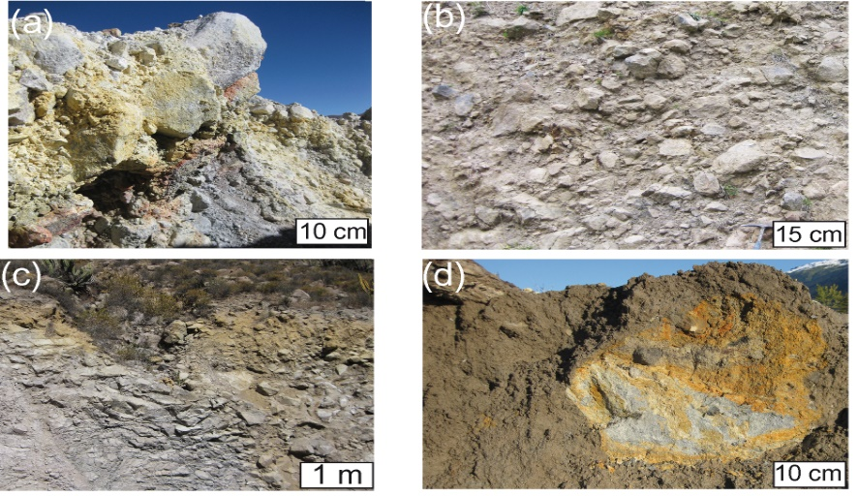
The basal backthrust along lateral levee in the French Massif Central | The cataclastic shear bands with granular segregations are observed in matrix breccias | 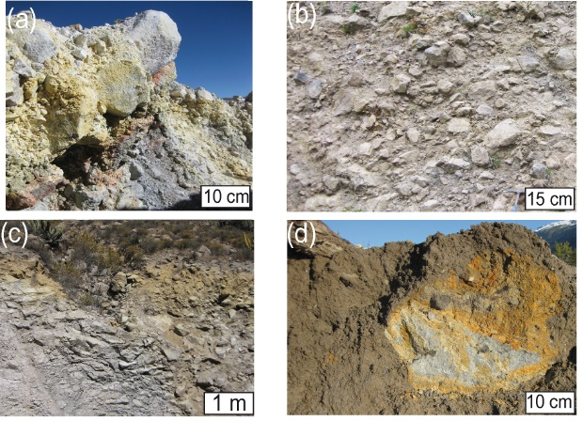
Distal graben structures from the Pichu Pichu volcanic complex in Peru | Graben structures are filled by the mixed matrix overlain by coarse- to medium-grained debris-flow deposits. Hyperconcentrated flow deposits are preserved in backward frontal thrusts  Coarse- to medium-grained debris-flow deposits ==> | 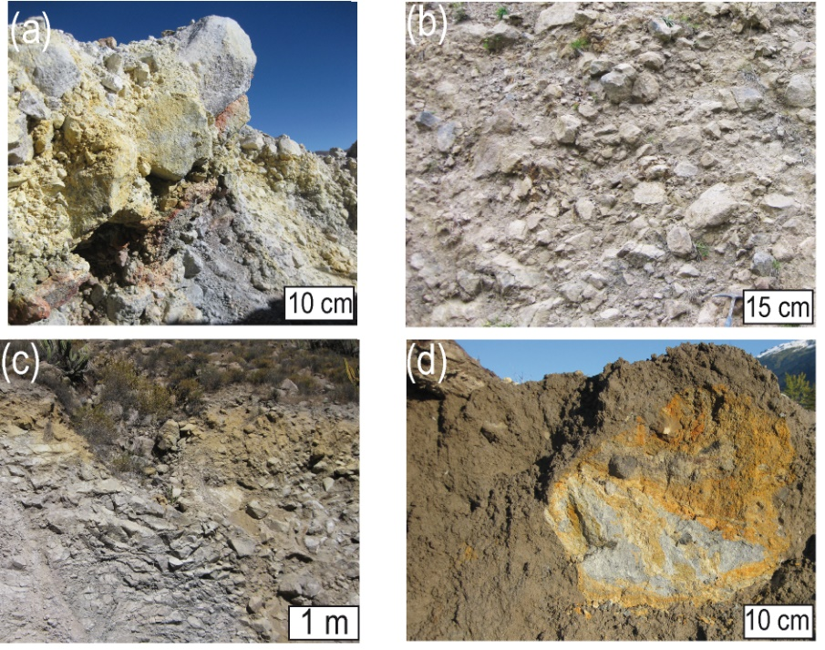
Along the frontal thrust lobe and in upstream diluted tail | Structural gradation of matrix breccias are observed with reverse grading in lithofacies assemblage The matrix transformation into debris flow at the confluence of the distal thrust lobe is associated with the impact wave and frontal surge in downstream areas (Meager in British Columbia and in the French Massif Central). | 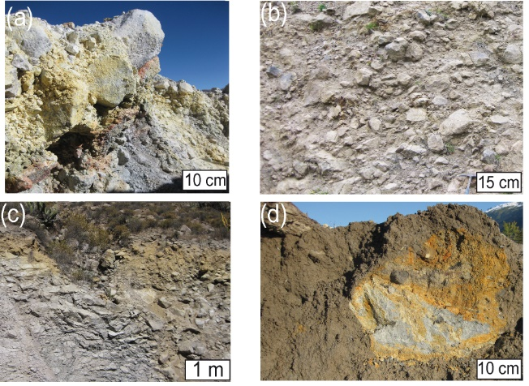
Upper sheared contact of rock-avalanche debris flow | Coating matrix, showing lava clasts with the rim and reverse grading (Meager in British Columbia), changes the initial granular distributions by increasing the clast size and aggregating the finer clayey fraction. The finer grain-size fraction disappears into the coating matrix. The proximal rock avalanche is transformed into a highly mobile debris flow (Bernard 2020). | 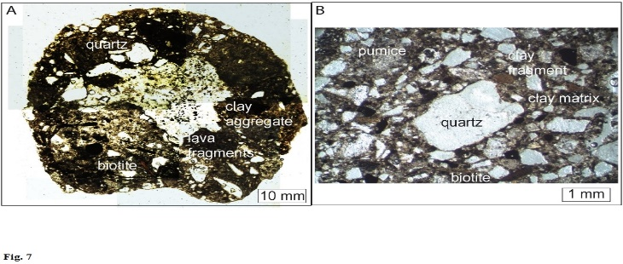
Basal contact of the distal matrix-rich debris avalanche in the French Massif Central | An assemblage of sub-rounded phenocrysts of quartz and feldspar in brown matrix are observed. Crush, comminution and frictional melting contribute to different matrix up to the distal transformations (Bernard and van Wyk de Vries 2017). | 