Supplementary material of “A statistical mechanics investigation of Unfolded Protein Response across organisms”

Nicole Luchetti^{1,2,*}, Keith M. Smith³, Margherita A. G. Matarrese¹, Alessandro Loppini⁴, Simonetta Filippi^{1,5,6,*}, Letizia Chiodo¹
¹ Department of Engineering, Università Campus Bio-Medico di Roma, Via Alvaro del Portillo 21, 00128 Rome, Italy
² Center for Life Nano- & Neuro-Science, Istituto Italiano di Tecnologia, Viale Regina Elena 291, 00161 Rome, Italy
³ Department of Sciences, University of Strathclyde, 16 Richmond Street, Glasgow, G1 1XQ, Scotland, UK
⁴ Department of Medicine and Surgery, Università Campus Bio-Medico di Roma, Via Alvaro del Portillo 21, 00128 Rome, Italy
⁵ National Institute of Optics, National Research Council, Largo Enrico Fermi 6, 50125 Florence, Italy
⁶ International Center for Relativistic Astrophysics Network, Piazza della Repubblica 10, 65122 Pescara, Italy

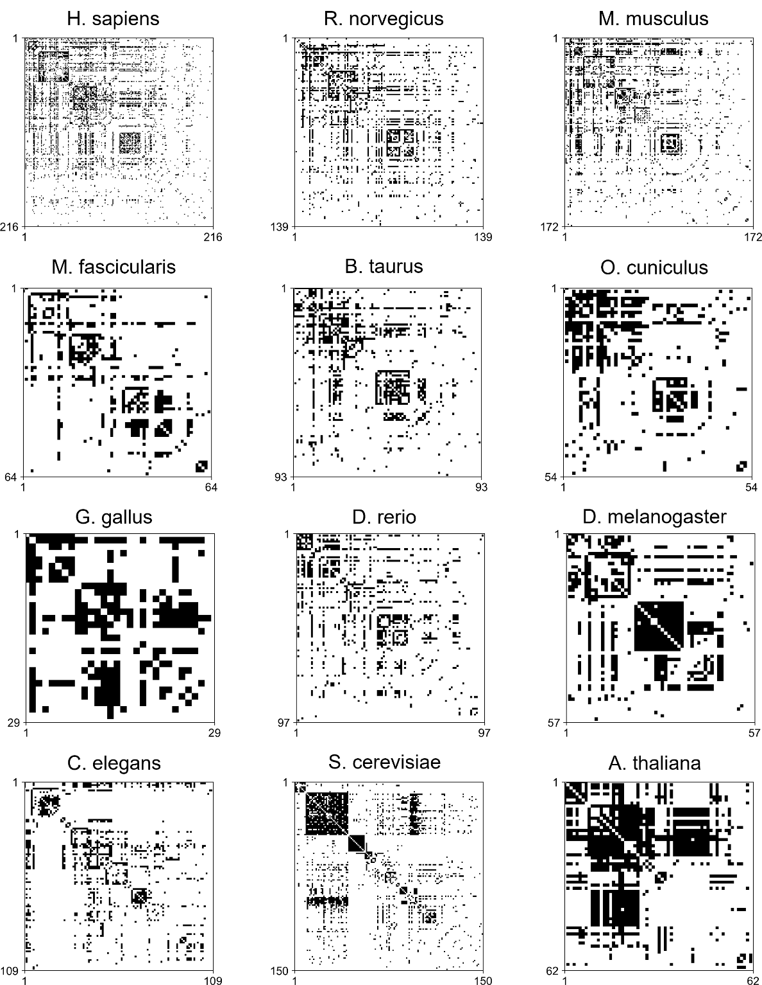

Figure S1: Matrix representation of native models.

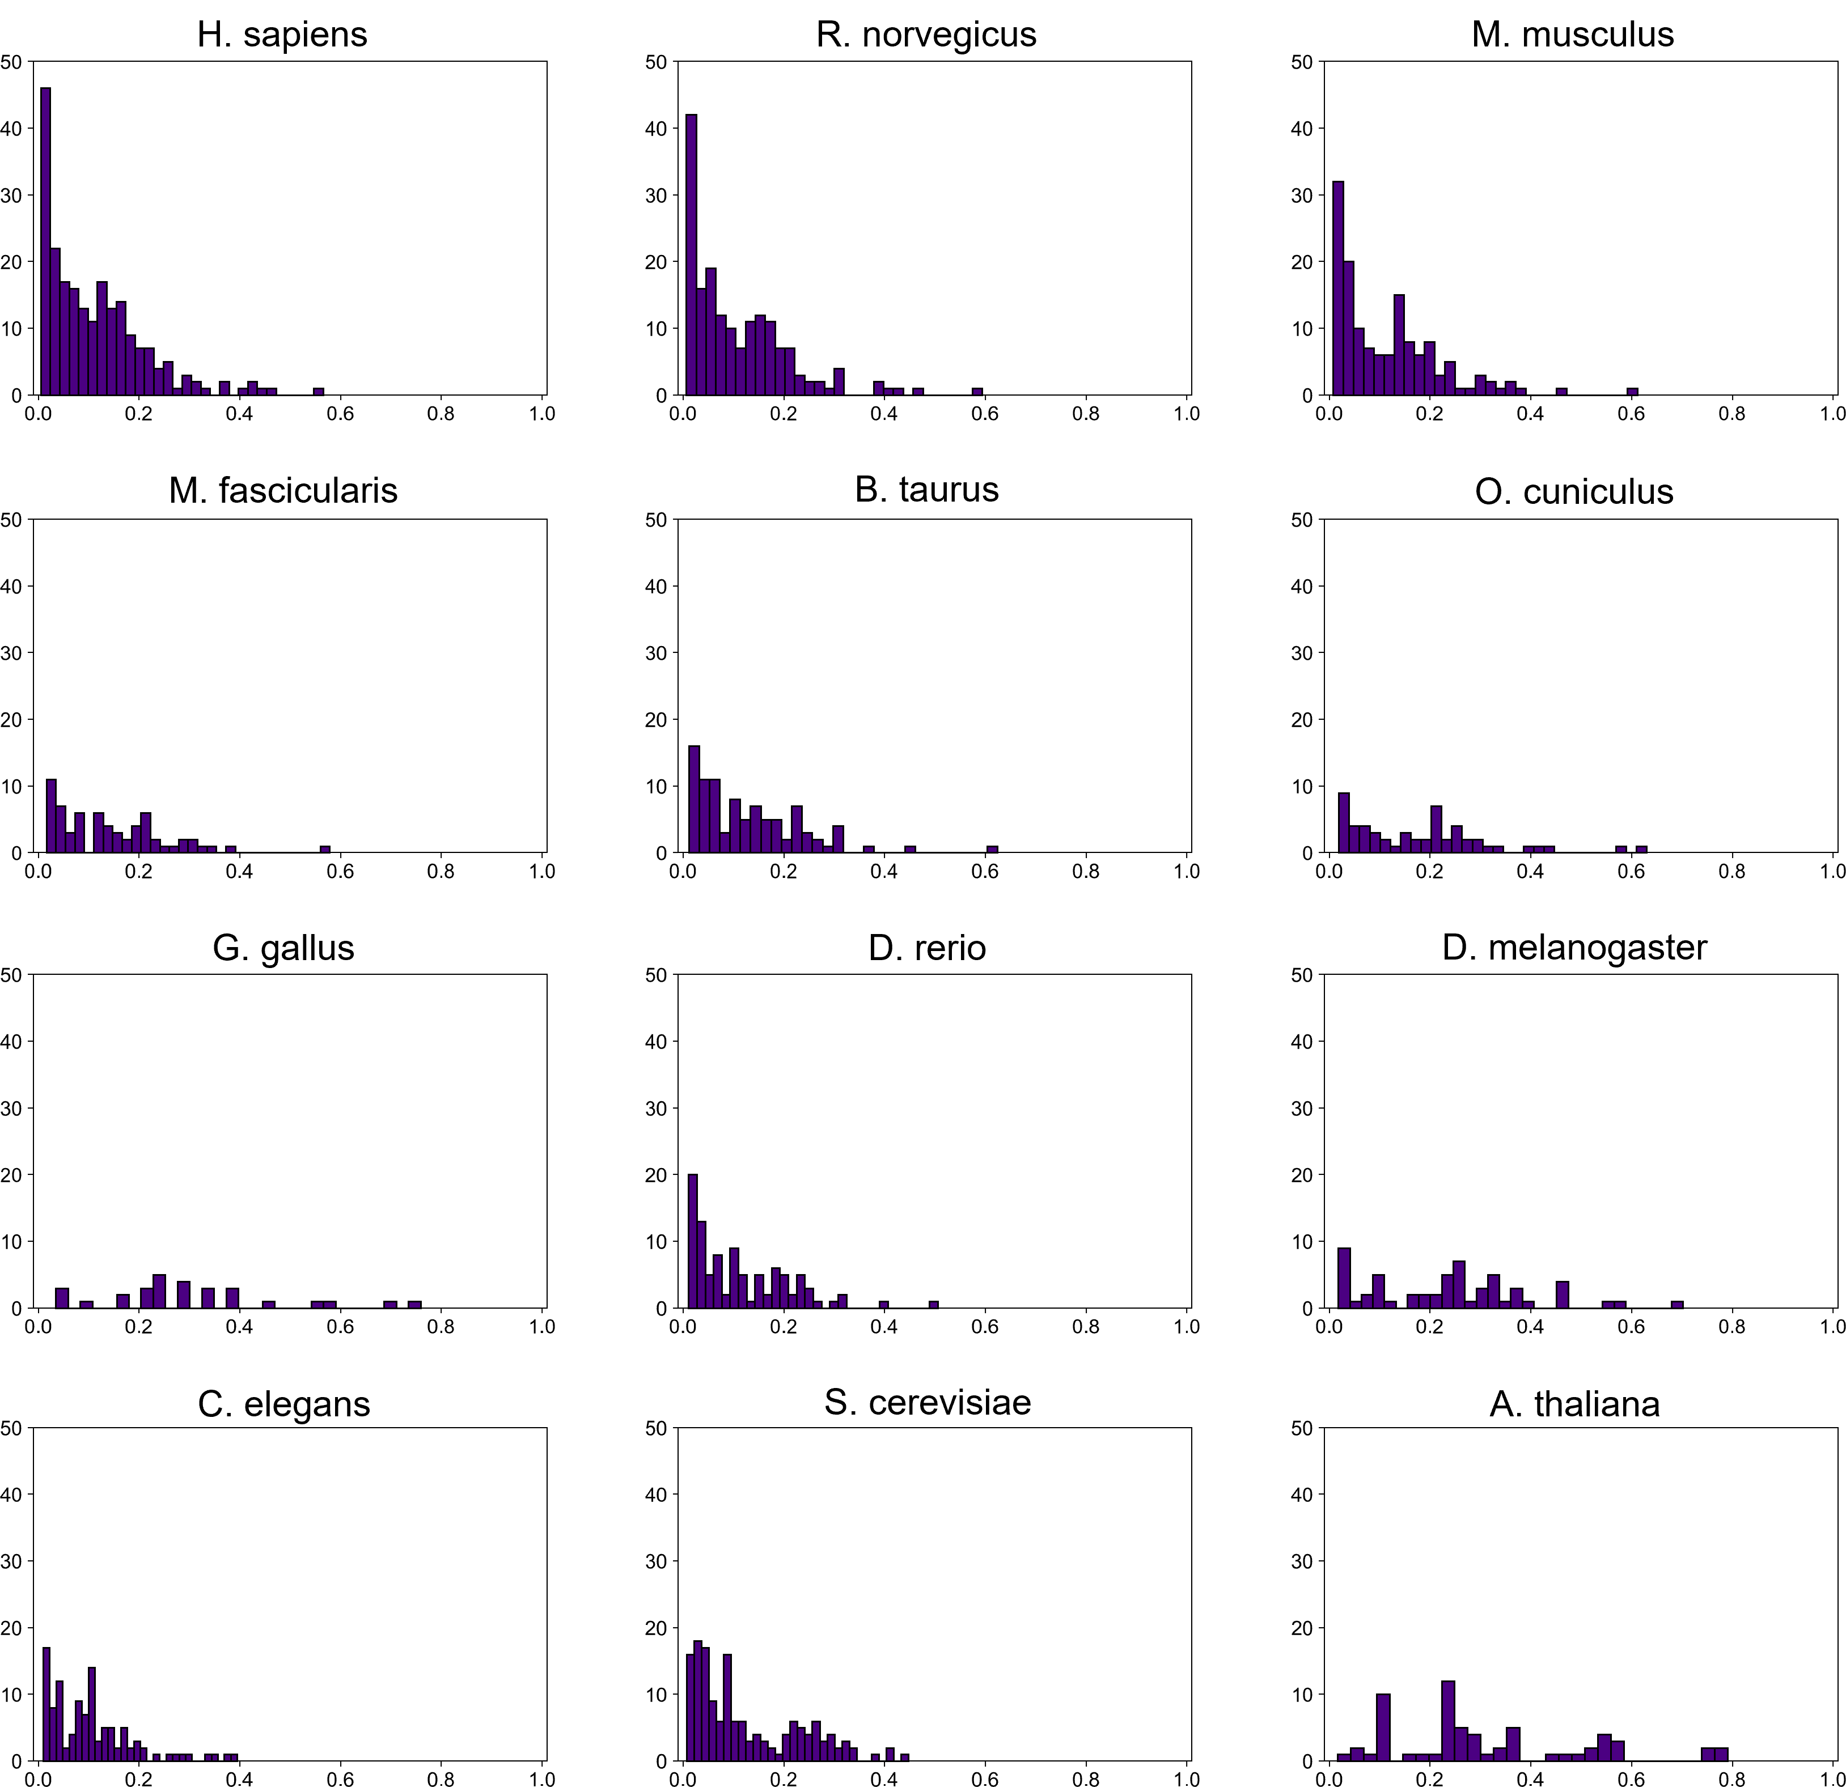
Figure S2: Normalized node-degree distributions of native models.

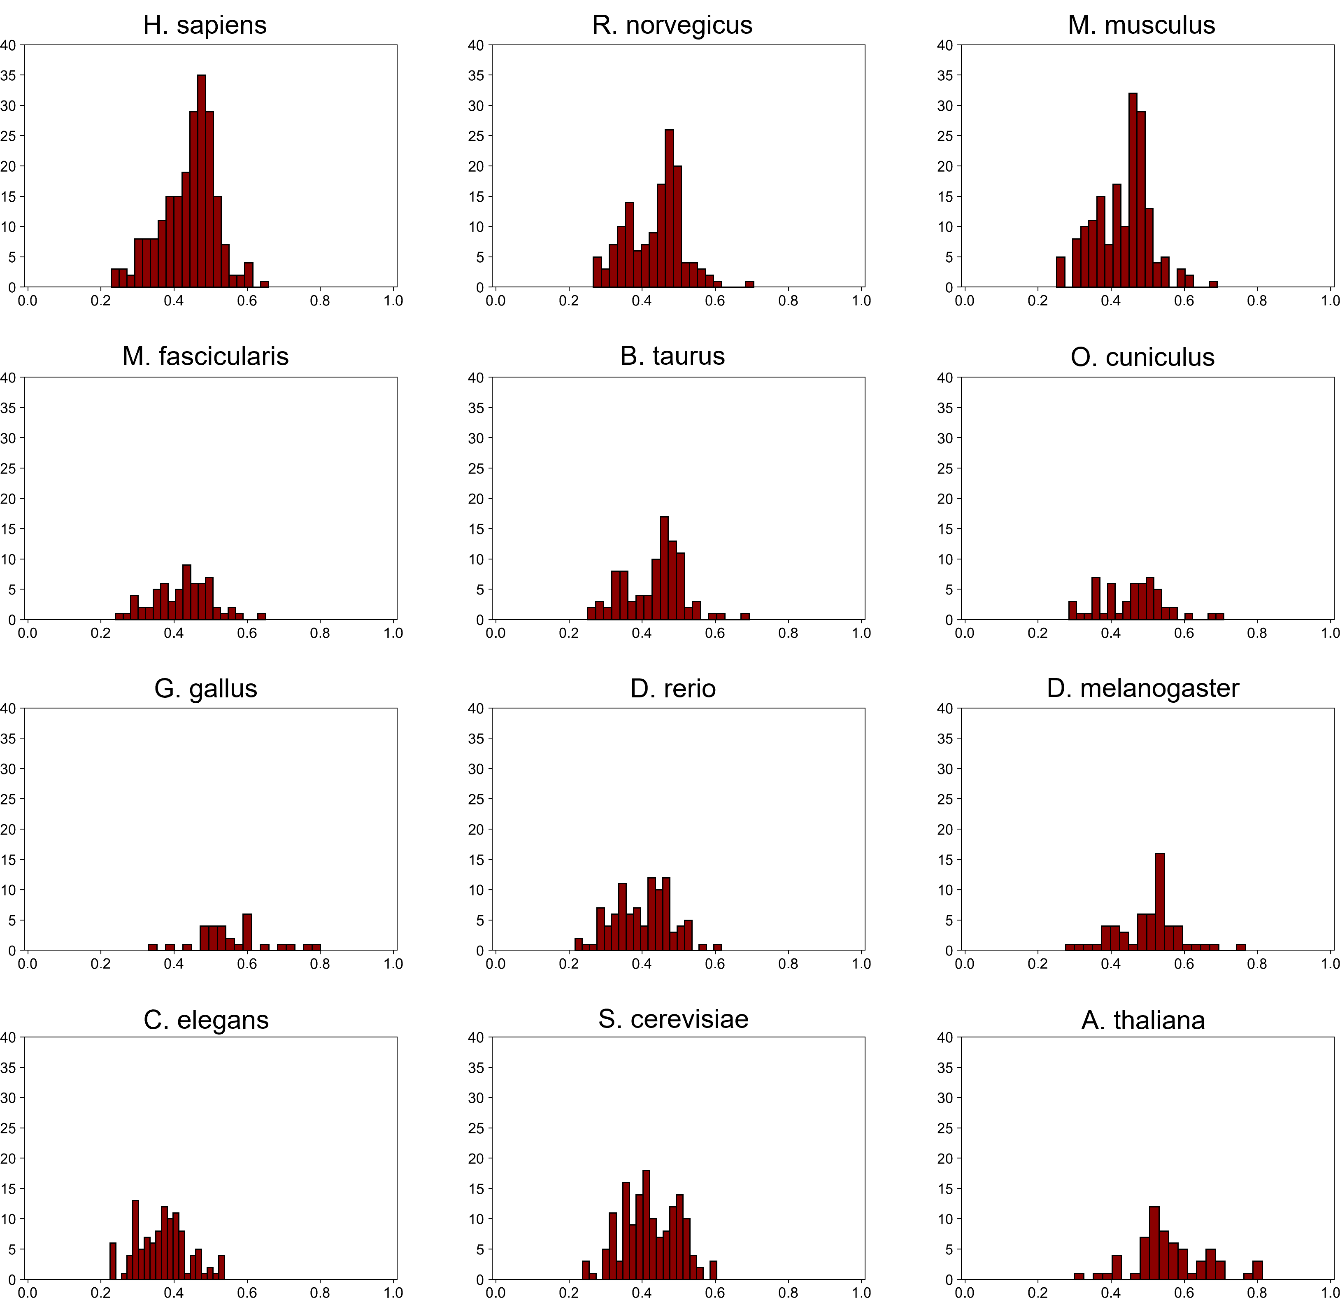
Figure S3: Normalized closeness centrality distributions of native models.

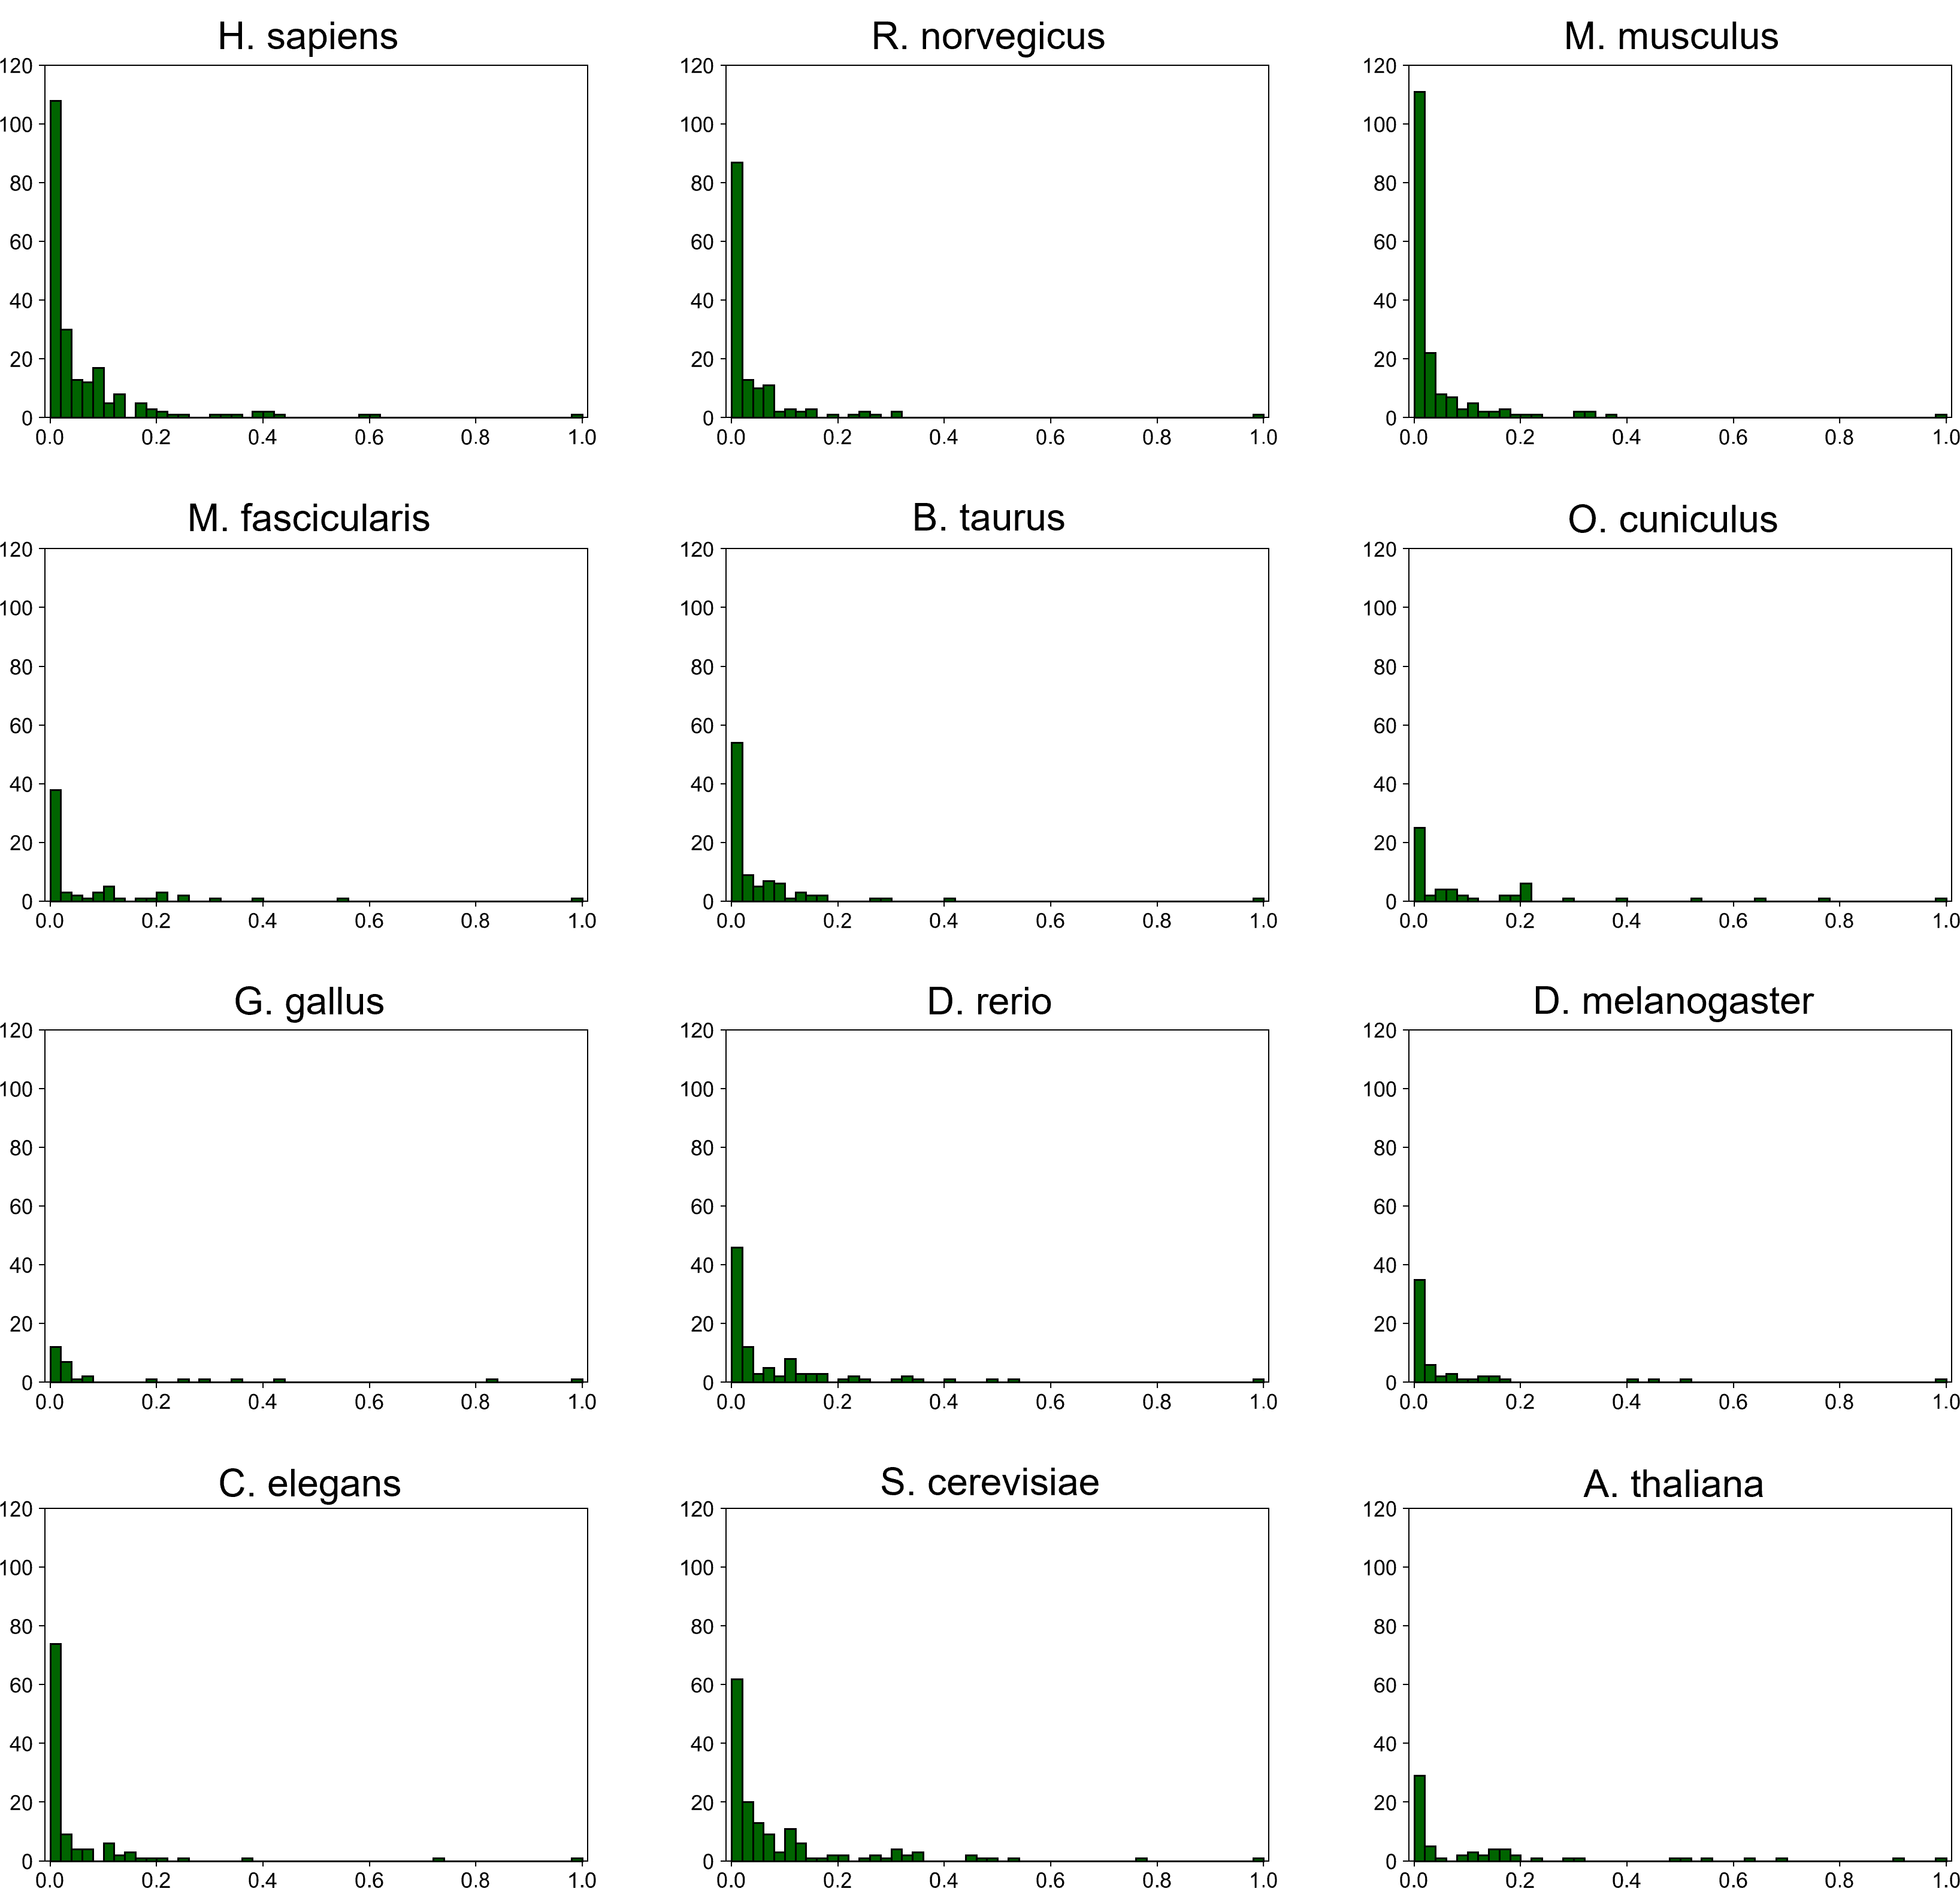

Figure S4: Normalized betweenness centrality distributions of native models.

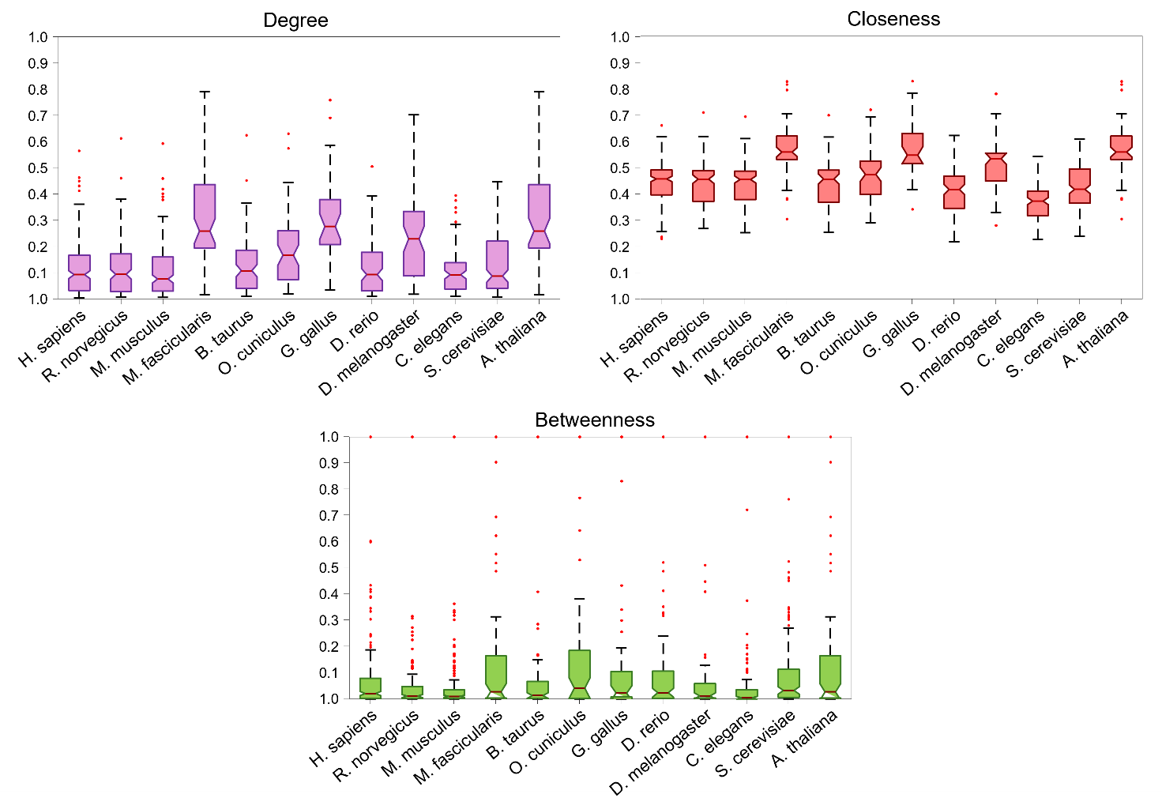
Figure S5: Representation of normalized network metrics.

